Supplementary Figure S1: Effects of PFF challenge on mitochondrial respiration and mitophagy in primary neurons.
(A-F) M83 primary cultured neurons were challenged with 1 µg/ml of PFFs for the indicated number of days, and pS129 α-synuclein signal (A-B) was assessed by immunofluorescence. (C) Mitochondrial oxygen consumption rate in cell mito stress assay was assessed by the seahorse bioanalyzer, yielding measurements for mitochondrial basal respiration (D), maximal respiration (E), and ATP production rate (F). Mean and SD is shown; one-way ANOVA was used for statistical analysis. *p < 0.05, **p < 0.01, ***p < 0.001, n.s., not significant.

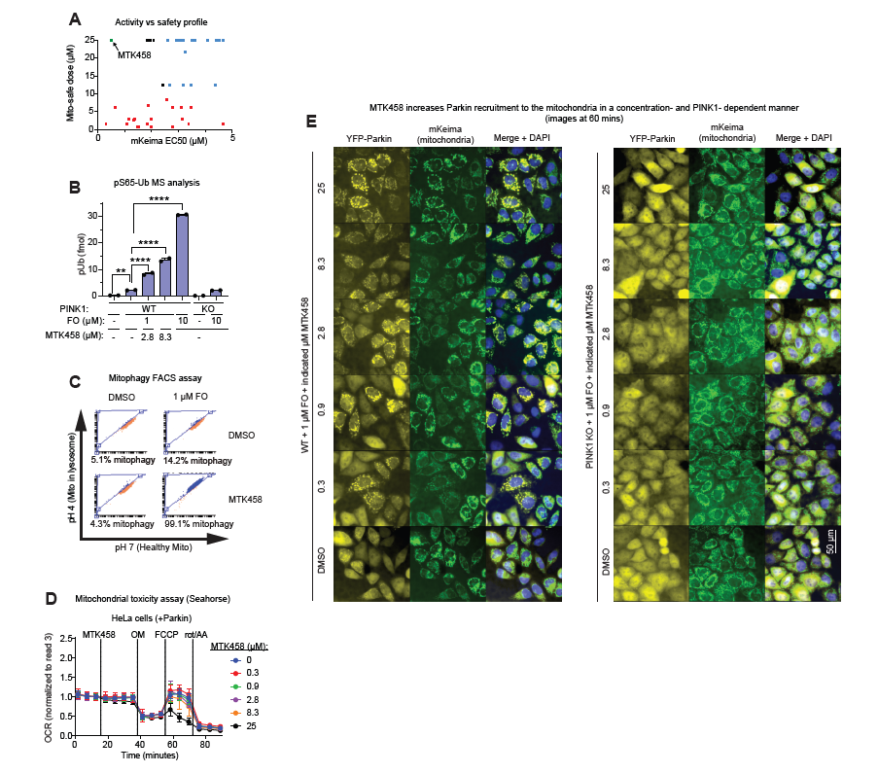
Supplementary Figure S2: Screening for PINK1 activator compounds.
(A) Compounds were screened for their ability to induce mitophagy in the mKeima assay and counter-screened for mitochondrial toxicity in the galactose/glucose assay. EC50 or EC20 measurements for either assay, respectively, are graphed. MTK458 is one of the best compounds in terms of high potency and low toxicity. (B) SK-OV-3 cells were treated with MTK458 ± FO for 6h and then harvested and analyzed for pUb content by mass spectrometry. (C) Example FACS plots from the mKeima mitophagy screening assay. MTK458 causes an increase in cells undergoing mitophagy if treated in the presence of FO. (D) HeLa cells expressing Parkin (YPMK cells) treated with MTK458 were assessed by Seahorse, showing decreased maximal mitochondrial respiration due to increased mitophagy after FCCP is injected to the cells. (E) Images of YPMK cells in the Parkin recruitment assay after FO ± MTK458 treatment. The percentage of cells with YFP-Parkin localized to the mitochondria is increased with MTK458 treatment, in a PINK1-dependent manner. Scale bar, 50 µm Mean ± SD. *p < 0.05, **p < 0.01, ***p < 0.001, ****p<0.0001, n.s., not significant.

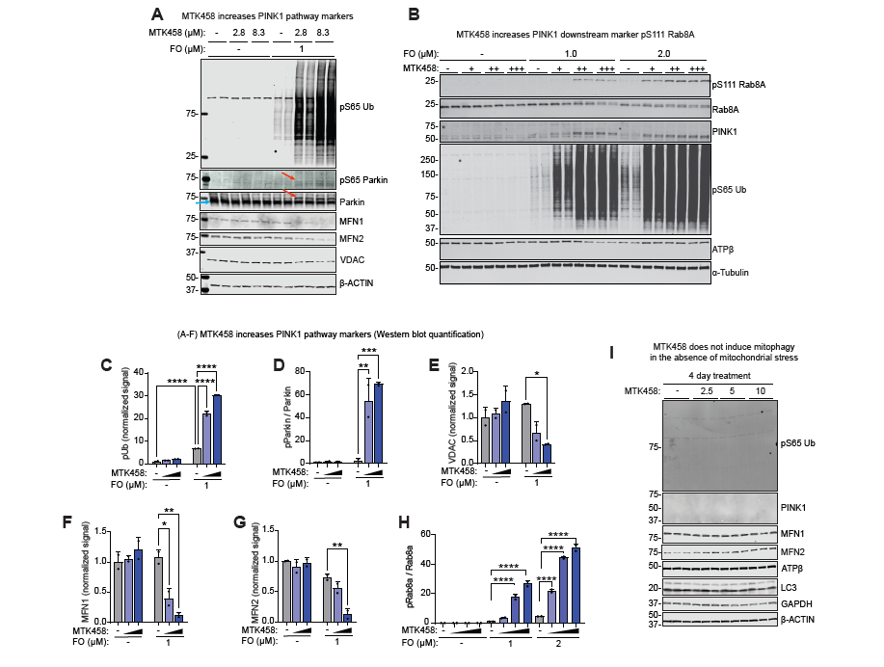
Supplementary Figure S3: MTK458 increases downstream PINK1 pathway biomarkers, but only in the presence of mitochondrial stress.
(A) YPMK cells were treated with or without MTK458 ± 1 µM FO for 2h and then analyzed by Western blotting for PINK1 pathway biomarkers. Red arrows indicate putative pS65 Parkin bands (on YFP-Parkin); blue arrow denotes YFP-Parkin. (B) SK-OV-3 cells were treated with increasing doses of MTK458 in conjunction with a low dose of FO for 24h. MTK458 treatment dose-responsively increases the PINK1 dependent pS111-Rab8A signal, as shown by Western blotting. (C-H) Quantification of PINK1 biomarkers from the Western blot in (B). (I) SK-OV-3 cells were treated for 4 days with MTK458, without mitotoxins, showing no significant changes in mitophagy or mitochondrial markers, and no increase in pUb levels or PINK1 stabilization. Mean ± SD. *p < 0.05, **p < 0.01, ***p < 0.001, ****p<0.0001, n.s., not significant.

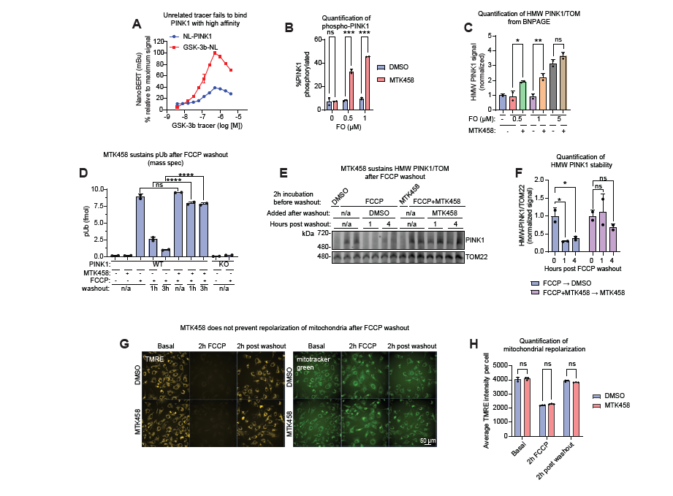 Supplementary Figure S4: MTK458 stabilizes the active form of PINK1 without inducing mitochondrial depolarization.
(A) As a negative control for Figure 3B, we used a proprietary (Promega, K8) tracer that binds to GSK-3b-NL, but not PINK1, to show the specificity of the assay. (B) Quantification of the Western blot in Figure 3F. (C) Quantification of the Western blot in Figure 3H. (D) pUb levels were quantified from cells collected in the FCCP washout experiment by mass spectrometry. (E) EPF1 cells were treated with 10 µM FCCP ± 2.8 µM MTK458 for 2h, followed by FCCP washout and treatment with DMSO or MTK458 for 1-4 hours. Cells were lysed for analysis on BN-PAGE, showing that MTK458 sustains the high molecular weight PINK1 complex even after FCCP removal. (F) Quantification of the gel in (E) is shown. (G) SK-OV-3 cells were treated with 10 µM FCCP ± 2.8 µM MTK458 for 2h, followed by FCCP washout and treatment with DMSO or MTK458 for 2 hours. At the indicated timepoints, mitochondrial membrane potential was quantified by live imaging with 10 nM TMRE. As a control, cells were also imaged with the mitotracker green dye at 100 nM. TMRE only enters polarized mitochondria, but mitotracker green enters all mitochondria. Scale bar, 50 µm. (H) Quantification of the TMRE intensity in (G) is shown. Mean ± SD. *p < 0.05, **p < 0.01, ***p < 0.001, ****p<0.0001, n.s., not significant.

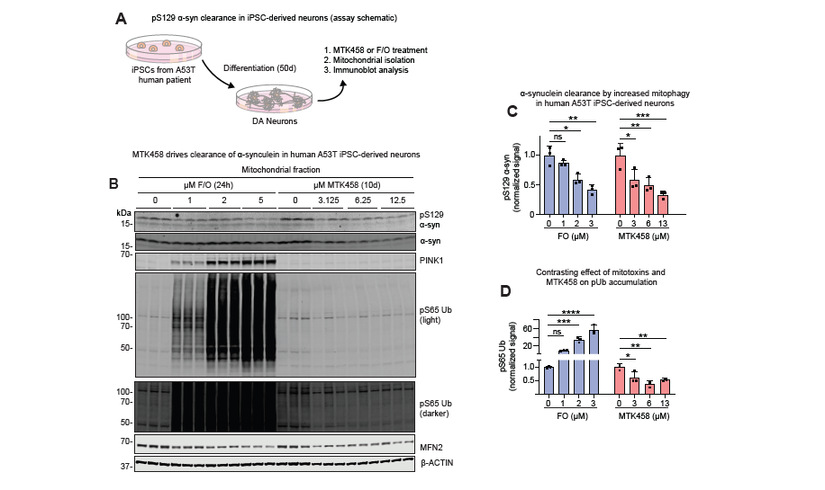
Supplementary Figure S5: MTK458 decreases α-synuclein aggregates in vitro
(A) Schematic describing the iPSC-derived neuron workflow (B) Human A53T patient-derived iPSC neurons were treated for 10 days with MTK458 for 24h with FO, then harvested and analyzed by immunoblotting. (C-D) Quantification of (B) is shown.

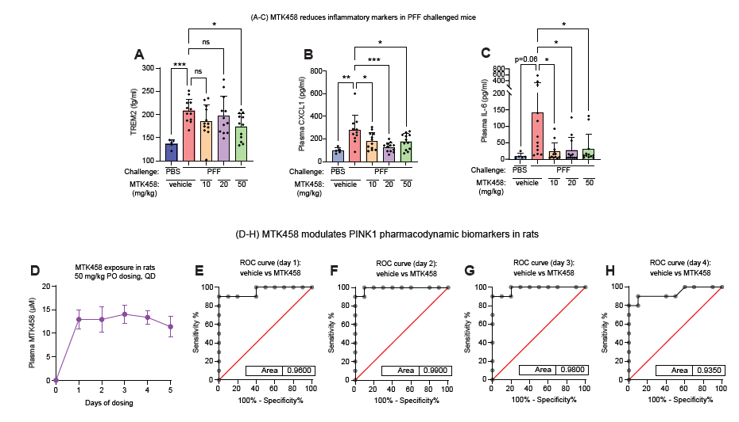
Supplementary Figure S6: MTK458 decreases inflammatory markers in PFF challenged mice and plasma pUb in naïve rats.
(A-C) Mice were challenged with striatal injection of PBS or PFF, and then dosed with MTK458 for 6 months. Mice were analyzed for TREM2 in the ipsilateral striatum (A), plasma CXCL1 (B), and plasma IL-6 (C) levels. (D) Related to Figure 6I-K. Sprague Dawley rats were dosed (PO, QD) with 50 mg/kg MTK458 for 5 days (6 doses), and plasma was drawn before dosing, or 3h after every dose. Plasma MTK458 concentrations were determined by mass spectrometry and plotted. Mean ± SD is shown. (E-H) ROC curves for plasma pUb levels (normalized to predosing levels) in vehicle or MTK458 dosed rats (after 1, 2, 3, or 4 days of dosing) are shown.

