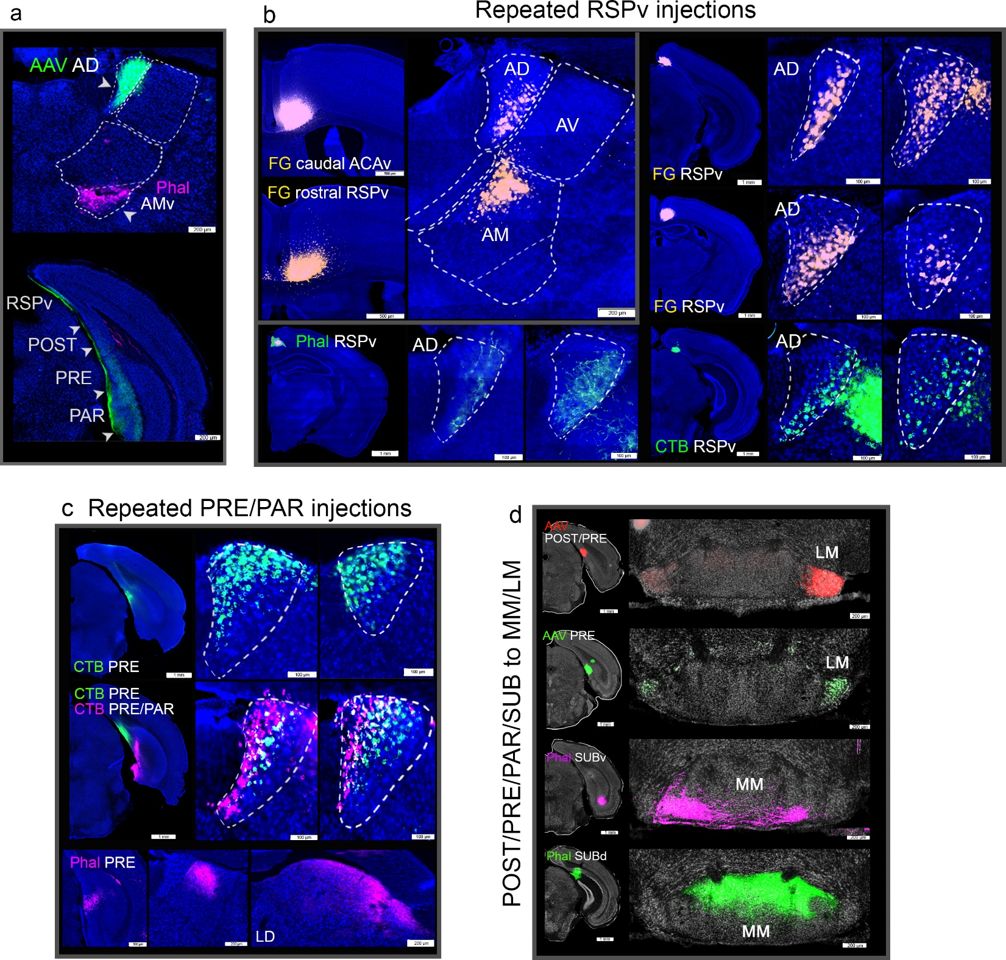
Extended Data Fig. 1, related to Fig. 2. AD connections
a. An anterograde AAV tracer injection in the AD labels all layers of the POST/PRE/PAR (AD→POST/PRE/PAR) and superficial layers of the RSPv (AD→RSPv). b. Repeated injections made across different levels of the RSPv consistently label primarily the AD.lateral. One FG injection that covers both the caudal ACAv and the rostral RSPv labels both the AD.lateral and the AMd.dorsal domains validating the AD.medial→RSPv and the AMd.dorsal→caudal ACAv and the connections.
c. Repeated tracer injections in the PRE and PAR consistently label the AD.medial. Labeling in the LD is shown as verification of the Phal PRE injection. d. Anterograde tracer injections in POST, PRE, PAR, and SUB show their distinct projections to the MM and LM, which were used to verify locations of the hippocampal injection sites. See Table 2 for structure abbreviations.

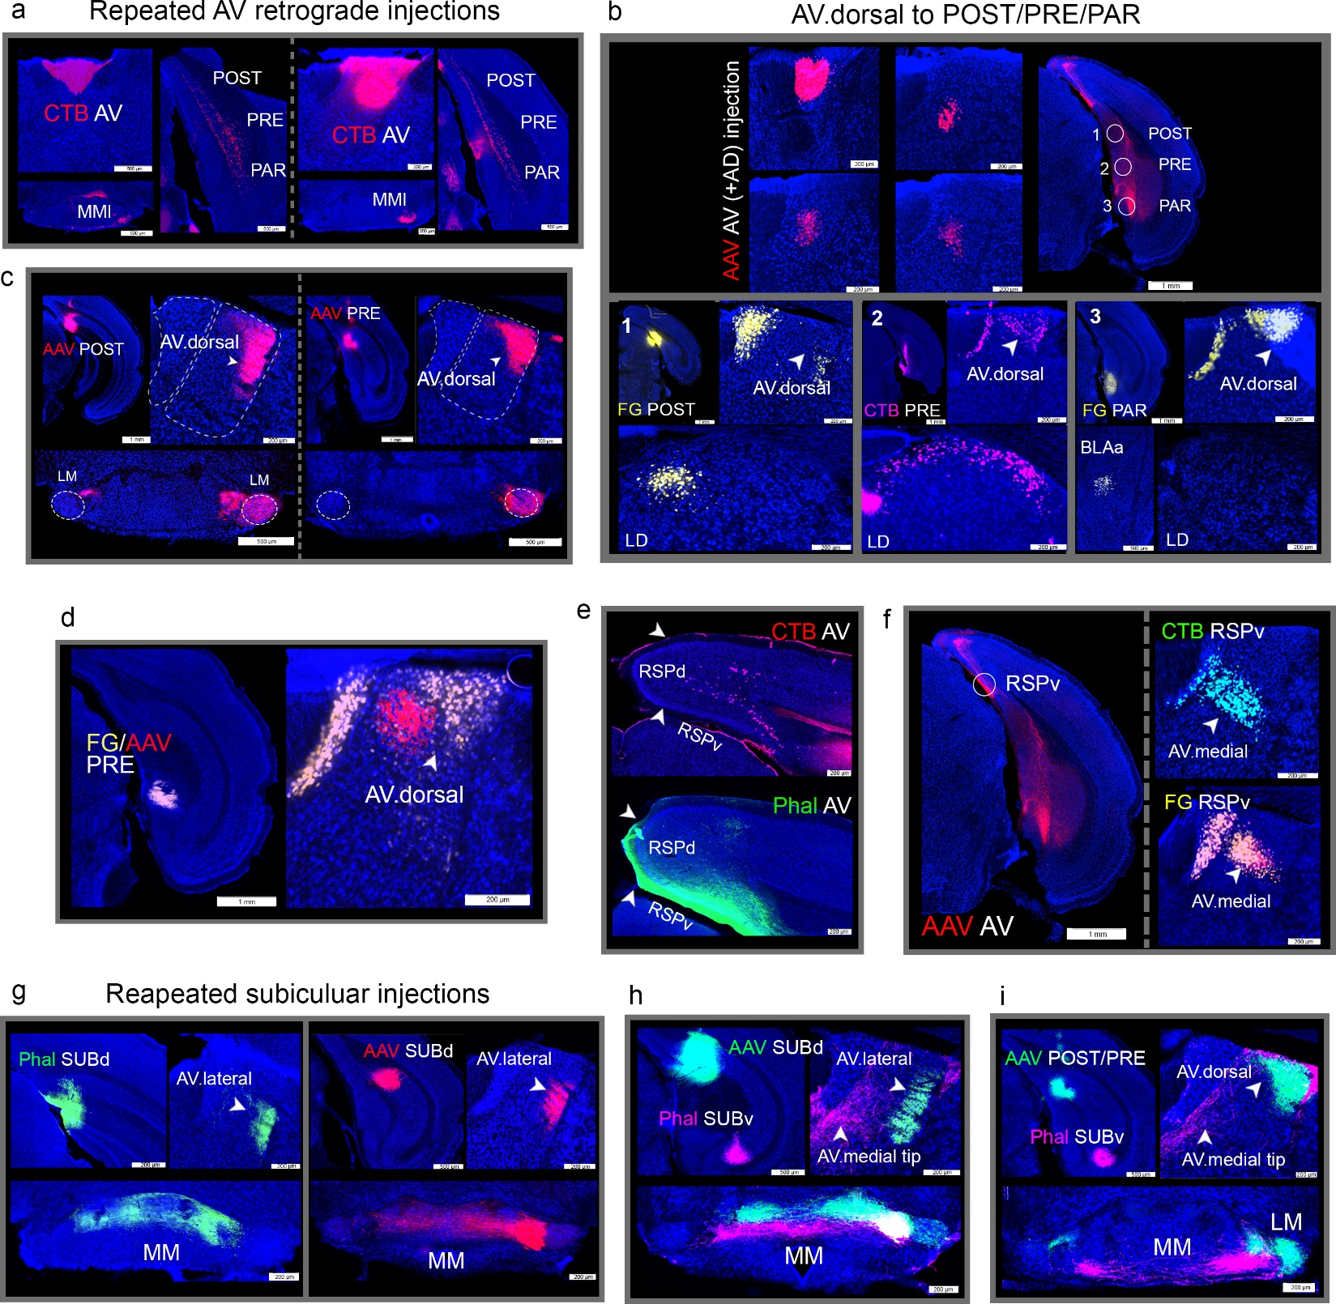
Extended Data Fig. 2, related to Fig. 3. AV connections
a. Repeated AV retrograde tracer injections consistently label neurons in the deep layers of POST, PRE, and PAR. Labeled neurons in the MMl shown as verification of AV injection location. b. Retrograde tracer injections were placed in regions of the axon terminals resulting from an AV (plus AD) anterograde tracer injection. CTB injections in the POST (1), PRE (2), and PAR (3) labels the AV.dorsal (and AD.medial) validating the AV and AD domain specific connections with each of the ROIs. In the bottom panels, retrogradely labeled cells in the LD (for POST, PRE, PAR) and BLA (for PAR) are shown to verify the tracer injection locations. For example, the PAR receives input from the BLA and none from the LD, while the POST and PRE receive input from different groups of neurons in the LD and none from the BLA. c. Anterograde AAV injections in the POST and PRE show projections specifically to AV.dorsal. Projections to MM and LM shown injection site location verification. d. An AAV/FG co-injection in PRE confirms the unidirectional AD.medial→PRE and the bidirectional AV.dorsal↔PRE connections. LD labeling is shown to verify PRE injection locations. e. CTB (top) and Phal (bottom) AV injections show bidirectional connections with RSPd and RSPv (AV↔RSPd/v). f. AV AAV injection shows projections to RSPv. Dashed circle denotes location of the CTB and FG injections that label neurons in the AV.medial validating the AV.medial→RSPv connection. g-i. Several anterograde tracer injections in the SUBd and SUBv consistently show SUBv→AV.medial and SUBd→AV.lateral connections. See Table 2 for structure abbreviations.

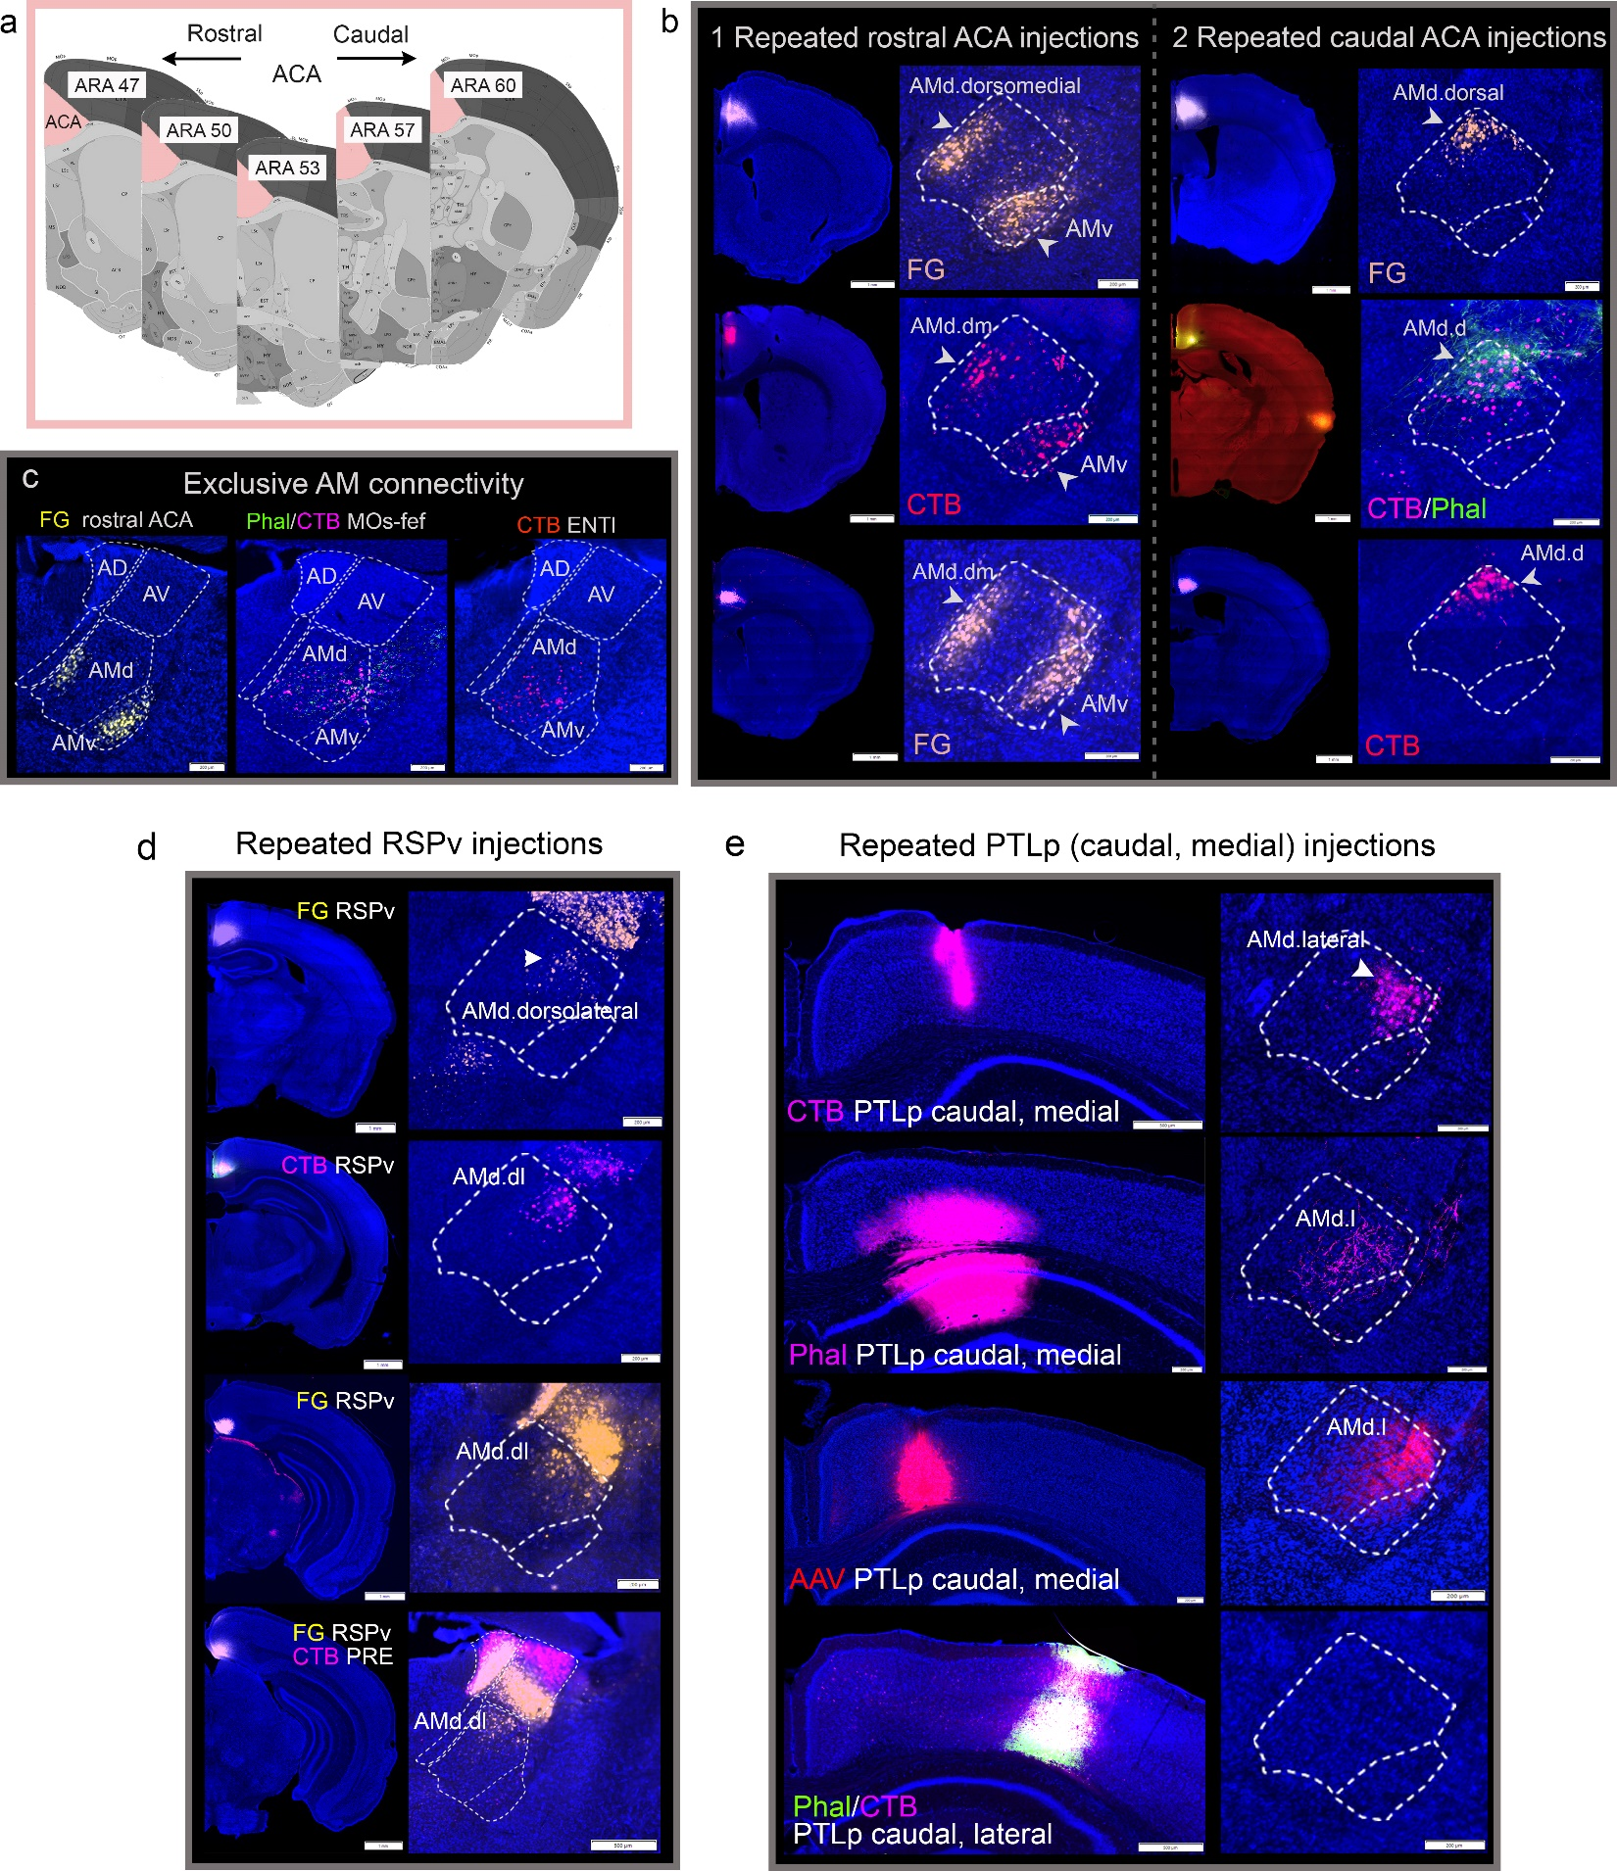

Extended Data Fig. 3, related to Figs. 4 & 5. AMd.dorsal, AMd.dorsolateral, and AMd.lateral domain connections
a. ARA atlas levels showing the approximate boundary between rostral (<ARA 53) and caudal (>ARA 53) ACA based on their connections with the AM. b. Numerous injections made in the rostral ACA (left) and caudal ACA (right) substantiate the AMd.dorsomedial↔rostral ACA and AMd.dorsal↔caudal ACA connectivity. c. The ACA, MOs-fef, and ENTl connectivity with the ATN are exclusively through the AM. Tracer injections in each of these ROIs label terminals or cells only in the AM and not in the AD or AV. d. Several retrograde injections in the RSPv consistently label neurons in the AMd.dorsolateral. In the final panel, a FG RSPv and a CTB PRE injection was made in the same brain. This case shows the AMd.dorsolateral→RSPv, but also the AV.medial→RSPv, AD.lateral→RSPv, AV.dorsal→PRE, and AD.medial→PRE connections. Note the absence of CTB labels in the AM. e. Many injections in the PTLp (caudal, medial part) label the AMd.lateral, while in the final panel, a Phal/CTB co-injection in the PTLp (caudal, lateral part) does not show any labeled axon terminals or cells in the AM validating the specific AMd.lateral↔PTLp (caudal, medial) connections. See Table 2 for structure abbreviations.

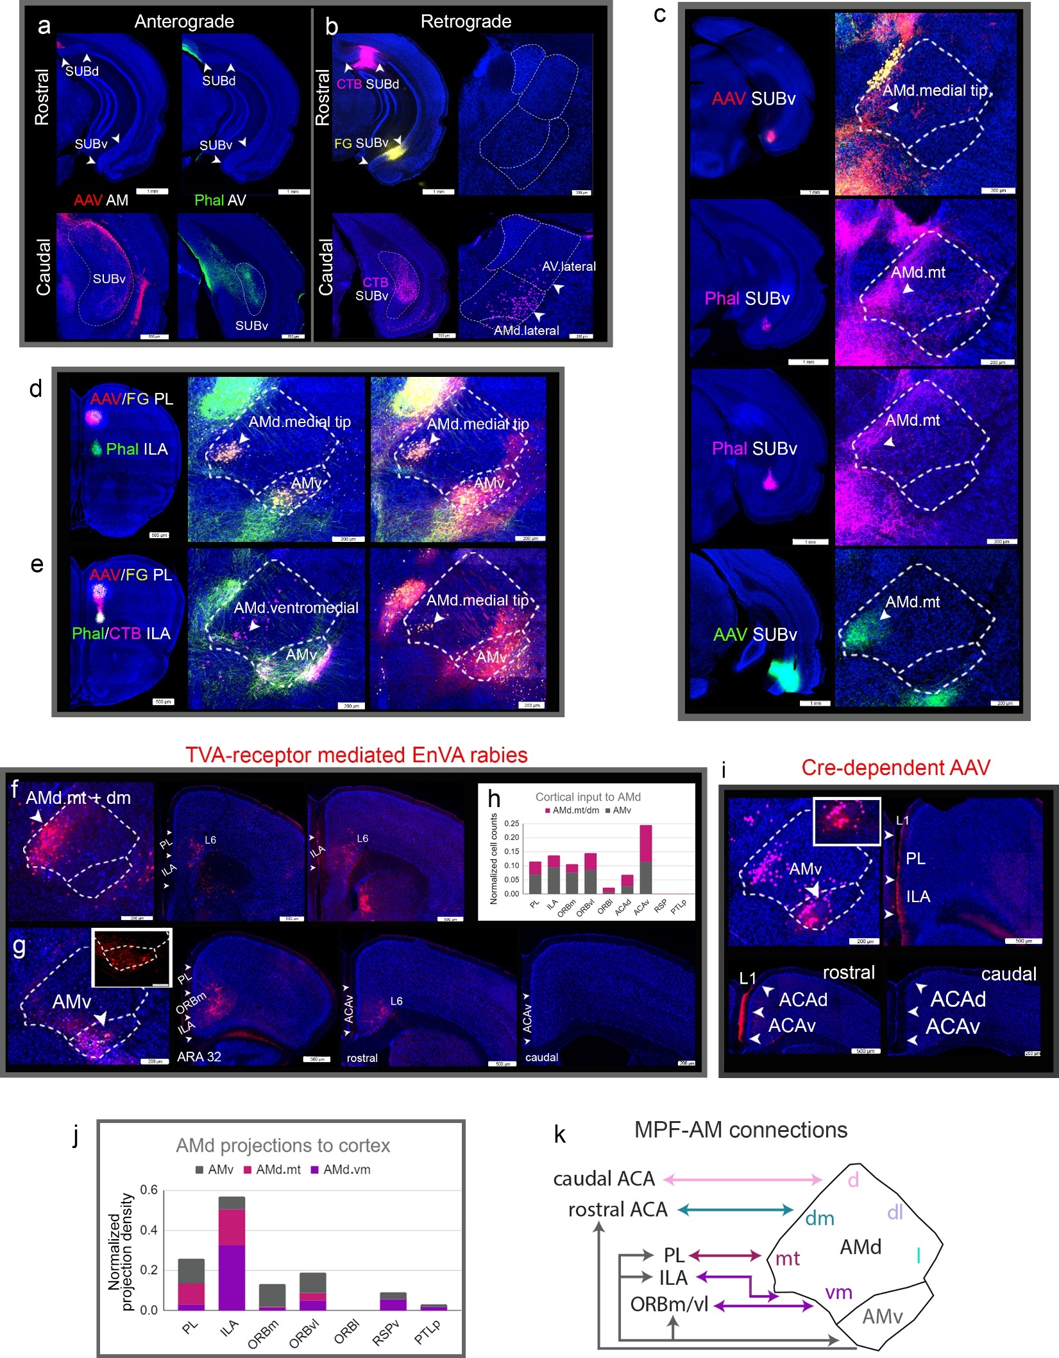Extended Data Fig. 4, related to Fig. 6. AMd.medial tip, AMd.ventromedial, and AMv connections
a. Projections from the AM and AV to SUB are sparse and are to a very specific region within the caudal SUB. Anterograde tracer injections in the AM and AV do not label the SUB in rostral sections, but instead label caudal parts of the SUBv albeit with different patterns. b. Retrograde tracer injections placed in the SUBd and SUBv in rostral levels show no labeled neurons in the AV or AM, while a CTB injection in the caudal SUBv labels neurons in the AV.lateral, AMd.lateral, and AMd.medial domains. c. Repeated SUBv injections validate the SUBv→AMd.medial projections. d-e. Distinction between AMd.medial tip and AMd.ventromedial domains. d. AAV/FG co-injection in PL shows AMd.medial tip↔PL (but also AMv↔PL). e. Anterograde/retrograde co-injections in the PL and ILA in the same brain show AMd.medial tip↔PL, AMd.ventromedial↔ILA, and AMv↔ILA/PL connections. f. A Cre-dependent TVA receptor mediated rabies injection in the AMv (AAVretro-Cre injection in the MPF) back labels neurons in the PL, ORBm, ILA, and rostral ACAv (layer VI), substantiating inputs to AMv from these regions. Note the absence of labels in the caudal ACAv. g. A Cre-dependent TVA receptor mediated rabies injection in the AMd.medial tip back labels cells in the PL and ILA confirming input from these regions to AMd.medial tip/dorsomedial (AAVretro-Cre injection in the MPF). h. Quantification of the data from f-g shows the distinct connections of AMd.medial tip versus the AMv. i. Cre-dependent tracing of AMv neurons (AAVretro-Cre in MPF) shows projections to layer 1 of PL, ILA, and rostral ACA. Observe the lack of labeling in the caudal ACA. j. Quantification of projections from the AMv, AMd.medial tip, and AMd.ventromedial domains showing their relative projections. Note the stronger projections from AMv and AMd.medial tip to PL, AMd.ventromedial to ILA, AMv to ORBm/vl (but not ORBl), and overall fewer projections to RSP and PTLp from these regions. This bar graph validates all the data presented for each of these domains. k. Summary of connections among the MPF and the AMd domains and AMv.

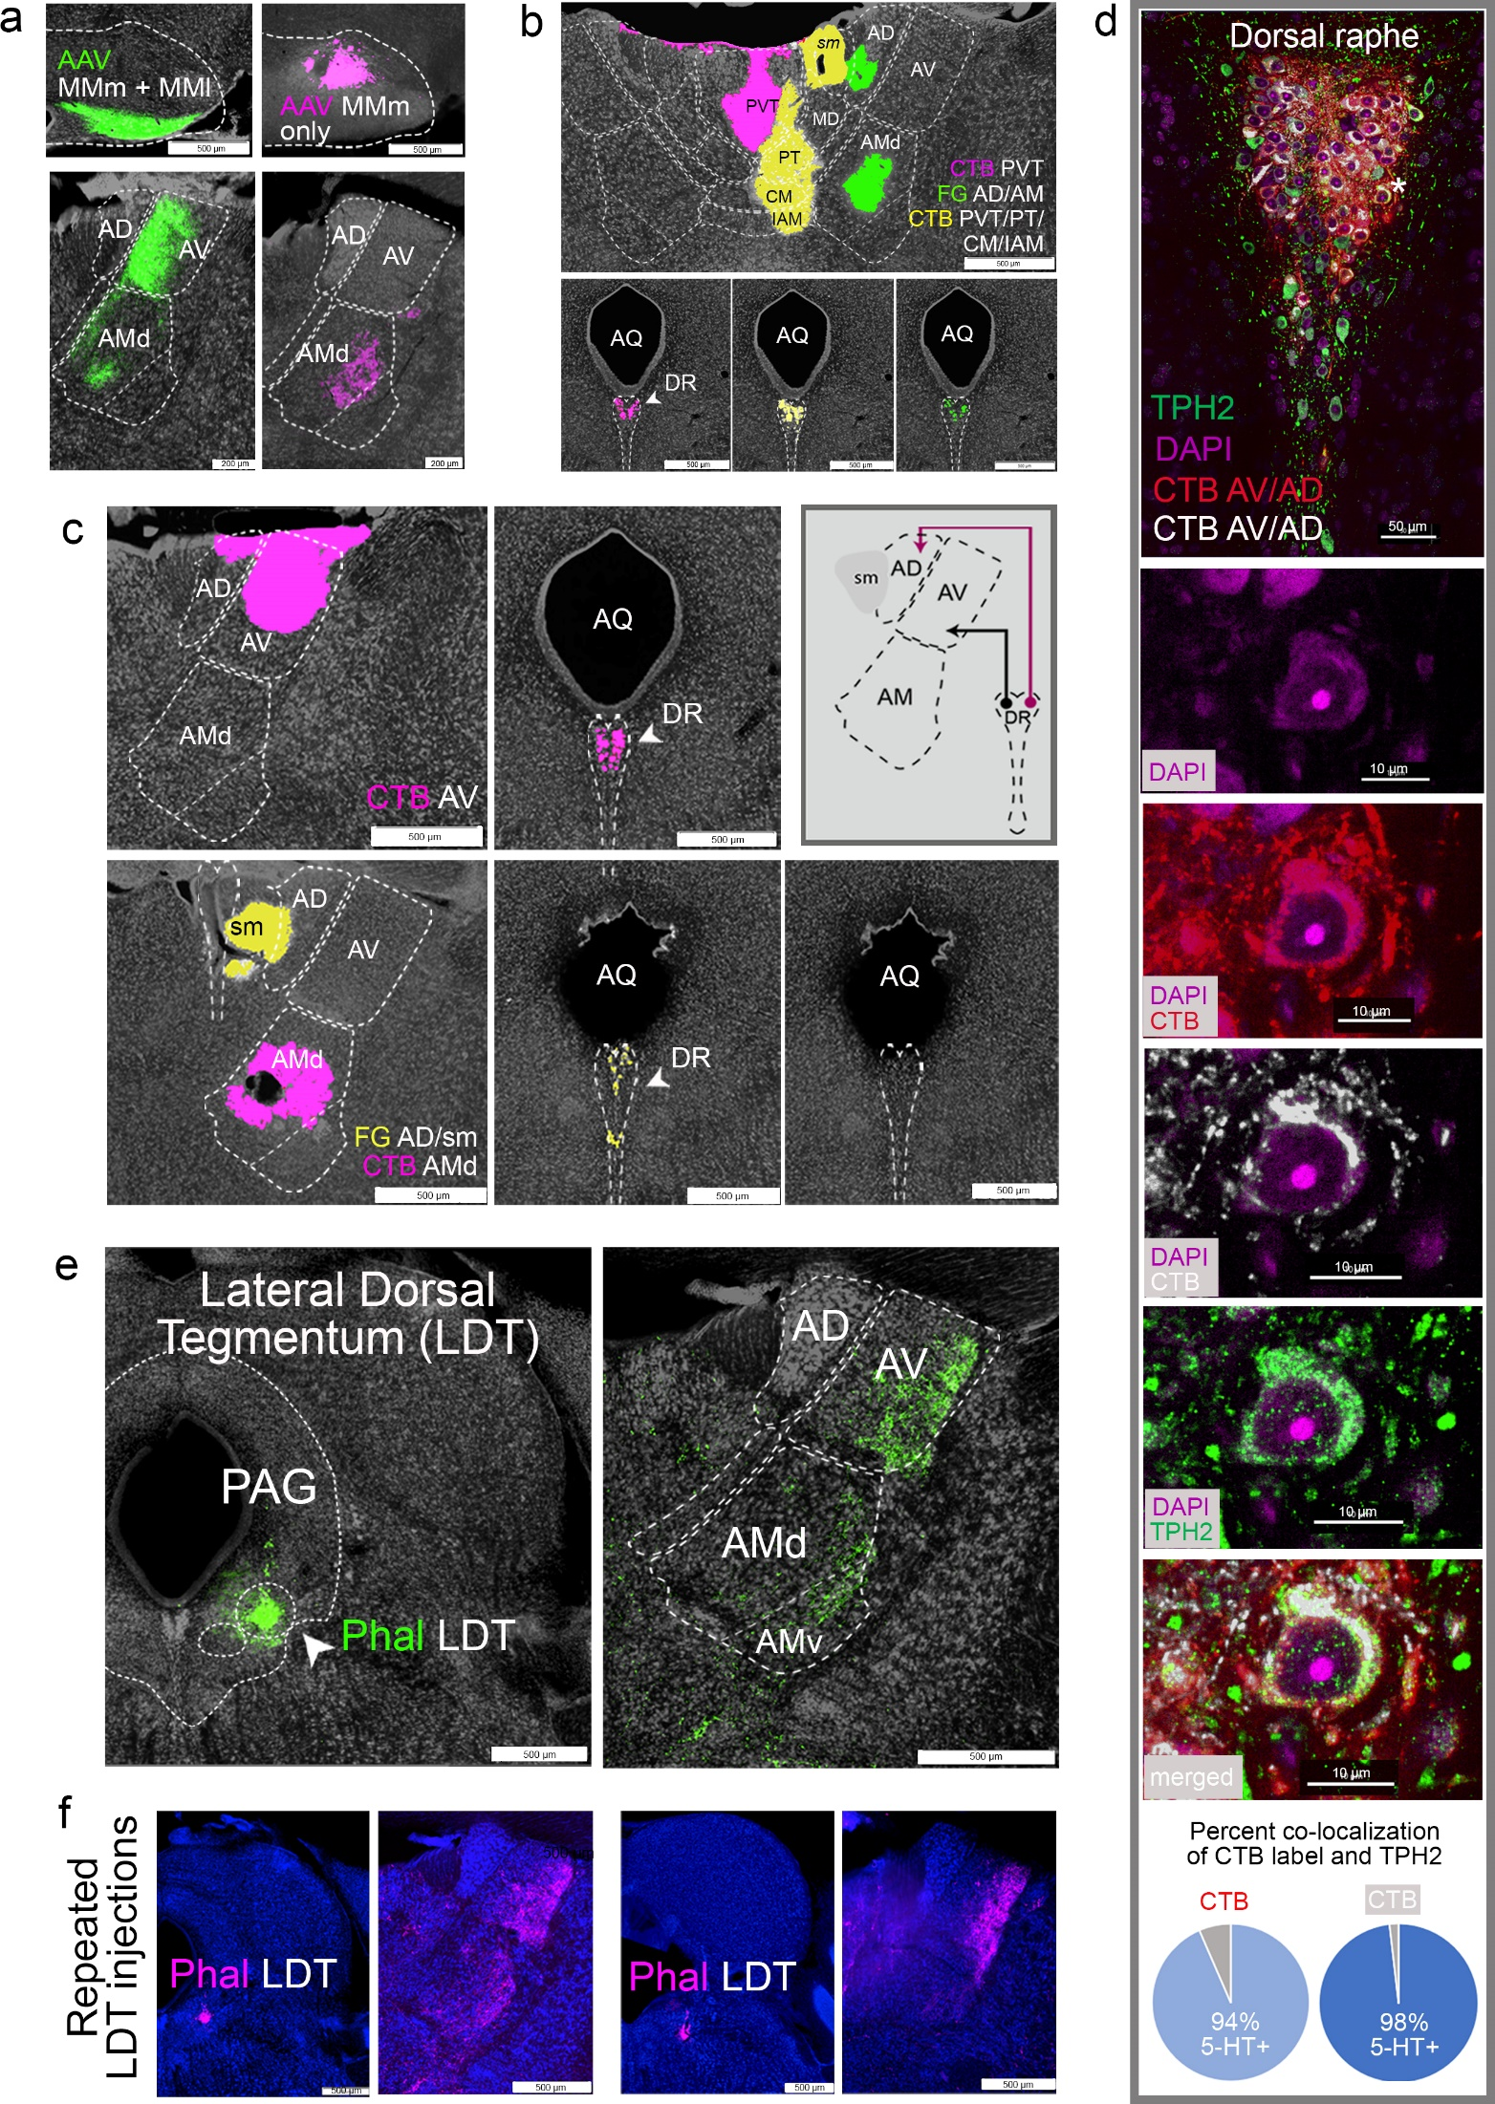Extended Data Fig. 5, related to Fig. 9. Connections of the ATN with the dorsal raphe and lateral dorsal tegmental nucleus
a. An AAV injection that spans both the MMm and MMl labels both the AM and AV, while one restricted to the MMm labels only the AM. b. Retrograde tracer injections in PVT (CTB, pink), PT, CM, IAM (CTB, yellow) show the well documented DR projections to the midline and intralaminar thalamic nuclei. A retrograde tracer in the AM, with leakage into the AD, also shows retrogradely labeled cells in the DR, suggesting a DR→AM/AD connection, but a circumscribed AM retrograde injection does not back label DR cells in c, which also shows DR→AV and confirms the DR→AD projection. Together, the data suggest DR→AD/AV. d. Most AV/AD projecting neurons in the dorsal raphe (DR) are serotonergic. In a single animal, two separate CTB tracer injections were made in the AV/AD (CTB 561, red and CTB 647, white). Both injections labeled neurons in the DR. Sections through the DR were stained for tryptophan hydroxylase (TPH2) to identify serotonin positive cells. A 60x image shows an overview of the DR with CTB and TPH2 labeled cells. A magnified image of a cell co-labeled with CTB and TPH2 is shown. The pie charts show that counts of CTB labeled cells and TPH2+ cells revealed that 94% and 98% of the CTB labeled DR cells were also positive for TPH2. e. A Phal injection in the LDT labels axons in the AV and AM. f. Given the small size of the LDT, repeated anterograde injections were made, which consistently labeled axons in the AV and AM. The LDT does not project to MM, which is also shown. See Table 2 for structure abbreviations.
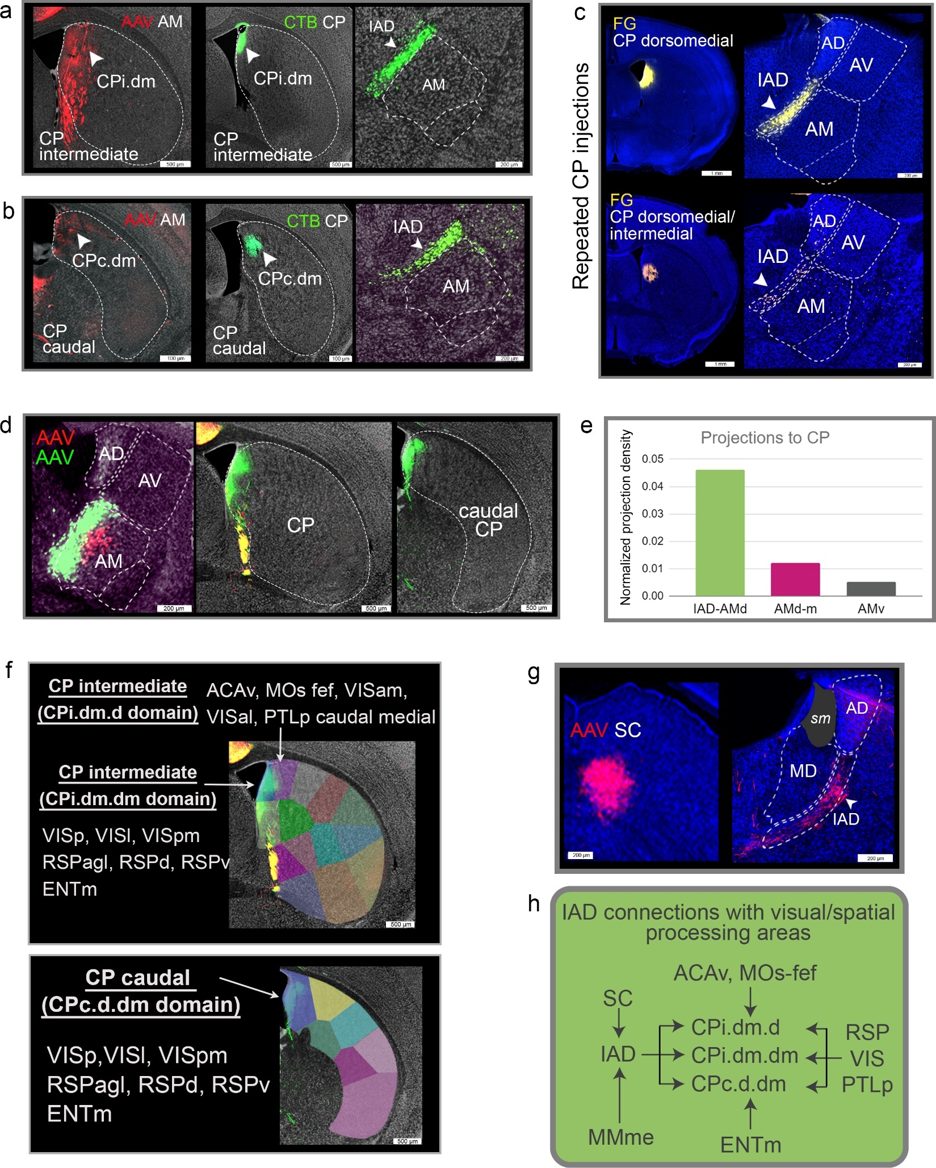

Extended Data Fig. 6. IAD connections with CP
a-b. An anterograde tracer in the AM labels terminals in the dorsomedial CP both at the rostral (CPi.dm, a) and caudal (CPc.dm, b) levels. Retrograde tracers placed in the CPi.dm and CPc.dm show labeled projection neurons in the IAD disclosing the IAD→CPi.dm/CPc.dm connection.
c. Repeated retrograde FG injections into the CPi.dm and intermediate domains (CPi.im) revealed retrograde labeling in the IAD, but not in AM, confirming IAD→CPi.dm projections.
d. Cre-dependent anterograde tracing of AMd/IAD neurons (Cre-dependent AAV-GFP) compared to Cre-dependent tracing of AM neurons that do not involve the IAD (Cre-dependent AAV-RFP) show the former labeling the CPi.dm and CPc.dm (green), whereas the latter injection that does not trace IAD neurons does not (red). Cre was delivered to the AM through a large AAVretro-Cre injection that affected the ILA, PL, and ACA. e. Quantification of the normalized projection density in the CP following Cre-dependent injections into the IAD/AMd, AMd.medial (AMd.m), and the AMv validates the IAD→CP connection. f. The detailed CPi (top) and CPc (bottom) dorsomedial domains are visualized atop the projections from the IAD. All ROIs that project to the CPi and CPc dorsomedial domains are presented to demonstrate the region’s role in integrating visual and spatial information. g. Anterograde AAV tracer injections into the SC revealed axonal labeling in the IAD suggesting an SC→IAD connection. h. Schematic of IAD in a network of ROIs involved in visual and spatial processing. Note that the CPi.dm (CPi.dm.d, CPi.dm.dm) and CPc.dm (CPc.d.dm) domains that the IAD projects to are the domains that integrate converging visual/spatial information from the ACAv, MOs-fef, ENTm, RSP, VIS, and PTLp. The inputs of each domain are listed. See Table 2 for structure abbreviations.

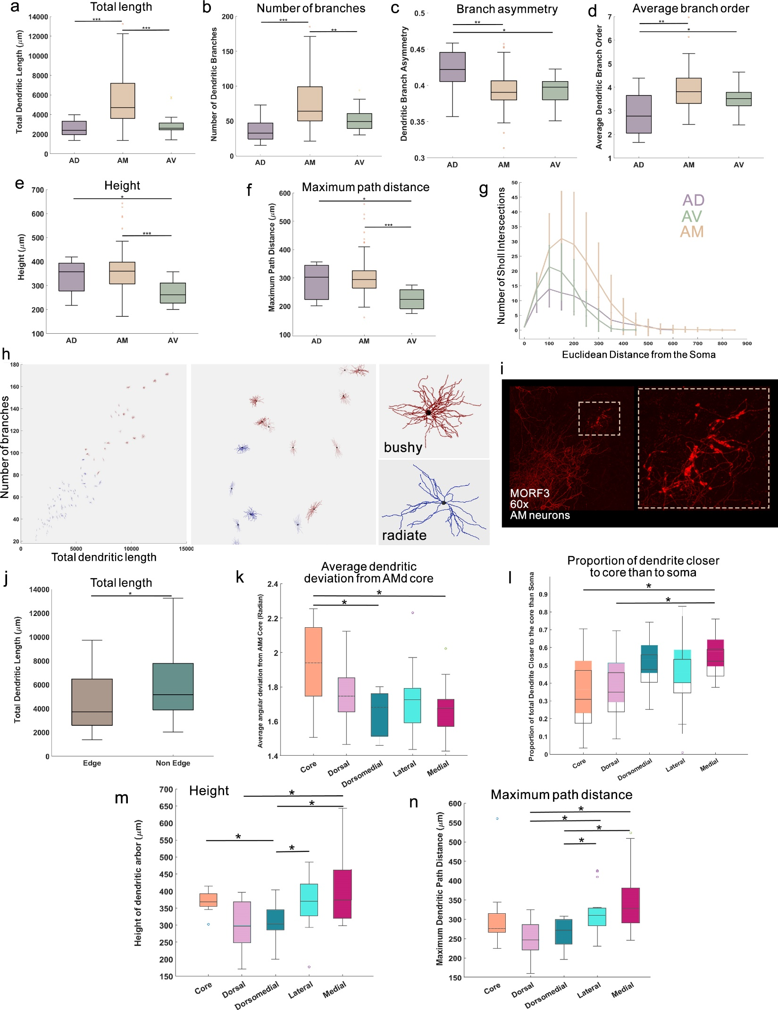Extended Data Fig. 7, related to Fig. 10. Dendritic morphological comparison of ATN neurons
Boxplot comparisons demonstrate differences between AD (n=10), AM (n=82), and AV (n=17) neurons in a, total dendritic length, b, total number of branches, c, branch asymmetry, d, average branch order, e, height, and f, maximum dendritic path distance. g. Sholl intersection profile (number of dendritic intersections per concentric sphere, drawn at 50 μm intervals) shows a larger number of intersections for AM neurons compared to AV and AD neurons. AV neurons have a higher peak intersection (AD and AV both peaking at the 100 μm sphere) compared to AD neurons, whereas the AD neurons extend further and have more intersections away from the cell body than AV neurons. h. All ATN neurons (n=109), classified into two morphological types based on total dendritic wiring length and number of branches, are plotted together in the left-most panel where the X-axis is total dendritic length and Y-axis is total number of branches. The middle panel magnifies the boundary region between the two morphological clusters where Type 1 neurons colored in blue are smaller, less complex and Type 2 neurons colored in red are larger, more complex. Representative Type 1 and Type 2 neurons resemble previously characterized radiate (blue) and bushy (red) neurons. The two neurons shown in the rightmost panel are the closest from their respective cluster centers. i. MORF3 60x confocal imaging of AM neurons show grape-like appendages that have been previously identified in thalamic neurons. See Table 2 for structure abbreviations. j. Boxplot comparison shows greater dendritic length between non-edge (n=45) neurons compared to the edge (n=27) AMd neurons. k-m. Comparative morphometric analyses of the neurons in the AMd domains demonstrate differences. k. Boxplot of average dendritic deviation from the AMd center. AMd.dorsomedial (n=11) and AMd.medial (n=17) domains show lower dendritic deviation than the AMd.core (n=12) domain. l. Boxplot showing the proportion of dendritic arbor closer to the AMd center than soma. AMd.medial neurons have a greater proportion of dendritic arbor closer to the AMd center than the core and the dorsal domain. m. Boxplot of height in which AMd.dorsomedial neurons show reduced height compared to AMd.core, AMd.lateral (n=20), and AMd.medial domains. AMd.medial had greater height than AMd.dorsal (n=12) neurons as well. n. Boxplot of maximum dendritic path length. Both medial and lateral domains show greater maximum dendritic path length compared to both dorsal and dorsomedial domains. False discovery rate corrected Wilcoxon signed rank test was used to find significant differences between AMd domains. For the boxplots, the line inside of each box is the sample median. The top and bottom edges of each box are the upper and lower quartiles, respectively. The distance between the top and bottom edges is the interquartile range (IQR). The upper quartile corresponds to the 0.75 quantile and the lower quartile corresponds to the 0.25 quantile. Outliers are values that are more than 1.5 · IQR away from the top or bottom of the box. Boxplot displays each outlier using an 'o' symbol. The whiskers are lines that extend above and below each box. One whisker connects the upper quartile to the nonoutlier maximum (the maximum data value that is not an outlier), and the other connects the lower quartile to the nonoutlier minimum (the minimum data value that is not an outlier).

