Theoretical and Applied Climatology
Supplementary Information (SI)
for
Distinct impacts of pure El Niño events on spring rainfall of Sri Lanka
Pathmarasa Kajakokulan¹, Gayan Pathirana^{1*}, Xin Geng², Upul Premarathne¹
¹Department of Oceanography and Marine Geology, Faculty of Fisheries and Marine Sciences & Technology, University of Ruhuna, Matara, Sri Lanka.
²CIC-FEMD/ILCEC, Key Laboratory of Meteorological Disaster of Ministry of Education (KLME), Nanjing University of Information Science and Technology, Nanjing, China.

*Corresponding author
Email: upgpathirana@gmail.com
Department of Oceanography and Marine Geology, Faculty of Fisheries and Marine Sciences & Technology, University of Ruhuna, Matara, Sri Lanka.

ORCID
Pathmarasa Kajakokulan - 0009-0007-7361-9620
Gayan Pathirana – 0000-0002-4670-579X
Xin Geng – 0000-0003-0970-8382
Upul Premarathne– 0000-0003-4934-1618

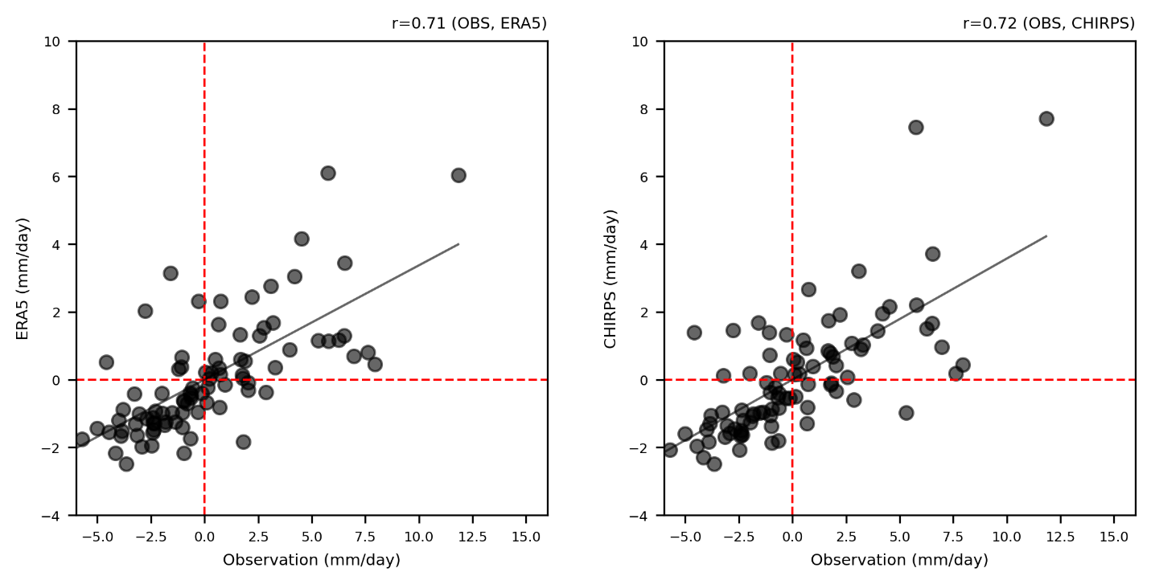
Fig. S1 The correlation between the observations of the precipitation data and a) the CHIRPS precipitation and b) the ERA5 precipitation.

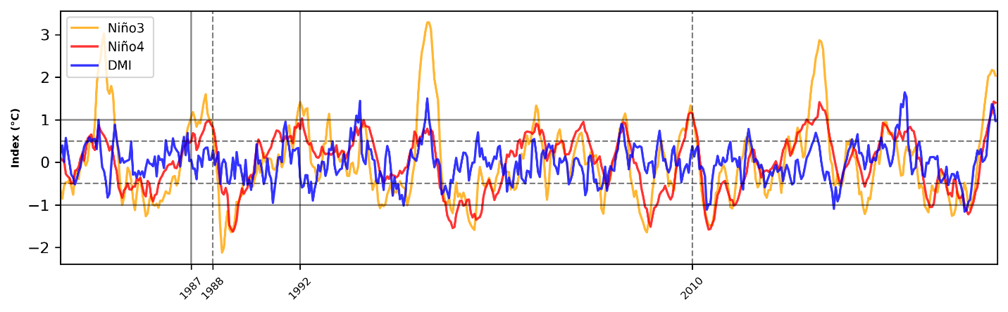
Fig. S2 Timeseries of Niño3 index (Orange), timeseries of Niño4 index (red), timeseries of DMI index (Blue) from January 1981 to December 2023 (Source: ERSSTV5). The thick (Dash) line indicates of Niño3 exceed the Niño4 (Niño4 exceed the Niño3).
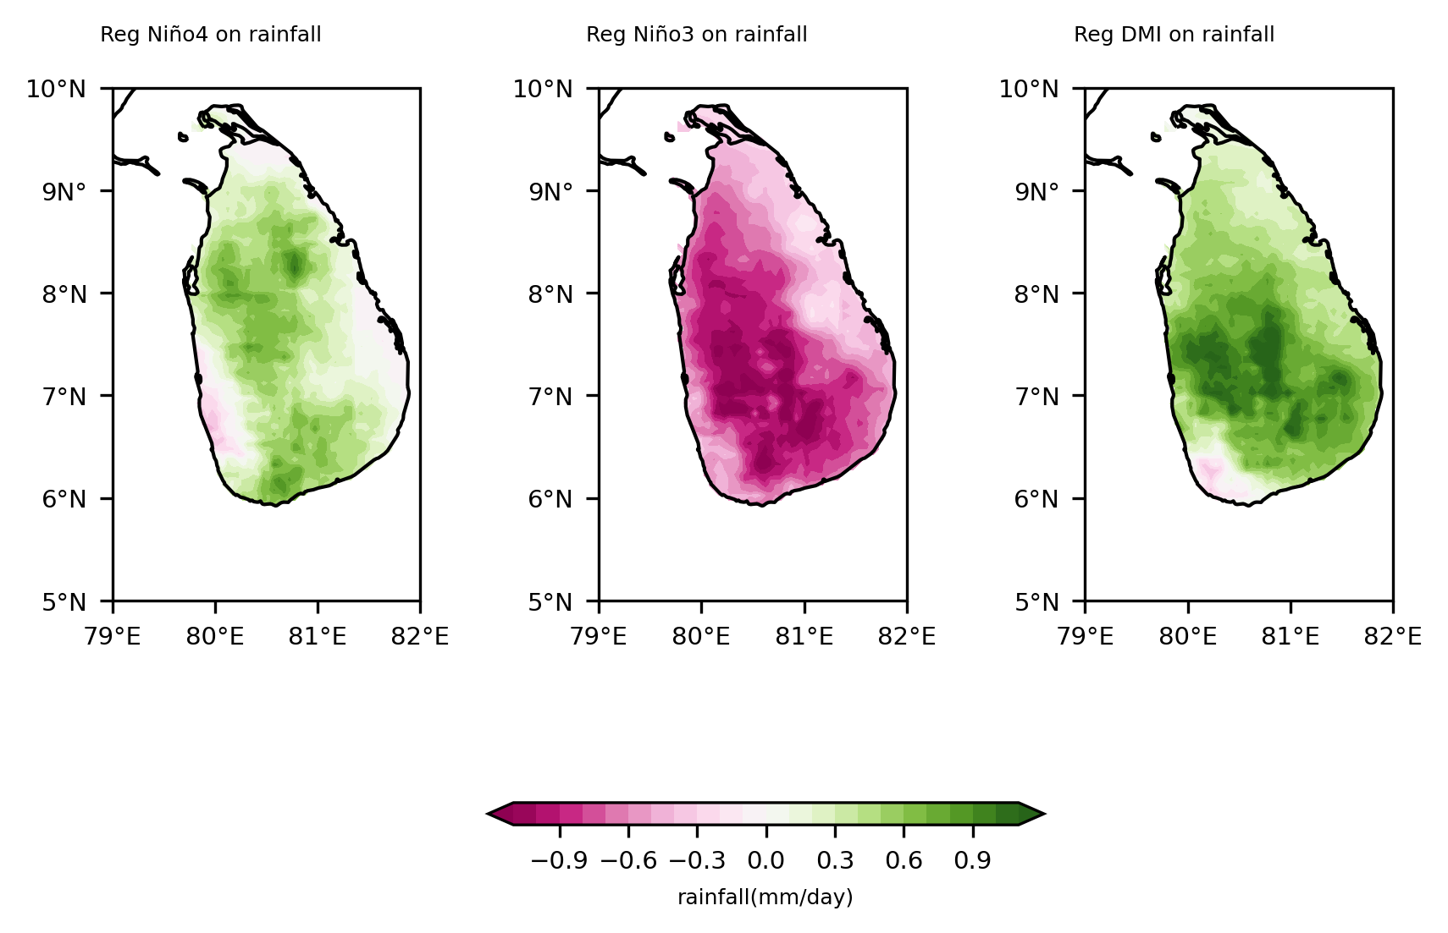
Fig. S3 Precipitation anomalies during El Niño decaying spring regressed onto Niño4, Niño3 during D[0]JF[+1] and DMI during SON[0] index for the period of 1981 to 2023. The results are based on multiple linear regression.
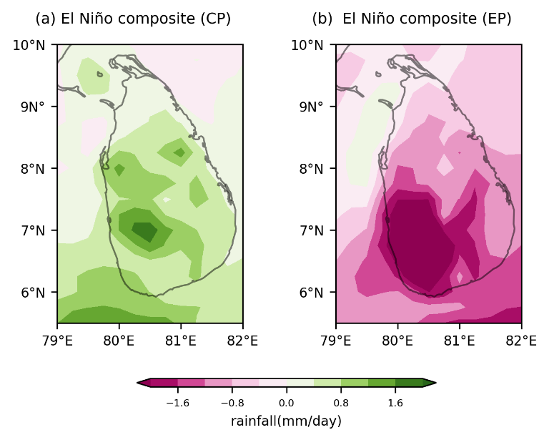
Fig. S4 Same as Figure 1, but from ERA5 data.

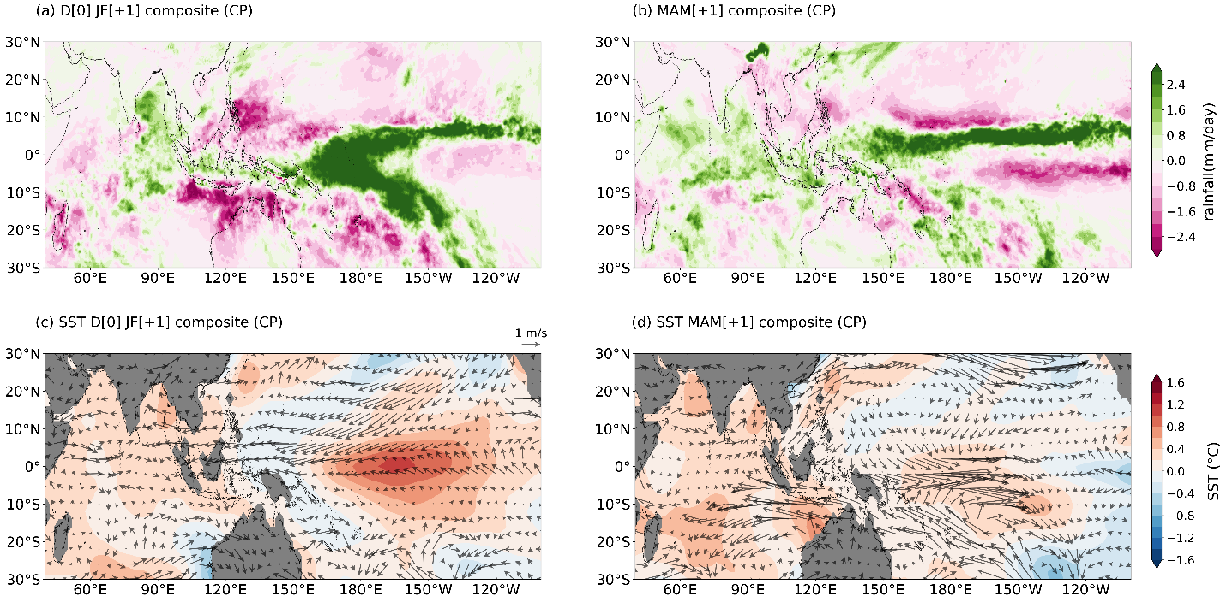
Fig. S5 Composite of precipitation anomalies for pure CP El Niño events of 1987/88, and 2009/10, a) El Niño peak winter, and b) El Niño decaying spring. Composite of SST anomalies (color shading, ºC), and low-level wind (850 hPa, vector) for pure CP El Niño events of 1987/88, and 2009/10 c) El Niño peak winter, and d) El Niño decaying spring.

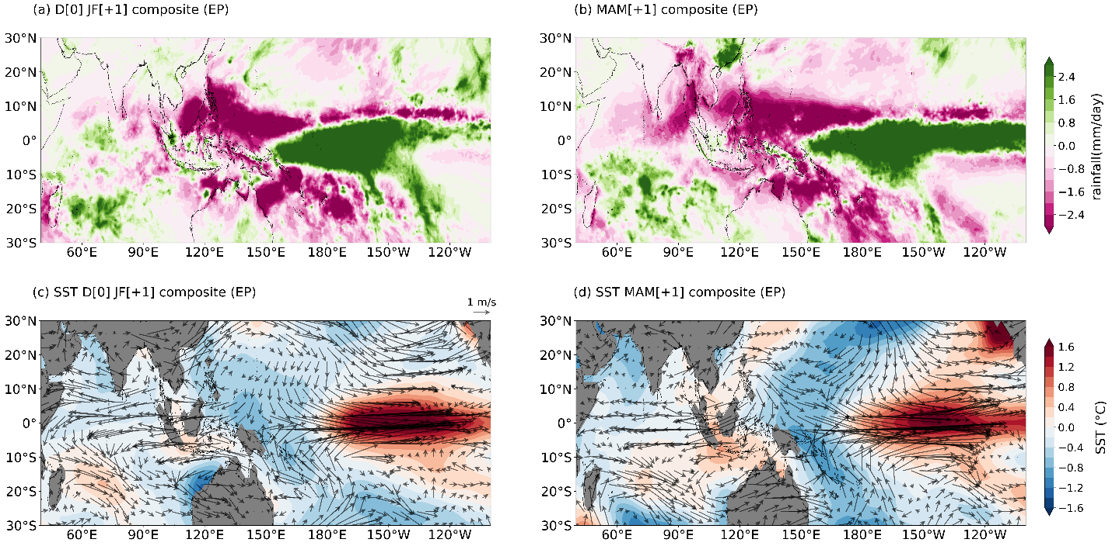
Fig. S6 Composite of precipitation anomalies for pure EP El Niño events of 1986/87, 1991/92, a) El Niño peak winter, and b) El Niño decaying spring. Composite of SST anomalies (color shading, ºC), and low-level wind (850 hPa, vector) for pure EP El Niño events of 1986/87, 1991/92, c) El Niño peak winter, and d) El Niño decaying spring.
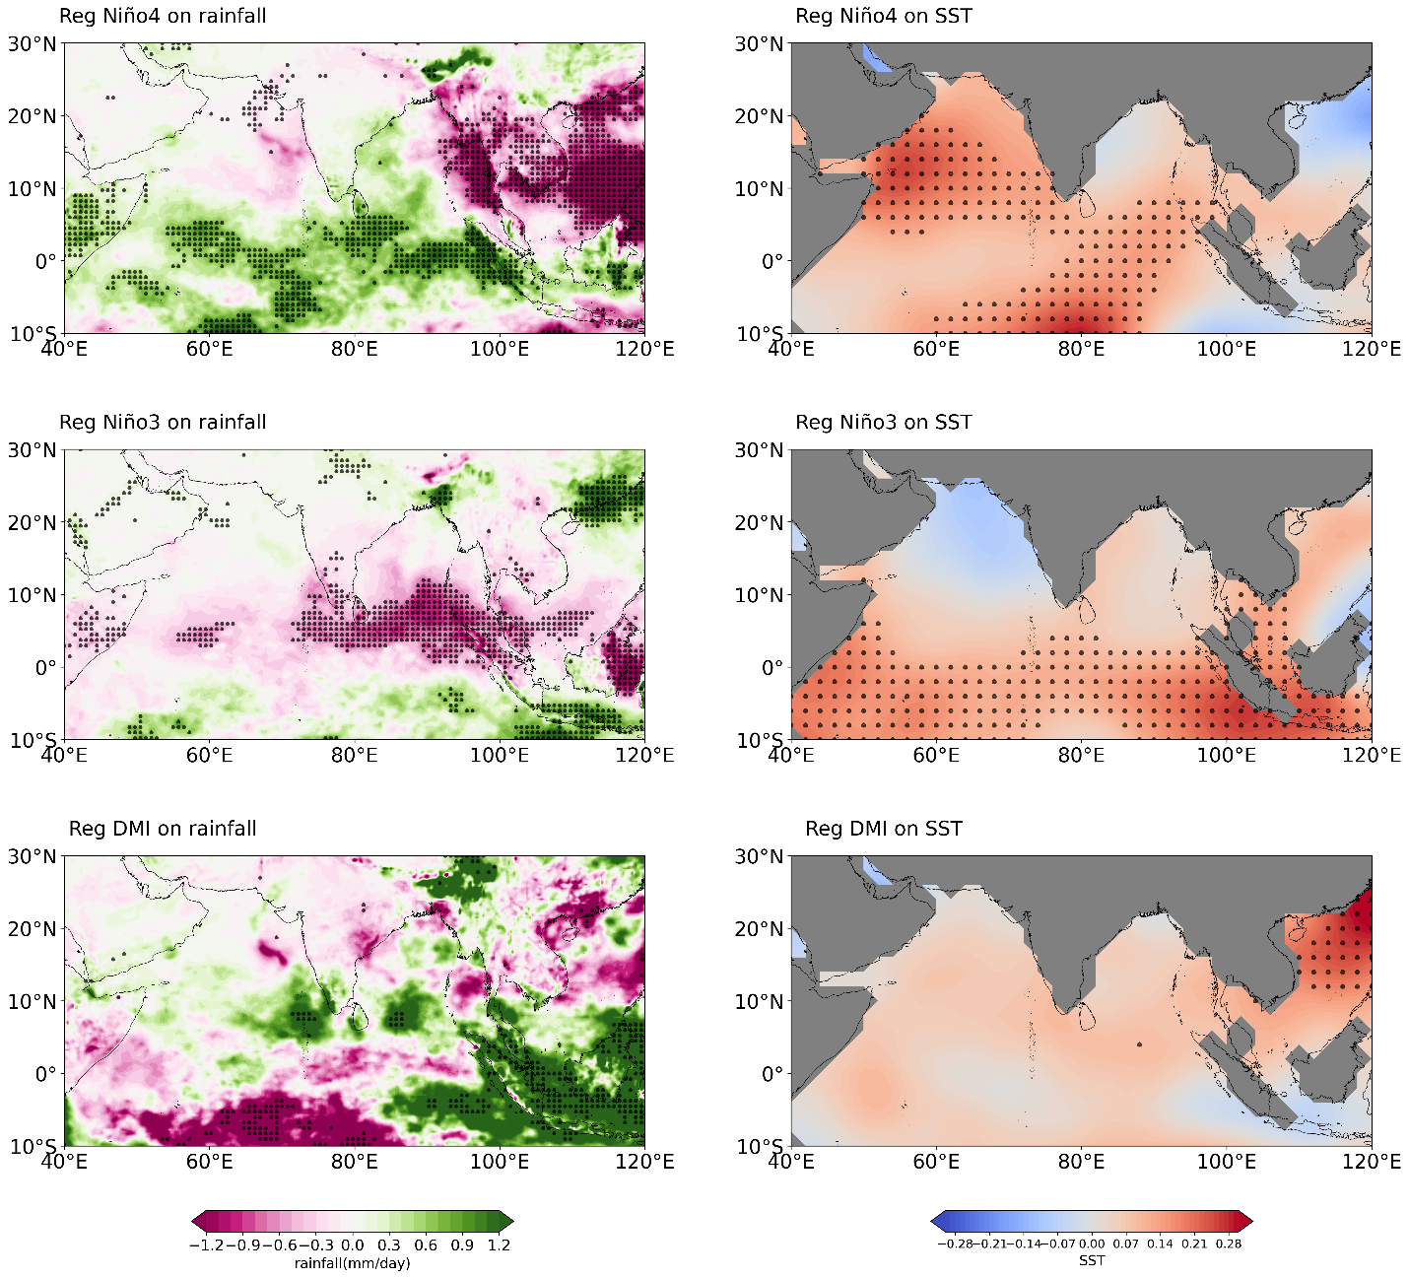
Fig. S7 Precipitation and SST anomalies during El Niño decaying spring regressed onto Niño4, Niño3 during D[0]JF[+1] and DMI during SON[0] index for the period of 1981 to 2023. The results are based on multiple linear regression.

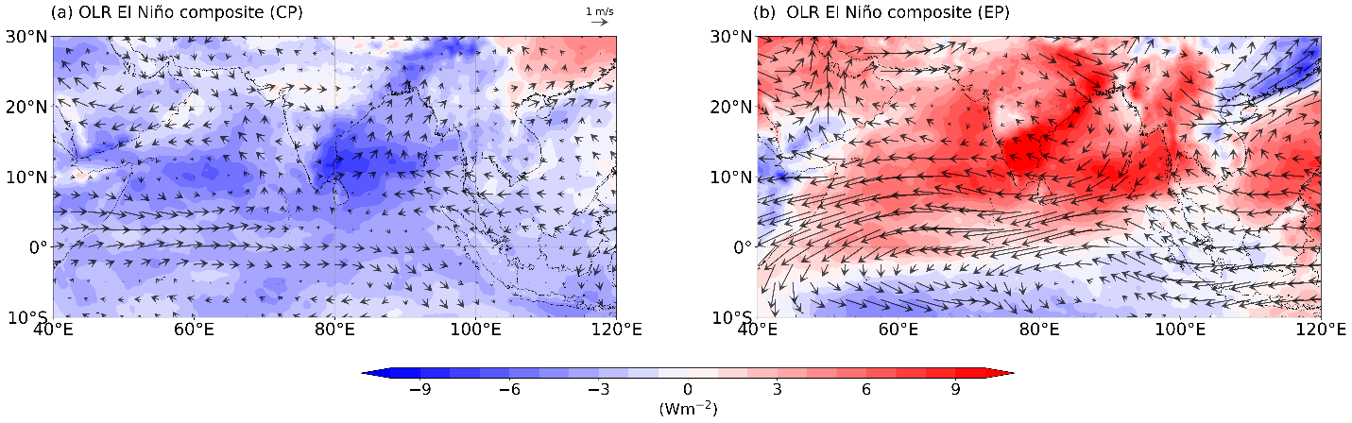
Fig. S8 Same as Figure 3, but for OLR.

