List of figures and tables
(Table 2, Table 3 and Figures 1,2,4,5,6 can be placed in the main text)
(Table 1 and Figure 3 can be attached as index)
Efficacy of prebiotic, probiotic and synbiotic administration in improving growth in children aged 0-59 months living in low- and middle-income countries: a systematic review and meta–analysis
Marietou Khouma, Mamadou Diallo, Doudou Sow, Aicha Djigual, Ndeye Sokhna Diop, Stephen Allen, Babacar Faye
Correspondence
Marietou Khouma, Department of Animal Biology, Faculty of Science and Technology, Cheikh Anta Diop University of Dakar; Email: marietou.khouma@ucad.edu.sn;

Table 1: Studies excluded after reading the full text
Table 2: Characteristics of studies
Table 3: Rating the quality of evidence

Figure 1: PRISMA diagram
Figure 2: Risk of bias for the 8 RCTs (RoB 2) tool
Figure 3: Geographical distribution of included articles
Figure 4:
- A: Effect of prebiotic, probiotic and synbiotic on the weight gain (kg) of children living in LMICs.
- B: Effect of prebiotic, probiotic and synbiotic on the weight gain (kg) of children by intervention.
- C: Effect of prebiotic, probiotic and synbiotic on the weight gain (kg) of children by nutritional status.
Figure 5:
- A: Effect of prebiotic, probiotic and synbiotic on the height gain (cm) of children living in LMICs.
- B: Effect of prebiotic, probiotic and synbiotic on the height gain (cm) of children by intervention.
- C: Effect of prebiotic, probiotic and synbiotic on the height gain (cm) of children by nutritional status.

Figure 6: Effect of prebiotic, probiotic and synbiotic administration on the head circumference gain (cm) of children.
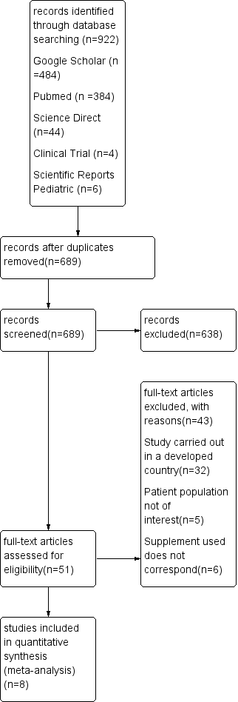
Included
Identification
Screening

Figure 1 : PRISMA diagram
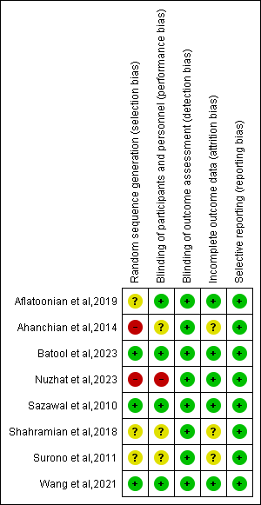
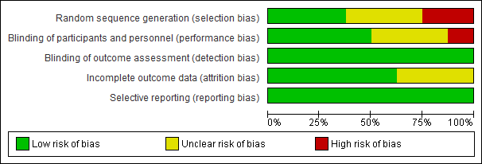
Figure 2 : Risk of bias for the 8 RCTs (RoB 2) tool (1).

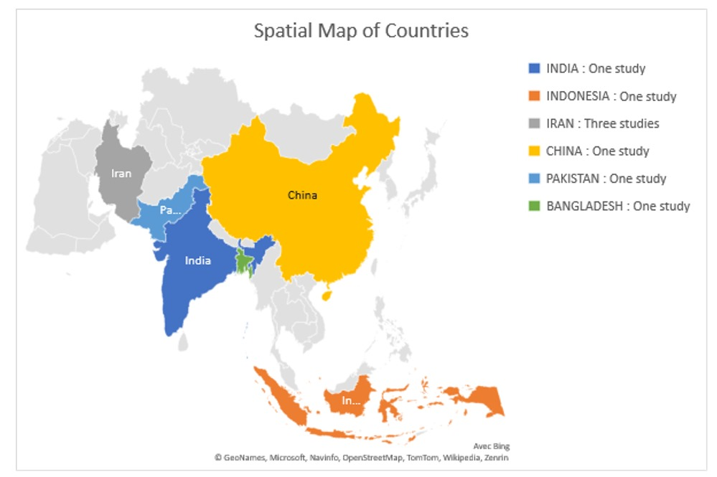

Figure 3: Geographical distribution of included studies

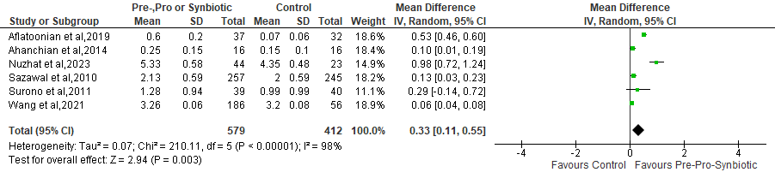
Fig.4. A: Effect of prebiotic, probiotic and synbiotic on the weight gain (kg) of children living in LMICs.
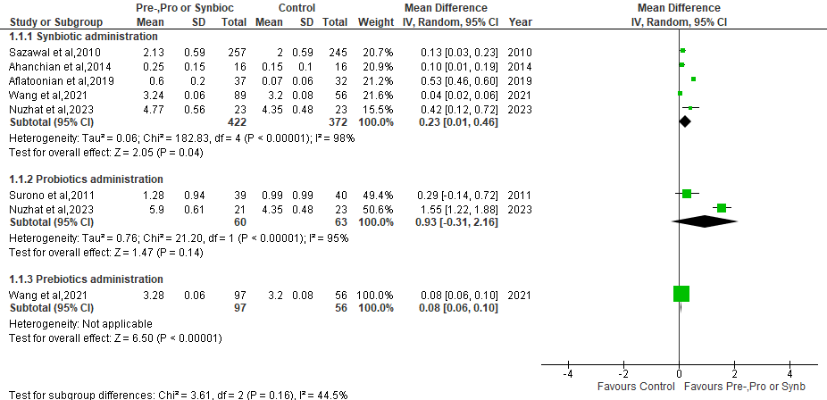

Fig.4. B: Effect of prebiotic, probiotic and synbiotic on the weight gain (kg) of children by intervention
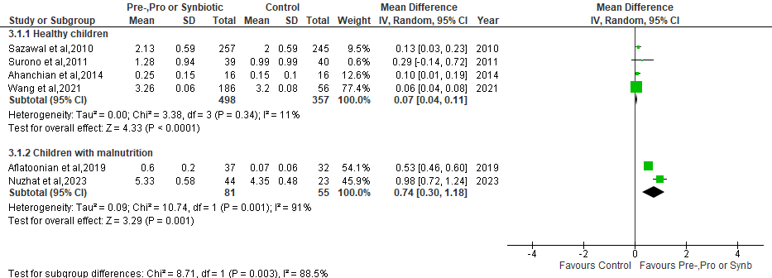
Fig.4. C: Effect of prebiotic, probiotic and synbiotic on the weight gain (kg) of children by nutritional status

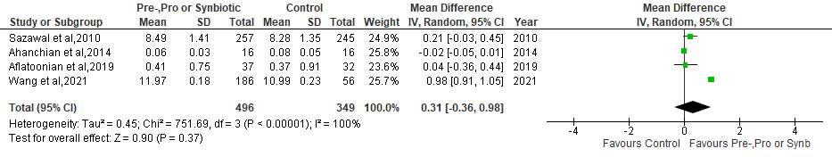
Fig.5. A: Effect of prebiotic, probiotic and synbiotic on the height gain (cm) of children living in LMICs
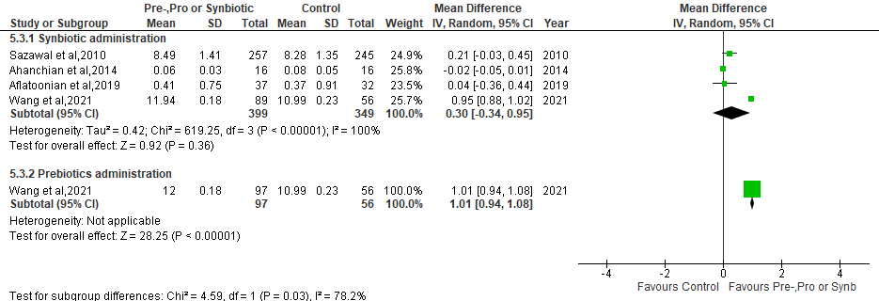
Fig.5. B: Effect of prebiotic, probiotic and synbiotic on the height gain (cm) of children by intervention.
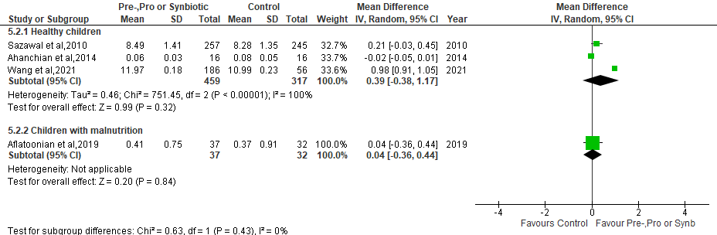

Fig.5. C: Effect of prebiotic, probiotic and synbiotic on the height gain (cm) of children by nutritional status

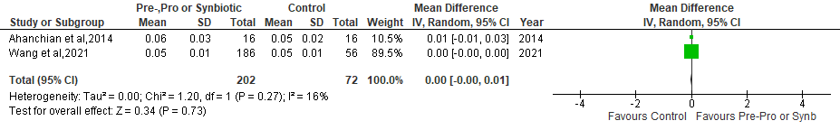
Fig.6: Effect of prebiotic, probiotic and synbiotic administration on the head circumference gain (cm) of children

Table 1: Studies excluded after reading the full text
Study (reference) | Reason for Exclusion
Scalabrin, DMF et al ; 2017(2) | 32 studies: conducted in High Income Countries (HICs)
Neumer, et al ; 2021(3) | 32 studies: conducted in High Income Countries (HICs)
Radke, et al ; 2017(4) | 32 studies: conducted in High Income Countries (HICs)
Ashley, et al ; 2012(5) | 32 studies: conducted in High Income Countries (HICs)
Rodriguez, et al ; 2019(6) | 32 studies: conducted in High Income Countries (HICs)
Johnston, et al ; 2015(7) | 32 studies: conducted in High Income Countries (HICs)
Scalabrin, et al ; 2009(8) | 32 studies: conducted in High Income Countries (HICs)
Cekola, et al ; 2015(9) | 32 studies: conducted in High Income Countries (HICs)
Al-Hosni, et al ; 2012(10) | 32 studies: conducted in High Income Countries (HICs)
Costalos, et al ; 2008(11) | 32 studies: conducted in High Income Countries (HICs)
Puccio, et al ; 2007(12) | 32 studies: conducted in High Income Countries (HICs)
Piemontese, et al ; 2011(13) | 32 studies: conducted in High Income Countries (HICs)
Wiezman, et al ; 2006(14) | 32 studies: conducted in High Income Countries (HICs)
Bocquet, et al ; 2013(15) | 32 studies: conducted in High Income Countries (HICs)
Chouraqui, et al ; 2008(16) | 32 studies: conducted in High Income Countries (HICs)
Pastor, et al ; 2020(17) | 32 studies: conducted in High Income Countries (HICs)
Rozé, et al ; 2012(18) | 32 studies: conducted in High Income Countries (HICs)
Ringel, et al ; 2015(19) | 32 studies: conducted in High Income Countries (HICs)
Wejryd, et al ; 2019(20) | 32 studies: conducted in High Income Countries (HICs)
Manzano, et al ; 2017(21) | 32 studies: conducted in High Income Countries (HICs)
Maldonado, et al ; 2019(22) | 32 studies: conducted in High Income Countries (HICs)
Saavedra, et al; 2004(23) | 32 studies: conducted in High Income Countries (HICs)
Gibson, et al ; 2009(24) | 32 studies: conducted in High Income Countries (HICs)
Dupont, et al ; 2015(25) | 32 studies: conducted in High Income Countries (HICs)
Wall, et al; 2019(26) | 32 studies: conducted in High Income Countries (HICs)
Campos, et al ; 2012(27) | 32 studies: conducted in High Income Countries (HICs)
Vlieger, et al; 2009(28) | 32 studies: conducted in High Income Countries (HICs)
Vendt, et al ; 2006(29) | 32 studies: conducted in High Income Countries (HICs)
Alliet et al ; 2022(30) | 32 studies: conducted in High Income Countries (HICs)
Meli, et al ; 2014(31) | 32 studies: conducted in High Income Countries (HICs)
Ahanchian, et al ; 2013 (32) | 32 studies: conducted in High Income Countries (HICs)
Kokke, et al ; 2008(33) | 32 studies: conducted in High Income Countries (HICs)
Kukkonen, et al ; 2008(34) | 5 studies: study population not of interest
Hays, et al ; 2016(35) | 5 studies: study population not of interest
Cooper, et al ; 2016(36) | 5 studies: study population not of interest
Martin, et al ; 2002(37) | 5 studies: study population not of interest
Xu, et al ; 2016(38) | 5 studies: study population not of interest
Helmyati, et al ; 2021(39) | 6 studies: appropriate supplement not used
Xiaonon, et al ; 2019(40) | 6 studies: appropriate supplement not used
Aly, et al ; 2017(41) | 6 studies: appropriate supplement not used
Zambrana, et al ; 2019(42) | 6 studies: appropriate supplement not used
Lee, et al; 2015(43)
Firmanshyah, et al; 2011(44)

Table 2: Characteristics of studies
Study | Country | Nutritional  Status | Study design and population | Intervention, Dosage, Duration | Control | No. (exp/control)
Prebiotic studies
Batool et al (2023) (45) | Pakistan | Severe acute malnutrition | 2-arm RCTs Double-blind ,children aged 6-59 months, ,hospital | RUTF with 4g of galacto-oligosaccharides per day for 2 months | starch | 204 (102/102)
Shahramian et al (2018)  (46) | Iran | Healthy | 3-arm RCT Double-blind, children aged 14 weeks-12 months,hospital, | Galacto-oligosaccharides and polydextrose, for 12 months | regular formula  breast-feeding | 180 (60/120)
Probiotic studies

Surono et al (2011)  (47) | Indonesia | Healthy | 2 arm RCT Double-blind,,children aged 15-54 months, community | Enterococcus faecium IS-27526 (2.31 x10⁸ CFU/day), 1mg daily for 3 months | 1 mg maltodextrin  in 125 ml commercial UHT low fat milk | 79 (39/40)
Probiotic/Synbiotic studies
Nuzhat et al (2023)  (49) | Bangladesh | Severe acute malnutrition | 3-arm RCT Single-blind, children aged 2-6 months, hospital | Bifidobacterium. infantis EVC001, Bifidobacterium. infantis EVC00 1.8 x10⁶ CFU/day) + (Lacto-N-neotetraose [LNnT]), 1.6g twice daily for 1 month | Lactose | 67 (44/23)
Synbiotic/ Prebiotic studies
Wang et al (2021)  (50) | China | Healthy | 3-arm RCT Double-blind,infants, aged 44 days-17 weeks, hospital | Bifidobacterium breve M-16V (3 x10⁷ CFU/g) + 0.8 g/100 ml scGOS/lcFOS, 0.8 g/100 ml scGOS/lcFOS daily for 4 months | breast-feeding | 242 (89/153)
Synbiotic studies
Aflatoonian et al (2020)  (51) | Iran | Mild to moderate growth retardation | 2-arm RCT Triple-blind trial, children aged 24 -59 months, hospital | Lactobacillus acidophilus, Lactobacillus rhamnosus, Lactobacillus bulgaricus, Lactobacillus casei, Bifidobacterium infantis, Bifidobacterium breve, and Streptococcus thermophiles10⁹ CFU and  FOS 1g daily for 1 month | placebo (unspecified) | 69 (37/32)
Ahanchian et al (2014)  (52) | Iran | Healthy | 2-arm RCT Double-blind; breastfed infants with cow`s milk protein allergy ,children aged 1-12 months,hospital | Lactobacillus casei, Lactobacillus rhamnosus, Streptococcus thermophilus, Bifidobacterium breve, Lactobacillus acidophilus, Bifidobacterium infantis, Lactobacillus bulgaricus 1 x10⁶ CFU + FOS (Protexin healthcare, Somerset, UK) daily for 1 month | Placebo (unspecified) | 32 (16/16)
Sazawal et al (2010)  (48) | India | Healthy | 2-arm RCT Double-blind, children aged 1-3 years, community | Bifidobacterium lactis HN019 1.9 x10⁷ CFU/day + 2.4 g of oligosaccharides 3 times daily for 12 months | control milk | 502 (257/245)

*Footnotes : RUTF, Ready to use therapeutic food ; CFU, Colony Forming Units; RCT, Randomized controlled trial;
UHT, Ultra High Temperature; GOS, galacto-oligosaccharides; FOS, fructo-oligosaccharides.

Table 3: Rating the quality of evidence

Certainty assessment |  |  |  |  |  |  | № of patients |  | Effect |  | Certainty | Importance
№ of studies | Study design | Risk of bias | Inconsistency | Indirectness | Imprecision | Other considerations | Administration of Prebiotics, Probiotics and Synbiotics | Control | Relative  (95% CI) | Absolute  (95% CI) | Certainty | Importance
Weight gain  6 | RCT | not serious | seriousª | not serious | Serious^{b} | none | 579 | 412 |  | MD 0.33 kg higher  (0.11 lower to 0.55higher) | ⨁⨁◯◯  Low | IMPORTANT
Height gain  4 | RCT | not serious | Seriousª | not serious | Serious^{b} | none | 496 | 349 |  | MD 0.31 cm higher  (0.36 lower to 0.98 higher) | ⨁⨁◯◯  Low | IMPORTANT
Head circumférence gain  2 | RCT | not serious | not serious | not serious | Serious^{b} | none | 202 | 72 |  | MD 0.00 cm lower  (0.00 lower to 0.01 higher | ⨁⨁⨁◯  Moderate | MPORTANT
Body Mass Index (BMI) gain  1 | RCT | not serious | not Serious | not serious | Serious^{b} | none | 37 | 32 |  | MD 0.37 KG/m² lower  (0.16 lower to 0.58 higher) | ⨁⨁⨁◯  Moderate | IMPORTANT

CI: confidence interval; MD: mean difference

*Explanations: a: Downgraded one level for considerable heterogeneity; b: Downgraded one level due to missing data

REFERENCES
1. Higgins JPT, Altman DG, Gøtzsche PC, Jüni P, Moher D, Oxman AD, et al. The Cochrane Collaboration’s tool for assessing risk of bias in randomised trials. BMJ. 18 oct 2011;343:d5928.
2. Scalabrin D, Harris C, Johnston WH, Berseth CL. Long-term safety assessment in children who received hydrolyzed protein formulas with Lactobacillus rhamnosus GG: a 5-year follow-up. Eur J Pediatr. févr 2017;176(2):217‑24.
3. Neumer F, Urraca O, Alonso J, Palencia J, Varea V, Theis S, et al. Long-Term Safety and Efficacy of Prebiotic Enriched Infant Formula-A Randomized Controlled Trial. Nutrients. 13 avr 2021;13(4):1276.
4. Radke M, Picaud JC, Loui A, Cambonie G, Faas D, Lafeber HN, et al. Starter formula enriched in prebiotics and probiotics ensures normal growth of infants and promotes gut health: a randomized clinical trial. Pediatr Res. 2017;81(4):622‑31.
5. Ashley C, Johnston WH, Harris CL, Stolz SI, Wampler JL, Berseth CL. Growth and tolerance of infants fed formula supplemented with polydextrose (PDX) and/or galactooligosaccharides (GOS): double-blind, randomized, controlled trial. Nutr J. 7 juin 2012;11:38.
6. Rodriguez-Herrera A, Mulder K, Bouritius H, Rubio R, Muñoz A, Agosti M, et al. Gastrointestinal Tolerance, Growth and Safety of a Partly Fermented Formula with Specific Prebiotics in Healthy Infants: A Double-Blind, Randomized, Controlled Trial. Nutrients. 5 juill 2019;11(7):1530.
7. Johnston WH, Ashley C, Yeiser M, Harris CL, Stolz SI, Wampler JL, et al. Growth and tolerance of formula with lactoferrin in infants through one year of age: double-blind, randomized, controlled trial. BMC Pediatr. 7 nov 2015;15:173.
8. Scalabrin DM, Johnston WH, Hoffman DR, P’Pool VL, Harris CL, Mitmesser SH. Growth and Tolerance of Healthy Term Infants Receiving Hydrolyzed Infant Formulas Supplemented With Lactobacillus rhamnosus GG: Randomized, Double-Blind, Controlled Trial. Clin Pediatr (Phila). 1 sept 2009;48(7):734‑44.
9. Cekola PL, Czerkies LA, Storm HM, Wang MH, Roberts J, Saavedra JM. Growth and Tolerance of Term Infants Fed Formula With Probiotic Lactobacillus reuteri. Clin Pediatr (Phila). oct 2015;54(12):1175‑84.
10. Al-Hosni M, Duenas M, Hawk M, Stewart LA, Borghese RA, Cahoon M, et al. Probiotics-supplemented feeding in extremely low-birth-weight infants. J Perinatol Off J Calif Perinat Assoc. avr 2012;32(4):253‑9.
11. Costalos C, Kapiki A, Apostolou M, Papathoma E. The effect of a prebiotic supplemented formula on growth and stool microbiology of term infants. Early Hum Dev. janv 2008;84(1):45‑9.
12. Puccio G, Cajozzo C, Meli F, Rochat F, Grathwohl D, Steenhout P. Clinical evaluation of a new starter formula for infants containing live Bifidobacterium longum BL999 and prebiotics. Nutr Burbank Los Angel Cty Calif. janv 2007;23(1):1‑8.
13. Piemontese P, Giannì ML, Braegger CP, Chirico G, Grüber C, Riedler J, et al. Tolerance and safety evaluation in a large cohort of healthy infants fed an innovative prebiotic formula: a randomized controlled trial. PloS One. 2011;6(11):e28010.
14. Weizman Z, Alsheikh A. Safety and tolerance of a probiotic formula in early infancy comparing two probiotic agents: a pilot study. J Am Coll Nutr. oct 2006;25(5):415‑9.
15. Bocquet A, Lachambre E, Kempf C, Beck L. Effect of infant and follow-on formulas containing B lactis and galacto- and fructo-oligosaccharides on infection in healthy term infants. J Pediatr Gastroenterol Nutr. août 2013;57(2):180‑7.
16. Chouraqui JP, Grathwohl D, Labaune JM, Hascoet JM, de Montgolfier I, Leclaire M, et al. Assessment of the safety, tolerance, and protective effect against diarrhea of infant formulas containing mixtures of probiotics or probiotics and prebiotics in a randomized controlled trial. Am J Clin Nutr. 2008;87(5):1365‑73.
17. Pastor-Villaescusa B, Hurtado J a., Gil-Campos M, Uberos J, Maldonado-Lobón J a., Díaz-Ropero M p., et al. Effects of Lactobacillus fermentum CECT5716 Lc40 on infant growth and health: a randomised clinical trial in nursing women. Benef Microbes. 11 mai 2020;11(3):235‑44.
18. Rozé JC, Barbarot S, Butel MJ, Kapel N, Waligora-Dupriet AJ, De Montgolfier I, et al. An α-lactalbumin-enriched and symbiotic-supplemented v. a standard infant formula: a multicentre, double-blind, randomised trial. Br J Nutr. juin 2012;107(11):1616‑22.
19. Ringel-Kulka T, Kotch JB, Jensen ET, Savage E, Weber DJ. Randomized, double-blind, placebo-controlled study of synbiotic yogurt effect on the health of children. J Pediatr. 2015;166(6):1475‑81.
20. Wejryd E, Marchini G, Frimmel V, Jonsson B, Abrahamsson T. Probiotics promoted head growth in extremely low birthweight infants in a double‐blind placebo‐controlled trial. Acta Paediatr. 2019;108(1):62‑9.
21. Manzano S, De Andrés J, Castro I, Rodríguez JM, Jiménez E, Espinosa-Martos I. Safety and tolerance of three probiotic strains in healthy infants: a multi-centre randomized, double-blind, placebo-controlled trial. Benef Microbes. 24 août 2017;8(4):569‑78.
22. Maldonado J, Gil-Campos M, Maldonado-Lobón JA, Benavides MR, Flores-Rojas K, Jaldo R, et al. Evaluation of the safety, tolerance and efficacy of 1-year consumption of infant formula supplemented with Lactobacillus fermentum CECT5716 Lc40 or Bifidobacterium breve CECT7263: a randomized controlled trial. BMC Pediatr. 21 oct 2019;19(1):361.
23. Saavedra JM, Abi-Hanna A, Moore N, Yolken RH. Long-term consumption of infant formulas containing live probiotic bacteria: tolerance and safety. Am J Clin Nutr. févr 2004;79(2):261‑7.
24. Gibson RA, Barclay D, Marshall H, Moulin J, Maire JC, Makrides M. Safety of supplementing infant formula with long-chain polyunsaturated fatty acids and Bifidobacterium lactis in term infants: a randomised controlled trial. Br J Nutr. juin 2009;101(11):1706‑13.
25. Dupont C, Hol J, Nieuwenhuis EES, Cow’s Milk Allergy Modified by Elimination and Lactobacilli study group. An extensively hydrolysed casein-based formula for infants with cows’ milk protein allergy: tolerance/hypo-allergenicity and growth catch-up. Br J Nutr. 14 avr 2015;113(7):1102‑12.
26. Wall CR, Hill RJ, Lovell AL, Matsuyama M, Milne T, Grant CC, et al. A multicenter, double-blind, randomized, placebo-controlled trial to evaluate the effect of consuming Growing Up Milk “Lite” on body composition in children aged 12–23 mo. Am J Clin Nutr. 1 mars 2019;109(3):576‑85.
27. Gil-Campos M, López MÁ, Rodriguez-Benítez MV, Romero J, Roncero I, Linares MD, et al. Lactobacillus fermentum CECT 5716 is safe and well tolerated in infants of 1–6 months of age: a randomized controlled trial. Pharmacol Res. 2012;65(2):231‑8.
28. Vlieger AM, Robroch A, Buuren S van, Kiers J, Rijkers G, Benninga MA, et al. Tolerance and safety of Lactobacillus paracasei ssp. paracasei in combination with Bifidobacterium animalis ssp. lactis in a prebiotic-containing infant formula: a randomised controlled trial. Br J Nutr. sept 2009;102(6):869‑75.
29. Vendt N, Grünberg H, Tuure T, Malminiemi O, Wuolijoki E, Tillmann V, et al. Growth during the first 6 months of life in infants using formula enriched with Lactobacillus rhamnosus GG: double-blind, randomized trial. J Hum Nutr Diet. 2006;19(1):51‑8.
30. Alliet P, Vandenplas Y, Roggero P, Jespers SNJ, Peeters S, Stalens JP, et al. Safety and efficacy of a probiotic-containing infant formula supplemented with 2’-fucosyllactose: a double-blind randomized controlled trial. Nutr J. 22 févr 2022;21(1):11.
31. Meli F, Puccio G, Cajozzo C, Ricottone GL, Pecquet S, Sprenger N, et al. Growth and safety evaluation of infant formulae containing oligosaccharides derived from bovine milk: a randomized, double-blind, noninferiority trial. BMC Pediatr. 20 déc 2014;14:306.
32. Ahanchian H, Kianifar HR, Farid R, Jafari SA. A New Synbiotic Can Increase Weight Gain in Infants with Cow’s Milk Allergy: A Randomized-Controlled Trial. J Allergy Clin Immunol. 1 févr 2013;131(2):AB183.
33. Kokke FT, Scholtens PA, Alles MS, Decates TS, Fiselier TJ, Tolboom JJ, et al. A Dietary Fiber Mixture versus Lactulose in the Treatment of Childhood Constipation: A Double-blind Randomized Controlled Trial. J Pediatr Gastroenterol Nutr. nov 2008;47(5):592.
34. Kukkonen K, Savilahti E, Haahtela T, Juntunen-Backman K, Korpela R, Poussa T, et al. Long-term safety and impact on infection rates of postnatal probiotic and prebiotic (synbiotic) treatment: randomized, double-blind, placebo-controlled trial. Pediatrics. 2008;122(1):8‑12.
35. Hays S, Jacquot A, Gauthier H, Kempf C, Beissel A, Pidoux O, et al. Probiotics and growth in preterm infants: A randomized controlled trial, PREMAPRO study. Clin Nutr. 1 août 2016;35(4):802‑11.
36. Cooper P, Bolton KD, Velaphi S, de Groot N, Emady-Azar S, Pecquet S, et al. Early Benefits of a Starter Formula Enriched in Prebiotics and Probiotics on the Gut Microbiota of Healthy Infants Born to HIV+ Mothers: A Randomized Double-Blind Controlled Trial. Clin Med Insights Pediatr. 2016;10:119‑30.
37. Martin F, Belinchón P, Martínez-Costa C, Perez M, Caro J, vasquez-garibay E, et al. Effect of Oral Nutritional Supplementation with or without Synbiotics on Sickness and Catch-up Growth in Preschool Children. Int Pediatr. 1 janv 2002;17.
38. Xu L, Wang Y, Wang Y, Fu J, Sun M, Mao Z, et al. A double-blinded randomized trial on growth and feeding tolerance with Saccharomyces boulardii CNCM I-745 in formula-fed preterm infants. J Pediatr (Rio J). 2016;92(3):296‑301.
39. Helmyati S, Shanti KM, Sari FT, Sari MP, Atmaka DR, Pratama RA, et al. Synbiotic Fermented Milk with Double Fortification (Fe-Zn) as a Strategy to Address Stunting: A Randomized Controlled Trial among Children under Five in Yogyakarta, Indonesia. Processes. mars 2021;9(3):543.
40. Xiao L, Gong C, Ding Y, Ding G, Xu X, Deng C, et al. Probiotics maintain intestinal secretory immunoglobulin A levels in healthy formula-fed infants: a randomised, double-blind, placebo-controlled study. Benef Microbes. 14 oct 2019;10(7):729‑39.
41. Aly H, Said RN, Wali IE, Elwakkad A, Soliman Y, Awad AR, et al. Medically Graded Honey Supplementation Formula to Preterm Infants as a Prebiotic: A Randomized Controlled Trial. J Pediatr Gastroenterol Nutr. juin 2017;64(6):966‑70.
42. Zambrana LE, McKeen S, Ibrahim H, Zarei I, Borresen EC, Doumbia L, et al. Rice bran supplementation modulates growth, microbiota and metabolome in weaning infants: a clinical trial in Nicaragua and Mali. Sci Rep. 26 sept 2019;9(1):13919.
43. Lee LY, Bharani R, Biswas A, Lee J, Tran LA, Pecquet S, et al. Normal growth of infants receiving an infant formula containing Lactobacillus reuteri, galacto-oligosaccharides, and fructo-oligosaccharide: A randomized controlled trial. Matern Health Neonatol Perinatol. 2015;1(1):1‑10.
44. Firmansyah A, Dwipoerwantoro PG, Kadim M, Alatas S, Conus N, Lestarina L, et al. Improved growth of toddlers fed a milk containing synbiotics. Asia Pac J Clin Nutr. 2011;20(1):69‑76.
45. Batool M, Saleem J, Zakar R, Iqbal S, Shahzad R, Butt MS, et al. Double-Blind Parallel Treatment Randomized Controlled Trial of Prebiotics Efficacy for Severe Acute Malnutrition Children in Southern Punjab, Pakistan. 26 avril 2023;10(5):783
46. Shahramian I, Kalvandi G, Javaherizadeh H, Khalili M, Noori NM, Delaramnasab M, et al. The effects of prebiotic supplementation on weight gain, diarrhoea, constipation, fever and respiratory tract infections in the first year of life. J Paediatr Child Health. août 2018;54(8):875‑80.
47. Surono IS, Koestomo FP, Novitasari N, Zakaria FR, Yulianasari null, Koesnandar null. Novel probiotic Enterococcus faecium IS-27526 supplementation increased total salivary sIgA level and bodyweight of pre-school children: a pilot study. Anaerobe. déc 2011;17(6):496‑500.
48. Sazawal S, Dhingra U, Hiremath G, Sarkar A, Dhingra P, Dutta A, et al. Effects of Bifidobacterium lactis HN019 and Prebiotic Oligosaccharide Added to Milk on Iron Status, Anemia, and Growth Among Children 1 to 4 Years Old. J Pediatr Gastroenterol Nutr. sept 2010;51(3):341‑6.
49. Nuzhat S, Hasan SMT, Palit P, Islam MR, Mahfuz M, Islam MM, et al. Effects of probiotic and synbiotic supplementation on ponderal and linear growth in severely malnourished young infants in a randomized clinical trial. Sci Rep. 1 févr 2023;13(1):1845.
50. Wang Y, Li Z, Wu JL, Zhang L, Liu M, Tan M, et al. A partially hydrolyzed formula with synbiotics supports adequate growth and is well tolerated in healthy, Chinese term infants: A double-blind, randomized controlled trial. Nutr Burbank Los Angel Cty Calif. 2021;91‑92:111472.
51. Aflatoonian M, Taghavi Ardakani A, Modarresi SZ, Modaresi V, Karimi M, Ordooei M, et al. The Effect of Synbiotic Supplementation on Growth Parameters in Mild to Moderate FTT Children Aged 2–5 Years. Probiotics Antimicrob Proteins. 1 mars 2020;12(1):119‑24.
52. Ahanchian H, Nouri Z, Jafari SA, Moghiman T, Amirian MH, Ezzati A, et al. Synbiotics in Children with Cow’s Milk Allergy: A Randomized Controlled Trial. Iran J Pediatr. févr 2014;24(1):29‑34.

