This word file include:
Supplementary Materials and Methods Information
Supplementary Tables (Table 1-6)
Supplementary Figures and Figure Legends (Supplementary Figure and Figure Legend 1-3)

Supplementary Materials and Methods
iPSC culture
The gene-edited cell lines were thawed and passaged following the manufacturer’s protocol. Frozen induced pluripotent stem cells (iPSCs) were thawed rapidly in a 37 ⁰C water bath. Subsequently, cryovials were gently transferred to a conical tube containing a pre-warmed mTeSR-Plus culture medium (100-0276; STEMCELL). Following centrifugation for 3 min at 200 x g at room temperature (RT), the appropriate number of cells was plated onto a Matrigel (354277; Corning)-coated 6-well culture plate containing 10 µM Y-27632 (1293823; Biogems). Once the colonies were stabilized, fresh culture medium was replaced daily. To passage iPSCs, the cells were dissociated using 1X TrypLE Express Enzyme (12604013; Thermo Fisher). The total cell number was counted, and an appropriate number of cells was plated on a Matrigel-coated T75 flask with 10 µM Rho-associated kinase inhibitor (ROCKi). Subsequently, the medium was replaced daily with fresh mTeSR-Plus.
After the cells were stabilized, the coating material and culture medium were replaced to culture the cells under identical conditions similar to those of the control iPSCs. When passaging the gene-edited iPSCs, the cells were plated in vitronectin (A14700; Invitrogen)-coated T75 culture flasks containing 10 µM Rho-associated protein kinase inhibitor (ROCKi). The following day of ROCKi withdrawal, the medium was replaced with a 1:1 ratio of mTeSR-Plus and Essential 8 medium (Gibco, 1517001), followed by the complete replacement of the medium with fresh Essential 8 medium. Subsequently, the cells were cultured using the aforementioned procedure.

Endothelial cell differentiation
Endothelial cells were generated as described previously. When pluripotent stem cells (PSCs) reached over 70 % confluency, cells were detached using 1X TrypLE Express Enzyme (12604039; Gibco) and resuspended by pipetting. After aspirating liquid from a variant of vitronectin (VTN)-N-coated T25 culture flask (A14700; Invitrogen), cells were plated at a density of ~1.6 x 10⁵ cells/cm² containing 10 µM of Y-27632 (1293823; Biogems). On day 0, cells were treated with RPMI-1640 (11875093; Gibco), 100 ng/mL Activin A (338-AC; R&D Systems), and 1X B-27 without insulin (A1895601; Gibco) and incubated for 17 h. On day 1, the medium was replaced with RPMI-1640, 5 ng/mL BMP4 (120-05ET; Peprotech), 1 µM CHIR-99021 (2520691; Biogems), and 1X B-27 without insulin. On days 2–4, the cells were cultured in StemPro-34 SFM (10639011; Gibco), supplemented with 400 µM 2-mercaptoethanol (MTG) (M6145; Sigma), 2 mM L-glutamine (25030081; Gibco), 50 µg/mL ascorbic acid (A8960; Sigma), 10 ng/mL bone morphogenetic protein 4 (BMP-4), 5 ng/mL basic fibroblast growth factor (bFGF) (100-18B; Peprotech), and 300 ng/mL vascular endothelial growth factor (VEGF) (100-20; Peprotech). On day 5, the cells were split using 1X TrypLE Express Enzyme and replated onto the VTN-N-coated T25 culture flasks at a density of 9.0 x 10³ cells/cm², using endothelial growth medium (EGM) (CC-3124; LONZA), supplemented with 20 ng/mL VEGF, 20 ng/mL bFGF, and 1 µM CHIR-99021.

Alkaline phosphate (AP) staining
For alkaline phosphate staining, iPSCs were plated at low density onto VTN-N-coated 6-well culture plates. After the colonies reached the desired size over 5 days, the wells were rinsed with 1 mL of 0.05 % phosphate-buffered saline with Tween 20 (PBST) and fixed in 1 mL of 4 % paraformaldehyde for 10 min at RT. The cells were washed with 1 mL of 0.05 % PBST, and subsequently 1 mL of staining solution was added, which comprised Fast Red Violet, Naphthol AS-BI phosphate solution, and triple-distilled water (TDW) (SCR004; Sigma). The cells were incubated for 30 min at RT in the dark. The cells were rinsed once with 0.05 % PBST and twice with 1x Dulbecco's phosphate-buffered saline (DPBS). Images were visualized using a Nikon ECLIPSE Ts2 microscope.

Fluorescence-activated cell sorting (FACS) analysis
For flow cytometry analysis, the cells were detached using 1X TrypLE Express Enzyme and fixed with Permeabilization and Fixation solution (554722; BD Biosciences) for 20 min at 4 ⁰C. Following two rinses with 1X Perm/Wash solution (554723; BD Biosciences), we used the following antibodies: allophycocyanin (APC)-conjugated HLA-A (568024; BD Biosciences), BV510-conjugated HLA-B (752615; BD Biosciences), phycoerythrin (PE)-conjugated HLA-C (566372; BD), and fluorescein isothiocyanate (FITC)-conjugated HLA-DR (11-9956-42; Invitrogen), with respective isotype control antibodies: APC-conjugated mouse IgG isotype control (554681; BD Biosciences), BV510-conjugated IgG isotype control (563039; BD Biosciences), phycoerythrin (PE)-conjugated mouse IgG isotype control (555058; BD Biosciences), and fluorescein isothiocyanate (FITC)-conjugated mouse IgG isotype control (11-4732-42; Invitrogen). These were incubated for 40 min at 4 ⁰C. The cells were rinsed twice with 1X Perm/Wash solution and subsequently analyzed using the Attune NxT instrument (Invitrogen).

Three germ lineage differentiation assay
the trilineage germ cell layers were differentiated using the STEMdiff Trilineage differentiation kit (05230; STEMCELL Technology), following the manufacturer’s protocol. The cells were plated into a 24-well culture plate at a density of 2.0 x 10⁵ cells/well (ectoderm and endoderm) or 1.0 x 10⁵ cells/well (mesoderm) containing 10 µM Y-27632 and 1 µg/mL iMatrix-511MG (MX892012; Nippi). To differentiate the ectoderm lineage, the medium was replaced daily for a week, whereas for mesoderm or endoderm lineage differentiation, the medium was replaced daily for only 5 days. For immunostaining, the cells were fixed with 4 % paraformaldehyde and stained following the methods described below.

Immunofluorescence (IF) assay
The cells were washed twice with 1X DPBS and fixed with 4 % paraformaldehyde for 30 min. After washing the cells with 1X DPBS twice, 50 mM NH₄Cl was added for 10 min to quench autofluorescence. To permeabilize the cells, 0.1 % PBST was added for 30 min. The cells were rinsed twice with 1X DPBS and soaked in 1X DPBS-based 2 % bovine serum albumin (BSA) for 30 min at RT. Consequently, primary antibodies, such as OTX2 (AF1979, 1:100; R&D), BRACHYURY (AF2085, 1:100; R&D), and SOX17 (AF1924, 1:100; R&D) were diluted with BSA and incubated overnight at 4 ⁰C. After washing twice with BSA, the cells were incubated with Alexa Fluor 488 (A10680, 1:200; Invitrogen) or Alexa Fluor 594 (A11037, 1:200; Invitrogen)-conjugated secondary antibodies in the dark for 30 min. For counterstaining, 0.5 µg/mL of 4′,6-diamidino-2-phenylindole (DAPI) was incubated for 10 min at RT. The cells were mounted with an antifade mounting medium (H-1700; VectorLabs) and visualized using a Cytation 5 (BioTek) fluorescence imaging system.

Western blotting
For cell lysis, 1 mL per 5.0 x 10⁶ cells of radio-immunoprecipitation assay buffer (RIPA) lysis buffer (89901; Invitrogen) containing 1X proteinase inhibitor cocktail (78430; Invitrogen) was added to the cells on ice for 10 min. Following centrifugation (13,200 x g, 20 min), the lysates were collected in fresh tubes. Protein concentration was quantified using a bicinchoninic acid assay (BCA) kit (23227; Invitrogen). Subsequently, we mixed 4X lithium dodecyl sulfate (LDS) sample buffer (B0007; Invitrogen) and 10X reducing agent (B0009; Invitrogen) with the cell lysates based on the sample concentration and denatured them by boiling for 5 min. Each sample was separated through electrophoresis on 4–12 % Bis-Tris polyacrylamide gel electrophoresis (PAGE) gels (NW04125BOX; Invitrogen). Subsequently, the proteins were transferred to a polyvinylidene fluoride (PVDF) membrane using iBlot and blocked for1 h with 5 % skim milk to prevent non-specific binding. Primary antibodies, such as HLA-A (ab52922, 1:5 000, Abcam), HLA-B (ab193415, 1:1 000; Abcam), HLA-C (ab126722, 1:1 000; Abcam), HLA-DR (ab92511, 1:1 000, Abcam), HLA-DRA (PTG-17221-1-AP, 1:1000; Proteintech), and β-actin (sc-47778 HRP, 1:1 000; SantaCruz) were diluted in 5 % skim milk, and the membranes were incubated at 4 ⁰C overnight. The membranes were washed thrice in 1X PBST buffer on an orbital shaker, followed by a 1-hour incubation with the secondary antibodies diluted at 1:10 000. Subsequently, the membranes were washed thrice, soaked in an enhanced chemiluminescence (ECL) reagent (K-12045; Advansta), and detected using an iBright 1500 instrument (Invitrogen).

In vitro immunogenicity assay
In vitro immunogenicity assay was performed to assess CD4+ T cell response. Human PBMCs were incubated in a culture dish (100 mm) in AIM-V medium (12055-083; Gibco) at 37 ⁰C in a 5 % CO₂ incubator after thawing, and an appropriate concentration of DNase was added. CD4+ T cells were sorted using the CD4+ T cell Isolation Kit (130-096-533; Miltenyi). The cells were incubated with 0.5 µM carboxyfluorescein succinimidyl ester (CFSE) (C34554; Invitrogen) at 37 ºC for 10 min in the dark and washed once with 1X DPBS. CD3-/CD4- cells in CD4- PBMCs were obtained using the CD3 Microbeads (130-050-101; Miltenyi). Subsequently, Mitomycin C (10 µg/mL) was added for 20 min and the cells were washed with AIM-V medium. For co-culturing, 3.0 x 10⁵ CD3-/CD4- PBMC and 4 x 10⁵ carboxyfluorescein succinimidyl ester (CFSE)-probed CD4+ T cells were combined into a 24-well culture plate. To induce a direct homologous antigen stimulation, 3 x 10³ iPSCs were added to each well. Human recombinant interleukin (IL)-2 (1 ng/mL) was added, and the cells were incubated for a week at 37 ⁰C. To confirm the immunogenicity of the iPSCs, the proliferation of carboxyfluorescein succinimidyl ester (CFSE)-labeled CD4+ T cells was assessed through flow cytometry. The remaining cells were co-cultured for seven days with additional stimulation by adding 3.0 x 10⁵ CD3-/CD4- PBMCs and 3.0 x 10³ iPSCs. This process was assessed at weekly intervals for a total of 3 weeks to assess long-term immunogenicity.

Assessment of genetic stability

Copy number variation (CNV) analysis
The genomic DNAs of YiP3 iPSCs (wild-type) and HLA-triple KO clones A7 and B2 were genotyped using the CytoScan-HD array (Thermo Fisher Scientific, Inc.), following the manufacturer’s protocol. Initially, 250 ng of genomic DNA was digested using NspI and amplified using Titanium Taq DNA polymerase (Takara Bio, Inc.). Subsequently, it was fragmented using a fragmentation reagent and labeled with biotin end-labeled nucleotides. Subsequently, the labeled DNA was hybridized to the microarray for 16–18 h. Following hybridization, the array was washed using the GeneChip Fluidics Station 450 (Thermo Fisher Scientific, Inc.), stained with GeneChip stain reagents (Thermo Fisher Scientific, Inc.), and scanned using the GeneChip System 3000 (Thermo Fisher Scientific, Inc.).
The data were analyzed using the Chromosome Analysis Suite (ChAS) (version 4.4.0.63; Thermo Fisher Scientific, Inc.). Copy number variation (CNV) was determined by assessing the log2 ratios of the sample signal against the signal from a genotyped internal reference and considering the allele difference (AD) and B-allele frequency (BAF).

Whole-genome sequencing and bioinformatic analysis
Sequencing libraries of YiP3, A7, and B2 were prepared from the input DNA (1 µg) using a TruSeq DNA sample prep kit following the manufacturer’s protocol (Illumina, Inc.). The sheared DNA fragments underwent end repair, A-tailing, adaptor ligation, and amplification, followed by clean-up. Subsequently, these libraries were subjected to paired-end sequencing using a 150-bp read length on the Illumina NovaSeq 6000 platform (Illumina, Inc.).
Clean reads from each sample, exhibiting a quality of > Q30 (%), were aligned with the human reference genome (GRCh38) using BWA (version 0.7.17). PCR duplicates were eliminated using MarkDuplicates of the Picard tool (version 2.25.8). To optimize read mapping quality, base quality score recalibration was conducted using the BaseRecalibrator Tool in GATK (version 4.1.8.1). Somatic mutations in HLA-triple KO clones A7 and B2 were detected using MuTect2 (version 4.1.8.1) with wild-type YiP3 serving as the reference. To balance specificity, standard Mutect2 somatic variant filters were applied to eliminate background germline variations and sequencing artifacts using the Genome Aggregation Database (gnomAD) germline resource (https://gnomad.broadinstitute.org/). Additional filters included checking for cross-sample contamination (CalculateContamination, GATK) and filtering for possible read-orientation sequencing artifacts (CollectF1R2Counts and LearnReadOrientationModel, GATK). High-confidence somatic mutations were characterized as a subset of somatic variant calls fulfilling the following criteria: (1) biallelic single nucleotide variants (SNVs) and insertion-deletion (InDels), (2) mapped read depth of ≥ 15, (3) a minimum alternate read depth of ≥ 5, and (4) exclusion of germline-like heterozygous single nucleotide variants (SNVs). The identified somatic variants were annotated using the Ensembl variant effect predictor (VEP) (version 108) and cross-referenced against the ClinVar and the Catalogue Of Somatic Mutations In Cancer (COSMIC) (version 98) databases. We used Cas-OFFinder (http://www.rgenome.net/cas-offinder/) to predict the potential of CRISPR/Cas9 off-targets. The positions of predicted off-targets and structural variants that may be induced by on-targets and/or off-targets were visualized using a Circos plot (https://circos.ca/).

RNA-seq and bioinformatic analysis
cDNA libraries were prepared from total RNA (1 μg) of each sample using the TruSeq Stranded mRNA sample prep kit (Illumina, Inc.), following the manufacturer’s protocols. Following qPCR assessment, libraries were subjected to paired-end sequencing using a 150-bp read length on an Illumina NovaSeq 6000 platform (Illumina, Inc.).
Clean reads with quality scores > Q30 were aligned with the human reference genome (GRCh38) using STAR (version 2.7.1a) with the default parameters. Gene expression was quantified using RSEM (version 1.3.1), and transcripts per kilobase million (TPM) were calculated as the expression values. To test whether a particular gene set (endoderm, mesoderm, and ectoderm development) was enriched, gene set enrichment analysis (GSEA) (https://www.gsea-msigdb.org/gsea/index.jsp) was applied with a background dataset consisting of 13,101 protein-coding genes expressed at > 0.3 fragments per kilobase of transcript per million mapped reads (FPKM), balancing the numbers of false positives and false negatives in YiP3, A7, or B2.

Supplementary Tables
Table 1. The primer list of pluripotency markers, three germ layer differentiation markers, and human leukocyte antigen (HLA)
Genes | Direction | Sequence
NANOG | Forward | GATTTGTGGGCCTGAAGAAA
NANOG | Reverse | CAGATCCATGGAGGAAGGAA
OCT4 | Forward | ACCCCTGGTGCCGTGAA
OCT4 | Reverse | GGCTGAATACCTTCCCAAATA
SOX2 | Forward | ATGGGTTCGGTGGTCAAGTC
SOX2 | Reverse | CTGATCATGTCCCGGAGGTC
LIN28 | Forward | GTTCGGCTTCCTGTCCAT
LIN28 | Reverse | CTGCCTCACCCTCCTTCA
KLF4 | Forward | TTCCCATCTCAAGGCACAC
KLF4 | Reverse | GGTCGCATTTTTGGCACT
PAX6 | Forward | GTGTCCAACGGATGTGTGAG
PAX6 | Reverse | CTAGCCAGGTTGCGAAGAAC
BRACHYURY | Forward | AATTGGTCCAGCCTTGGAAT
BRACHYURY | Reverse | CGTTGCTCACAGACCACA
SOX17 | Forward | CGCACGGAATTTGAACAGTA
SOX17 | Reverse | GGATCAGGGACCTGTCACAC
HLA-A | Forward | AGATACACCTGCCATGTGCAGC
HLA-A | Reverse | GATCACAGCTCCAAGGAGAACC
HLA-B | Forward | CTGCTGTGATGTGTAGGAGGAAG
HLA-B | Reverse | GCTGTGAGAGACACATCAGAGC
HLA-C | Forward | GGAGACACAGAAGTACAAGCGC
HLA-C | Reverse | ACATCCTCTGGAGGGTGTGAGA
HLA-DRA | Forward | AGCTGTGGACAAAGCCAACCTG
HLA-DRA | Reverse | CTCTCAGTTCCACAGGGCTGTT

Table 2. Primer sequence for Sanger sequencing (human leukocyte antigen [HLA]-A)
 | Primer name | Sequence | PCR product
PCR Primer | G0002-HLA-A-947-F | GGAGGGAAACCGCCTCTGC | 947bp
PCR Primer | G0002-HLA-A-947- R | GGAGATCTACAGGCGATCAGGG | 947bp
Sequencing primer | G0002-HLA-A-Seq-F | TCTTCACATCCGTGTCCCG
Sequencing Primer | G0002-Seq-R | ACTTGCGCTTGGTGATCTGA

Table 3. Primer sequence for Sanger sequencing (human leukocyte antigen [HLA]-B)
 | Primer name | Sequence | PCR product
Exon 2
PCR Primer | G0002-HLA-B-exon2-F | ACTTGTGTCGGGTCCTTCTTC | 714bp
PCR Primer | G0002-HLA-B-exon2-R | CTCGGACCCGGAGACTCG
Sequencing primer | G0002-HLA-B-Seq-F | TCAGAGTCTCCTCAGACGCC
Exon 3
PCR Primer | G0002-HLA-B-exon3-F | GGCTACTACAACCAGAGCGAG | 822bp
PCR Primer | G0002-HLA-B-exon3-R | GAAAAGTCACGGTTCCCAAGG
Sequencing primer | G0002-HLA-B-exon3- Seq-F | GTCGCCCCGAGTCTCCG
Sequencing primer | G0002-HLA-B-exon3- Seq-R | GAAAAGTCACGGTTCCCAAGG

Table 4. Primer sequence for Sanger sequencing (human leukocyte antigen [HLA]-DRA)
 | Primer name | Sequence | product size
Exon 2
PCR Primer | G0002-HLA-DRA-Exon2-F | GCCCGGGTAAAGAAAGTGAGAG | 754bp
PCR Primer | G0002-HLA-DRA-Exon2-R | GAATTTGGGGCTTGTTAATGGC | 754bp
Sequencing primer | G0002-HLA-DRA-exon2- Seq-F | ACTCTGGGTTCTTTAGCCCTC
Sequencing primer | G0002-HLA-DRA-exon2- Seq-R | GTTGGCCAATGCACCTTGAG
Exon 3
PCR Primer | G0002-HLA-DRA-exon 3-F | GGGGGTGCTGTCAGAGATTG | 748bp
PCR Primer | G0002-HLA-DRA-exon3-R | GGGAAATAAGGCAGAGTACATGGT | 748bp
Sequencing primer | G0002-HLA-DRA-exon3- Seq-F | CGTTTGTACCACAATTGAGCATGG
Sequencing primer | G0002-HLA-DRA-exon3- Seq-R | CACCGAGTTTCACACAAGCATC

Table 5. Variants associated with genome editing detected from whole-genome sequencing (WGS) data of clones A7 and B2
Clone | Structural  variant | Detail of variant type | Size of variant  (bp) | Position (bp) on chromosome | Related gene
A7 | Deletion | c.170_197del  (p.Phe57SerfsTer11) | 28 bp | Chr6:29,942,853-  29,942,880 | HLA-A
B2 | Deletion | c.165_198del  (p.Gln56ArgfsTer10) | 34 bp | Chr6:29,942,847-  29,942,880 | HLA-A
B2 | Deletion | CNV loss | 636,211 bp | Chr2:137,427,785-  138,063,995 | THSD7B ~  HNMT
B2 | Deletion | CNV loss | 1,085,752 bp | Chr6:31,356,818-  32,442,567 | HLA-B ~  HLA-DRA
*fs, frame-shift; Ter, termination

Table 6. Detection of somatic variants from whole-genome sequencing (WGS) data
Variants | No. of SNV |  |  | No. of InDel
Variants | YiP3:  Donor vs WT | WT vs A7 | WT vs B2 | YiP3:  Donor vs WT | WT vs A7 | WT vs B2
Variant type (total no. of variant) | 90 | 18 | 21 | 89 | 22 | 26
Introns | 78 | 17 | 18 | 78 | 17 | 20
5'-/3'-UTRs | 11 | 1 | 3 | 11 | 3 | 4
Coding exons | 1 | 0 | 0 | 0 | 2 | 2
Synonymous variants | 0 | 0 | 0 | 0 | 0 | 0
Variant related to functional effects | 1 | 0 | 0 | 0 | 2 | 2
Missense (+ start lost, stop lost) | 1 | 0 | 0 | 0 | 0 | 0
Frame-shift | 0 | 0 | 0 | 0 | 2 | 2
In-frame | 0 | 0 | 0 | 0 | 0 | 0
Nonsense | 0 | 0 | 0 | 0 | 0 | 0
Splice site | 0 | 0 | 0 | 0 | 0 | 0
Variant annotation (total no. of variant) | 0 | 0 | 0 | 0 | 0 | 0
PolyPhen2/SIFT | 0 | 0 | 0 | 0 | 0 | 0
ClinVar mutation | 0 | 0 | 0 | 0 | 0 | 0
Mutation in COSMIC Tier 1 gene | 0 | 0 | 0 | 0 | 0 | 0
*WT, Passage 15 of YiP3
Supplementary Figures and Figure Legends
Supplementary Fig. 1.
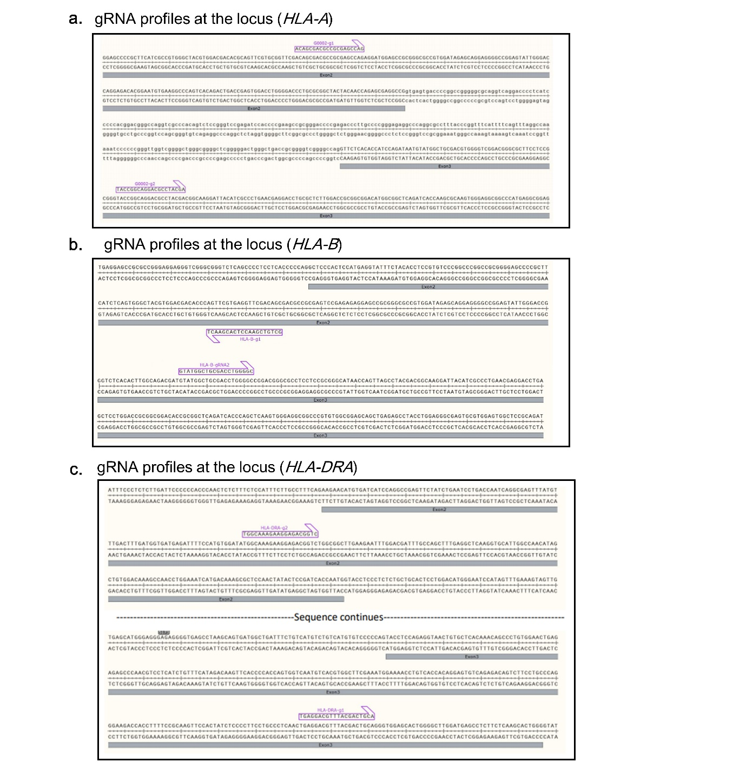
Supplementary Fig. 1. The profiles of guide RNA (gRNA) candidates targeting human leukocyte antigen (HLA)-A, -B, and -DRA at each locus
a. The profiles of two gRNA candidates targeting HLA-A at HLA-A locus. b. The profiles of two gRNA candidates targeting HLA-B at HLA-B locus. c. The profiles of two gRNA candidates targeting HLA-DRA at HLA-DRA locus.

Supplementary Fig. 2.
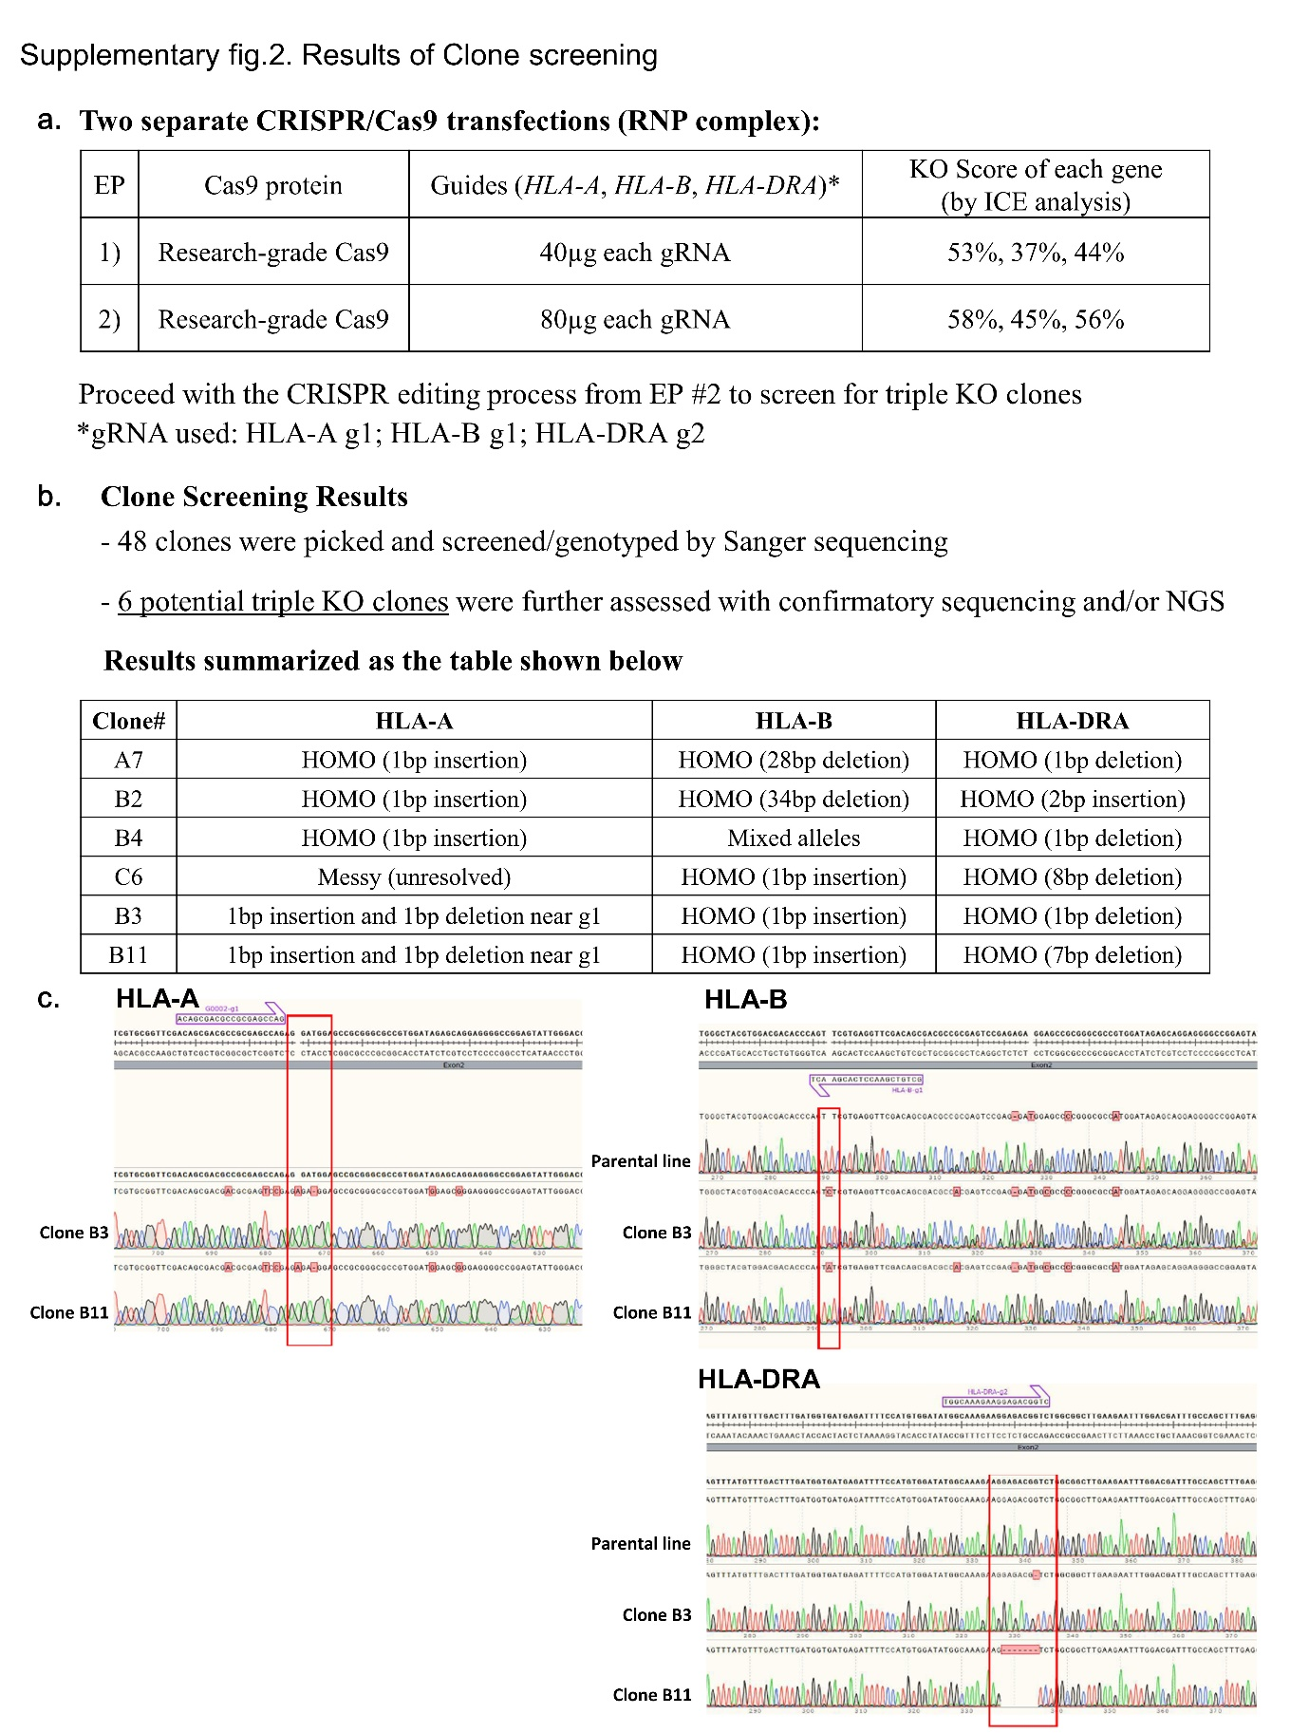
Supplementary Fig. 2. Results of clone screening
- The table representing the conditions of guide RNA (gRNA) and CAS9 ribonucleoprotein (RNP) complex for human leukocyte antigen (HLA)-A, -B, and -DRA, alongside the knockout (KO) score of each gene. b. The table displays the edited information of engineered clones screened and genotyped through Sanger sequencing. c. Sanger sequencing results for gene-edited clone candidates B3 and B11.

Supplementary Fig. 3.
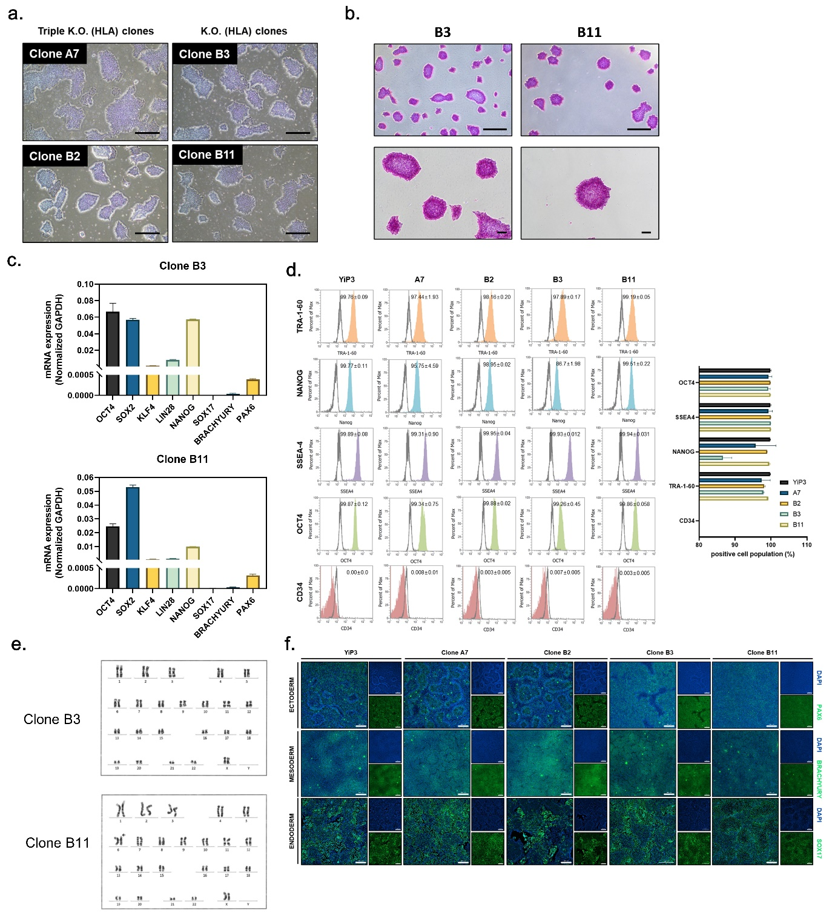
Supplementary Fig. 3. Quality screening of clone B3 and B11
a. Microscope image of induced pluripotent stem cells (iPSCs), clones A7, B2, B3, and B11. Scale bars, 500 μm. b. Alkaline phosphate (AP) staining image of iPSCs, YiP3, and clones B3 and B11. Scale bars, 500 μm. c. The real-time PCR data for the pluripotency markers, such as octamer-binding transcription factor 4 (OCT4), SRY (sex-determining region Y)-box 2 (SOX2), Krüppel-like factor 4 (KLF4), Lin-28 homolog A (LIN28), and Nanog homeobox (NANOG) and the three germ layer differentiation markers, such as SOX17, BRACHYURY, and paired box 6 (PAX6) in clones B3 and B11. d. The flow cytometry data for the pluripotency markers, such as tumor rejection antigen 1-60 (TRA-1-60), NANOG, stage-specific embryonic antigen-1 (SSEA-4), OCT4, and the negative marker CD34 in YiP3 and clones A7, B2, B3, and B11. The bar graph on the right represents the positive cell population for each marker, indicating low expression of NANOG in clone B3. e. Karyotyping results of clones B3 and B11. The arrows in the results for clone B11 indicate regions with chromosomal abnormalities. f. The immunocytochemistry images demonstrating the expression of markers paired box 6 (PAX6) for ectoderm, BRACHYURY for mesoderm, and SOX17 for endoderm after differentiation into the three germ layers using YiP3 and clones A7, B2, B3, and B11. Scale bars, 200 μm.

