Table of supplemental figures:
Fig. S1. Description of the Lipa^{-/-} mouse model. 2
Fig. S2. Blood analysis of Lipa^{-/-} mice treated with 4 different rAAV8 doses. 4
Fig. S3. Quantification of cholesterol and triglycerides per mg of liver, spleen, and jejunum 12-weeks post-injection. 5
Fig. S4. Long-term blood analysis of rAAV8.hAAT.LIPA treated Lipa^{-/-} mice. 7
Fig. S5. Quantification of cholesterol and triglycerides per mg of liver, spleen, and jejunum. 9
Fig. S6. Quantification of lipid deposits in thymus 11
Fig. S7. Read count of murine (m) and human (h) LIPA mRNA at 34-week post-injection. 13
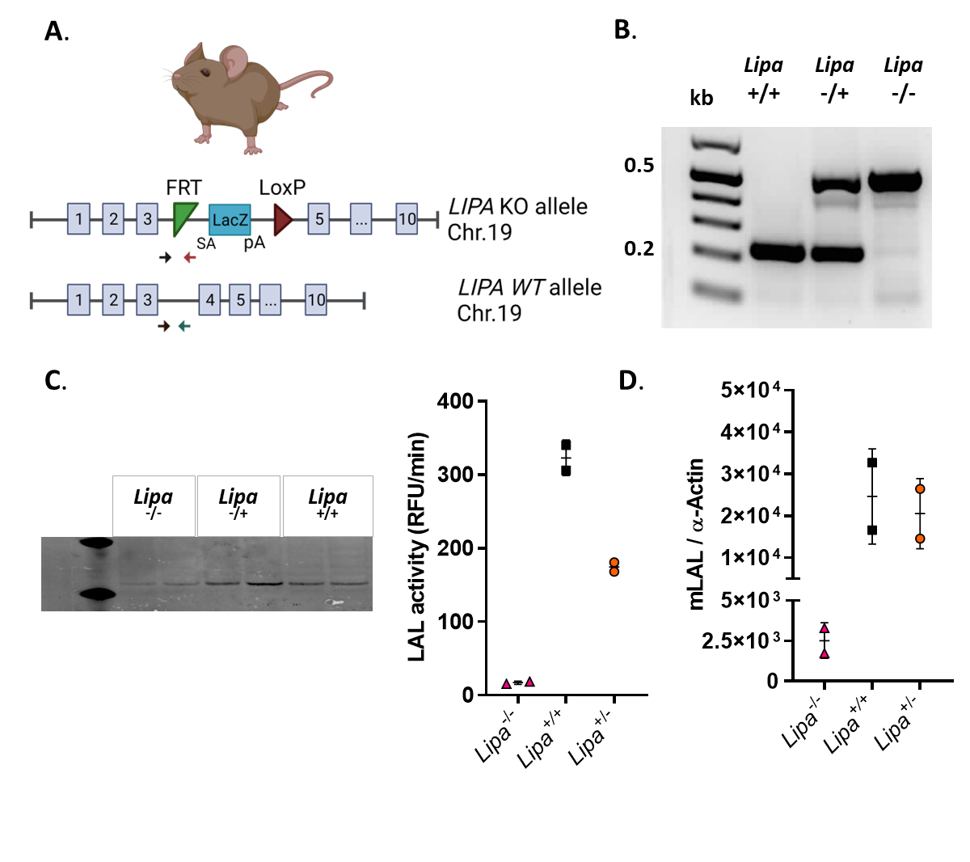
Fig. S1. Description of the Lipa^{-/-} mouse model. (A) Lipa gene in KO and WT alleles. Arrows represent genotyping primers (black: common LAL F, red: LAL-KO R and blue: LAL-WT R; Table 1). (B) Agarose gel of the genotyping PCR. Kb represents the 1kb DNA ladder. (C) Western blot of mouse liver with mLAL antibody and its quantification relative to α-actin expression. (D) Relative fluorescence units (RFU) of LAL enzymatic activity in mouse liver. Bars indicate mean ± SD (n=2).
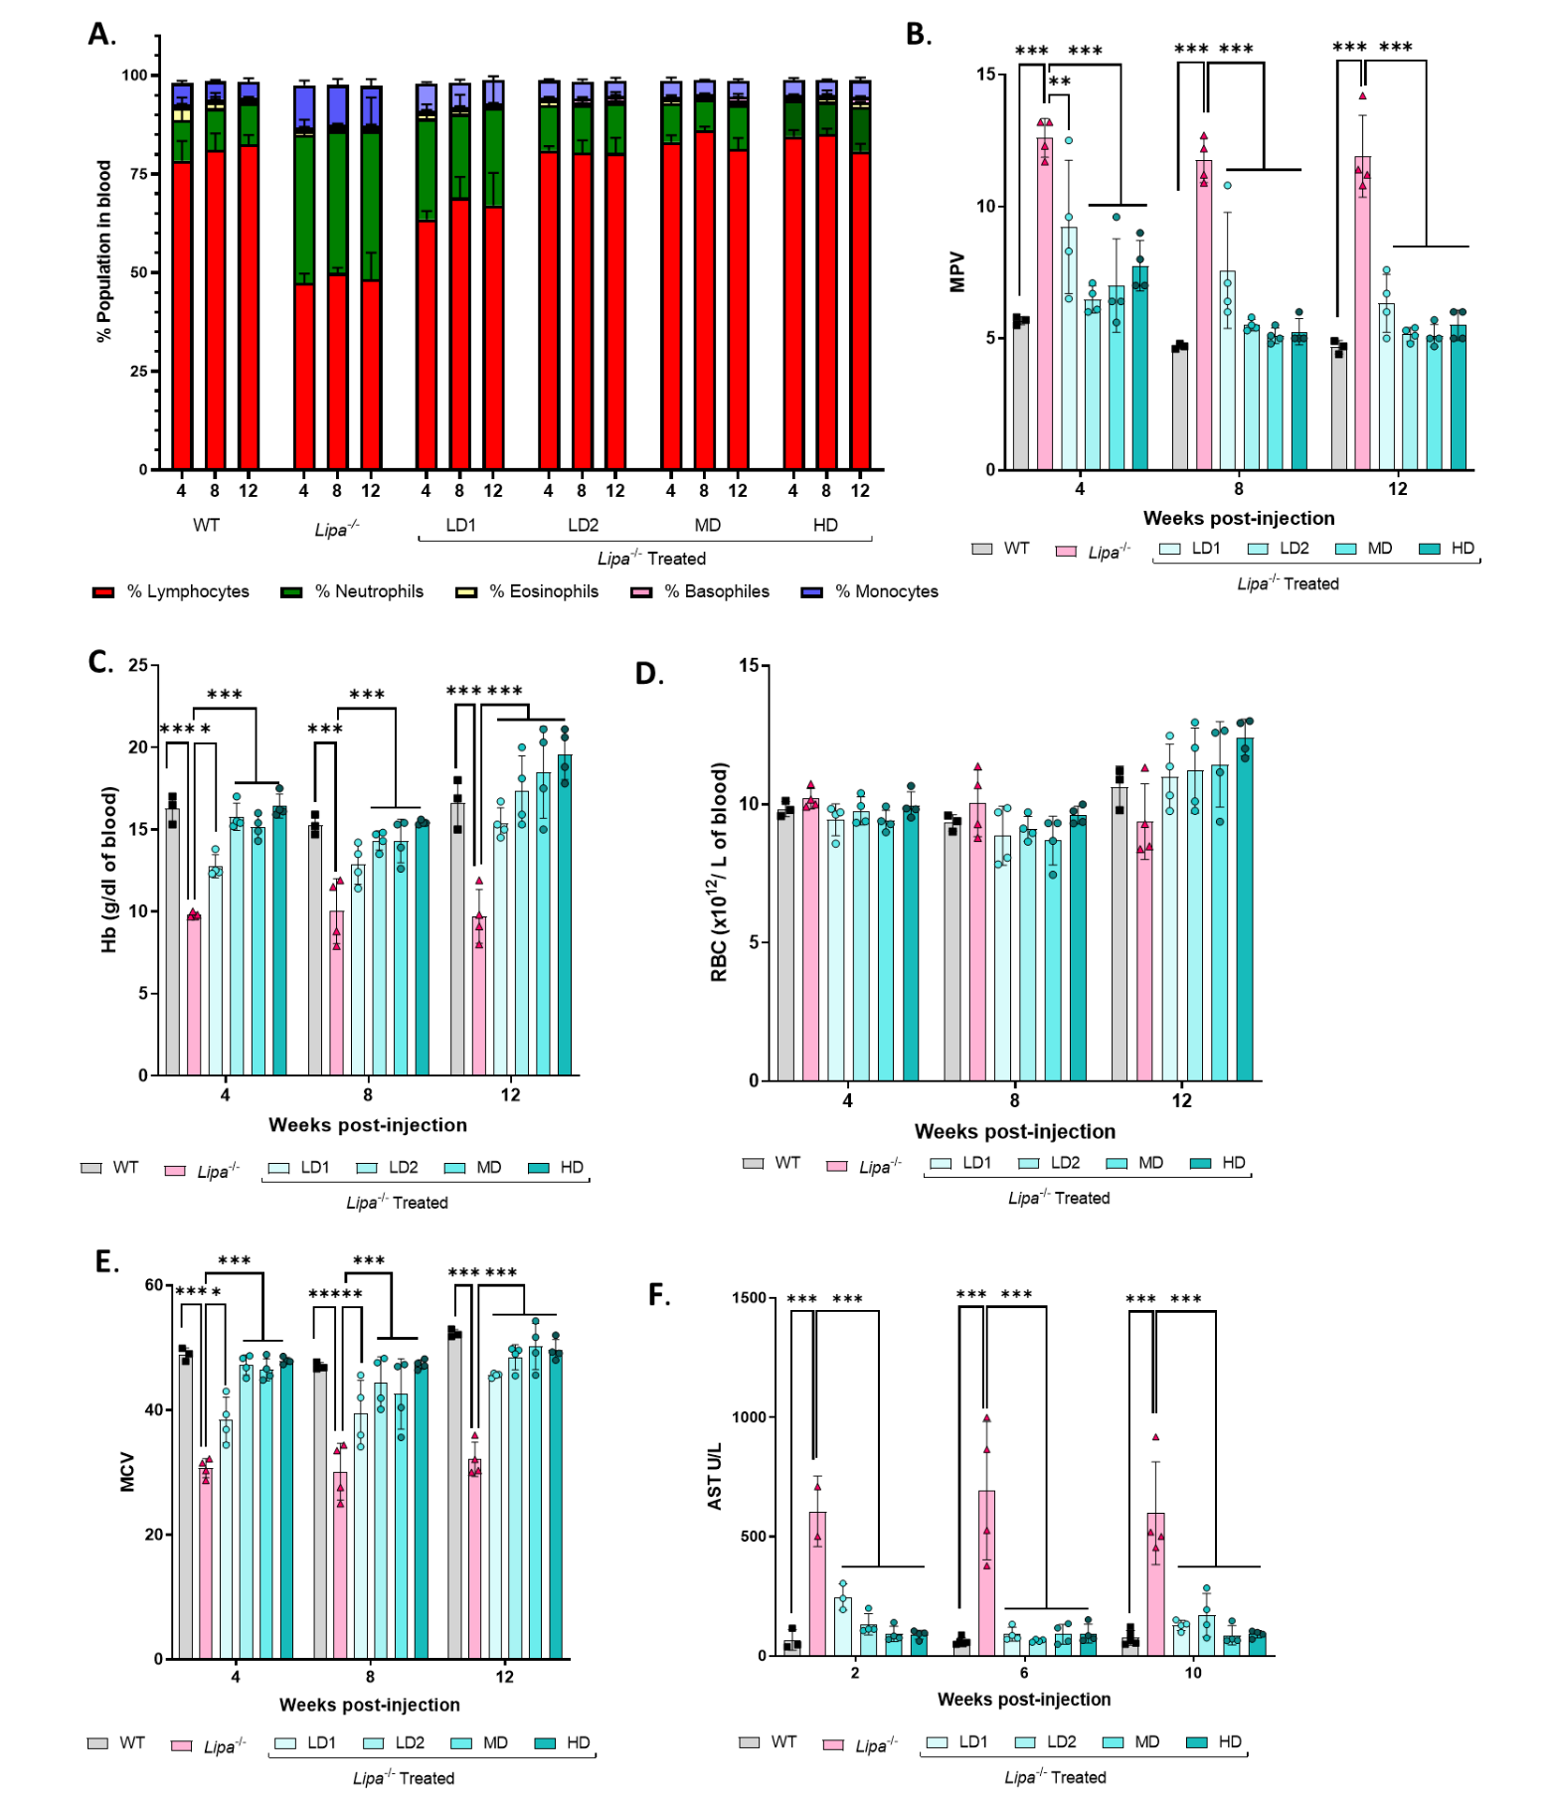
Fig. S2. Blood analysis of Lipa^{-/-} mice treated with 4 different rAAV8 doses. (A to B) Analysis of (A) blood cell populations and (B) mean platelet volume (MPV) at the indicated time points. (C-E) Analysis of red blood cells: (C) hemoglobin content, (D) count and (E) mean corpuscular volume (MCV) at the indicated time points. (F) Aspartate aminotransferase (AST) quantification (units per liter; U/L) in plasma samples at the indicate time points. Bars indicate mean ± SD (n=3-4) and statistical significance was calculated using two-way ANOVA with Tukey’s test (*p<0.033; **p<0.002; *** p<0.0001).
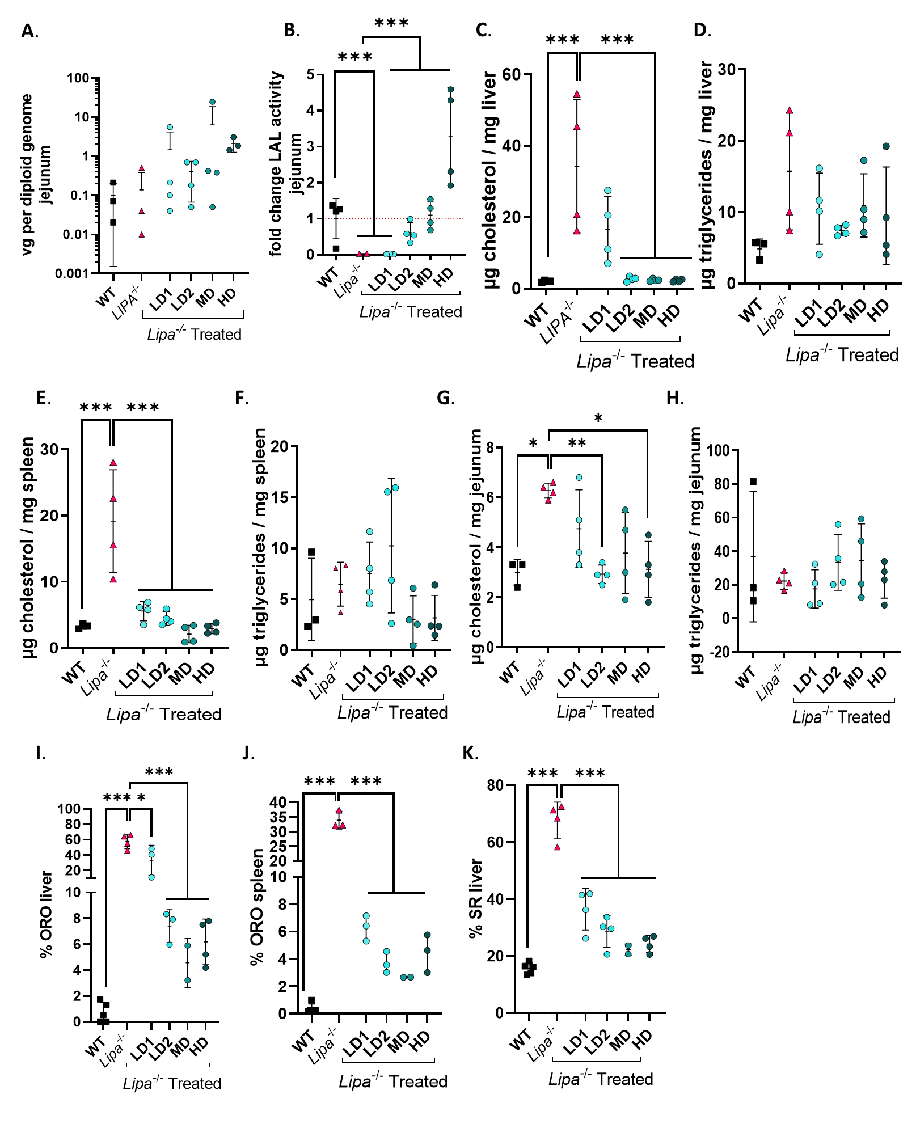
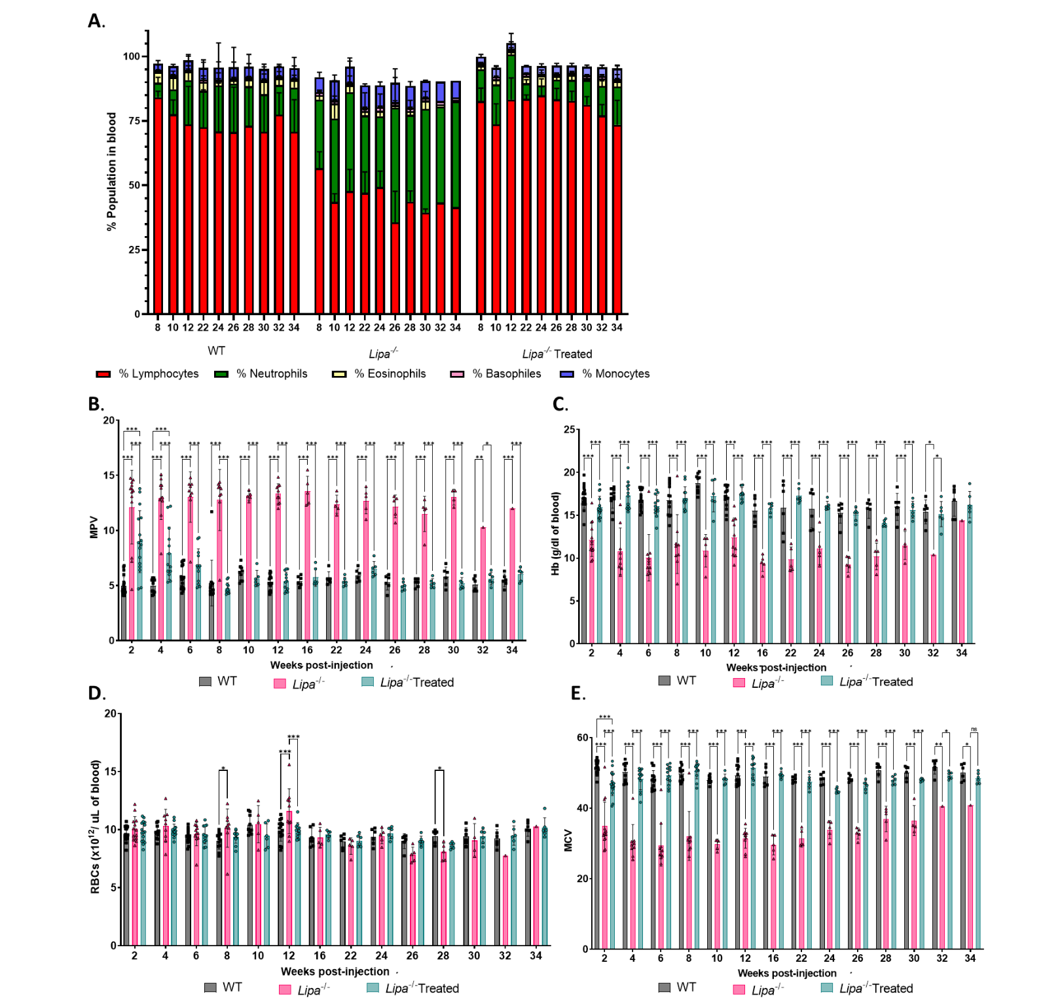
Fig. S3. Quantification of cholesterol and triglycerides in liver, spleen, and jejunum 12-weeks post-injection. (A) Vector copy number of rAAV8 in jejunum (n=3-4). (B) Fold change of LAL activity over WT mice in jejunum (n=3-4). Red dotted line indicates WT threshold. (C to D) Quantification of (C) cholesterol and (D) triglycerides per mg of liver (n=3-4). (E to F) Quantification of (E) cholesterol and (F) triglycerides per mg of spleen (n=3-4). (G to H) Quantification of (G) cholesterol and (H) triglycerides per mg of jejunum in function of the doses (n=3-4). (I to J) % of ORO-stained sections of (I) liver and (J) spleen (n=2-5). (K) % of SR-stained sections of liver (n=2-5). Bars indicate mean ± SD and statistical significance was calculated using two-way ANOVA with Tukey’s test (*p<0.033; **p<0.002; *** p<0.0001).
Fig. S4. Long-term blood analysis of rAAV8.hAAT.LIPA treated Lipa^{-/-} mice. (A) Blood cells composition measured at the indicated time-points (weeks). (B) Analysis of mean platelet volume (MCV) in WT, Lipa^{-/-} and rAAV8-treated Lipa^{-/-} mice measured at the indicated time-points (weeks). (C to E) Analysis of red blood cells: (C) hemoglobin (Hb) content, (D) RBC count and (E) mean corpuscular volume (MCV), measured at the indicated time-points. Bars indicate mean ± SD (n=1-20) and statistical significance was calculated using two-way ANOVA with Tukey’s test (*p<0.033; **p<0.002; *** p<0.0001).
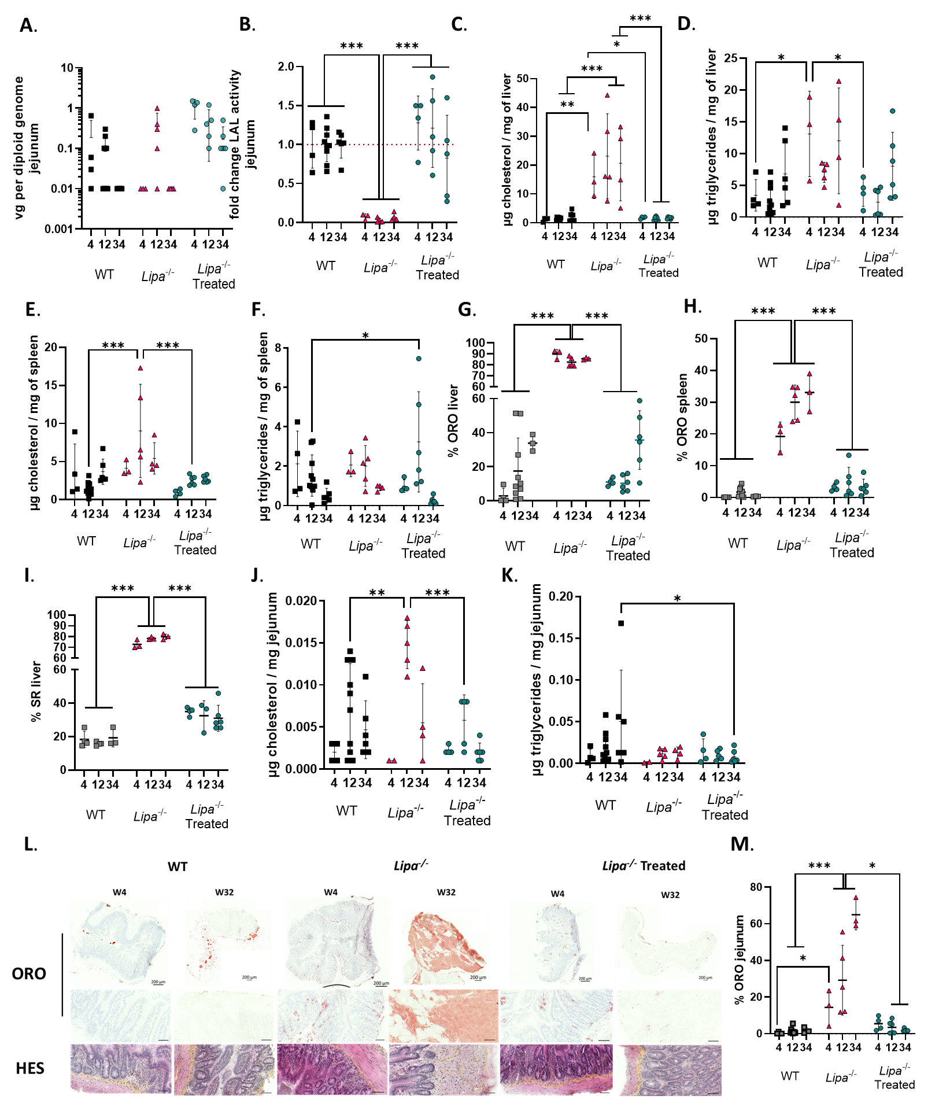
Fig. S5. Quantification of cholesterol and triglycerides per mg of liver, spleen, and jejunum overtime. (A) AAV copy number in jejunum at the indicated time-points (weeks) (n=3-6). (B) Fold change of LAL activity over WT mice at the indicated time-points (weeks) (n=3-6). Red dotted line indicates WT threshold. (C to D) Quantification of (C) cholesterol and (D) triglycerides per mg of liver at the indicated time-points (weeks) (n=3-6). (E to F) Quantification of (E) cholesterol and (F) triglycerides per mg of spleen liver at the indicated time-points (weeks) (n=3-6). (G to H) % of ORO-stained sections of (G) liver and (H) spleen (n=3-10). (I) % of SR-stained sections of liver (n=2-5). (J to K) Quantification of (J) cholesterol and (K) triglycerides per mg of jejunum at the indicated time-points (weeks) (n=3-6). (L) Histological sections of jejunum at 4 and 34-weeks post-injection stained with ORO and HES (scale bar: 50µm). (M) % of ORO-stained tissues in jejunum (n=3-10). Bars indicate mean ± SD and statistical significance was calculated using two-way ANOVA with Tukey’s test (*p<0.033; **p<0.002; *** p<0.0001).
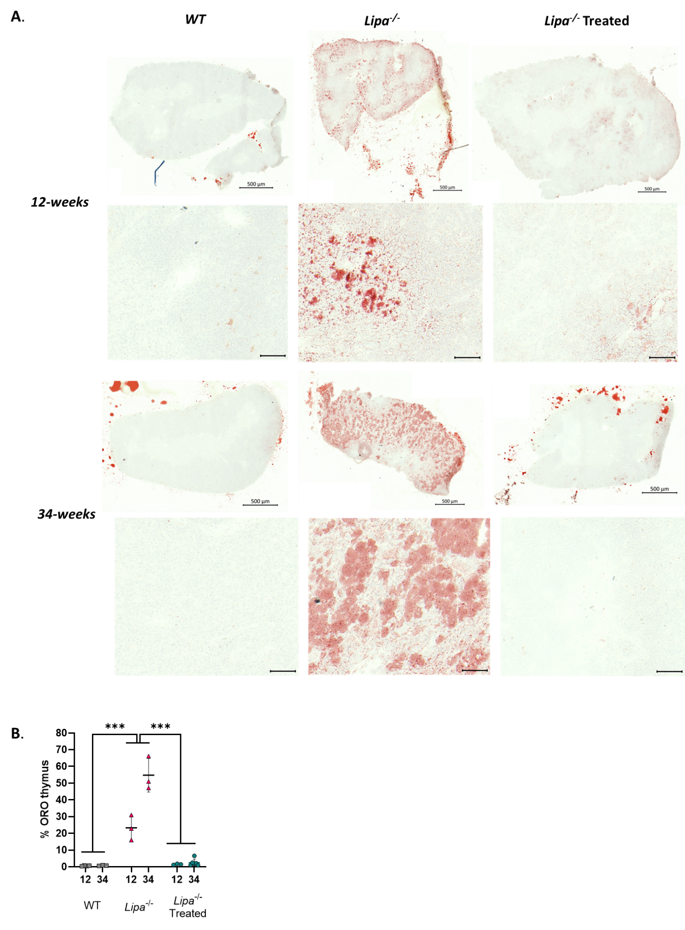
Fig. S6. Lipid deposits in thymus. (A) Histological section of thymus stained with ORO at 12- and 34-weeks post-injection (scale bar: 50µm). (B) % of ORO-stained sections in the thymus. Bars indicate mean ± SD (n=3-10) and statistical significance was calculated using two-way ANOVA with Tukey’s test (*p<0.033; **p<0.002; *** p<0.0001).
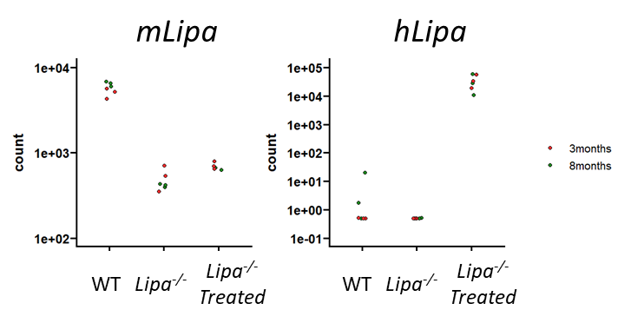
Fig. S7. Read count of murine (m) and human (h) LIPA mRNA at 34-weeks post-injection.

