Supplementary materials
Table S1: Divergence rate (%) of the wsp marker between the 11 Wolbachia strains and strain variants characterized from Mylothris butterfly species. A-supergroup Wolbachia strains are shown in pink, B-Wolbachia in blue. Inside cell colors vary in accordance with degree of similarity (white: less than 75% similarity, gray: between 75 & 97% similarity, dark-gray: more than 97% similarity).
Host species (N=) | id | Divergence (%)
Host species (N=) | id | 2 | 3 | 4 | 5 | 6 | 7 | 8 | 9 | 10 | 11
M. alluaudi (2)  M. uniformis (5)  M. yulei (1) | 1 wMall_A  wMuni_A  wMyul_A | 99,1 | 75,3 | 74,4 | 74,4 | 74,5 | 75,1 | 74,8 | 74,6 | 74,6 | 72,4
M. crawshayi (1) | 2: wMcra_A | - | 75,4 | 74,6 | 74,6 | 74,7 | 75,3 | 75,0 | 74,8 | 74,8 | 72,6
M. agathina (5)  M. chloris (4)  M. dubia (4)  M. interposita (1)  M. marginea (2)  M. sjostedti (3)  M. winstoni (1)  M. yulei (1) | 3: wMaga_B  wMchl_B  wMdub_B  wMint_B  wMmar_B  wMsjo_B  wMwin_B  wMyul2_B |  | - | 98,4 | 99,2 | 99,0 | 98,9 | 98,4 | 98,8 | 99,6 | 80,4
M. poppea (2) | 4: wMpop_B |  |  | - | 99,2 | 99,4 | 99,2 | 98,6 | 99,2 | 98,0 | 80,8
M. sagala (4)  M. knutsoni (2) | 5: wMsag_B  wMknu_B |  |  |  | - | 99,8 | 99,6 | 99,2 | 99,6 | 98,8 | 80,0
M. asphodelus (5)  M. bernice (4)  M. elodina (2) | 6: wMasp_B  wMber_B  wMelo_B |  |  |  |  | - | 99,8 | 99,4 | 99,8 | 99,6 | 80,2
M. trimenia (3)  M. rueppellii (1) | 7: wMtri_B  wMrue_B |  |  |  |  |  | - | 99,2 | 99,6 | 98,4 | 80,0
M. carolinae (1) | 8: wMcar_B |  |  |  |  |  |  | - | 99,2 | 98,0 | 79,6
M. rhodope (1) | 9: wMrho_B |  |  |  |  |  |  |  | - | 98,4 | 80,5
M. agathina (2)  M. marginea (1) | 10: wMaga_B  wMmar_B |  |  |  |  |  |  |  |  | - | 80,4
M. ducarmei (2) | 11: wMduc_B |  |  |  |  |  |  |  |  |  | -

Table S2: Divergence rate (%) of the wsp marker between the 14 Wolbachia strains and strain variants characterized from Bicyclus butterfly species (as characterized in this study and by (Duplouy and Brattstrom 2018)). A-supergroup strains are shown in pink, B-Wolbachia in blue. All variants share the same color. Inside cell colors vary and in accordance with degree of similarity (white: less than 75% similarity, gray: between 75 & 97% similarity, dark-gray: more than 97% similarity).
Infected species (N) | id | Divergence (%)
Infected species (N) | id | 13 | 14 | 15 | 3 | 4 | 6 | 16 | 17 | 18 | 19 | 29 | 21 | 22
B. mandanes (1)  B. collinsi (1) | 12: wBman_A  wBcol_A | 99,7 | 99,8 | 78,0 | 72,8 | 72,8 | 72,8 | 72,7 | 72,8 | 72,6 | 72,5 | 72,8 | 74,4 | 72,0
B. auricruda (2) | 13: wBaur_A  wBaur2_A | - | 99,8 | 78,0 | 72,9 | 72,8 | 72,9 | 72,7 | 72,8 | 72,7 | 72,6 | 72,9 | 74,7 | 71,8
B. xeneas occidentalis (2)  B.ignobilis (3) | 14: wBxen_A  wBign_A  wBxen2_A |  | - | 78,2 | 73,1 | 72,9 | 73,1 | 72,8 | 73,0 | 72,9 | 72,8 | 73,1 | 74,7 | 71,8
B. evadne (1) | 15: wBeva_A |  |  | - | 77,0 | 77,2 | 77,4 | 77,2 | 77,5 | 77,2 | 77,2 | 77,4 | 76,7 | 73,8
B. sangmelinae  B. funebris  B. ephorus | 3: wBsang_B  wBeph_B  wBfun_B |  |  |  | - | 98,3 | 99,1 | 99,1 | 98,9 | 98,8 | 98,9 | 99,1 | 79,1 | 81,8
B. pavonis | 4: wBpav_B |  |  |  |  | - | 99,2 | 99,1 | 99,3 | 98,9 | 99,0 | 98,8 | 77,9 | 82,1
B. xeneas xeneas  B. saussudei  B. nobilis  B. medontas | 6: wBxen_B  wBsau_B  wBnob_B  wBmed_B |  |  |  |  |  | - | 99,6 | 99,8 | 99,6 | 99,8 | 99,6 | 78,8 | 80,8
B. sylvicolus | 16: wBsyl_B |  |  |  |  |  |  | - | 99,5 | 99,3 | 99,5 | 99,3 | 78,6 | 80,8
B. jacksoni | 17: wBjac_B |  |  |  |  |  |  |  | - | 99,5 | 99,6 | 99,5 | 78,8 | 81,0
B. evadne | 18: wBeva_B |  |  |  |  |  |  |  |  | - | 99,5 | 99,3 | 78,6 | 81,2
B. dentata | 19: wBden_B |  |  |  |  |  |  |  |  |  | - | 99,5 | 78,5 | 80,6
B. anisops | 20: wBani_B |  |  |  |  |  |  |  |  |  |  | - | 78,4 | 80,4
B. trilophus | 21: wBtri_B |  |  |  |  |  |  |  |  |  |  |  | - | 83,3
B. taenias | 22: wBtae_B |  |  |  |  |  |  |  |  |  |  |  |  | -

Table S3: Divergence rate (%) between the Wolbachia strains and strain variants characterized from the Mylothris butterflies and the Bicyclus butterflies (as characterized in this study and by (Duplouy and Brattstrom 2018)). Central cells colored in accordance with degree of similarity between strains (white: less than 75% similarity, gray: between 75 and 97% similarity, dark-gray: more than 97% similarity).
Strain | 1: wMuni_A | 2: wMcra_A | 5: wMsag_B | 7: wMtri_B | 8: wMcar_B | 9: wMrho_B | 10: wMaga_B | 11: wMduc_B
12: wBman_A | 73,1 | 73,5 | 70,2 | 70,2 | 70,4 | 70,3 | 70,5 | 70,8
13: wBaur_A | 73,5 | 73,9 | 70,2 | 70,2 | 70,4 | 70,3 | 70,5 | 71,0
14: wBxen_A | 73,3 | 73,7 | 70,4 | 70,4 | 70,5 | 70,5 | 70,7 | 71,0
15: wBeva_A | 86,3 | 86,7 | 76,7 | 76,7 | 76,7 | 77 | 76,6 | 74,1
3: wBsang_B | 75,6 | 75,8 | 99,2 | 98,9 | 98,4 | 98,8 | 99,6 | 80,9
4: wBpav_B | 75,4 | 75,6 | 99,2 | 99,2 | 98,8 | 99,2 | 98 | 81,3
6: wBxen_B | 74,8 | 75 | 99,8 | 99,8 | 99,4 | 99,8 | 98,6 | 80,5
16: wBsyl_B | 74,5 | 74,7 | 99,4 | 99,4 | 99 | 99,4 | 98,6 | 80,4
17: wBjac_B | 75 | 75,1 | 99,6 | 99,6 | 99,2 | 99,6 | 98,4 | 80,7
18: wBeva_B | 75,4 | 75,6 | 99,4 | 99,4 | 99,4 | 99,4 | 98,2 | 80,3
19: wBden_B | 74,5 | 74,7 | 99,6 | 99,6 | 99,2 | 99,6 | 98,4 | 80,2
20: wBani_B | 74,8 | 75 | 99,8 | 99,4 | 99 | 99,4 | 98,6 | 80,1
21: wBtri_B | 72,9 | 73,2 | 80,6 | 81,2 | 80,2 | 80,8 | 80,8 | 99,4
22: wBtae_B | 73,5 | 73,7 | 75,9 | 75,9 | 75,7 | 75,9 | 76,7 | 82,0

Figure S1: Rooted phylogenetic relationships of the concatenated MLST and wsp genes sequences from the different Wolbachia characterized from the Mylothris butterflies, with bootstrap values. Additional Wolbachia strains characterized from Brugya malayi (D-supergroup strain) and from Opistophthalmus scorpions (F-supergroup strains) were added as outgroup. Habitat of the host is shown in right-circle.

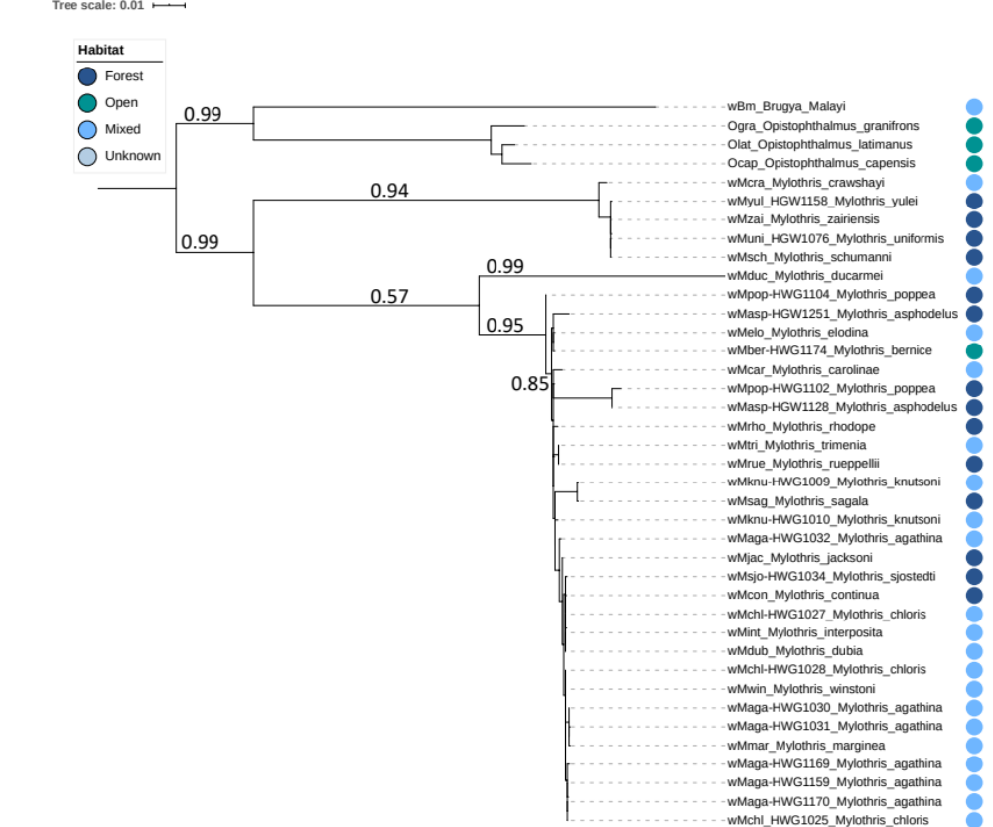

Figure S2: Rooted phylogenetic relationships of the concatenated MLST and wsp genes sequences from the Bicyclus butterflies, with bootstrap values. Additional Wolbachia strains characterized from Brugya malayi (D-supergroup strain) and from Opistophthalmus scorpions (F-supergroup strains) were added as outgroup. Habitat of the host is shown in right-circle.

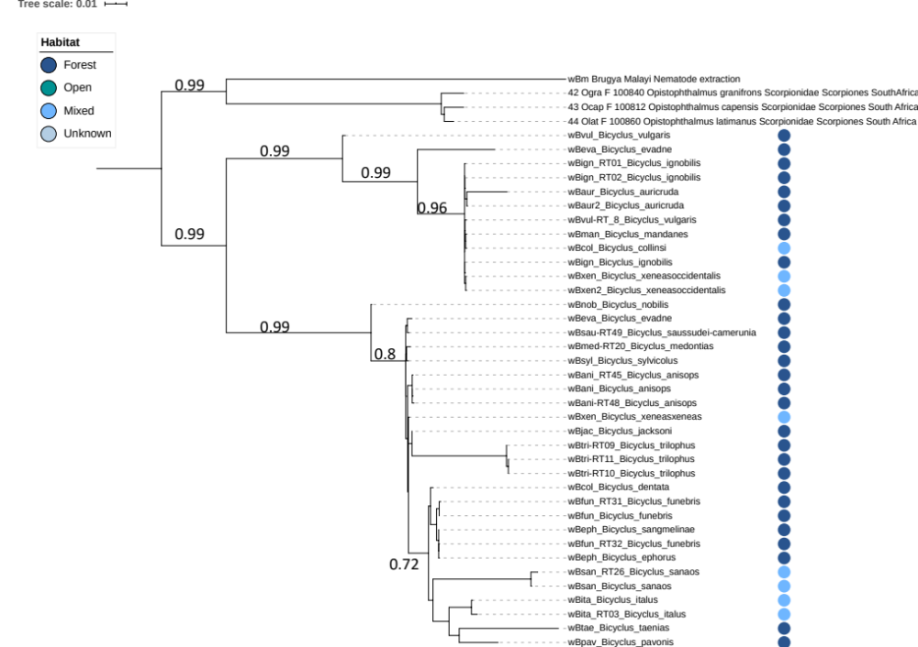

Figure S3: Phylogenetic tree of all available Wolbachia strains and strain variants characterized from Lepidoptera, Hymenoptera, and all other African arthropods. The tree was built using the concatenated sequences of the Wolbachia MLST and wsp markers. Colored squares, circles and triangles on the right provide the family, ecoregion and habitat of the hosts, respectively. Dataset includes strains described in the present study, as well as strains from Bicyclus butterflies as in [39], from Malagasy Nanos dung-beetles as in [11], and all pubMLST-registered strains from Lepidoptera, Hymenoptera and African arthropods [18]. Wolbachia strains characterized from Brugya malayi nematode (D-supergroup strain) and from Opistophthalmus scorpions (F-supergroup strains) were used as outgroup.

