Nanoparticles prepared from pterostilbene (PTE): a new strategy for reducing blood glucose and improving diabetic complications
Xi Zhao ^{a1}, Anhua Shi ^{a1}, Qiong Ma ª, Xueyan Yan^{b}, Ligong Bian^{c}, Pengyue Zhang ^{d*}, Junzi Wu ^{a *}
ª Yunnan Provincial Key Laboratory of Molecular Biology for Sinomedicine, School of Basic Medical, Yunnan University of Chinese Medicine, Kunming, Yunnan 650500, P.R. China
^{b} College of Second Clinical Medicine, Kunming Medical University, Kunming, Yunnan 650500, PR China
^{c} College of Basic Medicine, Kunming Medical University, Kunming, Yunnan 650500, PR China
^{d} Key Laboratory of acupuncture and tuina for treatment of encephalopathy, College of Acupuncture, Tuina and Rehabilitation, Yunnan University of Traditional Chinese Medicine, Kunming, 650500, China;
¹ Authors contributed equally to this work.
*Corresponding authors: E-mail: xnfz@ynutcm.edu.cn (Junzi Wu); zpy19802000@163.com (Pengyue Zhang)
The file includes
Figure S1-S2, Table S1, Table S2

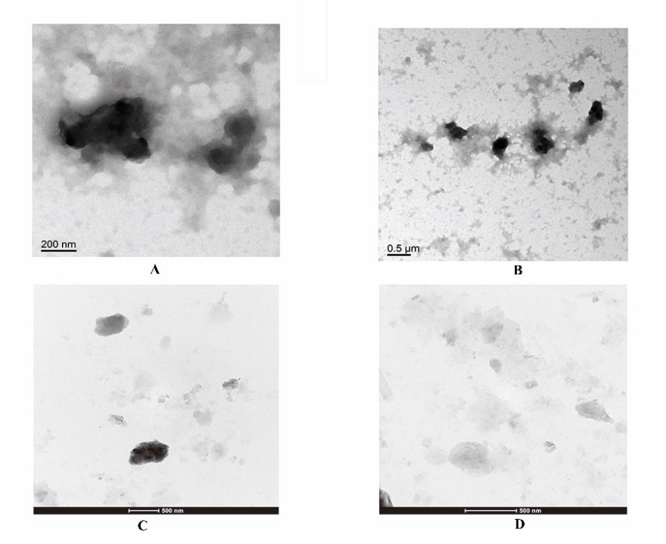
Figure.S1 Nanoparticle swelling images under TEM after 1(A), 4(B), 10(C), 40(D)days.

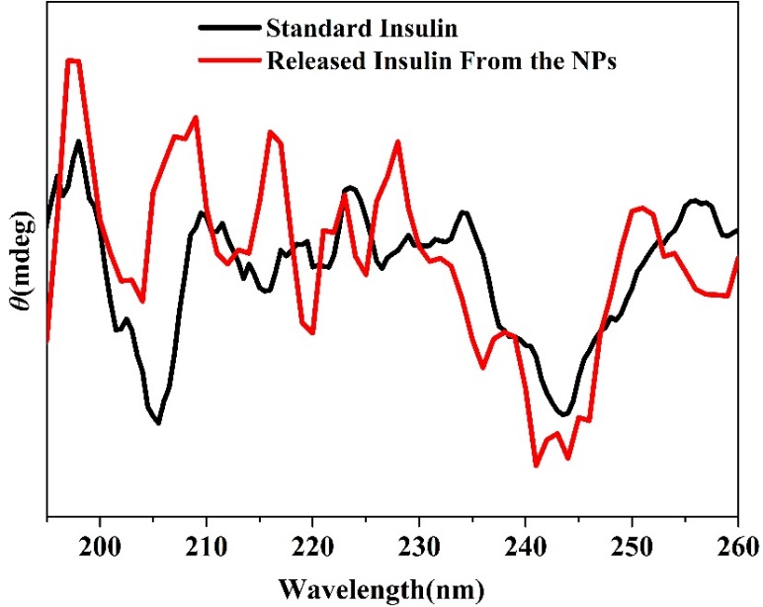
Figure.S2 CD spectra of the insulin released from NPs and standard insulin in PBS at pH 7.4, 25 °C.

Table S1. The Mw and Mn and PDI of the p(AAPBA-b-PTE).
Samples | PTE/ p(AAPBA)  mass ratio | Mw | Mn | PDI
p(AAPBA-b-PTE)1 | 500:1000 | 5.7×10⁴ | 4.4×10⁴ | 1.03
p(AAPBA-b-PTE)2 | 100:1000 | 5.9×10⁴ | 4.9×10⁴ | 1.10
p(AAPBA-b-PTE)3 | 50:1000 | 6.4×10⁴ | 5.1×10⁴ | 1.25
Abbreviations: PDI is polydispersity index.

Table S2. Ritger-Peppas results of p(AAPBA-b-PTE)2 NPs.
Samples | Glucose concentration（mg/mL） | Ritger-Peppas model |  |  | Transport mechanism
P(AAPBA-b-PTE)2 |  | n | k | R2
P(AAPBA-b-PTE)2 | 0 | 1.246 | 1.658 | 0.944 | Non-Fickian diffusion
P(AAPBA-b-PTE)2 | 1 | 2.113 | 3.385 | 0.938 | Non-Fickian diffusion
P(AAPBA-b-PTE)2 | 3 | 5.46 | 5.49 | 0.98 | Non-Fickian diffusion

