Supplementary Material
International Journal of Tropical Insect Science
Morphological and Molecular Characterization of Cryptic and Invasive Thrips Species in Central India
Manish Sharma^{1,2}, Jandrajupalli Sridhar¹, Dhimar Akanand¹ Sivalingam P.N¹ and Bhowmick A.K²
1ICAR- National Institute of Biotic Stress Management, Raipur-493225, Chhattisgarh, India
2Jawaharlal Nehru Krishi Viswa Vidyalaya, Jabalpur- 482004, Madhya Pradesh, India
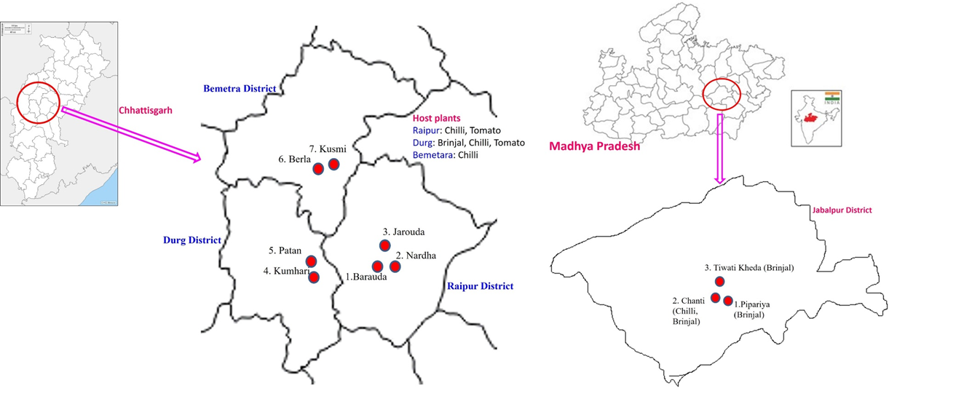

Supplementary Figure 1 Map depicting sampling details of Madhya Pradesh and Chhattisgarh

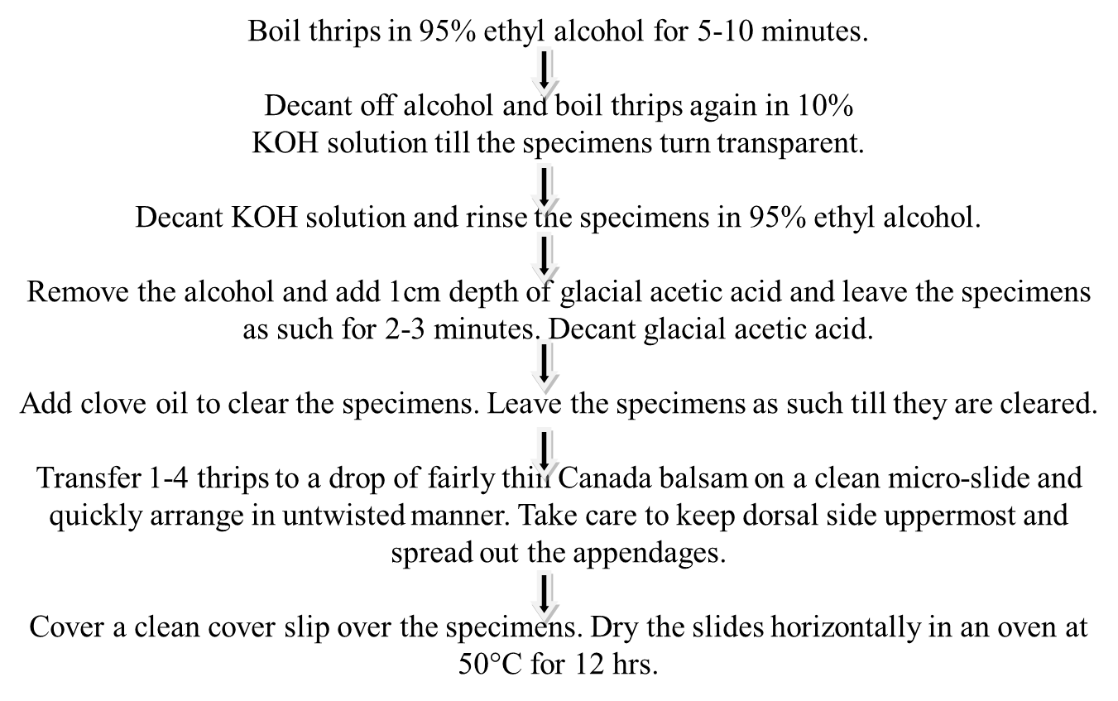

Supplementary Figure 2 standard procedure for mounting specimens on glass slides

