Supplementary Table 1. Items and scoring system for frailty index
Number | Variables | Scoring system
ADLs/IADLs
1 | Dressing | Not mentioned=0  Mentioned=1
2 | Walking in house | Not mentioned=0  Mentioned=1
3 | Bathing/showering | Not mentioned=0  Mentioned=1
4 | Eating | Not mentioned=0  Mentioned=1
5 | Getting in and out of bed | Not mentioned=0  Mentioned=1
6 | Use toilet | Not mentioned=0  Mentioned=1
7 | Cook/prepare warm meal | Not mentioned=0  Mentioned=1
8 | Shop groceries | Not mentioned=0  Mentioned=1
9 | Use telephone | Not mentioned=0  Mentioned=1
10 | Use map | Not mentioned=0  Mentioned=1
11 | Take medication | Not mentioned=0  Mentioned=1
12 | Do housework | Not mentioned=0  Mentioned=1
13 | Manage money | Not mentioned=0  Mentioned=1
Mobility limitations
14 | Walking 100 meters/1 block | Not mentioned=0  Mentioned=1
15 | Sitting for two hours | Not mentioned=0  Mentioned=1
16 | Getting up from chair | Not mentioned=0  Mentioned=1
17 | Climb one flight of stairs | Not mentioned=0  Mentioned=1
18 | Climb several flights of stairs | Not mentioned=0  Mentioned=1
19 | Stooping | Not mentioned=0  Mentioned=1
20 | Reaching | Not mentioned=0  Mentioned=1
21 | Pulling/pushing | Not mentioned=0  Mentioned=1
22 | Lifting | Not mentioned=0  Mentioned=1
Chronic disease
23 | Heart attack | Not mentioned=0  Mentioned=1
24 | Angina | Not mentioned=0  Mentioned=1
25 | Congestive heart failure | Not mentioned=0  Mentioned=1
26 | High blood pressure | Not mentioned=0  Mentioned=1
27 | Stroke | Not mentioned=0  Mentioned=1
28 | Diabetes | Not mentioned=0  Mentioned=1
29 | Chronic lung disease | Not mentioned=0  Mentioned=1
30 | Arthritis | Not mentioned=0  Mentioned=1
31 | Osteoporosis | Not mentioned=0  Mentioned=1
32 | Cancer | Not mentioned=0  Mentioned=1
33 | Parkinson | Not mentioned=0  Mentioned=1
34 | Dementia/Alzheimer’s disease | Not mentioned=0  Mentioned=1
35 | Psychological/psychiatric problems | Not mentioned=0  Mentioned=1
36 | Hip fracture | No=0  Yes=1
Self-rated health & Symptoms
37 | Self-reported health | Excellent=0  Very good=0.25  Good=0.5  Fair=0.75  Poor=1
38 | Hearing impairment | Excellent=0  Very good=0.25  Good=0.5  Fair=0.75  Poor=1
39 | Visual impairment | Excellent=0  Very good=0.25  Good=0.5  Fair=0.75  Poor/Spontaneous: registered or legally blind=1
40 | Sleep problems | Not during the last month/  Less than once a week/  Once or twice a week=0  Three or more times a week=1
41 | Falls | No=0  Yes=1
42 | Pain | No=0  Yes=1
Psychological symptoms
43 | Depressed | No=0  Yes=1
44 | Sad | No=0  Yes=1
45 | Felt everything was effort | No=0  Yes=1
46 | Could not get going | No=0  Yes=1
47 | Lonely | Hardly ever or never/  Some of the time=0  Often=1
48 | Happy (reverse-coded) | No=1  Yes=0
49 | Enjoyed life (reverse-coded) | No=1  Yes=0
Cognitive functioning
50 | Word recall （Immediate） | No less than 5=0  Less than 5=1
51 | Word recall （Delayed） | No less than 4=0  Less than 4=1
52 | Orientation in time | Day of week is correct = 0  Day of week is wrong = 0.25
52 | Orientation in time | Day of month is correct = 0  Day of month is wrong = 0.25
52 | Orientation in time | Month is correct = 0  Month is wrong = 0.25
52 | Orientation in time | Year is correct = 0  Year is wrong = 0.25
 | Total number of items | 52
Note: The items and answers are adapted from the questionnaires of the English longitudinal study of ageing.

Supplementary Table 2. Reference values for frailty-related blood factors
Blood factors | Reference range
High density lipoprotein (HDL) | >=1.03mmol/L
Triglycerides (TG) | <=1.7mmol/L
Ferritin (Rtin) | Male: 119 ng/ml ~193 ng/ml  Female: 74 ng/ml ~115 ng/ml
High-sensitivity C-reactive protein (hsCRP) | ＜3mg/L
Haemoglobin (Hgb) | Male: >=13g/dL  Female: >=12g/dL
White blood cell (WBC) | 1.8~7.8*10⁹/L
Dehydroepiandrosterone (DHEA) | Male：  60~64 year: 0.5~5.6umol/L  65~74 year: 0.3~6.7umol/L  75+ year: 0.3~4.2umol/L  Female：  60~64 year: 1.4~8.0umol/L  65~74 year: 0.9~6.8umol/L  75+ year: 0.4~5.3umol/L
Mean corpuscular haemoglobin (MCH) | 27~34pg/cell

Supplementary Table 3. AUC-ROC of logistic regression models with combined blood factors or a single blood factor
Variables | AUC-ROC | Sensitivity | Specificity
Eight blood factors | 0.758 | 0.798 | 0.606
MCH | 0.618 | 0.636 | 0.535
TG | 0.662 | 0.535 | 0.734
HDL | 0.661 | 0.566 | 0.704
Rtin | 0.638 | 0.713 | 0.500
hsCRP | 0.674 | 0.674 | 0.593
DHEA | 0.655 | 0.380 | 0.851
Hgb | 0.638 | 0.504 | 0.731
WBC | 0.657 | 0.450 | 0.791
Note: All models included age and sex as covariates; Eight blood factors include MCH, TG, HDL, Rtin, hsCRP, DHEA, Hgb and WBC. MCH, mean corpuscular haemoglobin; TG, triglyceride; HDL, high-density lipoprotein; Rtin, ferritin; hsCRP, high-sensitivity C-reactive protein; DHEA, dehydroepiandrosterone; Hgb, haemoglobin; WBC, white blood cell.

Supplementary Table 4. Sex-specific multivariate logistic regression analysis on blood factors and frailty
Sex | Variables (Unit of measurement) | OR | P | 95%CI for OR
Male | Intercept |  | 0.19
Male | Cfib (g/L) | 1.058 | 0.88 | 0.508~2.202
Male | HDL (mmol/L) | 0.495 | 0.24 | 0.152~1.612
Male | TG (mmol/L) | 1.536 | <0.05 | 1.035~2.280
Male | Rtin (ng/ml) | 0.996 | <0.05 | 0.993~0.9996
Male | hsCRP (mg/L) | 1.162 | 0.05 | 0.998~1.353
Male | DHEA (umol/L) | 0.861 | 0.16 | 0.700~1.061
Male | IGF-1 (ng/ml) | 1.040 | 0.15 | 0.986~1.097
Male | Fglu (mmol/L) | 0.872 | 0.56 | 0.549~1.385
Male | Hgb (g/dL) | 0.916 | 0.55 | 0.689~1.218
Male | HBAlc (%) | 1.197 | 0.63 | 0.579~2.476
Male | WBC (×10⁹/L) | 1.155 | 0.22 | 0.920~1.450
Male | MCH (pg/cell) | 1.028 | 0.71 | 0.890~1.186
Male | Age (year) | 1.033 | 0.29 | 0.972~1.098
Female | Intercept |  | 0.10
Female | Cfib (g/L) | 1.243 | 0.44 | 0.719~2.151
Female | HDL (mmol/L) | 0.531 | 0.09 | 0.257~1.099
Female | TG (mmol/L) | 1.305 | 0.20 | 0.867~1.965
Female | Rtin (ng/ml) | 0.998 | 0.27 | 0.996~1.001
Female | hsCRP (mg/L) | 1.130 | <0.05 | 1.003~1.273
Female | DHEA (umol/L) | 0.639 | <0.01 | 0.482~0.846
Female | IGF-1 (ng/ml) | 1.012 | 0.61 | 0.968~1.058
Female | Fglu (mmol/L) | 0.963 | 0.85 | 0.659~1.408
Female | Hgb (g/dL) | 0.575 | <0.001 | 0.448~0.737
Female | HBAlc (%) | 1.343 | 0.36 | 0.711~2.538
Female | WBC (×10⁹/L) | 1.235 | <0.05 | 1.042~1.464
Female | MCH (pg/cell) | 1.258 | <0.01 | 1.079~1.467
Female | Age (year) | 1.035 | 0.14 | 0.989~1.083
Note: Cfib, fibrinogen; HDL, high-density lipoprotein; TG, triglyceride; Rtin, ferritin; hsCRP, high-sensitivity C-reactive protein; DHEA, dehydroepiandrosterone; IGF-1, insulin-like growth factor 1; Fglu, fasting blood glucose; Hgb, haemoglobin; HBAlc, glycosylated haemoglobin; WBC, white blood cell; MCH, Mean corpuscular haemoglobin.

Supplementary Table 5. AUC-ROC of identified frailty-related blood factors by Sex
Sex | Variables | AUC-ROC | Sensitivity | Specificity
Male | Two blood factors | 0.695 | 0.674 | 0.693
Male | TG | 0.634 | 0.804 | 0.432
Male | Rtin | 0.630 | 0.500 | 0.776
Female | Five blood factors | 0.744 | 0.723 | 0.698
Female | MCH | 0.596 | 0.446 | 0.718
Female | DHEA | 0.658 | 0.470 | 0.800
Female | Hgb | 0.642 | 0.554 | 0.709
Female | WBC | 0.646 | 0.590 | 0.681
Female | hsCRP | 0.661 | 0.735 | 0.529
Note: AUC = area under the receiver operating characteristic curve; All models included age as covariate; Two blood factors include TG and Rtin; Five blood factors include MCH, DHEA, Hgb, WBC and hsCRP; TG, triglyceride; Rtin, ferritin; MCH, Mean corpuscular haemoglobin; DHEA, dehydroepiandrosterone; Hgb, haemoglobin; WBC, white blood cell; hsCRP, high-sensitivity C-reactive protein.
.

Supplementary Table 6. CoxPH analysis for frailty-related blood factors by sex
Sex | Variables | HR | 95%CI | P
Male | TG | 1.46 | 1.12~1.90 | <0.05
Male | Rtin | 0.997 | 0.994~0.999 | <0.05
Male | Age | 1.04 | 1.001~1.09 | <0.05
Female | MCH | 1.01 | 0.91~1.13 | 0.78
Female | DHEA | 0.88 | 0.75~1.03 | 0.12
Female | Hgb | 0.95 | 0.80~1.12 | 0.54
Female | WBC | 1.25 | 1.11~1.41 | <0.001
Female | hsCRP | 1.08 | 1.01~1.16 | <0.05
Female | Age | 1.08 | 1.05~1.12 | <0.001
Note: The C-index of male CoxPH model was 0.631, while it was 0.6699 for the female model; TG, triglyceride; Rtin, ferritin; MCH, Mean corpuscular haemoglobin; DHEA, dehydroepiandrosterone; Hgb, haemoglobin; WBC, white blood cell; hsCRP, high-sensitivity C-reactive protein.

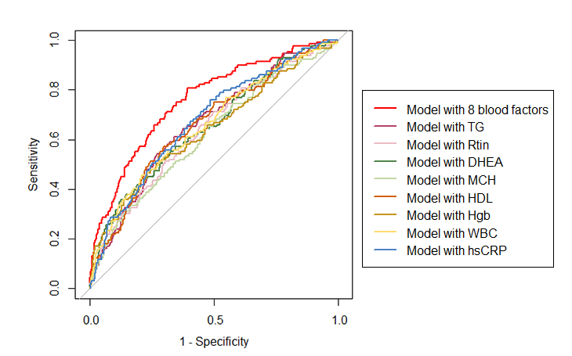
Note: The model with 8 blood factors had an area under curve (AUC) of 0.758. While among the 8 single blood factors, hsCRP had the highest AUC (0.674).
Supplementary Figure 1. Receiver operating characteristic curve (ROC) for models with combined or single blood factor

Supplementary Figure 2. Histogram of the number of abnormal blood factors at baseline (wave 4)

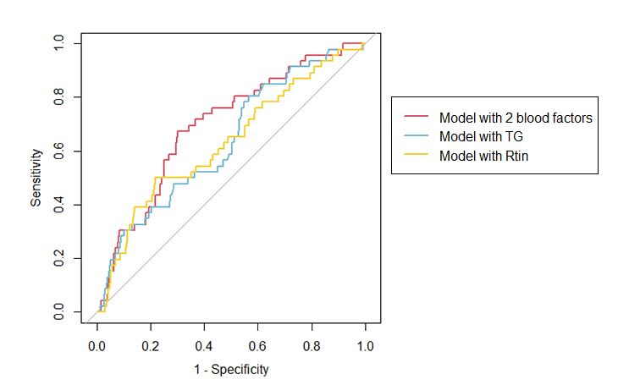
Note: The model with 2 blood factors had an area under curve (AUC) of 0.695. While among the 4 single blood factors, TG had the highest AUC (0.634).
Supplementary Figure 3. Receiver operating characteristic curve (ROC) for models with combined or single blood factor in men

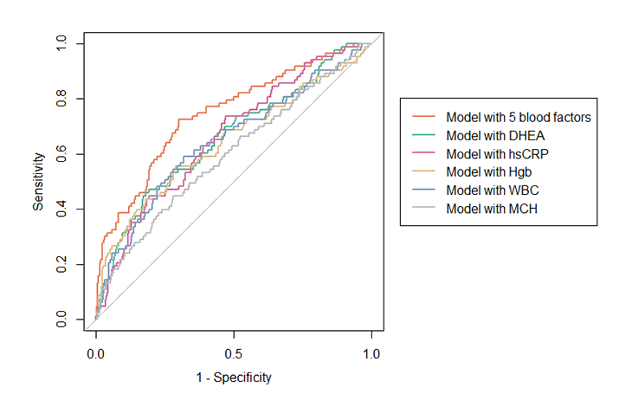
Note: The model with 5 blood factors had an area under curve (AUC) of 0.744. While among the 5 single blood factors, hsCRP had the highest AUC (0.661).
Supplementary Figure 4. Receiver operating characteristic curve (ROC) for models with combined or single blood factor in women

