Supplementary Information

Physiological and behavioral responses of pea aphid Acyrthosiphon pisum to the non-consumptive effects (NCEs) from the ladybird Harmonia axyridis

Xu Jun-Chao, Wang Ruo-Lin, Xing Qing-Jiang, Yang Yun, Wang Xing-Xing, Lu Zhaozhi, Liu Tong-Xian and Zhang Yi

Key Lab of Integrated Crop Pest Management of Shandong Province, College of Plant Health and Medicine, Qingdao Agricultural University, Qingdao,266109, China.
Shandong Engineering Research Center for Environment-Friendly Agricultural Pest Managemnent

Table S1. List of primers utilized in this study
 | Forward (5’ to 3’) | Reverse (5’ to 3’) | PCR type
Q-APTH | ATACATACCGTTTCCGTCTG | TCGTCTAGTTTCGTTTGTGT | Q-RT-PCR (E=98.5%)
Q-APTβH | TCATTACAGCACGCATTTTC | GCTGAATCCTCCAAGTGTAA | Q-RT-PCR (E=95.5%)
Q-APTPH | GTTACCGAGAGGACAACATT | TCATATACTGCGTGCAATGA | Q-RT-PCR (E=110.6%)
Q-APRpl7 (Ref) | GCGCGCCGAGGCTTAT | CCGGATTTCTTTGCATTTCTTG | Q-RT-PCR (E=100.7%)

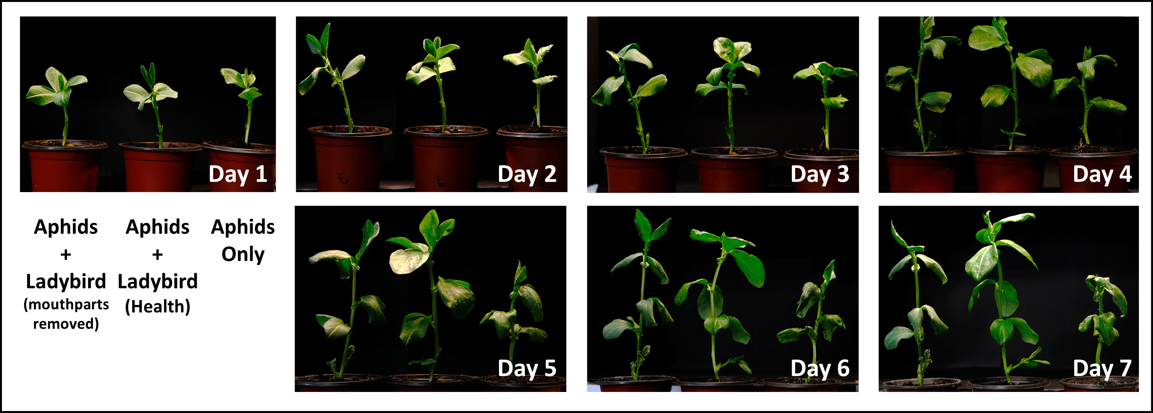
Fig. S1. the Vicia faba host plant status after 7 days of introducing aphids (50 individuals/plant) and the introduction of normal ladybirds or ladybirds with impaired feeding ability (for NCEs).

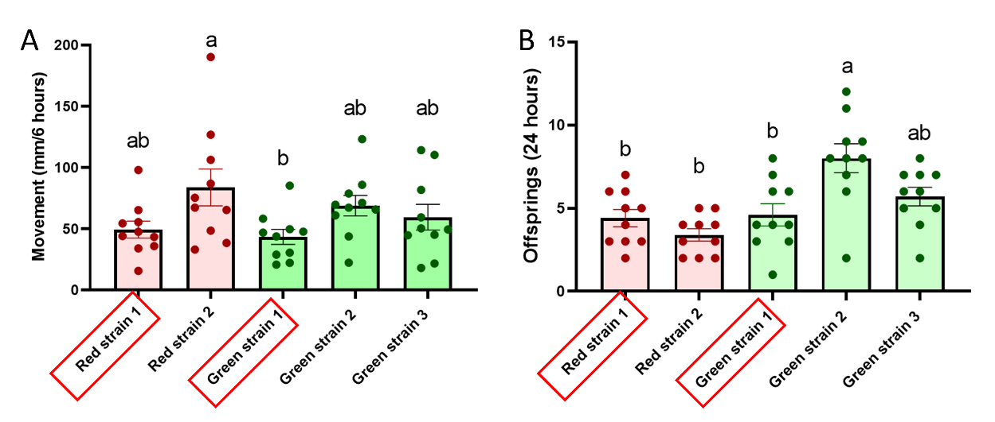
Fig. S2 The selection of experimental strains was based on the comparison of locomotion levels over 6 hours (A) and reproductive capacity over 24 hours (B) among five candidate aphid strains. These strains comprised two red strains and three green strains, with experimental conditions, handling procedures, and data acquisition and analysis consistent with the descriptions in the main text of the article. Comparison revealed that Red strain 1 and Green strain 1 exhibited similar levels of locomotion and reproductive capacity within the experimental timeframes (highlighted with red boxes). Consequently, these two strains were chosen as experimental subjects for further investigation.

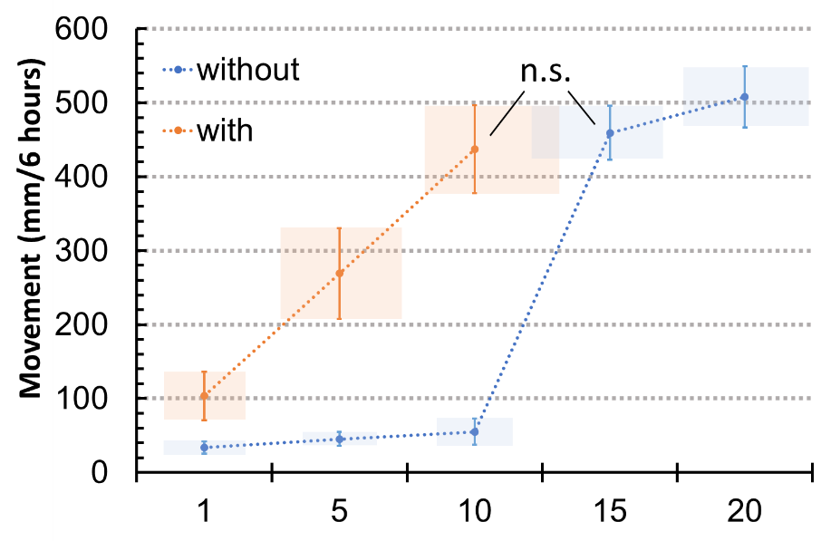
Fig. S3 The selection of experimental conditions was based on observations made in the experimental setup and during the 6-hour treatment period. Specifically, the movement distance of 10 aphids along with ladybirds (incapable of feeding) was similar to that of 15 aphids without ladybirds. The x-axis in the figure represents the number of aphids. Consequently, two treatment conditions were chosen for the experiments described in the manuscript: one with 10 aphids along with ladybirds (incapable of feeding) and another with 15 aphids alone. These conditions were selected to compare the similarities and differences in locomotion ability and other physiological and biological parameters of aphids under non-consumptive effects (NCEs) stimulation and under induction by high aphid density alone.

