Supplementary Materials

Methods
1. Molecular analysis
DNA was extracted from bone marrow aspirates using the QIAamp DNA Mini Kit (Qiagen, Hilden, Germany) or Qiasymphony Dsp DNA Mini Kit (Qiagen). Next generation sequencing (NGS) was performed using a customized myeloid panel (SM panel). Patients diagnosed from August 2017 to October 2020 were analyzed using the first version of the SM panel, which contained 87 genes, as previously described (1, 2). For patients diagnosed at a later stage, the second version of the SM panel, containing 110 genes, was used. In total, 87 genes were analyzed using both panels (sTable 1).
According to the manufacturer’s instructions, target capturing sequencing was performed using a customized target kit (Agilent Technologies, 3039061 for version 1, HEMEaccuTest MDS/MPN for version 2). The enriched fragments were amplified and sequenced on the HiSeq4000 (in version 1) or NextSeq550Dx (in version 2). After demultiplexing, the reads were aligned to the human reference genome hg19 (GRCh37) using BWA (0.7.10), and duplicate reads were removed with MarkDuplicates (GATK 4.0.6.0). Local realignment, score recalibration, and sequence data filtering were performed using GATK (4.0.6.0). Variants were annotated using SnpEff (4.3).
The pathogenicity of the annotated variants was determined according to the standards and guidelines of the Association for Molecular Pathology (AMP) (3) and Somatic Oncogenicity classification (4). All variants with a minor allele frequency >0.01 were filtered out based on the Exome Aggregation Consortium (ExAC, http://exac.broadinstitute.org/) and genome aggregation database (gnomAD, https://gnomad.broadinstitute.org/), as well as the ethnic-specific Korean Variant Archive (KOVA, http://kobic.re.kr /kova/). Variants of synonymous, intronic, or non-coding regions were further excluded. Among the remaining variants, those with more than 20 reads and 5% variant allele frequencies (VAF) were considered mutations. Hot-spot mutations in driver genes with less than 5% VAF were present with a low allele burden. All mutations were manually verified using the Integrative Genomic Viewer. Germline confirmation using buccal DNA was conducted for all detected DDX41 mutations.

2. Cytogenetic study
Conventional Bone marrow (BM) karyotyping was performed on G-banded metaphase chromosomes using routine techniques. Karyotypes were interpreted according to the International System for Human Cytogenetic Nomenclature 2016 and 2020. The number of cytogenetic events was considered the sum of chromosome gains, losses, partial gains, partial losses, and rearrangements. For 182 patients who presented with myelodysplastic neoplasms (MDS) features, fluorescence in situ hybridization (FISH) tests were conducted using six DNA probes: LSI ATM/CEP11 probe for detecting deletions at 11q22, LSI MYB probe for detecting deletions at 6q23, LSI D13S319/CEP13 probe for detecting deletions at 13q14, LSI TP53/CEP17 probe for detecting deletions at 17p13.1, and LSI IGH Dual Color, Break Apart Rearrangement probe and CEP12 probe for detecting trisomy 12. These FISH tests utilized the probes from Vysis Inc./Abbott Laboratories, located in Abbott Park (IL, USA).
sTable 1. List of genes sequenced for the entire study cohort.
Target genes | Interval | Number of regions | Size (base pairs)
ABCA12 | chr2:215797358-216002931 | 54 | 7929
ABL1 | chr9:133589707-133761070 | 12 | 3529
ASXL1 | chr20:30946579-31025141 | 17 | 4720
ATM | chr11:108098352-108236235 | 62 | 9171
ATRX | chrX:76763829-77041487 | 36 | 7543
ATXN7L1 | chr7:105248299-105517004 | 15 | 3132
BCOR | chrX:39909169-39937182 | 15 | 5348
BRAF | chr7:140426294-140624503 | 21 | 2379
BRCC3 | chrX:154299803-154348425 | 11 | 1021
CALR | chr19:13049494-13054795 | 10 | 1294
CBL | chr11:119077128-119170491 | 16 | 2721
CBLB | chr3:105377814-105588232 | 20 | 3079
CD101 | chr1:117544440-117576723 | 9 | 3066
CEBPA | chr19:33792244-33793425 | 1 | 1182
CREBBP | chr16:3777719-3929917 | 31 | 7368
CSF1R | chr5:149433632-149465990 | 22 | 3003
CSF3R | chr1:36931697-36945097 | 16 | 2698
CTCF | chr16:67644736-67671775 | 10 | 2184
CUX1 | chr7:101459311-101926382 | 34 | 5433
DDX41 | chr5: 176938739-176943985 | 14 | 3924
DNMT1 | chr19:10244343-10311559 | 43 | 5292
DNMT3A | chr2:25457148-25536853 | 25 | 2888
EGFR | chr7:55086971-55273310 | 31 | 4084
EP300 | chr22:41489009-41574960 | 31 | 7245
ERG | chr21:39739557-39947624 | 12 | 1764
ETV6 | chr12:11803062-12044535 | 10 | 1443
EZH2 | chr7:148504738-148544390 | 21 | 2456
FBXW7 | chr4:153244033-153332955 | 14 | 2618
FLT3 | chr13:28578189-28674647 | 25 | 3004
GATA1 | chrX:48649517-48652675 | 5 | 1346
GATA2 | chr3:128199862-128205874 | 5 | 1443
GNAS | chr20:57415162-57485884 | 17 | 4096
HIPK2 | chr7:139257673-139477422 | 16 | 3708
IDH1 | chr2:209101803-209116275 | 8 | 1248
IDH2 | chr15:90627498-90645622 | 11 | 1359
INVS | chr9:102866804-103062956 | 17 | 3395
IRF1 | chr5:131819643-131825170 | 9 | 978
JAK2 | chr9:5021988-5126791 | 23 | 3399
KDM2B | chr12:121867919-122018816 | 29 | 4276
KDM6A | chrX:44732798-44970656 | 31 | 4470
KIT | chr4:55524182-55604723 | 21 | 2931
KRAS | chr12:25362729-25398318 | 6 | 708
LAMB4 | chr7:107664484-107763609 | 35 | 5507
MECOM | chr3:168802697-169381160 | 20 | 3816
MET | chr7:116335811-116436178 | 21 | 4359
KMT2A (MLL1) | chr11: 118307112-118392899 | 40 | 15360
KMT2C (MLL3) | chr7:151833917-152132871 | 62 | 15030
KMT2D (MLL4) | chr12: 49415518-49449172 | 51 | 21294
KMT2E (MLL5) | chr7:104681400-104753780 | 27 | 5743
MN1 | chr22:28146903-28196531 | 2 | 3963
MPL | chr1:43803520-43818443 | 12 | 1993
NCOR2 | chr12:124809948-124979797 | 49 | 7734
NF1 | chr17:29422226-29705949 | 63 | 9011
NLRP1 | chr17:5405134-5487277 | 18 | 4493
NOTCH1 | chr9:139390523-139440238 | 34 | 7668
NPM1 | chr5:170814953-170837569 | 12 | 894
NRAS | chr1:115251156-115258781 | 4 | 570
NUP98 | chr11:3692612-3803347 | 35 | 5567
OCA2 | chr15:28000534-28327020 | 24 | 2573
PDGFRA | chr4:55106220-55161439 | 24 | 3450
PHF12 | chr17:27233201-27278622 | 17 | 3519
PHF6 | chrX:133511648-133559360 | 9 | 1207
PRPF40B | chr12:50017374-50037975 | 26 | 2682
PRPF8 | chr17:1553953-1587865 | 42 | 7151
PTPN11 | chr12:112856916-112942568 | 16 | 1822
RAD21 | chr8:117859739-117878968 | 13 | 1896
RAD50 | chr5:131893017-131978781 | 27 | 4211
RINT1 | chr7:105172763-105207758 | 16 | 2417
ROBO1 | chr3:78648063-79639061 | 34 | 5223
ROBO2 | chr3:75986645-77695209 | 32 | 4862
RUNX1 | chr21:36164432-36421196 | 11 | 1584
RUNX1T1 | chr8:92972470-93115112 | 20 | 2350
SETBP1 | chr18:42281312-42643663 | 6 | 4980
SF3A1 | chr22:30730583-30752781 | 16 | 2382
SF3B1 | chr2:198257027-198299723 | 27 | 4045
SMC1A | chrX:53407024-53449549 | 26 | 3882
SMC3 | chr10:112327575-112364060 | 29 | 3654
SRSF2 | chr17:74732243-74733242 | 2 | 666
STAG2 | chrX:123156478-123234447 | 34 | 3861
TET1 | chr10:70332096-70451571 | 11 | 6411
TET2 | chr4:106111627-106197676 | 10 | 6165
TP53 | chr17:7565257-7579912 | 14 | 1378
TP53BP1 | chr15:43699581-43785241 | 31 | 6130
U2AF1 | chr21:44513212-44527604 | 9 | 790
U2AF2 | chr19:56166471-56185434 | 14 | 1541
WT1 | chr11:32410604-32456891 | 11 | 1568
ZRSR2 | chrX:15808619-15841365 | 12 | 1690

3. Statistics
3.1. Pairwise associations among genes and cytogenetic abnormalities
To assess pairwise association among genes and/or cytogenetic abnormalities, we calculated the co-occurrence of genomic abnormalities across patients. The number of patients showing mutation co-occurrence was quantified. Next, 2×2 contingency tables were generated by each pair and the significance was evaluated using Fisher’s exact test. Furthermore, the odds ratio was calculated for each possible pairing of genes and/or cytogenetic abnormalities. Odds ratios less than 1 indicate that the mutation pairs were mutually excluded, while odds ratios greater than 1 imply mutation co-occurrence.

3.2. Genomic clustering based on Bayesian Networks
We used Bayesian Networks (BNs) to define the relationships between genomic abnormalities in MDS, myeloproliferative neoplasms (MPN), and overlapping conditions in a more comprehensive manner. BNs are graph-based statistical models used to model complex probabilistic relationships. They employ directed graphs to represent conditional dependencies between variables, supporting probabilistic inference and decision-making under uncertainty. In the BN model, nodes represented distinct genomic abnormalities, and directed edges indicated conditional dependencies.

3.3. Hierarchical Dirichlet Process

We employed a Bayesian nonparametric approach to analyze complex genomic data, specifically focusing on identifying distinct genomic subgroups within a large patient cohort. This approach was grounded in the use of a Dirichlet Process Mixture Model (DPMM). A significant advantage of the DPMM is its inherent flexibility, allowing for the number of clusters to be inferred from the data itself, rather than being pre-specified. This characteristic makes the DPMM a versatile tool for a wide range of clustering applications.

The DPMM hinges on the Dirichlet Process (DP), defined by a concentration parameter ($α$) and a base distribution ($H$). The base distribution ($H$) represents the underlying parameter distributions across clusters, while the concentration parameter ($α$) governs the probable number of clusters. The DPMM's mathematical formulation is as follows: $DP(α,H)$, with $α$ controlling cluster abundance and $H$ detailing the parameter space. Each cluster $k$ is associated with a parameter $θ_{k}$, independently drawn from the base distribution $H$. The data points $x_{i}$ are then generated from $α$ based on the parameters $θ_{k}$ of their respective clusters.

The implementation of DPMM in our study is primarily based on Markov Chain Monte Carlo (MCMC) methods, specifically Gibbs sampling, which facilitates the estimation of cluster memberships for each data point and the determination of corresponding cluster parameters. For our analysis, we utilized the R package hdp, which is publicly accessible at https://github.com/nicolaroberts/hdp. This package facilitated the Monte Carlo Markov Chain (MCMC) sampling of the Dirichlet Process (DP) posterior. Our approach involved running the MCMC process under four distinct initial conditions, essentially creating four separate chains. In each chain, the initial 2000 iterations were discarded to mitigate the impact of initial conditions on the results. Subsequently, we collected 2000 samples, selecting every 20th iteration to reduce autocorrelation. To refine our cluster analysis, we implemented a merging criterion based on cosine similarity. Specifically, clusters exhibiting a cosine similarity above 0.8 were merged, ensuring a more robust and meaningful clustering outcome.

3.4. Bradley-Terry model
A Bradley-Terry model was used to assign the relative order of mutation acquisition for each DP component, based on pairwise relationships among patients with at least two mutations. Each genetic mutation is treated as a 'competitor,' and the Variant Allele Fraction (VAF) values are used to infer their relative strengths or occurrences over time. By comparing pairs of mutations (much like competitors in a tournament), the model assesses which mutation is more dominant or prevalent, which in turn suggests its relative timing in the genetic sequence. By setting a threshold where a decisive 'win' in the comparative strength of mutations is determined when the difference in corrected VAF values is greater than or equal to 5, the analysis becomes more robust and specific. ﻿R package BradleyTerry2 (version 1.0-8) was used to generate estimates of relative mutation timing and provide point estimates and 95% confidence intervals, representing the results of the Bradley–Terry model for the relative ordering of genes in their temporal acquisition.

Results
sTable 2. Baseline characteristics of the study cohort for training.
Variables | MDS | MPN | MDS/MPN | AA
Number of patients | 698 | 715 | 78 | 94
Age at diagnosis (years) | 58.5 (23.0-81.0) | 58.0 (26.8-76.0), 0.173 | 66.0 (30.9-83.1), <0.01 | 53.0 (21.3-82.1), <0.01
Sex (Female) | 39.4% (275/698) | 53.1% (380/715) | 39.7% (31/78) | 53.2% (50/94)
Hemoglobin (g/L) | 9.4 (5.8-14.4) | 13.0 (7.3-19.2), <0.01 | 9.8 (5.8-14.6), 0.212 | 10.0 (6.1-15.2), <0.05
Hematocrit (%) | 28.5 (17.4-42.4) | 39.8 (23.0-61.0), <0.01 | 31.2 (18.3-44.8), <0.05 | 30.0 (17.9-45.5), 0.077
MCV (fl) | 99.2 (81.0-117.8) | 90.3 (73.5-111.8), <0.01 | 92.7 (78.1-113.4), <0.01 | 100.7 (86.2-115.9), 0.217
MCH (pg) | 33.2 (25.5-39.3) | 29.5 (21.9-37.9), <0.01 | 29.8 (23.4-36.8), <0.01 | 33.8 (29.1-38.4), <0.05
MCHC (%) | 33.3 (29.9-35.4) | 32.5 (29.6-34.6), <0.01 | 32.2 (29.5-34.2), <0.01 | 33.6 (31.1-35.8), <0.01
RBC Count (×10¹²/L) | 2.9 (1.7-4.6) | 4.4 (2.4-7.6), <0.01 | 3.3 (2.0-5.2), <0.01 | 3.0 (1.7-4.6), 0.217
Platelets (×10⁹/L) | 80.5 (9.0-366.0) | 510.0 (31.8-1326.5), <0.01 | 112.5 (10.8-583.8), <0.01 | 62.5 (7.0-245.7), <0.01
WBC Count (×10⁹/L) | 3.1 (1.0-11.2) | 9.0 (2.7-31.0), <0.01 | 18.0 (2.9-84.3), <0.01 | 3.3 (1.1-7.0), 0.25
Neutrophils (×10⁹/L) | 39.0 (7.4-79.1) | 66.0 (36.6-87.1), <0.01 | 53.2 (16.9-81.0), <0.01 | 42.0 (17.3-72.0), 0.122
Monocytes (%) | 6.0 (0.4-28.0) | 5.0 (1.0-13.0), <0.01 | 17.0 (1.9-49.4), <0.01 | 6.0 (2.0-19.7), 0.564
PB blast (%) | 0.0 (0.0-6.0) | 0.0 (0.0-5.1), <0.05 | 0.0 (0.0-8.1), <0.01 | 0.0 (0.0-0.7), <0.01
BM blast (%) | 2.0 (0.0-17.0) | 0.0 (0.0-4.0), <0.01 | 2.0 (0.0-13.1), 0.088 | 0.0 (0.0-1.7), <0.01
BM cellularity (%) | 30.0 (1.0-90.0) | 50.0 (1.0-100.0), <0.01 | 70.0 (1.0-100.0), <0.01 | 10.0 (5.0-24.6), <0.01
Dys.E* | 73.4% (495/674) | 2.6% (12/466) | 40.0% (30/75) | 0% (0/85)
Dys.G* | 72.7% (490/674) | 3.2% (15/466) | 92.0% (69/75) | 0% (0/85)
Dys.M* | 67.1% (452/674) | 3.9% (18/466) | 56.3% (49/75) | 0% (0/85)
Myelofibrosis* | 11.3% (76/674) | 50.2% (234/466) | 21.3% (16/75) | 0% (0/85)
Ring sideroblasts (%) | 0.0 (0.0-43.3) | 0.0 (0.0-0.0), <0.01 | 0.0 (0.0-0.0), <0.01 | 0.0 (0.0-0.0), <0.01
Transplantation* | 45.0% (314/698) | 10.6% (76/715) | 29.5% (23/78) | 11.7% (11/94)
Abnormal karyotype* | 53.9% (376/698) | 15.1% (108/715) | 25.6% (20/78) | 16.0% (15/94)
Number of mutations | 1.0 (0.0-5.0) | 2.0 (0.0-4.1), <0.01 | 3.0 (0.0-8.0), <0.01 | 0.0 (0.0-1.7), <0.01
2-year survival rate (%) | 73.2±1.9 | 97.2±0.7 | 70.3±7.1 | 91.5±4.2
5-year survival rate (%) | 57.0±2.6 | 95.4±1.2 | 60.3±11.1 | 87.9±5.4
10-year survival rate (%) | 38.4±4.0 | 92.8±1.9 | 60.3±11.1 | 75.3±12.5
Continuous variables were described as median and range (2.5-97.5%), P value of Mann-Whitney test using MDS as the control group.
Categorical variables were described as frequency and percentage.

sTable 3. Baseline characteristics of the study cohort for validation.
Variables | MDS | MPN | MDS/MPN | AA
Number of patients | 55 | 77 | 7 | 11
Age at diagnosis (years) | 62.0 (23.0-82.3) | 56.0 (26.7-79.3), 0.054 | 56.0 (21.4-74.0), 0.688 | 47.0 (30.5-65.0), <0.05
Sex (Female) | 63.6% (35/55) | 45.5% (35/77) | 42.9% (3/7) | 54.5% (6/11)
Hemoglobin (g/L) | 9.1 (5.0-13.7) | 13.5 (7.8-17.0), <0.01 | 9.3 (5.7-12.2), 0.938 | 9.5 (4.7-14.7), 0.606
Hematocrit (%) | 27.3 (15.1-42.2) | 41.1 (25.0-55.8), <0.01 | 29.5 (17.4-37.1), 0.841 | 28.4 (14.5-42.0), 0.744
MCV (fl) | 100.0 (81.5-113.3) | 91.3 (81.8-121.9), <0.01 | 96.9 (89.6-107.8), 0.656 | 107.5 (94.1-126.8), 0.066
MCH (pg) | 33.6 (24.8-38.4) | 30.1 (25.4-39.2), <0.01 | 30.2 (29.2-35.9), 0.178 | 35.1 (32.2-42.8), <0.05
MCHC (%) | 33.1 (30.5-34.9) | 32.4 (30.1-34.4), <0.01 | 31.9 (30.4-33.4), <0.05 | 33.7 (32.1-35.2), 0.13
RBC Count (×10¹²/L) | 2.7 (1.5-4.6) | 4.5 (2.3-6.5), <0.01 | 2.8 (1.9-4.0), 0.929 | 2.9 (1.4-4.1), 0.731
Platelets (×10⁹/L) | 76.0 (6.4-282.8) | 571.0 (78.0-1152.5), <0.01 | 138.0 (27.9-691.0), 0.344 | 63.0 (14.5-140.0), 0.182
WBC Count (×10⁹/L) | 2.3 (0.8-14.5) | 9.0 (3.9-21.2), <0.01 | 9.9 (4.5-24.6), <0.01 | 3.2 (2.0-4.9), 0.09
Neutrophils (×10⁹/L) | 31.0 (7.4-70.2) | 66.0 (41.6-82.5), <0.01 | 59.0 (14.9-73.8), 0.133 | 49.0 (28.5-69.5), <0.05
Monocytes (%) | 6.0 (1.0-25.0) | 6.0 (2.0-14.3), 0.928 | 26.0 (9.2-47.4), <0.01 | 8.0 (1.5-17.2), 0.159
PB blast (%) | 0.0 (0.0-9.6) | 0.0 (0.0-5.4), 0.357 | 0.0 (0.0-2.5), 0.584 | 0.0 (0.0-0.0), 0.079
BM blast (%) | 2.0 (0.0-16.3 | 0.0 (0.0-3.2), <0.01 | 1.0 (0.0-3.7), 0.097 | 0.0 (0.0-3.2), <0.01
BM cellularity (%) | 30.0 (5.0-96.5) | 60.0 (20.0-90.0), <0.01 | 70.0 (22.5-100.0), <0.01 | 15.0 (5.0-27.5), <0.05
Dys.E* | 80.0% (44/55) | 1.8% (1/56) | 71.4% (5/7) | 9.1% (1/11)
Dys.G* | 67.3% (37/55) | 42.9% (3/7) | 100% (7/7) | 9.1% (1/11)
Dys.M* | 61.8% (34/55) | 42.9% (3/7) | 71.4% (5/7) | 9.1% (1/11)
Myelofibrosis* | 21.8% (12/55) | 50.0% (28/56) | 42.9% (3/7) | 0% (0/11)
Ring sideroblasts (%) | 0.0 (0.0-46.7) | 0.0 (0.0-0.0), <0.05 | 0.0 (0.0-0.0), 0.423 | 0.0 (0.0-0.0), 0.311
Transplantation* | 38.2% (21/55) | 9.1% (7/77) | 42.9% (3/7) | 9.1% (1/11)
Abnormal karyotype* | 47.3% (26/55) | 15.6% (12/77) | 14.3% (1/7) | 18.2% (2/11)
Number of mutations | 1.0 (0.0-5.3) | 1.0 (0.0-5.1), 0.121 | 3.0 (0.2-5.8), 0.086 | 0.0 (0.0-1.0), <0.05
2-year survival rate (%) | 67.7±7.7 | 93.6±3.1 | 71.4±17.1 | 100
Continuous variables were described as median and range (2.5-97.5%), P value of Mann-Whitney test using MDS/CCUS as the control group.
Categorical variables were described as frequency and percentage.

sTable 4. Comparison of the two study cohorts.
Variables | Training set | Validation set | P
Number of patients | 1585 | 150 | -
Age at diagnosis (years) | 58.0 (24.0-79.0) | 58.0 (23.4-81.3) | 0.767
Sex (Female) | 46.4% (736/1585) | 52.7% (79/150) | 0.169
Hemoglobin (g/L) | 10.7 (6.1-18.0) | 10.9 (5.3-16.8) | 0.727
Platelets (×10⁹/L) | 172.0 (12.0-1101.4) | 257.5 (12.9-1030.9) | 0.066
WBC Count (×10⁹/L) | 5.5 (1.2-30.1) | 6.5 (1.2-21.6) | 0.927
2022 WHO classification (morphologically defined)
MDS
CCUS | 19 (1.2%) | 1 (0.7%) | 0.733
MDS-LB | 294 (18.5%) | 24 (16.0%) | 0.733
MDS-LB-RS | 48 (3.0%) | 3 (2.0%) | 0.733
MDS-H | 55 (3.5%) | 4 (2.7%) | 0.733
MDS-IB1 | 163 (10.3%) | 9 (6.0%) | 0.733
MDS-IB2 | 108 (6.8%) | 13 (8.7%) | 0.733
MDS-F | 11 (0.7%) | 1 (0.7%) | 0.733
MPN
PV | 127 (8.0%) | 13 (8.7%) | 0.902
ET | 278 (17.5%) | 35 (23.3%) | 0.902
PMF | 233 (14.7%) | 23 (15.3%) | 0.902
Secondary MF | 60 (3.8%) | 6 (4.0%) | 0.902
CNL | 4 (0.3%) | 0 (0%) | 0.902
JMML | 5 (0.3%) | 0 (0%) | 0.902
CEL | 1 (0.1%) | 0 (0%) | 0.902
MPN-NOS | 7 (0.4%) | 0 (0%) | 0.902
MDS/MPN
CMML | 62 (3.9%) | 4 (2.7%) | 0.47
MDS/MPN-N | 7 (0.4%) | 1 (0.7%) | 0.47
MDS/MPN-RS-T | 1 (0.1%) | 0 (0%) | 0.47
MDS/MPN-NOS | 8 (0.5%) | 2 (1.3%) | 0.47
AA
AA | 94 (5.9%) | 11 (7.3%) | 1.0
2-year survival rate (%) | 83.5±1.1 | 83.1±3.8 | -
5-year survival rate (%) | 73.4±1.7 | 83.1±3.8 | -
10-year survival rate (%) | 60.3±2.9 | 83.1±3.8 | -
Continuous variables were described as median and range (2.5-97.5%), P value of Mann-Whitney test.
Categorical variables were described as frequency and percentage, P value of Chi-Square test.

sFigure 1. Clinical characteristics of the study cohort (training set).
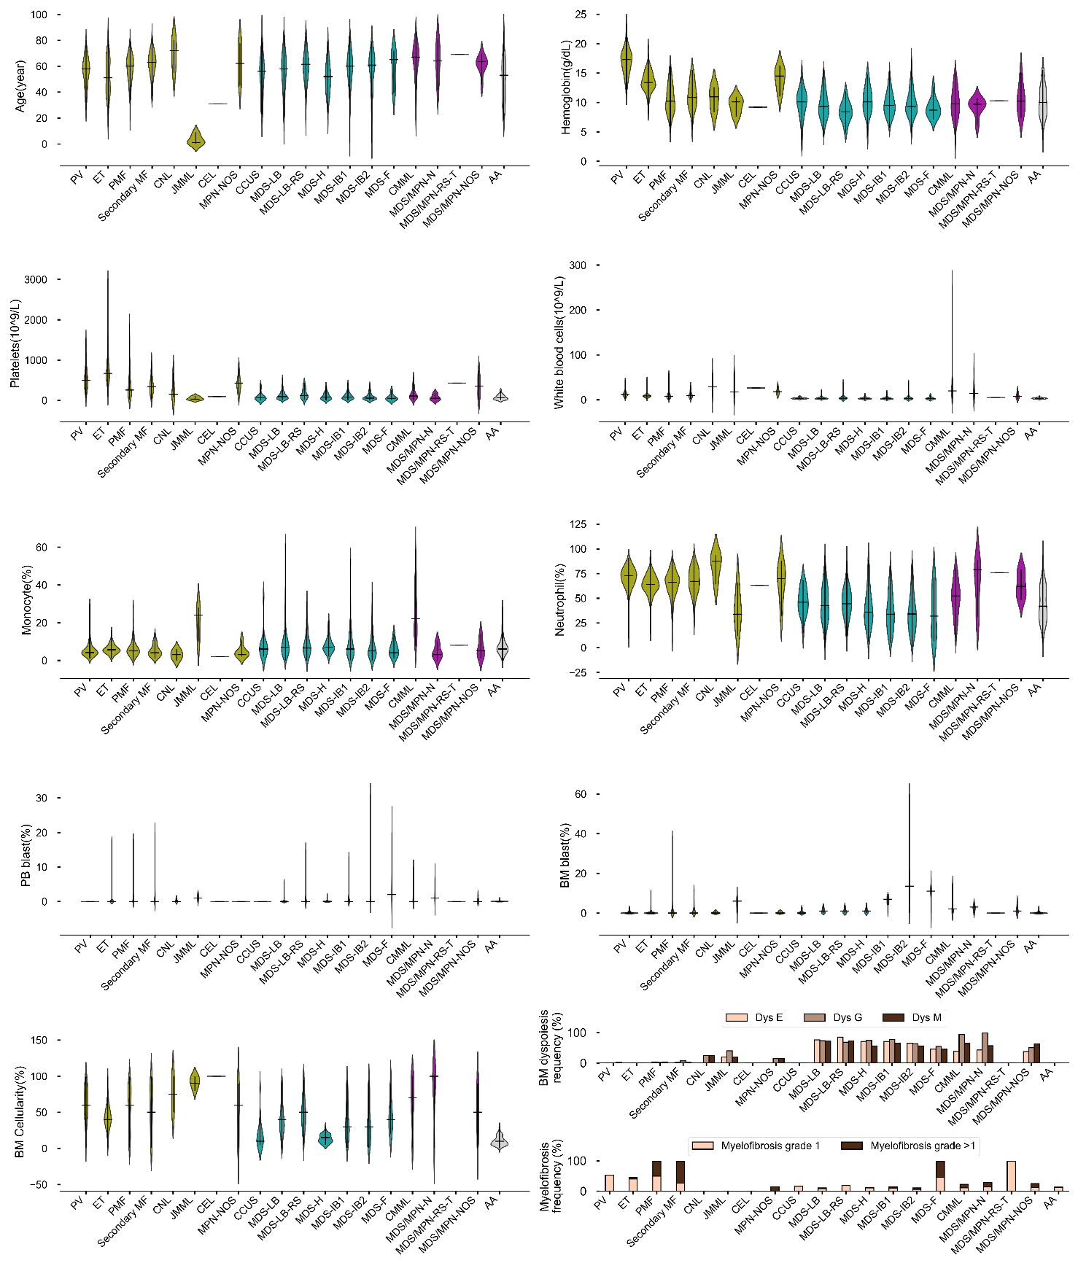

sFigure 2. VAF distribution of driver mutations.
The boxplots reveal the spread and central values of VAFs within each category, with the median value represented by the line within each box, the interquartile range denoted by the box itself, and the whiskers extending to the furthest points excluding outliers, which are marked as individual circles.
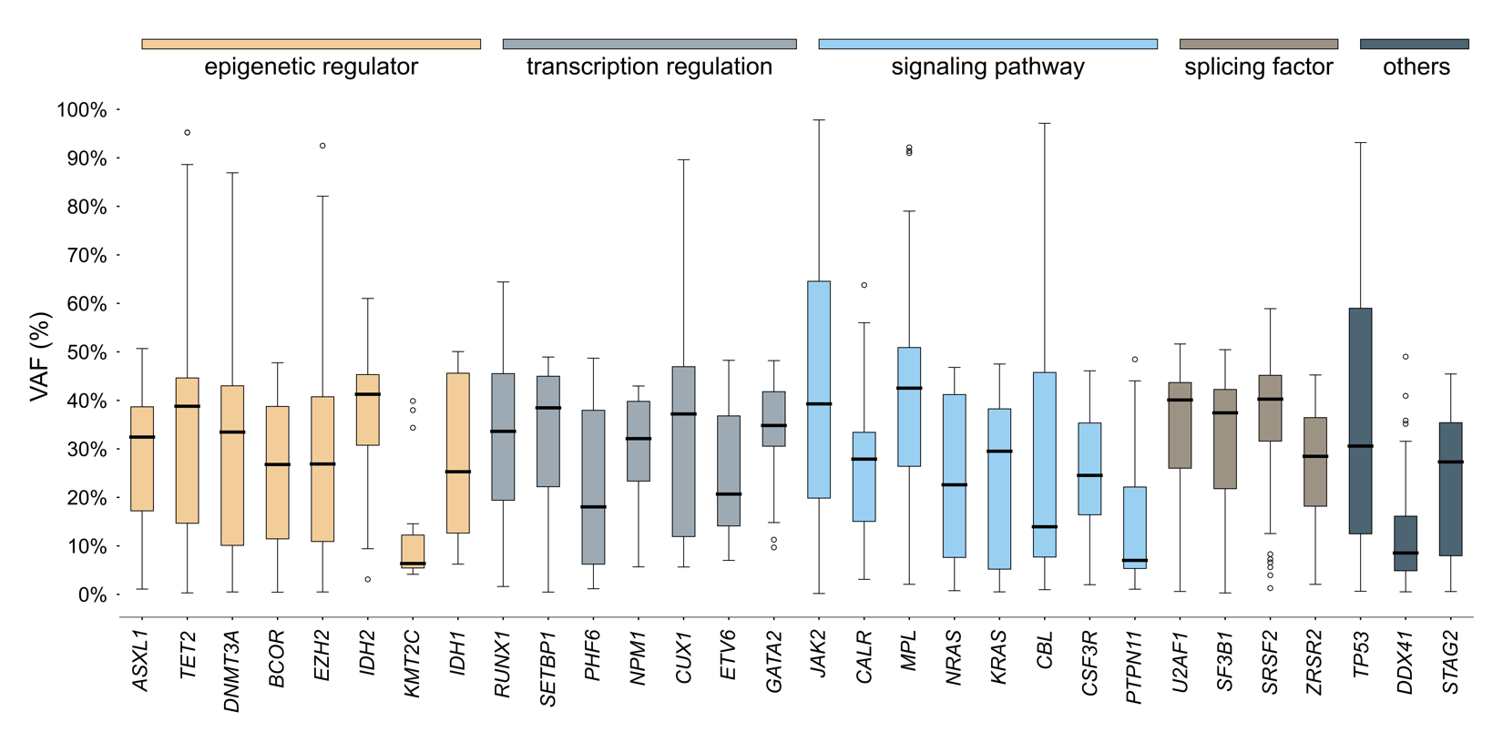

sFigure 3. Pairwise associations among genes and cytogenetic abnormalities.
Pairwise associations among genes and cytogenetic abnormalities that have occurred more than 1% were analyzed. In the lower triangle, the number of patients showing co-occurrences of genomic abnormalities are illustrated using gray scale. In the upper triangle, the co-occurrence and mutual exclusivity were assessed using odds ratios, and their significances were evaluated using Fisher’s test with Benjamini-Hochberg Correction.
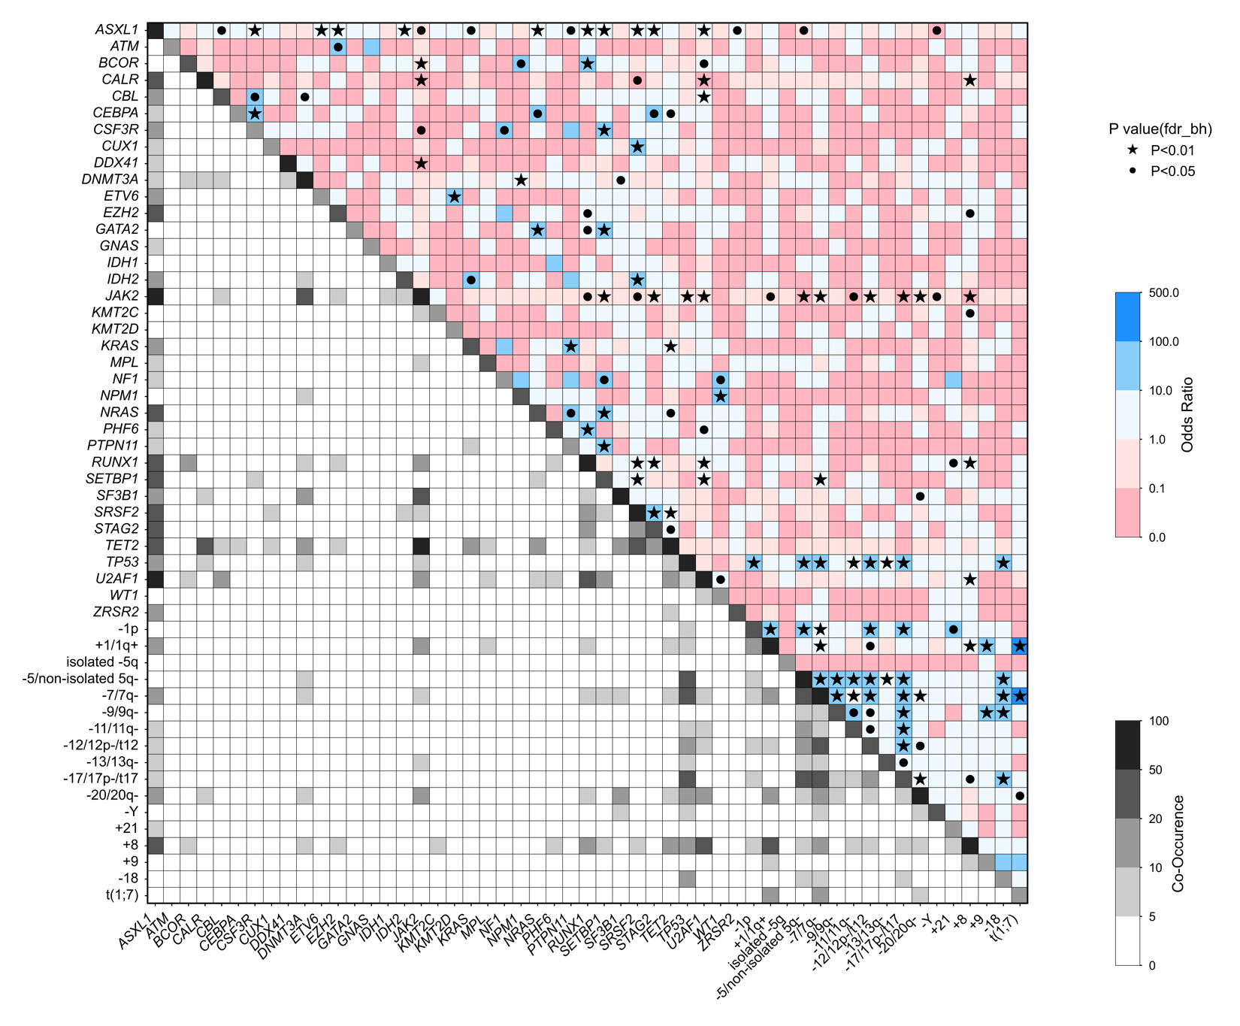

sFigure 4. Genomic associations based on Bayesian Networks.
The size of each node accounts for the number of correspondent genomic or cytogenetic alterations. The color of each link represents co-occurrence (odds >1, blue) or mutual exclusivity (odd <1, red). We computed edge strength using Fisher’s exact test and pruned the insignificant edges (P>0.05). Edge thickness represents the value of log-odds ratios. In cases of mutually exclusive relationships, it was made proportional to the absolute value of the log-odds. Furthermore, the node colors correspond to categories mentioned in sFigure 2.

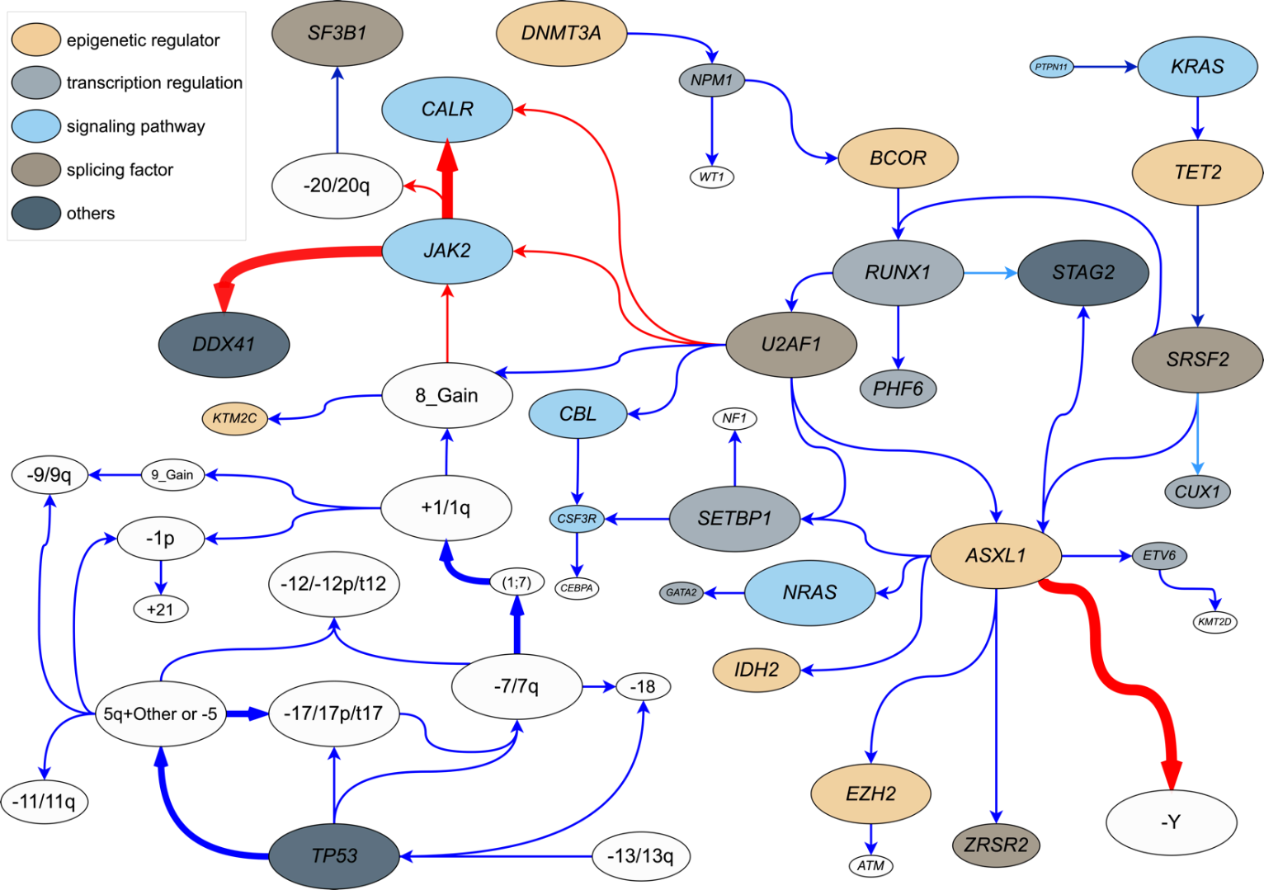

sFigure 5. Genomic profiles and posterior distributions from the Hierarchical Dirichlet Process.
Bar graphs of genomic profiles (red bars) and posterior distributions (blue bars) of 10 distinct DP groups. The x-axis of the graph spans from 0 to 1.
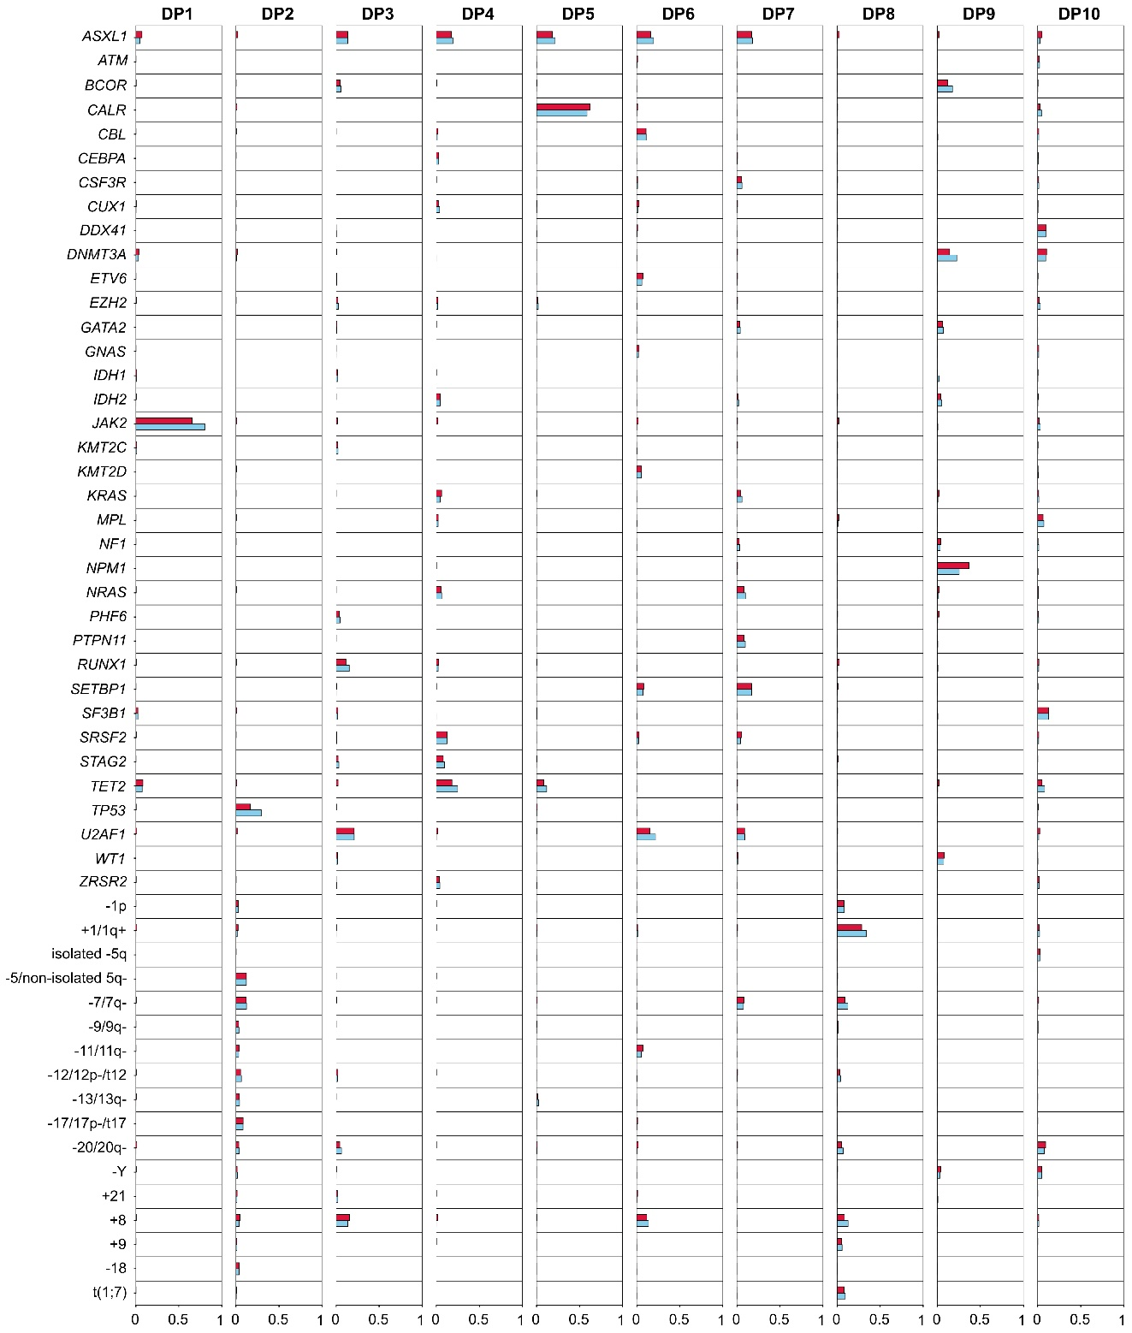
sFigure 6. Frequencies of disease phenotypes in each genomic subgroup.
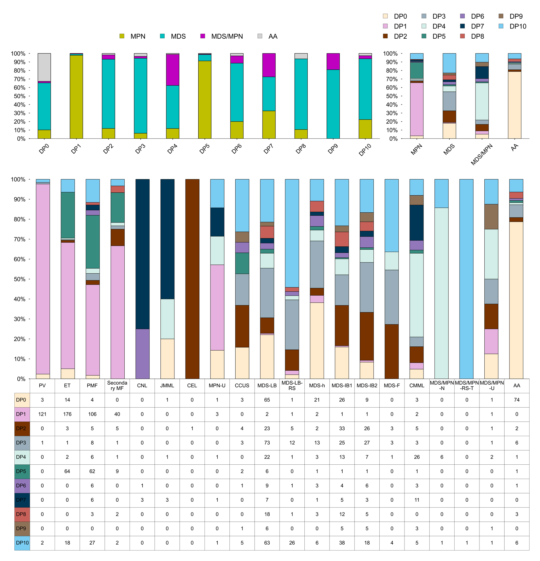

Figure 7. Hematological parameters of each genomic subgroup.
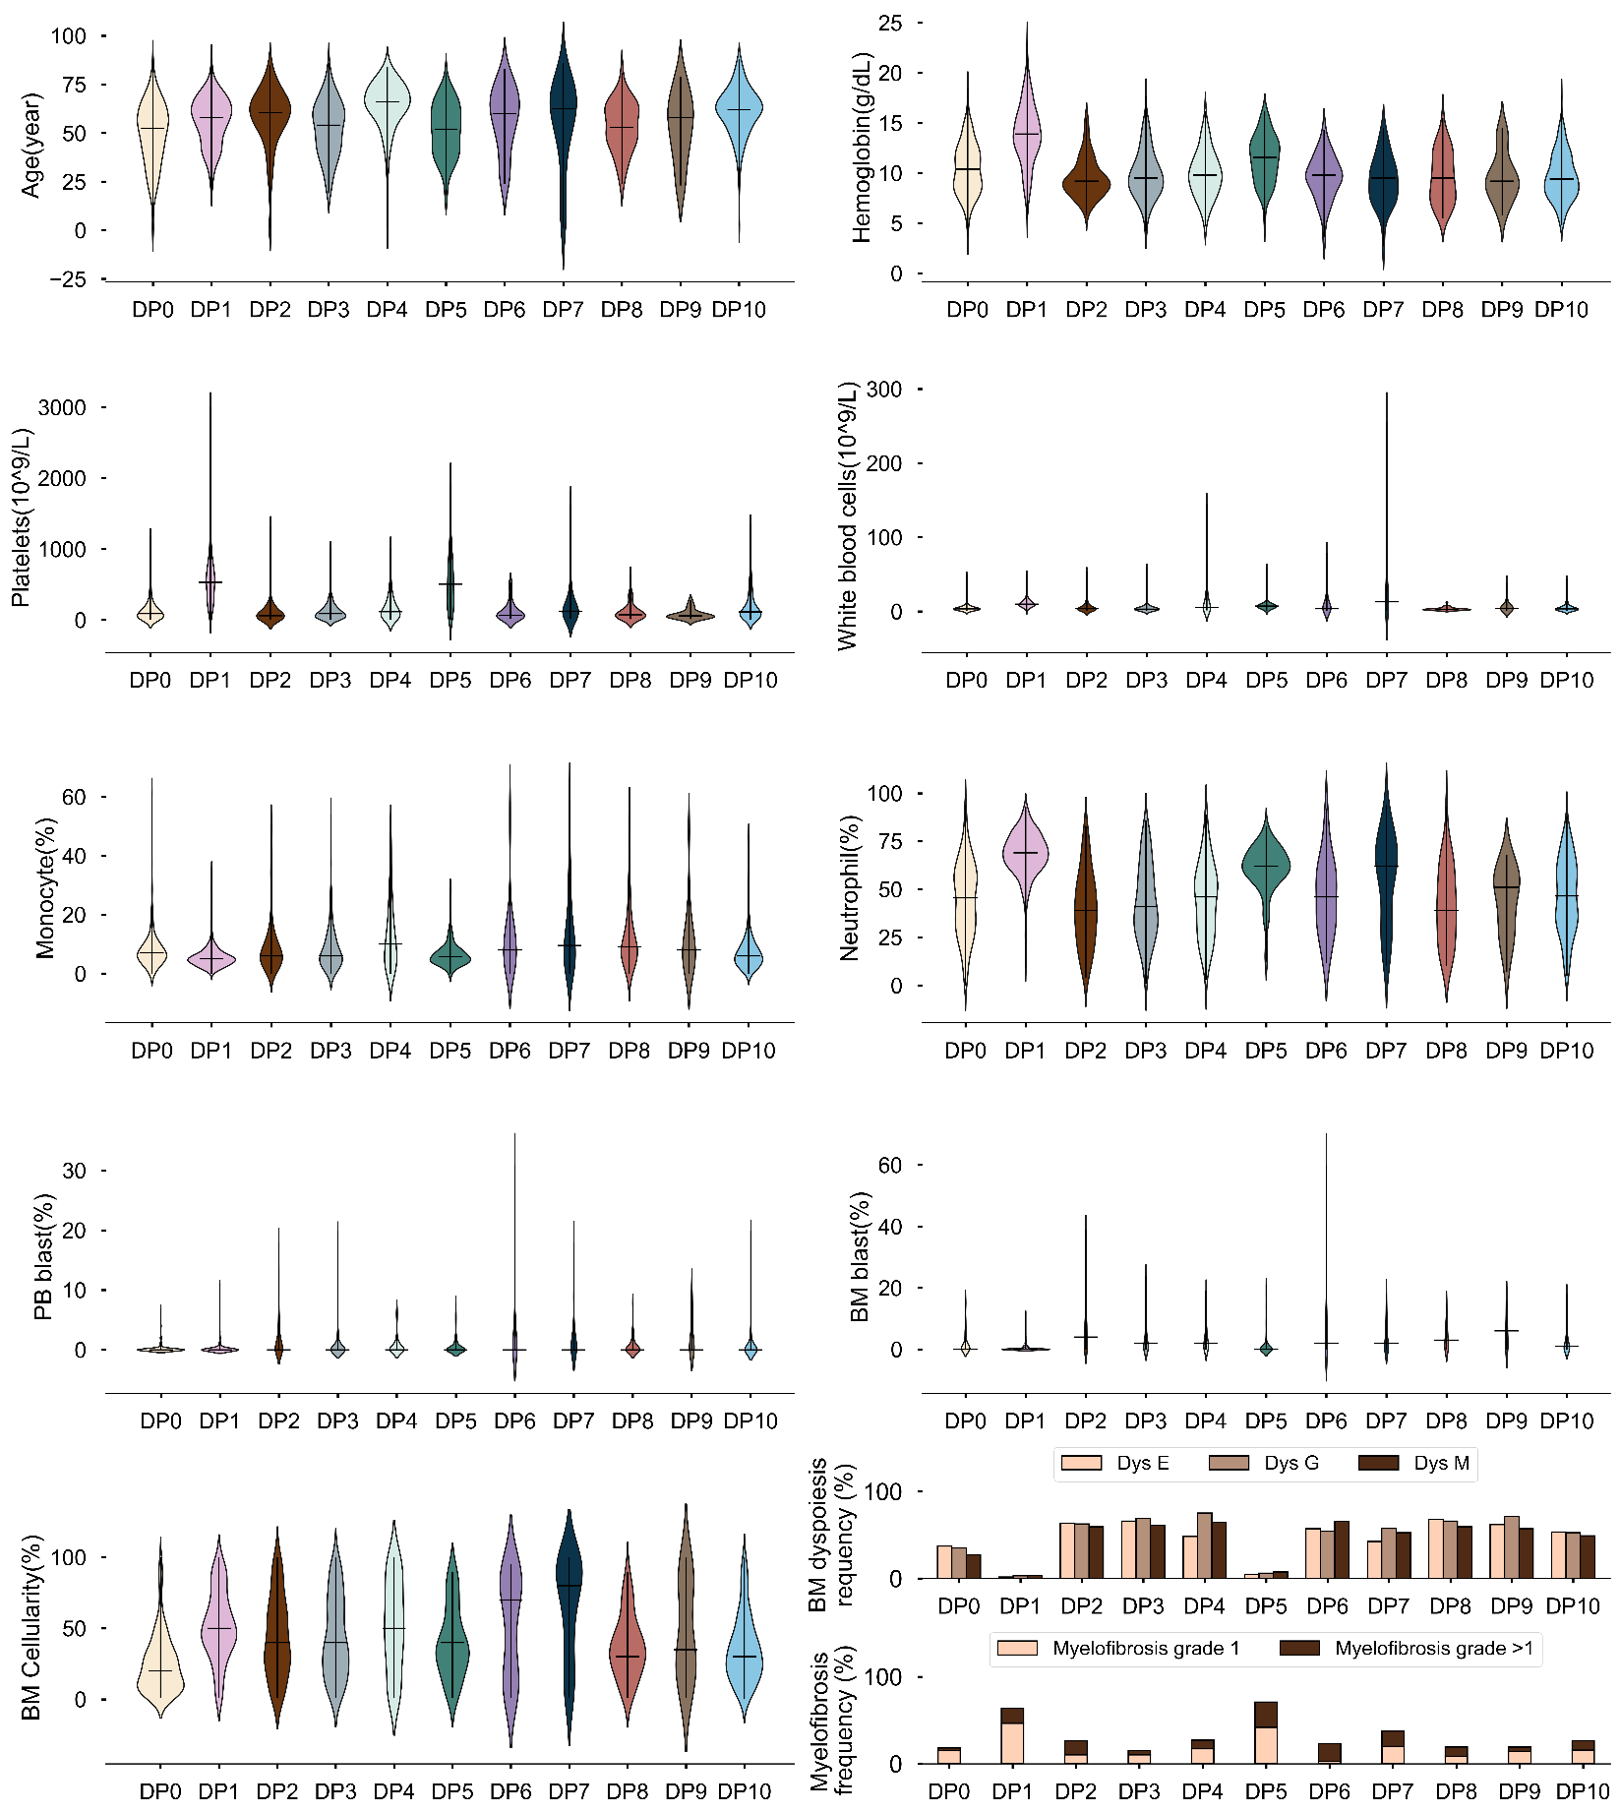

sFigure 8. Bradley-Terry Model Analysis of Genetic Mutation Sequences in each genomic cluster.
Each point corresponds to the log-odds value, indicating the relative probability that one specific genetic mutation occurs before another within a given pair. These results suggest that if the log-odds for gene B relative to gene A is 1.71, then the probability of mutation B occurring first is 1.71 times greater compared to mutation A. The error bars depicted alongside each point delineate the 95% confidence intervals. We only present the figures of DP groups with enough mutations for the calculation.
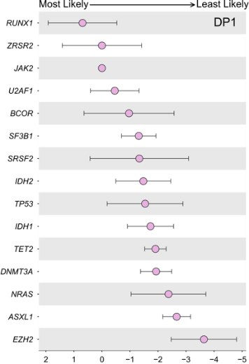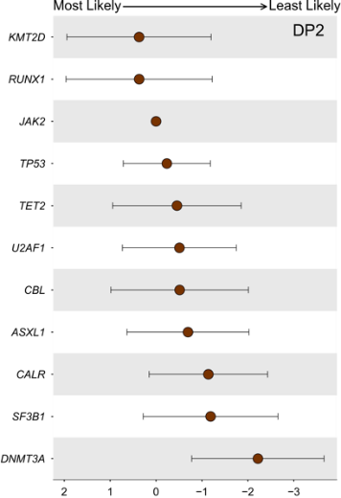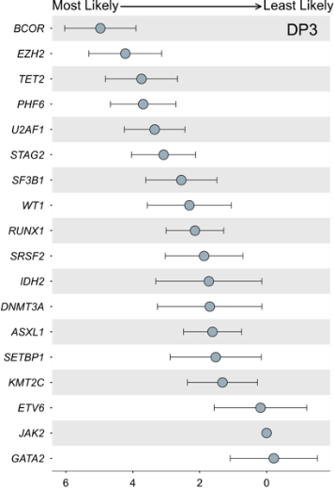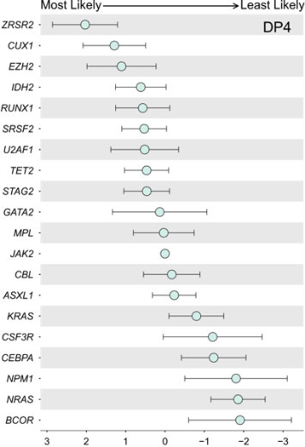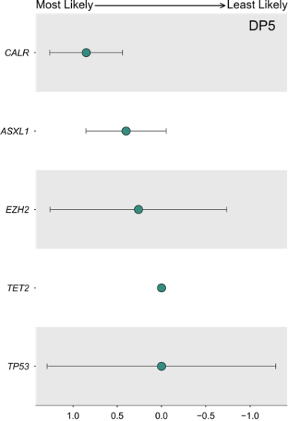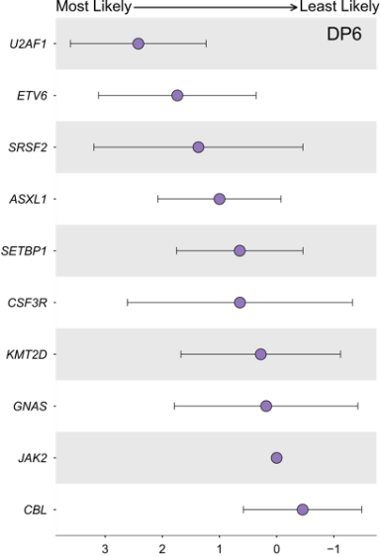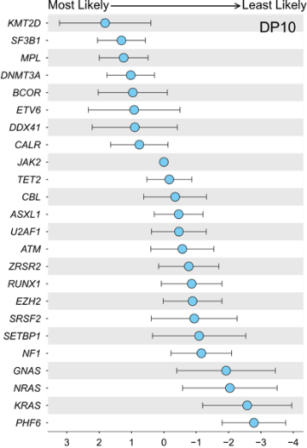

﻿
sFigure 9. Survival probability according to the newly defined genomic subgroups (Training set).
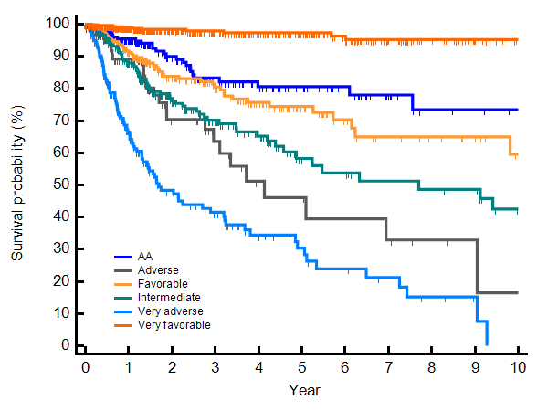
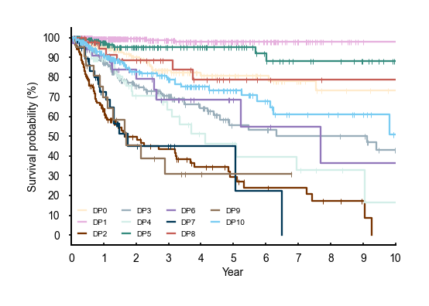
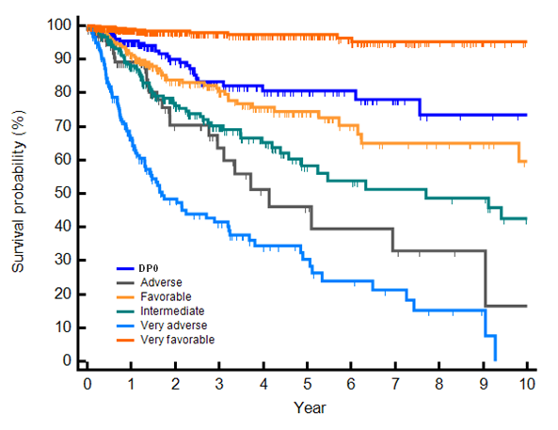
Risk groups
DP groups

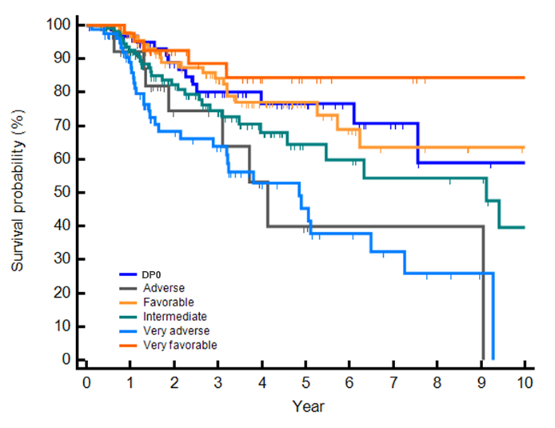
None-transplanted group
Transplanted group
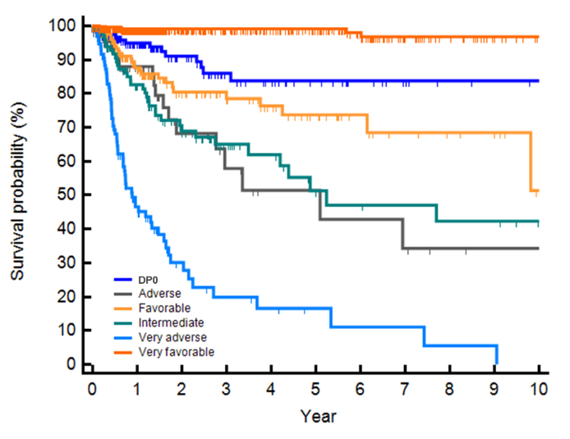

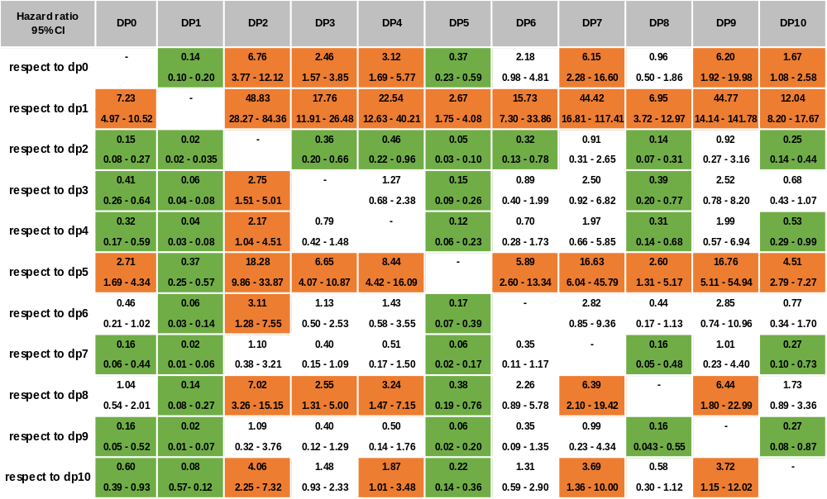

sFigure 10. Survival probability according to the newly defined genomic subgroups (Validation set).
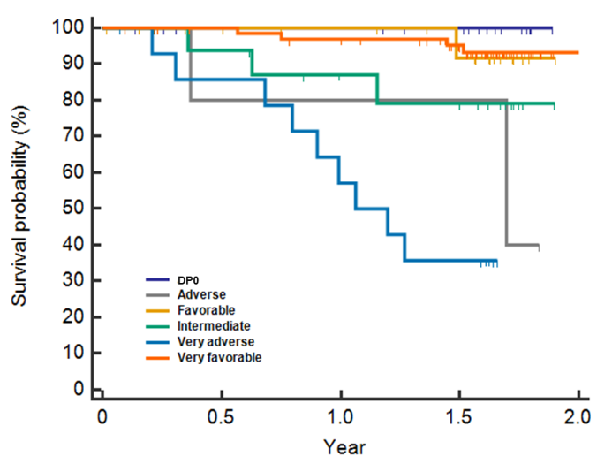
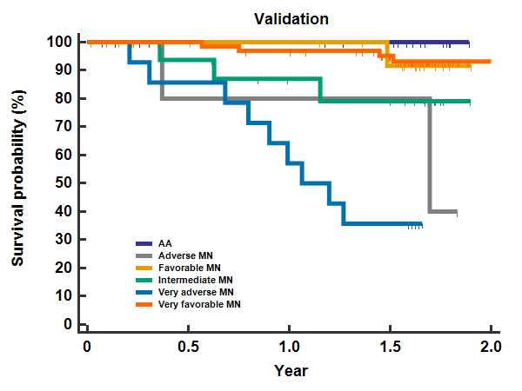
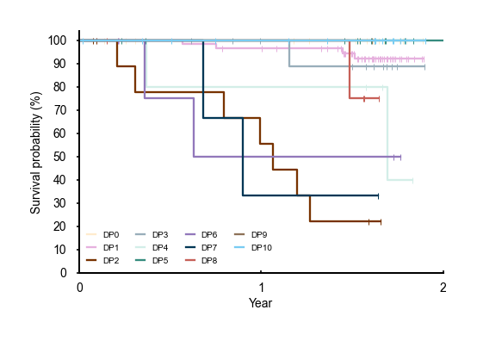
DP groups
Risk groups
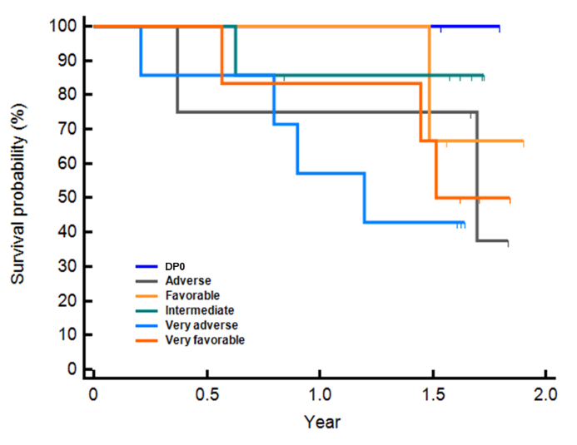
Transplanted group
Non-transplanted group
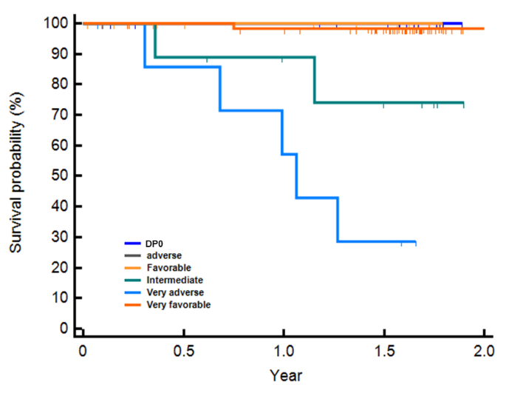

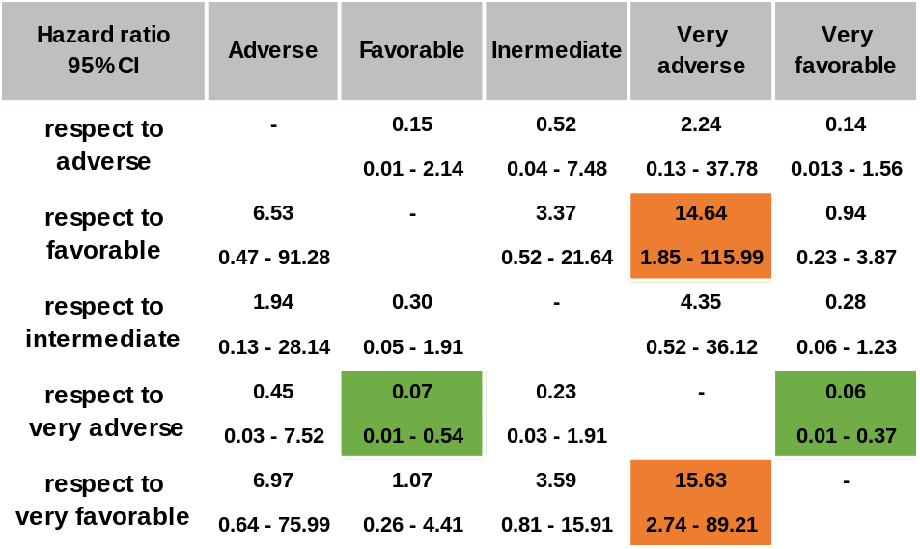

References

1. Lee J-M, Kim Y-J, Park S-S, Han E, Kim M, Kim Y. Simultaneous monitoring of mutation and chimerism using next-generation sequencing in myelodysplastic syndrome. J Clin Med. 2019; 8(12): 2077.

2. Lee J-M, Lee H, Eom K-S, Lee S-E, Kim M, Kim Y. Impact of integrated genetic information on diagnosis and prognostication for myeloproliferative neoplasms in the next-generation sequencing era. J Clin Med. 2021; 10(5): 1033.

3. Li MM, Datto M, Duncavage EJ, Kulkarni S, Lindeman NI, Roy S, et al. Standards and guidelines for the interpretation and reporting of sequence variants in cancer: a joint consensus recommendation of the Association for Molecular Pathology, American Society of Clinical Oncology, and College of American Pathologists. J Mol Diagn. 2017; 19(1): 4-23.

4. Horak P, Griffith M, Danos AM, Pitel BA, Madhavan S, Liu X, et al. Standards for the classification of pathogenicity of somatic variants in cancer (oncogenicity): joint recommendations of Clinical Genome Resource (ClinGen), Cancer Genomics Consortium (CGC), and Variant Interpretation for Cancer Consortium (VICC). Genet Med. 2022; 24(5): 986-998.

