Magnetic and Microwave Absorption Properties of Barium Hexaferrites synthesized by sol-gel method with addition of PMMA in various ratios

Serdar Gökçe
Department of Physics, Gebze Technical University, Gebze, Kocaeli, 41400, Turkey
E - mail address: sgokce@gtu.edu.tr

X-Ray Diffratction
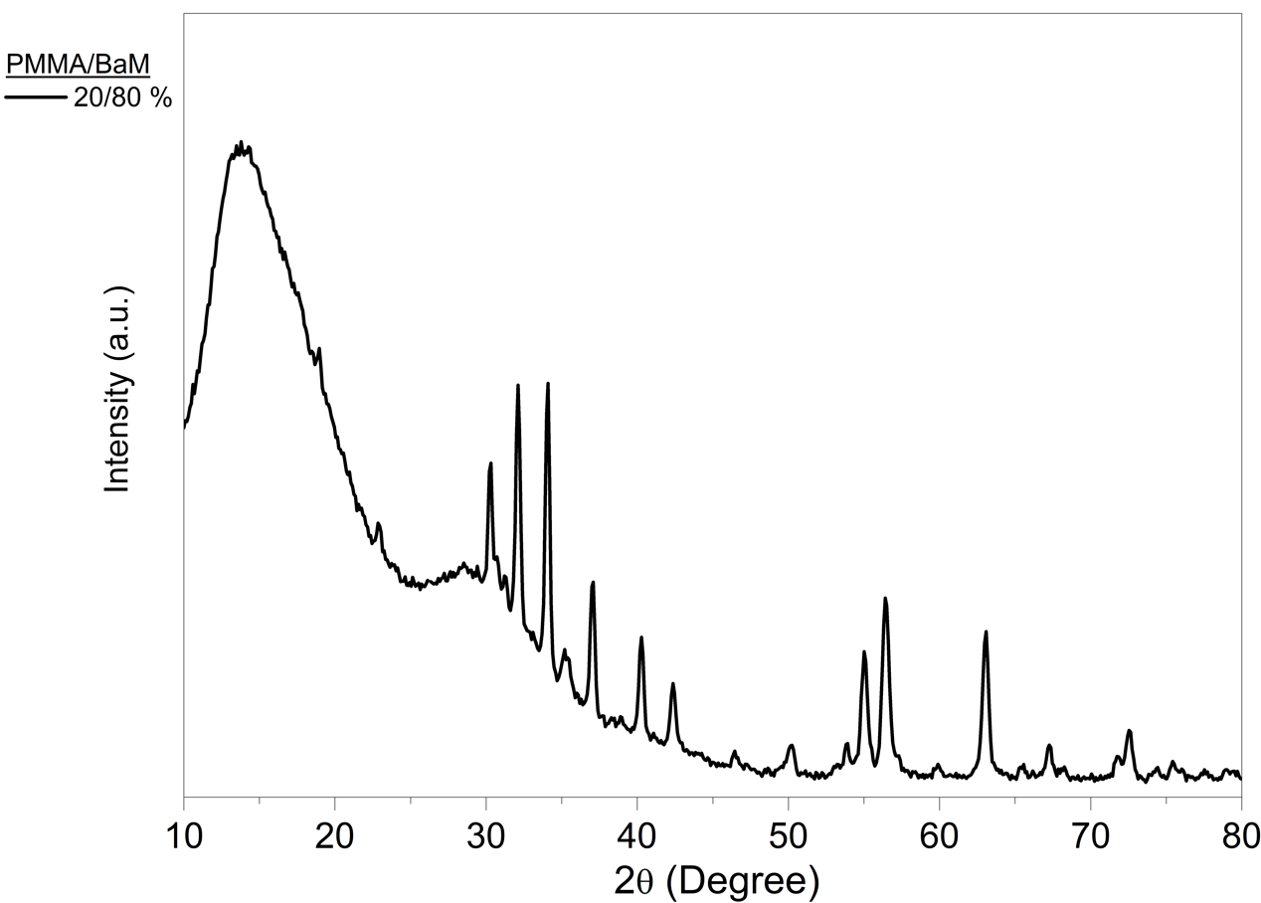
Fig. S1. XRD pattern of PB1 hexaferrite sample (PMMA/BaM ratio: 20/80 %).

