SUPPLEMENTARY MATERIALS FOR:

PET Imaging of Sphingosine Phosphate Receptor 1 with [¹⁸F]TZ4877 in Nonhuman Primates

Jiwei Gu^{1,3}, Ming-Qiang Zheng^{1,3}, Daniel Holden^{1,3}, Krista Fowles^{1,3}, Lin Qiu⁴, Zachary Felchner^{1,3}, Li Zhang^{1,3}, Jim Ropchan^{1,3}, Robert J. Gropler⁴, Richard E. Carson^{1,3}, Zhude Tu⁴, Henry Huang^{1,3}, Ansel T. Hillmer^{1,2,3}

¹Yale PET Center, Yale School of Medicine
²Department of Psychiatry, Yale School of Medicine
³Department of Radiology and Biomedical Imaging, Yale School of Medicine
⁴Mallinckrodt Institute of Radiology, Washington University School of Medicine in St. Louis

Contents:

Supplementary Figure 1: [¹⁸F]TZ4877 occupancy plots with cold TZ82112 blocking.

Supplementary Table 1: Cytokine Response to Endotoxin

Supplementary Table 2: [¹⁸F]TZ4877 Organ Residence Times

Supplementary Table 3: [¹⁸F]TZ4877 Absorbed Dose Estimates
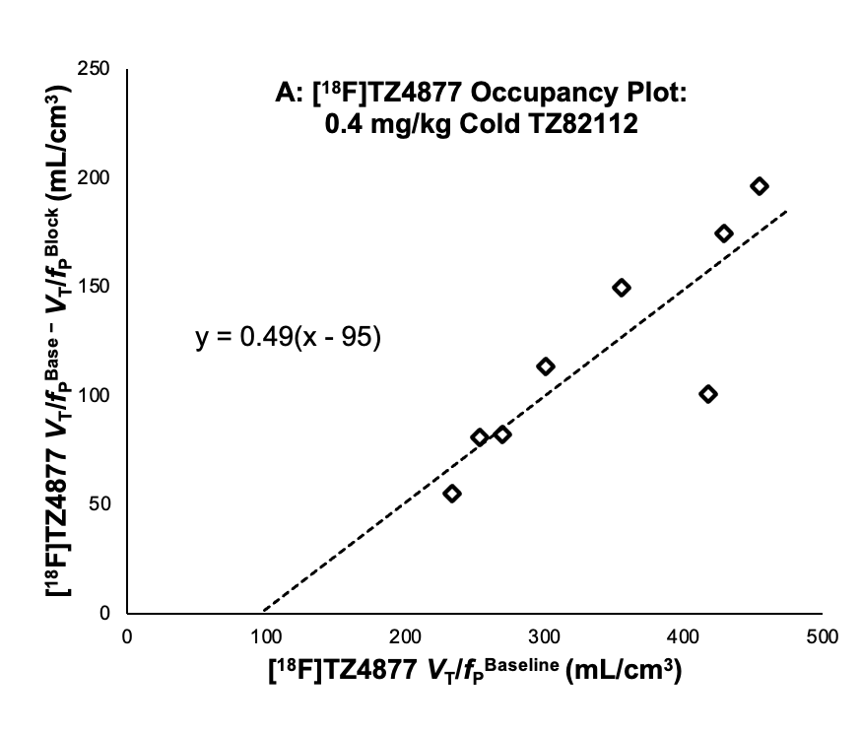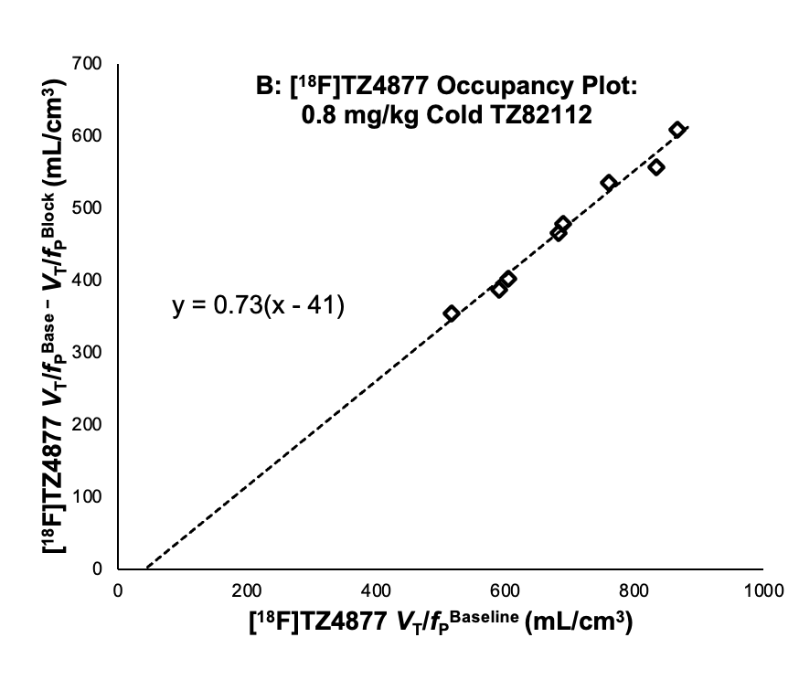

Supplementary Figure 1: [¹⁸F]TZ4877 occupancy plots with cold TZ82112 blocking. Optimal linear fit (dashed line) with estimated parameter values are shown. Cold TZ82112 dose-dependently reduced [¹⁸F]TZ4877 V_{T}/f_{P}. The S1PR₁-specific blocking drug TZ82112 was administered in doses of 0.4 mg/kg (A) and 0.8 mg/kg (B).

Supplementary Table 1: Cytokine concentrations measured relative to 1 ng/kg endotoxin dosing. Presented values are in pg. – indicates values below the detection limit of the assay panel.

 | TNF-𝝰 | IL-1𝝱 | IL-6 | IL-8 | IL-18 | IL-22 | IL-28A | MCP-1
M1 BL | 0.32 | 1.18 | 4.92 | 1.04E+05 | 93.04 | 17.84 | 54.10 | 91.06
M1 90 min | 2.65 | 1.06 | 6.78 | 8.45E+04 | 95.31 | 11.31 | 51.66 | 154.35
M1 180 min | 2.65 | 1.15 | 9.38 | 8.20E+04 | 110.15 | 17.39 | 55.10 | 886.85
M1 300 min | 1.88 | 1.29 | 10.28 | 1.16E+05 | 102.15 | 24.59 | 70.75 | 339.42
M2 BL | - | 0.18 | 1.12 | 3.39E+04 | 13.40 | 3.91 | 33.93 | 29.33
M2 90 min | 1.88 | 0.21 | - | 4.85E+03 | 14.47 | 4.84 | 27.75 | 48.90
M2 180 min | 1.87 | - | 1.77 | 4.49E+04 | 16.66 | 7.90 | 18.94 | 252.28
M2 300 min | - | - | 0.63 | 8.69E+03 | 10.76 | 8.27 | 18.94 | 114.49

Supplementary Table 2: [¹⁸F]TZ4877 Organ Residence Times, in h.
Organ | Male (h) | Female (h)
Brain | 0.070 | 0.067
Gall Bladder | 0.227 | 0.145
Heart | 0.036 | 0.028
Kidneys | 0.054 | 0.046
Liver | 0.912 | 1.000
Testes | 0.002 | n/a
Urinary Bladder | 0.021 | 0.010
Remainder | 1.30 | 1.326
Sum | 2.62 | 2.62

Supplementary Table 3: [¹⁸F]TZ4877 Absorbed Dose Estimates (in mSv/MBq)
 | Male | Female
Adrenals | 0.034 | 0.038
Brain | 0.013 | 0.014
Breasts | N/A | 0.010
Esophagus | 0.015 | 0.021
Eyes | 0.007 | 0.008
Gallbladder Wall | 0.416 | 0.314
Left colon | 0.013 | 0.016
Small Intestine | 0.013 | 0.016
Stomach Wall | 0.015 | 0.017
Right colon | 0.024 | 0.020
Rectum | 0.009 | 0.011
Heart Wall | 0.024 | 0.023
Kidneys | 0.046 | 0.051
Liver | 0.130 | 0.171
Lungs | 0.014 | 0.017
Ovaries | N/A | 0.011
Pancreas | 0.019 | 0.032
Prostate | 0.009 | N/A
Salivary Glands | 0.008 | 0.009
Red Marrow | 0.010 | 0.012
Osteogenic Cells | 0.009 | 0.010
Spleen | 0.011 | 0.015
Testes | 0.014 | N/A
Thymus | 0.011 | 0.013
Thyroid | 0.008 | 0.009
Urinary Bladder Wall | 0.018 | 0.014
Uterus | N/A | 0.011
Total Body | 0.011 | 0.016
Effective Dose | 0.020 | 0.023

