Supporting Information

Synthesis, Reaction Kinetics and Properties of Aromatic Hyperbranched Polyesters of different Generations (G1 to G4) prepared via One-shot Solution Polycondensation

Ramadasu Gunasekhar^{1,‡}, Balaraman Indumathy^{1,‡}, Prasad Gajula²,
Jin Woo Bae^{2,**}, Arun Anand Prabu^{1,*}
¹Department of Chemistry, School of Advanced Sciences, Vellore Institute of Technology, Vellore 632014, Tamil Nadu, India
²Multifunctional Organic Polymer Laboratory, Future Convergence Engineering, School of Energy, Materials and Chemical Engineering, Korea University of Technology and Education, 1600, Chungjeol-ro, Cheonan 31253, Republic of Korea
*Correspondence E-mail: anandprabu@vit.ac.in (A.A.P); **Co-Correspondence E-mail: jwbae@koreatech.ac.in (J.W.B)
‡R.G. and B.I. have contributed equally to this work.

Table S1. Integrations of ¹H-NMR spectra of Ar.HBPs (G1-G4)
H atom  (Proton Position) | Chemical Shift (ppm)
H atom  (Proton Position) | Ar.HBP-G1 | Ar.HBP-G2 | Ar.HBP-G3 | Ar.HBP-G4
a. (-CH₃) | 1.9 | 2.1 | 2.3 | 2.8
b. (-CH₂-) for (CH₂-O-C=O) | 3.4 | 3.4 | 3.4 | 3.4
c. (-CH₂-) for (CH₂-OH) | 4.0 | 4.0 | 4.1 | 4.1
d. Ar.(-CH₂-) | 6.6 | 6.6 | 6.7 | 6.7
e. Ar.(-CH₂-) | 6.8 | 6.8 | 6.9 | 6.9
f. Ar.(-OH) | 9.2 | 9.2 | 9.2 | 9.2
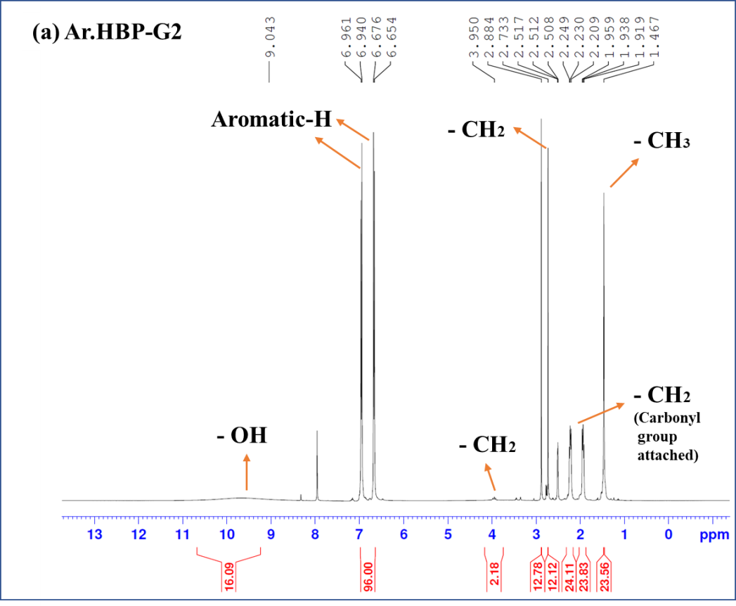
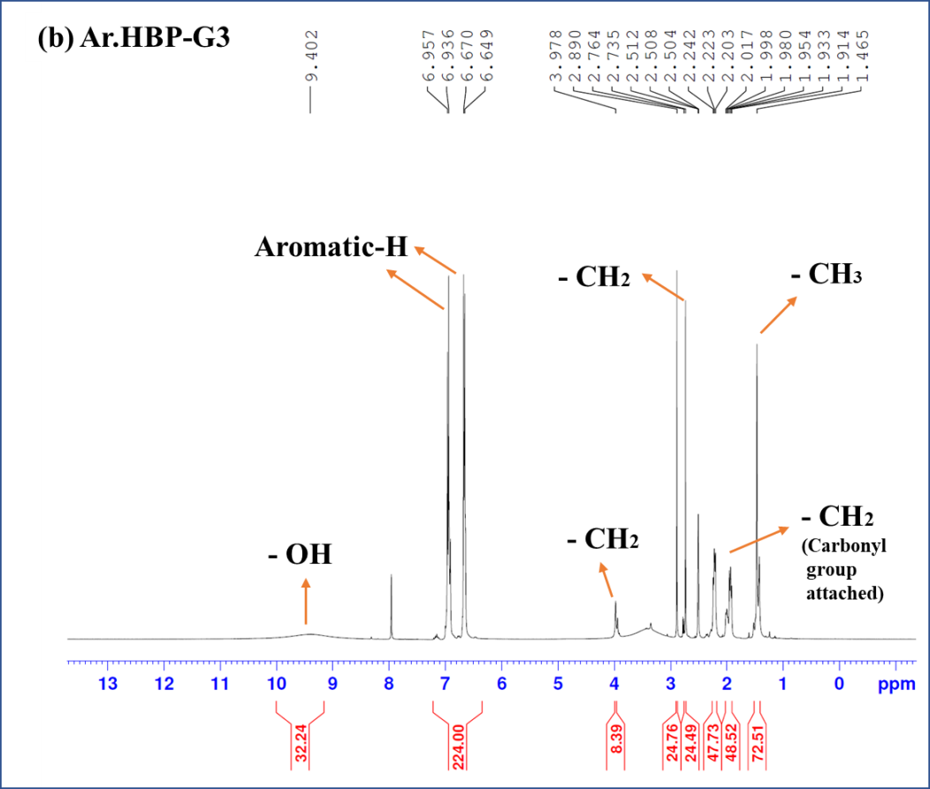
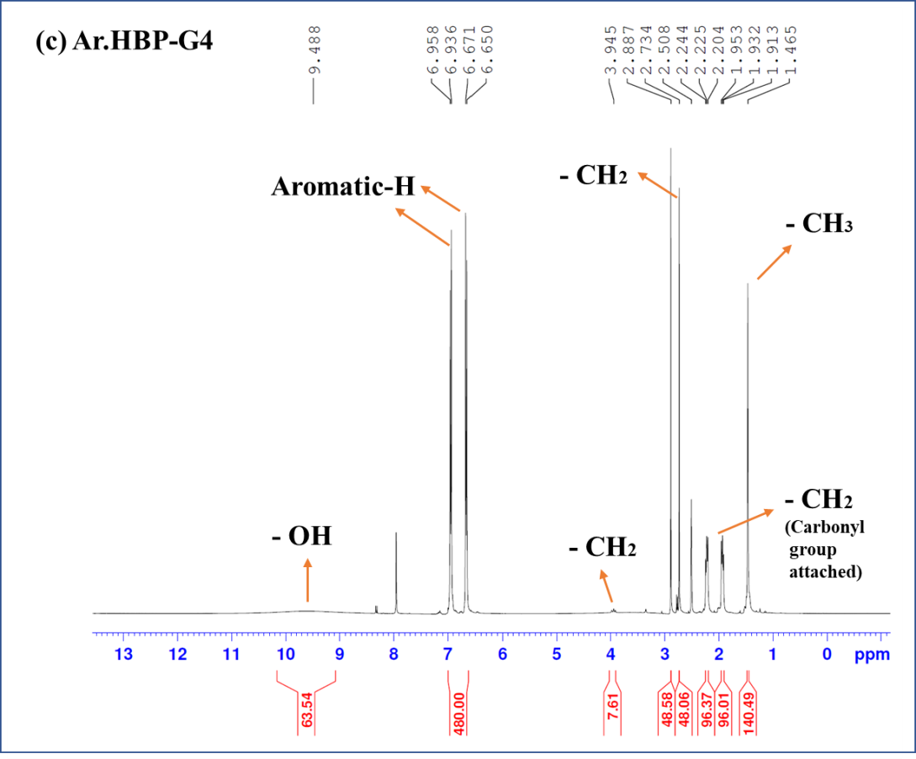
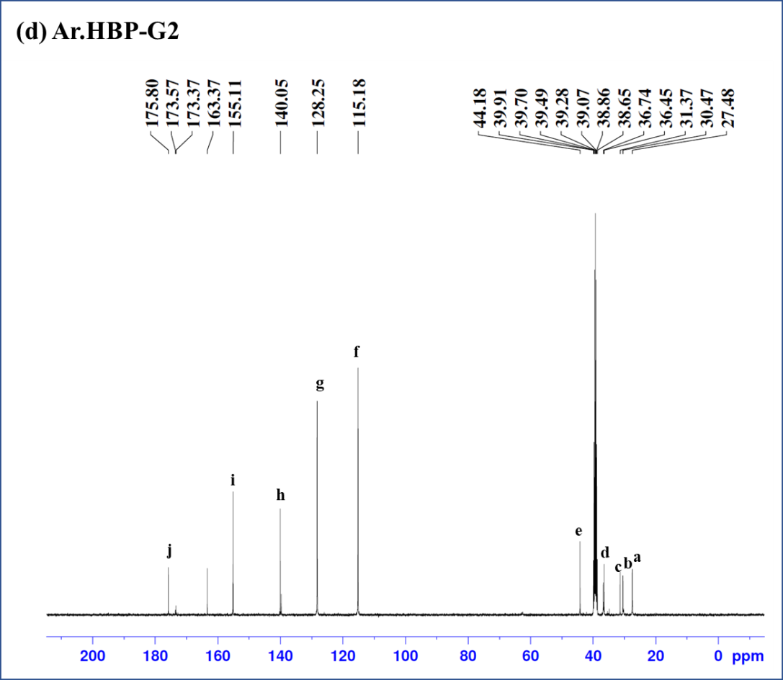
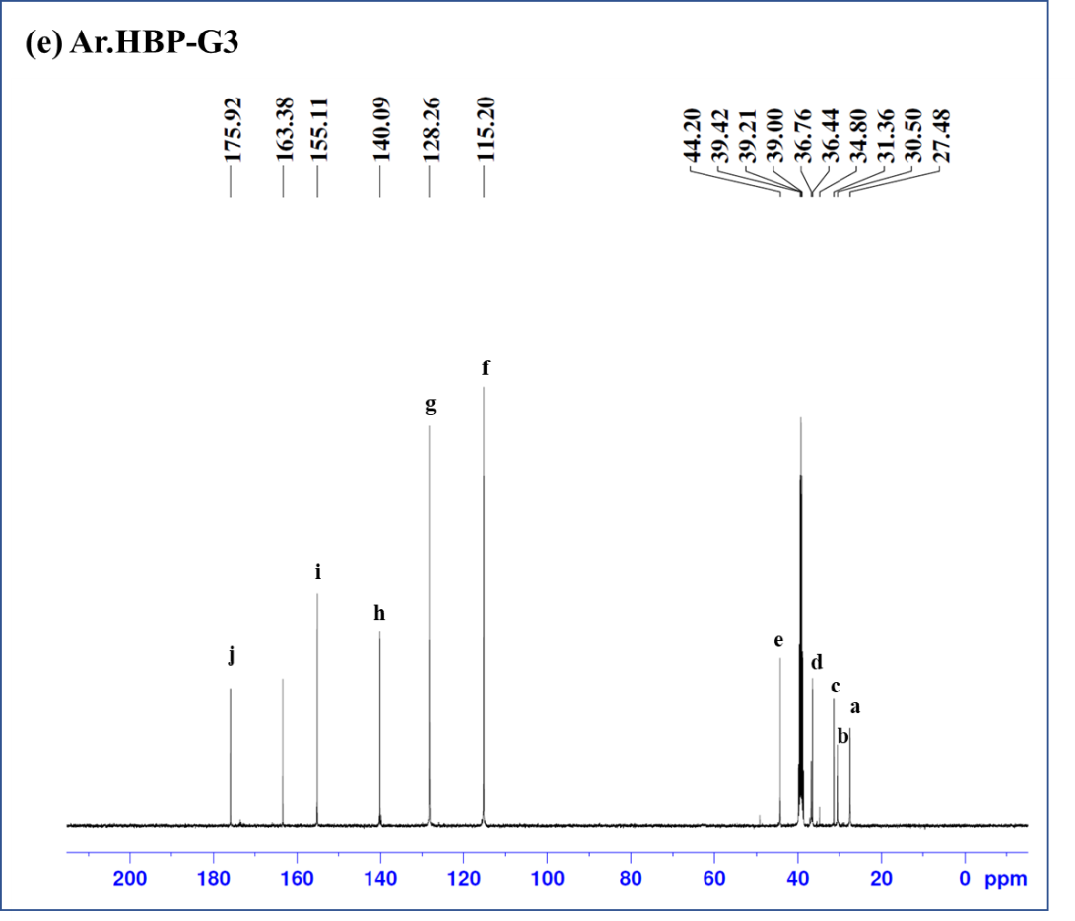
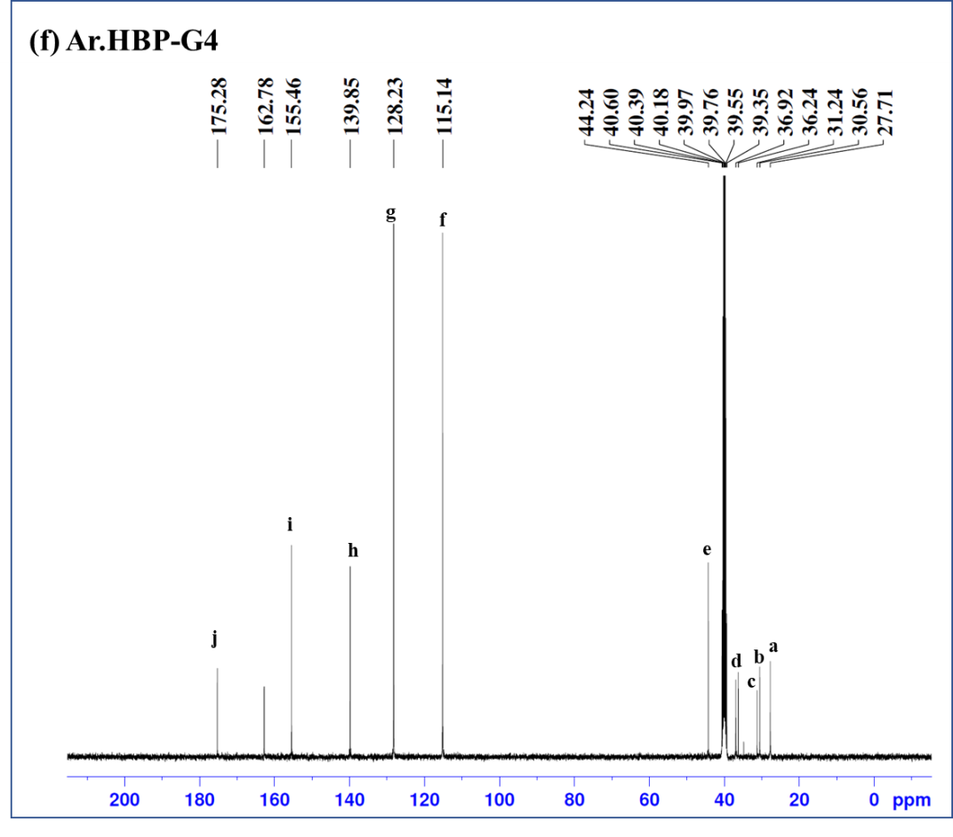
Figure S1. (a-c). ¹H-NMR spectra of Ar.HBPs (G1–G4) and (d-f). ¹³C-NMR spectra of Ar.HBPs (G1–G4).
Polymerization reaction kinetics of Ar.HBPs:
Table S2: FTIR transmittance data of acid and ester carbonyl peaks as a function of reaction time and ester-to-acid peak ratio for Ar.HBP-G1.

Reaction Time (h) | Transmittance % |  | 1706/1648 (cm⁻¹) ratio
Reaction Time (h) | Acid C=O, 1648 cm⁻¹ | Ester C=O, 1706 cm⁻¹ | 1706/1648 (cm⁻¹) ratio
3 | 93.15 | 72.56 | 0.7789
5 | 91.39 | 71.05 | 0.7774
9 | 88.88 | 71.05 | 0.7993
13 | 79.09 | 81 | 1.0241
15 | 69.72 | 85.36 | 1.2243
19 | 46.89 | 93.4 | 2.0133
21 | 40.45 | 95.16 | 2.3525
23 | 40.69 | 95.91 | 2.3570

Table S3: FTIR transmittance data of acid and ester carbonyl peaks as a function of reaction time and ester-to-acid peak ratio for Ar.HBP-G2.
Reaction Time (h) | Transmittance % |  | 1707/1648 (cm⁻¹) ratio
Reaction Time (h) | Acid C=O, 1648 cm⁻¹ | Ester C=O, 1707 cm⁻¹ | 1707/1648 (cm⁻¹) ratio
3 | 93.75 | 71.56 | 0.7774
5 | 91.49 | 71.89 | 0.7789
9 | 87.88 | 72.25 | 0.7897
13 | 79.59 | 81.34 | 1.0344
15 | 68.12 | 86.16 | 1.2286
19 | 45.59 | 93.56 | 2.0145
21 | 40.11 | 95.34 | 2.3509
23 | 39.34 | 96.11 | 2.3680
25 | 37.69 | 102.4 | 3.1345
29 | 37.55 | 102.76 | 3.1409

Table S4: FTIR transmittance data of acid and ester carbonyl peaks as a function of reaction time and ester-to-acid peak ratio for Ar.HBP-G3.
Reaction Time (h) | Transmittance % |  | 1709/1648 (cm⁻¹) ratio
Reaction Time (h) | Acid C=O, 1648 cm⁻¹ | Ester C=O, 1709 cm⁻¹ | 1709/1648 (cm⁻¹) ratio
3 | 93.66 | 71.36 | 0.7755
5 | 91.19 | 71.59 | 0.7799
9 | 86.28 | 72.52 | 0.7879
13 | 78.76 | 82.45 | 1.0324
15 | 68.12 | 86.96 | 1.2268
19 | 44.65 | 93.26 | 2.0154
21 | 40.17 | 95.44 | 2.3418
23 | 39.43 | 96.91 | 2.3862
25 | 37.97 | 102.54 | 3.1463
29 | 35.55 | 104.2 | 3.8944
31 | 35.27 | 104.76 | 3.8777

Table S5: FTIR transmittance data of acid and ester carbonyl peaks as a function of reaction time and ester-to-acid peak ratio for Ar.HBP-G4.
Reaction Time (h) | Transmittance % |  | 1711/1648 (cm⁻¹) ratio
Reaction Time (h) | Acid C=O, 1648 cm⁻¹ | Ester C=O, 1711 cm⁻¹ | 1711/1648 (cm⁻¹) ratio
3 | 92.99 | 71.22 | 0.7699
5 | 91.29 | 71.76 | 0.7723
9 | 85.82 | 72.45 | 0.7845
13 | 79.87 | 83.21 | 1.0442
15 | 68.31 | 87.32 | 1.2245
19 | 45.22 | 92.98 | 2.0324
21 | 40.66 | 95.67 | 2.3397
23 | 39.76 | 97.12 | 2.3797
25 | 37.13 | 101.99 | 3.1411
29 | 35.74 | 104.67 | 3.8886
31 | 34.27 | 108.46 | 4.2587
33 | 34.11 | 108.76 | 4.2954

