Table 3. Conditional (fixed) logit model results for pregnant women attending ANC/PMTCT services

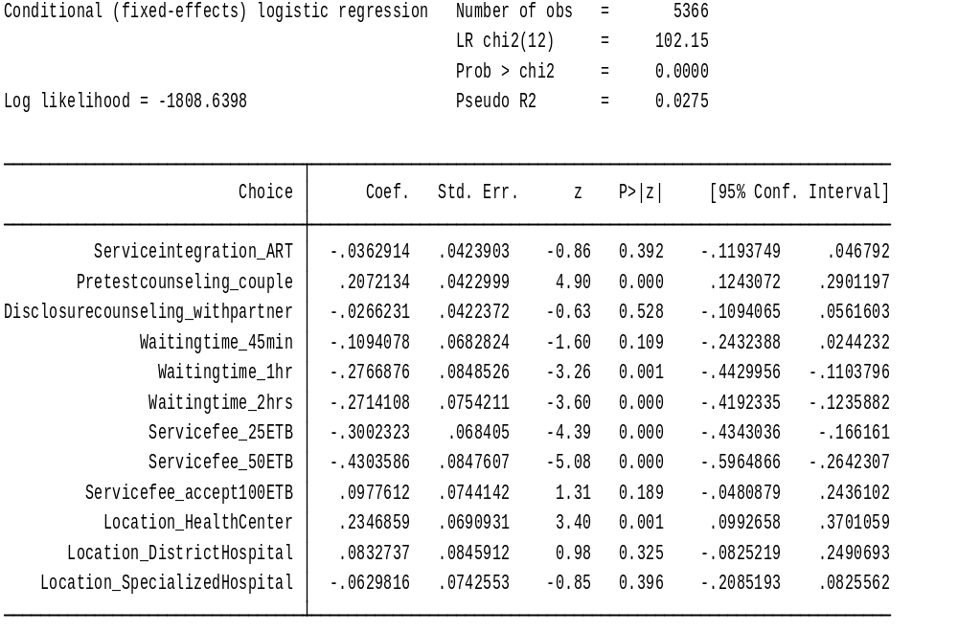

Table 4. Conditional (fixed) logit OR of pregnant women attending ANC/PMTCT services

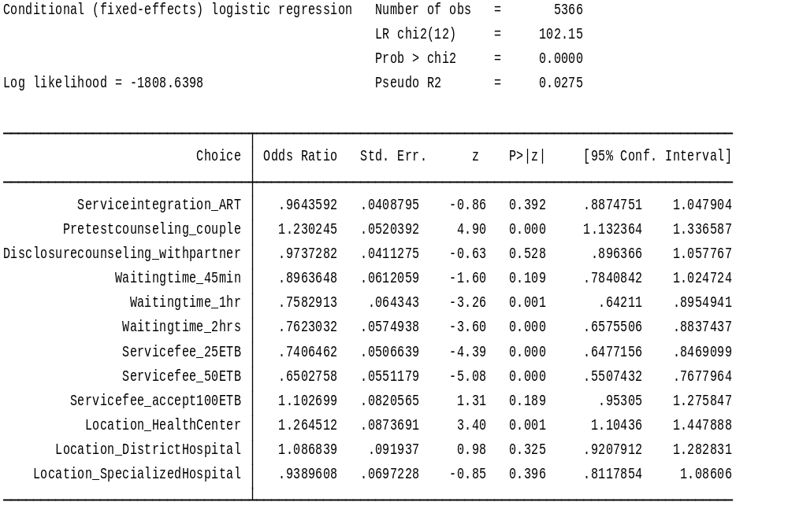

Table 5. Random effect regression model results for the interaction variable: urban high-HIV prevalence and rural low-HIV prevalence settings

