Figure S1: Control for Immunohistochemistry of pituitary adenomas. Immunohistochemical (IHC) staining for OGT and OGA of a post-mortem normal pituitary gland. Secondary antibody-only IHC also provided a negative control for all IHC staining shown in this article.
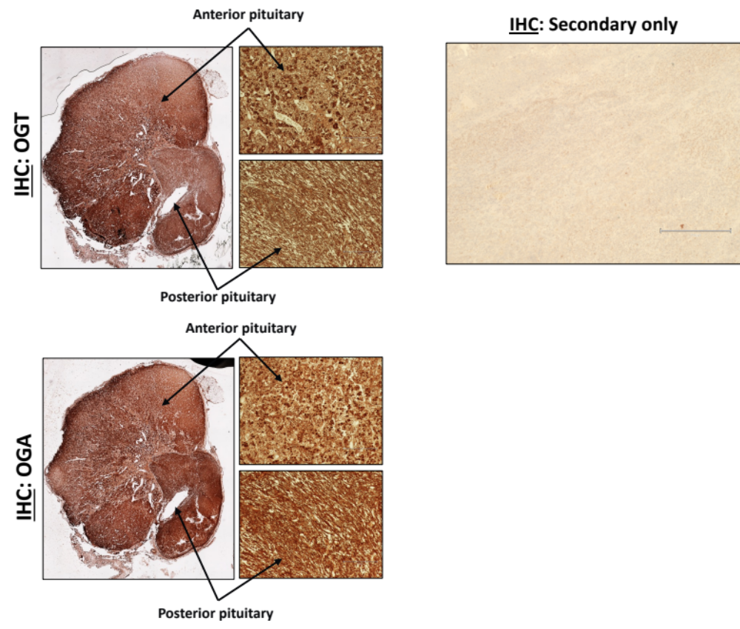

SUP TABLES
Table S1: Clinical characteristics of pituitary adenomas analyzed in this study.
Table S2: Alignment table statistics of RNA-sequencing.
Table S3: Differential expression genes in TPIT-positive vs. TPIT-negative Non-Functioning (NF) pituitary adenomas (Analysis A).
Table S4: Differential expression genes in TPIT positive Functioning (ACTH-secreting) vs. Non-Functioning (NF) corticotroph adenomas (Analysis B).
Table S5: Gene Ontology analysis of genes significantly deregulated in analysis A.
Table S6: Gene Ontology analysis of genes significantly deregulated in analysis B.
Table S7: Genes significantly correlating with OGT in functioning corticotroph adenomas. Pearson correlation was used.
Table S8: Genes significantly correlating with OGT in non-functioning gonadotroph adenomas. Pearson correlation was used.
Table S9: Gene Ontology analysis of genes significantly correlating with OGT in functioning corticotroph adenomas.
Table S10: Gene Ontology analysis of genes significantly correlating with OGT in non-functioning gonadotroph adenomas.

