Supplementary Materials
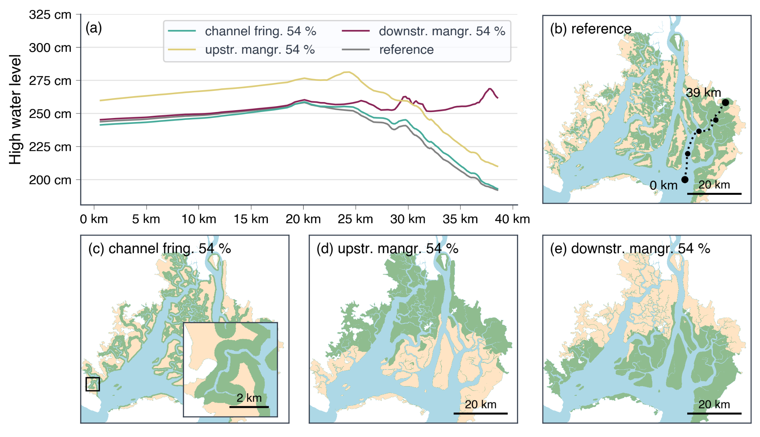
Figure S1 | High water level profiles along a longitudinal transect in the eastern branch for an extreme sea level event during El Nino (a) along a transect in the western branch (b) for the 54 % channel fringing scenario (green line; pattern shown in c), upstream concentrated mangroves (yellow line; pattern shown in d), downstream concentrated mangroves (green line; pattern shown in e) for the scenario with current mangrove extent (grey line; pattern shown in b). All water levels are referenced to the XGM2019 geoid.

High water level profiles in the mangroves for the different channel fringing scenarios show the largest differences between mangrove coverage scenarios for more extreme sea levels (figure 5). For all considered sea levels, the 25 % mangrove coverage scenario results in the highest water levels in the 200 m nearest to the channels. For the neutral spring tide, high water levels in the first 400 m are very similar for all mangrove coverages but the 25 % scenario. For the + 60 cm scenario, high water levels from the 25 % and 50 % scenario are higher in the first 400 m but high water levels from the 75 % and all mangroves scenarios are different. In case of the + 120 cm sea level scenarios, high water levels from the 25 % scenario are substantially higher than other scenarios. Other scenarios show similar high water levels along the first 200 m and divert further from the channel.
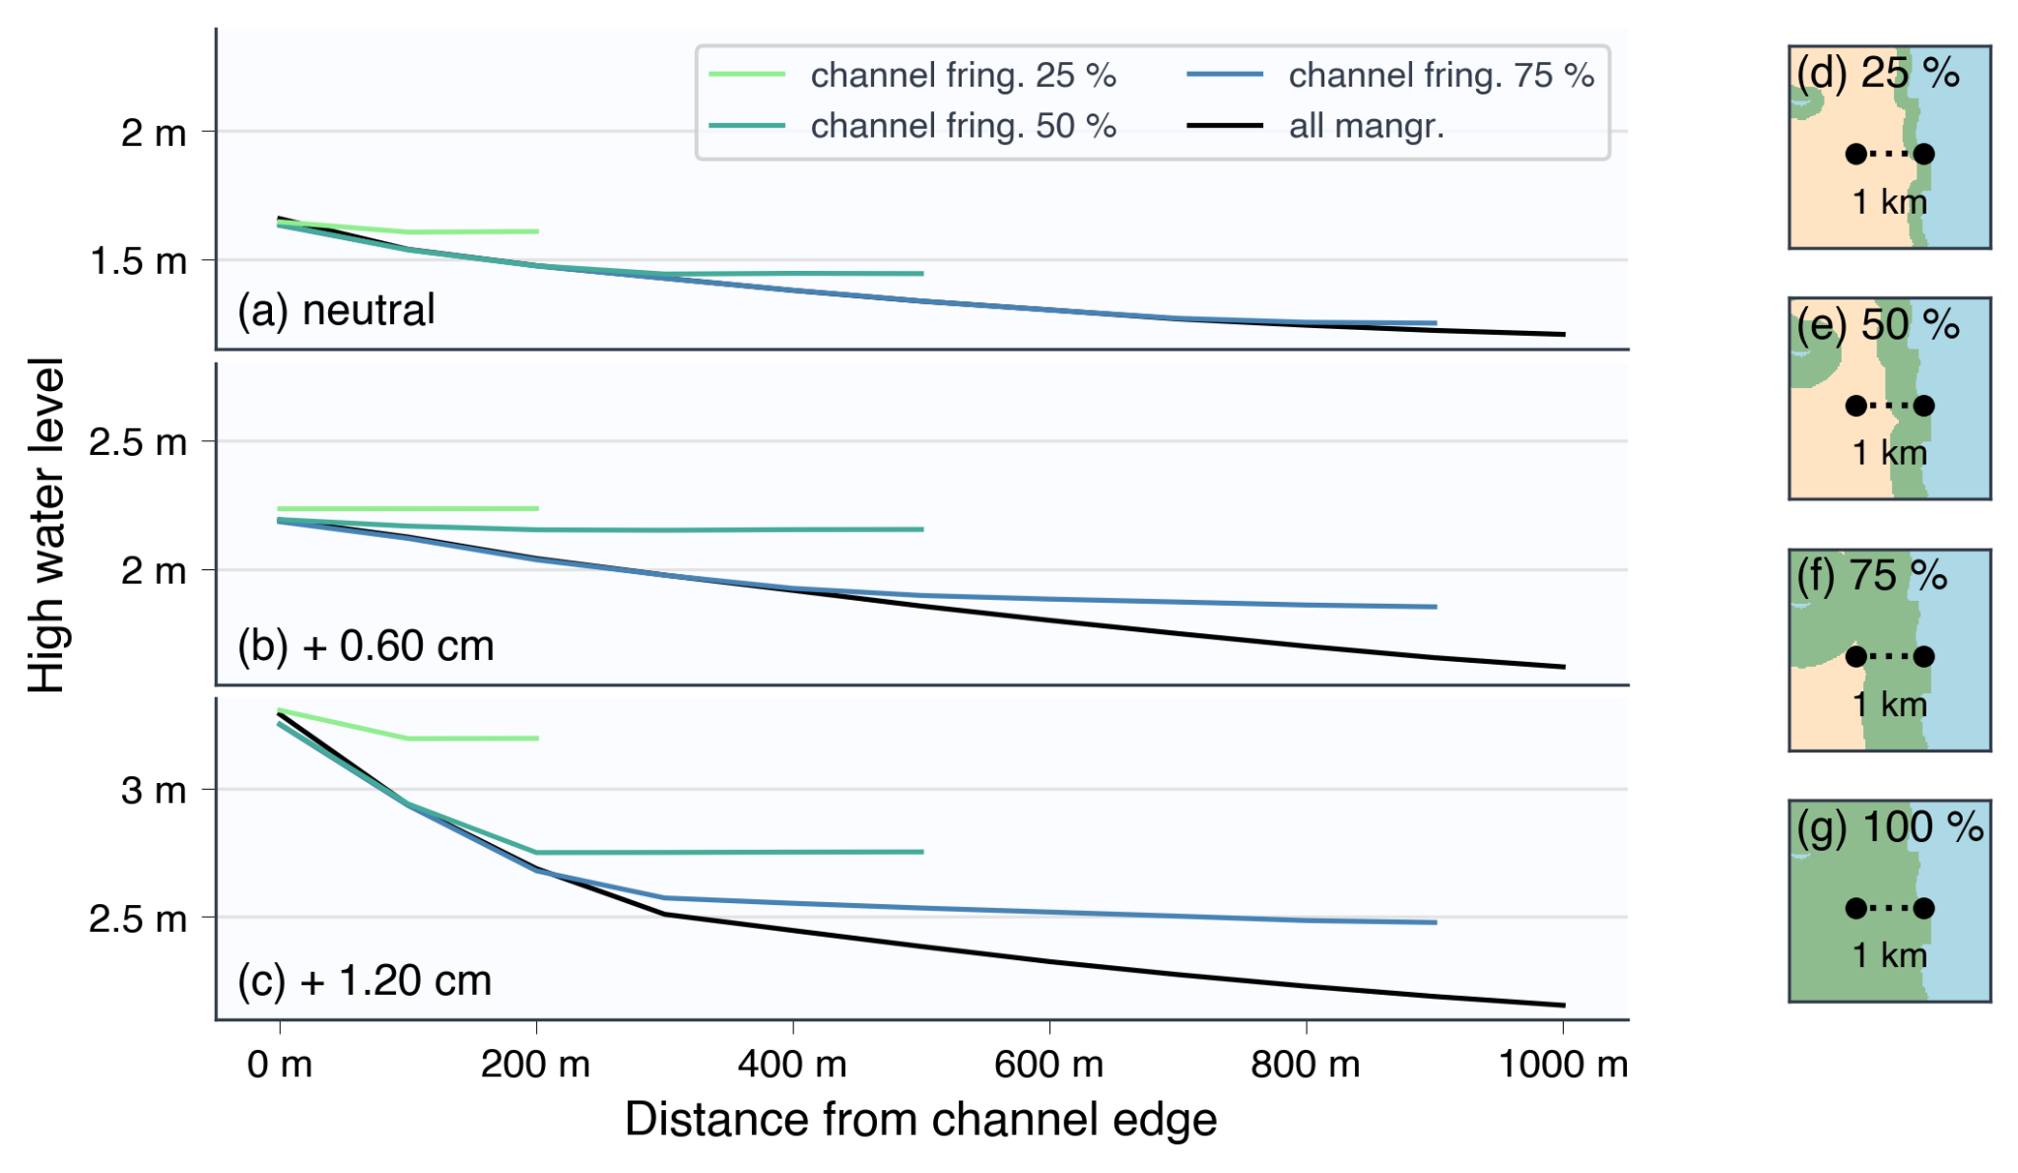
Supplementary figure 2 | High water level profiles along a representative profile into the mangroves for all channel fringing scenarios in case of neutral sea level conditions (a), an El Niño event with a spring tide 60 cm higher than neutral conditions (b) and an extreme El Niño event with a spring tide 120 cm higher (c). The channel fringing scenarios with 25 % (d), 50 % (e) and 75 % (f) mangrove coverage correspond to a mangrove width of 200 m, 500 m and 900 m respectively. For the all mangrove scenario (g), mangroves extend further inland than 1 km. Mangrove platform elevation is approximately equal over all scenarios with local elevation ranging between 1.12 and 1.16 m. All water levels are referenced to the XGM2019 geoid.
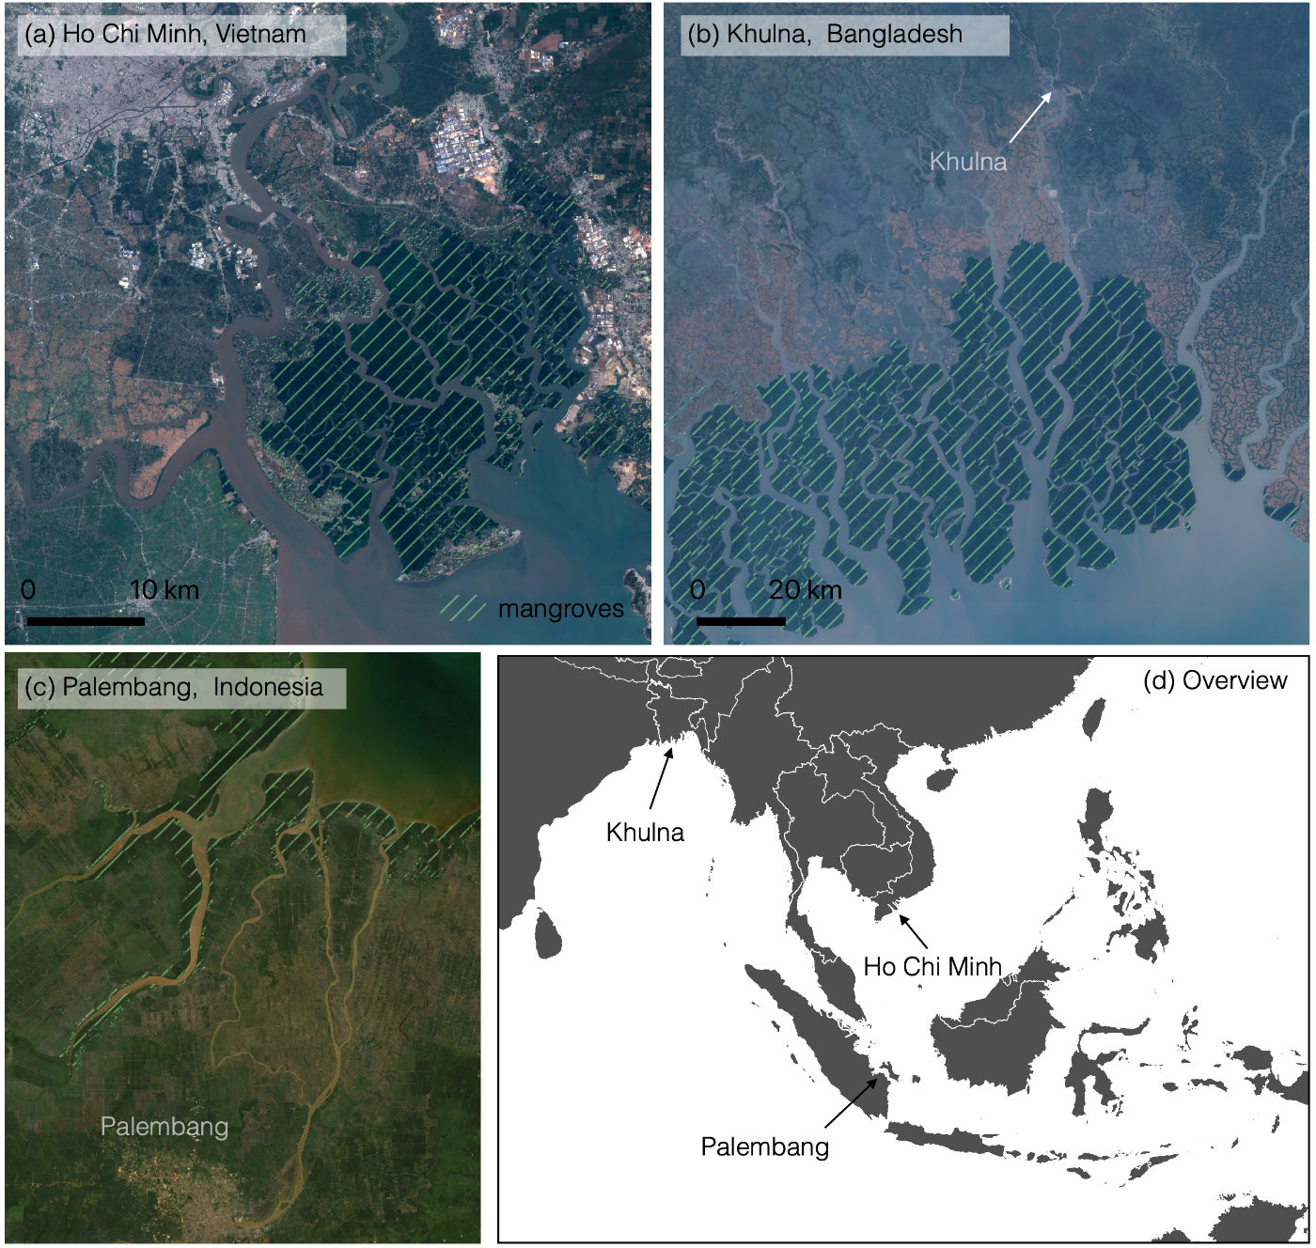Supplementary figure 3 | Overview of funnel-shaped estuaries which house some of the world’s top 10 most impacted cities due to coastal flooding (Hallegate et al. 2013) and are currently sheltered from the open ocean by large areas of mangroves: Ho Chi Minh (Vietnam), ranked 4th (a); Khulna (Bangladesh), ranked 8th (b) and Palembang (Indonesia), ranked 9th (c).
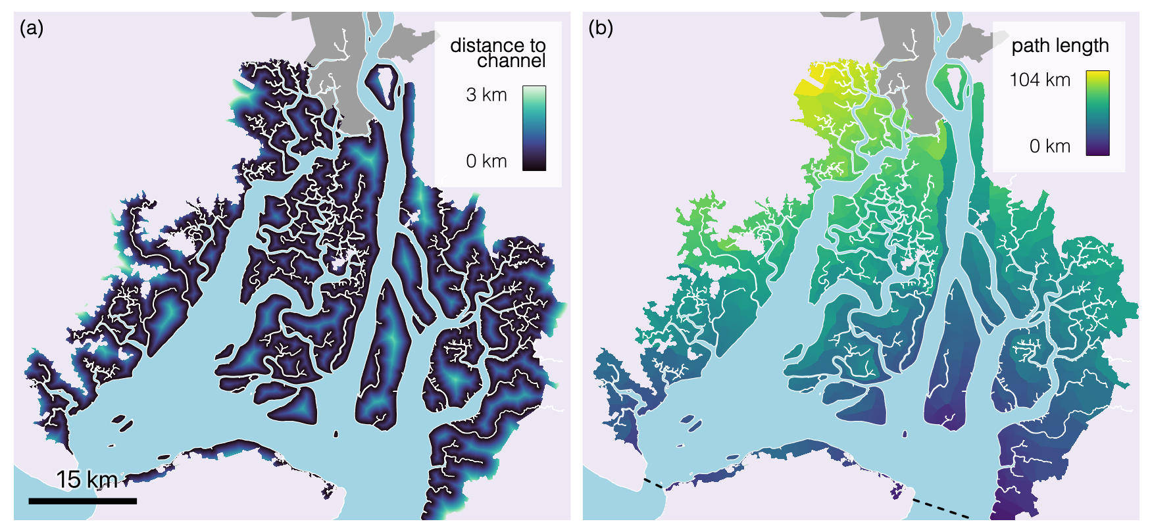
Supplementary figure 4 | Map of the distance to the nearest channel (a) and the total path length (b). The latter is calculated by summing the distance to the nearest channel (panel a) and the shortest distance along the channel to the mouth of either the western or eastern branch of the delta (dashed black lines).

