Supplementary information for Dynamic piezoelectric MEMS-based acoustic attenuators
Runar P. Dahl-Hansen*¹, Olav Kvaløy², Firehun Tsige Dullo¹, and Tom Trones²
*¹Smart Sensors and Microsystems, SINTEF Digital, Forskningsveien 1, 0373 Oslo, Norway
²Minuendo AS, Kongens gate 3, 0153 Oslo, Norway
*Corresponding author: runard@sintef.no

Additional information

Device-design
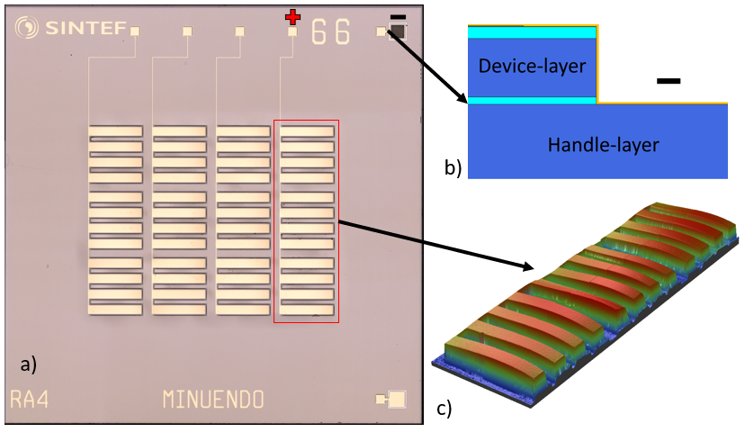
Figure S 1: Chosen device-geometry for this work. A microscope image of a die with a 1000 [µm] cantilever-array is shown in a). b) schematically show the reactive ion etching and handle-wafer contacting strategy used to ensure smooth cantilever-motion upon actuation, while c) show a 3D WLI scan of the indicated cantilever-column in a), highlighting typical minor variations occurring across a die.
Figure S 1 shows one tested device with 1000 [µm] long cantilevers, showing the positive top and negative bottom electrodes. Conceptually highlighting, b) shows where the device-layer has been etched by reactive ion etching through the device layer to contact the handle. This is done to ground the structure and make sure that the bottom Si-part of the cantilever sees the same potential as the bottom Pt electrode upon actuation, to avoid stiction. Applying an electric field thus gives an additional electrostatic repulsion of the cantilever-tip from the step edge, ensuring that the device opens smoothly, also at lower voltages. All cantilevers are etched free using reactive ion etching (Bosch-process) through the backside handle wafer, and frontside device layer. The cantilever release from the step-edge along the periphery, is done using vapor hydrofluoric acid from the backside, to etch away the 1 µm thick buried SiO₂. After etching away the box-layer, the cantilevers curve down because of the built-in compressive stress of the SiO₂. c) shows a white light interferometry measurement (WLI) of the indicated array in the microscopy image at 0 [V] bias, the downward cantilever bending clearly visible.

Coupler LPM calibration
For the verification of the piezoMEMS components we use a simple measurement coupler. The LPM of such a coupler will be equally simple and results relative precise. The coupler itself is measured before adding the device under test (DUT). This acts as a calibration of the measurement system and the LPM of the coupler. By keeping the measurement situation simple, the added LPM-component defining the DUT is easy to derive.
In our project the measurement coupler is an undamped hard walled cylinder (see Figure 2). The cylinder has a length of 30mm and a diameter of 8mm. This gives the coupler the resemblance of the dimensions of an ear.
As mentioned, the process starts with a calibration measurement of the coupler alone. The results are compared to LPM simulations of the same. The specific parameters in the LPM is computed by putting the physical dimensions of the coupler into formulas (7), (8) and (9). In this work the Spice-clone Tina-TI ²² from Texas Instruments is used to model the responses.
To get the model precise the acoustic impedance of the circular opening of the coupler must be added to the model. When the DUT is introduced to this simple model, this is done simply to add a resistor. For the simulation of the coupler alone the component values are:
Table S 1: Component values ref. Figure 3 (a).
Component | Value | Component (Transmission Line) | Value
L1 | 70 [H] | l tl | 30E-3 [m]
R1 | 4.2 [M$Ω$] | R tl | 189 [k$Ω$]
R3 | 80 [M$Ω$] | L tl | 23 [kH]
C1 | 2.1 [fF] | Ctl | 380 [pF]

The R₃ is of course omitted (or set to zero) since there are no DUT present. Both temperature and humidity will alter the component values slightly.
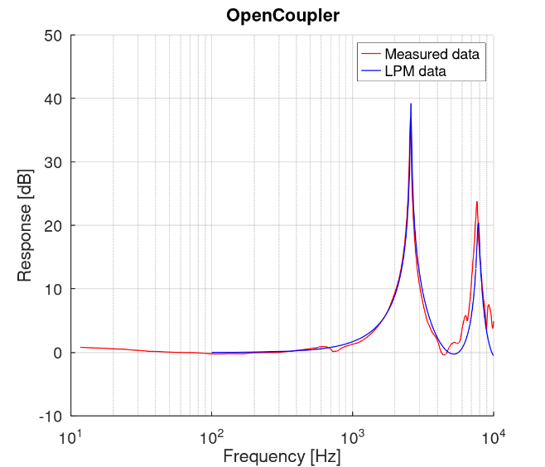
Figure S 2: Measurements and simulations of the open coupler, without the DUT.
Within the model, the measurement coupler has only one primary component: the 30 mm long transmission line. The rest of the components in the LPM represent the acoustic impedance of the 8 mm diameter opening. The latter are important when modelling the coupler alone because they represent major loss factor to an otherwise almost lossless system. When the DUT is measured, the values of the radiation impedance when operating the DUT should ideally change, since the slit opening changes, but I choose to keep it constant as the acoustic impedance is almost negligible relative to the DUT.
The most prominent peak is the quarter wavelength resonance of the closed/open coupler. The measured (and simulated) resonance peak is slightly lower than this ¼ wavelength frequency due to the inductive part of the acoustic impedance of the opening.
The excellent alignment between the measurements and the LPM-simulations indicate the models validity.

Piezoelectric and ferroelectric thin film characteristics
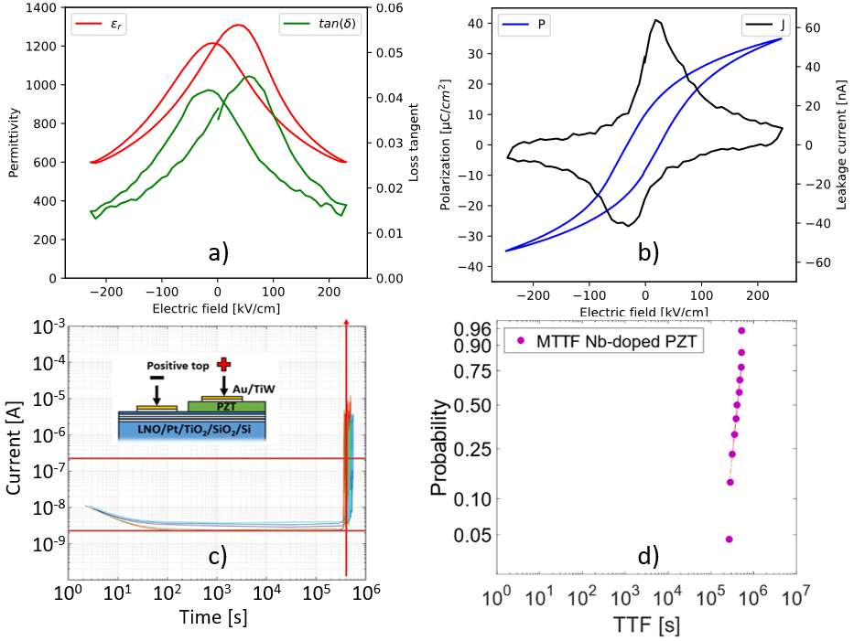
Figure S 3: Permittivity (red) and dielectric loss (green) in a), ferroelectric hysteresis (blue) and potentiostatic IV-curve (black) in b) for the PZT-films used in this work. c) shows the HALT current vs time measurement for a sample set of 12, indicating the 100x increase in leakage failure condition. d) shows the failure probability distribution of the 12 tested devices, indicating the Weibull-fitting in red dotted lines.
Figure S 3 shows measurements of the permittivity and dielectric loss (a), ferroelectric hysteresis and potentiostatic leakage current density (b), of the dies used in this work. 2 gives the average values for the polarization at 30 V (P_{30 V}), remnant polarization (P_{R}), coercive field (E_{C}), breakdown strength (BDS), median time-to-failure (MTTF), relative permittivity at 0 V ($ε_{r,0V}$), and dielectric loss tangent ($tan⁡(δ)$) and their standard-deviations for 12 samples measured across 3 wafers. All measured values indicate that the films are well-processed and in the range of expected theoretical and experimental values for Nb-doped PZT thin films^{36–38}.
Highly accelerated lifetime testing (HALT) was here done at T=175ºC and E=150 kV/cm. In HALT the leakage as a function of time at a given electric field and temperature is measured. Device-failure is defined by a 100x increase in the leakage-current relative to the base-level in the absence of capacitive, and ferroelectric currents (Curie-von Schweidler law) and manifests itself as a rapid increase in leakage after a period of electrical degradation. The failure probability-distribution is defined by:
$$\begin{aligned}P_{f}\left(t\right)=1-e^{-{\left(\frac{t}{α}\right)}^{β}}\#\left(S1\right)\end{aligned}$$
where t is the time-to-failure, $β$ the Weibull Modulus and $α$ the Weibull scale, i.e., the reported median time to failure (MTTF).
Generally, the tests are designed to accelerate known degradation-mechanisms of chemical defects, positively charged oxygen vacancies ($V_{O}^{∙∙}$) and negatively charged lead vacancies ($V_{Pb}^{''}$) in particular, driven towards the cathode and anode respectively, by the applied electric field. These are chemical defects inherent in the current thin film composition; Pb(Zr_{0.52}Ti_{0.48})_{0.98}Nb_{0.02}O₃, of which the use of oxide electrodes (here LaNiO₃), are incorporated into the layer-stack to decrease the degradation-rate. Defect-accumulation eventually leads to charge-injection and electrical breakdown. Well-processed, (001)-oriented PZT-films with controlled stoichiometry, however, should possess high activation-energies for defect-migration, thus resulting in long electrical lifetimes. The Eyring equation:
$$\begin{aligned}\frac{t_{1}}{t_{2}}={\left(\frac{V_{2}}{V_{1}}\right)}^{n}e^{\frac{E_{A}}{k}\left(\frac{1}{T_{1}}-\frac{1}{T_{2}}\right)}\#\left(S2\right)\end{aligned}$$
can be used to extrapolate the electrical lifetime to a given condition, given a voltage-acceleration and an activation-energy.
As indicated, no severe leakage transients are observed prior to the electrical breakdown. It is notable that even at 175ºC the average leakage is always well below 35 nA, yielding a power-consumption below about 1 µW. This is remarkable for PZT thin films. Inserting values from previous work⁷; E_{A}=1.03 eV, n=2.56, into eq. (2), the estimated lifetime upon continuous usage at typical operating voltages 30 V is 4988 years. The tested devices showed a MTTF of 126 h (95% confidence: 111-140 h) with a Weibull-modulus of 5.4.
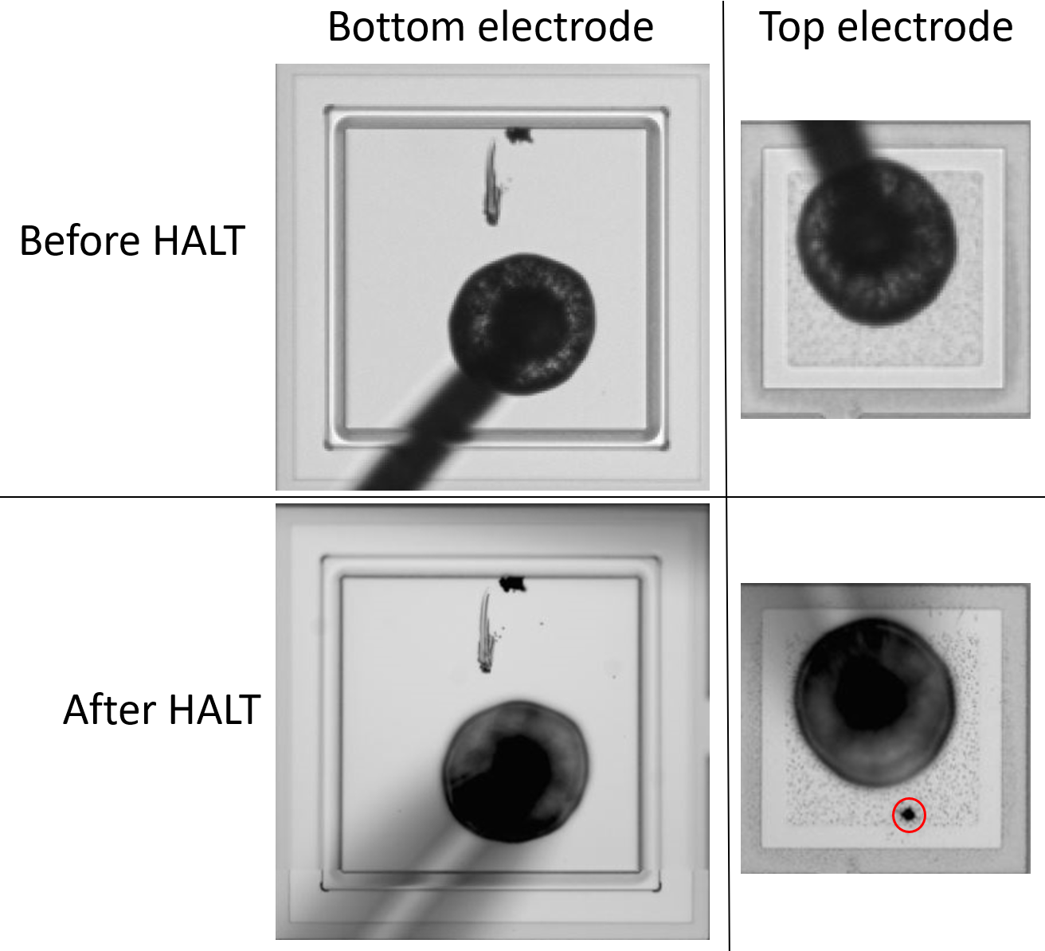
Figure S 4: Microscope images of bottom electrode grounding pad (left) and top electrode (right) pads on devices before and after HALT. The inner part is etched down to the handle-wafer, and the outer a contact reaching the Pt bottom electrode. The highlighted pinhole appearing on the top electrode-pads after HALT are characteristic electrothermal breakdown-events across the thin film, commonly encountered during electromechanical breakdown of piezoelectric thin films.
Table S 2: summary of the key properties of the present PZT thin films.
P_{30 V} [C/cm²] | P_{R} [C/cm²] | E_{C} [kV/cm] | BDS [kV/cm] | MTTF: 175ºC, 150 kV/cm [h] | $$ε_{r,0V}$$ | $$tan⁡(δ)$$
$$25.9±0.7 \%$$ | $$6.4±11 \%$$ | $$21.5±3.9 \%$$ | $$535±14 \%$$ | 126, 95% conf.: [111-140], M: 5.4 | $$1233±1.1 \%$$ | $$0.03±1.4 \%$$

Equations for calculating values in a Lumped Parameters Model
The acoustic radiation is computed with the following formulas taken from Beranek²¹ for a circular piston in a baffle:
$$\begin{aligned}M1= 0.27\frac{ρ}{ a} \left[\frac{kg}{m^{4}}\right]\#\left(S3\right)\end{aligned}$$
$$\begin{aligned}C1= 5.94\frac{a^{3}}{ρ c^{2}} \left[\frac{m^{4}s^{2}}{kg}\right]\#\left(S4\right)\end{aligned}$$
$$\begin{aligned}R1= 0.1404\frac{ρ c}{a^{2}} \left[\frac{kg}{m^{4} s}\right]\#\left(S5\right)\end{aligned}$$
$$\begin{aligned}R2= 0.318\frac{ρ c}{a^{2}} \left[\frac{kg}{m^{4} s}\right]\#\left(S6\right)\end{aligned}$$
It assumes a circular area emitting the sound where ‘r’ is the radius of the opening/surface:
$c=340 \left[\frac{m}{s}\right]$ the speed of sound
$ρ=1.22 \left[\frac{kg}{m^{3}}\right]$ density of air
$η = {1.9}^{-5}\left[\frac{kg}{ms}\right]$ viscosity of air
The transmission line representing the coupler in TinaTI³⁹ needs three parameters plus the actual length of the device in question. The parameters can be computed with the following equations:
$$\begin{aligned}R_{ta}=\frac{8η}{πr^{4}}\left[\frac{kg}{m^{4} s}\right]\#\left(S7\right)\end{aligned}$$
$$\begin{aligned}L_{ta}= \frac{ρ}{πr^{2}}[val2]\#\left(S8\right)\end{aligned}$$
$$\begin{aligned}C_{ta}= \frac{πr^{2}}{ρc^{2}}\left[\frac{m^{4}s^{2}}{kg}\right]\#\left(S9\right)\end{aligned}$$
If the length of the line is multiplied into these equations we get the modelling losses of a tube, the inductance or mass of a tube and the capacitance of an acoustic volume.
The variable loss is R3 not calculated, but found by trial and error, as its geometry advocates for FEM modelling to compute it.
Figure 3 shows the LPM of the measurement setup. The whole system is chosen to be very simple. In this way the change of the variable loss is easy to distinguish from the rest of the system.
Two specific measurements of series mentioned above are chosen, one in a closed and one in an open state. These two are compared to LPM simulations with high and low damping resistance inserted respectively. The rest of the LPM is held constant.
The value of the damping resistor in the LPM is varied manually to fit the measured curve and the best fit reported as the representative value for the respective state/polarizing voltage. At the top in the figure (a) we can see a typical LPM for the measurement system. B) show the resulting measured responses for 0 and 30 V together with simulated results. The high agreement of the responses indicates that the model is accurate. The simulated resistive part of the LPM in the two cases are 500 $MΩ$ and 3.6 $MΩ$

Comparing LPM Simulations with measurement results
The whole measurement series can be simulated by changing only one component in the LPM, The variable loss R₃. The other components are computed with the above formulas and are:
Table S 3: Component values used when simulating the system, ref. Figure 3 a)
Component | Value | Component (Transmission Line) | Value
L1 | 324 [H] | $$l_{tl}$$ | 32E-3 [m]
R1 | 57 [M$Ω$] | $$R_{tl}$$ | 189 [k$Ω$]
R3 | 130 [M$Ω$] | $$L_{tl}$$ | 23 [kH]
C1 | 43 [fF] | $$C_{tl}$$ | 368 [pF]

The resulting responses with R3 varied are shown below. The simulation results indicate that the cantilever-design tested here, has an impedance ranging from $500 MΩ$ to $3.6 MΩ$ when stimulated with V_{P} from 0 to 30 V respectively. This meets the specified target of 10 -100 [M$Ω$] in both extremes.
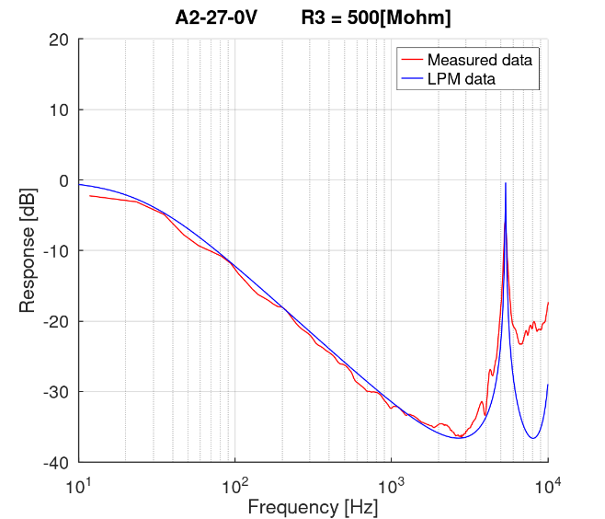 | 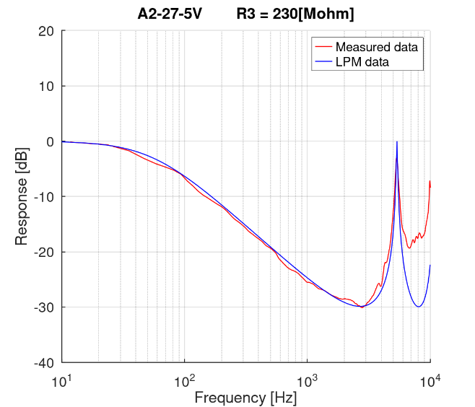
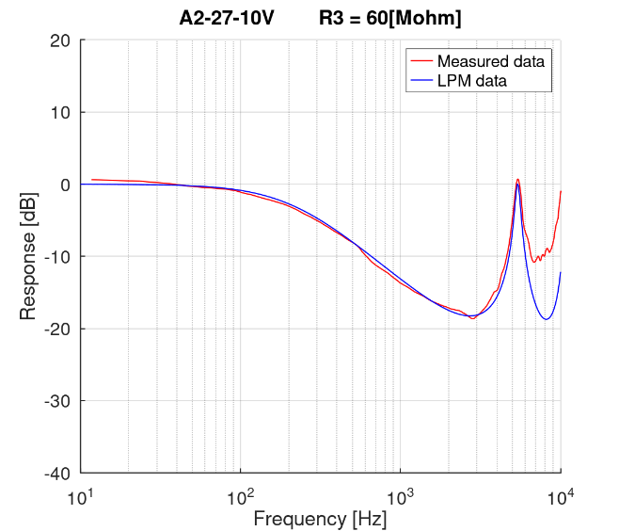 | 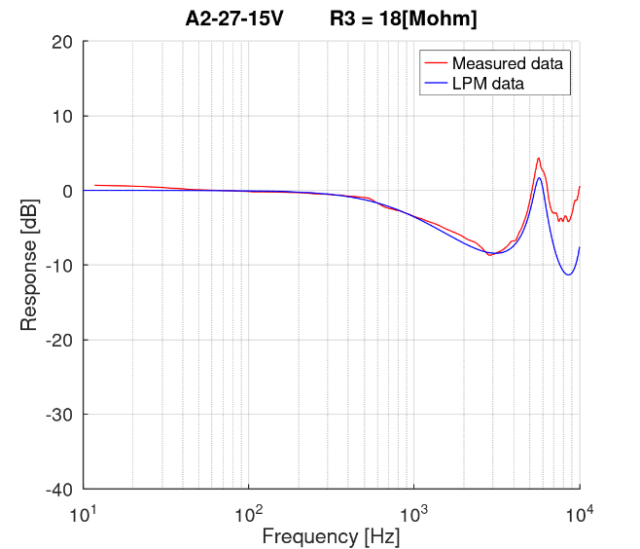
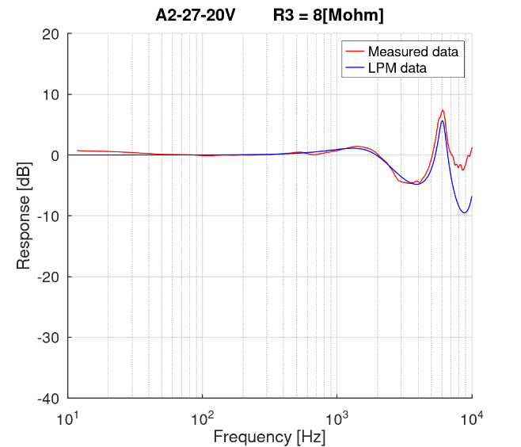 | 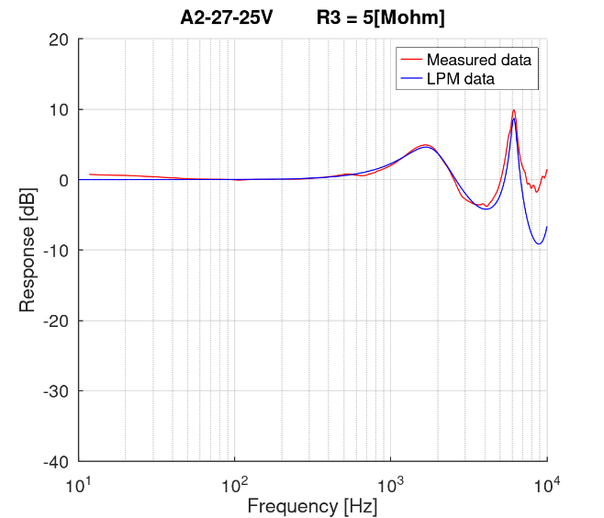
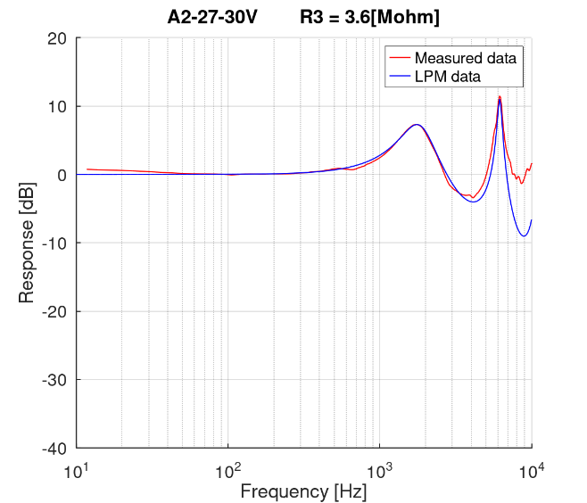
Figure S 5: Fitting results by for different values of the variable loss component, R₃.

Aspects related to the acoustic impedance
Table S 4: Calculated impedance relative to cantilever tip displacement ($t_{D}$)
V_{P} [V] | Average $t_{D}$ [µm] | Calculated impedance [M$Ω$]
0 | -1.0 | -
5 | 8.0 | 328.1
10 | 20.9 | 48.1
15 | 34.1 | 18.1
20 | 47.7 | 9.2
25 | 65.3 | 4.9
30 | 80.8 | 3.2

We can see in eq. (S10), which computes the losses in narrow slits, that the loss decreases with increasing opening displacement of the slit with the ratio of 1/t³. The losses are fluid dynamic losses in the flow of air through the slit. The dimensions are as defined in Figure S 6 below.
$$\begin{aligned}Ra=12\frac{ηd}{lt^{3}} \left[\frac{kg}{m^{4}s}\right]\#\left(S10\right)\end{aligned}$$
$η$ = 1.85E-5 [Ns/m²] is the viscosity of air, d is the depth of the slit and l is the length of the slit. t is the opening displacement. The problem is of course that our slit has no real depth, at least not when the beams are opened. In addition, the slit along the two sides of a beam will be of a complex shape as the beam’s deflection being semi-circular. From this it follows that this formula will not represent the losses in our case.
We still want to investigate if the relation between the simulated/measured impedance and tip displacement can be found with a simple relationship. Trying with the function ${K/t}^{2}$where K is an arbitrary constant, we insert t as the measured average beam tip displacement and let the resistance follow the function. With K chosen as 2.1E-8, we get results shown as the last column in Table S 4. Figure S 6, the red curve, shows these computation result. The figure shows that with these simplified assumptions the impedance function can be approximated well except for in the closed position. In this position none of the assumptions of a regular slits apply, so that is as expected.
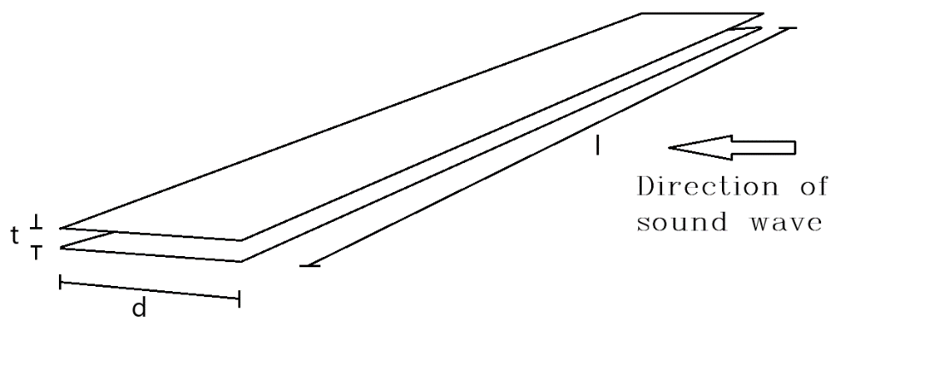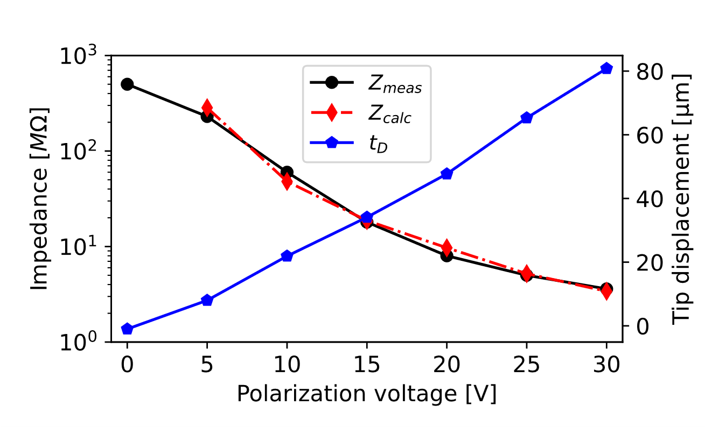
Figure S 6: a) A schematic thin slit with dimensions as in eq. (S10) above. b) measured tip deflection (blue), measured acoustic impedance (black) and calculated impedance using the simple thin-slit approximation (red).

Design variations
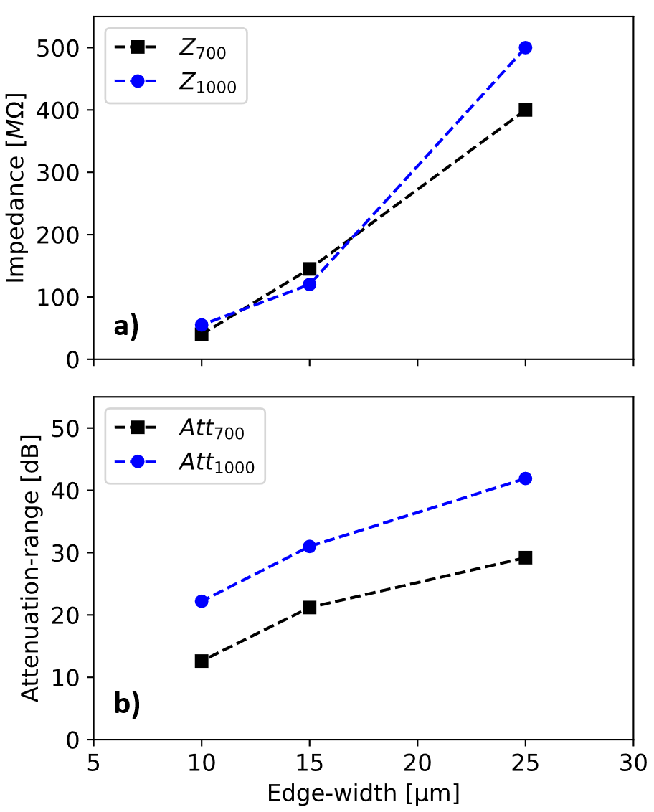
Figure S 6: a) Measured acoustic impedance for 700 [µm] (black) and 1000 µm (blue) long cantilevers as a function of step-edge width at 0 [V] bias. b) shows the achieved attenuation range from 0-30 [V] as a function of step-edge width.
Six variations of the cantilever array-structures were modelled and fabricated as shown in Figure S 6 and Table S 5. The best performing configuration, cantilever length: 1000 [µm] and step-edge width 25 [µm] was chosen for the present study. The measured 0 [V] acoustic impedance decrease with decreasing step-width, indicating that the step edge reduces the air-leakage through the device. It is desired to maximize the impedance in the closed position, and it is clear from Figure S 6 that a width of 10 [µm] is too narrow to get the desired effect, given a target 0 [V] impedance of 100 [M$Ω$].
Table S 5: Design-variations for cantilever-type acoustic attenuators at 0 and 30 V bias respectively.
Design | Cantilever length [µm] | Step-length [µm] | Bias [V] | Att. - range @1.8 kHz [dB] | Equivalent Loss [M$Ω$]
A1 | 700 | 25 | 0 | 29.2 | 400
A1 | 700 | 25 | 30 |  | 13
A2 | 1000 | 25 | 0 | 41.9 | 500
A2 | 1000 | 25 | 30 |  | 3.6
A3 | 700 | 15 | 0 | 21.2 | 145
A3 | 700 | 15 | 30 |  | 3.6
A4 | 1000 | 15 | 0 | 31.0 | 120
A4 | 1000 | 15 | 30 |  | 12
A5 | 700 | 10 | 0 | 12.6 | 40
A5 | 700 | 10 | 30 |  | 10
A6 | 1000 | 10 | 0 | 22.2 | 55
A6 | 1000 | 10 | 30 |  | 4

Algorithm for cantilever analysis
After WLI-characterization, the resulting images were analysed assessing the bending and microstructure of each individual cantilever. The custom developed algorithm finds the center of mass of each cantilever from the raw WLI data, and fits to $\frac{1}{r}=\frac{z^{''}}{\sqrt{{\left[1+{\left(z^{'}\right)}^{2}\right]}^{3}}}$,, yielding the radius of curvature in the X/Y direction as well as the tip displacement for each given condition. Figure S 7 shows an exemplified scan upon detecting the 3D properties of each cantilever in the structure.
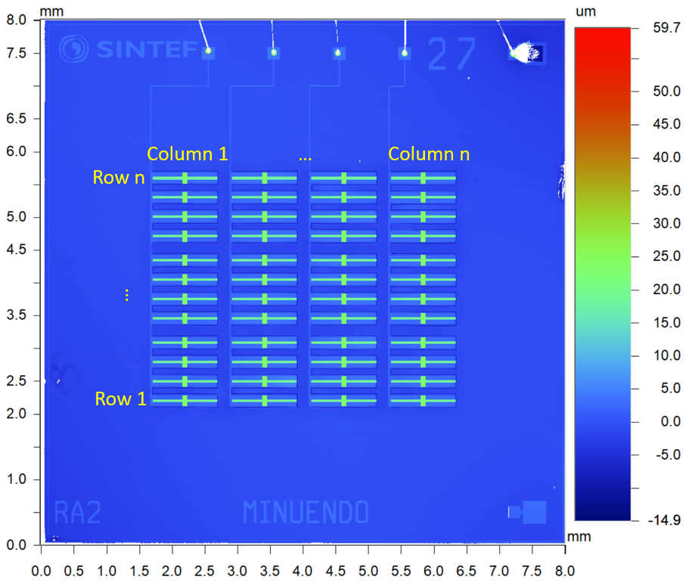
Figure S 7: Example of cantilever-analysis from a white light interferometry scan.

