Supplementary Tables and Figures
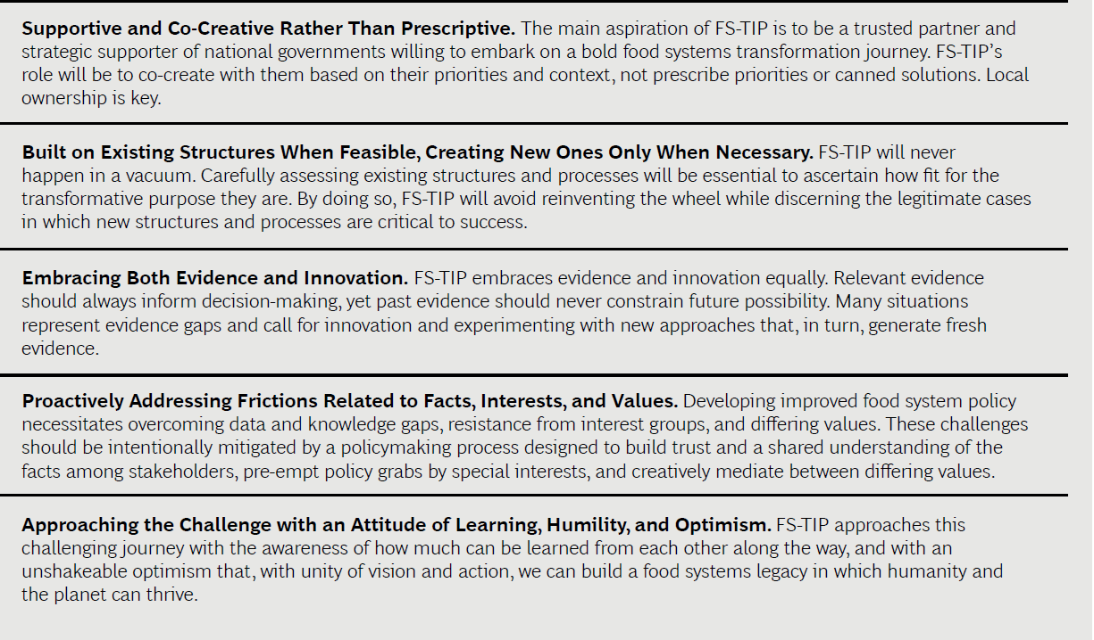
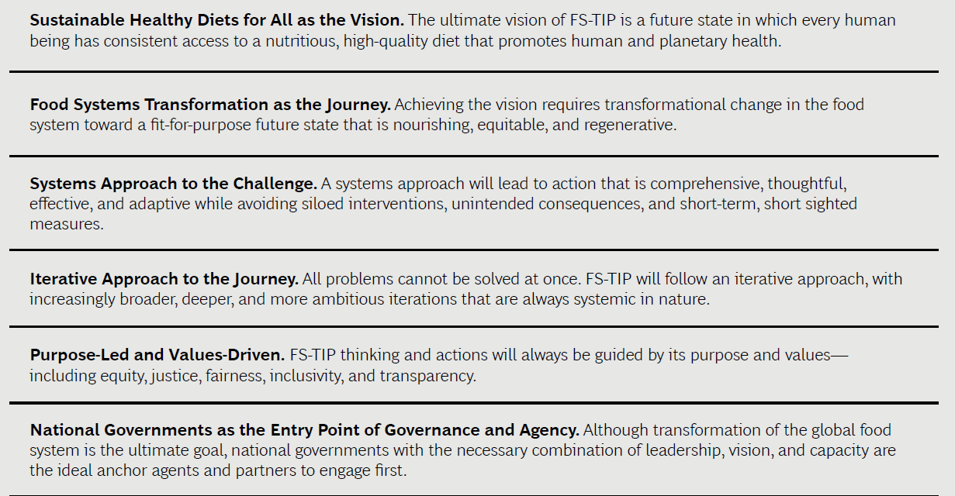
Supplementary Table 1. Guiding principles for the FS-TIP process

Supplementary table 2: The participation of various stakeholders from each country in the FS-TIP process.
 | Rwanda |  |  | Malawi |  |  | Ghana
 | In-country experts, convener or advisor for process team | Engaged as sounding boards (validated findings) | Ministries/  Sectors engaged | In-country experts, convener or advisor for process team | Engaged as sounding boards (validated findings) | Ministries/  Sectors engaged | In-country experts, convener or advisor for process team | Engaged as sounding boards (validated findings) | Ministries/  Sectors engaged
GOVERNMENT | 3 | 17 |  |  | 25 |  | 3 | 16
Ministerial linkages |  | 1 | Ministry of Agriculture and Animal resources, Local Government, Environment, National Child Development Agency, National Agriculture Export Board, Chamber of Deputies, Rwanda Agriculture and Animal Resources Development Board |  |  | Ministry of Agriculture, Health, Trade, Economic planning and development, Environmental Affairs, Local Government services, Finance, Natural Resources, Energy and Mining, Local Government and Rural Government, National Planning Commission |  |  | National Development Planning Commission, Environmental protection Agency, Ministry of Food and Agriculture, Health, Fisheries and Aquaculture development, Land and Natural resources, Environment Science Technology & Innovation, Trade and Industry, Finance and Economic Planning, Environmental Protection Agency
Cabinet committees and secretaries |  | 2
Parliamentary committees |  | 1
Parastatals |  | 1 |  |  |  |  | 3
Roles not defined |  | 4
Government advisor |  | 1
Directors |  | 5
Division/department heads |  | 5
NGO | 8 | 11 | World Food Programme, FAO, Association for Cooperation and Research in Development (ACORD) Rwanda, FCDO, One acre fund, SAIC Rwanda, Africa Development Promise, ADECOR, Tony Blair Institute (TBI), Boston Consulting Group (BCG) | 12 | 7 | Donor Committee on Agriculture and Food Security, AGRA, BCG, TBI, Akademiya 2063 | 10 | 2 | WFP, AGRA, BCG, TBI
RESEARCH | 1 | 1 | Regional Center for Integrated Development (RCID), International Food Policy Research Institute (IFPRI) | 2 |  | IFPRI |  | 1
ACADEMIA | 3 | 1 | University of Rwanda | 3 |  |  | 3 | 9 | University of Ghana, Kumasi Technical University, University of Health and Allied Sciences, University of Development Studies, Kwame Nkurumah University of Science and Technology
PRIVATE/BUSINESS ENTITY | 1 | 1 | INYANGE | 1
CIVIL SOCIETY | 0 | 2 | Scaling up Nutrition civil society Alliance | 1 | 1 | Farmers Union of Malawi
Total number of participants | 16 | 53 |  | 19 | 33 |  | 19 | 28

Supplementary Table 3: Level of involvement of stakeholders and sectors
Involvement level | Sectors involved
 | Rwanda | Malawi | Ghana
High (part of the in-country team of experts | University of Rwanda | University of Malawi | National Development and Planning Commission, University of Ghana, African Center for Economic Transformation
Low (feedback/validation processes) | Ministry of Agriculture and Animal resources,  Ministry of Local Government, Ministry of Environment, National Child Development Agency,  National Agriculture Export Board,  Chamber of Deputies,  Rwanda Agriculture and Animal Resources Development Board | Ministry of Agriculture Ministry of Health,  Ministry of Trade,  Ministry of Economic planning and development, Ministry of Environmental Affairs,  Local Government services, Ministry of Finance, Ministry of Natural Resources, Energy and Mining,  Ministry of Local Government and Rural Government,  National Planning Commission, | National Development Planning Commission, Environmental protection Agency,  Ministry of Food and Agriculture,  Ministry of Health, Ministry of Fisheries and Aquaculture development, Ministry of Land and Natural resources,  Ministry of Environment Science Technology & Innovation,  Ministry of Trade and Industry,  Ministry of Finance and Economic Planning, Environmental Protection Agency

Quantitative study
Qualitative Study
55 participants approached to complete the online survey
10 completed survey and were included in the analysis
25 participants approached
25 interviewed and included in the analysis
45 did not respond

Supplementary figure 1: Participant flow chart for the quantitative and qualitative study

