Supplementary Online Content

Long-Term Effects of Flexible Visitation in the ICU on Family Members' Mental Health: 12-Month Results from a Randomized Clinical Trial

A secundary analysis of a randomized crossover trial: ICU Visits

TRIAL REGISTRATION: ClinicalTrials.gov Identifier: NCT02932358
JAMA. 2019;322(3):216-228. doi:10.1001/jama.2019.8766

TableS1:Charactheristics of the total sample and participants excluded from the study........................................................2
FigureS1: Subgroup Analyses of the Effects of Flexible Visitation vs. Restricted Visitation on the Incidence of Post-Traumatic Stress in Family Members...................................................................................................................................3
FigureS2: Subgroup Analyses of the Effects of Flexible Visitation vs. Restricted Visitation on the Incidence of Anxiety in Family Members...............................................................................................................................................................4
FigureS3: Subgroup Analyses of the Effects of Flexible Visitation vs. Restricted Visitation on the Incidence of Depression Family Members................................................................................................................................................5
FigureS4: Diagrams illustrating symptoms of anxiety, depression and post-traumatic stress.............................................6
Table S2: Results of individuals who completed the follow-up, with associated psychiatric symptoms (anxiety, depression and post-traumatic stress)...................................................................................................................................7

Table S1. Charactheristics of the total sample and participants excluded from the study.
 | Total (n = 519) | Excluded from the study (n = 541)
Age, mean (SD¹) | 46.6 (13.8) (515) | 43.8 (13.6) (531)
Sex
Men | 150/519 (28.9%) | 165/541 (30.5%)
Women | 369/519 (71.1%) | 376/541 (69.5%)
Educational attainment, median (IQR²) | 11.0 (8.0; 15.0) (468) | 11.0 (8.0; 15.0) (470)
Higher education | 159/513 (30.9%) | 133/529 (25.1%)
Monthly household income, median (IQR),US$³ | 2700.0 (1600.0; 4850.0) (447) | 2000.0 (1200.0; 3800.0)
Unemployed or retired | 155/507 (30.5%) | 131/516 (25.3%)
Living with care recipient | 286/517 (55.3%) | 287/527 (54.4%)
History of anxiety | 71/515 (13.7%) | 64/533 (12.0%)
History of depression | 69/514 (13.4%) | 58/531 (10.9%)
ICU length of stay, median (IQR) | 5.0 (3.0; 7.0) (518) | 4.0 (3.0; 7.0) (540)
Surrogate decision maker | 461/511 (90.2%) | 471/523 (90.0%)

Figure S1: Subgroup Analyses of the Effects of Flexible Visitation vs. Restricted Visitation on the Incidence of Post-Traumatic Stress in Family Members.
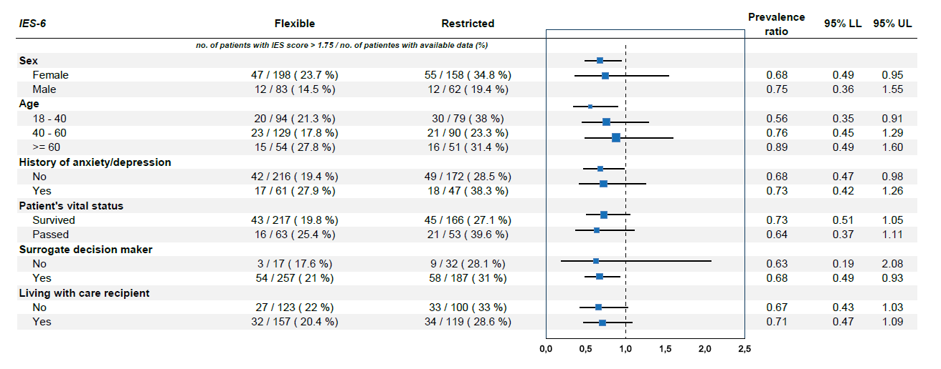

Figure S2: Subgroup Analyses of the Effects of Flexible Visitation vs. Restricted Visitation on the Incidence of Anxiety in Family Members.
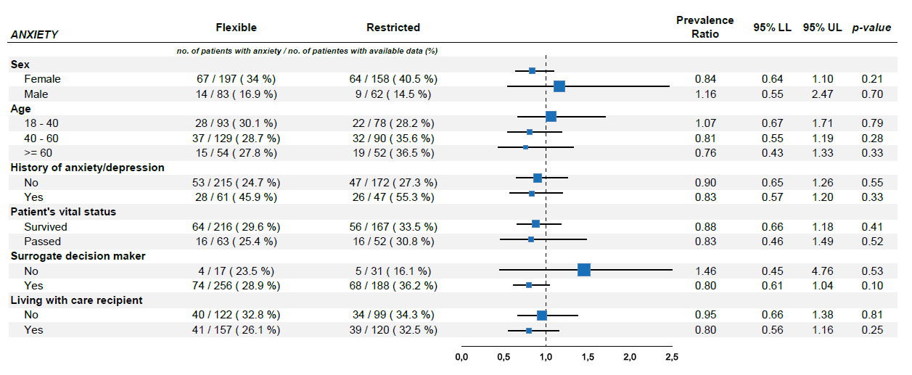

Figure S3: Subgroup Analyses of the Effects of Flexible Visitation vs. Restricted Visitation on the Incidence of Depression in Family Members
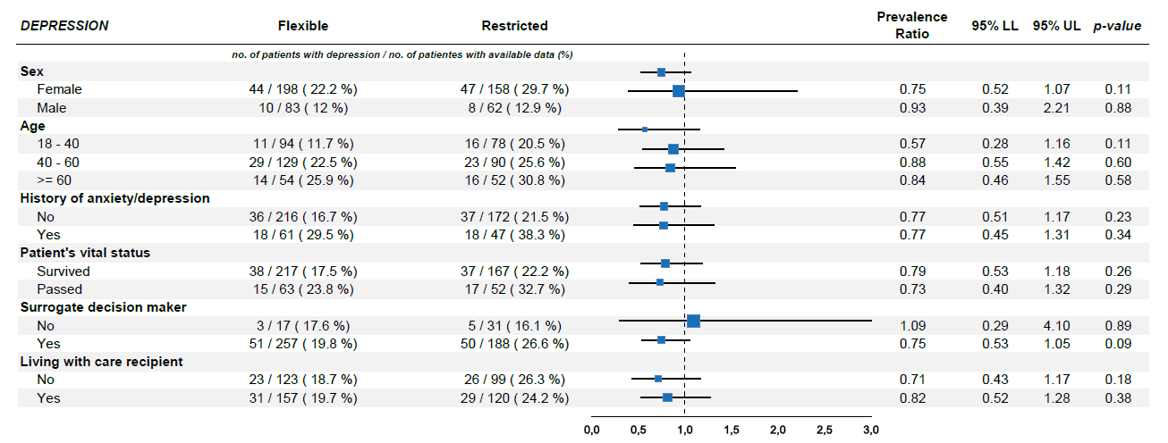

Figure S4. Diagrams illustrating symptoms of anxiety, depression and post-traumatic stress.
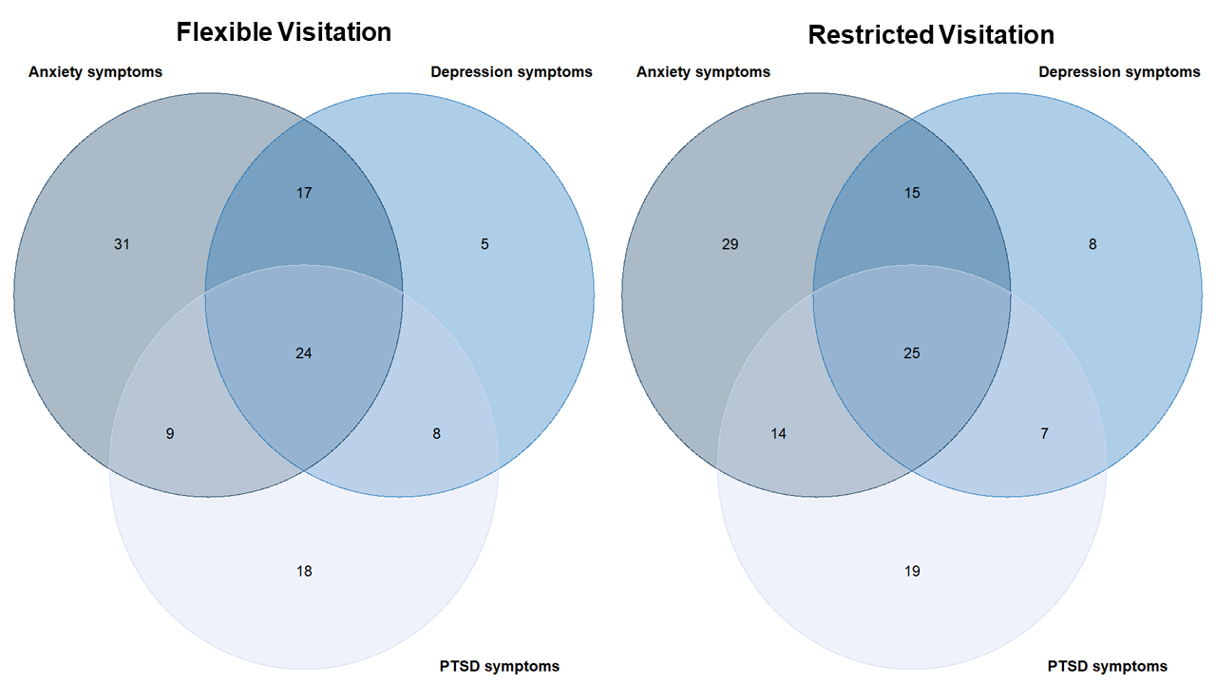

PTSD: Post-traumatic stress disorder

Table S2. Results of individuals who completed the follow-up, with associated psychiatric symptoms (anxiety, depression and post-traumatic stress)

 | Total (n = 519) | Flexible visitation (n = 288) | Restricted visitation (n = 231) | p-valor
With at least 2 psychiatric symptoms | 125/500 (25.0%) | 62/281 (22.0%) | 63/219 (28.7%) | 0.10
With all 3 psychiatric symptoms | 56/501 (11.1%) | 29/281 (10.3%) | 27/220 (12.2%) | 0.58
With anxiety and depression | 24/502 (4.7%) | 12/281 (4.2%) | 12/221 (5.4%) | 0.69
With anxiety and post-traumatic stress | 29/501 (5.7%) | 13/281 (4.6%) | 16/220 (7.2%) | 0.28
With depression and post-traumatic stress | 16/500 (3.2%) | 8/281 (2.8%) | 8/219 (3.6%) | 0.80

