Supplemental information for
AtML: Accurate identification of Arabidopsis thaliana root cell identity in single-cell sequencing using machine learning
Supplementary Table 1. The composition of the data for the root tip cell subpopulation of Arabidopsis thaliana.
Cell type | Number of cells | Number of cells | Total number
Endodermis | 794 | 206 | 1000
Lateral_Root_Cap | 788 | 212 | 1000
Atrichoblast | 798 | 202 | 1000
Trichoblast | 808 | 192 | 1000
Cortex | 799 | 201 | 1000
Procambium | 813 | 187 | 1000

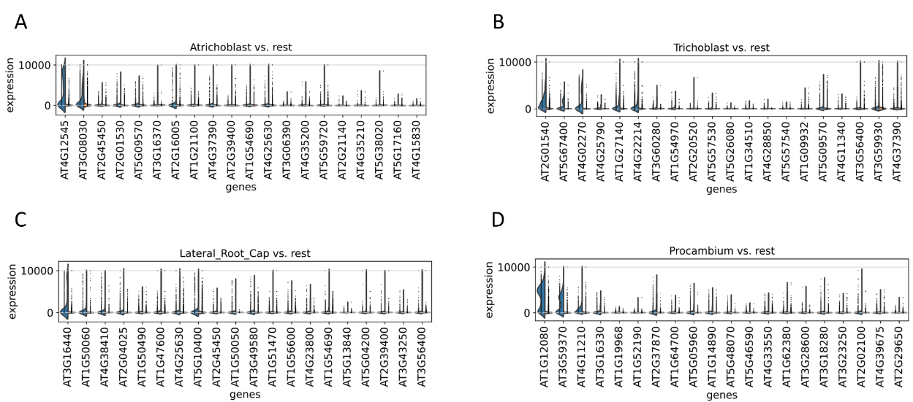

Supplementary Fig. 1. Computational analysis of 160 marker genes. (A to D) The selection of marker genes by MIC_XGB (comprising 160 marker genes) is compared through split violin plots, displaying the expression levels of these genes in specific cell types on the left in blue, and their aggregate expression across the other five cell types on the right in orange.

