SUPPLEMENTARY MATERIAL

DEFAULT MODE NETWORK | CENTRAL EXECUTIVE NETWORK
Medial orbitofrontal, parahippocampal, posterior cingulate, isthumus cingulate | Precentral gyrus, superior parietal, rostral middle frontal, lateral orbitofrontal, and  inferior, middle and superior temporal
Table S1. Regions Of Interest from the Desikan-Killiany atlas assigned to the Default Mode Network (left), and Central Executive Network (right) (Desikan et al., 2006).

EC1Back Transition - Alpha band

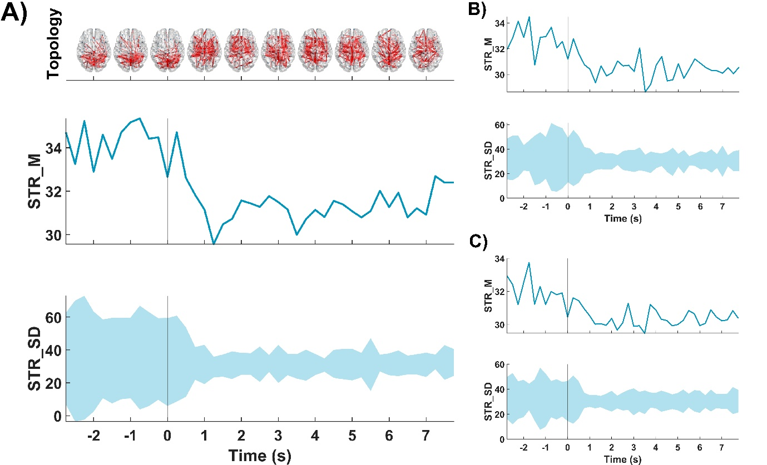

Figure S1. Evolution across time of the STR_M and STR_SD for the ROI showing the highest strength for each subject: A) global neural network, B) DMN and C) CEN. Within each section, in the upper row it is depicted the evolution of the STR_M, and in the lower row the evolution of the STR_SD during the ECEO transition in the alpha band. The transition between both states is marked with a vertical line (i.e., 0 s). Moreover, for the global neural network, the evolution of the topology during the transition is depicted in the upper part of the section A).

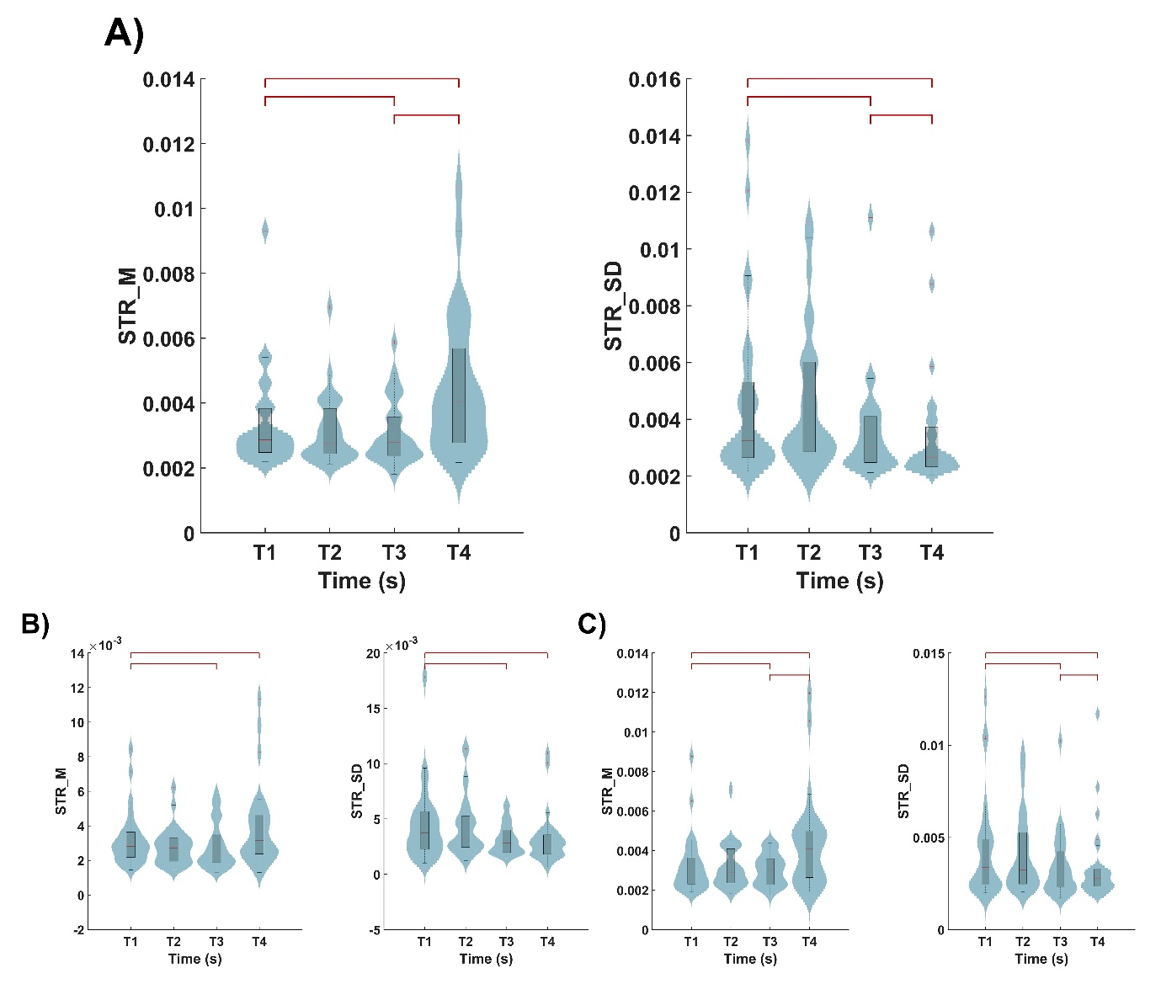
Figure S2. A) Data distribution of the grand-averaged global network STR_M, and STR_SD during the EC1Back transition in the alpha band. Analogous comparisons for the results regarding DMN and CEN are depicted in sections B) and C), respectively. Within each panel, the boxplots group the FC values of a different time range: from -3 to -1.5 s (T1), from -1.5 to 0 s (T2), from 0 to 1.5 s (T3), and from 3 to 4.5 s (T4). The statistically significant differences (p-value<0.05, corrected Wilcoxon signed-rank test) are indicated with dark red lines.

1BackEC Transition - Alpha band

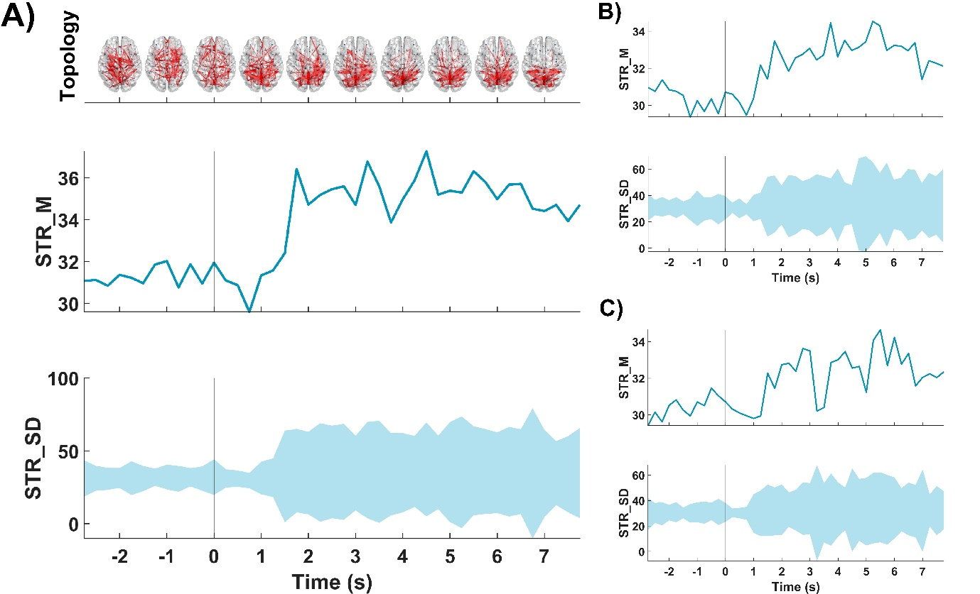
Figure S3. Evolution across time of the STR_M and STR_SD for the ROI showing the highest strength for each subject for: A) global neural network, B) DMN and C) CEN. Within each section, in the upper row it is depicted the evolution of the STR_M, and in the lower row the evolution of the STR_SD during the 1BackEC transition in the alpha band. The transition between both states is marked with a vertical line (i.e., 0 s). Moreover, for the global neural network, the evolution of the topology during the transition is depicted in the upper part of the section A).

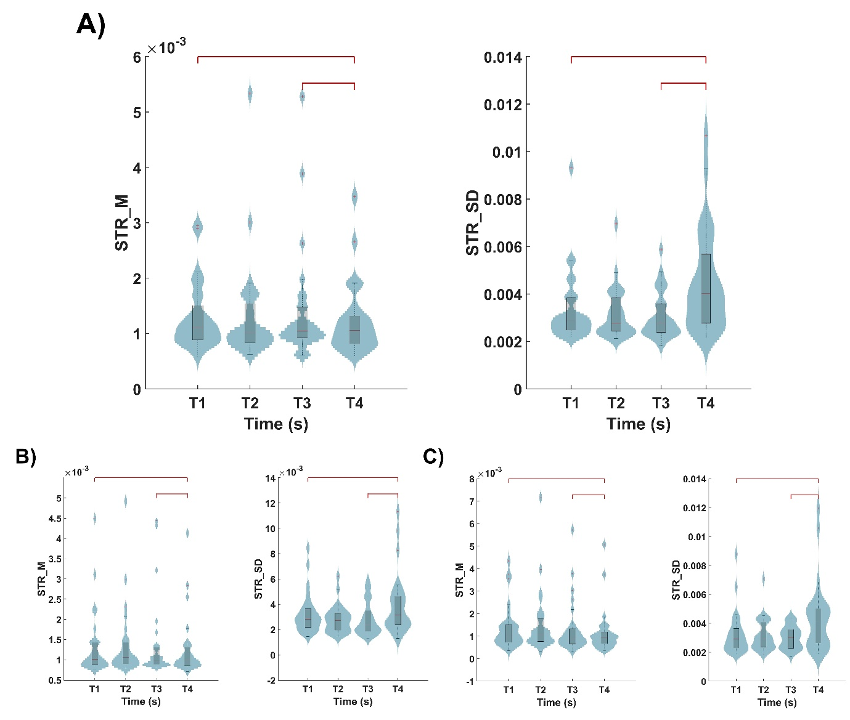

Figure S4. A) Data distribution of the grand-averaged global network STR_M, and STR_SD during the 1BackEC transition in the alpha band. Analogous comparisons for the results regarding DMN and CEN are depicted in sections B) and C), respectively. Within each panel, the boxplots group the FC values of a different time range: from -3 to -1.5 s (T1), from -1.5 to 0 s (T2), from 0 to 1.5 s (T3), and from 3 to 4.5 s (T4). The statistically significant differences (p-value<0.05, corrected Wilcoxon signed-rank test) are indicated with dark red lines.

ECEO Transition - Beta band

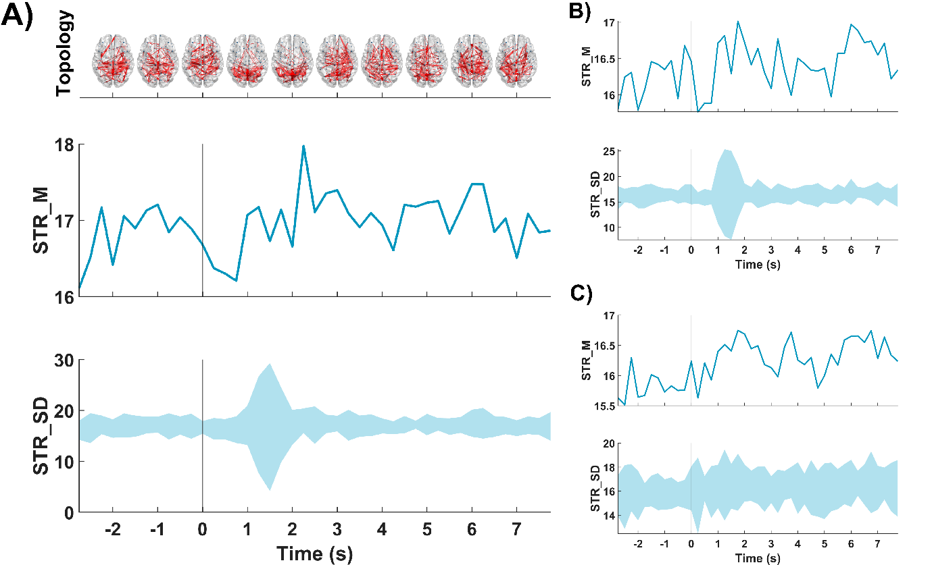
Figure S5. Evolution across time of the STR_M and STR_SD for: A) global neural network, B) DMN and C) CEN. Within each section, in the upper row it is depicted the evolution of the STR_M, and in the lower row the evolution of the STR_SD during the ECEO transition in the beta band. The transition between both states is marked with a vertical line (i.e., 0 s). Moreover, for the global neural network, the evolution of the topology during the transition is depicted in the upper part of the section A).

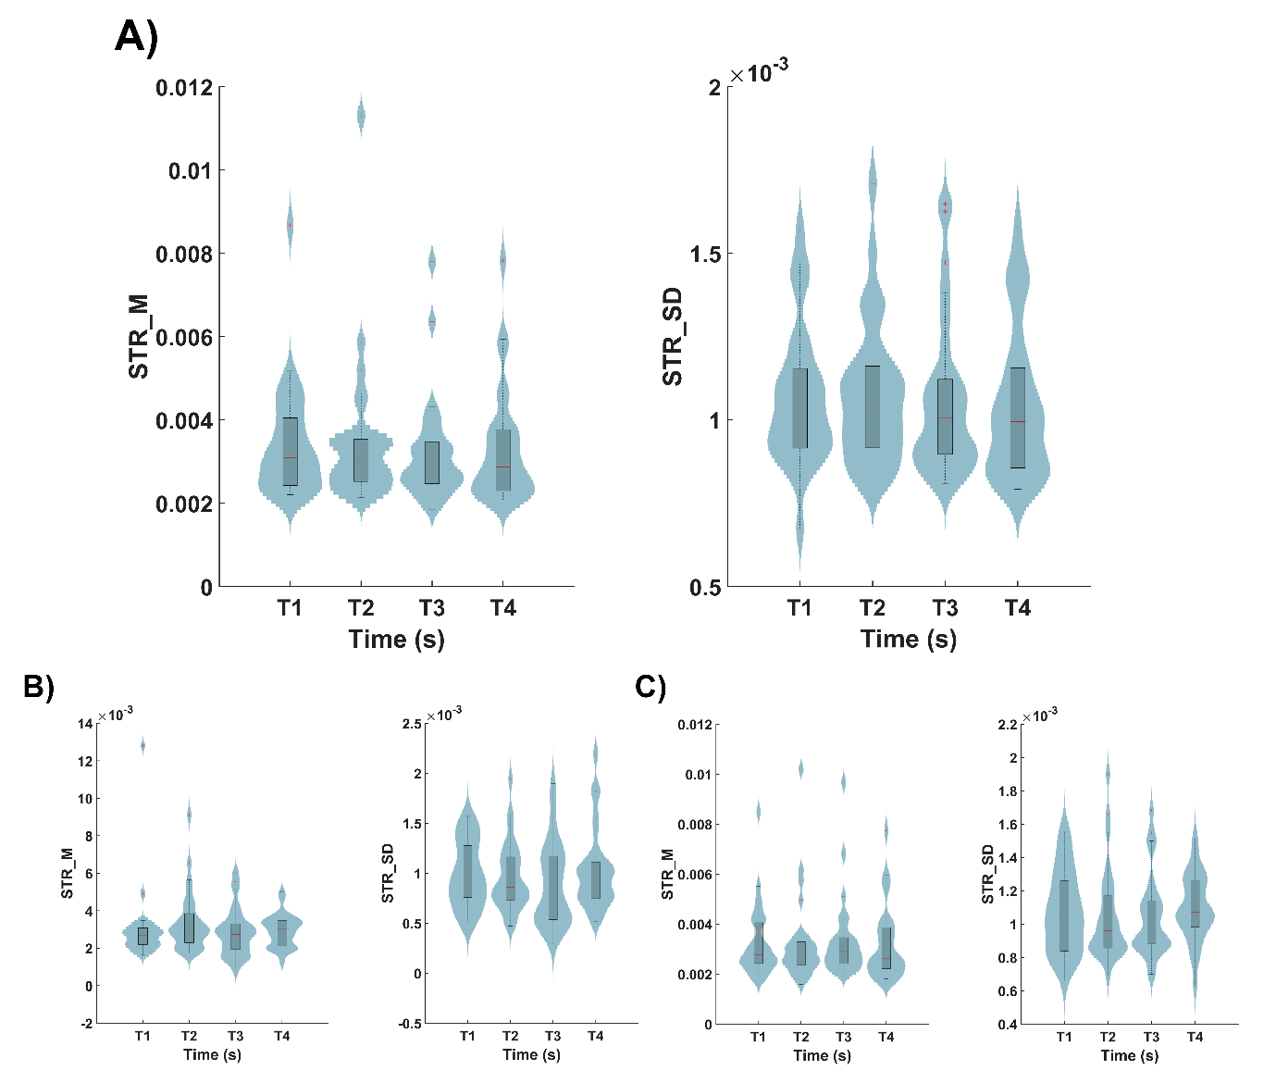
Figure S6. A) Data distribution of the global network STR_M, and STR_SD during the ECEO transition in the beta band. Analogous comparisons for the results regarding DMN and CEN are depicted in sections B) and C), respectively. Within each panel, the boxplots group the FC values of a different time range: from -3 to -1.5 s (T1), from -1.5 to 0 s (T2), from 0 to 1.5 s (T3), and from 3 to 4.5 s (T4). The statistically significant differences (p-value<0.05, corrected

EOEC Transition - Beta band

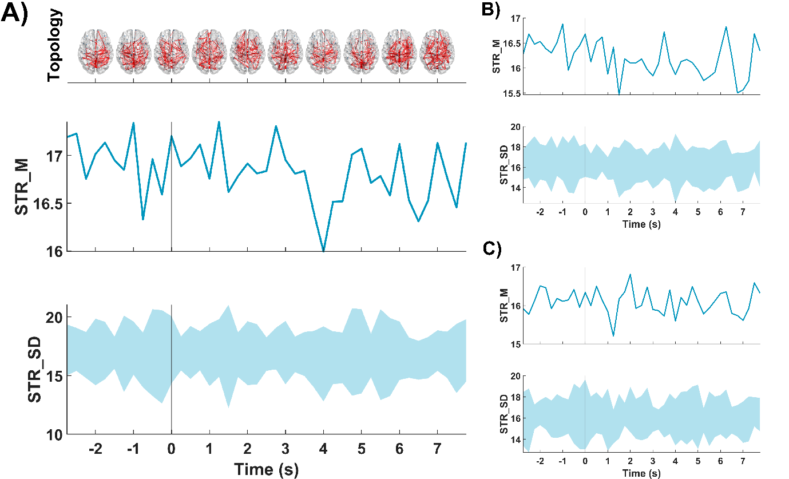
Figure S7. Evolution across time of the STR_M and STR_SD for: A) global neural network, B) DMN and C) CEN. Within each section, in the upper row it is depicted the evolution of the STR_M, and in the lower row the evolution of the STR_SD during the EOEC transition in the beta band. The transition between both states is marked with a vertical line (i.e., 0 s). Moreover, for the global neural network, the evolution of the topology during the transition is depicted in the upper part of the section A).

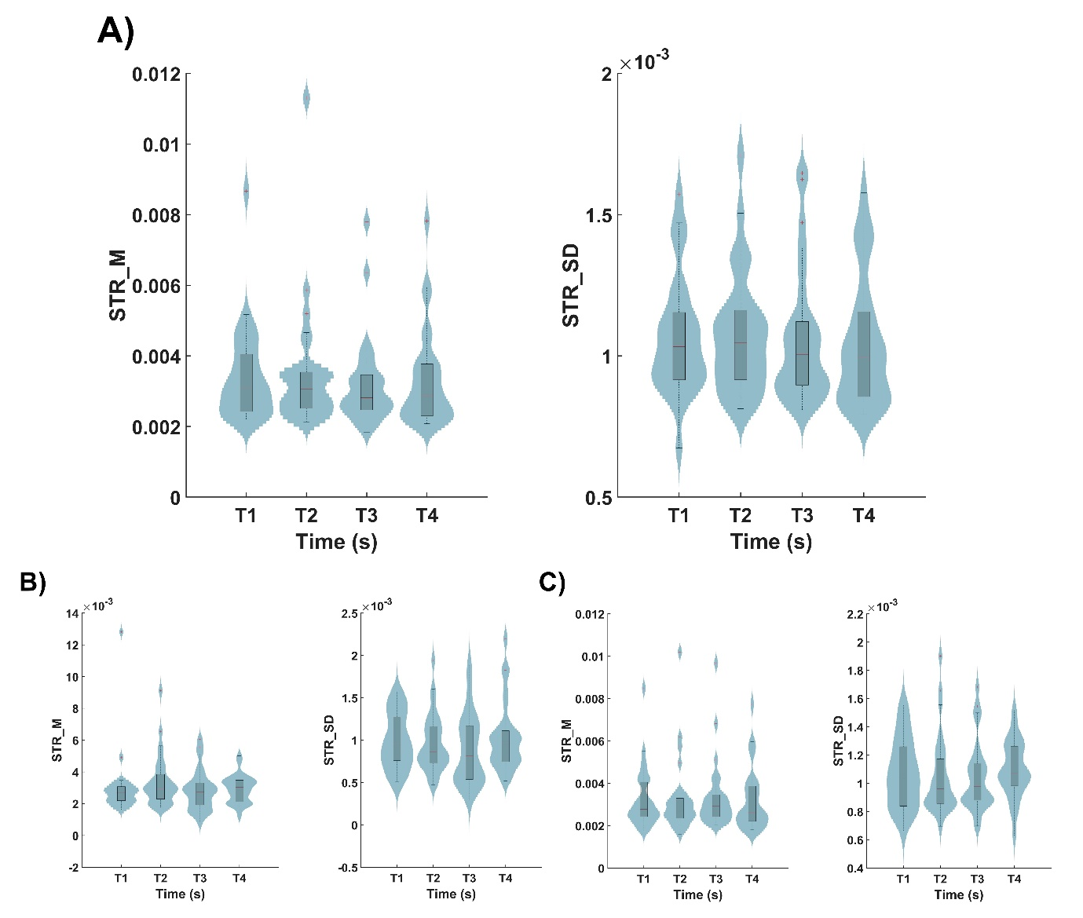

Figure S8. A) Data distribution of the global network STR_M, and STR_SD during the EOEC transition in the beta band. Analogous comparisons for the results regarding DMN and CEN are depicted in sections B) and C), respectively. Within each panel, the boxplots group the FC values of a different time range: from -3 to -1.5 s (T1), from -1.5 to 0 s (T2), from 0 to 1.5 s (T3), and from 3 to 4.5 s (T4).

EO1Back Transition - Beta band

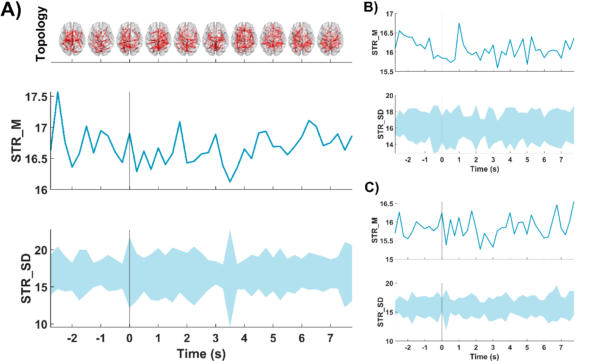

Figure S9. Evolution across time of the STR_M and STR_SD for: A) global neural network, B) DMN and C) CEN. Within each section, in the upper row it is depicted the evolution of the STR_M, and in the lower row the evolution of the STR_SD during the EO1Back transition in the beta band. The transition between both states is marked with a vertical line (i.e., 0 s). Moreover, for the global neural network, the evolution of the topology during the transition is depicted in the upper part of the section A).

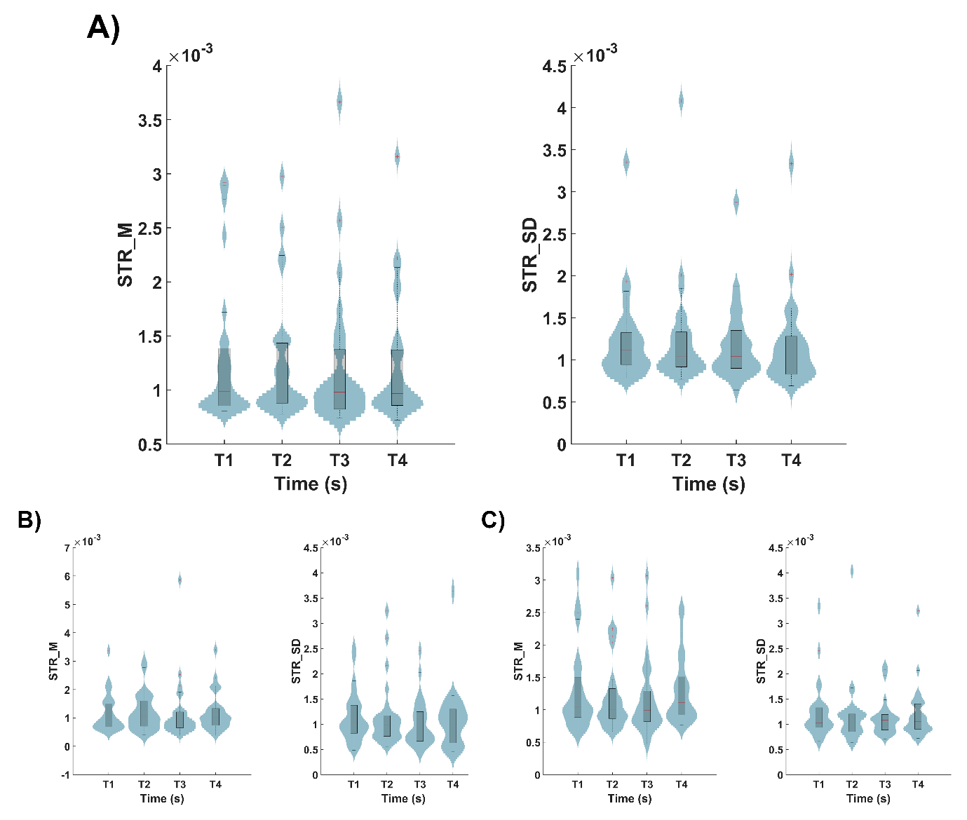
Figure S10. A) Data distribution of the global network STR_M, and STR_SD during the EO1Back transition in the beta band. Analogous comparisons for the results regarding DMN and CEN are depicted in sections B) and C), respectively. Within each panel, the boxplots group the FC values of a different time range: from -3 to -1.5 s (T1), from -1.5 to 0 s (T2), from 0 to 1.5 s (T3), and from 3 to 4.5 s (T4).

1BackEO Transition - Beta band

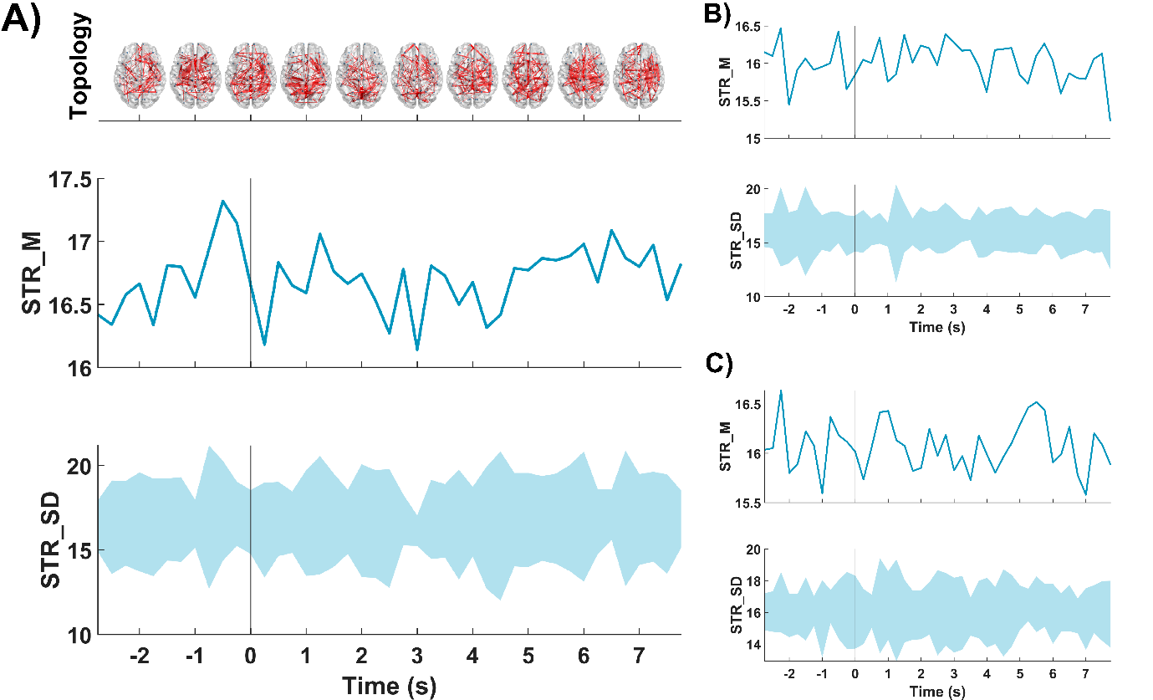
Figure S11. Evolution across time of the STR_M and STR_SD for: A) global neural network, B) DMN and C) CEN. Within each section, in the upper row it is depicted the evolution of the STR_M, and in the lower row the evolution of the STR_SD during the 1BackEO transition in the beta band. The transition between both states is marked with a vertical line (i.e., 0 s). Moreover, for the global neural network, the evolution of the topology during the transition is depicted in the upper part of the section A).

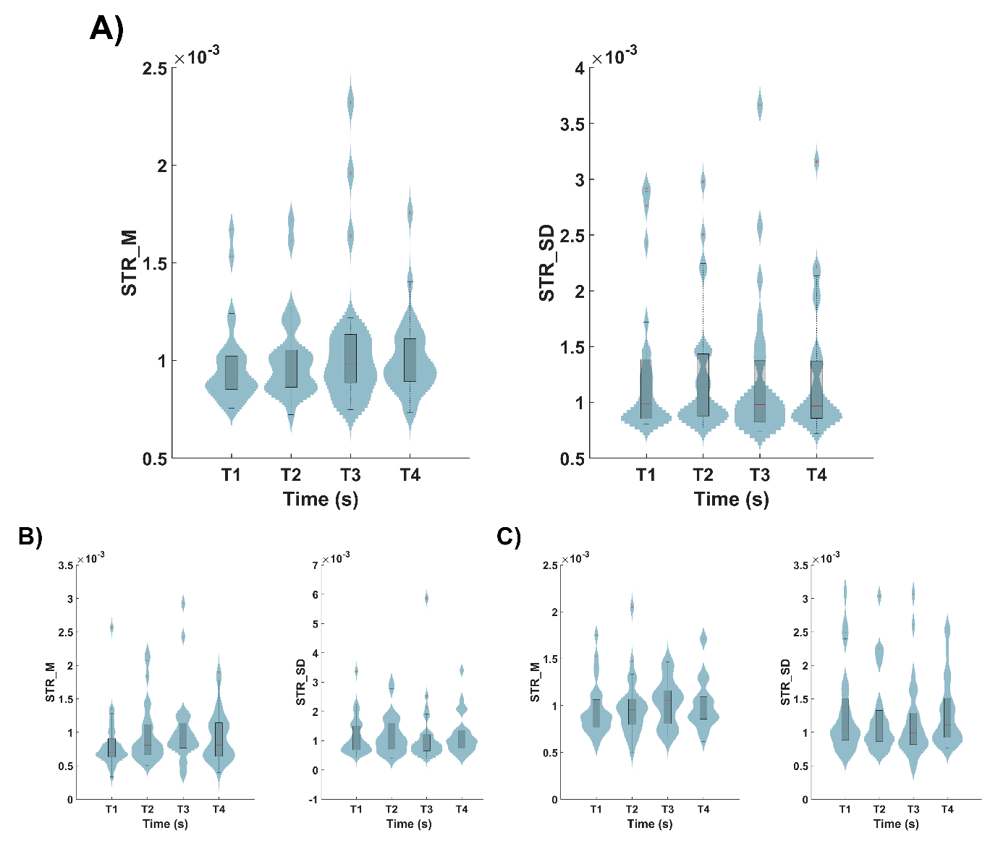
Figure S12. A) Data distribution of the global network STR_M, and STR_SD during the 1BackEO transition in the beta band. Analogous comparisons for the results regarding DMN and CEN are depicted in sections B) and C), respectively. Within each panel, the boxplots group the FC values of a different time range: from -3 to -1.5 s (T1), from -1.5 to 0 s (T2), from 0 to 1.5 s (T3), and from 3 to 4.5 s (T4).

