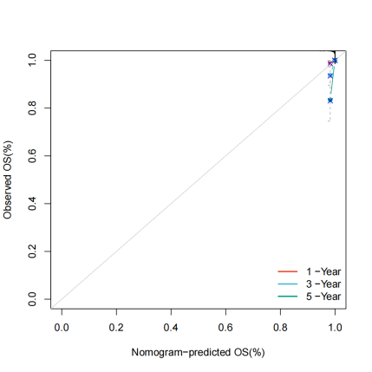
Figure 1. Calibration plot of nomogram.

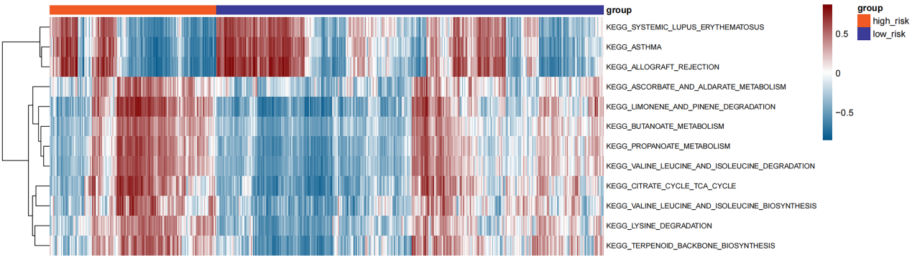
Figure 2. The GSVA enrichment analysis of the signaling pathways is based on the TCGA dataset.

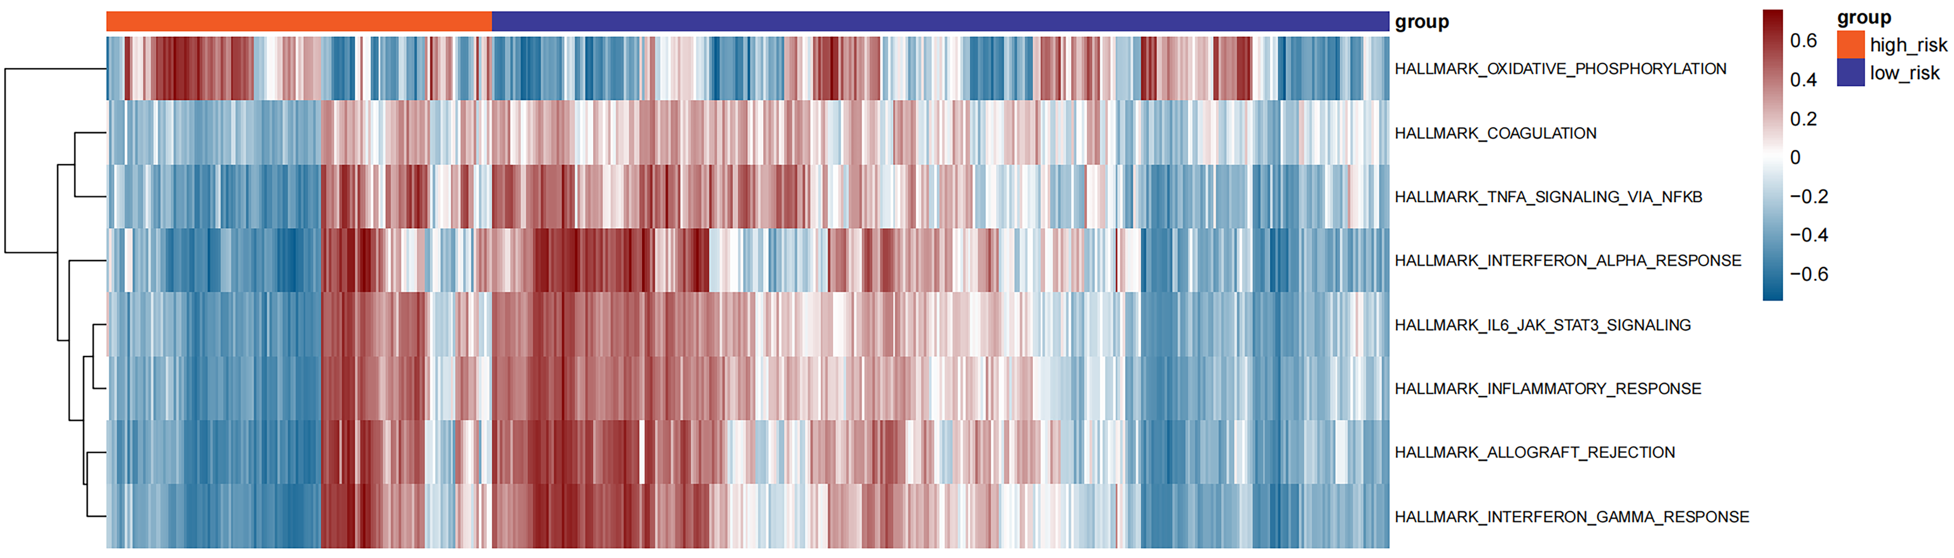
Figure 3. The GSVA enrichment analysis of the hallmark set is based on the TCGA dataset.

