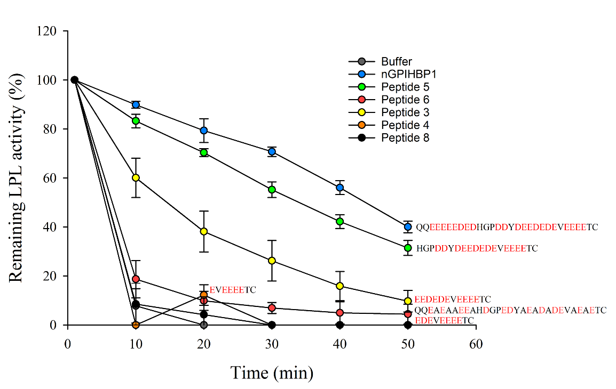
Figure S1. Time-dependent inactivation of LPL in the presence of nGPIHBP1 or various peptides. 10 nM LPL was incubated in 20 mM HEPES, pH 7.4, 150 mM NaCl at 37 °C with 1 μM nGPIHBP1 or peptides. At the indicated times, LPL aliquots were withdrawn from the reaction mixture and LPL activity was determined. LPL activities are presented as a percentage of remaining initial activity.

