Supplementary Appendix 1
This supplement contains the following items:

ASCEND Study Collaborative Group 3
ASCEND-Eye Visual Function Questionnaire 6
Calculation of NEI-VFQ-25 composite and subdomain scores 7
Table S1: Data Cut-Points for NEI-VFQ-25 Composite and Vision-Targeted Subdomain Scoring Categories 9
Table S2 Baseline Characteristics of Visual Functioning Questionnaire Responders and Non-Responders by Eligibility to be sent the Questionnaire 10
Table S3 Reported Definite or Probable Adherence with Study Treatment Stratified by Years Post-Randomisation 13
Figure S1 General Vision Subdomain Score from the NEI-VFQ-25 by Aspirin Allocation 14
Figure S2 General Vision Subdomain Score from the NEI-VFQ-25 by Omega-3 Fatty Acids Allocation 14
Figure S3 Ocular Pain Subdomain Score from the NEI-VFQ-25 by Aspirin Allocation 15
Figure S4 Ocular Pain Subdomain Score from the NEI-VFQ-25 by Omega-3 Fatty Acids Allocation 15
Figure S5 Near Activities Subdomain Score from the NEI-VFQ-25 by Aspirin Allocation 16
Figure S6 Near Activities Subdomain Score from the NEI-VFQ-25 by Omega-3 Fatty Acids Allocation 16
Figure S7 Distance Activities Subdomain Score from the NEI-VFQ-25 by Aspirin Allocation 17
Figure S8 Distance Activities Subdomain Score from the NEI-VFQ-25 by Omega-3 Fatty Acids Allocation 17
Figure S9 Social Functioning Subdomain Score from the NEI-VFQ-25 by Aspirin Allocation 18
Figure S10 Social Functioning Subdomain Score from the NEI-VFQ-25 by Omega-3 Fatty Acids Allocation 18
Figure S11 Mental Health Subdomain Score from the NEI-VFQ-25 by Aspirin Allocation 19
Figure S12 Mental Health Subdomain Score from the NEI-VFQ-25 by Omega-3 Fatty Acids Allocation 19
Figure S13 Role Dependency Subdomain Score from the NEI-VFQ-25 by Aspirin Allocation 20
Figure S14 Role Dependency Subdomain Score from the NEI-VFQ-25 by Omega-3 Fatty Acids Allocation 20
Figure S15 Vision-Specific Dependency Subdomain Score from the NEI-VFQ-25 by Aspirin Allocation 21
Figure S16 Vision-Specific Dependency Subdomain Score from the NEI-VFQ-25 by Omega-3 Fatty Acids Allocation 21
Figure S17 Driving Subdomain Score from the NEI-VFQ-25 by Aspirin Allocation 22
Figure S18 Driving Subdomain Score from the NEI-VFQ-25 by Omega-3 Fatty Acids Allocation 22
Figure S19 Colour Vision Subdomain Score from the NEI-VFQ-25 by Aspirin Allocation 23
Figure S20 Colour Vision Subdomain Score from the NEI-VFQ-25 by Omega-3 Fatty Acids Allocation 23
Figure S21 Peripheral Vision Subdomain Score from the NEI-VFQ-25 by Aspirin Allocation 24
Figure S22 Peripheral Vision Subdomain Score from the NEI-VFQ-25 by Omega-3 Fatty Acids Allocation 24
Figure S23 General Health Subdomain Score from the NEI-VFQ-25 by Aspirin Allocation 25
Figure S24 General Health Subdomain Score from the NEI-VFQ-25 by Omega-3 Fatty Acids Allocation 25
References 26

ASCEND Study Collaborative Group

Writing Committee
Emily Sammons (Corresponding author), Louise Bowman, William Stevens, Georgina Buck, Imen Hammami, Sarah Parish, Jane Armitage
Steering Committee
Chairman: R Collins, Study coordinator: J Armitage; Clinical coordinator: L Bowman; Statisticians: S Parish, R Peto; Administrative coordinator: J Barton; Lay member: D Simpson; Other members: A Adler, T Aung, C Baigent, HJ Bodansky, A Farmer, R Haynes, R McPherson, M Mafham, HAW Neil, N Samani, P Sleight, P Weissberg.
Data Monitoring Committee
Chair: P Sandercock, Members: H Gerstein, R Gray, C Hennekens.
Coordinating Office (Clinical Trial Service Unit, Nuffield Department of Population Health, University of Oxford):
Administration and support: J Barton, L Fletcher, K Murphy (coordinators); S Hurley, R Lee, S Pickworth, M Willett, M Wincott.
Clinical support and adjudication: J Armitage, L Bowman, M Mafham, E Sammons
Statistics and computing: M Lay, S Parish; G Buck, A Murawska, W Stevens, K Wallendszus, A Young, I Hammami
Research support: K Melham, G Brown, J Latham-Mollart, A Brewer
Collaborators
Ophthalmologists: P Scanlon¹, P Patel²
Public Health England (now the UK Health Security Agency): M Olson³
Public Health Wales⁴: J Kay, S Banerjee, L Evans, A Davies, M Griffiths, H Clayton
Health Intelligence Ltd⁵: P Kirby. M Pennington⁸, D Clarke
Northgate Ltd⁶: J Anslow, A Hallam, J Witts, S Egan, A Wharton
Cheshire DESP⁷: A Sachdev, A Derbyshire, E Williamson, K Hepplestone
East and North Hertfordshire DESP⁸: S Mithra, S Oliver, P Wiatrak-Olszewska
Greater Nottingham DESP⁹: T Gazis, K Alvey, E Wu
Humber DESP¹⁰: H Cook, N Gregory, P Parkinson
North East London DESP¹¹: J Anderson, L Bolter
North Nottinghamshire DESP¹²: P Maharajan, R McFee, L Allsop, D Sowter, D Hodgson
North Yorkshire DESP¹³: J Thow, J Featonby, R Furnival
Oxfordshire DESP¹⁴: P Scanlon, H Lipinski, H Benjamin, T McAfee
South East Sussex DESP¹⁵: E Payne, L Still

Funding
The Macular Society¹⁶
British Heart Foundation¹⁷

- Department of Ophthalmology, Gloucestershire Hospitals NHS Foundation Trust, Cheltenham General Hospital, Sandford Road, Cheltenham, GL53 7AN
- Moorfields Eye Hospital, 162 City Road, London, EC1V 2PD
- Health Information Consulting Ltd, Low Barn, Homestall Lane, Faversham, Kent, ME13 8UT
- Public Health Wales Research and Evaluation Division, Knowledge Directorate, Floor 5, 2 Capital Quarter, Tyndall Street, Cardiff, CF10 4BZ
- InHealth Intelligence, Unity House, Road 5, Winsford Industrial Estate, Winsford, Cheshire, CW7 3RB
- Northgate Public Services (UK) Ltd, Crome Lea Business park, Madingley road, Coton, CB23 7PH
- Cheshire Diabetic Eye Screening Programme, Eagle Bridge Health and Wellbeing Centre, Dunwoody Way, Crewe, CW1 3AW
- East and North Hertfordshire Diabetic Eye Screening Programme, Administration Centre H4, Hertford County Hospital, North Road, Hertford, SG14 1LP
- Greater Nottinghamshire Diabetic Eye Screening Programme, 2nd Floor, Ropewalk House, 113 The Ropewalk, Nottingham, NG1 5DU
- Humber Diabetic Eye Screening Programme, Alderson House, Hull Royal Infirmary, Hull, HU3 2JZ
- North East London Diabetic Eye Screening Programme, The Eye Screening Centre, Homerton University Hospital, Homerton Row, Hackney, London, E9 6SR
- North Nottinghamshire Diabetic Eye Screening Programme, Kings Mill Hospital, Trust Admin Building - Level 2, Mansfield Road, Sutton In Ashfield, Notts, NG17 4JL
- North Yorkshire Diabetic Eye Screening Programme, 2 Cayley Court, George Cayley Drive, Clifton Moor, York, YO30 4WH
- Oxfordshire Diabetic Eye Screening Programme, Level 0, West Wing, John Radcliffe Hospital, Headley Way, Headington, Oxford, OX3 9DU
- South East Sussex Diabetic Eye Screening Programme, Bexhill Hospital, East Sussex Healthcare NHS Trust, Hollier's Hill, Bexhill-on-Sea, TN40 2DZ
- Macular Society, Crown Chambers, South Street, Andover, SP10 2BN
- British Heart Foundation, Greater London House, 5th Floor, 180 Hampstead Road, London, UK, NW1 7AW

ASCEND-Eye Visual Function Questionnaire
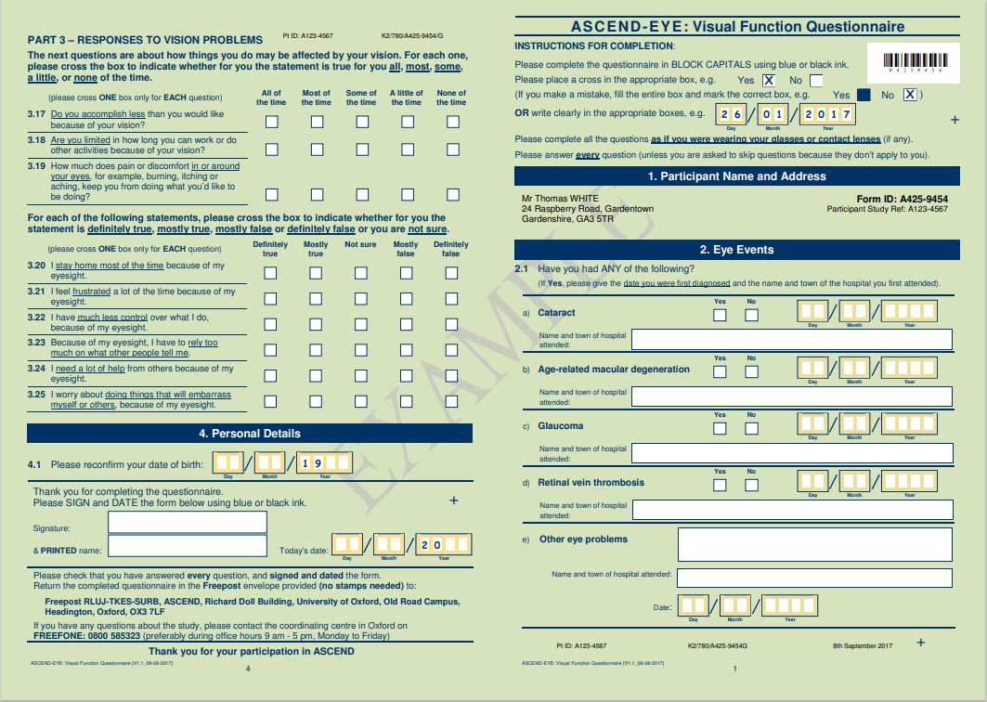

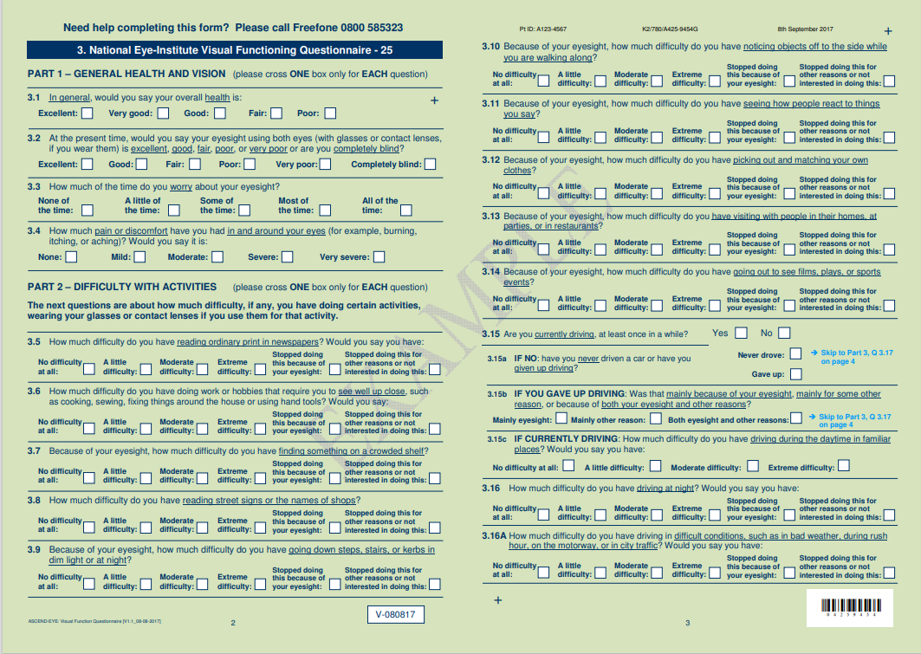

Calculation of NEI-VFQ-25 composite and subdomain scores
The NEI-VFQ-25 subdomain and composite scores were calculated using the “NEI-VFQ-25 Scoring Algorithm – August 2000” ¹ as follows: Step 1: Numeric values from the survey were recoded following the scoring rules shown in table A. All items were converted to a 0 to 100 scale where higher scores represented better functioning. In this format, scores represent the achieved percentage of the possible total, e.g. a score of 25 represents 25% of the highest possible score.
Step 2: Items within each subdomain were averaged together. Table B indicates which items contributed to each subdomain. Items left blank (missing data) were not considered when calculating the subdomain scores. Subdomains with at least one item answered were used to generate a subdomain score. Hence, scores represented the average for all items in the subdomain that the respondent answered.
The subdomain scores were then averaged to calculate an overall composite score, excluding the general health rating question (Q1). By averaging subdomain scores rather than individual items, equal weight is given to each visual domain, whereas averaging the items would give more weight to domains with more items.
Table A: Recoding of responses (analysis step 1)
Question Number | Change response category | Recoded value
1,3,4,15c | 1 | 100
 | 2 | 75
 | 3 | 50
 | 4 | 25
 | 5 | 0
2 | 1 | 100
 | 2 | 80
 | 3 | 60
 | 4 | 40
 | 5 | 20
 | 6 | 0
5,6,7,8,9,10,11, 12, 13, 14, 16, 16a, | 1 | 100
 | 2 | 75
 | 3 | 50
 | 4 | 25
 | 5 | 0
 | 6 | *
17, 18, 19, 20, 21, 22, 23, 24, 25 | 1 | 0
 | 2 | 25
 | 3 | 50
 | 4 | 75
 | 5 | 100
*Response choice “6” indicates that the person does not perform the activity because of non-vision-related problems. If this choice is selected, the item is coded as missing.

Table B: Averaging of questions to generate NEI-VFQ-25 subdomains (analysis step 2)
Scale | Number of questions | Questions to be averaged after recoding
General health | 1 | 1
General vision | 1 | 2
Ocular pain | 2 | 4, 19
Near activities | 3 | 5, 6, 7
Distance activities | 3 | 8, 9. 14
Vision-specific: social functioning | 2 | 11,13
Vision-specific: mental health | 4 | 3, 21, 22, 25
Vision-specific: role difficulties | 2 | 17, 18
Vision-specific: dependency | 3 | 20, 23, 24
Driving * | 3 | 15c, 16, 16a
Colour vision | 1 | 12
Peripheral vision | 1 | 10
* Q15c has four response levels, which are expanded to a 5-level response using Q15b:
- If 15b = 1, then 15c should be recoded to 0
- If 15b = 2, then 15c should be recoded as missing
- If 15b = 3, then 15c should be recoded as missing.
Questions 15c, 16 and 16a represent the only questions included in the driving subdomain score. However, participants navigate to Q15c via three screening questions to clarify whether they are currently driving. Where there was missing data or where a nonsensical combination of answers was given for questions 15 to 16a, ASCEND-Eye applied the following rules:
Analysis of Q15c was restricted to those who either indicated in Q15 that they were current drivers or indicated in Q15a or Q15b that they have given up driving. Questions 16 and 16a may be answered by anyone who has ever driven, including those who are currently driving (as in question 15) and those who have previously driven but gave up (question 15a). Questions 16 and 16a offer a second opportunity to indicate that an individual has stopped driving at night or in adverse weather conditions, respectively, due to visual impairment or other reasons. Therefore, individuals were included in analyses of questions 16 and 16a if an answer had been given, irrespective of their responses to questions 15, 15b or 15c, but those who responded to question 15a that they have never driven were excluded.

Table S1: Data Cut-Points for NEI-VFQ-25 Composite and Vision-Targeted Subdomain Scoring Categories

NEI-VFQ-25 Component | Ordinal Category*
Composite score | ≥90, 80-89, 70-79, 60-69 and <60
Subdomain score
General Vision | 100,80-99,60-79 and <60
Ocular Pain | ≥90,80-89, 70-79,60-69 and <60
Near Activities | 100, 90-99, 80-89, 70-79 and <70
Distance Activities | 100, 90-99, 80-89, 70-79 and <70
Social Functioning | ≥90, 80-89, 70-79 and <70
Mental Health | ≥90, 80-89, 70-79, 60-69 and <60
Role Dependency | ≥90, 80-89, 70-79 and <70
Vision-Specific Dependency | 100, <100
Driving | 100, 80-99, 60-79 and <60
Colour Vision | 100,75-99 and <75
Peripheral Vision | 100,75-99 and <75
General Health† | 100, 75-99, 50-74, 25-49 and <25
*Data cut points were chosen on the basis of preliminary blinded assessment of the distribution of scores
†Analyses of the General Health subdomain were conducted post-hoc.

Table S2 Baseline Characteristics of Visual Functioning Questionnaire Responders and Non-Responders by Eligibility to be sent the Questionnaire
Baseline Characteristic | Eligible to be sent the VFQ (n=11,301) |  |  |  | Ineligible to be sent the VFQ  (n=4179)
Baseline Characteristic | Responders  (n=8846)* |  | Non-responders (n=2455)
Age at randomisation (years)
Mean (SD) | 62.5±8.3 |  | 62.8±9.0 |  | 65.2±10.7
<60 | 3339 | (37.7%) | 901 | (36.7%) | 1350 | (32.3%)
≥60<70 | 3860 | (43.6%) | 1024 | (41.7%) | 1363 | (32.6%)
≥70 | 1647 | (18.6%) | 530 | (21.6%) | 1466 | (35.1%)
Sex
Male | 5529 | (62.5%) | 1550 | (63.1%) | 2605 | (62.3%)
Female | 3317 | (37.5%) | 905 | (36.9%) | 1574 | (37.7%)
Type of diabetes
Type 1 | 559 | (6.3%) | 138 | (5.6%) | 214 | (5.1%)
Type 2 | 8287 | (93.7%) | 2317 | (94.4%) | 3965 | (94.9%)
Duration of diabetes (years)
Median (IQR) | 7(3-12) |  | 7 (4-13) |  | 7 (4-13)
≥0<5 years | 2918 | (33.0%) | 751 | (30.6%) | 1222 | (29.2%)
≥5<10 years | 2544 | (28.8%) | 690 | (28.1%) | 1100 | (26.3%)
≥10<20 years | 1952 | (22.1%) | 552 | (22.5%) | 1033 | (24.7%)
≥20 years | 1020 | (11.5%) | 313 | (12.7%) | 529 | (12.7%)
Unknown | 412 | (4.7%) | 149 | (6.1%) | 295 | (7.1%)
Diabetes management
Diet only | 1508 | (17.0%) | 396 | (16.1%) | 625 | (15.0%)
Oral hypoglycaemic agent(s) only | 5166 | (58.4%) | 1416 | (57.7%) | 2438 | (58.3%)
Insulin +/- oral hypoglycaemic agent(s) | 2172 | (24.6%) | 643 | (26.2%) | 1116 | (26.7%)
Participant-reported diabetic retinopathy
Yes | 1628 | (18.4%) | 537 | (21.9%) | 858 | (20.5%)
No | 7151 | (80.8%) | 1895 | (77.2%) | 3267 | (78.2%)
Unknown | 67 | (0.8%) | 23 | (0.9%) | 54 | (1.3%)
Participant-reported treatment for hypertension
Yes | 5386 | (60.9%) | 1534 | (62.5%) | 2613 | (62.5%)
No | 3405 | (38.5%) | 904 | (36.8%) | 1526 | (36.5%)
Unknown | 55 | (0.6%) | 17 | (0.7%) | 40 | (1.0%)
Systolic blood pressure
(mmHg)
Mean (SD) | 135.8±14.9 |  | 136.3±15.2 |  | 136.8±15.9
<130 | 2023 | (22.9%) | 522 | (21.3%) | 849 | (20.3%)
≥130<140 | 1822 | (20.6%) | 491 | (20.0%) | 778 | (18.6%)
≥140 | 2626 | (29.7%) | 720 | (29.3%) | 1209 | (28.9%)
Unknown | 2375 | (26.8%) | 722 | (29.4%) | 1343 | (32.1%)
Diastolic blood pressure
(mmHg)
Mean (SD) | 77.4±9.2 |  | 77.0±9.6 |  | 76.4±9.9
<75 | 2371 | (26.8%) | 650 | (26.5%) | 1202 | (28.8%)
≥75 <85 | 2788 | (31.5%) | 753 | (30.7%) | 1078 | (25.8%)
≥85 | 1311 | (14.8%) | 326 | (13.3%) | 554 | (13.3%)
Unknown | 2376 | (26.9%) | 726 | (29.6%) | 1345 | (32.2%)
Body mass index
(kg/m²)
Mean (SD) | 30.6±6.1 |  | 30.9±6.3 |  | 30.9±6.5
<25 | 1313 | (14.8%) | 309 | (12.6%) | 627 | (15.0%)
≥25, <30 | 3230 | (36.5%) | 901 | (36.7%) | 1398 | (33.5%)
≥30<35 | 2429 | (27.5%) | 688 | (28.0%) | 1123 | (26.9%)
≥35 | 1619 | (18.3%) | 472 | (19.2%) | 870 | (20.8%)
Unknown | 255 | (2.9%) | 85 | (3.5%) | 161 | (3.9%)
Cigarette smoking
Current | 555 | (6.3%) | 224 | (9.1%) | 500 | (12.0%)
Former | 3947 | (44.6%) | 1133 | (46.2%) | 1971 | (47.2%)
Never | 4243 | (48.0%) | 1067 | (43.5%) | 1667 | (39.9%)
Unknown | 101 | (1.1%) | 31 | (1.3%) | 41 | (1.0%)
Non-study medication
ACE-inhibitor or ARB | 5115 | (57.8%) | 1461 | (59.5%) | 2479 | (59.3%)
Aspirin use before screening | 3157 | (35.7%) | 879 | (35.8%) | 1472 | (35.2%)
Thiazide or related diuretic | 1639 | (18.5%) | 465 | (18.9%) | 853 | (20.4%)
Calcium channel blocker | 2088 | (23.6%) | 605 | (24.6%) | 1080 | (25.8%)
Statin | 6769 | (76.5%) | 1862 | (75.8%) | 3022 | (72.3%)
Total cholesterol
(mmol/L)
Mean (SD) | 4.1±0.9 |  | 4.1±0.9 |  | 4.2±0.9
<4 | 2681 | (30.3%) | 704 | (28.7%) | 1169 | (28.0%)
≥4 <5 | 2246 | (25.4%) | 595 | (24.2%) | 954 | (22.8%)
≥5 | 817 | (9.2%) | 226 | (9.2%) | 427 | (10.2%)
Not available | 3102 | (35.1%) | 930 | (37.9%) | 1629 | (39.0%)
HDL cholesterol
(mmol/L)
Mean (SD) | 1.3±0.4 |  | 1.3±0.4 |  | 1.2±0.4
<1 | 1222 | (13.8%) | 343 | (14.0%) | 605 | (14.5%)
≥1<1.5 | 3202 | (36.2%) | 870 | (35.4%) | 1451 | (34.7%)
≥1.5 | 1310 | (14.8%) | 307 | (12.5%) | 490 | (11.7%)
Not available | 3112 | (35.2%) | 935 | (38.1%) | 1633 | (39.1%)
Non-HDL cholesterol
(mmol/L)
Mean (SD) | 2.9±0.8 |  | 2.9±0.8 |  | 3.0±0.9
<2.5 | 2053 | (23.2%) | 505 | (20.6%) | 832 | (19.9%)
≥2.5 <3.5 | 2558 | (28.9%) | 716 | (29.2%) | 1119 | (26.8%)
≥3.5 | 1123 | (12.7%) | 299 | (12.2%) | 595 | (14.2%)
Not available | 3112 | (35.2%) | 935 | (38.1%) | 1633 | (39.1%)
Glycosylated haemoglobin - HbA1c
IFCC (mmol/mol) mean (SD) | 54.0±12.2 |  | 55.6±13.5 |  | 56.1±14.0
DCCT (%) mean (SD) | 7.1±1.1 |  | 7.2±1.2 |  | 7.3±1.3
<48 (6.5) | 1957 | (22.1%) | 496 | (20.2%) | 819 | (19.6%)
≥48 (6.5), <64 (8.0) | 2792 | (31.6%) | 697 | (28.4%) | 1175 | (28.1%)
≥64 (8.0) | 990 | (11.2%) | 332 | (13.5%) | 555 | (13.3%)
Not available | 3107 | (35.1%) | 930 | (37.9%) | 1630 | (39.0%)
CKD-EPI estimated GFR
(ml/min/1.73m²)
Mean (SD) | 87.8±19.8 |  | 84.8±20.4 |  | 79.5±23.1
≥90 | 2902 | (32.8%) | 671 | (27.3%) | 950 | (22.7%)
≥60<90 | 2299 | (26.0%) | 659 | (26.8%) | 1058 | (25.3%)
<60 | 540 | (6.1%) | 194 | (7.9%) | 542 | (13.0%)
Not available | 3105 | (35.1%) | 931 | (37.9%) | 1629 | (39.0%)
Urinary albumin:creatinine ratio†
(mg/mmol)
Median (IQR) | 0.50 (0.00-1.14) |  | 0.59 (0.16-1.40) |  | 0.71 (0.27-1.88)
<3 | 5120 | (57.9%) | 1313 | (53.5%) | 2093 | (50.1%)
≥3 | 613 | (6.9%) | 197 | (8.0%) | 438 | (10.5%)
Not available | 3113 | (35.2%) | 945 | (38.5%) | 1648 | (39.4%)
Townsend Deprivation Index
<-3 | 3101 | (35.1%) | 764 | (31.1%) | 1239 | (29.6%)
≥-3<0 | 3588 | (40.6%) | 930 | (37.9%) | 1504 | (36.0%)
≥0<2 | 1071 | (12.1%) | 364 | (14.8%) | 602 | (14.4%)
≥2<4 | 625 | (7.1%) | 244 | (9.9%) | 446 | (10.7%)
≥4<6 | 323 | (3.7%) | 112 | (4.6%) | 268 | (6.4%)
≥6 | 118 | (1.3%) | 37 | (1.5%) | 106 | (2.5%)
Unknown | 20 | (0.2%) | 4 | (0.2%) | 14 | (0.3%)
Ethnic origin
White | 8564 | (96.8%) | 2346 | (95.6%) | 4025 | (96.3%)
Indian/Pakistani/Bangladeshi | 107 | (1.2%) | 39 | (1.6%) | 38 | (0.9%)
African/Caribbean | 54 | (0.6%) | 29 | (1.2%) | 57 | (1.4%)
Other/unknown | 121 | (1.4%) | 41 | (1.7%) | 59 | (1.4%)
ACE= angiotensin-converting enzyme; ARB = angiotensin receptor blocker; DCCT = Diabetes Control and Complications Trial; FAs = Fatty acids; GFR = Glomerular Filtration Rate; HDL= High-density lipoprotein; IFCC = International Federation of Clinical Chemistry; IQR = Interquartile range; SD = Standard Deviation; VFQ=Visual Function Questionnaire
*Out of 8846 VFQ respondents, 7 answered a bespoke first page of questions that sought incident eye diagnoses but did not complete the NEI-VFQ-25, and 8839 completed both parts of the form.
†There was an analysis rule in ASCEND which stated that those with a below detectable threshold albumin component of their urinary albumin:creatinine ratio, would be recorded as zero. This applied to just over 25% of participants with no baseline eye screening records.
Percentages may not total 100 because of rounding.

Table S3 Reported Definite or Probable Adherence with Study Treatment Stratified by Years Post-Randomisation

 | Aspirin Randomization |  |  | Omega-3 FAs Randomization
 | Active (%) | Placebo (%) | Overall (%) | Active (%) | Placebo (%) | Overall (%)
Years post-randomisation
<3 | 89.3% | 90.3% | 89.5% | 93.8% | 93.2% | 93.5%
≥3<5 | 78.2% | 78.3% | 78.2% | 87.8% | 86.9% | 87.4%
≥5<7 | 70.5% | 70.6% | 70.5% | 83.8% | 82.6% | 83.2%
≥7 | 62.9% | 64.0% | 63.5% | 79.6% | 78.4% | 79.0%
All | 79.3% | 79.3% | 79.3% | 88.4% | 87.5% | 87.9%
FAs=Fatty acids
Criteria used to define definite or probable adherence:
- Definitely adherent = participant reported taking treatment every or most days during the follow-up period.
- Probably adherent = participant was previously adherent, was still receiving medication and had not reported stopping treatment within the last seven months.

Figure S1 General Vision Subdomain Score from the NEI-VFQ-25 by Aspirin Allocation
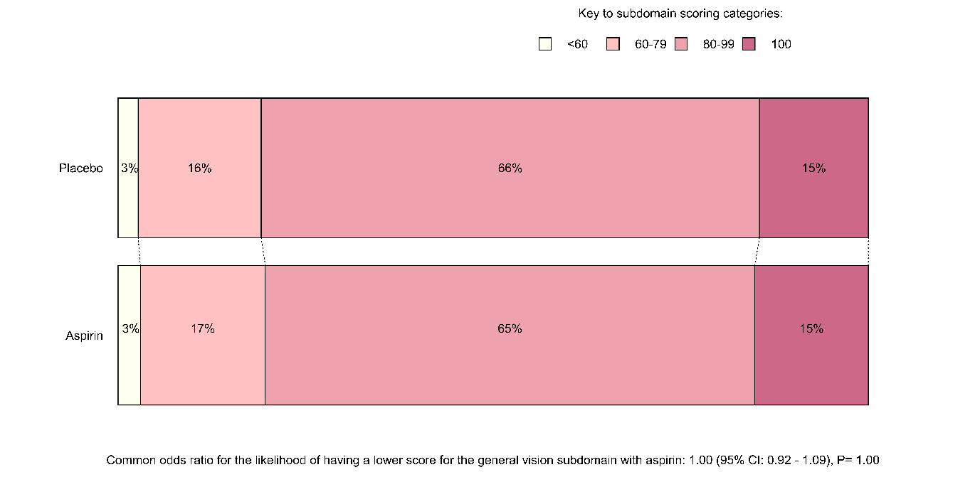
The number of participants who gave non-missing answers and contributed to this analysis was 8812

Figure S2 General Vision Subdomain Score from the NEI-VFQ-25 by Omega-3 Fatty Acids Allocation
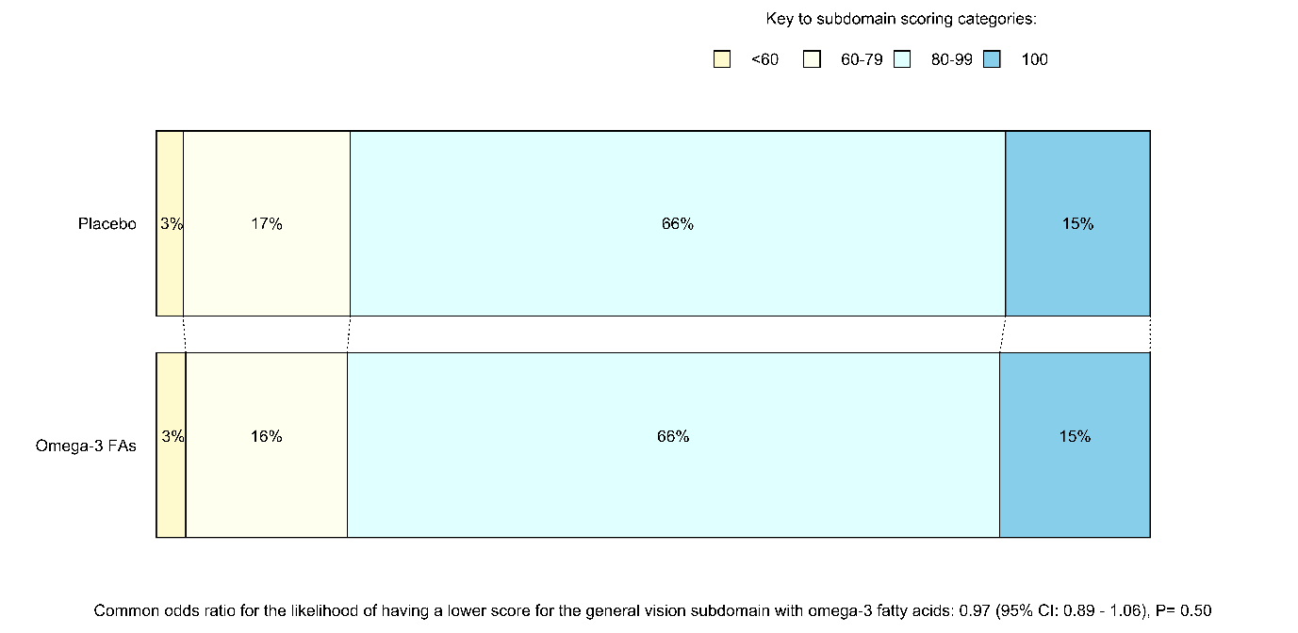
The number of participants who gave non-missing answers and contributed to this analysis was 8812

Figure S3 Ocular Pain Subdomain Score from the NEI-VFQ-25 by Aspirin Allocation
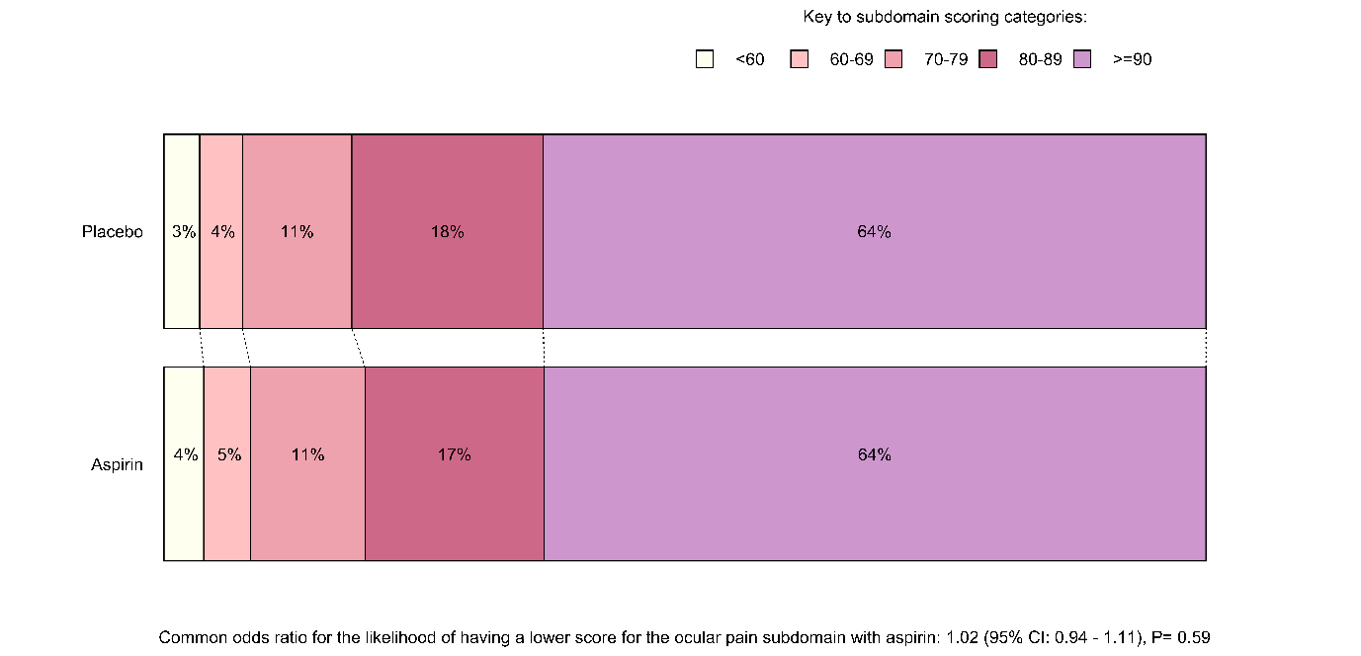
The number of participants who gave non-missing answers and contributed to this analysis was 8838

Figure S4 Ocular Pain Subdomain Score from the NEI-VFQ-25 by Omega-3 Fatty Acids Allocation
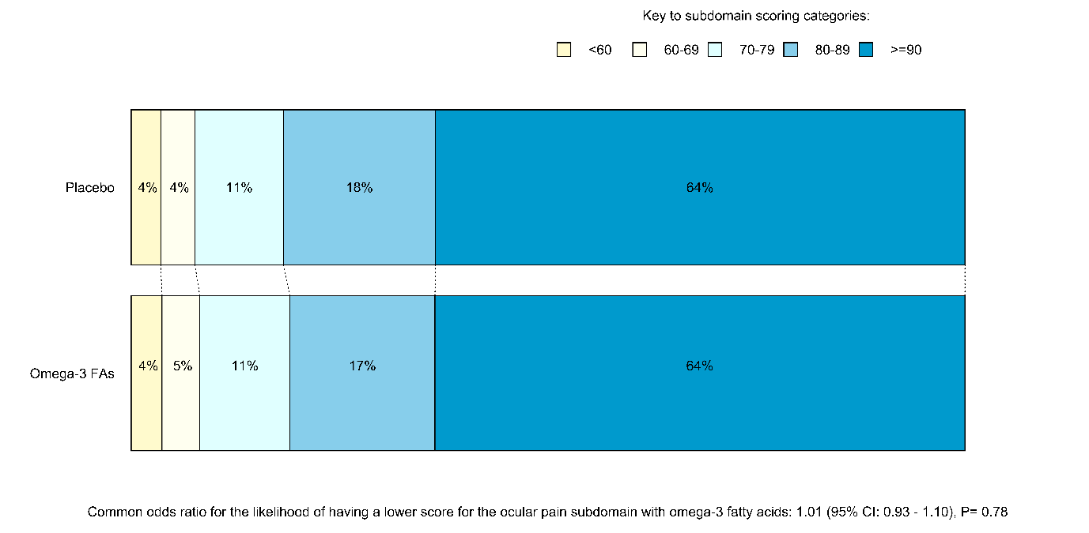
The number of participants who gave non-missing answers and contributed to this analysis was 8838

Figure S5 Near Activities Subdomain Score from the NEI-VFQ-25 by Aspirin Allocation
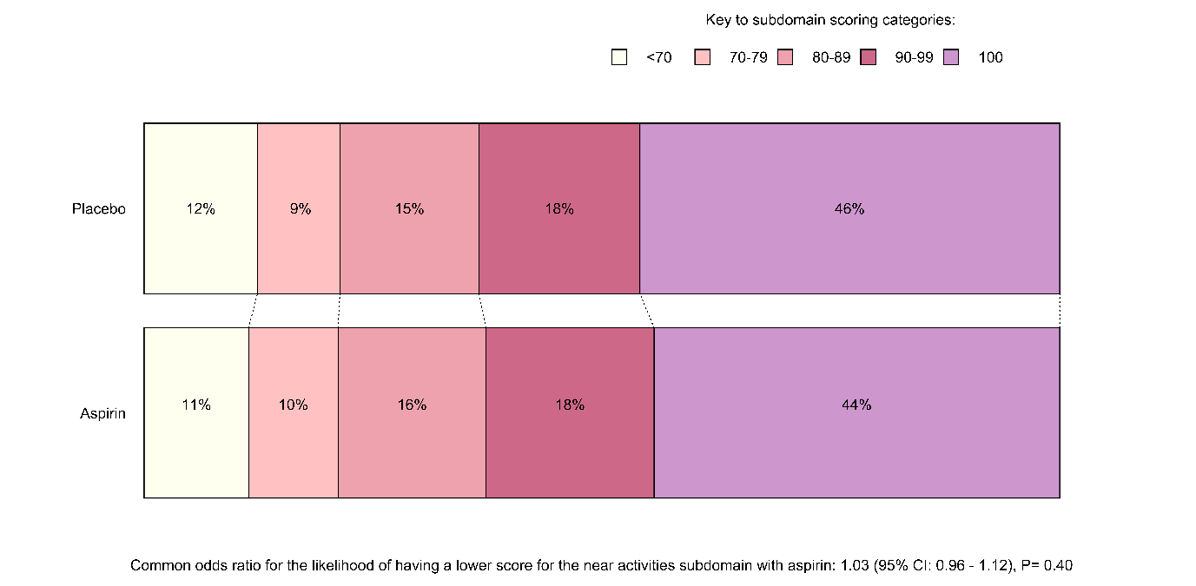
The number of participants who gave non-missing answers and contributed to this analysis was 8815

Figure S6 Near Activities Subdomain Score from the NEI-VFQ-25 by Omega-3 Fatty Acids Allocation
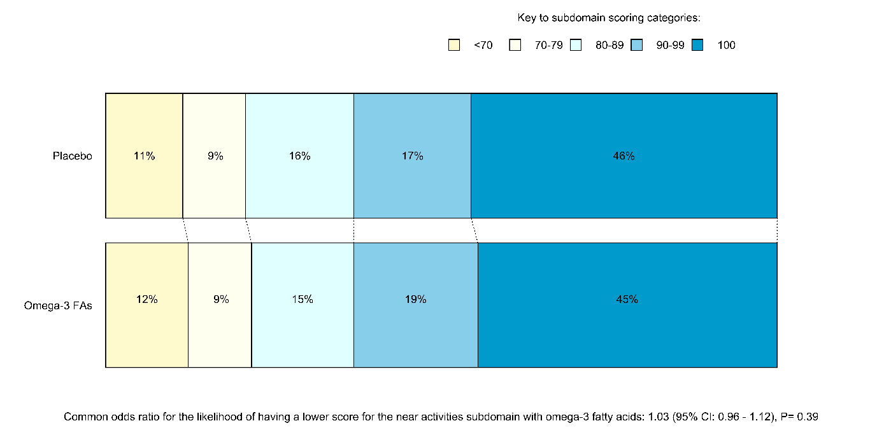
The number of participants who gave non-missing answers and contributed to this analysis was 8815

Figure S7 Distance Activities Subdomain Score from the NEI-VFQ-25 by Aspirin Allocation
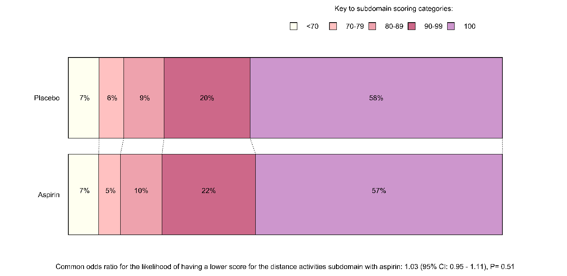
The number of participants who gave non-missing answers and contributed to this analysis was 8814

Figure S8 Distance Activities Subdomain Score from the NEI-VFQ-25 by Omega-3 Fatty Acids Allocation
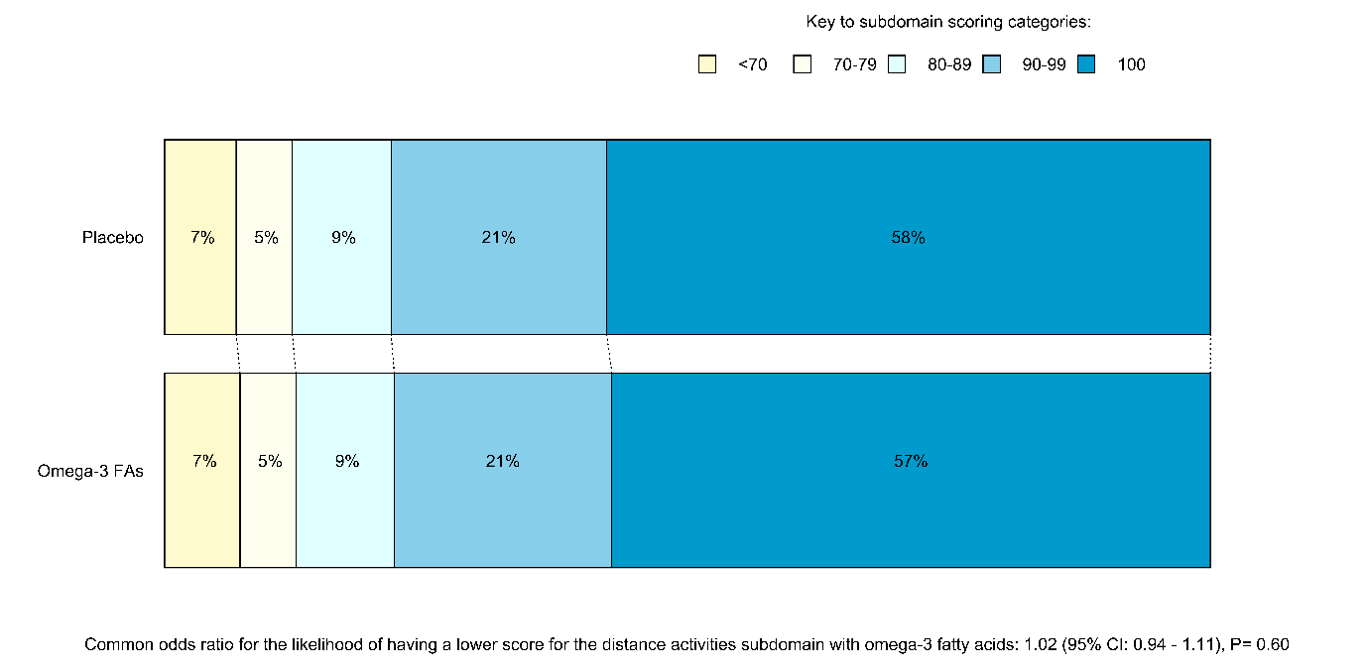
The number of participants who gave non-missing answers and contributed to this analysis was 8814

Figure S9 Social Functioning Subdomain Score from the NEI-VFQ-25 by Aspirin Allocation
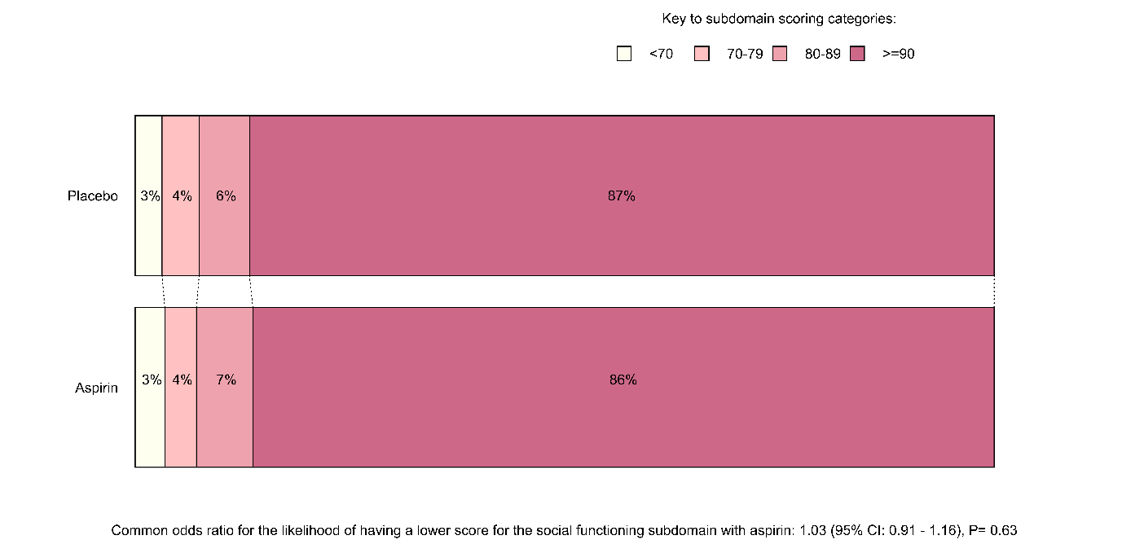
The number of participants who gave non-missing answers and contributed to this analysis was 8810

Figure S10 Social Functioning Subdomain Score from the NEI-VFQ-25 by Omega-3 Fatty Acids Allocation
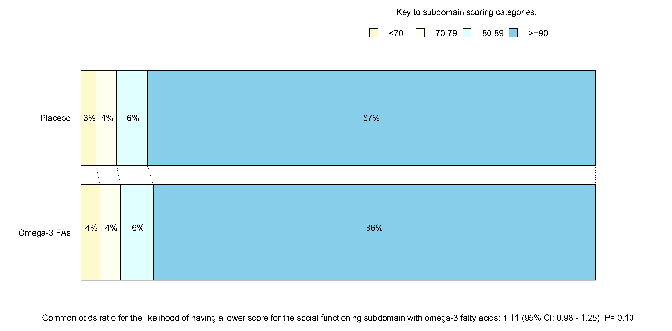
The number of participants who gave non-missing answers and contributed to this analysis was 8810

Figure S11 Mental Health Subdomain Score from the NEI-VFQ-25 by Aspirin Allocation
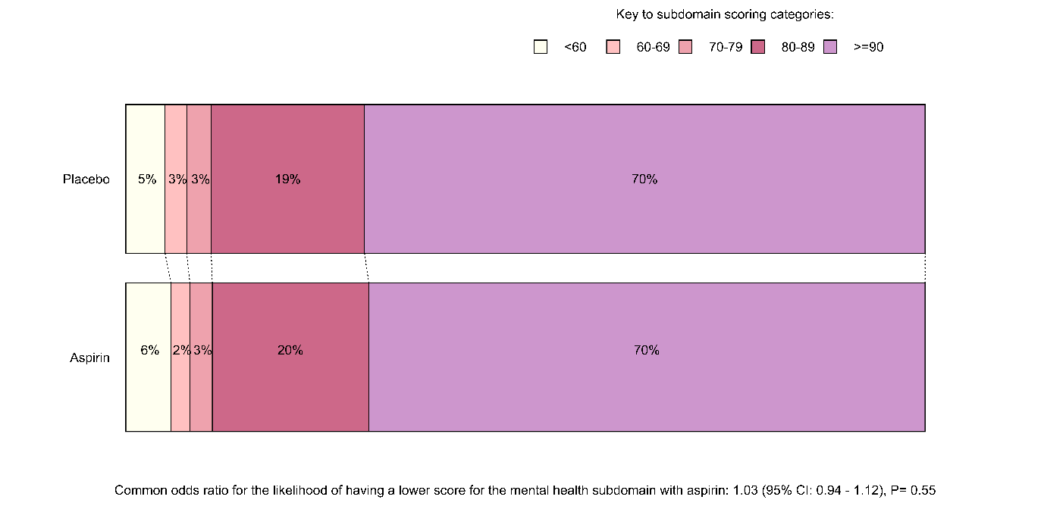
The number of participants who gave non-missing answers and contributed to this analysis was 8833

Figure S12 Mental Health Subdomain Score from the NEI-VFQ-25 by Omega-3 Fatty Acids Allocation
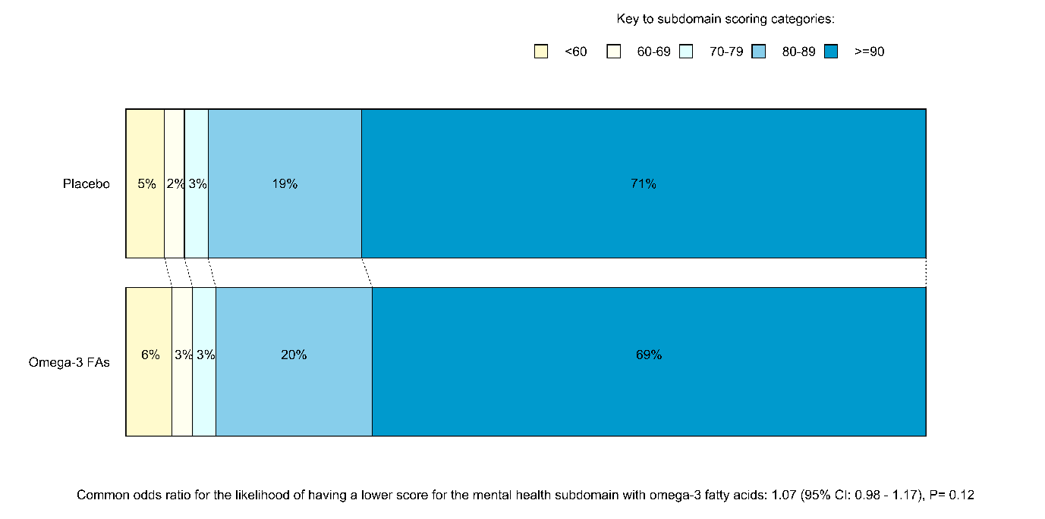
The number of participants who gave non-missing answers and contributed to this analysis was 8833

Figure S13 Role Dependency Subdomain Score from the NEI-VFQ-25 by Aspirin Allocation
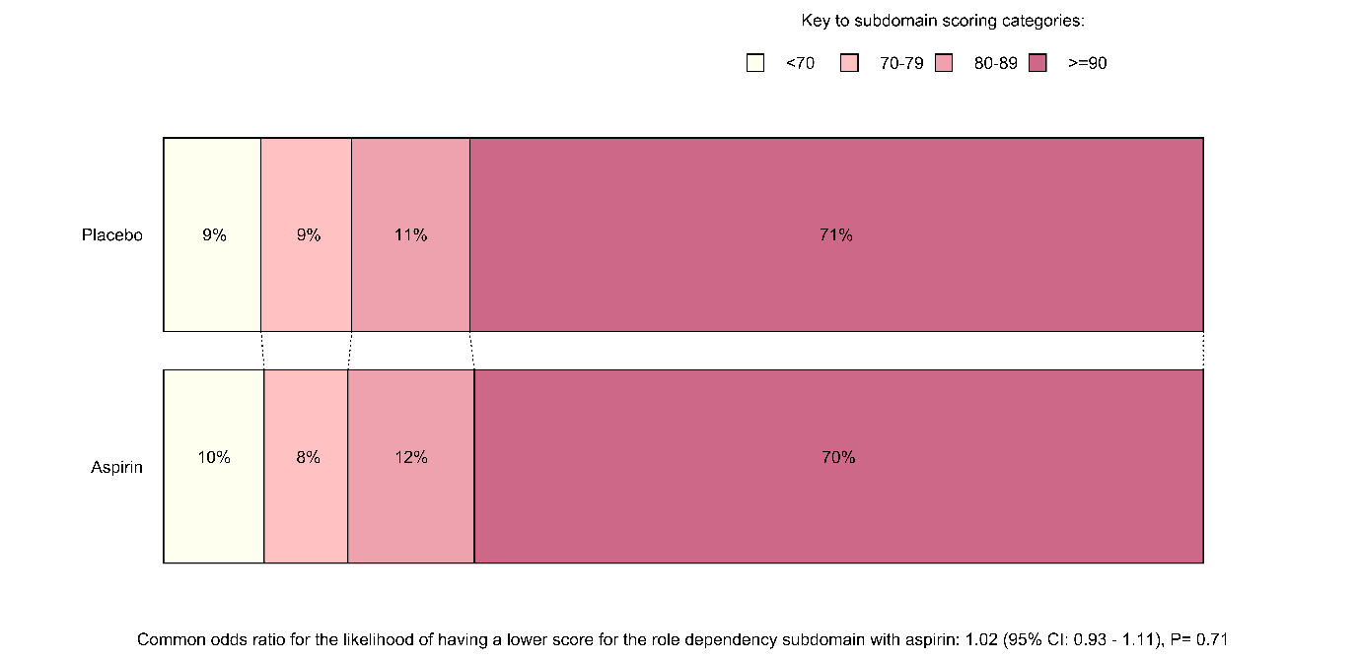
The number of participants who gave non-missing answers and contributed to this analysis was 8734

Figure S14 Role Dependency Subdomain Score from the NEI-VFQ-25 by Omega-3 Fatty Acids Allocation
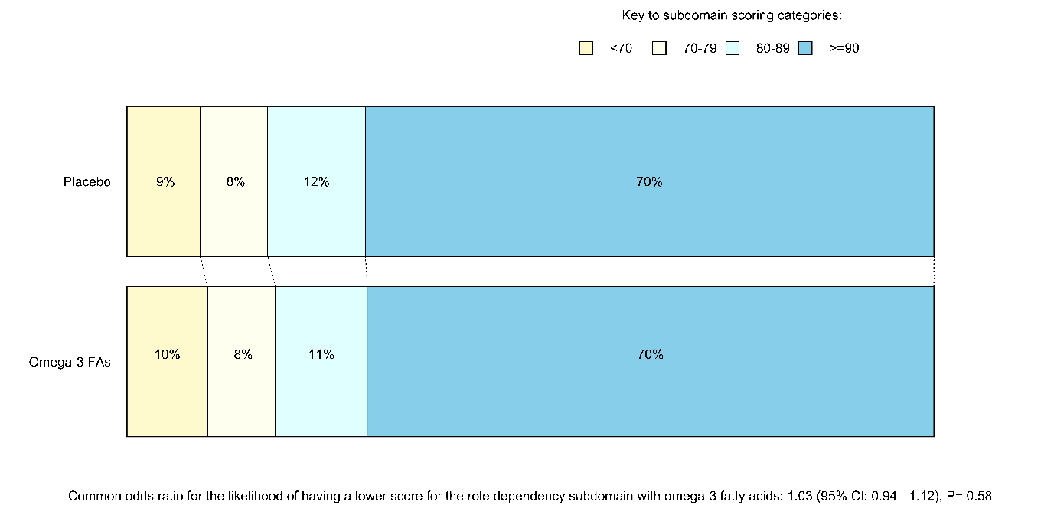
The number of participants who gave non-missing answers and contributed to this analysis was 8734

Figure S15 Vision-Specific Dependency Subdomain Score from the NEI-VFQ-25 by Aspirin Allocation
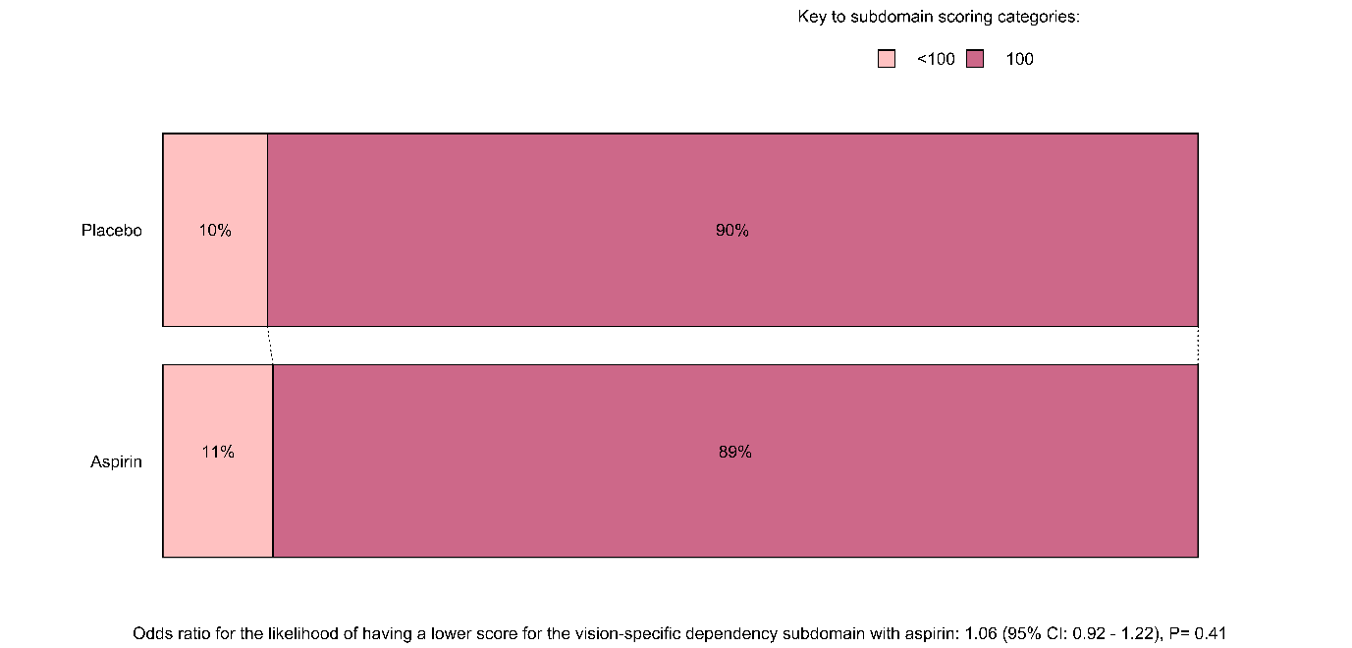
The number of participants who gave non-missing answers and contributed to this analysis was 8793

Figure S16 Vision-Specific Dependency Subdomain Score from the NEI-VFQ-25 by Omega-3 Fatty Acids Allocation
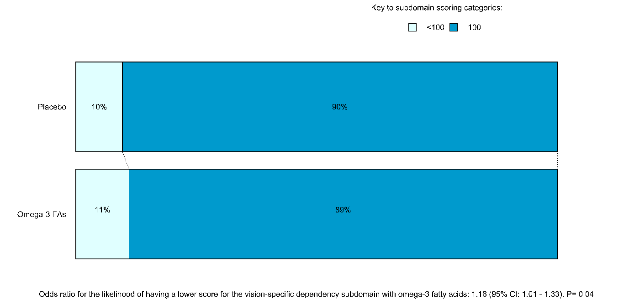
The number of participants who gave non-missing answers and contributed to this analysis was 8793

Figure S17 Driving Subdomain Score from the NEI-VFQ-25 by Aspirin Allocation
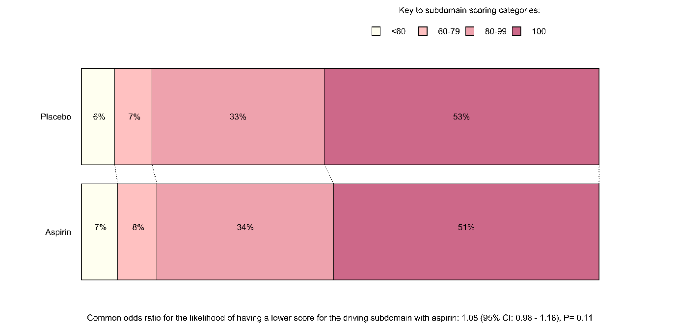
The number of participants who gave non-missing answers and contributed to this analysis was 6416

Figure S18 Driving Subdomain Score from the NEI-VFQ-25 by Omega-3 Fatty Acids Allocation
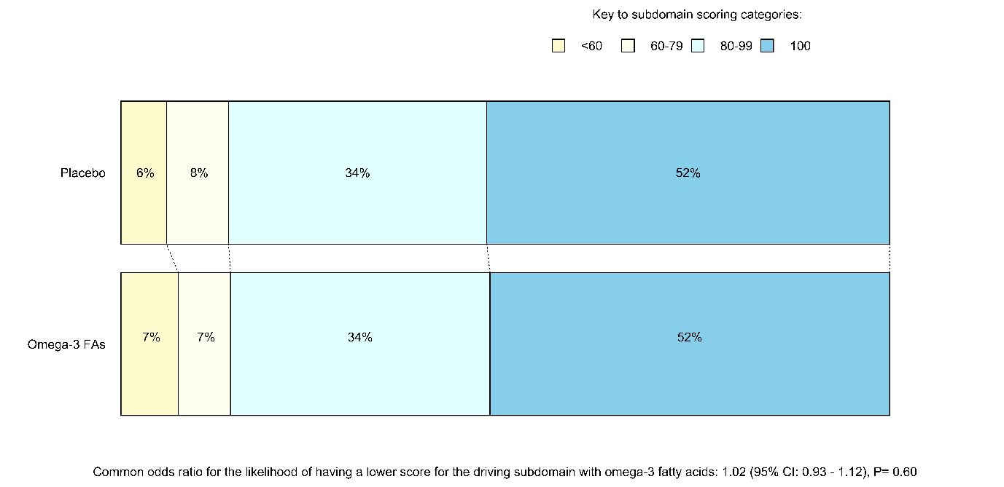
The number of participants who gave non-missing answers and contributed to this analysis was 6416

Figure S19 Colour Vision Subdomain Score from the NEI-VFQ-25 by Aspirin Allocation
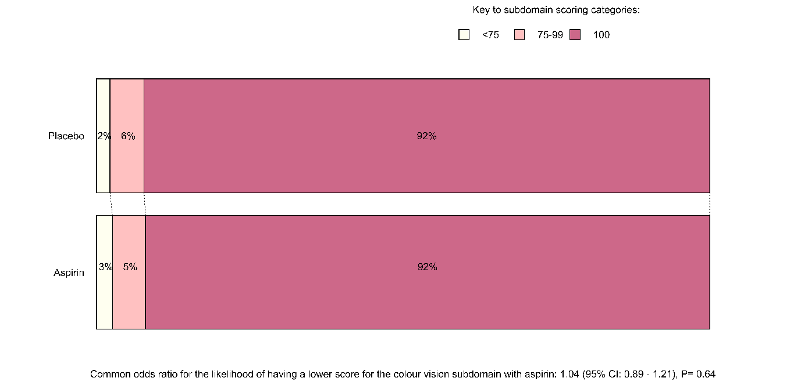
The number of participants who gave non-missing answers and contributed to this analysis was 8742

Figure S20 Colour Vision Subdomain Score from the NEI-VFQ-25 by Omega-3 Fatty Acids Allocation
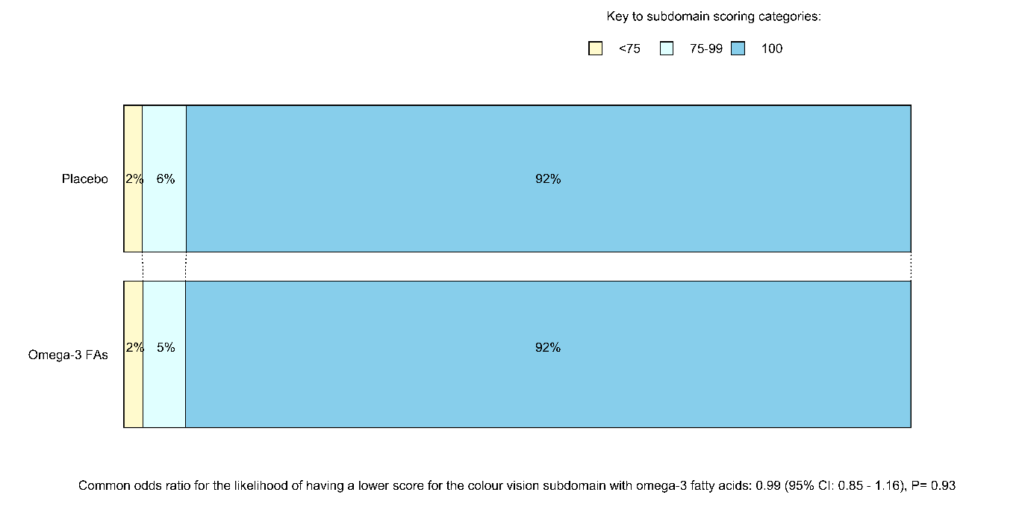
The number of participants who gave non-missing answers and contributed to this analysis was 8742

Figure S21 Peripheral Vision Subdomain Score from the NEI-VFQ-25 by Aspirin Allocation
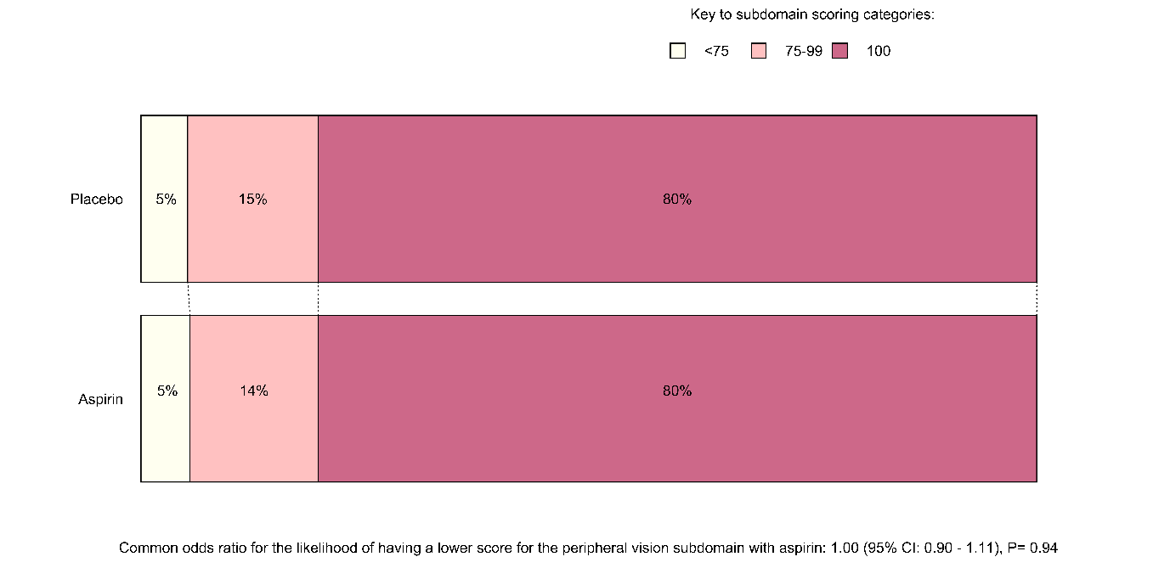
The number of participants who gave non-missing answers and contributed to this analysis was 8780

Figure S22 Peripheral Vision Subdomain Score from the NEI-VFQ-25 by Omega-3 Fatty Acids Allocation
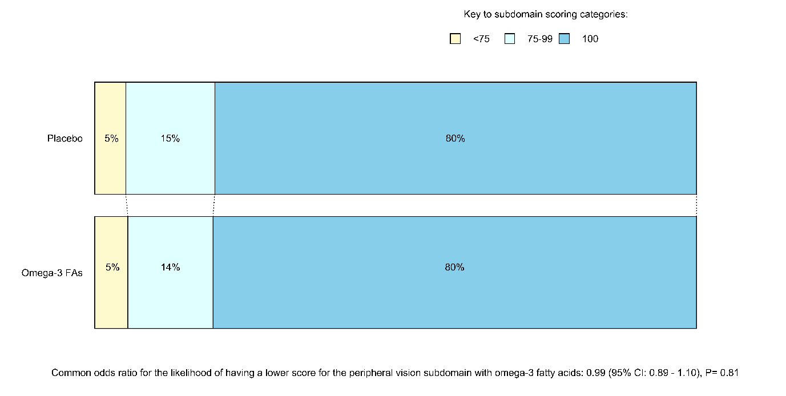
The number of participants who gave non-missing answers and contributed to this analysis was 8780

Figure S23 General Health Subdomain Score from the NEI-VFQ-25 by Aspirin Allocation
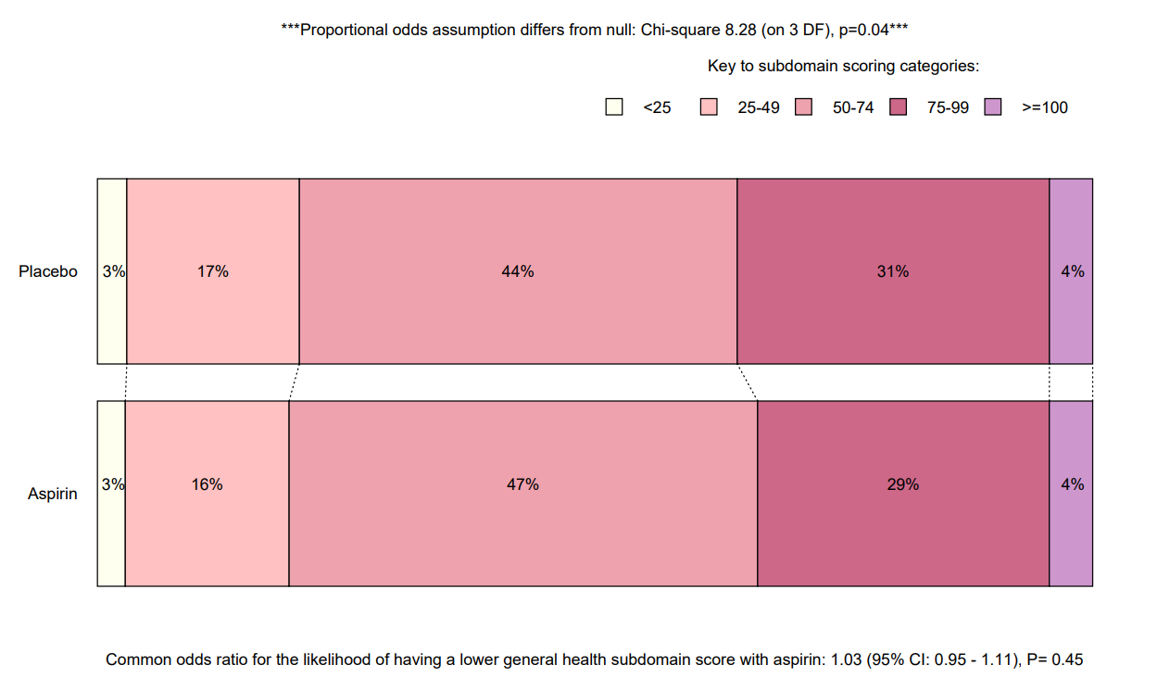
The number of participants who gave non-missing answers and contributed to this analysis was 8547

Figure S24 General Health Subdomain Score from the NEI-VFQ-25 by Omega-3 Fatty Acids Allocation
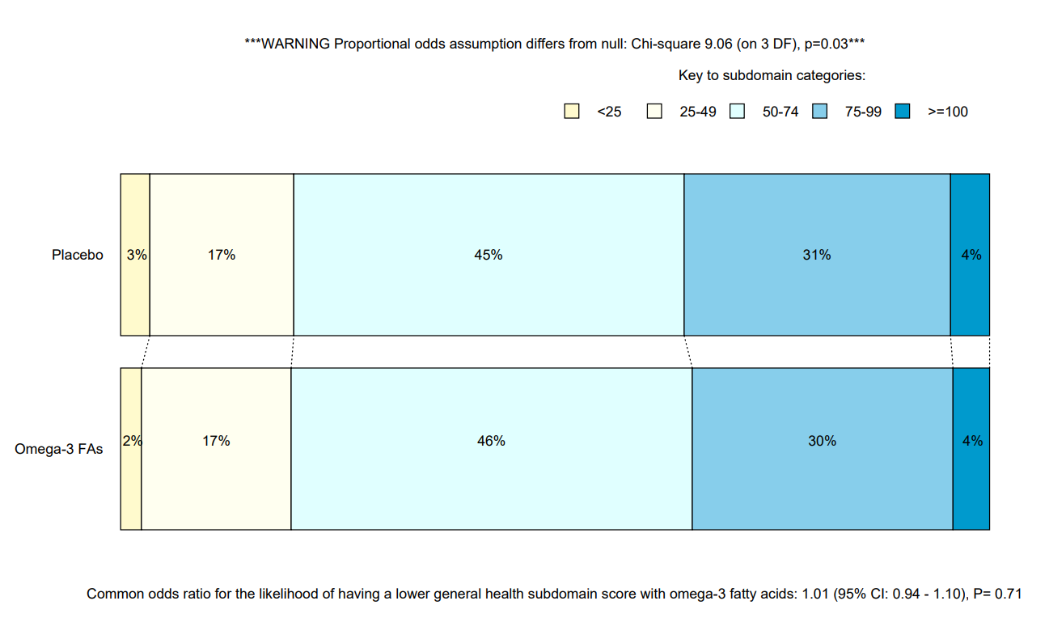
The number of participants who gave non-missing answers and contributed to this analysis was 8547

References
1. Mangione CM, Lee PP, Gutierrez PR, et al. Development of the 25-list-item National Eye Institute Visual Function Questionnaire. Archives of Ophthalmology 2001; 119(7): 1050-8.
2. Roozenbeek B, Lingsma HF, Perel P, et al. The added value of ordinal analysis in clinical trials: an example in traumatic brain injury. Critical Care 2011; 15(3): R127.
3. Valenta Z, Pitha J, Poledne R. Proportional odds logistic regression--effective means of dealing with limited uncertainty in dichotomizing clinical outcomes. Statistics in Medicine 2006; 25(24): 4227-34.

