Supplementary Materials
Model Development
Slice Selection and Severity Evaluation CNN
For slice selection model, we proposed a custom designed 18-layer CNN for binary classification. We firstly introduced a dual-branch structure with spatial attention mechanism proposed by Fukui et. al. 2019 [1]. In this structure, an attention branch was utilized for generating attention location map based on CAM [2], while the other branch output the classification result by merging the result of attention branch. The two branches can be trained and optimized at the same time. In this way, attention branch mechanism can boost the visual explanation ability and improve the performance of image recognition model simultaneously. Meanwhile, another attention mechanism called Concurrent spatial and channel squeeze & excitation (scSE) was used in our model. scSE modules can recalibrate the extracted feature map by given higher activation where it gets high importance spatially or channel-wise. It enables the CNN to learn more meaningful feature maps and is proven to be able to boost the classification and segmentation performance of CNNs. We integrate scSE modules into our slice selection model to embed pixel-wise spatial information. The basic building block in original ResNet was replaced by scSE blocks to allow the CNN extract more spatial and channel information. The two attention mechanisms of the model allow it to provide a natural visualization to explain the classification.
The input of the network was a two-dimensional CT slice, with size of 224×224 pixels. The scSE modules generate multiple feature maps for input CT images. Following that, the extracted feature map is fed to the dual branch structure. The attention branch can generate spatial attention location map based on the feature map. Then the spatial information is merged in the perception branch and give final classification result. Grad-CAM mechanism is used in perception branch to visualize the interest lesion region and generate an activation map.
We used binary cross entropy as loss function and the computed loss was back propagated to update the parameters by SGD optimizer with momentum of 0.9. The number of training epochs was 40 and the batch size was 128. The learning rate is initialized as 0.005 and decreased by a factor of 0.1 every 10 epochs. Each training image is applied random rotation and flipping for data augmentation.
We also designed an internal validation test to assess the ability of the AI diagnostic system to classify the cases as normal vs abnormal (TB) in a real-world clinic. The test set consisted of 30 TB suspected cases (mean age, 41.2±13.2 years; range, 19-70 years; male 21, female 9) and 30 normal controls (mean age, 33.8±10.3 years; range, 20-63 years; male 14, female 16) from fever clinic between February and June, 2020. The main clinical symptoms for these cases were fever, cough, and fatigue. To achieve the optimal performance, we set the threshold (if the predicted probability is higher than the threshold, the patient was classified as TB positive) to 0.995. From the perspective of a whole case, all normal cases were determined as no findings, while 29 cases from TB group were detected to have at least one lesion.
Object Detection CNN
CenterNet is the state of art anchor-free object detection model which achieves trade-off between accuracy and speed. We adopt Hourglass network with 104 layers as backbone since it outperformed other backbones. In CenterNet, objects are represented by only the center points of their ROIs. The backbone of CenterNet firstly generates a heatmap for each input image. All the peak points in the heatmap represent centers of ROIs. Then, the widths and heights of ROIs can be directly regressed form image features at the center location.
During the training phase of CenterNet, annotated ground truth ROIs are firstly converted into heatmaps. For each training image, CenterNet can generate a heatmap and then the error between predicted heatmap and annotated heatmap is optimized by focal loss function [3]. All the patches are resized into 512×512 and applied data augmentation. The parameters of network are randomly initialized and initial learning rate is 5e⁻⁴. Learning rate decay by 0.1 every 40 iteration. The model is trained by Adam optimizer with a batch-size of 4 for 200 epochs.
Disease Diagnosis CNN
Squeeze and Excitation network is state of art classification model which introduced a module called SE module to improve representational ability of convolution neural networks. SE modules are seamlessly integrated into basic blocks of ResNet to re-calibrate channel-wise features dynamic. SE modules extract multiple feature maps from input images and then fully connected layers with Softmax activation function can predict the probability of each category.
Transfer learning is used in this model so that pretrained knowledge of ImageNet image classification task can be applied in disease diagnosis task. The original ResNet-18 output tens of category while in this project there are only 6 categories. In our model, the output fully connected layer size is modified to 512×6 corresponds to the 6 categories. The pretrained model is finetuned on our training data for 100 epochs. Adam optimizer with a learning rate 0.05 is used to optimize the neural network. The learning rate decays by a factor of 0.98 each epoch. In order to improve the accuracy of model, Label smoothing technique is used during training phase which improves generalization performance of proposed model.
References
1. H. Fukui, T. Hirakawa, T. Yamashita and H. Fujiyoshi, "Attention Branch Network: Learning of Attention Mechanism for Visual Explanation," 2019 IEEE/CVF Conference on Computer Vision and Pattern Recognition (CVPR), Long Beach, CA, USA, 2019, pp. 10697-10706, doi: 10.1109/CVPR.2019.01096.
2. B. Zhou, A. Khosla, A. Lapedriza, A. Oliva and A. Torralba, "Learning Deep Features for Discriminative Localization," 2016 IEEE Conference on Computer Vision and Pattern Recognition (CVPR), Las Vegas, NV, 2016, pp. 2921-2929, doi: 10.1109/CVPR.2016.319.
3. T. Lin, P. Goyal, R. Girshick, K. He and P. Dollár, "Focal Loss for Dense Object Detection," 2017 IEEE International Conference on Computer Vision (ICCV), Venice, 2017, pp. 2999-3007, doi: 10.1109/ICCV.2017.324.

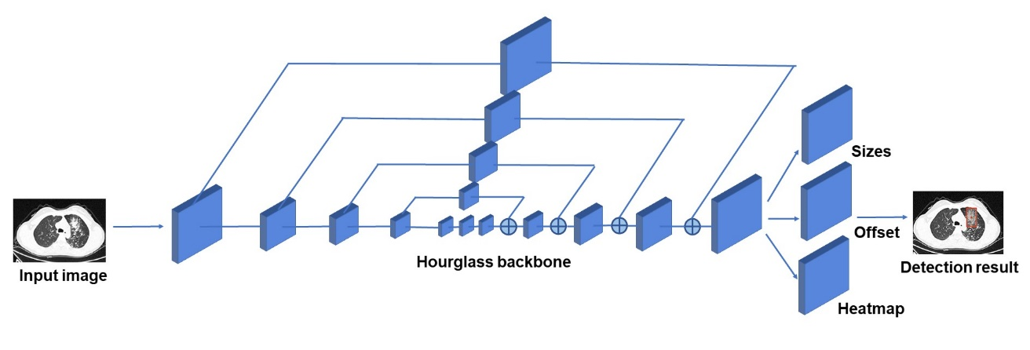
Fig. S1 Neural network architecture of the subsystem is based on CenterNet for object detection.

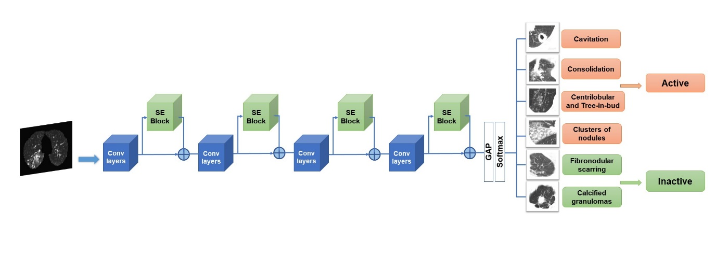
Fig. S2 Neural network architecture of the subsystem is based on ResNet-20 for classification.

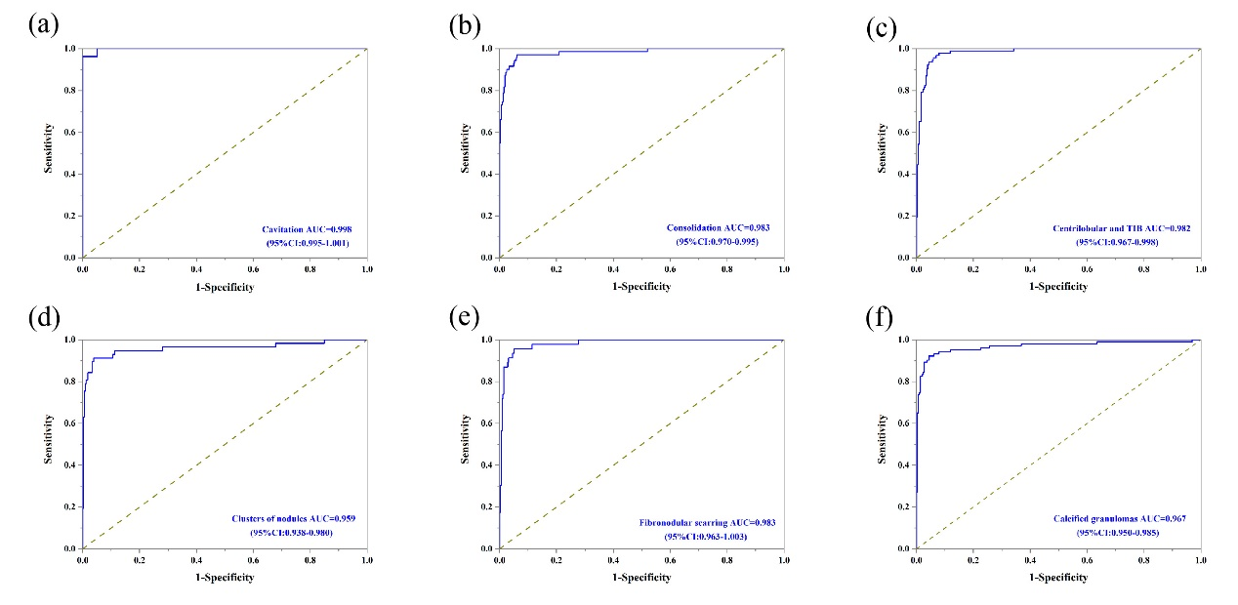Fig. S3 ROCs of classification performance for six critical imaging features on the validation cohort. ROC receiver operating characteristic curve

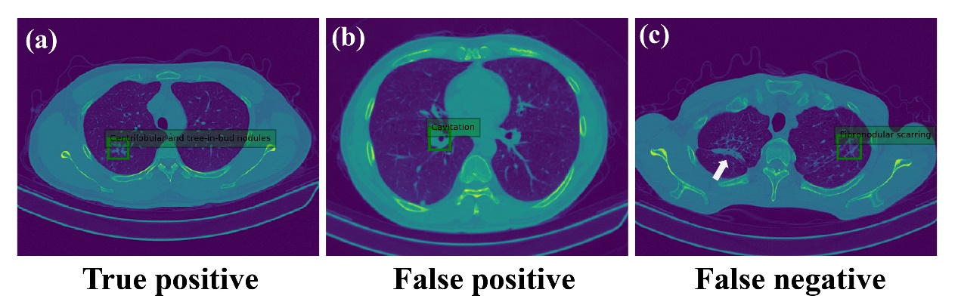
Fig. S4 Examples of the candidate regions detected and diagnosed by the AI algorithm. (a) Model localize and diagnose the TB lesion correctly. (b) Blood vessel in the hilum was misdiagnosed as cavitation. (c) Calcified granuloma in the right upper lobe (white arrow) was missed by the algorithm. AI artificial intelligence, TB tuberculosis

Table S1 Performance of the AI model for classification and diagnosis in the development phase
 | Validation set
 | Recall (%) | Precision (%) | F1-score | AUC
Cavitation | 85.16% | 100% | 91.99% | 0.998
Consolidation | 78.87% | 91.80% | 84.85% | 0.983
Centrilobular and Tree-in-bud | 84.78% | 88.64% | 86.67% | 0.982
Clusters of nodules | 71.93% | 95.35% | 82.00% | 0.959
Fibronodular scarring | 76.09% | 87.50% | 81.40% | 0.983
Calcified granulomas | 92.55% | 84.47% | 88.33% | 0.967

