Supplementary Information

Table S1. Antibodies used in this study.
Antigen | Company | Catalogue# | Dilution (immunofluorescence) | Dilution (western blotting)
RIP3 | NOVUS | NBP1-77299 |  | 1:1000
MLKL | Sigma-Aldrich | SAB1302339 |  | 1:500
p-MLKL | Abcam | ab196436 |  | 1:1000
Acrolein | NOF | N213320 |  | 1:1000
GPx4 | established by Imai H. |  | 1:1000 | 1:5000
GAPDH | Wako | 016-25523 |  | 1:1000 for insoluble fraction, 1:10000 for other samples
ZO-1 | Thermo Fisher Scientific | 61-7300 | 1:400
C9 | Santa-Cruz | sc-66190 |  | 1:600
C3b/iC3b/C3c | Hycult | HM-1065 | 1:50
Iba1 | wako | 019-19741 | 1:500
F4/80 | Biorad | MCA-497 | 1:100
cleaved-caspase 8 | Cell Signaling Technology | 8592 |  | 1:1000
Cre | Merck | MAB3120 | 1:1000
Anti-mouse IgG, HRP-linked Antibody | Cell Signaling Technology | 7076S |  | 1:3000~1:6000
Anti-rabbit IgG, HRP-linked Antibody | Cell Signaling Technology | 7074S |  | 1:3000~1:6000
Anti-rabbit Alexa Fluor 647 | Invitrogen | A32733 | 1:500
Anti-mouse Alexa Fluor 647 | Invitrogen | A-21235 | 1:500
Anti-rat Alexa Fluor 647 | Invitrogen | A-21247 | 1:500
Anti-rabbit Alexa Fluor 488 | Invitrogen | A-11008 | 1:250

Fig. S1
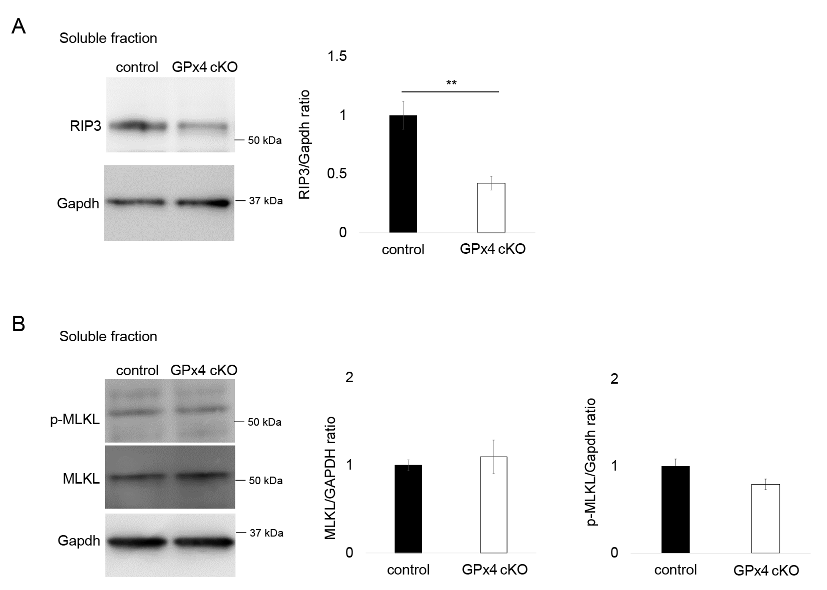
Abundance of (A) RIP3, (B) MLKL, and p-MLKL in detergent-soluble fraction samples of RPE-choroid was compared on western blot between GPx4 cKO and control mice 12 days after AAV injections. n=4 per group. There was no statistical significance in the levels of MLKL and p-MLKL between the two groups.

Fig. S2
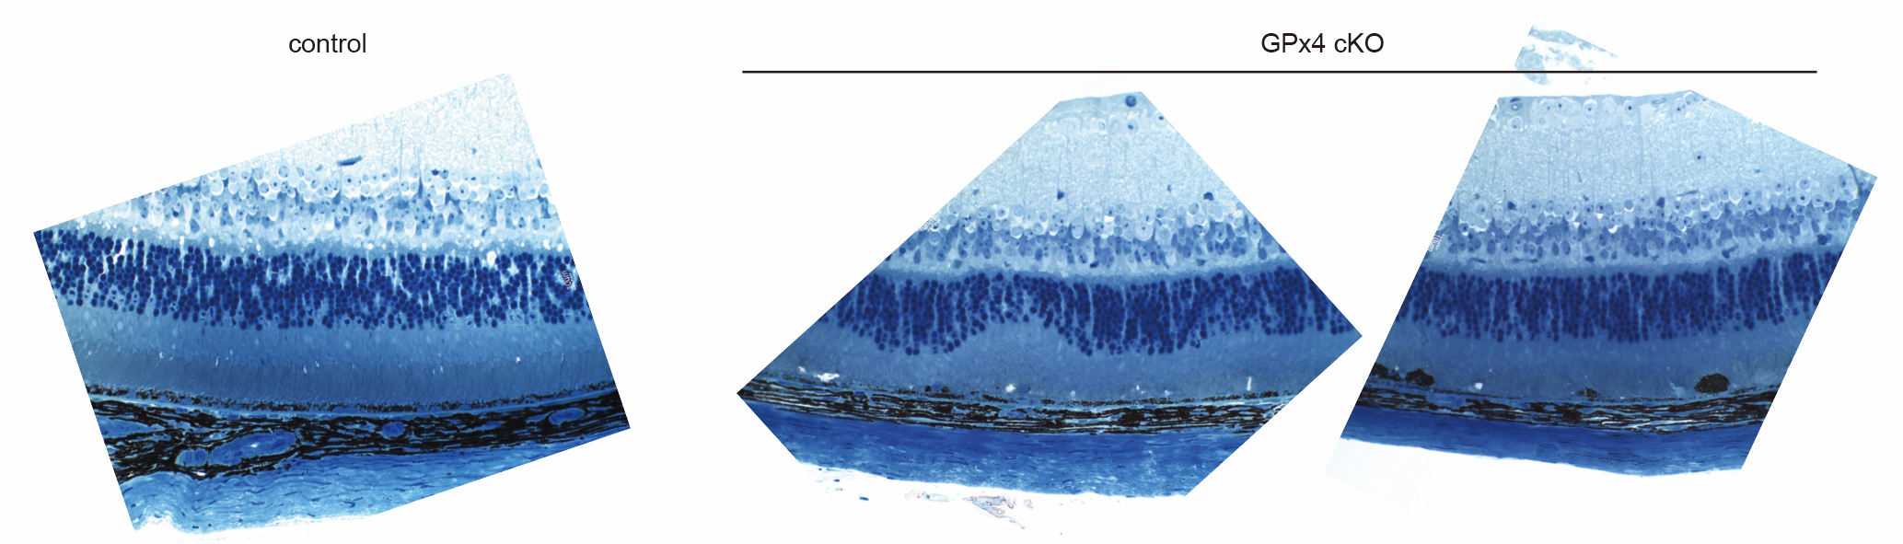
Toludine blue staining of the retina sections in GPx4 cKO and control mice 13 days after AAV injections. Note the multiple voids in the subretinal space of GPx4 cKO mice.

