Extended Data

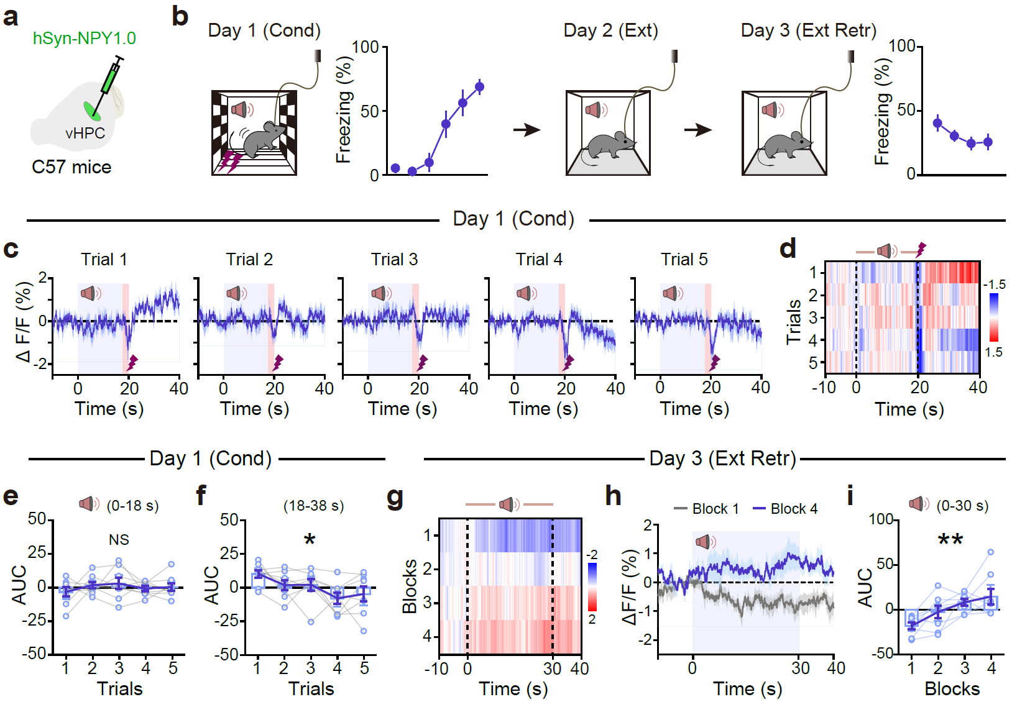

Extended Data Fig. 1 | Dynamics of vCA1 extracellular NPY during fear conditioning and extinction retrieval. a, Schematic of the experimental setup illustrating viral expression of hSyn-NPY1.0 in the vCA1 region of C57 mice. b, Schematic illustrates the behavioral procedure and quantifies freezing responses during fear conditioning (Cond, Day 1) and extinction retrieval (Ext Retr, Day 3). c, d, Average NPY1.0 signal (ΔF/F) in response to auditory tones and foot shocks throughout trials 1–5 on Day 1 (c), with a corresponding ΔF/F (%) heatmap of all five conditioning trials (d). e, AUC analysis of ΔF/F during the auditory tone period (0–18 s) for each conditioning trial on Day 1. f, AUC of ΔF/F during the 18–38 s window for each trial during Cond. g, Heatmap of NPY1.0 signal during Ext Retr. h, Average NPY1.0 signal during Block 1 and 4 of Ext Retr. i, AUC analysis of ΔF/F during the 0–30 s window across Ext Retr blocks. n = 8 mice. Exact statistic tests and P values are provided in Source Data.

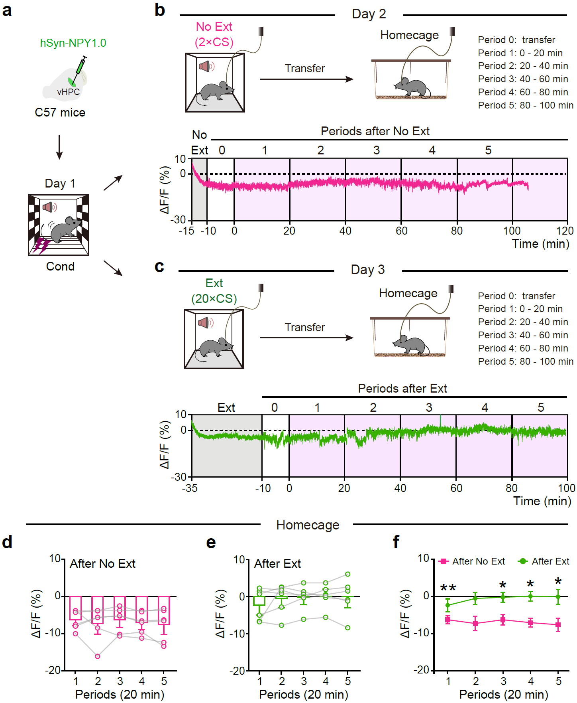

Extended Data Fig. 2 | Dynamics of vCA1 extracellular NPY during homecage periods following No Ext and Ext paradigms. a, Schematic of viral injection of hSyn-NPY1.0 into the vHPC and experimental timeline for assessing the dynamics of vCA1 extracellular NPY. On Day 1, C57 mice undergo fear conditioning (Cond) with subsequent transfer to the homecage on Day 2 (No Ext or Ext condition). b, c, Representative traces of the NPY1.0 fluorescence (ΔF/F) during the homecage period following the No Ext (b) or Ext (c) procedure. Periods after the No Ext (b) or Ext (c) procedure are shown, with each period representing 20-min intervals after transfer. The pink (b) or green (c) trace represents the response following either No Ext (b) or Ext (c) paradigm, respectively. The grey shading indicates the No Ext (b) or Ext (c) periods. d, e, Quantification of NPY1.0 signal across five periods after the No Ext (d) or Ext (e) procedure. f, Comparison of NPY1.0 signal after the No Ext and Ext paradigms. n = 6 mice. Exact statistic tests and P values are provided in Source Data.

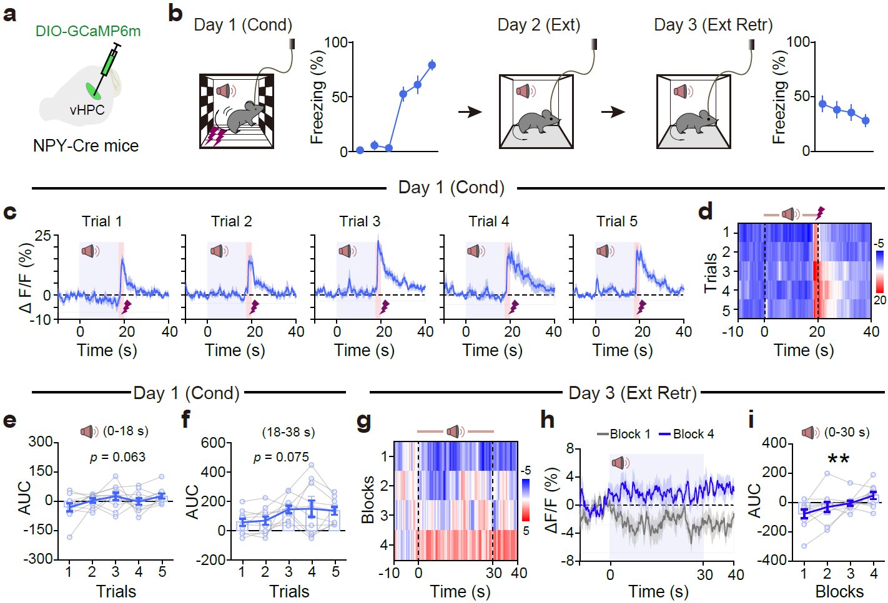

Extended Data Fig. 3 | Dynamics of calcium signals in vCA1 NPY⁺ interneurons during fear conditioning and extinction retrieval. a, Schematic of viral injection. b, Schematic illustrates the behavioral procedure and quantifies freezing responses during fear conditioning (Day 1) and extinction retrieval (Ext Retr, Day 3). c, d, Average GCaMP6m fluorescence (ΔF/F) of NPY⁺ interneurons in response to auditory tones and foot shocks across trials 1–5 on Day 1 (c), with a corresponding ΔF/F (%) heatmap of all five conditioning trials (d). e, AUC analysis of ΔF/F of GCaMP6m fluorescence during the auditory tone period (0–18 s) for each conditioning trial on Day 1. f, AUC of ΔF/F during the 18–38 s window for each trial during Cond. g, Heatmap of calcium dynamics during Ext Retr. h, Average GCaMP6m fluorescence during Block 1 and 4 of Ext Retr. i, AUC analysis of ΔF/F during the 0–30 s window across Ext Retr blocks. n = 10 mice. Exact statistic tests and P values are provided in Source Data.

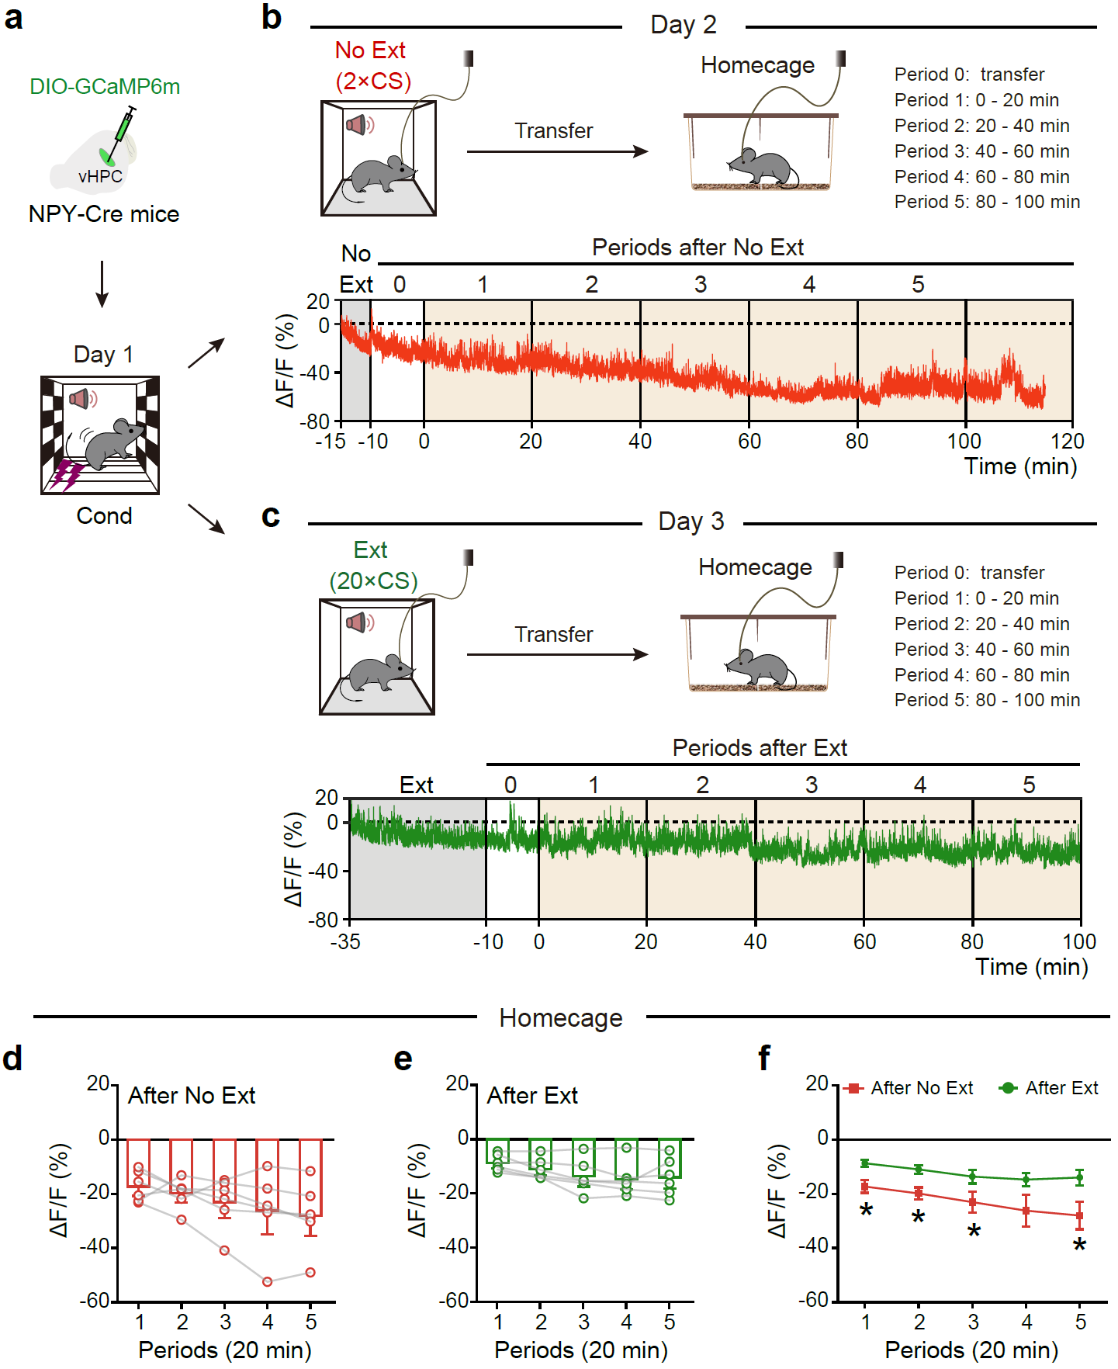

Extended Data Fig. 4 | Dynamics of calcium signals in vCA1 NPY⁺ interneurons during homecage periods following No Ext and Ext paradigms. a, Schematic of viral injection of DIO-GCaMP6m into the vHPC and experimental timeline for assessing the dynamics of GCaMP6m fluorescence (ΔF/F) in vCA1 NPY⁺ interneurons. On Day 1, NPY-Cre mice undergo fear conditioning (Cond) with subsequent transfer to the homecage on Day 2 (No Ext or Ext condition). b, c, Representative traces of the GCaMP6m fluorescence (ΔF/F) during the homecage period following the No Ext (b) or Ext (c) procedure. Periods after the No Ext (b) or Ext (c) procedure are shown, with each period representing 20-minute intervals after transfer. The red (b) or green (c) trace represents the response following either No Ext (b) or Ext (c) paradigm, respectively. The grey shading indicates the No Ext (b) or Ext (c) periods. d, e, Quantification of GCaMP6m fluorescence across five periods after the No Ext (d) or Ext (e) procedure. f, Comparison of calcium signal after the No Ext and Ext paradigms. n = 6 mice. Exact statistic tests and P values are provided in Source Data.

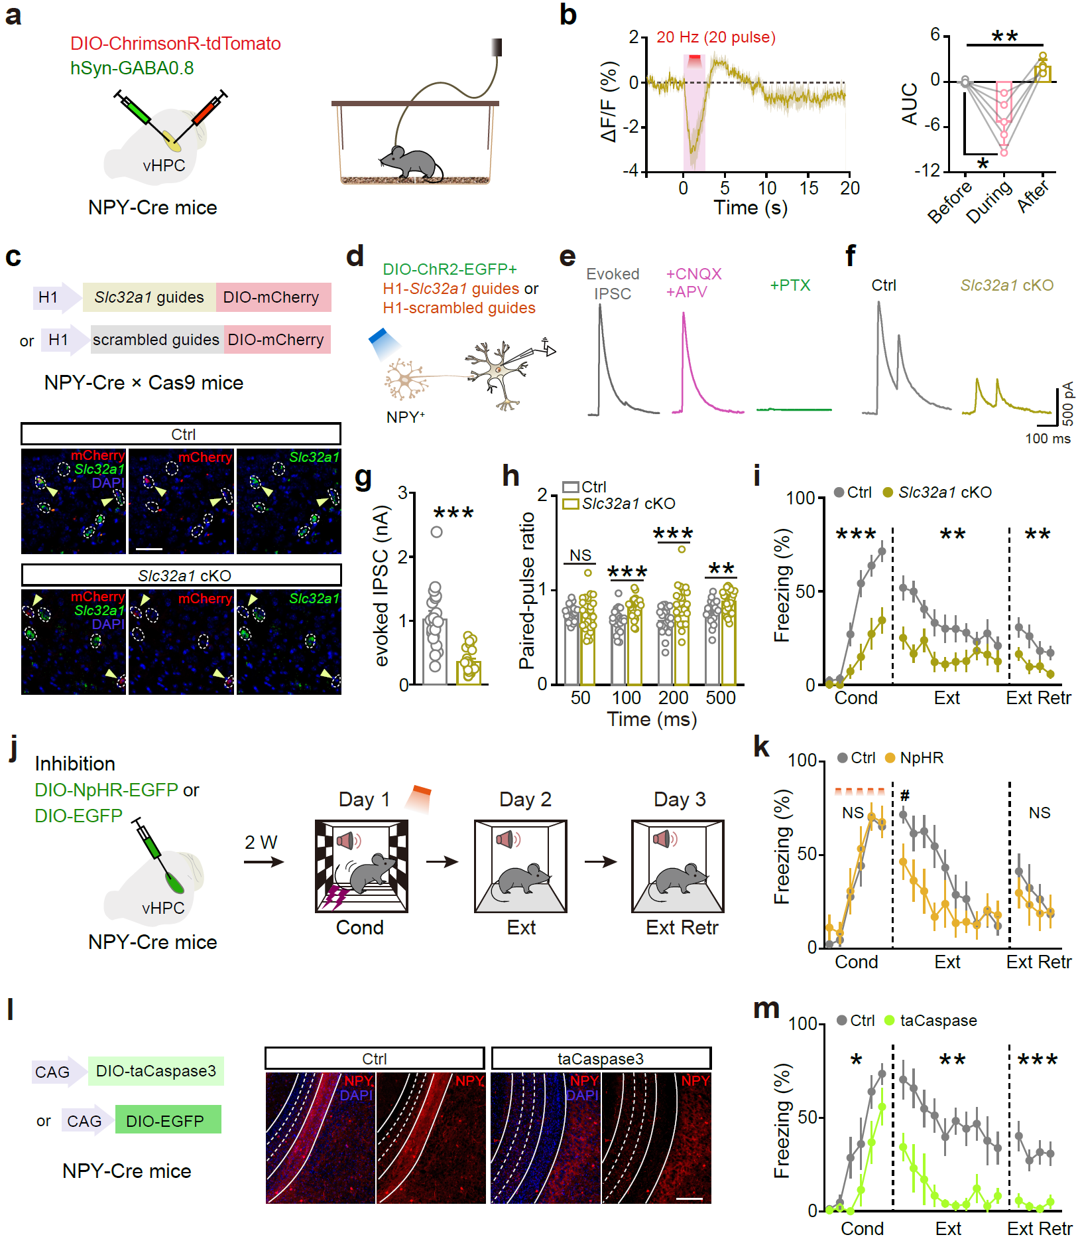

Extended Data Fig. 5 | The role of GABA in NPY⁺ interneurons in memory processes. a, Schematic of viral injection for fiber photometry in NPY-Cre mice. b, Averaged trace showing the change in GRAB_{GABA0.8} fluorescence in response to stimulating NPY⁺ interneurons with 20 pulses at 20 Hz frequency. AUC of the ΔF/F GABA0.8 sensors fluorescence before, during and after NPY⁺ neuronal activation. n = 5 mice. c, Schematic illustrating the selective deletion of the Slc32a1 gene in NPY⁺ interneurons (Slc32a1 cKO) and representative images showing expression of Vgat. Scale bar, 50 μm. d–f, Patch-clamp recordings of optogenetically evoked inhibitory postsynaptic currents (oIPSCs) in vCA1 pyramidal neurons following stimulation of NPY⁺ interneurons. d, Schematic showing electrophysiological recordings in acute vHPC slices. e, Example traces evoked by blue light in the presence of CNQX plus APV, and PTX (e) in Ctrl group. f, Representative traces of oIPSCs induced by paired photostimulations in Ctrl and Slc32a1 cKO groups. g, Comparison of evoked IPSC amplitudes in NPY⁺ interneurons in Ctrl and Slc32a1 cKO groups. h, Statistics of oIPSCs induced by paired photostimulations at various time intervals. n = 3 mice and 23 cells for Ctrl, n = 3 mice and 26 cells for Slc32a1 cKO. i, Effects of Slc32a1 cKO in vCA1 NPY⁺ interneurons on fear conditioning and extinction. n = 14 for Ctrl, and 14 for Slc32a1 cKO. j, Schematic of viral injection and behavioral procedure for optogenetically inhibiting NPY⁺ interneurons during fear conditioning. k, Effects of inhibition of vCA1 NPY⁺ interneurons during fear conditioning on behavioral responses during fear conditioning and following extinction. n = 8 for Ctrl, and 7 for NpHR. l, Schematic of genetic ablation of vCA1 NPY⁺ interneurons. Representative images showcasing NPY expression. Scale bar, 200 μm. m, Effects of genetic ablation of vCA1 NPY⁺ interneurons on fear conditioning and extinction. n = 8 for Ctrl, and 7 for taCaspase. Exact statistic tests and P values are provided in Source Data.

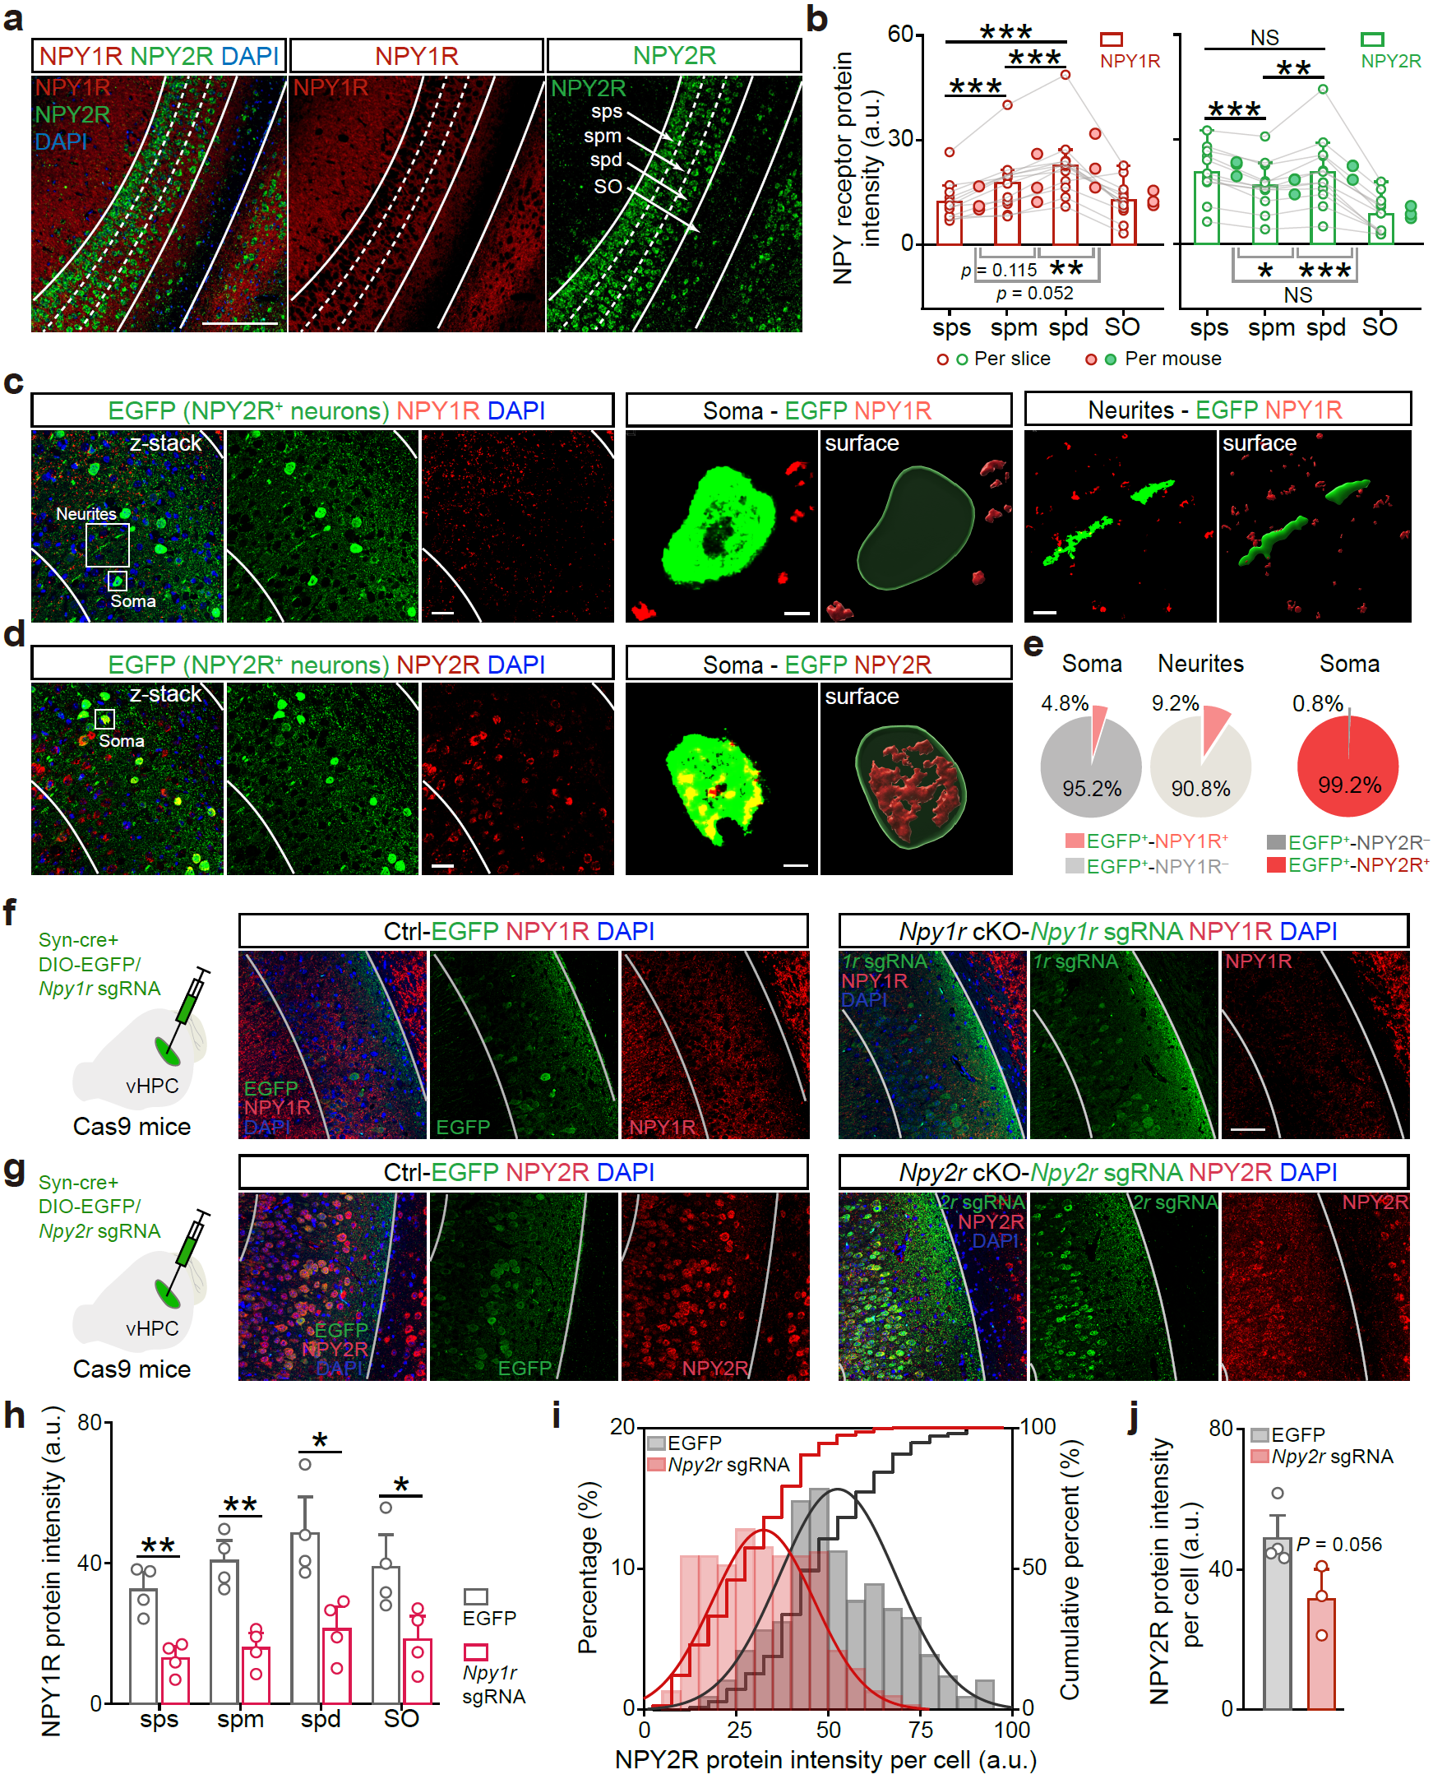

Extended Data Fig. 6 | Layer- and compartment-specific distribution of NPY1R and NPY2R proteins in vCA1, with antibody validation. a, Representative immunofluorescence images of NPY1R (red) and NPY2R (green) protein across vCA1 layers (sps, spm, spd, SO). DAPI, blue. Scale bar, 200 μm. b, Layer-resolved quantification of receptor signal intensity (a.u.). Open circles, individual slices; filled circles, per-mouse means. Both receptors show significant laminar variation. n = 3 mice and 12 coronal slices. c, d, Subcellular localization relative to genetically tagged NPY2R⁺ neurons. NPY2R-Cre mice received AAV-DIO-EGFP in vCA1 to label NPY2R⁺ cells (green). Confocal z-stacks (40 ×) were rendered in 3D (Imaris) to assign receptor signal to soma or neurites. c, NPY1R immunoreactivity (red) is sparse at EGFP⁺ somata but extends prominently along nearby neurites. d, NPY2R immunoreactivity (red) is concentrated on EGFP⁺ somata with comparatively little labeling on processes. Scale bars: 30 µm (field), 3 µm (soma), 7 µm (neurites). e, Compartment-wise colocalization summary for EGFP-identified NPY2R⁺ neurons (pie charts). At somata: NPY1R rarely colocalizes (4.8% EGFP⁺/NPY1R⁺), whereas NPY2R is nearly universal (99.2% EGFP⁺/NPY2R⁺). Along neurites: NPY1R is more frequently detected (9.2% EGFP⁺/NPY1R⁺). n = 4 mice. f, g, CRISPR validation of antibody specificity in Cas9 mice. Confocal z-stacks (40 ×) showing single optical planes and maximum projections. AAV-Syn-Cre and DIO-EGFP were co-infused with sgRNAs targeting Npy1r (f) or Npy2r (g) (right), or control EGFP (right). Npy1r sgRNA selectively reduced NPY1R staining while Npy2r sgRNA selectively reduced NPY2R staining. Scale bars, 50 µm. h, Layer-resolved reduction of NPY1R intensity after Npy1r sgRNA‑mediated cKO. n = 4 mice per group. i, j, Cell-wise distribution of NPY2R intensity after Npy2r sgRNA‑mediated cKO. i, Histogram/CDF show a leftward shift in per-cell intensity; j, Corresponding group means (trend, P = 0.056). n = 4 EGFP and 3 Npy2r cKO mice. Exact statistic tests and P values are provided in Source Data.

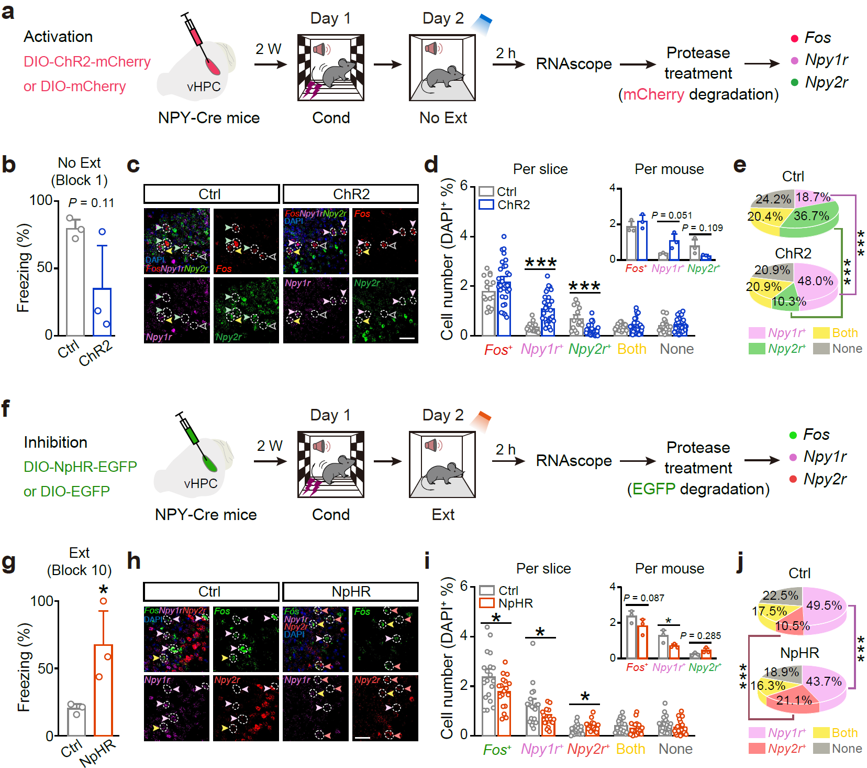

Extended Data Fig. 7 | Biasing NPY⁺ interneuron activity shifts the balance between Npy1r⁺ and Npy2r⁺ populations in vCA1. a–e, Optogenetic activation during No Ext. a, NPY-Cre mice received vHPC injections of DIO-ChR2-mCherry or control DIO-mCherry. On Day 2, mice underwent the No Ext protocol and tissue was collected 2 h later for multiplex RNAscope (Fos, Npy1r, Npy2r); a protease step was included to degrade residual mCherry before imaging. b, Freezing during No Ext (Block 1) did not differ between groups (n = 3 Ctrl, 3 ChR2). c, Representative RNAscope fields (Fos, red; Npy1r, magenta; Npy2r, green). Open white arrowheads mark Fos⁺ cells lacking both receptors; light-magenta, Fos⁺/Npy1r-only; light-green, Fos⁺/Npy2r-only; yellow, Fos⁺ double-labelled cells. Scale bar, 50 μm. d, Quantification (left, per slice; right, per mouse) expressed as % of DAPI⁺ cells shows that ChR2 activation increases Npy1r⁺ counts while reducing Npy2r⁺ cells. Ctrl, n = 15 brain slices of 3 mice; ChR2, n = 30 brain slices of 3 mice. e, Corresponding composition plots reveal a shift toward Npy1r⁺ neurons at the expense of Npy2r⁺. f–j, Optogenetic inhibition during Ext. f, NPY-Cre mice were injected with DIO-NpHR-EGFP or control DIO-EGFP, trained on Ext (Day 2), and sampled 2 h later for RNAscope after protease digestion to remove EGFP. g, NpHR increased freezing at Block 10 (n = 3 Ctrl, 3 NpHR). h, Representative RNAscope images of (Fos, green; Npy1r, magenta; Npy2r, red). Light-magenta arrowheads mark Fos⁺/Npy1r-only cells; light-red, Fos⁺/Npy2r-only; yellow, Fos⁺ double-labelled cells. Scale bar, 50 µm. i, Quantification (left, per slice; right, per mouse) shows that NpHR inhibition decreases Npy1r⁺ counts and increases Npy2r⁺ counts within the tagged population. Ctrl, n = 19 slices from 3 mice; NpHR, n = 18 slices from 3 mice. j, Composition plots reflect a shift toward Npy2r⁺ neurons and away from Npy1r⁺ cells. Exact statistic tests and P values are provided in Source Data.

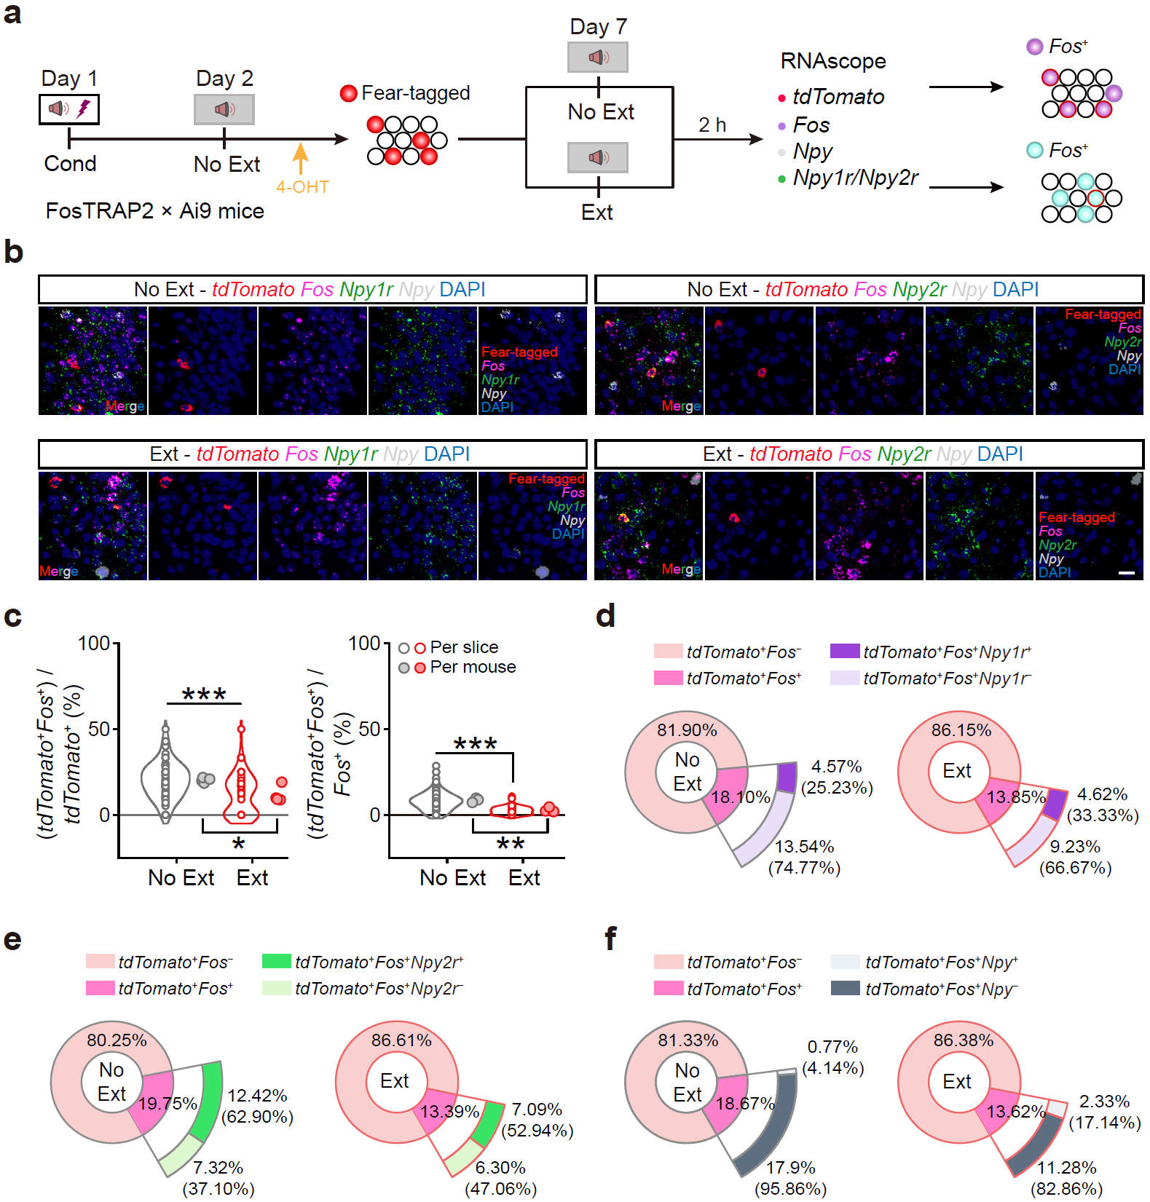

Extended Data Fig. 8 | Identification of fear memory engram cells and expression of Npy1r, Npy2r, and Npy in TRAP2::Ai9 mice. a, Experimental timeline. FosTRAP2::Ai9 mice were fear-conditioned (Day 1). On Day 2, a brief retrieval (No Ext, 2×CS) was paired with 4-OHT to tag the fear ensemble (tdTomato⁺). On Day 7, mice received either another No Ext (2×CS) or an extinction session (Ext, 20×CS), and vCA1 tissue was collected 2 h later for multiplex RNAscope (tdTomato, Fos, Npy, Npy1r, Npy2r). b, Representative fields showing fear-tagged (tdTomato⁺, red) neurons, Fos (magenta), and Npy (grey), Npy1r (green), and Npy2r (green) expression in the No Ext and Ext conditions. Scale bar, 20 μm. c, Quantification of the proportion of tdTomato⁺ neurons that are Fos⁺ in No Ext and Ext conditions, with a significantly higher overlap in the No Ext group. d, Pie charts showing the proportion of tdTomato⁺Fos⁺ neurons that co-express Npy1r (purple) in No Ext and Ext conditions. n = 38 brain slices of 3 mice for No Ext, n = 24 brain slices of 4 mice for Ext. e, Pie charts showing the proportion of tdTomato⁺Fos⁺ neurons that co-express Npy2r (green) in No Ext and Ext conditions. n = 27 brain slices of 3 mice for No Ext, n = 23 brain slices of 4 mice for Ext. f, Pie charts showing the proportion of tdTomato⁺Fos⁺ neurons that co-express Npy (grey) in No Ext and Ext conditions. n = 65–71 brain slices of 3 mice for No Ext, n = 47–58 brain slices of 4 mice for Ext. Exact statistic tests and P values are provided in Source Data.

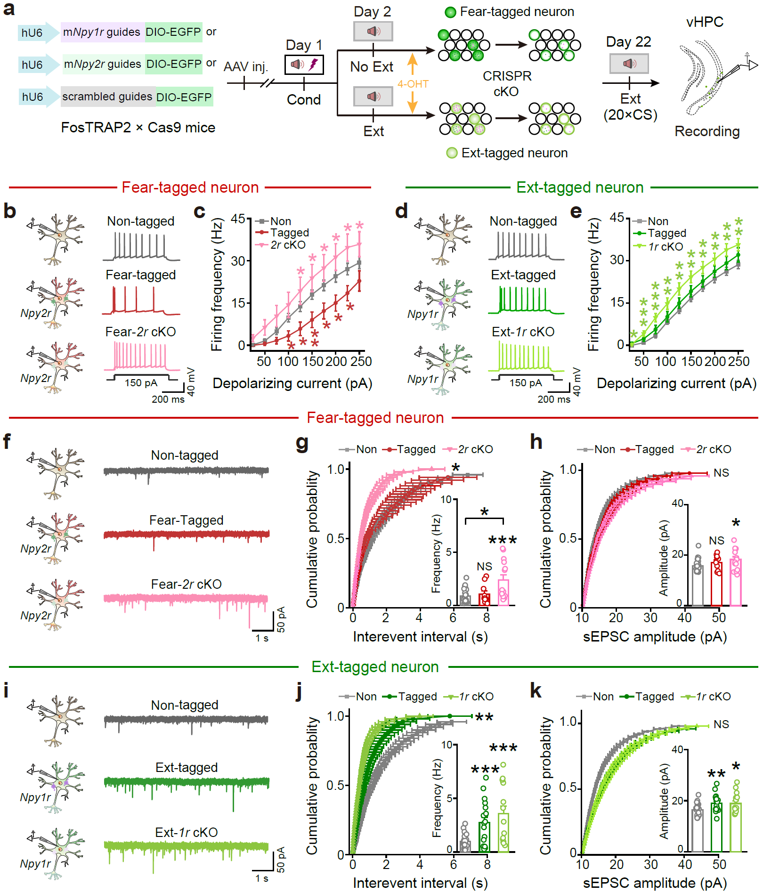

Extended Data Fig. 9 | Following extinction, electrophysical recordings of the action potentials and sEPSCs of fear-tagged and Ext-tagged neurons with or without NPY receptor gene cKO. Following extinction, fear-tagged neurons exhibited significant decreases in AP and sEPSC frequencies, which were reversed by Npy2r KO selectively in these neurons. By contrast, the Ext-tagged neurons showed no significant increase in AP frequencies but exhibited increased sEPSC frequencies. Npy1r KO in the Ext-tagged neurons increased their AP firing frequencies. a, Behavioral procedure for electrophysiological recordings, and schematic of Npy2r, Npy1r gene cKO in Fear- and Ext-tagged neurons respectively. b, Representative traces of AP firing evoked by current injection (150 pA) in Non-, Fear-tagged and Npy2r cKO neurons. c, Npy2r cKO in Fear-tagged neurons significantly reversed the decreased firing frequency following extinction. n = 26 cells of eight mice for Non-tagged, n = 12 cells of four mice for Fear-tagged, n = 17 cells of five mice for Npy2r cKO. d, Representative traces of AP firing evoked by current injection (150 pA) in Non-, Ext-tagged and Npy1r KO neurons. e, Npy1r cKO in Ext-tagged neurons enhanced the firing frequency compared to Non-tagged neurons after extinction. n = 43 cells of thirteen mice for Non-tagged, n = 19 cells of four mice for Fear-tagged, n = 34 cells of six mice for Npy1r cKO. f, Representative traces of sEPSCs in Non-, Fear-tagged and Npy2r cKO neurons following extinction. g, Npy2r cKO in Fear-tagged neurons increased the sEPSC frequency. h, Npy2r cKO in Fear-tagged neurons didn’t increase the sEPSC amplitude. n = 26 cells of ten mice for Non-tagged, n = 10 cells of four mice for Fear-tagged, n = 14 cells of six mice for Npy2r cKO. i, Representative traces of sEPSCs in Non-, Ext-tagged and Npy1r cKO neurons following extinction. j, Npy1r cKO in Ext-tagged neurons increased the sEPSC frequency. k, Npy1r cKO in Ext-tagged neurons didn’t alter the sEPSC amplitude. n = 26 cells of eleven mice for Non-tagged, n = 18 cells of six mice for Ext-tagged, n = 15 cells of six mice for Npy1r cKO. Exact statistic tests and P values are provided in Source Data.

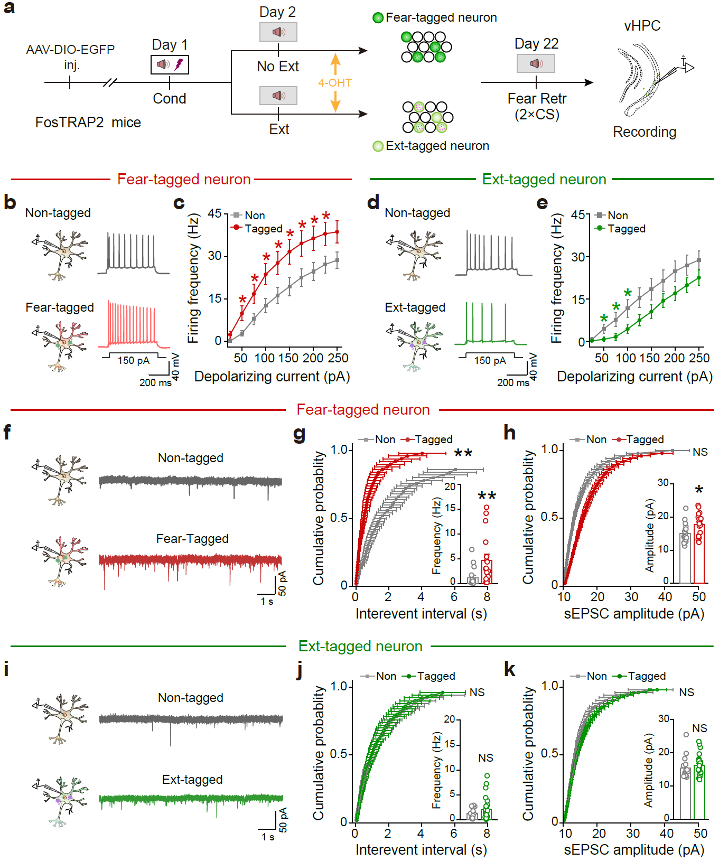

Extended Data Fig. 10 | Following fear memory retrieval, electrophysical recordings of the APs and sEPSCs of Fear- and Ext-tagged neurons. Following spontaneous recovery as fear memory retrieval with heightened fear, fear-tagged neurons displayed increased AP and sEPSC frequencies while Ext-tagged neurons exhibited decreased AP frequencies. a, Schematic for recording Fear- and Ext- tagged neurons following fear memory retrieval. b, d, Representative traces of AP firing evoked by current injection (150 pA) in Non-, Fear-tagged (b) and Ext-tagged neurons (d). c, e, AP frequencies of fear-tagged neurons significantly increased compared to non-tagged neurons (c), while Ext-tagged neurons significantly decreased (e), following fear memory retrieval on Day 22. n = 17 cells of three mice for Non-tagged, n = 20 cells of three mice for Fear-tagged. n = 15 cells of three mice for Non-tagged, n = 16 cells of three mice for Ext-tagged. f, i, Representative traces of sEPSCs. g, h, The frequency of sEPSC in Fear-tagged neurons increased, but the amplitude increased slightly, following fear memory retrieval. n = 18 cells of three mice for Non-tagged, n = 17 cells of three mice for Fear-tagged. j, k, Following spontaneous recovery as fear memory retrieval, there were no significant changes in the frequency and amplitude of sEPSCs in Ext-tagged neurons. n = 15 cells of three mice for Non-tagged, n = 24 cells of four mice for Ext-tagged. Exact statistic tests and P values are provided in Source Data.

