Supplementary Figures

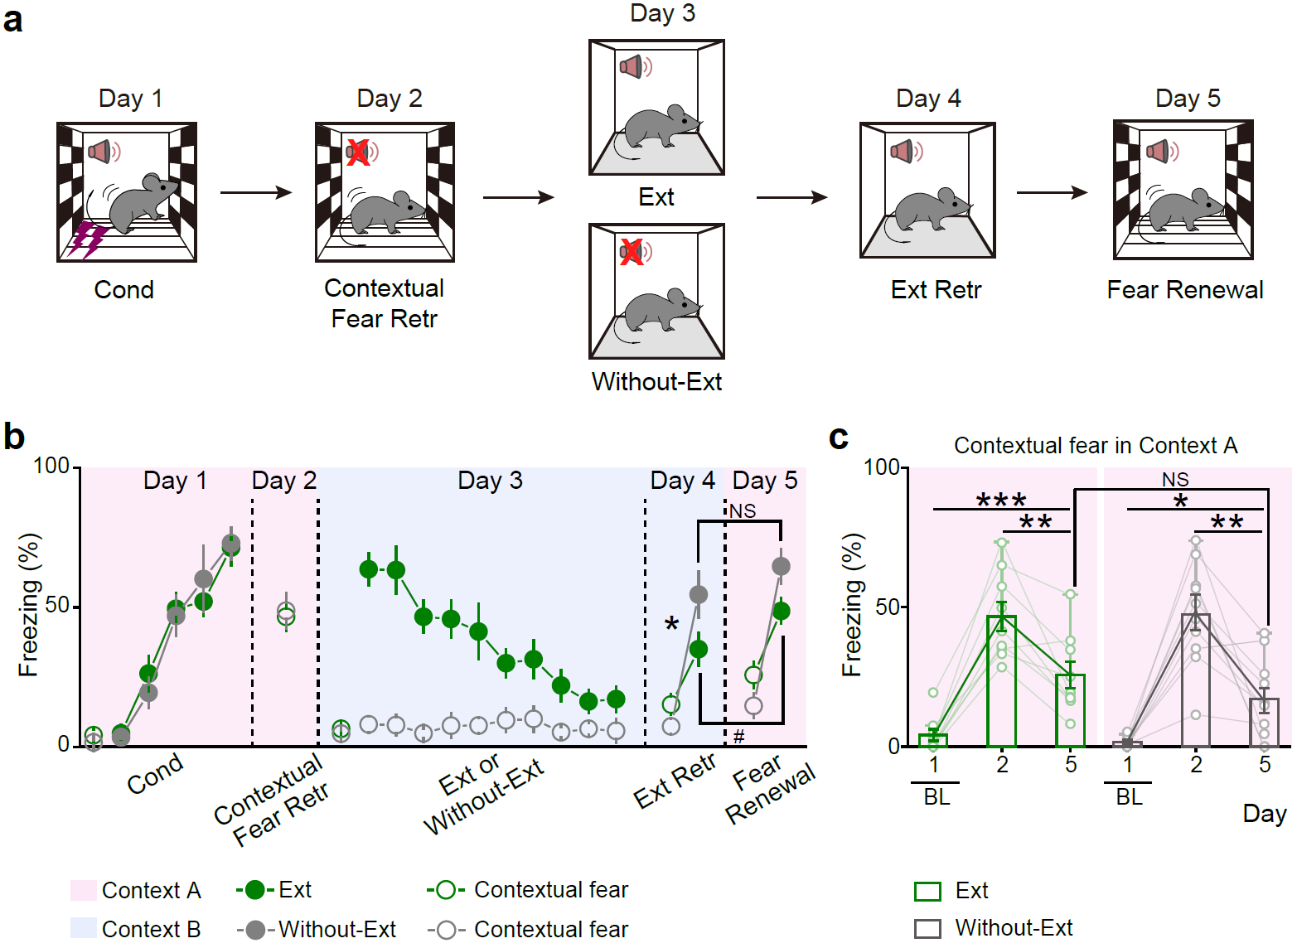

Supplementary Fig. 1 | Characterization of auditory cued fear conditioning and extinction paradigms. a, Schematic illustrating the behavioral procedure. b, Freezing levels during fear conditioning (Cond), contextual fear retrieval (Contextual Fear Retr), extinction (Ext), without extinction (Without-Ext), extinction retrieval (Ext Retr), and fear renewal. Day 3, Mice in the Ext group underwent extinction training in context B, while the Without-Ext group remained in context B for the same duration without exposure to conditioned tone. c, Contextual freezing levels in context A during Cond (baseline, BL), Contextual Fear Retr, and Fear renewal. BL, Baseline. n = 9 mice per group. n = 9 mice per group. Exact statistic tests and P values are provided in Source Data.

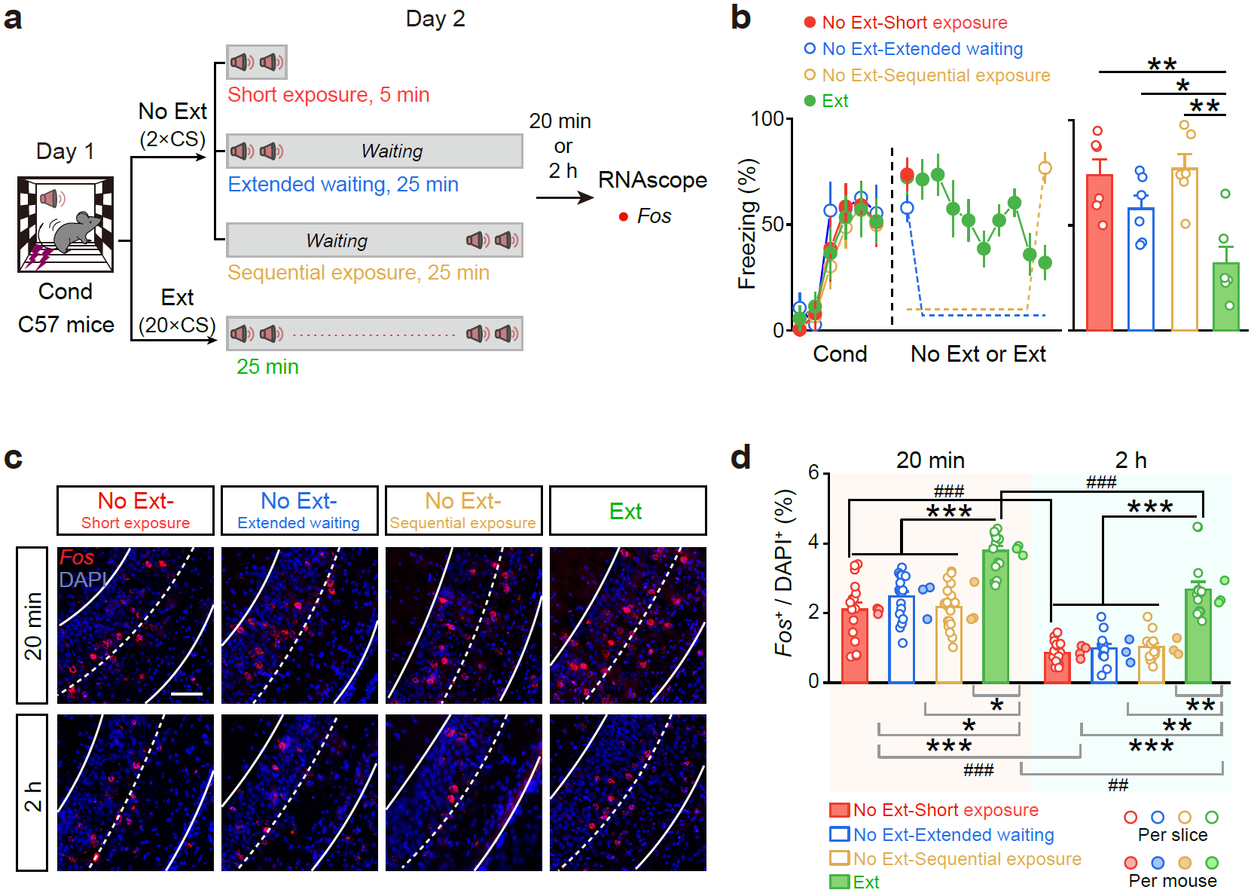

Supplementary Fig. 2 | Fos expression following No Ext variants and Ext conditions. a, Experimental procedure for assessing Fos expression following different behavioral conditions. No Ext-short exposure (2×CS, 5 min), No Ext-extended waiting (2×CS, 25 min), No Ext-sequential exposure (2×CS, 25 min), Ext (20×CS, 25 min). b, Freezing levels during fear conditioning, No Ext with different variants, and Ext conditions. n = 6 mice per group. c, Representative images illustrating Fos expression during different behavioral procedures. Scale bar, 50 μm. d, Quantification and comparison Fos expression across conditions. Exact statistic tests and P values are provided in Source Data.

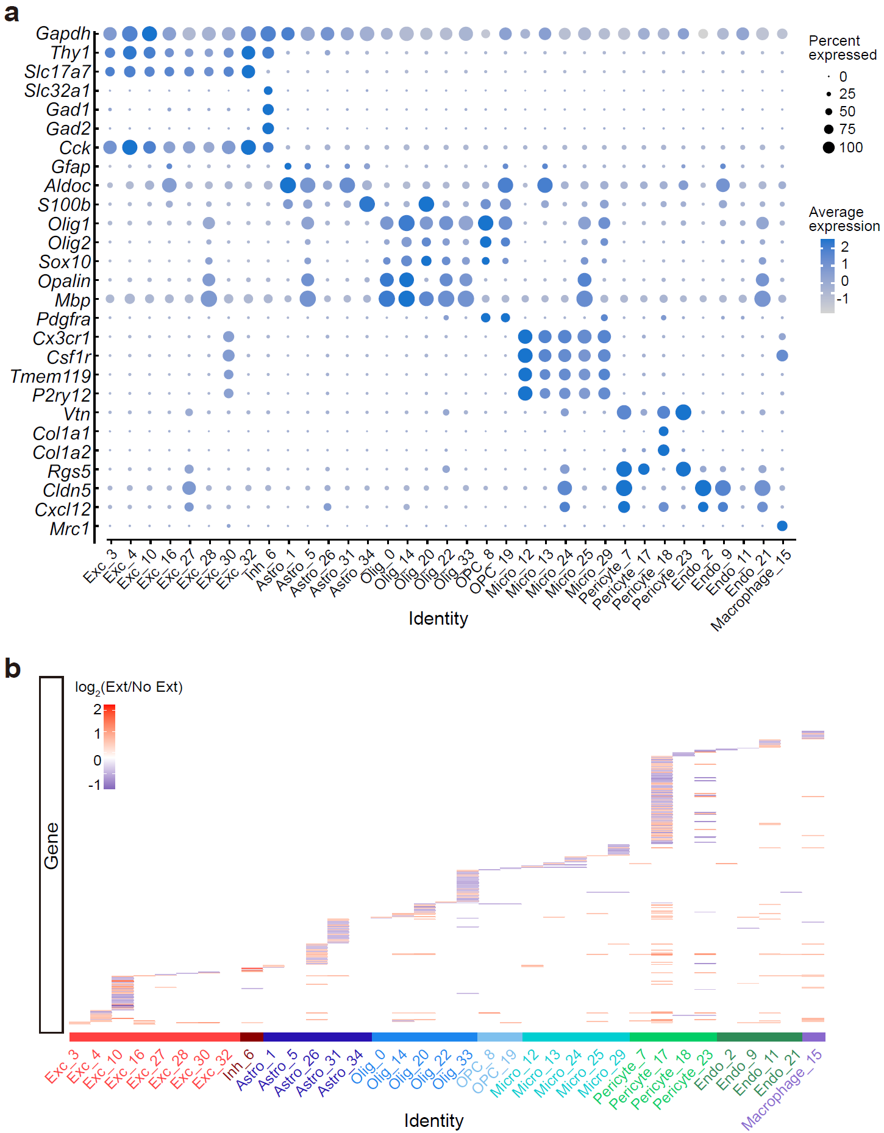

Supplementary Fig. 3 | Molecular signatures and DEGs of different cell clusters in vHPC. a, Molecular signatures of different clusters by percentage of cells expressing the gene (circle size) and average gene expression level (color scale). These clusters encompassed excitatory neurons (Clusters 3, 4, 10, 16, 27, 28, 30, 32), inhibitory neurons (Cluster 6), astrocytes (Clusters 1, 5, 26, 31, 34), oligodendrocytes (Clusters 0, 14, 20, 22, 33), oligodendrocyte precursor cells (OPCs, Clusters 8, 19), microglia (Clusters 12, 13, 24, 25, 29), pericytes (Clusters 7, 17, 18, 23), endothelium (Clusters 2, 9, 11, 21), and macrophages (Cluster 15), with comparable representation in both groups. b, Heatmap of log₂ fold changes between No Ext and Ext by cell types. Each perpendicular line represents a differentially expressed gene (DEG).

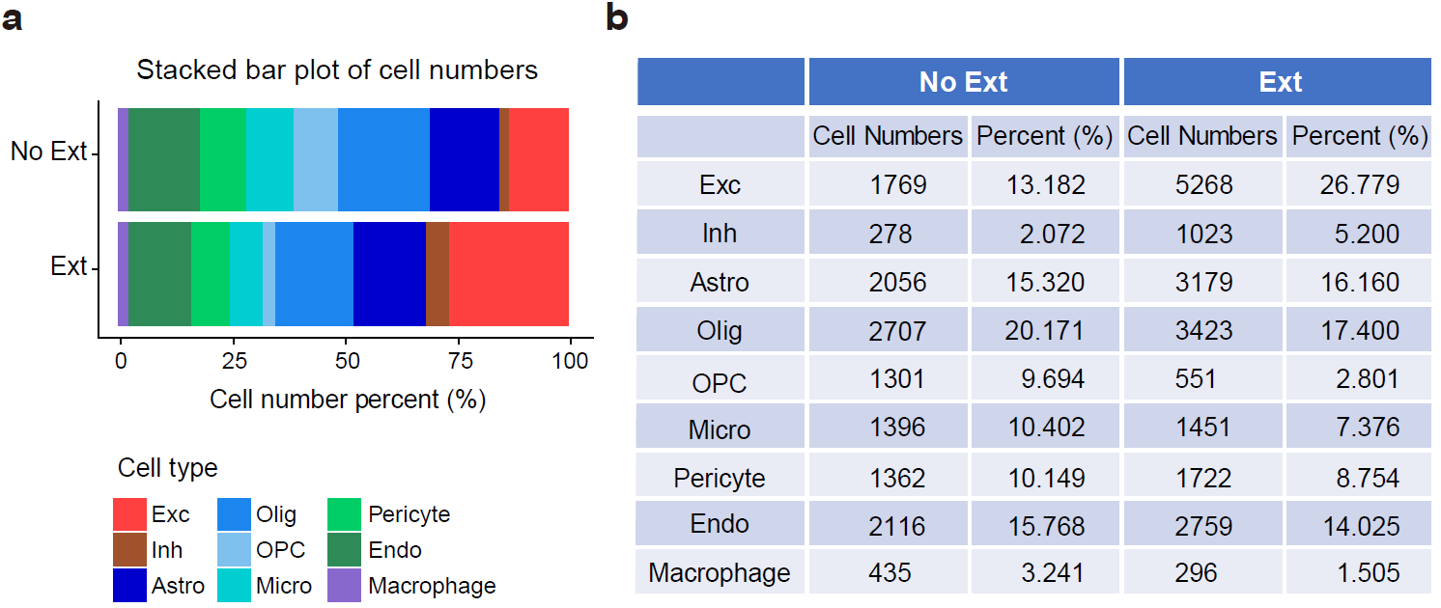

Supplementary Fig. 4 | Cell type distribution in vHPC during No Ext and Ext conditions. a, Stacked bar plot showing the percentage distribution of different cell types in the vHPC for No Ext and Ext conditions. The percentages represent the relative proportion of each cell type in the total population. b, Table presenting the cell numbers and percentage of each cell type in the vHPC for No Ext and Ext conditions. Cell types include excitatory neurons (Exc), inhibitory neurons (Inh), astrocytes (Astro), oligodendrocytes (Olig), oligodendrocyte precursor cells (OPC), microglia (Micro), pericytes (Pericyte), endothelial cells (Endo), and macrophages. For each condition, the total number of cells and their relative percentage are shown.

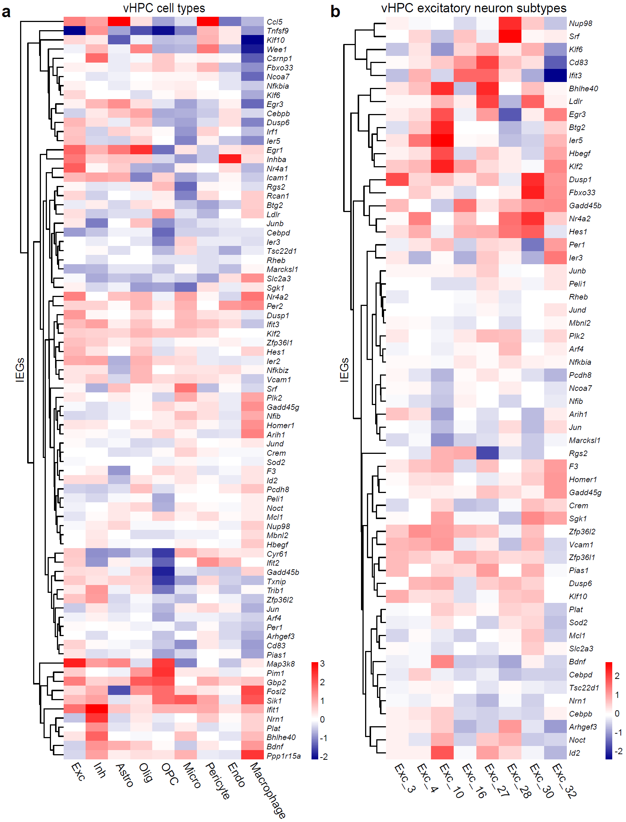

Supplementary Fig. 5 | Different expression levels of IEGs across different cell types and clusters of No Ext and Ext mice. A clustered heatmap displaying the log₂ fold change profiles of the known IEGs from comparing No Ext vs. Ext across different cell types (a) and different clusters of excitatory neurons (b) (columns).

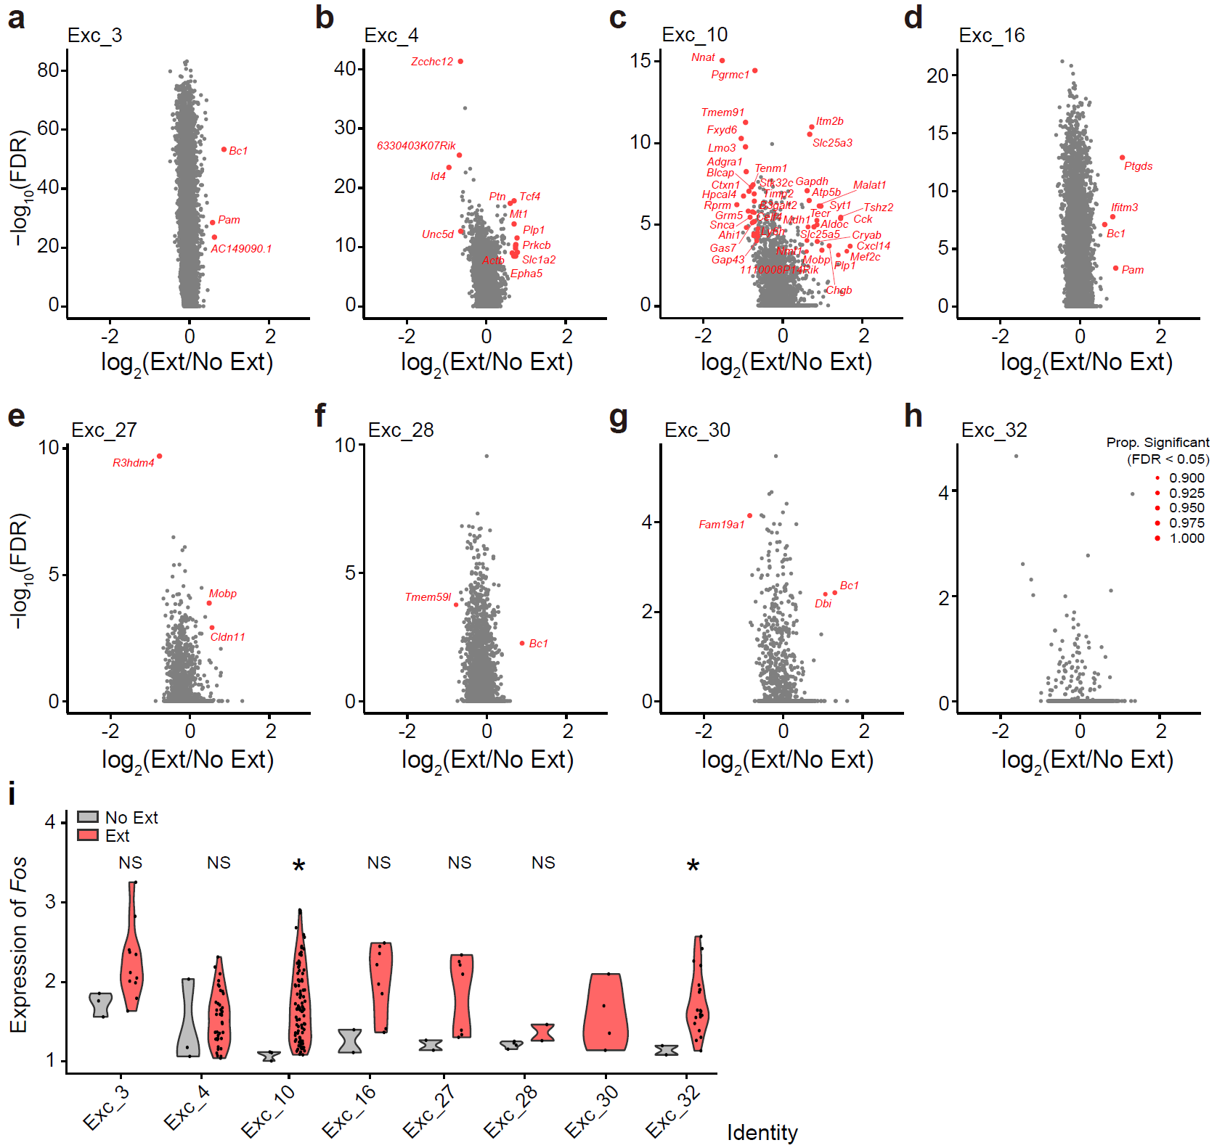

Supplementary Fig. 6 | Extinction triggered varied transcriptomic program changes in all the 8 clusters. a–h, Volcano plots of DEGs (determined by MAST test) that were upregulated and downregulated by extinction in eight different excitatory neuron subtypes. DEGs (|log₂(Ext/No Ext)| ≥ 0.585, FDR < 0.05, with ≥ 90% resampling support) were indicated by red dots. i, Violin plot of expression of Fos across different excitatory neuron subtypes in No Ext and Ext. Exact statistic tests and P values are provided in Source Data.

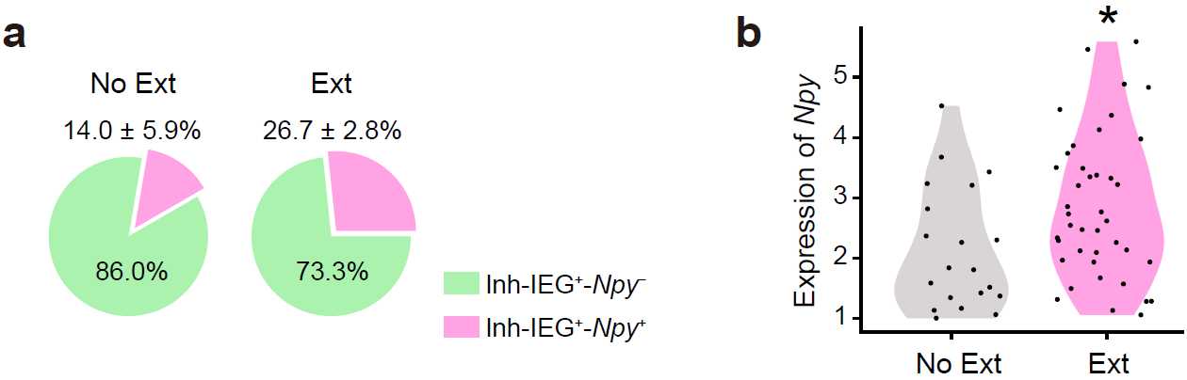

Supplementary Fig. 7 | Npy expression in IEG⁺ inhibitory neurons during extinction. a, Pie charts showing a higher proportion of Npy⁺ neurons within the inhibitory neurons that expressed elevated IEG expression (Inh-IEG⁺) (Inh-IEG⁺-Npy⁺) in the Ext group compared to No Ext group. To control for the unequal numbers of inhibitory (Inh) neurons between conditions, the Ext dataset was randomly down‑sampled 1,000 times to match the No Ext inhibitory‑cell count. In each permutation, we re-defined the IEG⁺ inhibitory neuron set (Inh-IEG⁺) as inhibitory neurons with ≥1 IEG in the 90th percentile of expression across the combined No Ext and down-sampled Ext inhibitory populations. Pie wedges report the mean composition across permutations: pink, Inh-IEG⁺/Npy⁺; green, Inh-IEG⁺/Npy–. Values above pies are the mean ± s.e.m. fraction of Inh-IEG⁺/Npy⁺, and percentages inside wedges denote the complementary Inh-IEG⁺/Npy– fraction. b, Npy transcript levels within Inh‑IEG⁺ cells (violin plots). For display, the panel shows the resampling iteration corresponding to the 90th‑percentile P‑value from the permutation distribution; each dot is a cell. Each dot represents a single cell. Exact statistic tests and P values are provided in Source Data.

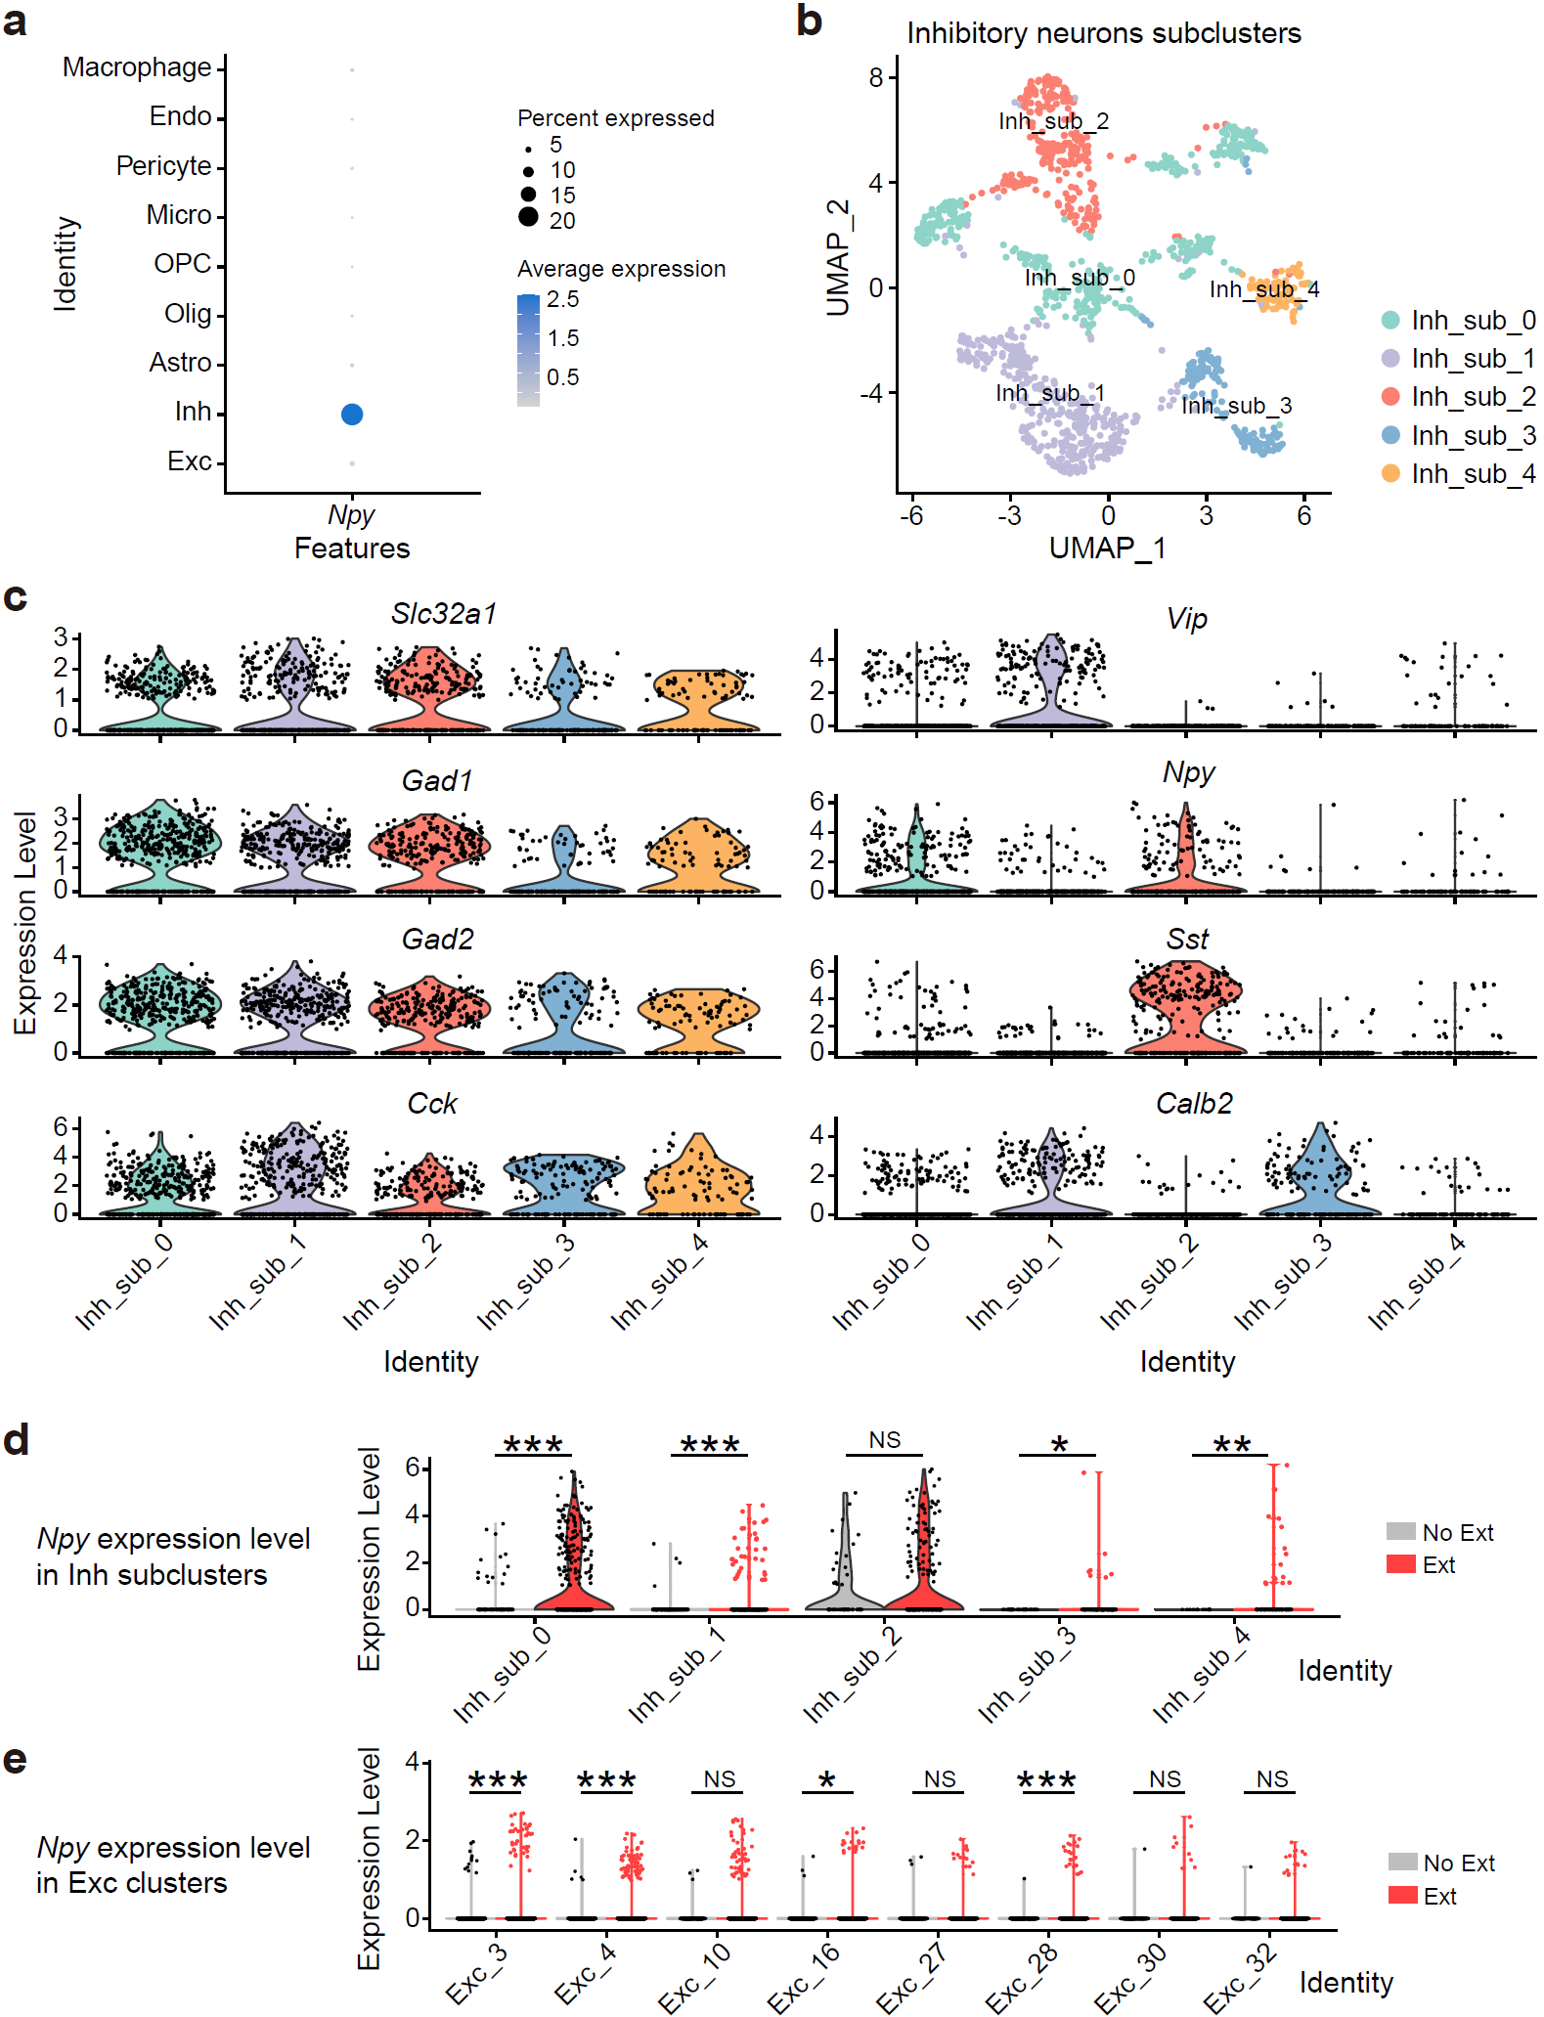

Supplementary Fig. 8 | Npy expression in inhibitory neuron subclusters and excitatory neuron clusters. a, Dot plot showing Npy-specific expression in inhibitory interneurons. Each dot represents a cell type, with the size indicating the proportion of cells expressing Npy and the color representing the average expression level. b, UMAP plot showing the distribution of inhibitory neuron subclusters (Inh_sub_0 to Inh_sub_4) based on single-cell transcriptomic data. c, Violin plots showing the expression levels of various marker genes (Slc32a1, Gad1, Gad2, Cck, Vip, Npy, Sst, and Calb2) across the five inhibitory neuron subclusters (Inh_sub_0 to Inh_sub_4). Each marker is associated with specific inhibitory subpopulations, with Npy expression observed across multiple subclusters (Inh_sub_0 and Inh_sub_2). d, Violin plots illustrating Npy expression levels in the inhibitory neuron subclusters during the No Ext and Ext conditions. e, Violin plots showing the expression levels of Npy in excitatory neuron clusters (Exc_3, Exc_4, Exc_10, Exc_16, Exc_27, Exc_28, Exc_30, Exc_32). Each dot represents a single cell. Exact statistic tests and P values are provided in Source Data.

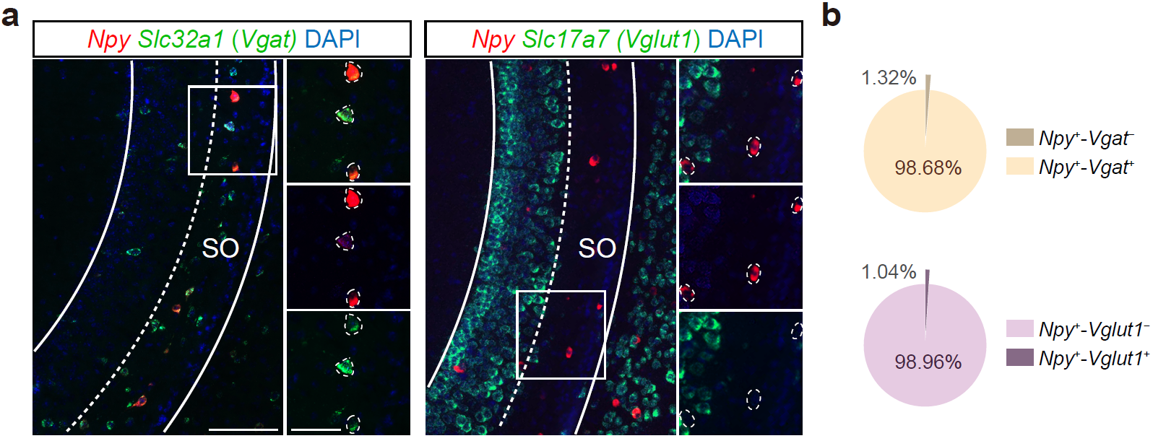

Supplementary Fig. 9 | Expression of Npy in Vgat⁺ GABAergic neurons and Vglut1⁺ glutamatergic neurons. a, Dual-color RNAscope in vCA1 showing Npy mRNA (red) together with Slc32a1 (vesicular GABA transporter, Vgat; green, left) or Slc17a7 (vesicular glutamate transporter 1, Vglut1; green, right); nuclei are DAPI-stained (blue). Dashed lines delineate the stratum oriens (SO). Inset shows higher-magnification views of boxed regions. Scale bars, 100 μm (overview) and 50 μm (insets). b, Fraction of Npy⁺ cells co-expressing the indicated markers. Of all Npy⁺ cells, 98.68% were Vgat⁺ and 1.32% were Vgat– (top), whereas 98.96% were Vglut1– and 1.04% were Vglut1⁺ (bottom). Data are from 4 slices in 2 naïve C57BL/6J mice.

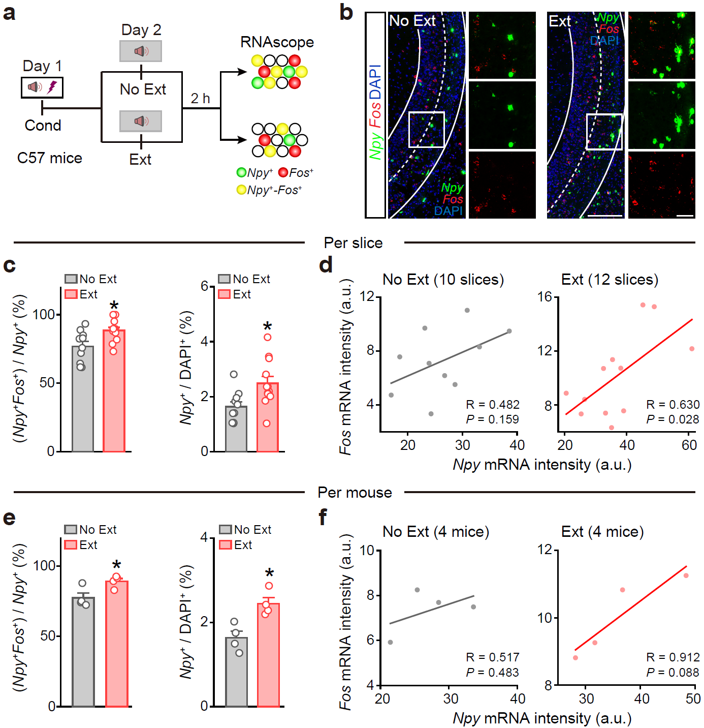

Supplementary Fig. 10 | Extinction couples Npy expression with Fos activation in vCA1. a, Timeline: C57BL/6J mice were conditioned (Day 1), then subjected on Day 2 to either No Ext or Ext; vCA1 tissue was collected 2 h later for multiplex RNAscope. b, Dual-color RNAscope for Npy (green) and Fos (red) in vCA1. Insets show higher magnification of boxed regions. Scale bars, 200 µm (overview) and 50 µm (insets). c, Per-slice quantification showing (left) the fraction of Npy⁺ neurons that are Fos⁺ and (right) the proportion of Npy⁺ cells among all DAPI⁺ cells. No Ext: 10 slices; Ext: 12 slices (from 4 mice per group). d, Per-slice correlation between Npy and Fos mRNA signal (a.u.). Pearson’s R and P-value are indicated. e, Same measures as in c, computed per mouse (No Ext: n = 4; Ext: n = 4). f, Per-mouse correlation between Npy and Fos mRNA mean intensity. Exact statistic tests and P values are provided in Source Data.

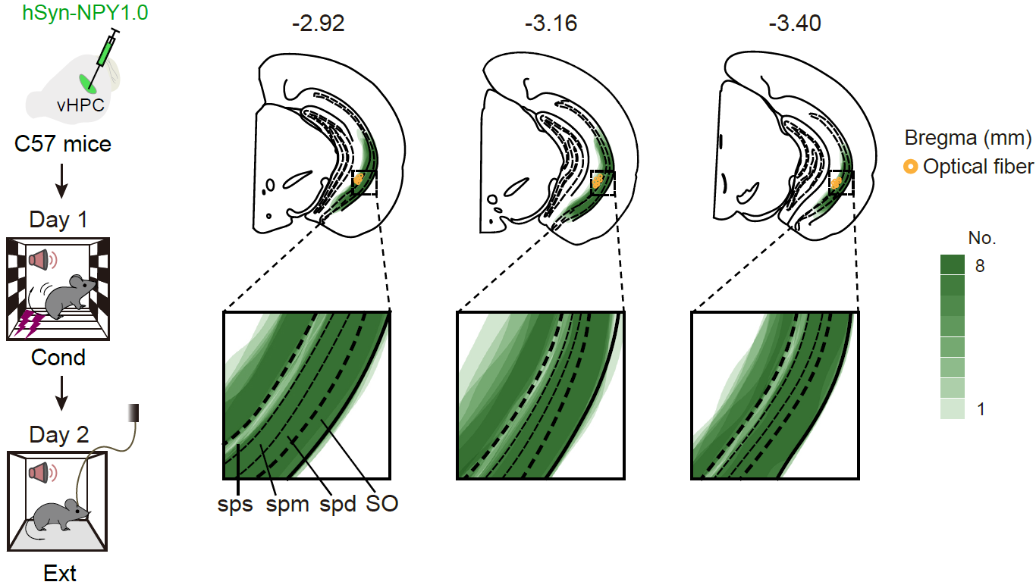

Supplementary Fig. 11 | Histological validation of viral expression of NPY1.0 and optical fiber placement, related to Fig. 1g–o. Left, Schematic illustrating the viral injection and behavioral procedure. Right, Locations of optical fiber tips and viral expression scope in the vCA1 region for all mice.

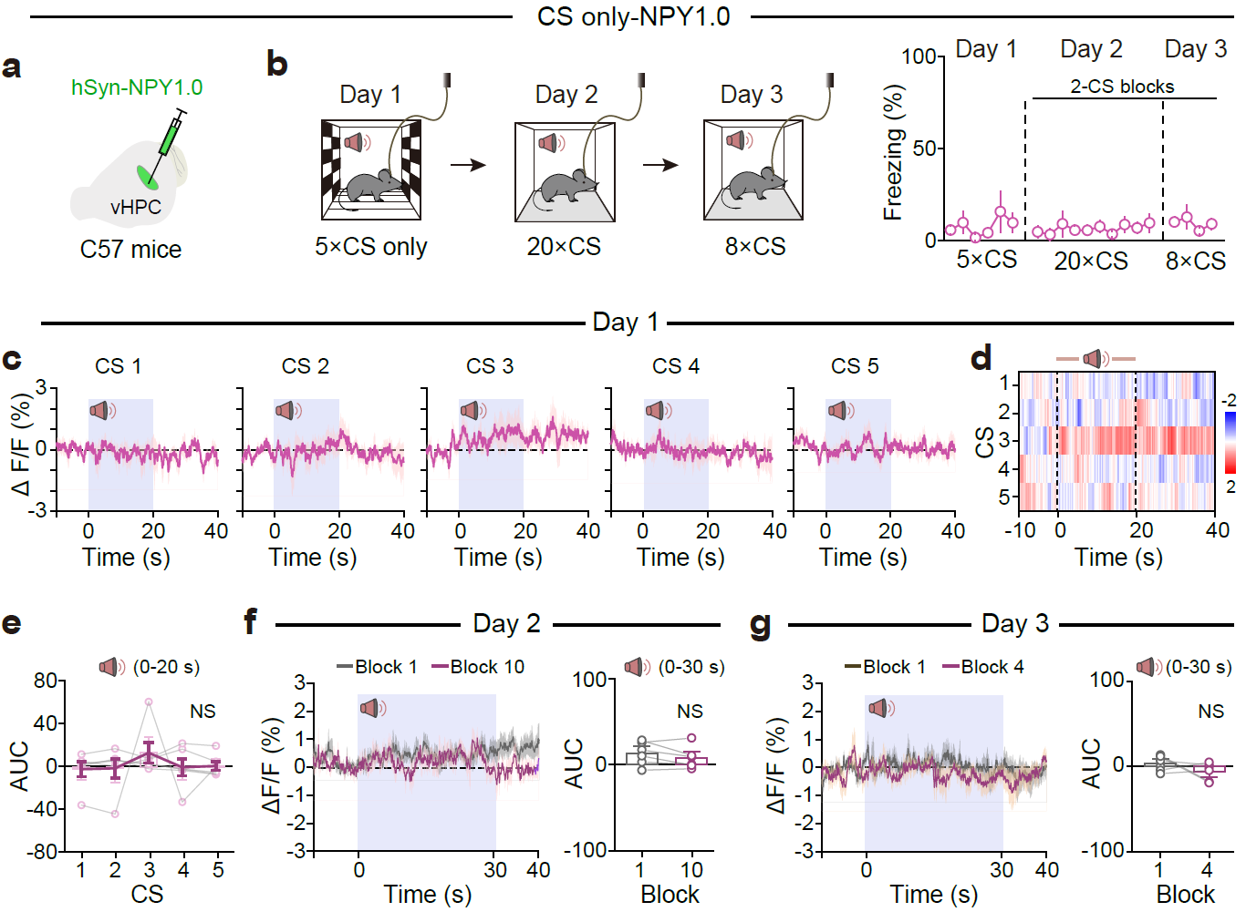

Supplementary Fig. 12 | Dynamics of vCA1 extracellular NPY during different training sessions in the absence of shock. a, Schematic of viral injection of hSyn-NPY1.0 into the vHPC. b, Behavioral procedure and freezing levels during different training sessions in CS only condition. c, d, Average NPY1.0 fluorescence (ΔF/F) response to auditory tones alone throughout trials 1–5 on Day 1 (c), with a corresponding ΔF/F (%) heatmap showing responses across all five CS-only trials (d). e, AUC analysis of ΔF/F during the auditory tone period (0–20 s) for each CS-only trial on Day 1. f, g, Average NPY1.0 fluorescence and corresponding AUC during CS presentation (0–30 s) on Day 2 (block 1 vs. 10; f) and Day 3 (block 1 vs. 4; g). Exact statistic tests and P values are provided in Source Data.

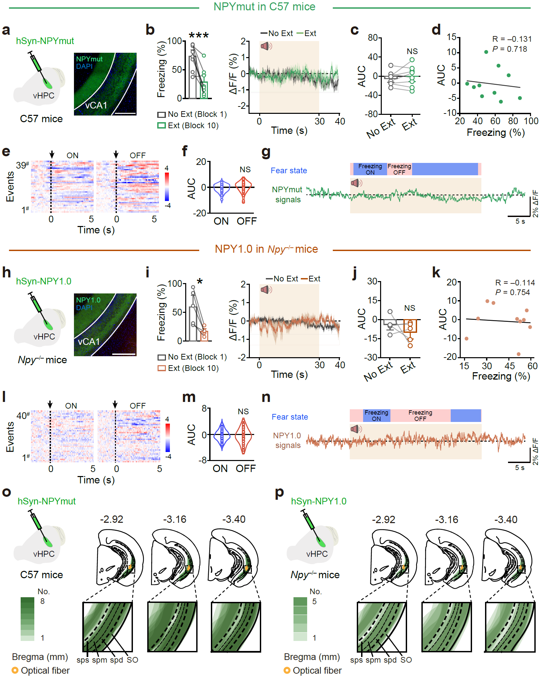

Supplementary Fig. 13 | Neither NPYmut sensor in wild-type mice nor the NPY1.0 sensor in Npy knockout mice exhibited detectable responses in vCA1 during extinction learning. a, h, Schematic of viral injection and expression of the genetically encoded hSyn-NPYmut (a) and hSyn-NPY1.0 (h) sensors for fiber photometry recording. Scale bar, 200 μm. b–g, NPYmut sensor in wild-type mice did not show significant responses during extinction. n = 8 mice for No Ext and Ext. b, Freezing levels. e, f, Heatmaps (e) and AUC (f) of NPYmut fluorescence for 5 s following freezing ON and OFF epochs. n = 8 mice and 39 events for freezing ON and OFF states, respectively. g, Example trace illustrating the relationship between fear state and NPYmut signals. i–n, NPY1.0 sensor in Npy knockout (Npy–/–) mice did not show a significant response during extinction. n = 5 mice. i, Freezing levels. l, m, Heatmaps (l) and AUC (m) of NPY1.0 fluorescence of Npy–/– mice during freezing ON and OFF epochs. n = 5 mice and 40 trials for freezing ON and OFF, respectively. n, Example trace illustrating the relationship between fear state and NPY1.0 signals in Npy–/– mice. o, p, Histological validation of viral expression of NPYmut sensor and optical fiber placement in C57 mice (o, related to Extended Data Fig. 15a–g), as well as viral expression of NPY1.0 sensor and optical fiber placement in Npy–/– mice (p, related to Supplementary Fig. 15h–n) across all mice. Exact statistic tests and P values are provided in Source Data.

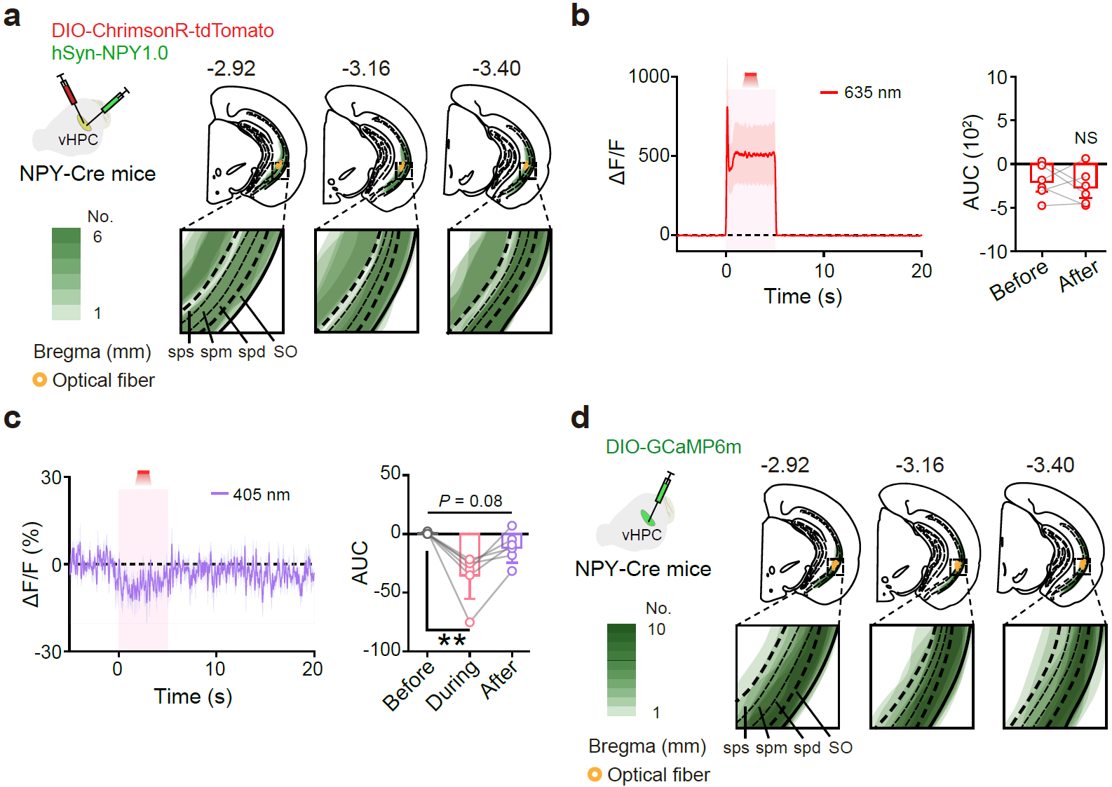

Supplementary Fig. 14 | Validation of viral expression and optical fiber placements in vCA1 of NPY-Cre mice. a, d, Schematic of the viral injection and experimental setup showing the expression of hSyn-NPY1.0 and DIO-ChrimsonR-tdTomato (a, related to Fig. 2a–c, n = 6 mice) or DIO-GCaMP6m (d, related to Fig. 2d–f, n = 10 mice) in NPY-Cre mice. The lower panel shows the location of optical fibers in vCA1 at three different Bregma coordinates (–2.92, –3.16, –3.40 mm), with the yellow circle indicating optical fiber tips for all mice. The shading indicates viral expression across all mice. b, c, Representative trace of tdTomato (λ = 635 nm, b) or reference (λ = 405 nm, c) fluorescence (ΔF/F%) upon photostimulation with 635 nm light (left) and corresponding AUC (right) analysis before, during and after photostimulation related to Fig. 2a–c. Exact statistic tests and P values are provided in Source Data.

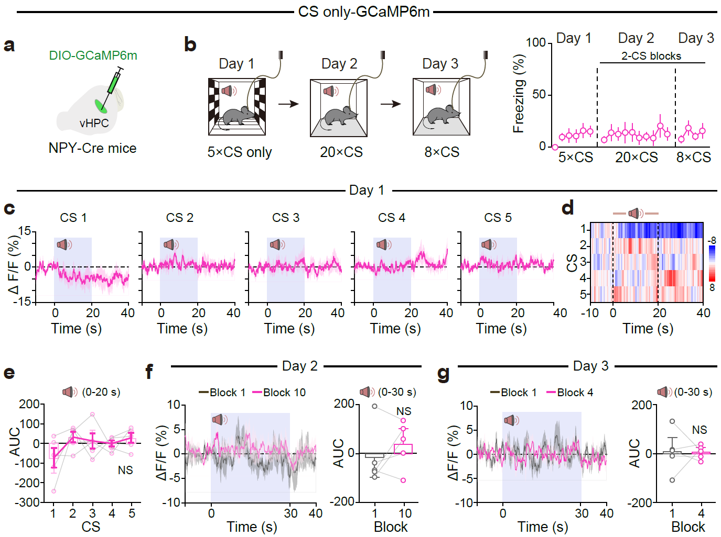

Supplementary Fig. 15 | Dynamics of calcium signals in vCA1 NPY⁺ interneurons during different training sessions in the absence of shock. a, Schematic of viral injection of DIO-GCaMP6m into the vHPC of NPY-Cre mice. b, Behavioral procedure and freezing levels during different training sessions in CS only condition. c, d, Average GCaMP6m fluorescence (ΔF/F) response to auditory tones alone throughout trials 1–5 on Day 1 (c), with a corresponding ΔF/F (%) heatmap showing responses across all five CS-only trials (d). e, AUC analysis of ΔF/F during the auditory tone period (0–20 s) for each CS-only trial on Day 1. f, g, Average GCaMP6m fluorescence (ΔF/F) and corresponding AUC during CS presentation (0–30 s) on Day 2 (block 1 vs. 10; f) and Day 3 (block 1 vs. 4; g). Exact statistic tests and P values are provided in Source Data.

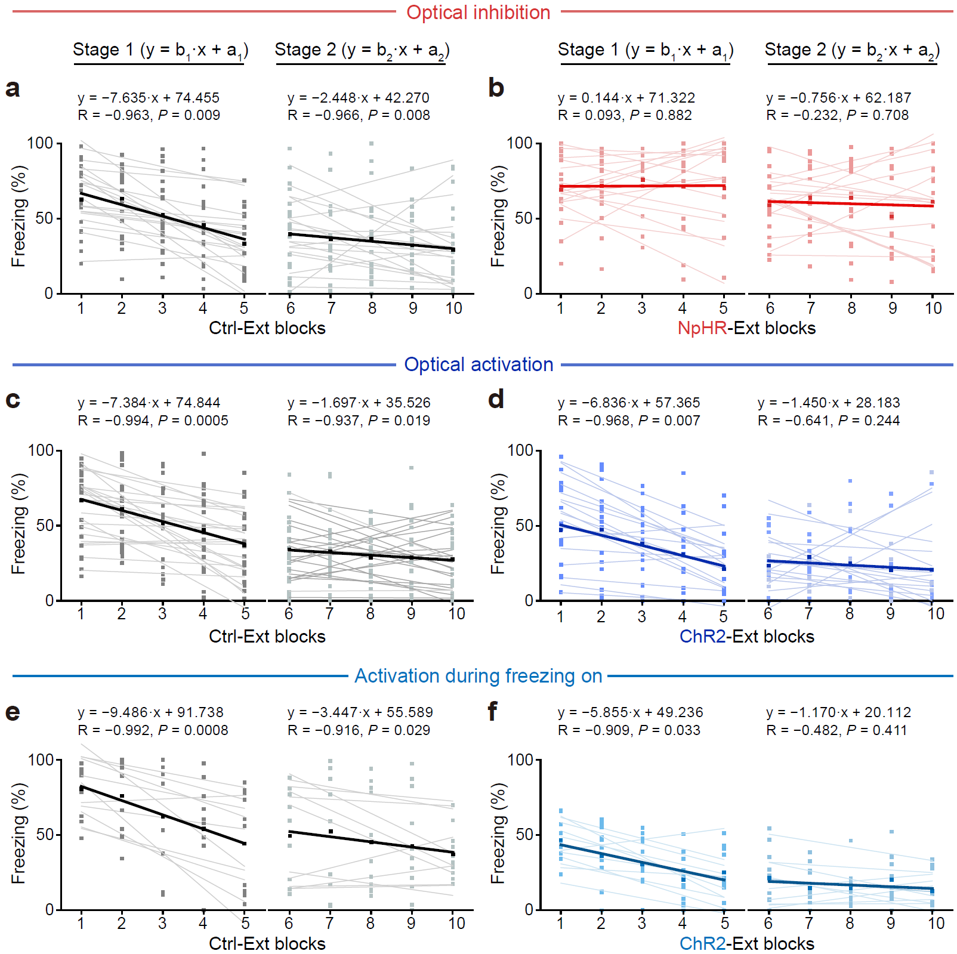

Supplementary Fig. 16 | Effects of optogenetic manipulations of vCA1 NPY⁺ neuronal activity on extinction slope, related to Fig. 3c–j. Linear fitting was performed for extinction Stage 1 and Stage 2 in mice used for optogenetic inhibition of NPY⁺ interneurons. Means are shown as thick lines. The equation, Pearson's r (R) and P-value (P) were shown for the means.

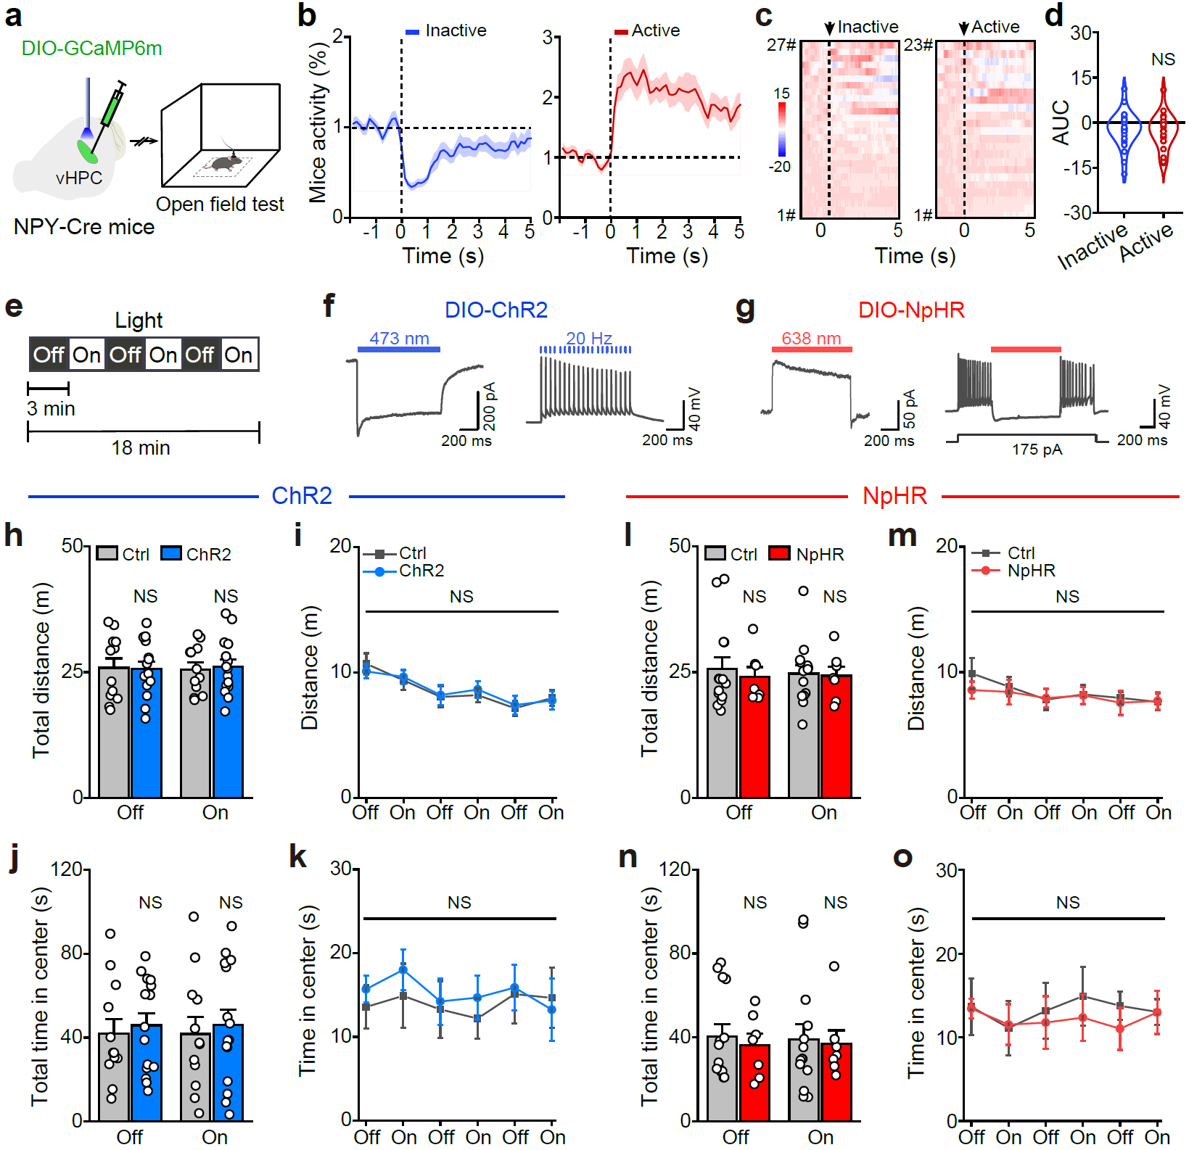

Supplementary Fig. 17 | No significant correlation was found between locomotor activity and vCA1 NPY⁺ neuronal activity a, Schematic of viral injection and the behavioral procedure for fiber photometry recording in open field tests. b, Based on locomotor activity, behaviors were categorized as either inactive or active in open field tests. c, Heatmaps of calcium responses of vCA1 NPY⁺ neurons for the corresponding inactive and active state. d, AUC of the △F/F GCaMP6m fluorescence for 5 s following locomotor activity, whether inactive or active. n = 27 trials for inactive state, n = 23 trials for active state of four mice. e, Schematic procedure for optogenetic manipulations of NPY⁺ neuronal activity in the vCA1. f, g, Functional identification of ChR2 (f) and NpHR (g) expressed in vCA1 NPY⁺ neurons. h–o, Activation or inhibition of vCA1 NPY⁺ neurons didn’t affect locomotor activity and time spent in the center. n = 14 mice for Ctrl of inhibition, n = 7 mice for NpHR, n = 12 mice for Ctrl of activation, n = 15 mice for ChR2. Exact statistic tests and P values are provided in Source Data.

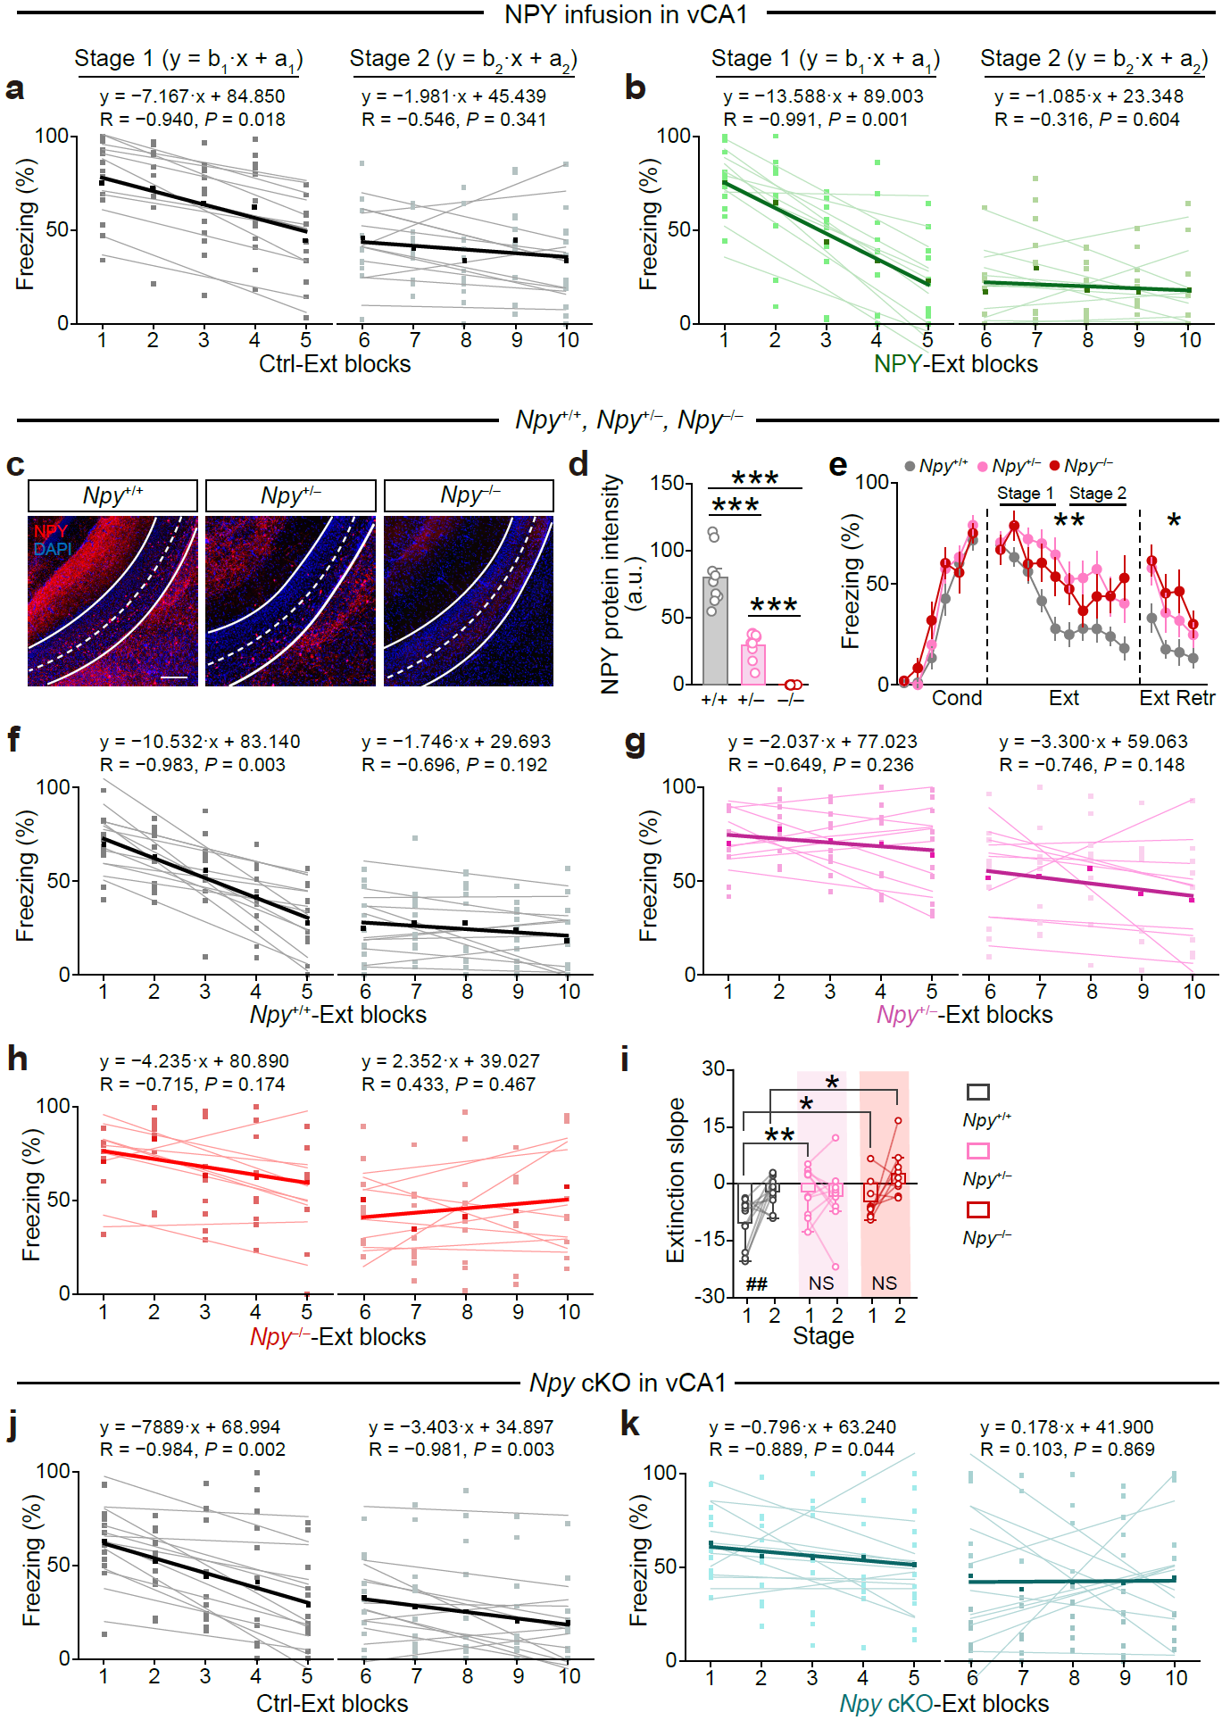

Supplementary Fig. 18 | Effects of NPY peptide or knockout of Npy on fear extinction. a, b, Linear fitting was performed for extinction Stage 1 and Stage 2 in mice used for pharmacology manipulation NPY levels, related to Fig. 3m, n. Means are shown as thick lines. The equation, Pearson's r (R) and P-value (P) were shown for the means. c–i, Effects of conventional knockout or knockdown of Npy on fear extinction. c, Representative images of NPY expression in vCA1 of Npy^{+/+}, Npy^{+/–} and Npy–/– mice. Scale bar, 200 μm. d, Quantification of NPY expression levels by IHC. n = 3 mice and 9 coronal sections for Npy^{+/+}, Npy^{+/–} and Npy–/–, respectively. e, Cued freezing of Npy^{+/–} and Npy–/– mice during conditioning, extinction, and extinction retrieval. n = 12 mice for Npy^{+/+}, n = 10 mice for Npy^{+/–}, n = 9 mice for Npy–/–. f–h, Linear fitting was performed for extinction Stage 1 and Stage 2 in mice used for Npy^{+/+}, Npy^{+/–} and Npy–/– mice. Means are shown as thick lines. The equation, Pearson's r (R) and P-value (P) were shown for the means. i, In Npy knockout or knockdown mice, the difference in extinction slope between Stage 1 and 2 during extinction training was lost. Exact statistic tests and P values are provided in Source Data. j, k, Linear fitting was performed for extinction Stage 1 and Stage 2 in Npy cKO mice, related to Fig. 3o–q. Means are shown as thick lines. The equation, Pearson's r (R) and P-value (P) were shown for the means.

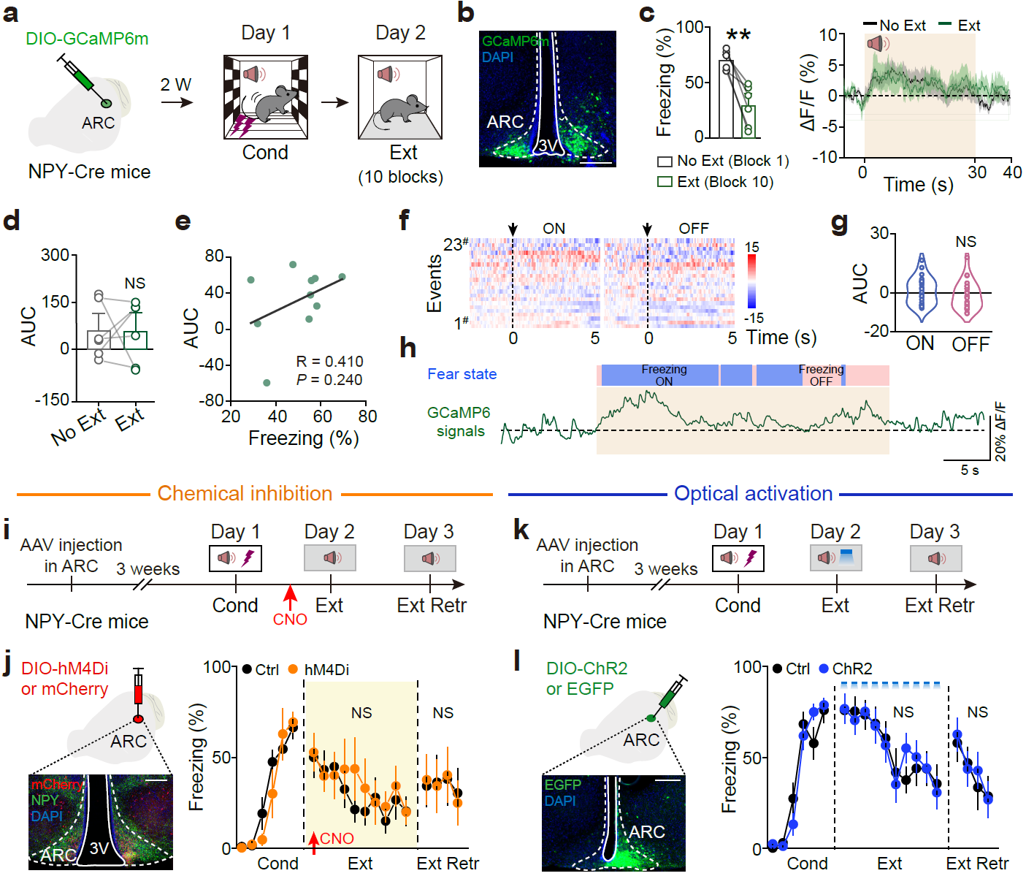

Supplementary Fig. 19 | NPY⁺ neurons in the hypothalamic arcuate nucleus have no impact on fear memory. a, Schematic of viral injection and the behavioral procedure for fiber photometry recording in ARC. b, Representative image showing the expression of GCaMP6m in ARC. Scale bar, 200 μm. c–e, The response of GCaMP6m in the ARC did not have significant difference between the Ext and No Ext state. c, Freezing levels. f, g, Heatmaps (f) and AUC (g) of GCaMP6m responses during freezing ON and OFF. n = 6 mice and 23 trials for freezing ON and OFF, respectively. h, Example trace illustrating the relationship between fear state and GCaMP6 signals. i, k, Schematic behavioral procedure for chemical inhibition and optical activation of NPY⁺ neurons in the ARC. j, Left: Representative image showing the expression of hM4Di-mCherry in ARC NPY⁺ neurons, Scale bar, 200 μm; Right: Chemical inhibition of NPY⁺ neurons in ARC had no effect on extinction. n = 7 mice for Ctrl, and 6 mice for hM4Di. l, Left: Representative image showing the expression of ChR2-EGFP in ARC NPY⁺ neurons, Scale bar, 200 μm; Right: Activation of NPY⁺ neurons in ARC failed to affect fear extinction. n = 8 mice for Ctrl, and 10 mice for ChR2. Exact statistic tests and P values are provided in Source Data.

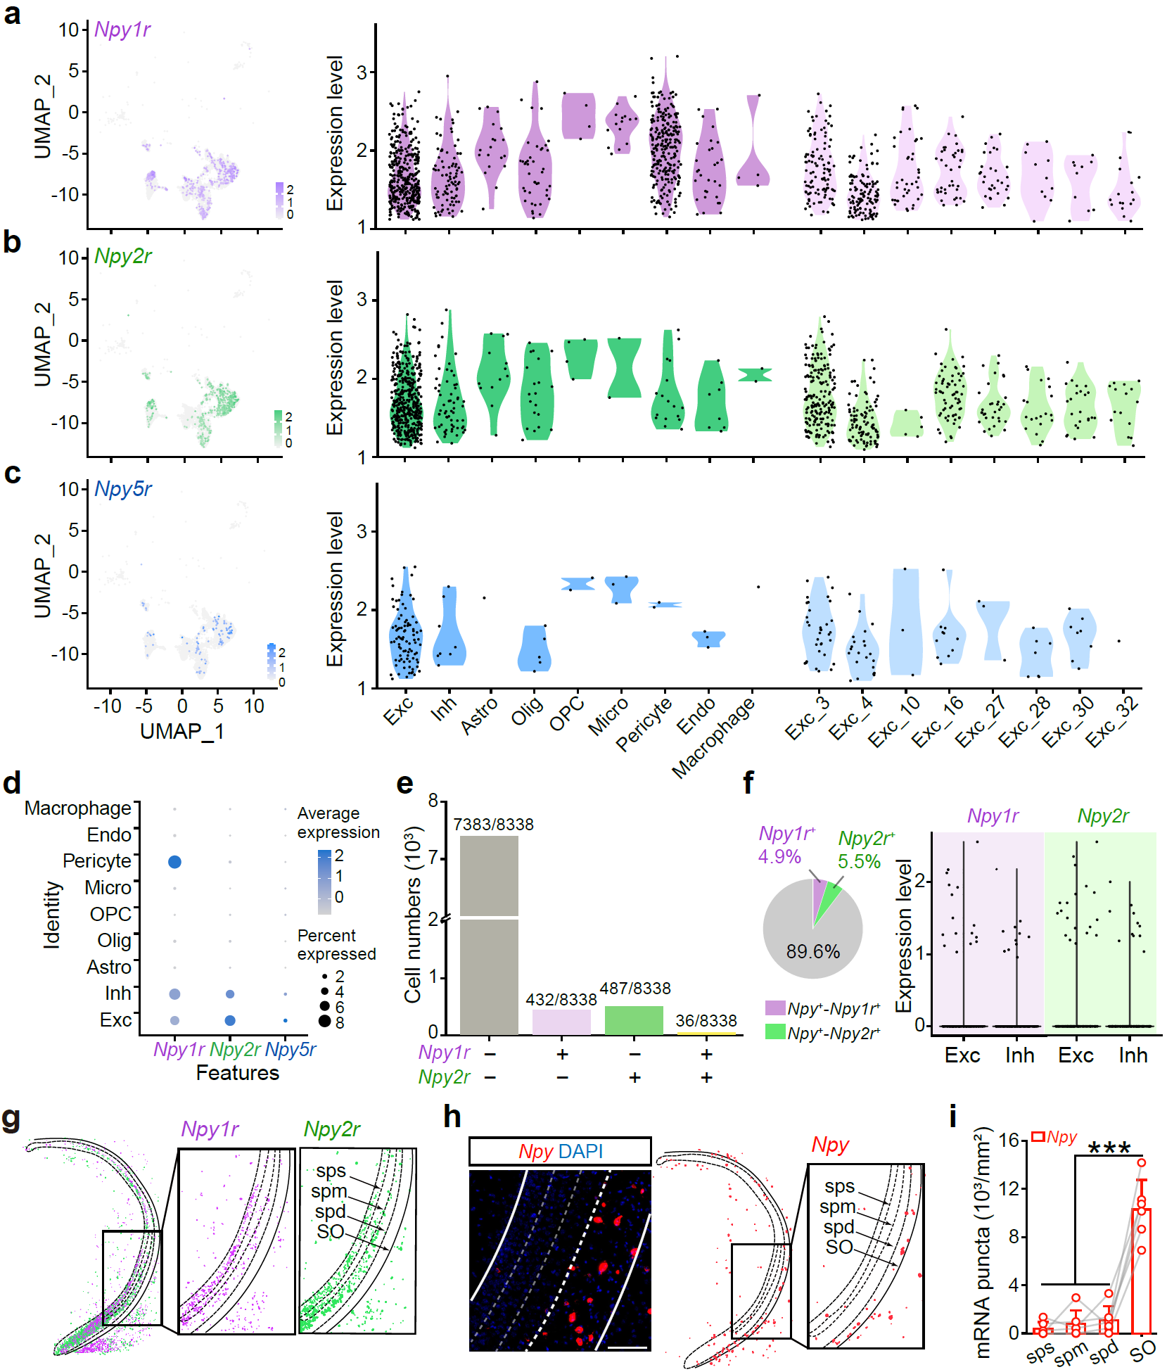

Supplementary Fig. 20 | Expression and distribution of NPY receptors in vHPC. a–c, UMAP representation (left) and violin plots (right) showing the expression levels of Npy1r⁺, Npy2r⁺ and Npy5r⁺ across different cell types and excitatory neuron subtypes in vHPC. Each dot represents a single cell. d, Dot plot showing Npy1r, Npy2r and Npy5r expression across different cell types. Dot size indicates the proportion of cells expressing each receptor, and the color represents the mean expression level. e, Non-overlapping NPY receptor subtype-expressing neurons. Bar plots illustrating the cell numbers of neurons expressing different NPY receptor subtypes. f, Pie chart and violin plots showing negligible expression of Npy1r and Npy2r within Npy⁺ inhibitory neurons. 550 Npy⁺ neurons, 27 Npy⁺/Npy1r⁺ neurons, 30 Npy⁺/Npy2r⁺ neurons. g, h, RNAscope images depicting the regional and laminar specificities of Npy1r, Npy2r, and Npy expression in vHPC. n = 4 coronal slices from 4 mice and for Npy1r, Npy2r, and Npy, respectively. vCA1-sps, superficial pyramidal layer of vCA1; vCA1-spm, middle pyramidal layer of vCA1; vCA1-spd, deep pyramidal layer of vCA1. i, Quantification of Npy puncta across the SO and sps, spm, and spd pyramidal layers of the vCA1. Exact statistic tests and P values are provided in Source Data.

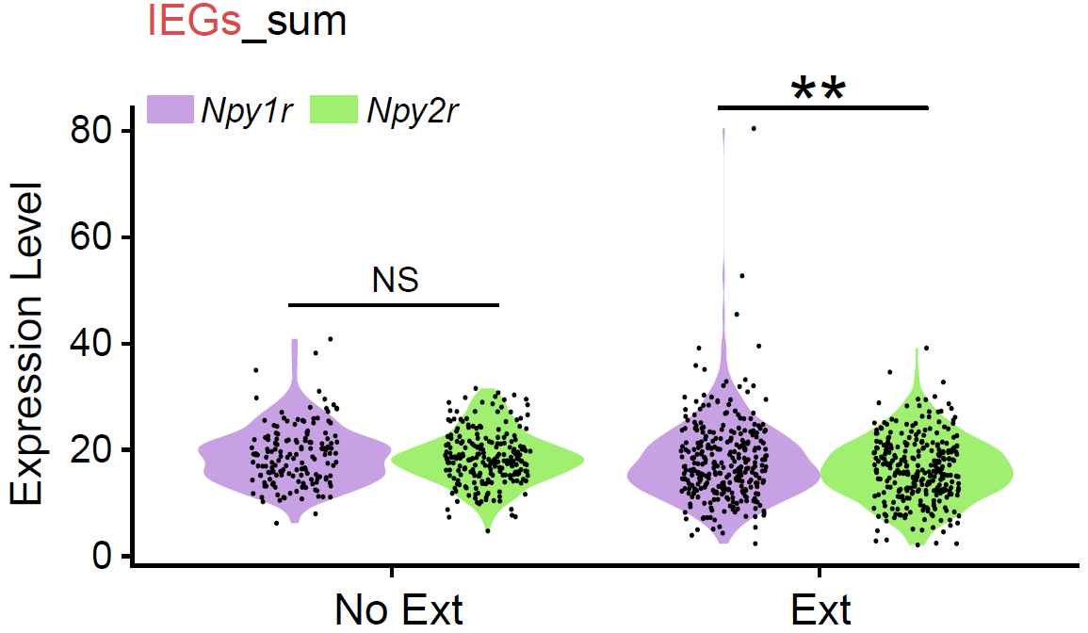

Supplementary Fig. 21 | Differential expression of IEGs in Npy1r- and Npy2r-expresing neurons following extinction. Violin plots show the expression levels of IEGs (sum) in Npy1r (purple) and Npy2r (green) receptors under no extinction (No Ext) and extinction (Ext) conditions. Black dots represent individual data points. Exact statistic tests and P values are provided in Source Data.

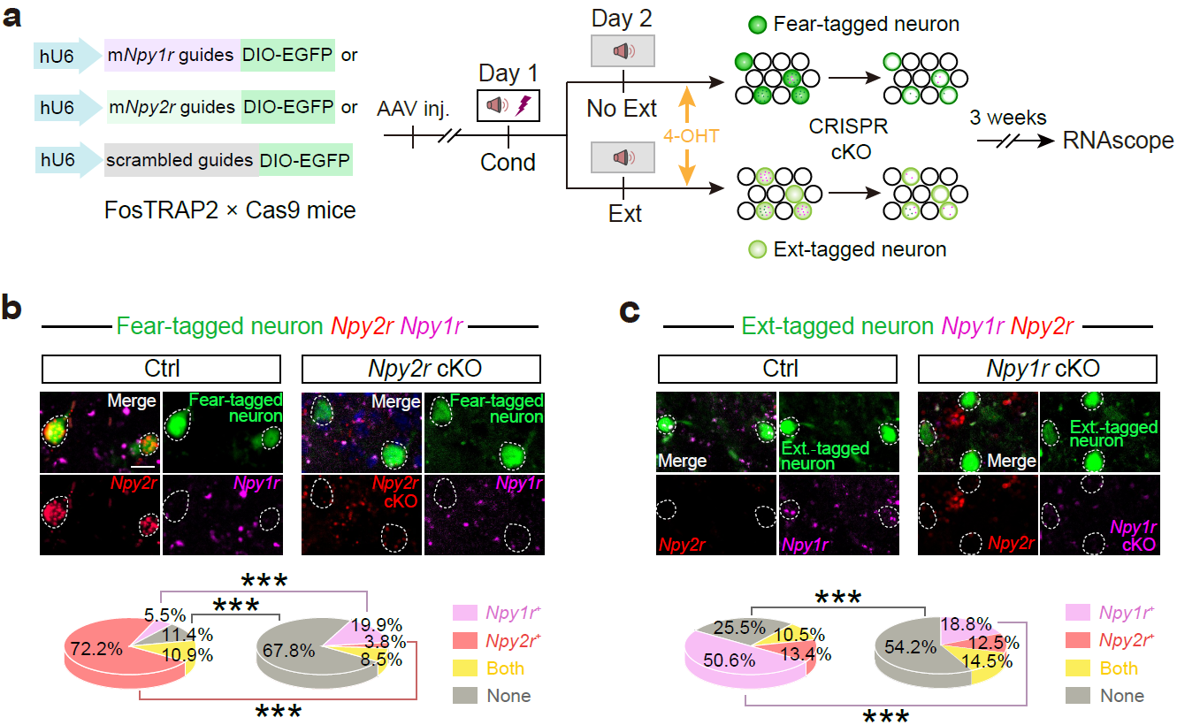

Supplementary Fig. 22 | Validation of CRISPR/Cas9-mediated conditioned KO (cKO) of Npy2r or Npy1r in Fear- and Ext-tagged neurons. a, Experimental design to validate the efficacy of the CRISPR/Cas9 system in depleting Npy2r and Npy1r mRNA levels in Fear- and Ext-tagged neurons, respectively. b, The expression of Npy2r, Npy1r in the Fear-tagged and Npy2r cKO neurons. Scale bar, 20 mm. n = 12 brain slices of three mice for Ctrl; n = 17 brain slices of two mice for Npy2r cKO. c, The expression of Npy1r, Npy2r in the Ext-tagged and Npy1r cKO neurons. Scale bar, 20 mm. n = 10 brain slices of two mice for Ctrl, n = 31 brain slices of three mice for Npy1r cKO. Exact statistic tests and P values are provided in Source Data.

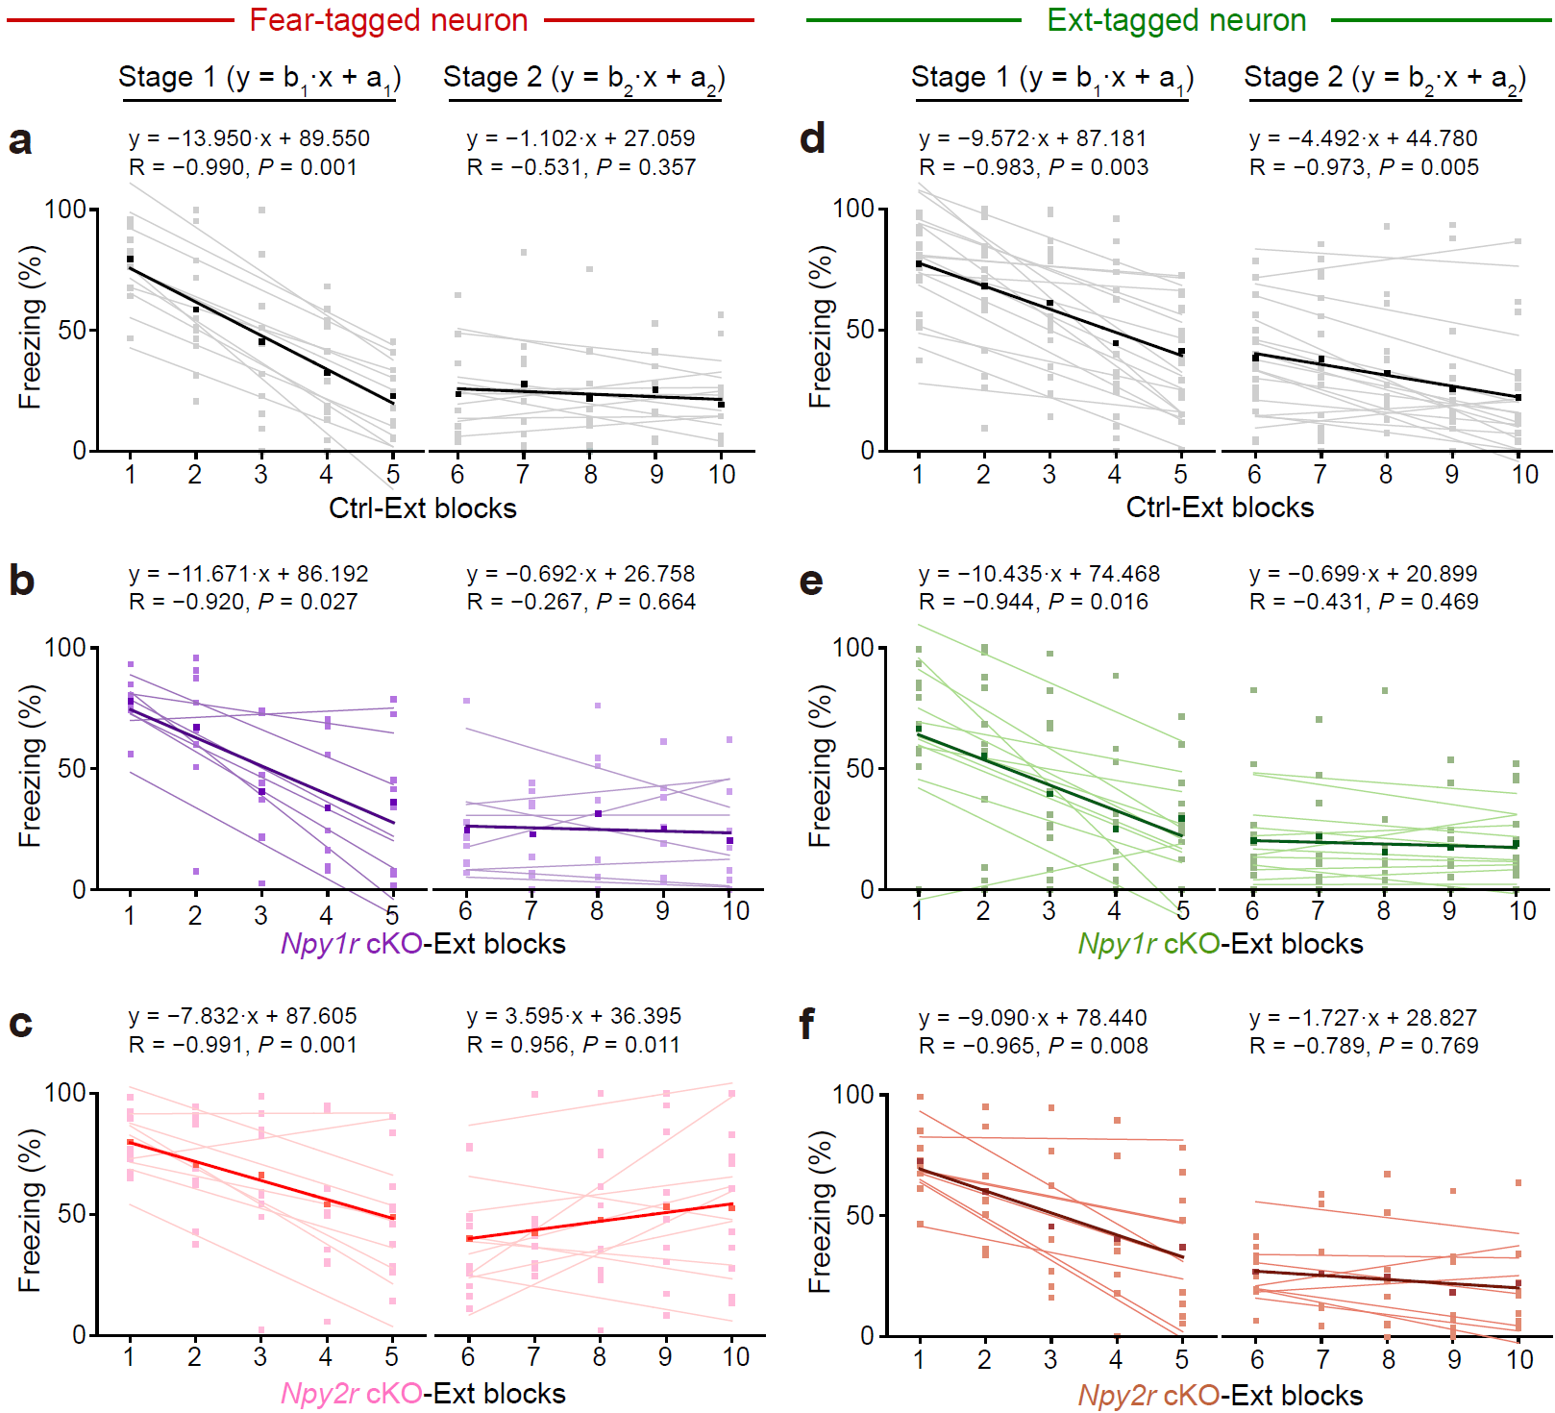

Supplementary Fig. 23 | NPY receptor gene cKO in fear- or Ext-tagged neurons altered fear and extinction memory, related to Fig. 5a–e. Linear fitting was performed for extinction Stage 1 and Stage 2 in mice used for NPY receptor gene cKO. Means are shown as thick lines. The equation, Pearson's r (R) and P-value (P) were shown for the means.

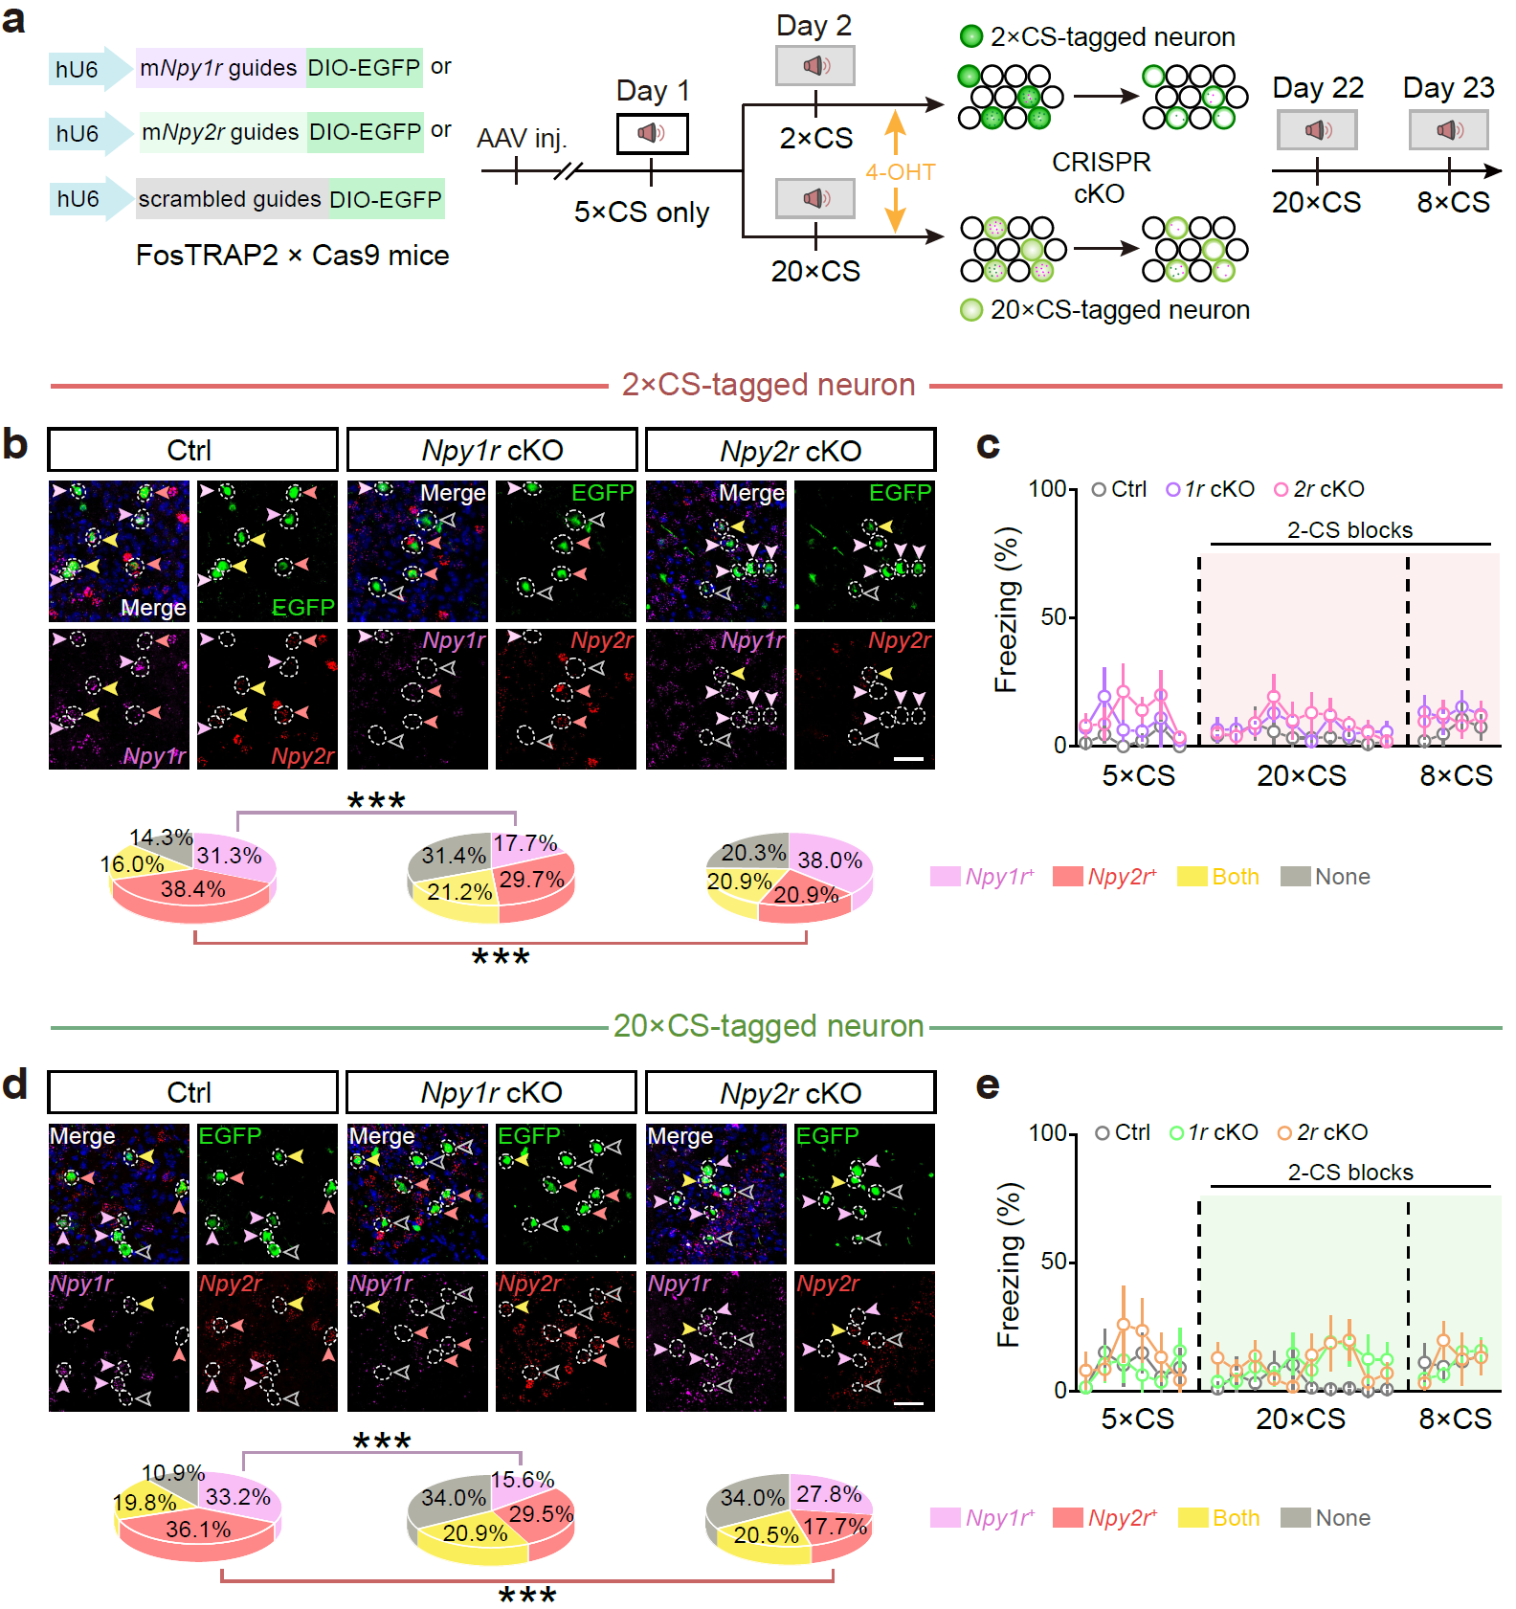

Supplementary Fig. 24 | Conditional knockout of Npy1r or Npy2r in CS‑tagged neurons without shock (CS only) did not induce significant freezing. a, Experimental scheme. FosTRAP2 × Cas9 mice received vHPC injections of AAVs carrying U6-sgRNA (mNpy1r, mNpy2r, or scrambled control) together with DIO-EGFP. Mice were exposed to tones without foot shock. On Day 2, 4-OHT was administered immediately after either 2×CS or 20×CS to trap the corresponding CS-tagged ensembles, restricting CRISPR editing to these neurons. Three weeks later (Days 22–23) mice were presented with 20×CS followed by 8×CS for behavioral readout. b, Representative fields of 2×CS-tagged EGFP⁺ neurons (green) with RNAscope for Npy1r (magenta) and Npy2r (red) in control, Npy1r-cKO and Npy2r-cKO groups. Arrowheads: light magenta, Npy1r⁺ only; pink/red, Npy2r⁺ only; yellow, double-positive; open gray, double-negative. Scale bar, 50 µm. Pie charts summarize receptor identity among EGFP⁺ cells (Ctrl, n = 14 slices/3 mice; Npy1r-cKO, n = 24 slices/3 mice; Npy2r-cKO, n = 16 slices/3 mice). c, Freezing across tone blocks for the cohorts in b. Deleting Npy1r or Npy2r in 2×CS-tagged neurons did not elicit freezing (Ctrl, n = 6 mice; Npy1r-cKO, n = 5; Npy2r-cKO, n = 5). Shaded region indicates the 2-CS test blocks. d, As in b for 20×CS-tagged ensembles (Ctrl, n = 14 slices/2 mice; Npy1r-cKO, n = 17 slices/3 mice; Npy2r-cKO, n = 16 slices/3 mice). Scale bar, 50 µm. e, Freezing for the cohorts in d during tone presentations; no genotype effect (all groups, n = 6 mice). Exact statistic tests and P values are provided in Source Data.

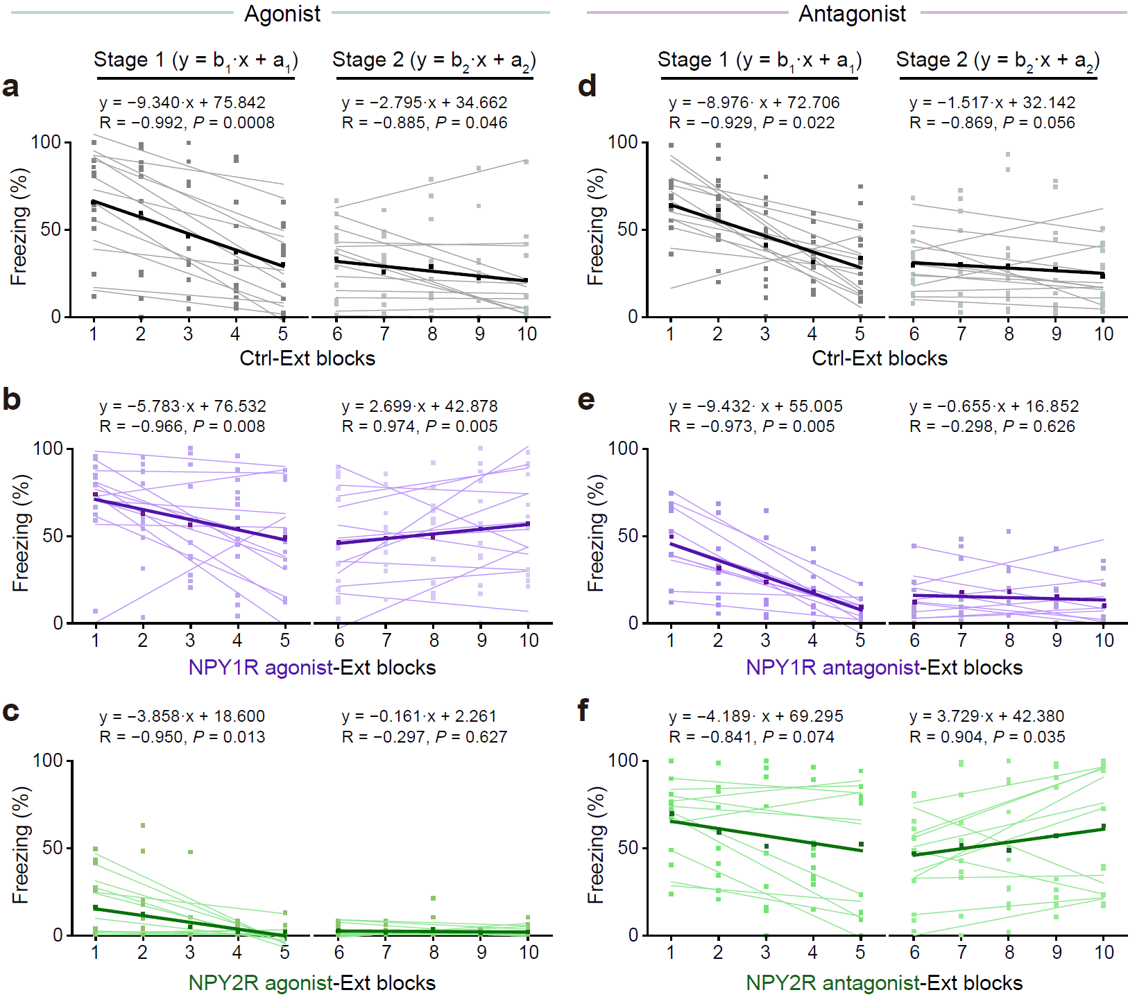

Supplementary Fig. 25 | Effects of pharmacological modulation of NPY1R and NPY2R activity on extinction slope, related to Fig. 5f–j. Linear fitting was performed for extinction Stage 1 and Stage 2 in mice used for pharmacological modulation of NPY receptor activity. Means are shown as thick lines. The equation, Pearson's r (R) and P-value (P) were shown for the means.

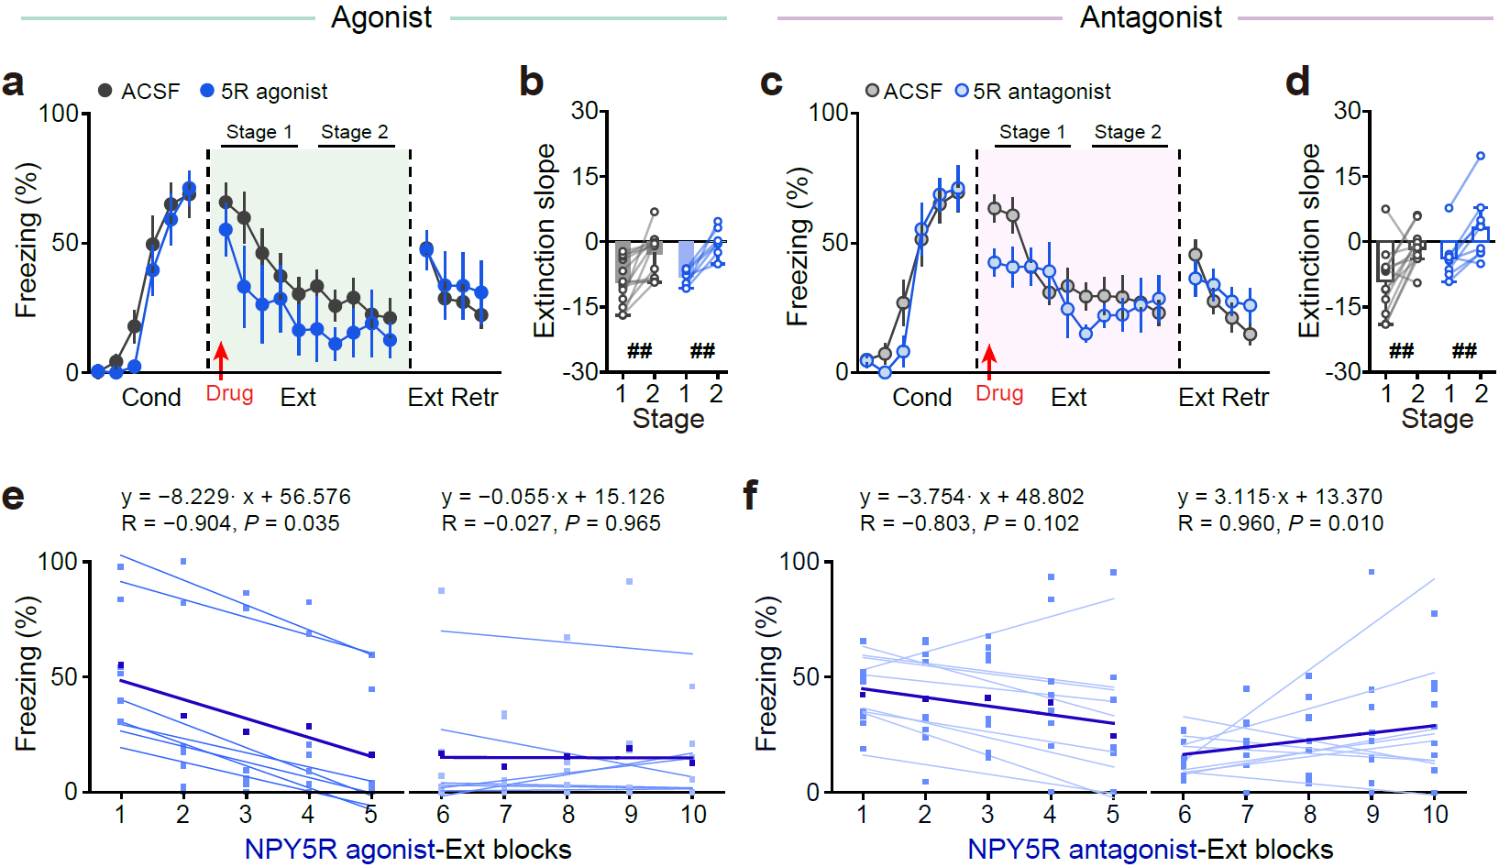

Supplementary Fig. 26 | Pharmacological interventions targeting NPY5R in vCA1 had no discernible effects on fear extinction. a–d, Microinjection the agonist (a, b) and antagonist (c, d) of NPY5R in vCA1 had no effect on extinction. a, b, n = 13 mice for ACSF, n = 7 mice for NPY5R agonist. c, d, n = 13 mice for ACSF, n = 9 mice for NPY5R antagonist. e, f, Linear fitting was performed for extinction Stage 1 and Stage 2 in mice with microinjection the agonist (e) and antagonist (f) of NPY5R. Means are shown as thick lines. The equation, Pearson’s r (R) and P-value (P) were shown for the means. The freezing level of ACSF control group taken from Fig. 5g, h and Fig. 5i, j, respectively, is regraphed again for comparison. Exact statistic tests and P values are provided in Source Data.

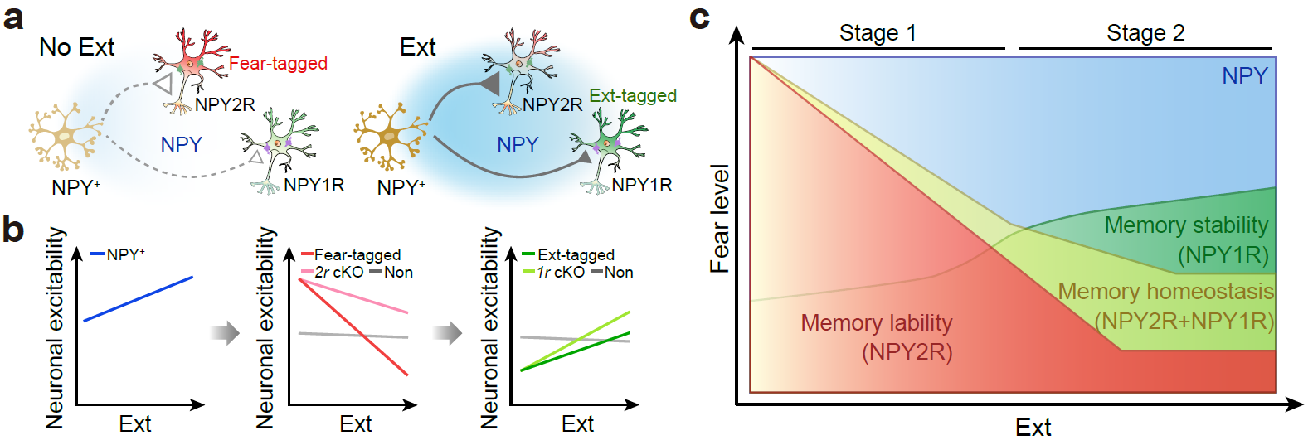

Supplementary Fig. 27 | Scheme illustrating NPY modulation of neuronal ensembles for memory lability and stability. In contrast to No Ext, during extinction (Ext), NPY⁺ neuronal activity progressively increases. The increased inhibition from released NPY to Npy2r-expressing Fear-tagged neurons gradually intensifies, but this inhibition is negated by Npy2r cKO in Fear-tagged neurons. Likewise, Ext-tagged neuronal activity increases progressively during extinction. The inhibition of NPY to Npy1r-expressing Ext-tagged neurons is less pronounced; however, Npy1r cKO enhances the activity of Ext-tagged neurons. Overall, locally released NPY in the vCA1 target distinct Npy2r- and Npy1r-subensembles to establish a setpoint between memory lability and stability.

