Supplementary Information

Analog Reservoir Computing via Double-Gate
Morphotropic Phase Boundary Transistors

Jangsaeng Kim^{1,2,3†}, Eun Chan Park^{1†}, Wonjun Shin^{2,3†}, Ryun-Han Koo³, Chang-Hyeon Han¹, He Young Kang¹, Jae Kyeong Jeong¹*, and Daewoong Kwon¹*

¹Department of Electronic Engineering, Hanyang University, Seoul 04763, Republic of Korea
²Research Laboratory of Electronics, Massachusetts Institute of Technology, Cambridge, MA 02139, USA
³Department of Electrical and Computer Engineering and Inter-university Semiconductor Research Center, Seoul National University, Seoul 08826, Republic of Korea

† These authors contributed equally: Jangsaeng Kim, Eun Chan Park, Wonjun Shin

* Corresponding author (e-mail: dw79kwon@hanyang.ac.kr, jkjeong1@hanyang.ac.kr)

Contents

Supplementary Figure 1–18
Supplementary Table 1
Supplementary Note 1–7
Supplementary References

Supplementary Figures

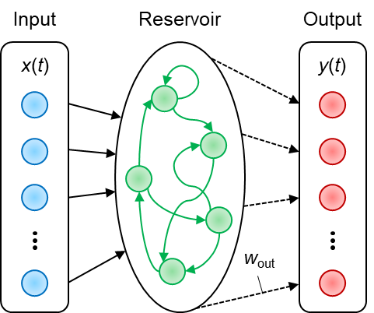
Supplementary Figure 1. Schematic of a conventional ARC system comprising a dynamic reservoir and a readout network. Inputs are transformed into a high-dimensional feature space within the reservoir, enabling a nuanced analysis by the readout network.

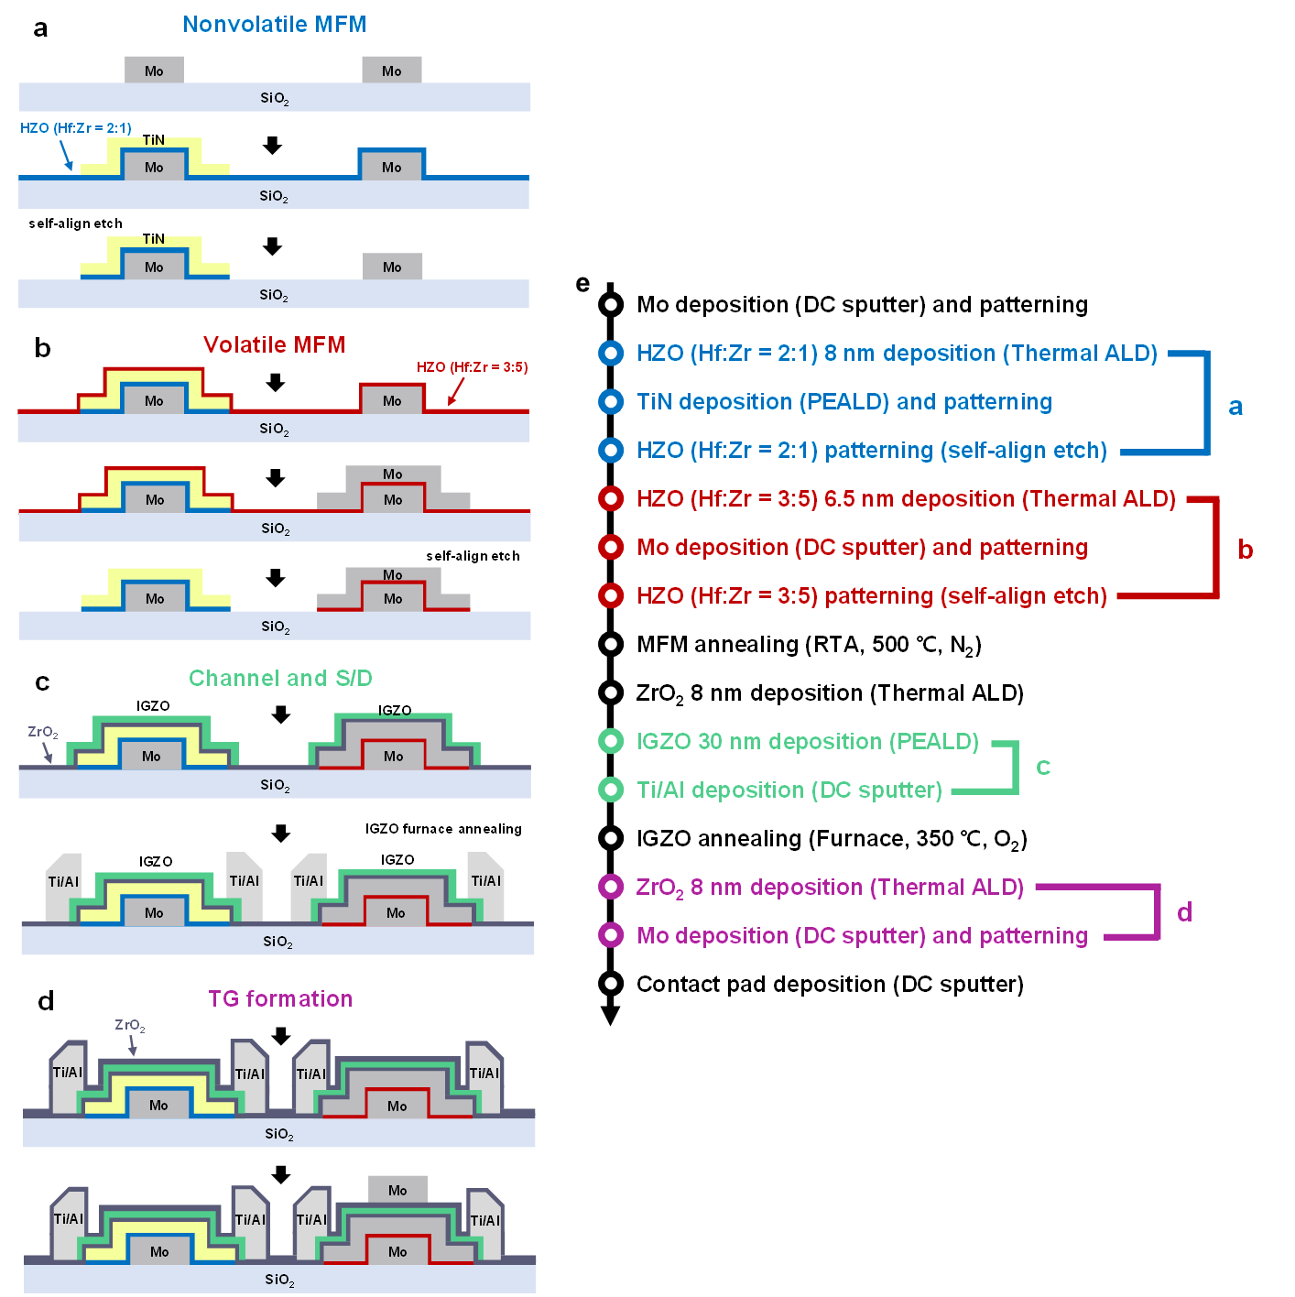
Supplementary Figure 2. Fabrication process for volatile DG MPBTFT and nonvolatile FeTFT. a–d Schematic views of key process steps. e Key process steps for fabricating volatile and nonvolatile TFTs. The structural similarities between volatile and nonvolatile TFTs facilitate the integration of both types of TFTs on a single wafer.

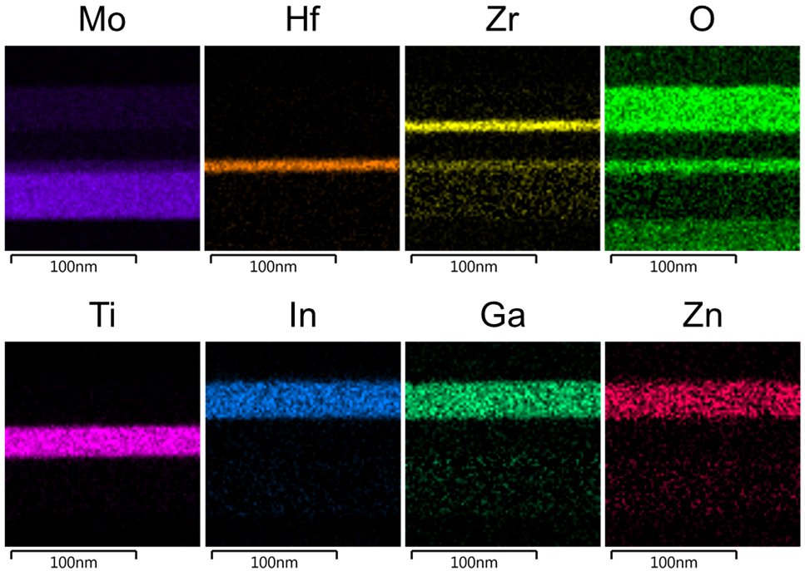
Supplementary Figure 3. EDS analysis of nonvolatile FeTFT with a Mo/HZO/TiN/ZrO₂/ IGZO stack.

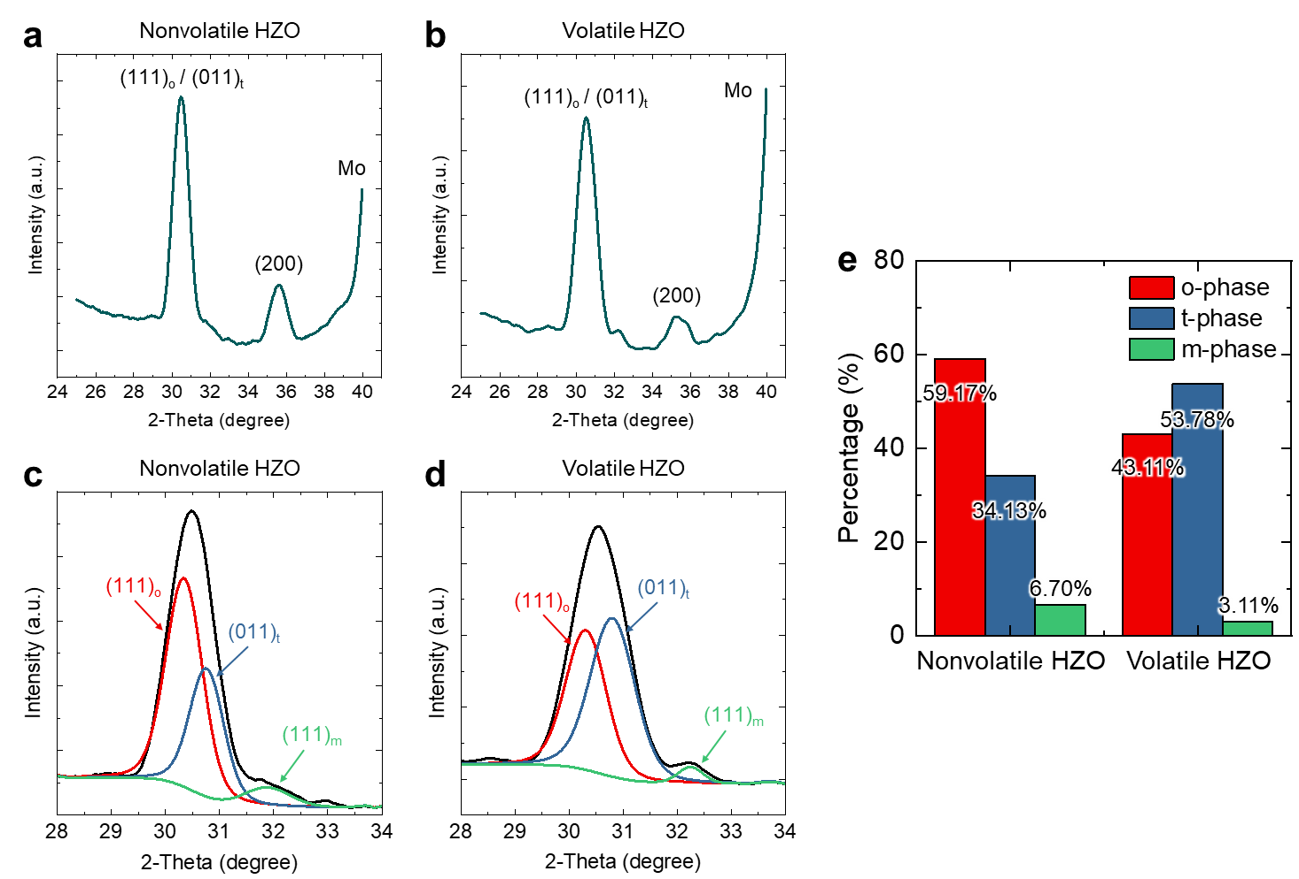
Supplementary Figure 4. XRD analyses of nonvolatile and volatile HZO films. XRD spectra of a nonvolatile and b volatile HZO films. Deconvoluted XRD spectra of c nonvolatile and d volatile HZO films through the fixed peak positions. Unlike the stable monoclinic phase (m-phase, (111)_{m}), which has clearly distinct diffraction peaks, the orthorhombic phase (o-phase, (111)_{o}) and tetragonal phase (t-phase, (011)_{t}) have similar peaks. In this study, the relative phase fractions of the (111)_{o} and (011)_{t} peaks were calculated under the assumption that their respective phases correspond to 30.4° and 30.8° [1–3]. e Relative phase ratio derived from XRD. Both the nonvolatile and volatile HZO films have minimal non-ferroelectric phase (m-phase). The o-phase and t-phase predominate in the nonvolatile and volatile HZO films, respectively.

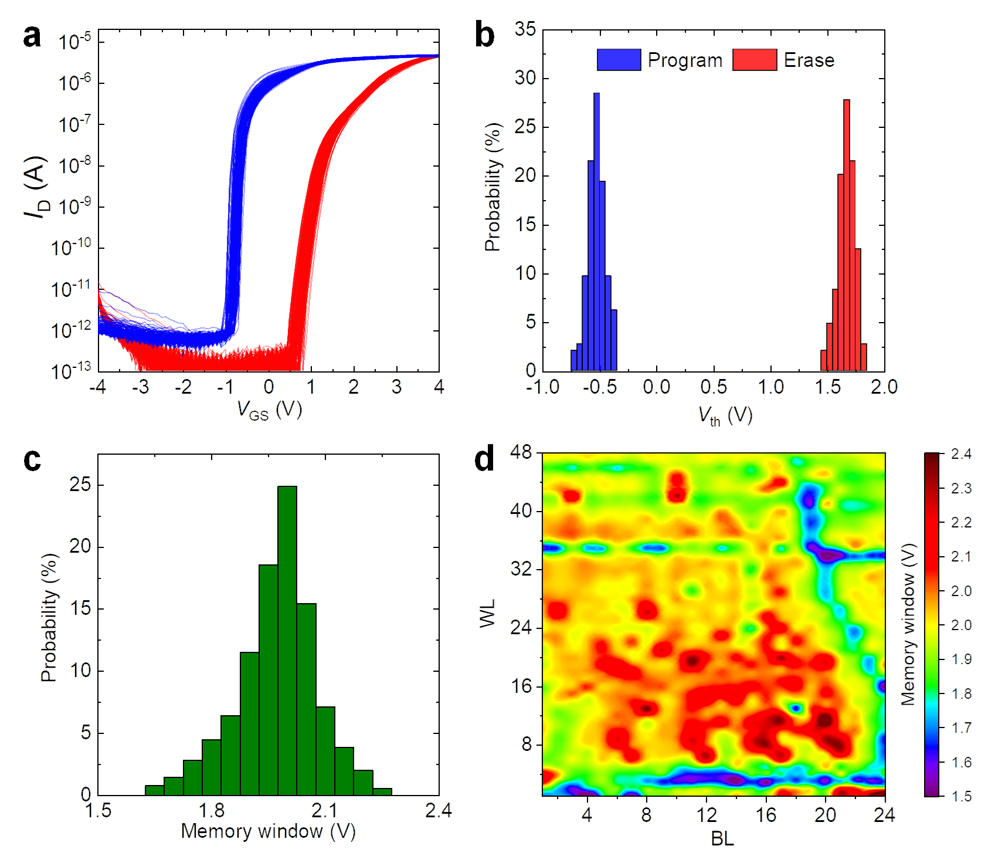
Supplementary Figure 5. Device-to-device variation of nonvolatile FeTFTs. a Transfer characteristics (I_{D}-V_{GS}) and b threshold voltages (V_{th}s) of the FeTFTs at PGM and ERS states. c, d Memory window (MW) distribution of the FeTFTs within a fabricated array.

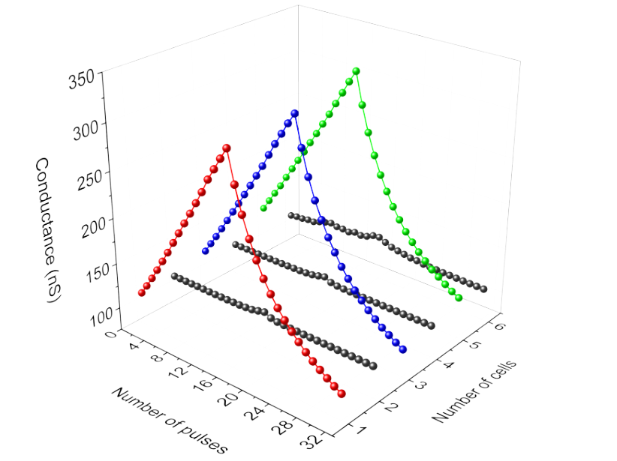
Supplementary Figure 6. Selective PGM/ERS operations within a nonvolatile FeTFT array. Only the target FeTFTs are programmed or erased, whereas other FeTFTs within the array are effectively inhibited. The results verify the random-access capability of the fabricated FeTFT array.

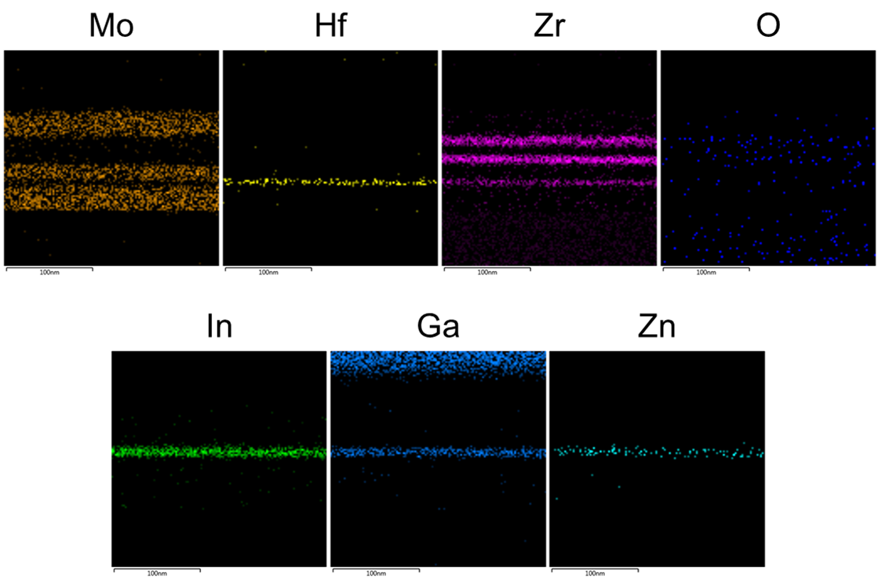
Supplementary Figure 7. EDS analysis of volatile DG MPBTFT with a Mo/HZO/Mo/ ZrO₂/IGZO/ZrO₂/Mo stack.

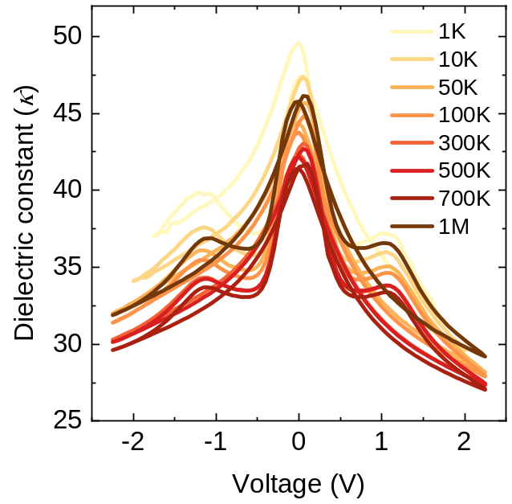
Supplementary Figure 8. Dielectric constant (κ) of HZO thin film near the MPB as a function of the number of cycles. The HZO thin film near the MPB exhibits a high κ of approximately 50.

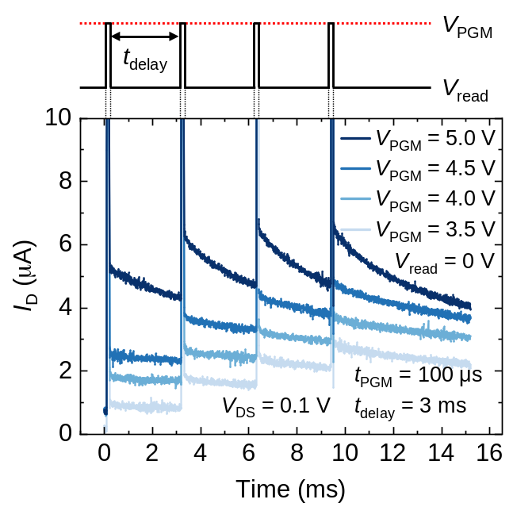
Supplementary Figure 9. Dynamic response of the I_{D}s in the volatile DG MPBTFT to consecutive PGM pulses with various V_{PGM}s. The upper panel represents the sequence of applied PGM pulses, succeeded by constant read voltages. The time interval between each PGM pulse is 3 ms.

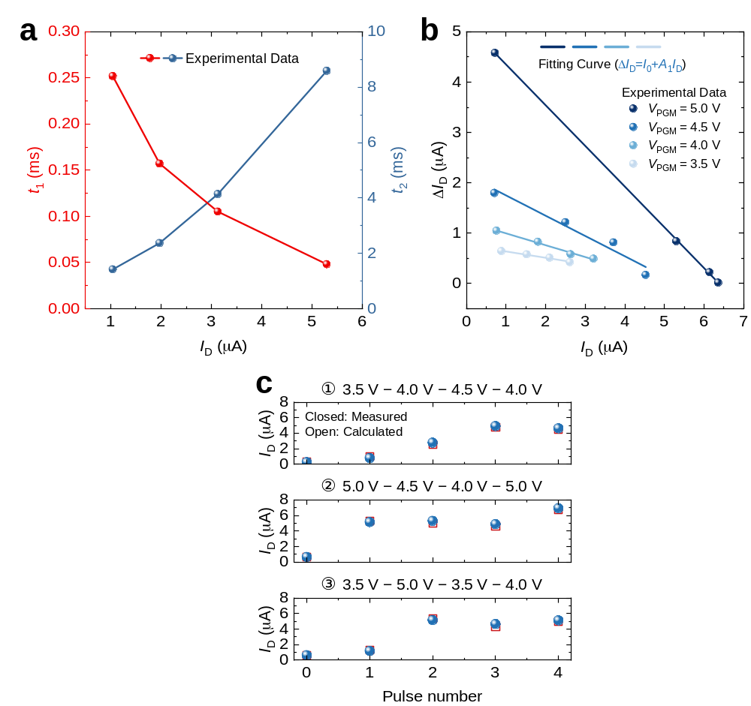
Supplementary Figure 10. Fitting parameters for volatile memory characteristics of volatile DG MPBTFTs. a Fitting parameters for various initial I_{D}s. b Changes in I_{D} according to various V_{PGM}s. The relaxation process of the volatile DG MPBTFTs, observed after the removal of the PGM pulse, is fitted with the double exponential function as follows:
$I_{D}=I_{0}+A_{1}e^{-t/t_{1}}+A_{2}e^{-t/t_{2}}$, (1)
where t denotes the time elapsed following the removal of the PGM pulse. The terms t₁ and t₂ represent two distinct characteristic time constants that are indicative of the rapid and gradual decay processes, respectively. The parameters A₁, A₂, and I₀ are constants of the relaxation process. A₁ and A₂ modulate the amplitudes of the rapid and gradual decay components, and I₀ represents the I_{D} when the relaxation process is completed after sufficient time. By using the fitting parameters shown in the a and b, the relaxation process of the DG MPBTFTs can be accurately modeled, given the amplitude of the applied PGM pulse and the initial I_{D}. c Experimentally measured I_{D} of the DG MPBTFT and calculated I_{D} using the model, when four PGM pulses with randomly assigned amplitudes are applied. The predictive capability of the model demonstrates a high degree of accuracy through the three sets of different PGM pulse trains.

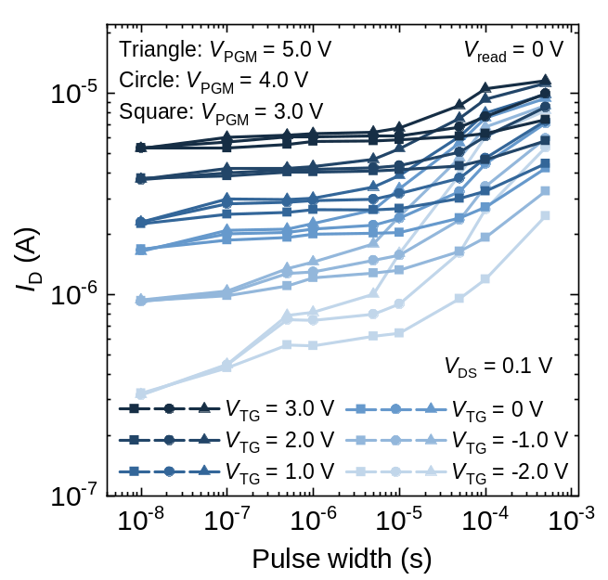
Supplementary Figure 11. Changes in I_{D} when a PGM pulse is applied to the BG as a function of pulse width for various V_{TG}s and V_{PGM}s. Widening the pulse width and increasing the V_{PGM} result in more significant changes in I_{D}.

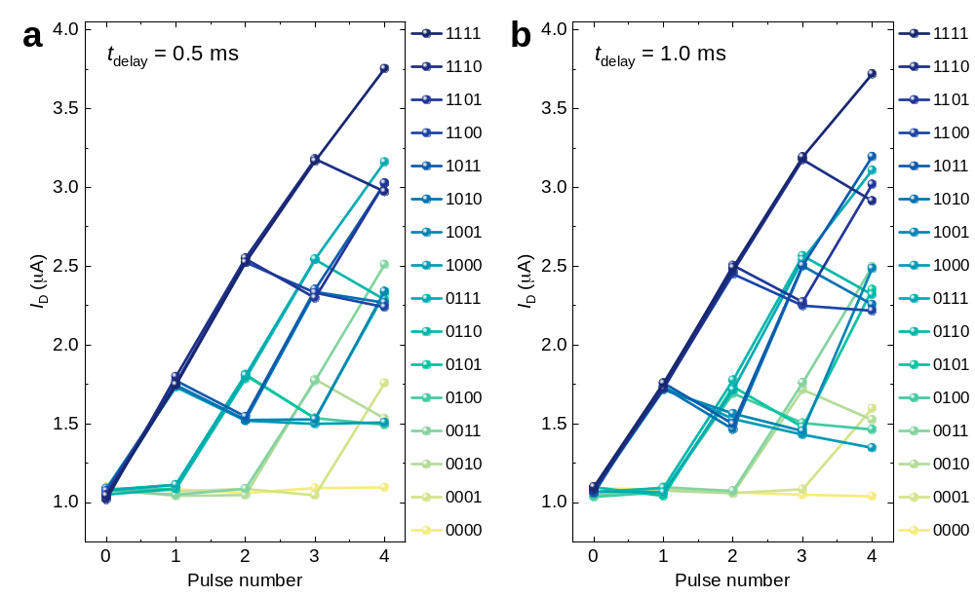
Supplementary Figure 12. I_{D} evolutions in response to 16 different input pulse trains (4.0 V, 100 μs) over various time intervals (t_{delay}s). When the t_{delay} is short, the decay of I_{D} is negligible, resulting in substantial overlap and poorly distinguished reservoir states. Insufficiently differentiated states diminish the richness of the reservoir states and impair system performance. Optimization of the input pulse train is essential for high performance.

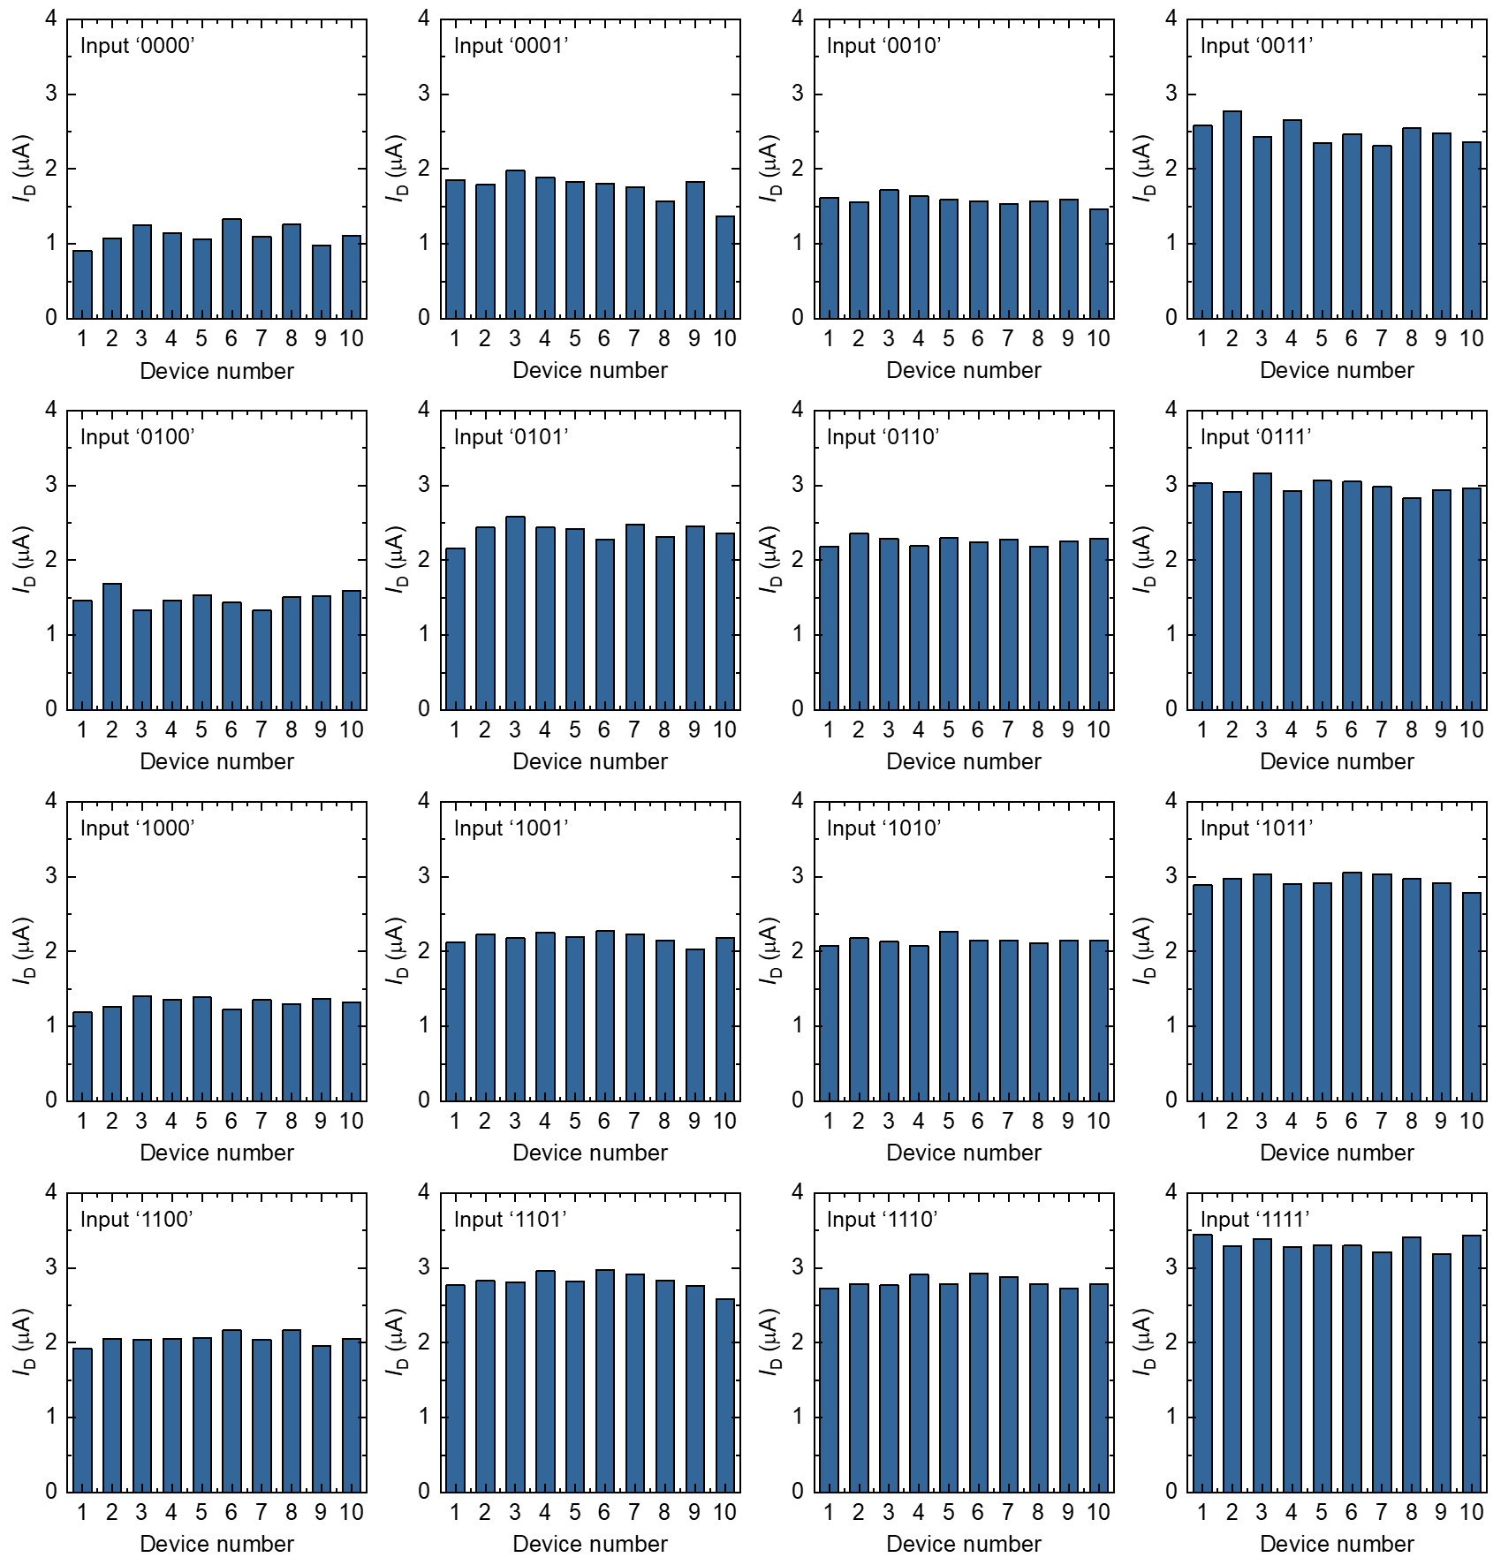
Supplementary Figure 13. Device-to-device variations of volatile DG MPBTFTs. I_{D} evolutions of 10 volatile DG MPBTFTs in response to 16 different input pulse trains (4.0 V, 100 μs) exhibit device-to-device variations (σ/μ) of approximately 0.045 on average (σ/μ = 0.023 ~ 0.11). Although device-to-device variations are generally perceived as a challenge in semiconductor device reliability, they present a unique advantage in the context of reservoir computing. These variations inherently increase the diversity of the reservoir’s response to inputs, effectively expanding the reservoir size [4, 5]. This diversity enhances the ability of the ARC system to differentiate between similar input patterns, subsequently improving the system performance. Therefore, device-to-device variations play a crucial role in optimizing the functionality of ARC systems, contributing positively to the robustness and efficiency of the system.

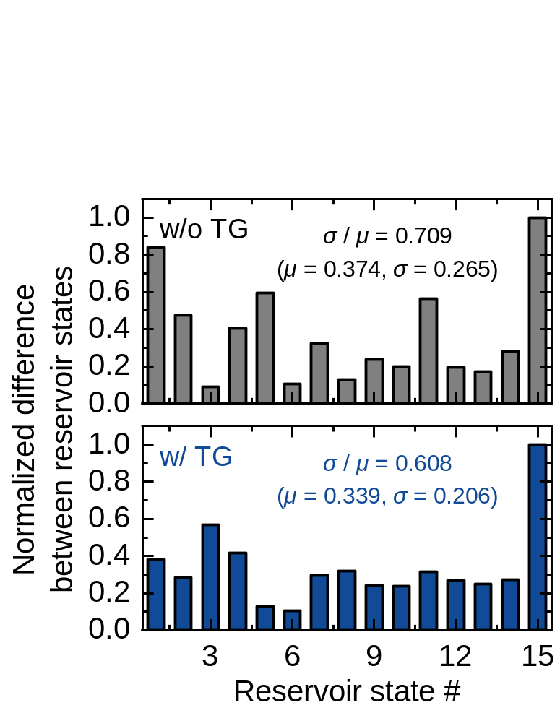
Supplementary Figure 14. Comparison of normalized differences between the reservoir states with and without TG utilization. More pronounced differentiation of the reservoir states is observed when utilizing TG, as indicated by reduced normalized difference variation.

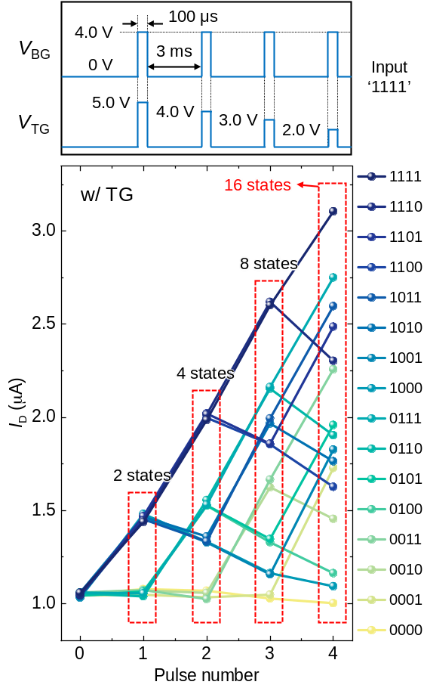
Supplementary Figure 15. I_{D} evolutions with different TG pulse scheme. The final reservoir states can be further optimized by adjusting the TG pulse scheme.

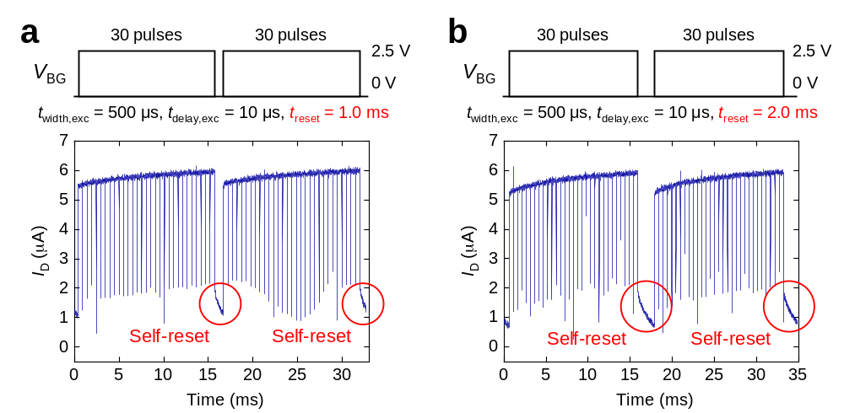
Supplementary Figure 16. Neuronal behaviors of volatile DG MPBTFTs with various reset times (t_{reset}s). If the neuron is not completely reset before the next excitatory pulses are applied (insufficient t_{reset}), it can be fired with fewer pulses, illustrating a dynamic response to the varying input sequences.

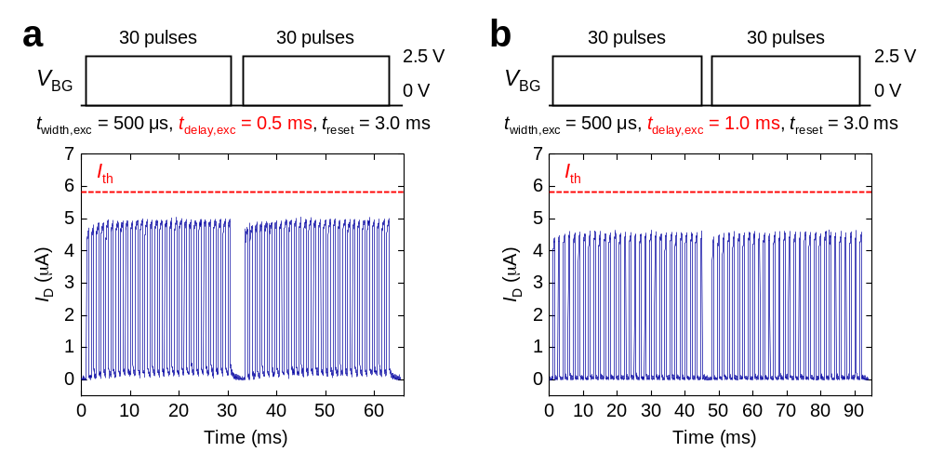
Supplementary Figure 17. Neuronal behaviors of volatile DG MPBTFTs with various delay between pulses (t_{delay}s). Even if the V_{high} is high enough to cause polarization switching, most of the polarization switching induced by previous pulses can dissipate before the arrival of subsequent pulses when the delay between pulses is extended. Therefore, the neuron is reset to its initial state, and the integration function is hindered.

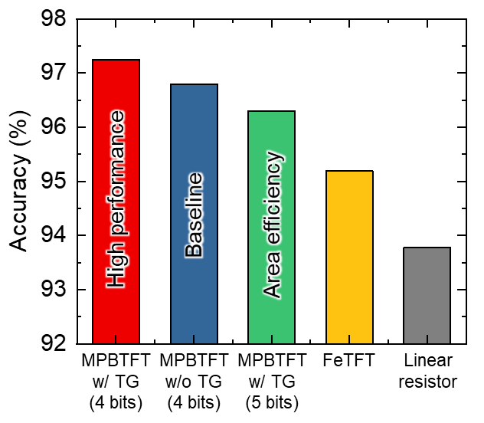
Supplementary Figure 18. Performance of the MPBTFT-based ARC system for different readout network sizes. Readout network sizes of 110×500×150×10 and 88×500×150×10 are used for systems with 4 and 5 bits reservoir states, respectively.

Supplementary Tables

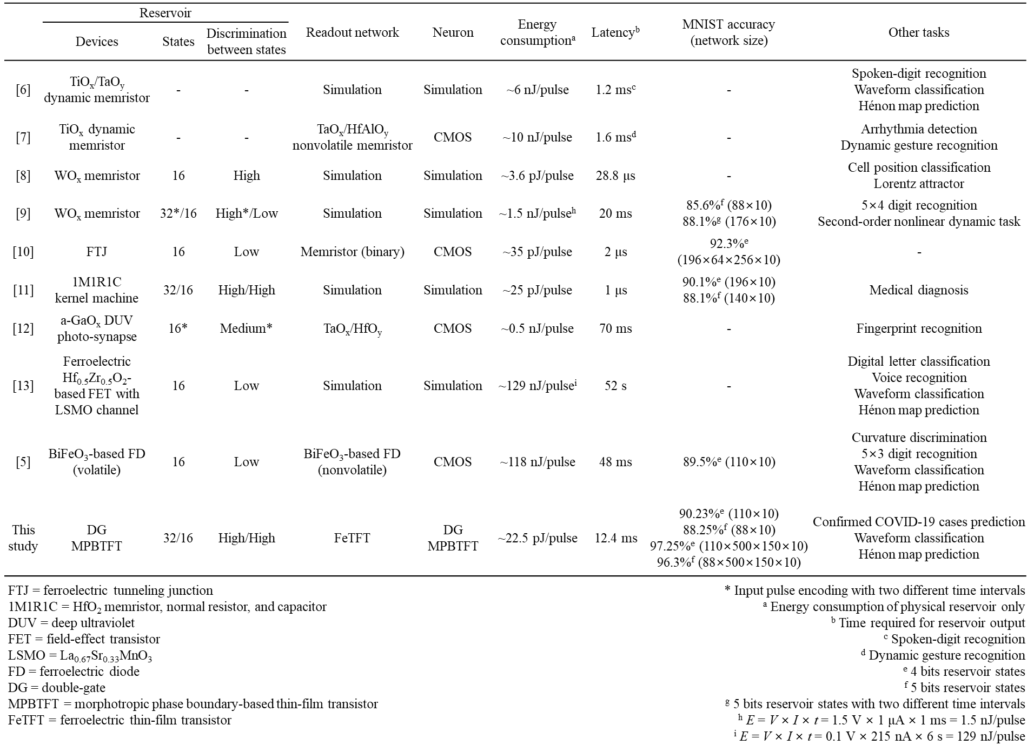
Supplementary Table 1. Benchmarking analysis against hardware-based ARC systems using state-of-the-art physical reservoirs. Since several hardware-based ARC systems use complex pre-processing techniques, readout networks of different sizes, and handle different applications, it is difficult to directly compare performance. Our MPBTFT-based ARC system demonstrates seamless integration of physical reservoir, readout network, and LIF neuron, while exhibiting high energy efficiency and performance. The DG MPBTFT-based physical reservoir exhibits high discrimination between reservoir states, significantly low energy consumption, and relatively low latency with minimal hardware burden.

Supplementary Notes

Supplementary Note 1. Advantages of our approach in hardware-based ARC system
In the realm of hardware-based ARC systems, the fundamental challenge lies in material and device engineering; specifically, the necessity for devices that exhibit distinct volatile and nonvolatile switching characteristics to implement the reservoir and readout networks, respectively. There have been several studies using various devices to implement hardware-based ARC systems. These ARC systems leverage the inherent physical properties of materials to emulate a dynamic reservoir and offer dual advantages. In addition to achieving comparable performance to software-based systems across a wide range of applications, such as pattern/speech recognition and chaotic system prediction [4, 6, 14–17], ARC systems also significantly enhance energy efficiency [4, 7]. Two-terminal memristors, the most widely used to demonstrate the ARC system, attracted attention owing to their high speed and scalability. Despite these advantages, the stochastic nature of the filament formation and rupture processes in memristors introduce large variability and compromise the reliability of the ARC system. These limitations can be overcome using alternative materials and devices that utilize ferroelectric polarization switching with a more deterministic switching mechanism [18]. Moreover, hafnium-based fluorite ferroelectrics exhibit fast switching speeds, low-power consumption [19–22], and high compatibility with conventional CMOS processes [23, 24]. However, most previously studied hardware-based ARC systems that utilize ferroelectric materials have been limited to the implementation of physical reservoirs [10, 13, 25, 26], and the full integration of the reservoir, readout network, and artificial neuron remains a significant challenge due to the requirement of distinct materials for each component. While Chen, Z. et al. used two-terminal ferroelectric diodes to implement both the physical reservoirs and readout networks [5], the inherent attributes of two-terminal diodes present substantial constraints in the implementation of the neurons essential for the ARC system. The integration of neurons should be adequately explored for the full integration of the ARC components.
Furthermore, a persistent challenge in the field is a clear differentiation between reservoir states. Many studies have difficulty clearly distinguishing reservoir states [5, 9, 11–13, 27–29]. Most of these studies demonstrated physical reservoirs capable of representing 16 reservoir states (4 bits). However, problems of state overlap and indistinct state differentiation often arise even when physical reservoirs represent only eight reservoir states (3 bits) [5]. Clearly distinguishable reservoir states are crucial for the effective processing and recognition of temporal data within ARC systems, directly influencing their performance and efficiency [9, 11–13, 30]. Various attempts have been made to mitigate these challenges, including strategies such as employing input encoding with various pulse intervals [9, 12]. Although these strategies enhance the distinction between reservoir states, their inefficiency in terms of area and power consumption detracts from the advantages of hardware-based ARC systems. Moreover, owing to the slow current decay characteristics of the physical reservoirs used in several studies, the time taken to acquire reservoir states has been a bottleneck, inadvertently impeding the processing speed of the overall ARC system [5, 12, 13, 25, 27, 28]. To address these challenges, we propose a material-device co-optimization method for the area- and energy-efficient ARC system utilizing HZO-based TFTs. Our ARC system has the following advantages:
1) We report, for the first time, MPBTFTs for ARC systems. MPBTFTs enable low-power operation by having a high polarization magnitude at a relatively low voltage compared to anti-ferroelectric materials. Moreover, a large dynamic range and rapid current relaxation process facilitate a clear differentiation between reservoir states and ensure fast data processing capabilities. The material versatility of HZO facilitates the implementation of distinct volatile and nonvolatile memory characteristics. The polar o-phase of the HZO is used for nonvolatile FeTFT-based artificial synapse that requires multilevel conductance, and HZO near the MPB is used as a physical reservoir and LIF neuron owing to its volatile memory characteristics. This study provides the possibility of neuromorphic applications leveraging the MPB, which was previously limited to use as a cell capacitor in DRAM technology.
2) In addition to material engineering, the DG configuration of MPBTFT further enhances the performance of ARC. The DG MPBTFTs with four terminals offer superior controllability and reliability compared to the commonly used two-terminal devices. A persistent challenge in the ARC is a clear differentiation between reservoir states, which many studies struggle with. Clearly distinguishable reservoir states without overlapping are crucial for the performance and efficiency of ARC. While various attempts, such as complex input encoding methods, have been made to mitigate these challenges, their inefficiency in terms of area and power consumption detracts from the advantages of ARC. By contrast, DG MPBTFTs enhance the reservoir state differentiation and successfully demonstrate expanded 5-bit reservoir states with minimal hardware burden, which has rarely been implemented in previous studies. Furthermore, DG MPBTFT-based LIF neuron processes both excitatory and inhibitory pulses within a single device, reducing system complexity and power consumption.
3) For the first time, the seamless integration of physical reservoir, readout network, and LIF neuron is achieved by leveraging volatile MPBTFTs and nonvolatile FeTFTs. The adoption of similar fabrication processes for both TFTs with HZO films enables their co-integration on a single wafer with high CMOS compatibility.
With this point of view, we believe that our MPBTFT-based ARC system opens a new paradigm for researchers in the field of hardware-based ARC and novel applications of MPBTFTs, and provides insights to address the limitations of conventional ARC systems.

Supplementary Note 2. Volatile and nonvolatile HZO thin films for ARC systems

(a) Implementation of volatile and nonvolatile HZO thin films
The characteristics of the volatile HZO-based TFTs for ARC systems are realized through HZO thin films near the MPB. In many previous studies, the origin of ferroelectric properties of HfO₂-based ferroelectric materials is derived from the orthorhombic (o)-phase and tetragonal (t)-phase generated during the crystallization process of the HfO₂–ZrO₂ mixed thin film [31–33]. The evolution of the phase in HZO thin film is determined by various conditions such as grain size, thin film thickness, and external stress. In this study, the characteristics of the HZO-based TFTs are optimized by modulating the composition ratio of ZrO₂ in the HZO thin film, which is the most dominant factor. The polarization switching dynamics of the HZO thin film vary depending on the ZrO₂ content.
In HZO thin films with high Hf composition, the monoclinic (m)-phase is formed abundantly. When the composition ratio of Hf and Zr are similar, o-phase formation is highly activated and exhibits ferroelectricity with hysteresis characteristics. By contrast, in HZO thin films with high Zr composition, the t-phase is formed dominantly and exhibits anti-ferroelectricity. The HZO thin films near the MPB that exist between these two crystalline phases have several metastable crystalline phases. Increasing Zr composition in the HZO thin film induces a phase transition from the o-phase to the t-phase owing to the larger asymmetric interstitial distance of ZrO₂ compared to HfO₂, reducing the total energy of the grain and facilitating the phase transition. Consequently, higher ZrO₂ composition decreases coercive voltage (V_{c}) and eliminates the energy barrier between the two phases. The flattened mixed phase between the paraelectric and ferroelectric phases has no hysteresis and a high dielectric constant [34–38]. Owing to their high dielectric constant, HZO thin films near the MPB attract attention as thin films for dynamic random-access memory (DRAM), which requires high capacitor performance [38–41]. Herein, we focused on the controllable hysteresis characteristics of the device.

(b) XRD analyses of volatile and nonvolatile HZO thin films
The distinctive electrical characteristics of the volatile DG MPBTFTs are attributed to the HZO thin films near the MPB. The deconvolution of the XRD spectra through the fixed peak positions reveals significant distinctions in the phase compositions of the volatile and nonvolatile HZO films (Supplementary Figures 4c and d). The non-ferroelectric phase (m-phase) is minimally present in both the volatile and nonvolatile HZO films, highlighting their dominant ferroelectric properties. However, a significant difference exists in the ratio of the ferroelectric phases (o-/t-phases) between the two HZO films. In the nonvolatile HZO films, the ratio of the o-/t- phases is approximately 59%/34%, while the ratio is approximately 43%/53% in the volatile HZO films (Supplementary Figure 4e). This difference indicates a significant increase in the proportion of the t-phase within the volatile HZO films, attributable to the higher composition ratio of ZrO₂. Conversely, the o-phase predominates in the nonvolatile HZO films.

Supplementary Note 3. Advantages of IGZO FeTFTs with an MFMIS structure
The utilization of an IGZO channel material offers notable benefits, including the capability for fabrication at temperatures lower than those required to induce ferroelectricity in the HZO film [42]. This advantage is particularly significant as it allows for the integration of IGZO channels into ferroelectric devices without compromising the ferroelectric properties of the HZO film. Moreover, the FeTFTs with IGZO channel exhibit a high on/off current ratio, low-power consumption, and fast operation speeds [42–46].
The ferroelectric properties in the FeTFTs with an MFMIS structure can be enhanced by meticulously adjusting the area ratio (AR) between the metal–ferroelectric–metal (MFM) layer (A_{FE}) and the metal–insulator–semiconductor (MIS) layer (A_{MOS}) [46, 47]. This approach effectively modulates the capacitance ratio between the MFM and MIS layers within the MFMIS structure, dependent on the AR (A_{FE}/A_{MOS}) between the A_{FE} and the A_{MOS}. As the AR decreases while maintaining the A_{MOS}, the capacitance of the MFM layer reduces. This reduction leads to an intensification of the electric field across the MFM layer, enhancing the polarization within the MFM layer and consequently improving the memory window (MV) of the FeTFTs. Moreover, precise capacitance matching between these layers significantly enhances the reliability of the FeTFTs by mitigating the electric field across the insulating layer [47–49]. The inner metal (IM) layer within the MFMIS structure plays a pivotal role in reducing cycle-to-cycle variation of the device by rectifying the inhomogeneous polarization in the ferroelectric layer [50]. The IM layer ensures a reliable device operation through a uniform electric field distribution and channel conductivity. Furthermore, the ferroelectric devices with MFMIS structure are renowned for their robust endurance characteristics [46, 51].

Supplementary Note 4. Volatile DG MPBTFT-based physical reservoirs
Each volatile DG MPBTFT-based physical reservoir leverages the inherent memory effects of ferroelectric materials, characterized by their hysteresis behavior, to retain information regarding past inputs. This capability is indispensable for effectively processing time-dependent or sequential data because physical reservoirs respond to input signals over time rather than just responding to instantaneous input signals. In this study, the TG of DG MPBTFT is strategically utilized to improve physical reservoir characteristics, enhancing the performance and efficiency of the ARC system.

(a) Volatile DG MPBTFT-based physical reservoirs without TG utilization
DG MPBTFT-based physical reservoirs can represent 16 unique binary combinations (4 bits) in total for binary inputs with 4 timeframes. As the number of applied input pulses increases, the number of reservoir states generated by the DG MPBTFT-based physical reservoirs increases exponentially. As the number of reservoir states increases, a corresponding increase in the overlap between states is inevitable. Therefore, addressing this issue is crucial for ensuring effective state differentiation and high system performance.
The nonlinearity and short-term memory characteristics ensure that the DG MPBTFTs exhibit distinctly separated final conductance states upon exposure to various input pulse trains (Figure 3h). Nonetheless, certain input pulse train configurations, such as the ‘1001’ and ‘0110’ inputs, may yield similar final conductance states. Physical reservoirs should generate distinguishable reservoir states for various input data to enable the processing and recognition of temporal data within an ARC system and achieve high performance [9, 11–13, 30]. Similar final conductance states that are not sufficiently differentiated significantly reduce the richness of the reservoir states, posing challenges in detecting and distinguishing subtle variations between input signals.

(b) Volatile DG MPBTFT-based physical reservoirs with TG utilization
To address the challenges of generating distinguishable reservoir states for various input data within an ARC system, the TG of DG MPBTFT is utilized in this study to significantly enhance the differentiation of the final conductance states. Different input pulse trains were applied to the BG, while a fixed pulse scheme was applied to the TG (Figure 3i). The approach significantly enhances the distinctness between reservoir states, providing a clear differentiation. The rationale behind this improved distinctness lies in the impact of the bias condition applied to the TG on PGM efficiency. The application of gradually decreasing voltage pulses to the TG across the 4 timeframes augments the influence of the input data in the latter timeframe, resulting in a clear distinction between the final reservoir states. Furthermore, adequate utilization of TG enhances the I_{D} change of the DG MPBTFT, which can achieve a broad spectrum of final conductance states. This characteristic suggests enhanced potential for more distinct separations between reservoir states.
The utilization of TG in DG MPBTFTs not only clearly distinguishes reservoir states but also enables the expansion of reservoir states. This capability marks a substantial advancement over previous studies that have rarely achieved a 5-bit representation of physical reservoirs. Previous studies that implemented 5 bits relied on input encoding methods utilizing varied pulse intervals, which considerably increased the area and power consumption [9, 12]. In contrast, DG MPBTFT-based physical reservoirs enable state expansion with a minimal hardware burden. Expanded reservoir states can enhance the area and energy efficiency of the MPBTFT-based ARC system.

Supplementary Note 5. Volatile DG MPBTFT-based LIF neurons
One notable advantage of the volatile DG MPBTFT-based LIF neuron is its capacity to process both excitatory and inhibitory pulses within a single device, enabling the versatile modulation of neuronal behavior. This unique capability is attributed to the opposing effects of the inhibitory pulses applied to the TG and excitatory pulses applied to the BG. While the excitatory pulses enhance the polarization of the HZO film toward the channel, facilitating an increase in I_{D}, the inhibitory pulses revert this polarization, effectively reducing I_{D}.
When inhibitory pulses with V_{inh} exceeding 3.0 V are applied after a sequence of excitatory pulse trains, the neuron does not fire with 13 excitatory pulses (Figure 4e). By contrast, when V_{inh} is less than 3.0 V, the neuron fires in response to the subsequent application of the same number of excitatory pulses. The inhibitory efficiency of LIF neurons increases as the V_{inh} increases.
When inhibitory pulses with widths (t_{width,inh}) up to 100 μs are applied, the neuron can fire in response to 13 excitatory pulses (Figure 4f). However, at an inhibitory pulse with t_{width,inh} of 500 μs, the neuron is fully inhibited and does not fire by the same number of excitatory pulses. The inhibitory efficiency of LIF neurons increases as the t_{width,inh} increases.
When one or two inhibitory pulses, each with a V_{inh} of 5.0 V and a t_{width,inh} of 100 μs, are applied, the neuron is able to fire after receiving 13 excitatory pulses (Figure 4g). On the contrary, the application of inhibitory pulses more than three fully inhibits the neuron, leading to a complete reset to its initial state. The inhibitory efficiency of LIF neurons increases as the number of applied inhibitory pulses increases.

Supplementary Note 6. MPBTFT-based ARC system for handwritten digit recognition
The MPBTFT-based ARC system consists of a nonvolatile FeTFT-based readout network and volatile DG MPBTFT-based physical reservoirs and LIF neurons (Figure 5a). When the input pulses are applied to the physical reservoir, each DG MPBTFT responds dynamically. The state of the physical reservoir evolves over time in response to input pulses and is fed into the readout network. The readout network, which consists of a FeTFT array, generates outputs for the input pulses in the form of a current by combining the reservoir states based on their synaptic weights. When necessary, a pair of FeTFTs can be used to represent the positive and negative weights. The output currents are transmitted to the DG MPBTFT-based LIF neurons as excitatory or inhibitory pulses. This architecture enables efficient ARC, which is required for addressing complex systems, including images and temporal data. In this study, the simulations were performed using the measured electrical characteristics of the fabricated DG MPBTFTs and FeTFTs.

Supplementary Note 7. Estimation of energy consumption
The energy consumption of the volatile DG MPBTFT ($E_{MPBTFT}$) for handwritten digit recognition task is quantitatively estimated as follows,
$E_{MPBTFT}=V_{read}×I_{MPBTFT}×t_{width}=0.1 V×2.25 μA×100 μs=22.5 pJ/pulse$, (2)
where $V_{read}$ is the read voltage, $I_{MPBTFT}$ is the average current response of the MPBTFT, and $t_{width}$ is the pulse width. We assume $I_{MPBTFT}$ of 2.25 μA from the current evolution characteristics of the MPBTFT (ranges from ~1 μA to ~3.5 μA). Such energy consumption is significantly lower than those of the state-of-the-art physical reservoirs used for hardware-based ARC systems (Supplementary Table 1).
The energy consumption of the nonvolatile FeTFT ($E_{FeTFT}$) for handwritten digit recognition task is quantitatively estimated as follows,
$E_{FeTFT}={V_{read}}^{2}×G_{FeTFT}×t_{width}={(0.1 V)}^{2}×200 nS×100 μs=0.2 pJ/pulse$, (3)
where $G_{FeTFT}$ is the average conductance of the FeTFT. We assume $G_{FeTFT}$ of 200 nS from the LTP/LTD characteristics of the FeTFT (ranges from ~100 nS to ~300 nS). The energy consumption of the FeTFT is much lower than that of the MPBTFT. The estimation results demonstrate that the MPBTFT-based ARC system exhibits high energy efficiency. Note that the energy efficiency can be further enhanced by reducing the read voltage and pulse width in future ARC systems.

Supplementary References

- Gaddam, V., Das, D. & Jeon, S. Insertion of HfO2 Seed/Dielectric Layer to the Ferroelectric HZO Films for Heightened Remanent Polarization in MFM Capacitors. IEEE Transactions on Electron Devices 67, 745–750 (2020).
- Park, M. H. et al. Evolution of phases and ferroelectric properties of thin Hf0.5Zr0.5O2 films according to the thickness and annealing temperature. Appl. Phys. Lett. 102, 242905 (2013).
- Das, D., Gaddam, V. & Jeon, S. Demonstration of High Ferroelectricity (Pr ~ 29 μC/cm2) in Zr Rich HfxZr1–xO2 Films. IEEE Electron Device Letters 41, 34–37 (2020).
- Moon, J. et al. Temporal data classification and forecasting using a memristor-based reservoir computing system. Nat. Electron. 2, 480–487 (2019).
- Chen, Z. et al. All-ferroelectric implementation of reservoir computing. Nat. Commun. 14, 3585 (2023).
- Zhong, Y. et al. Dynamic memristor-based reservoir computing for high-efficiency temporal signal processing. Nat. Commun. 12, 408 (2021).
- Zhong, Y. et al. A memristor-based analogue reservoir computing system for real-time and power-efficient signal processing. Nat. Electron. 5, 672–681 (2022).
- Choi, S. et al. 3D-integrated multilayered physical reservoir array for learning and forecasting time-series information. Nat. Commun. 15, 2044 (2024).
- Du, C. et al. Reservoir computing using dynamic memristors for temporal information processing. Nat. Commun. 8, 2204 (2017).
- Yu, J. et al. Energy efficient and robust reservoir computing system using ultrathin (3.5 nm) ferroelectric tunneling junctions for temporal data learning. 2021 Symposium on VLSI Technology. IEEE (2021).
- Jang, Y. H. et al. Time-varying data processing with nonvolatile memristor-based temporal kernel. Nat. Commun. 12, 5727 (2021).
- Zhang, Z. et al. In-sensor reservoir computing system for latent fingerprint recognition with deep ultraviolet photo-synapses and memristor array. Nat. Commun. 13, 6590 (2022).
- Liu, Z. et al. Interface-type tunable oxygen ion dynamics for physical reservoir computing. Nat. Commun. 14, 7176 (2023).
- Milano, G. et al. In material reservoir computing with a fully memristive architecture based on self-organizing nanowire networks. Nat. Mater. 21, 195–202 (2022).
- Usami, Y. et al. Inmaterio reservoir computing in a sulfonated polyaniline network. Adv. Mater. 33, 2102688 (2021).
- Tang, J. et al. Bridging biological and artificial neural networks with emerging neuromorphic devices: fundamentals, progress, and challenges. Adv. Mater. 31, 1902761 (2019).
- Tanaka, G. et al. Recent advances in physical reservoir computing: a review. Neural Netw. 115, 100–123 (2019).
- Chanthbouala, A. et al. A ferroelectric memristor. Nat. Mater. 11, 860–864 (2012).
- Noheda, B., Nukala, P. & Acuautla, M. Lessons from hafnium dioxide-based ferroelectrics. Nat. Mater. 22, 562–569 (2023).
- Luo, Z. et al. High-precision and linear weight updates by subnanosecond pulses in ferroelectric tunnel junction for neuroinspired computing. Nat. Commun. 13, 699 (2022).
- Li, J. et al. Reproducible ultrathin ferroelectric domain switching for high‐performance neuromorphic computing. Adv. Mater. 32, 1905764 (2020).
- Tian, B. et al. A robust artificial synapse based on organic ferroelectric polymer. Adv. Electron. Mater. 5, 1800600 (2019).
- Böscke, T. S. et al. Ferroelectricity in hafnium oxide thin films. Appl. Phys. Lett. 99, 102903 (2011).
- Wei, Y. et al. A rhombohedral ferroelectric phase in epitaxially strained Hf0.5Zr0.5O2 thin films. Nat. Mater. 17, 1095–1100 (2018).
- Liu, K. et al. Multilayer reservoir computing based on ferroelectric α-In2Se3 for hierarchical information processing. Adv. Mater. 34, 2108826 (2022).
- Nako, E. et al. Experimental demonstration of novel scheme of HZO/Si FeFET reservoir computing with parallel data processing for speech recognition. 2022 IEEE Symposium on VLSI Technology and Circuits (VLSI Technology and Circuits). IEEE (2022).
- Farronato, M. et al. Reservoir computing with charge‐trap memory based on a MoS2 channel for neuromorphic engineering. Adv. Mater. 35, 2205381 (2023).
- Jang, Y. H. et al. A high-dimensional in-sensor reservoir computing system with optoelectronic memristors for high-performance neuromorphic machine vision. Materials Horizons 11, 499–509 (2024).
- Kim, D. et al. Ferroelectric synaptic devices based on CMOS-compatible HfAlO x for neuromorphic and reservoir computing applications. Nanoscale 15, 8366–8376 (2023).
- Seoane, L. F. Evolutionary aspects of reservoir computing. Philos. Trans. R. Soc. B Biol. Sci. 374, 20180377 (2019).
- Schroeder, U. et al. The fundamentals and applications of ferroelectric HfO2. Nature Reviews Materials 7, 653–669 (2022).
- Park, M. H. et al. Review and perspective on ferroelectric HfO2-based thin films for memory applications. Mrs Communications 8, 795–808 (2018).
- Mulaosmanovic, H. et al. Ferroelectric field-effect transistors based on HfO2: a review. Nanotechnology 32, 502002 (2021).
- Park, M. H. et al. Morphotropic Phase Boundary of Hf1–xZrxO2 Thin Films for Dynamic Random Access Memories. ACS Applied Materials & Interfaces 10, 42666–42673 (2018).
- Kashir, A. et al. Hf1–xZrxO2/ZrO2 Nanolaminate Thin Films as a High-κ Dielectric. ACS Applied Electronic Materials 3, 5632–5640 (2021).
- Müller, J. et al. Ferroelectricity in Simple Binary ZrO2 and HfO2. Nano Letters 12, 4318–4323 (2012).
- Chuang, C. H. et al. Sharp Transformation across Morphotropic Phase Boundary in Sub-6 nm Wake-Up-Free Ferroelectric Films by Atomic Layer Technology. Adv. Sci. 10, 2302770 (2023).
- Gaddam, V. et al. Novel Approach to High κ (~59) and Low EOT (~3.8 Å) near the Morphotrophic Phase Boundary with AFE/FE (ZrO2/HZO) Bilayer Heterostructures and High-Pressure Annealing. ACS Appl. Mater. Interfaces 14, 43463–43473 (2022).
- Jung, M., Gaddam, V., & Jeon, S. A review on morphotropic phase boundary in fluorite-structure hafnia towards DRAM technology. Nano Convergence 9, 44 (2022).
- Du, X. et al. High-κ Hf0. 3Zr0. 7O2 film with morphotropic phase boundary for DRAM capacitor by controlling H2O dose. Applied Surface Science 638, 158078 (2023).
- Kim, S. et al. Method to achieve the morphotropic phase boundary in Hf x Zr 1− x O 2 by electric field cycling for DRAM cell capacitor applications. IEEE Electron Device Letters 42, 517–520 (2021).
- Nomura, K. et al. Room-temperature fabrication of transparent flexible thin-film transistors using amorphous oxide semiconductors. Nature 432, 488–492 (2004).
- Lu, W. et al. First Demonstration of Dual-Gate IGZO 2T0C DRAM with Novel Read Operation, One Bit Line in Single Cell, I ON= 1500 μA/μm@ V DS= 1V and Retention Time> 300s. 2022 International Electron Devices Meeting (IEDM). IEEE (2022).
- Mo, F. et al. Experimental demonstration of ferroelectric HfO 2 FET with ultrathin-body IGZO for high-density and low-power memory application. 2019 Symposium on VLSI Technology. IEEE (2019).
- Samanta, S. et al. Amorphous IGZO TFTs featuring extremely-scaled channel thickness and 38 nm channel length: Achieving record high Gm, max of 125 μS/μm at VDS of 1 V and ION of 350 μA/μm. 2020 IEEE Symposium on VLSI Technology. IEEE (2020).
- Sun, C. et al. First demonstration of BEOL-compatible ferroelectric TCAM featuring a-IGZO Fe-TFTs with large memory window of 2.9 V, scaled channel length of 40 nm, and high endurance of 10 8 cycles. 2021 Symposium on VLSI Technology. IEEE (2021).
- Khan, A. I., Ali K., & Suman D. The future of ferroelectric field-effect transistor technology. Nature Electronics 3, 588–597 (2020).
- Zheng, Z. et al. Boosting the memory window of the BEOL-compatible MFMIS ferroelectric/anti-ferroelectric FETs by charge injection. 2022 IEEE Symposium on VLSI Technology and Circuits (VLSI Technology and Circuits). IEEE (2022).
- Sun, C. et al. Temperature-dependent operation of InGaZnO ferroelectric thin-film transistors with a metal-ferroelectric-metal-insulator-semiconductor structure. IEEE Electron Device Letters 42, 1786–1789 (2021).
- Lee, S. et al. Effect of floating gate insertion on the analog states of ferroelectric field-effect transistors. IEEE Transactions on Electron Devices 70, 349–353 (2022).
- Wang, X. et al. First Demonstration of BEOL-Compatible MFMIS Fe-FETs with 3D Multi-Fin Floating Gate: In-situ ALD-deposited MFM, L CH of 50 nm,> 2× 10 9 Endurance, and 58.3% Area Saving. 2023 IEEE Symposium on VLSI Technology and Circuits (VLSI Technology and Circuits). IEEE (2023).

