Supplementary materials

Table S1. List of the species included in the study.

Plant Species | Family | Type of diaspore | Seed weight (mg)¹ | Seed area (mm²)¹
Avena sativa L. | Poaceae | Spike | 76.25 ± 15.05 | 121.9 ± 12.33
Arabidopsis thaliana; (L.), Heynh. | Brassicaceae | Silique | 0.028 ± 0.002 | 0.18 ± 0.02
Brachypodium distachyon (L.) P. Beauv. | Poaceae | Spike | 3.29 ± 0.98 | 8.66 ± 0.41
Brachypodium hybrdium C., J., M, H & Jenkins | Poaceae | Spike | 6.87 ± 0.76 | 11.26 ± 0.75
Brachypodium stacei C., J., M. M. & Langdon | Poaceae | Spike | 5.05 ± 1.02 | 9.61 ± 1.04
Calendula arvensis (Vaill.) L. | Asteraceae | Achene | 12.27 ± 4.90 | 35.99 ± 5.98
Capsella bursa-pastoris L. | Brassicaceae | Silique | 0.08 ± 0.01 | 0.4 ± 0.06
Eruca sativa (L.) Cav. | Brassicaceae | Silique | 2.63 ± 0.47 | 2.69 ± 0.24
Medicago polimrpha L. | Fabaceae | Legume | 36.14 ± 7.48 | 27.96 ± 1.74
Malva sylvestris L. | Malvaceae | Capsule (schizocarp) | 2.27 ± 0.46 | 4.65 ± 0.38
Papaver roheas L. | Papaveraceae | Capsule | 0.07 ± 0.01 | 0.35 ± 0.06
Sinapis alba L. | Brassicacae | Silique | 4.93 ± 0.51 | 2.98 ± 0.3
Spergularia arvensis L. | Caryophyllaceae | Capsule | 1.2 ± 0.14 | 1.54 ± 0.2
Urtica urens L. | Urticaceae | Achene | 0.73 ± 0.13 | 3.26 ± 0.36

1 From well-watered conditions ± 1 S.D.

Table S2. Model-adjusted means table for variation in seed dispersal traits across climate and irrigation treatments DR: drought; WW: well-watered).

 | Seed Mass* (mg) |  | Seed area*  (mm²) |  | Wing loading  (mg/mm²) |  | Terminal velocity (ms⁻¹) |  | Abscission height (m) |  | Holding  Time (s) |  | C/N*
Climate | DR | WW | DR | WW | DR | WW | DR | WW | DR | WW | DR | WW | DR | WW
Current Ambient | 0.89 | 1.11 | 1.80 | 1.90 | 0.51 | 0.6 | 3.22 | 3.36 | 0.38 | 0.51 | 0.145 | 0.184 | 4.45 | 4.79
Elevated temperature | 0.61 | 0.84 | 1.46 | 1.58 | 0.48 | 0.51 | 2.95 | 3.28 | 0.27 | 0.39 | 0.121 | 0.143 | 4.44 | 5.01

*Values shown come from log-transformed data.

Table S3. Summary of the General Linear Models performed to analyze species-specific variation in terminal velocity and abscission height between two climates (C) and two watering (I) treatments at a species level. Significant factors *P<0.05, **P<0.01, ***P<0.0001. Separate models are conducted for each species.

Species | Abbreviations | Terminal velocity |  |  | Abscission height
 |  | C | I | C x I | C | I | C x I
A. sativa | AS | F_{1,44}= 0.6 | F_{1,44}= 0.04 | F_{1,44}= 9.97** | F_{1,729}=1.69 | F_{1,729}=496.3*** | F_{1,729}=10.23**
A. thaliana | AT | F_{1,38}= 3.02 | F_{1,38}= 1.25 | F_{1,38}= 4.62* | F_{1,3826}=841.50*** | F_{1,3826}=432.84*** | F_{1,3826}=52.94***
B. distachyon | BD | F_{1,41}= 1.51 | F_{1,41}= 0.29 | F_{1,41}= 0.06 | F_{1,465}=285.44*** | F_{1,465}=78.37*** | F_{1,465}=12.09***
B. hybridum | BH | F_{1,42}= 14.53*** | F_{1,42}= 8.62** | F_{1,42}= 6.12* | F_{1,806}=109.42*** | F_{1,806}=154.38*** | F_{1,806}=18.76***
B. stacei | BS | F_{1,41}= 3.06 | F_{1,41}= 2.05 | F_{1,41}= 5.69* | F_{1,690}=602.31*** | F_{1,690}=218.63*** | F_{1,690}=104.05***
C. arvensis | CA | F_{1,61}= 9.82** | F_{1,61}= 5.61* | F_{1,61}= 3.02 | F_{1,279}=50.06*** | F_{1,279}=33.48*** | F_{1,279}=0.79
C. burso-pastoris seeds | CBP_s | F_{1,45}= 0.27 | F_{1,45}=0.01 | F_{1,45}= 5.04* | F_{1,2120}=66.94*** | F_{1,2120}=805.49*** | F_{1,2120}=28.03***
C. burso-pastoris diaspore | CBP_d | F_{1,36}= 9.05** | F_{1,36}= 0.09 | F_{1,36}= 0.23 | - | - | -
E. sativa seeds | ES_s | F_{1,43}= 33.97*** | F_{1,43}= 8.23** | F_{1,43}= 15.31*** | F_{1,399}=1.47 | F_{1,399}=31.87*** | F_{1,399}=48.61***
E. sativa diaspore | ES_d | F_{1,43}= 17.86*** | F_{1,43}= 5.61* | F_{1,43}= 0.25 | - | - | -
M. polymorpha | MP | F_{1,44}= 22.85*** | F_{1,44}= 0.37 | F_{1,44}= 1.00 | F_{1,509}=11.27*** | F_{1,509}=24.58*** | F_{1,509}=5.56*
M. sylvestris | MS | F_{1,40}= 35.66*** | F_{1,44}= 3.55 | F_{1,44}= 1.53 | F_{1,206}=45.05*** | F_{1,206}=57.53*** | F_{1,206}=7.27**
P. roheas | PR | F_{1,42}=0.23 | F_{1,42}= 0.09 | F_{1,42}= 0.53 | F_{1,87}=3.70* | F_{1,87}=1.14 | F_{1,87}=1.70
S. alba seeds | SA_s | F_{1,44}= 3.71 | F_{1,44}= 11.49** | F_{1,44}= 3.09 | F_{1,493}=49.14*** | F_{1,493}=128.02*** | F_{1,493}=0.04
S. alba diaspore | SA_d | F_{1,43}= 1.77 | F_{1,43}= 4.14* | F_{1,43}= 0.03 | - | - | -
S. arvensis | SPA | F_{1,42}= 0.92 | F_{1,42}= 6.79* | F_{1,42}= 0.96 | F_{1,890}=142.81*** | F_{1,890}=24.08*** | F_{1,890}=6.88**
U. urens | UU | F_{1,58}= 3.77* | F_{1,58}= 0.75 | F_{1,58}= 1.45 | F_{1,302}=40.47*** | F_{1,302}=17.45*** | F_{1,302}=1.57

Table S4. Summary of results of the multiple regression analyses to investigate the predictors of dispersal distance at each experimental scenario. Significant factors *P<0.05, **P<0.01, ***P<0.0001. Climatic conditions: CC_WR = Climate change, drought; CC_WW = Climate change well-watered; NC_WR = current conditions, drought; NC_WW = current conditions well-watered.

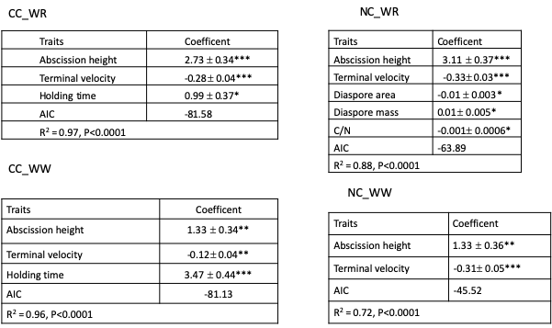
Figure S1. Photographs of the individual seeds of each species used in the study. The scale bar on the graphs is 2mm.

Avena sativa  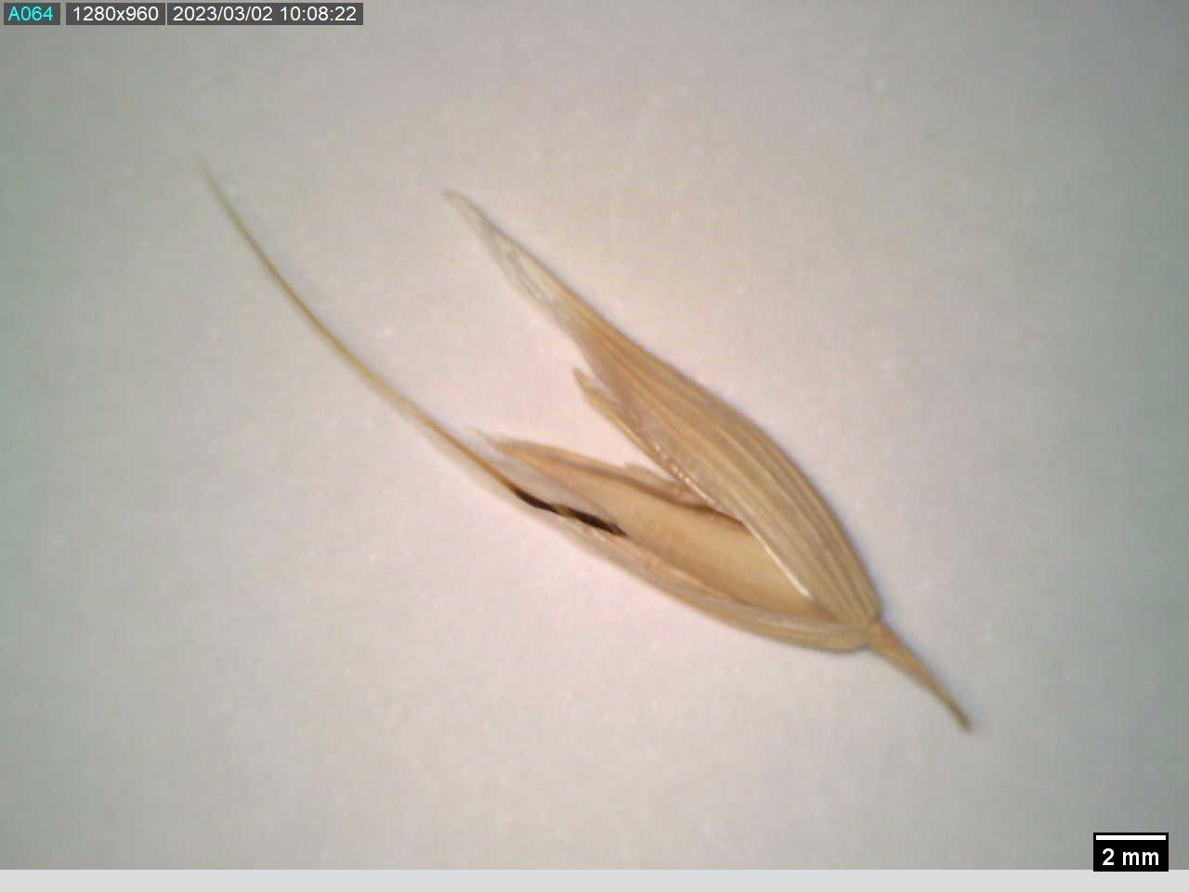 | Arabidopsis thaliana  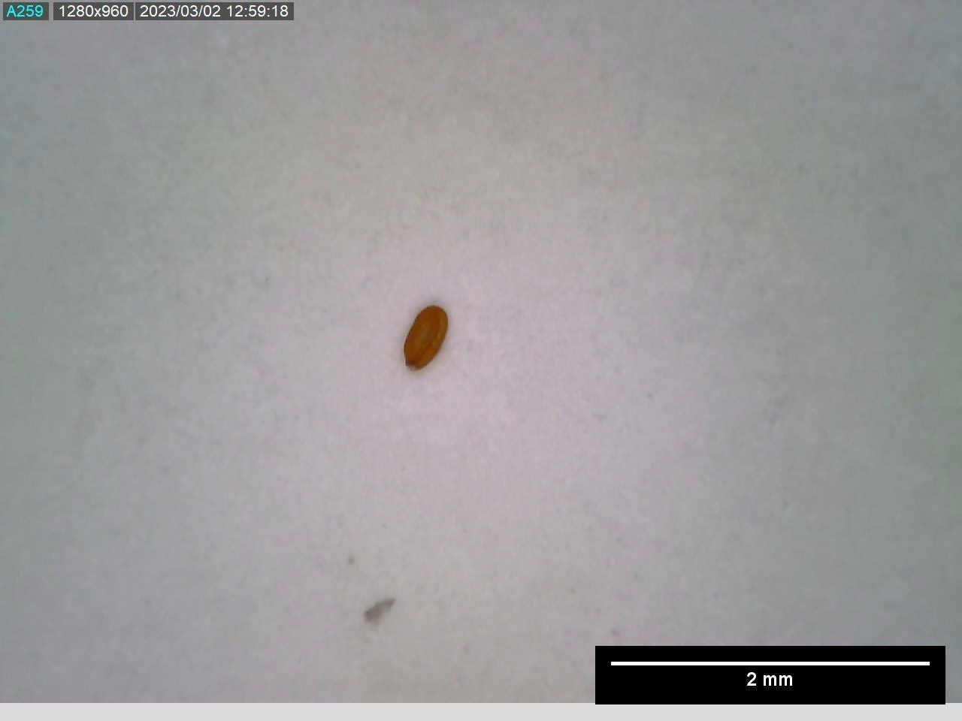 | Brachypodium distachion  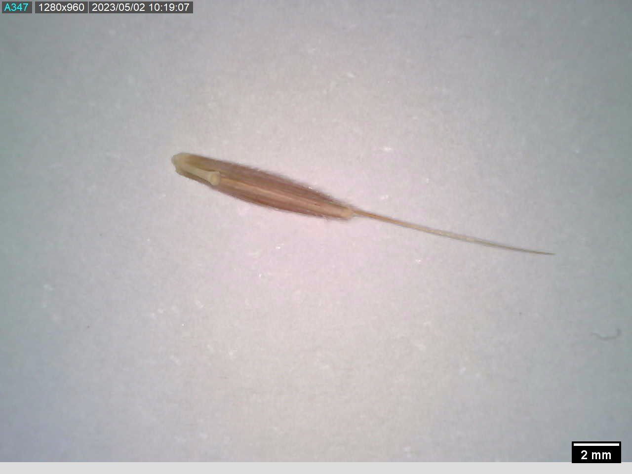 | Brachypodium hybridum  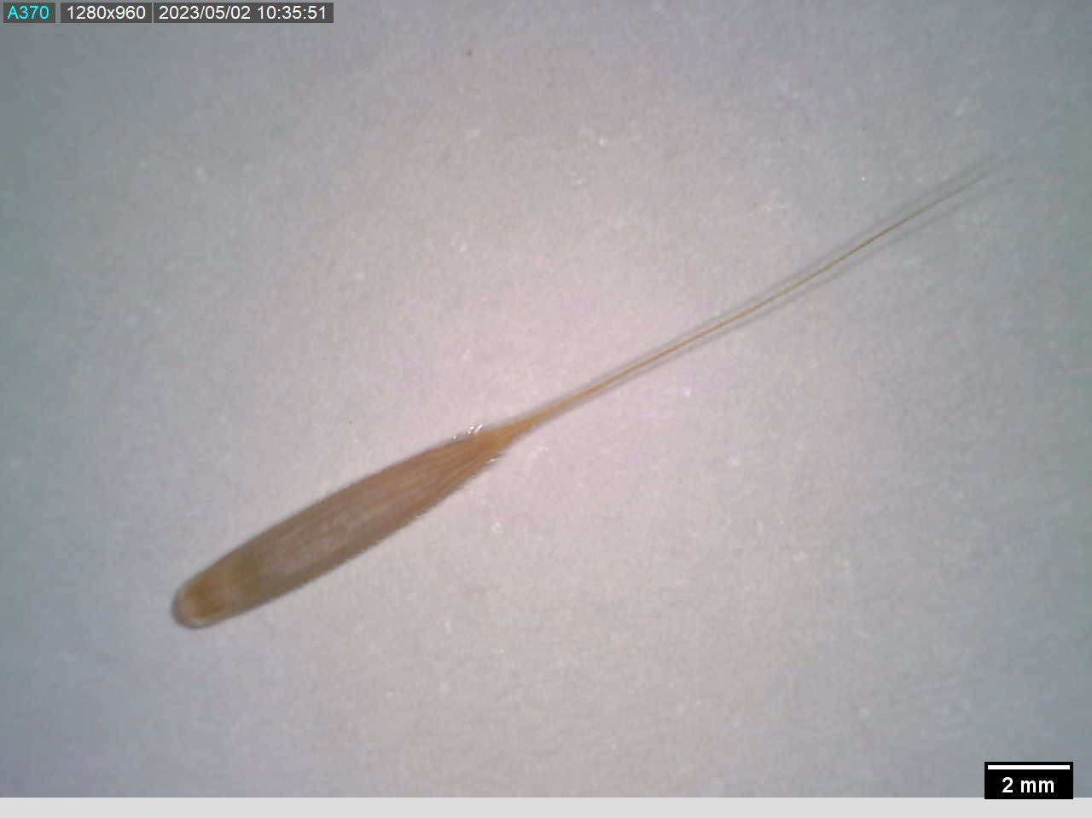
Brachypodium stacei  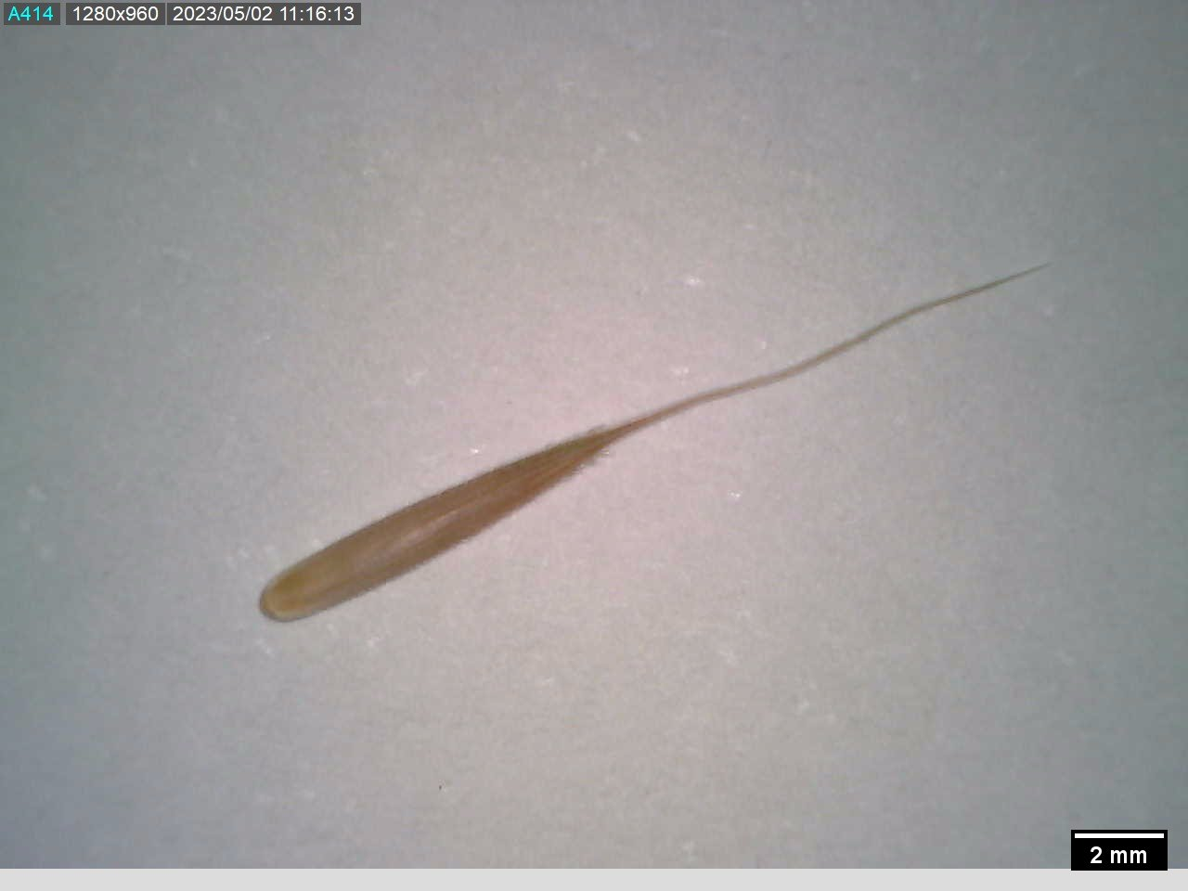 | Calendula arvensis  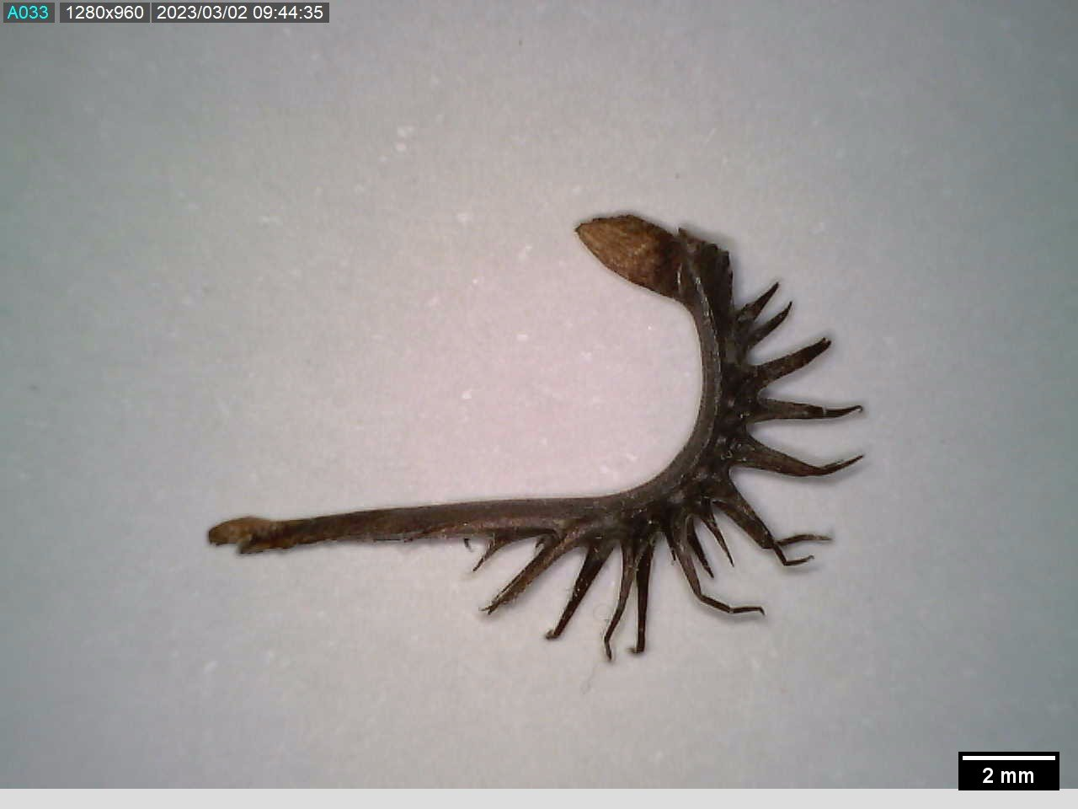 | Capsella bursa-pastoris  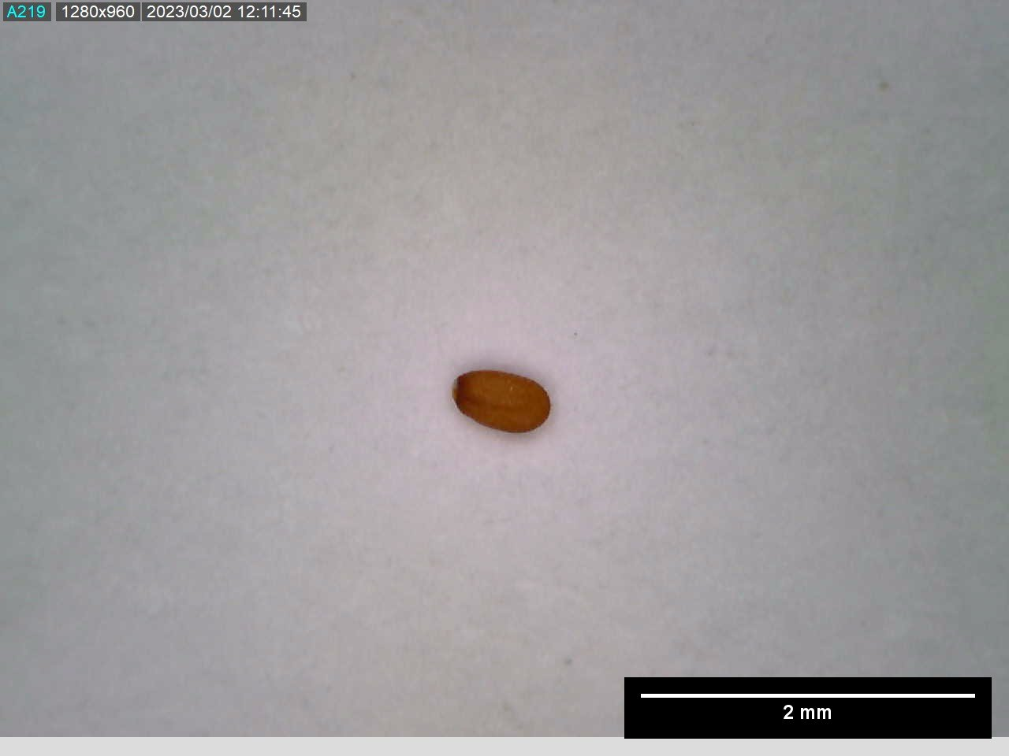 | Eruca sativa  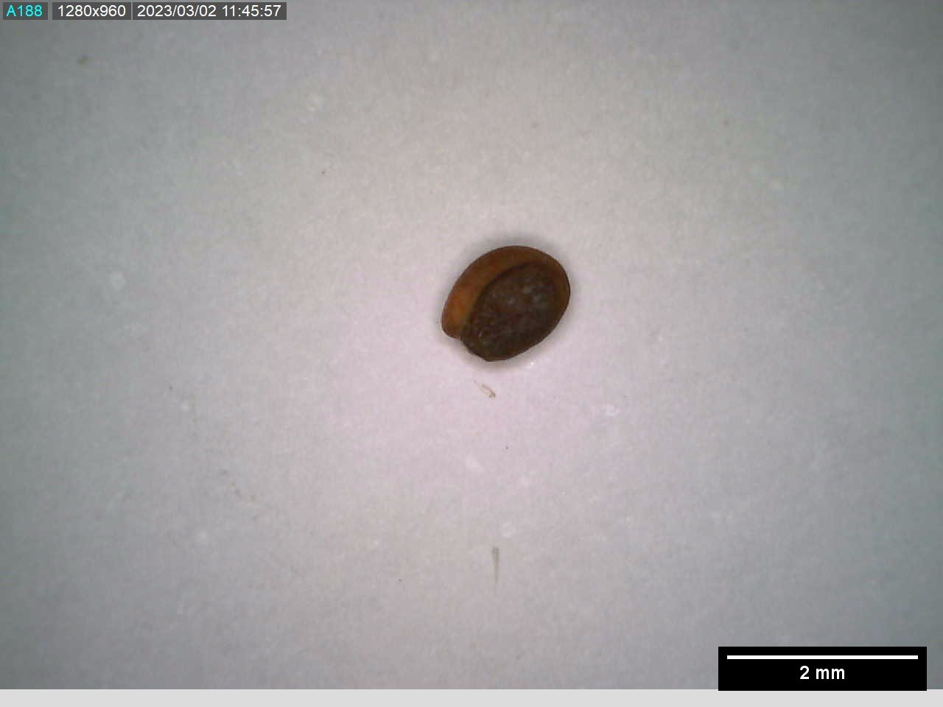
Medicago polymorpha  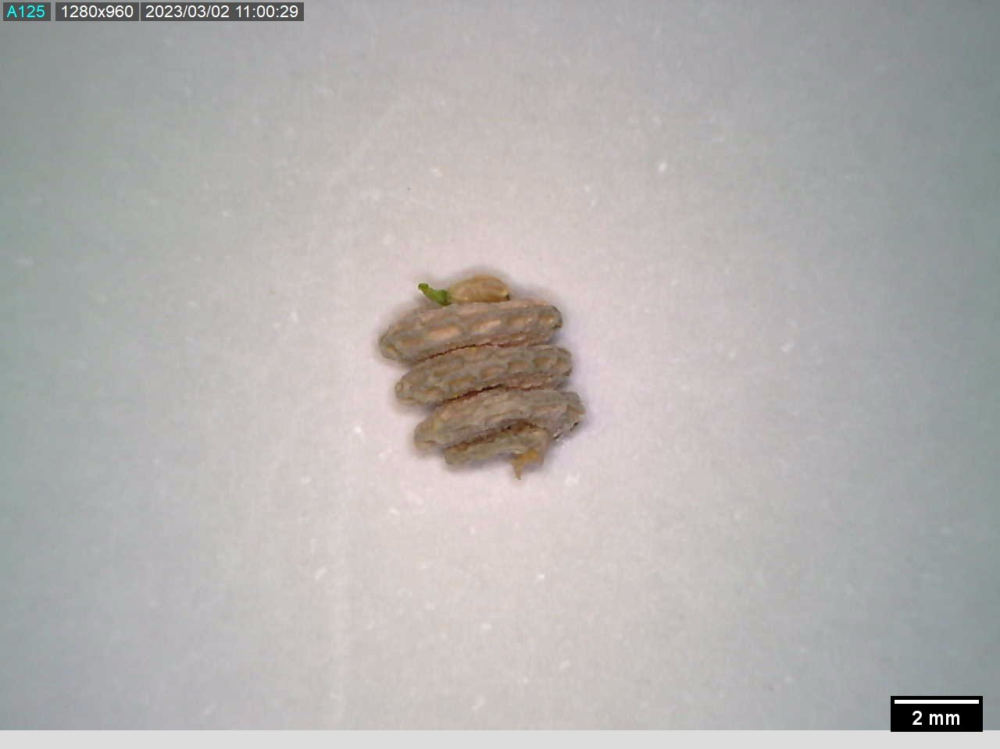 | Malva sylvestris  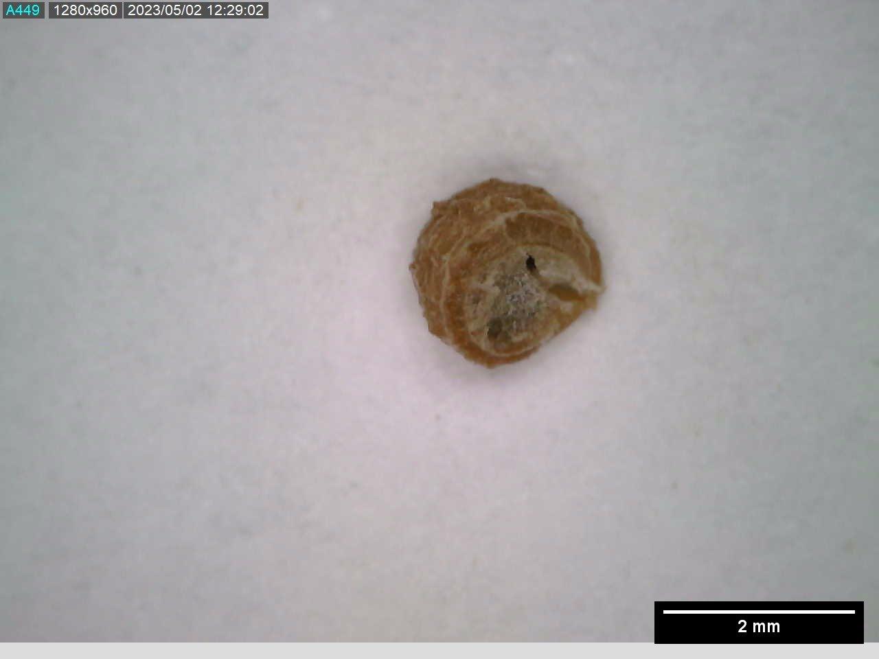 | Papaver roheas  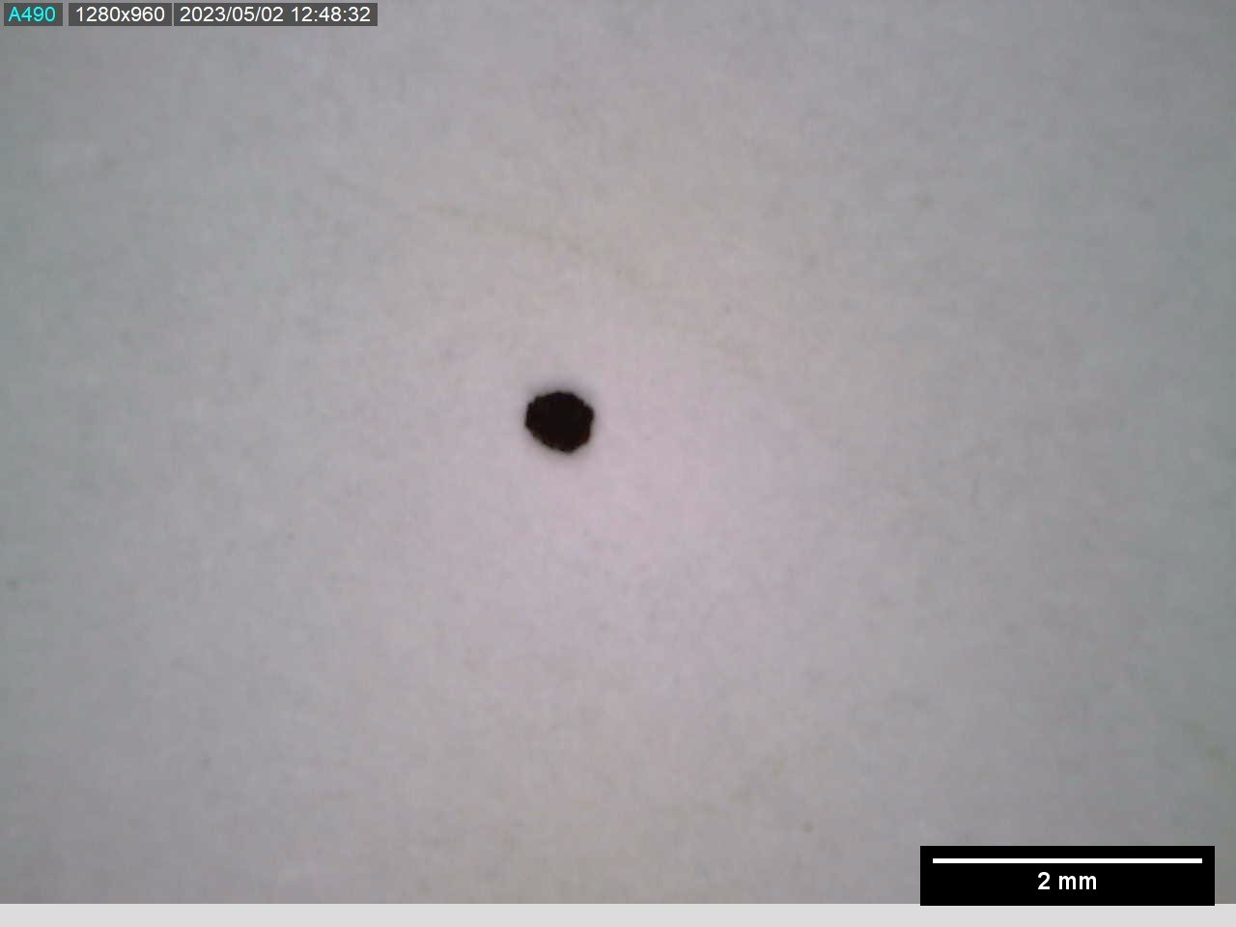 | Sinapis alba  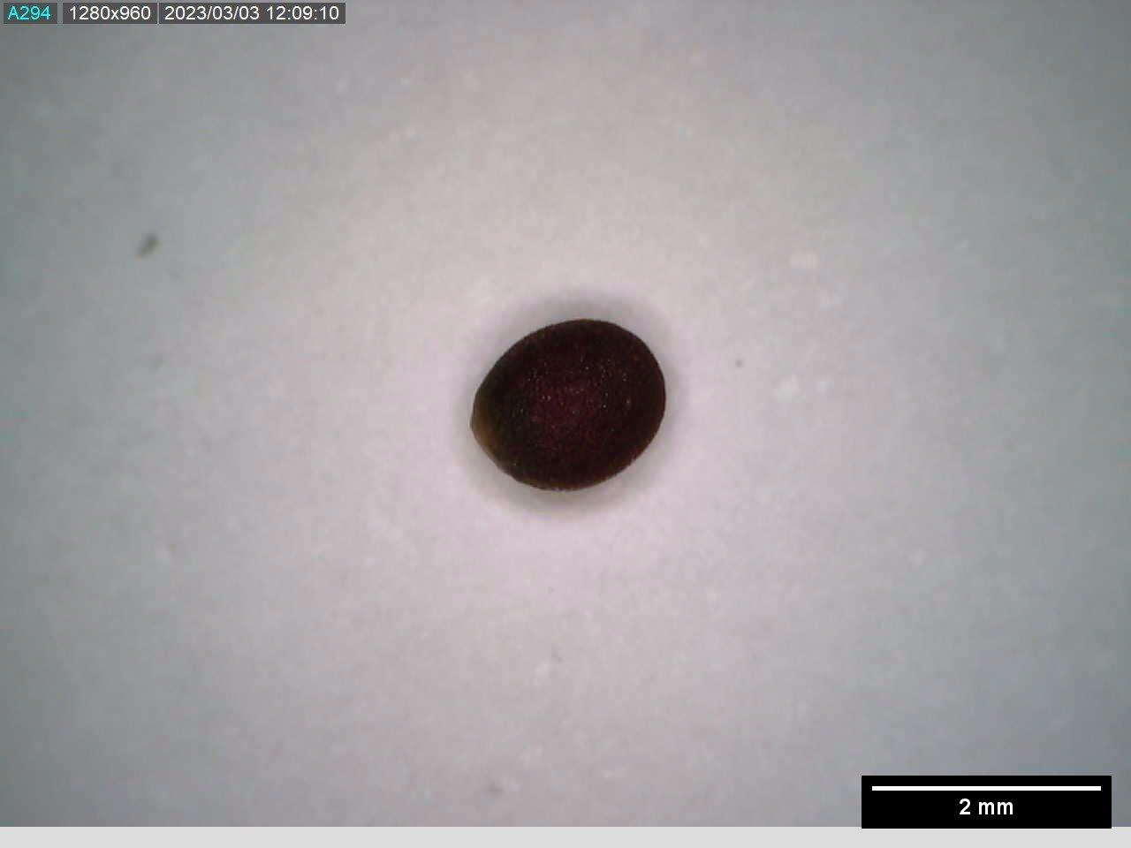
 | Spergularia arvensis  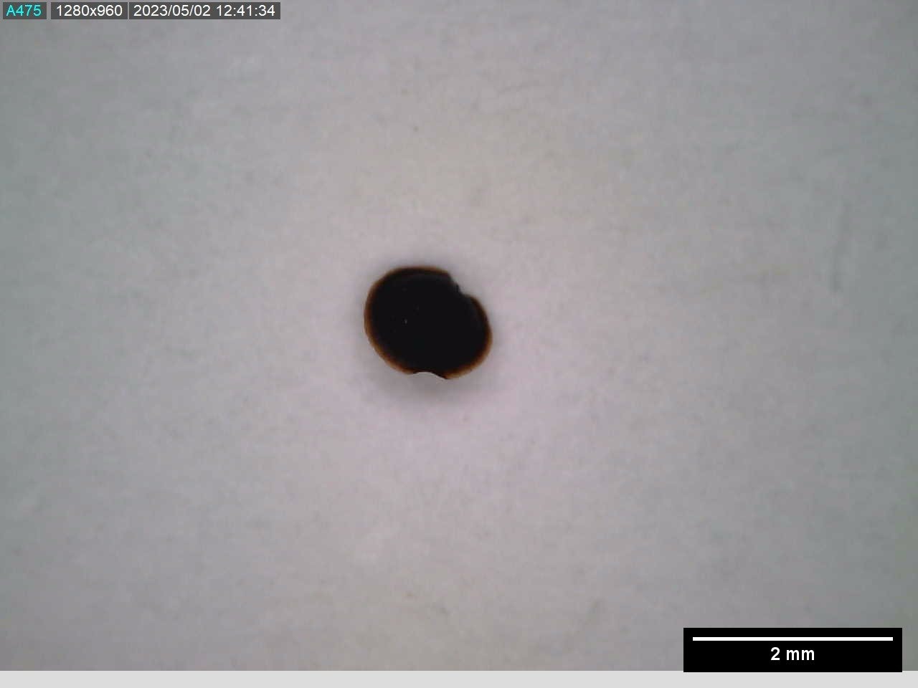 | Urtica urens  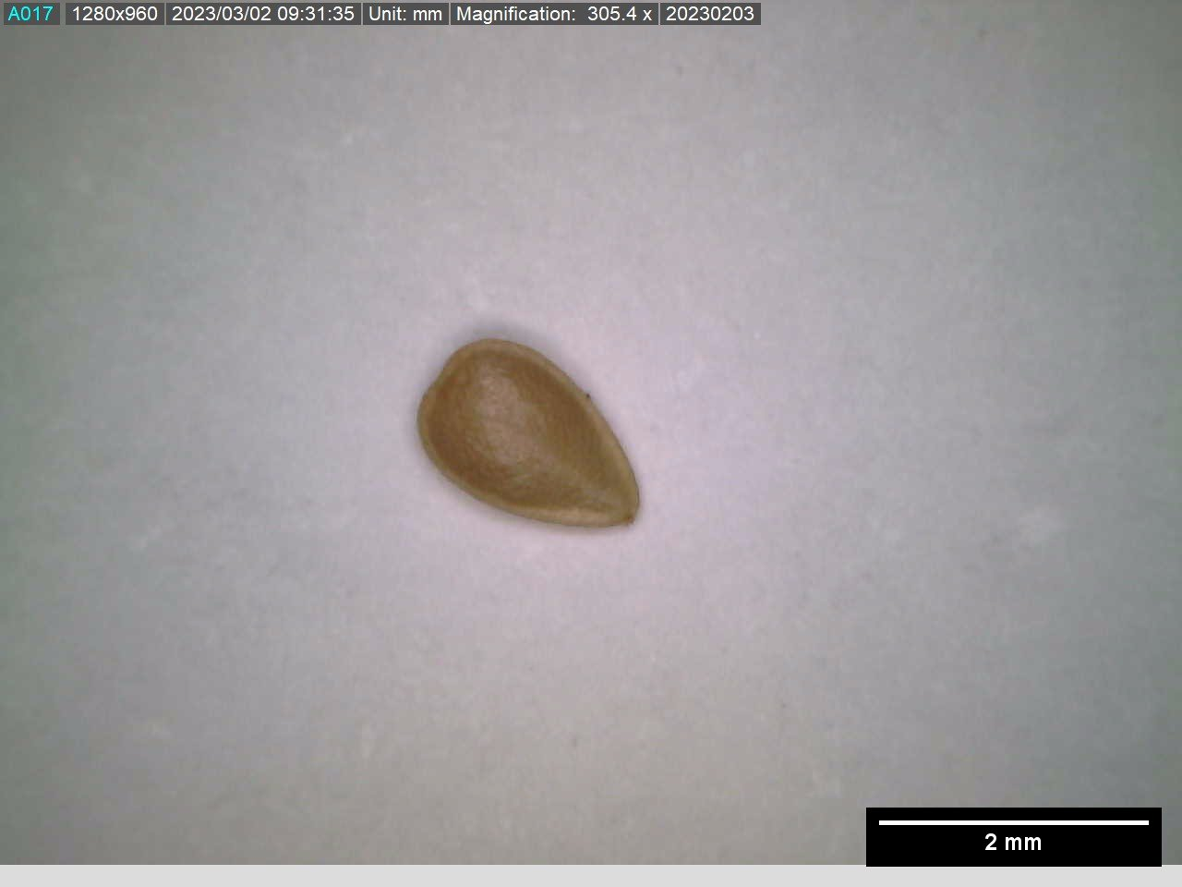

Figure S2. Photograph of the material used to characterize the seed area and morphology parameters.

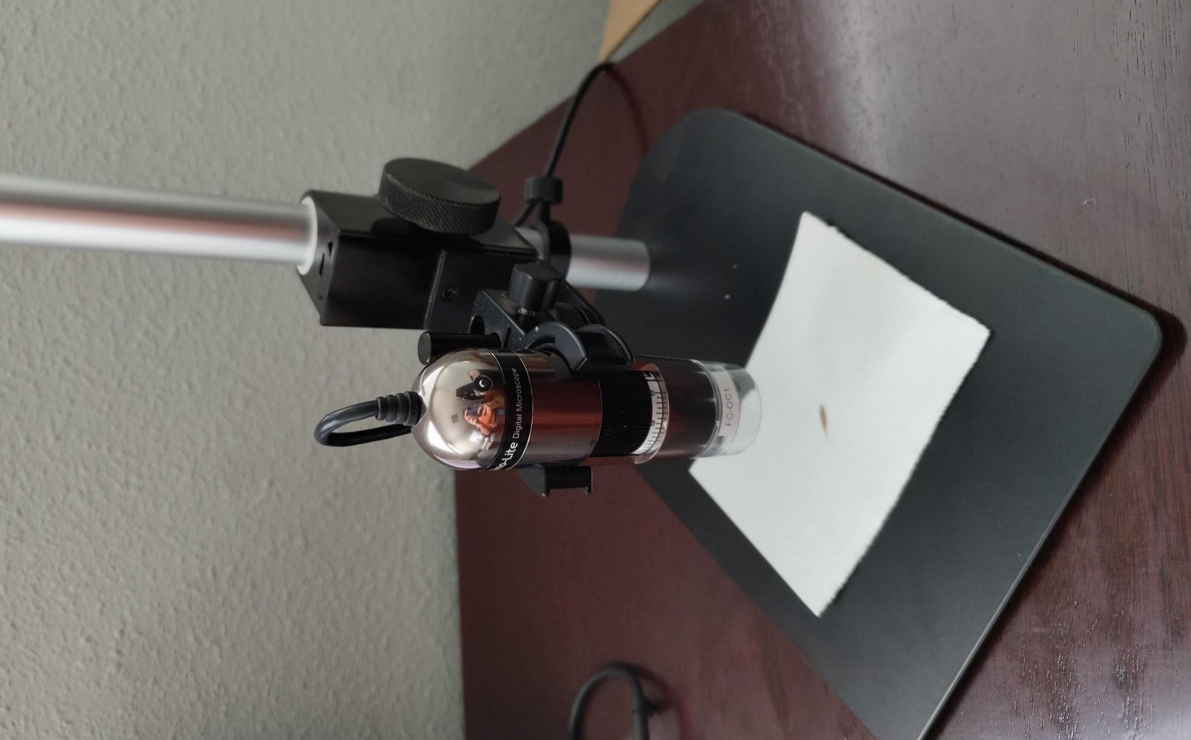

Figure S3. Photograph of the vertical chamber where experiments to determine seeds’ terminal velocity were performed.

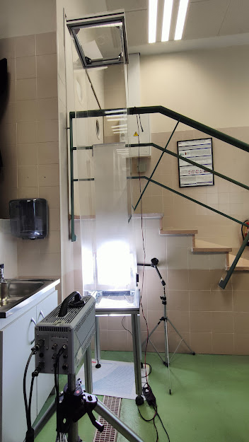

Figure S4. Left, the image of the diaspore fall track during the vertical tunnel assays to determine the terminal velocity. Right, temporal evolution of the terminal velocity in each irrigation treatment and ambient. WR = drought; WW= well-watered).

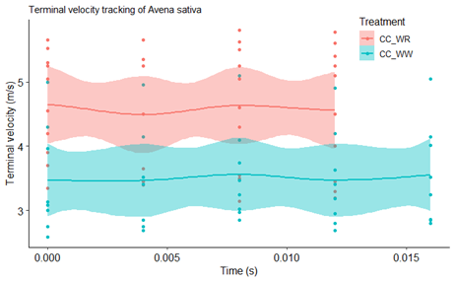
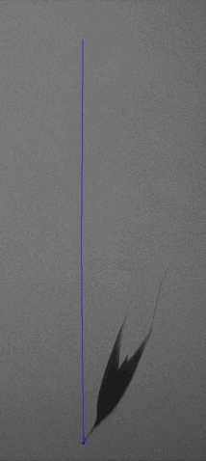

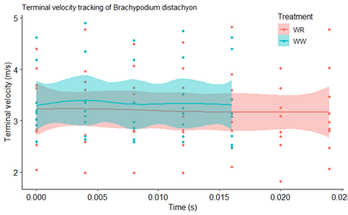
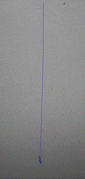

Figure S5. Pictures of three Brassicaceae species in which the indehiscence of siliques is common.

Capsella bursa-pastoris  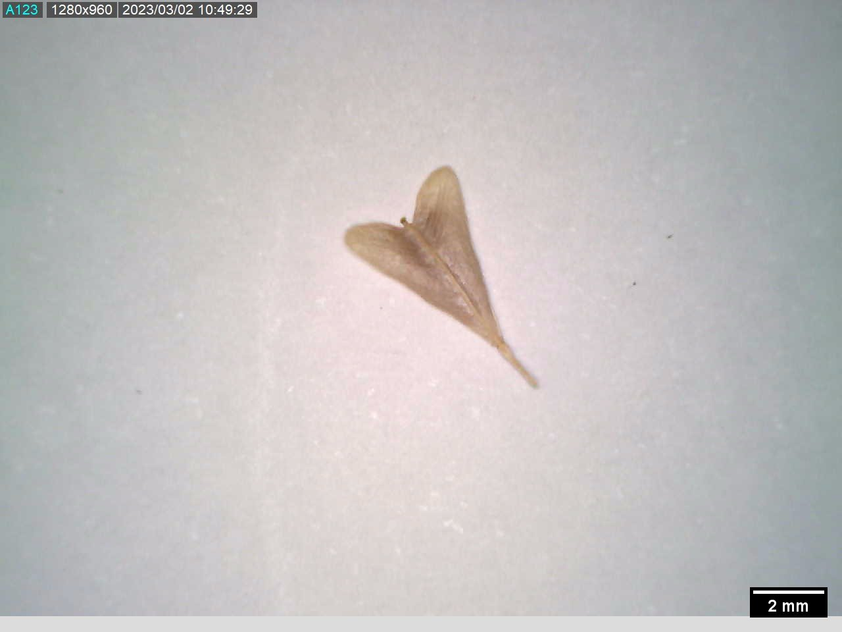 | Eruca sativa  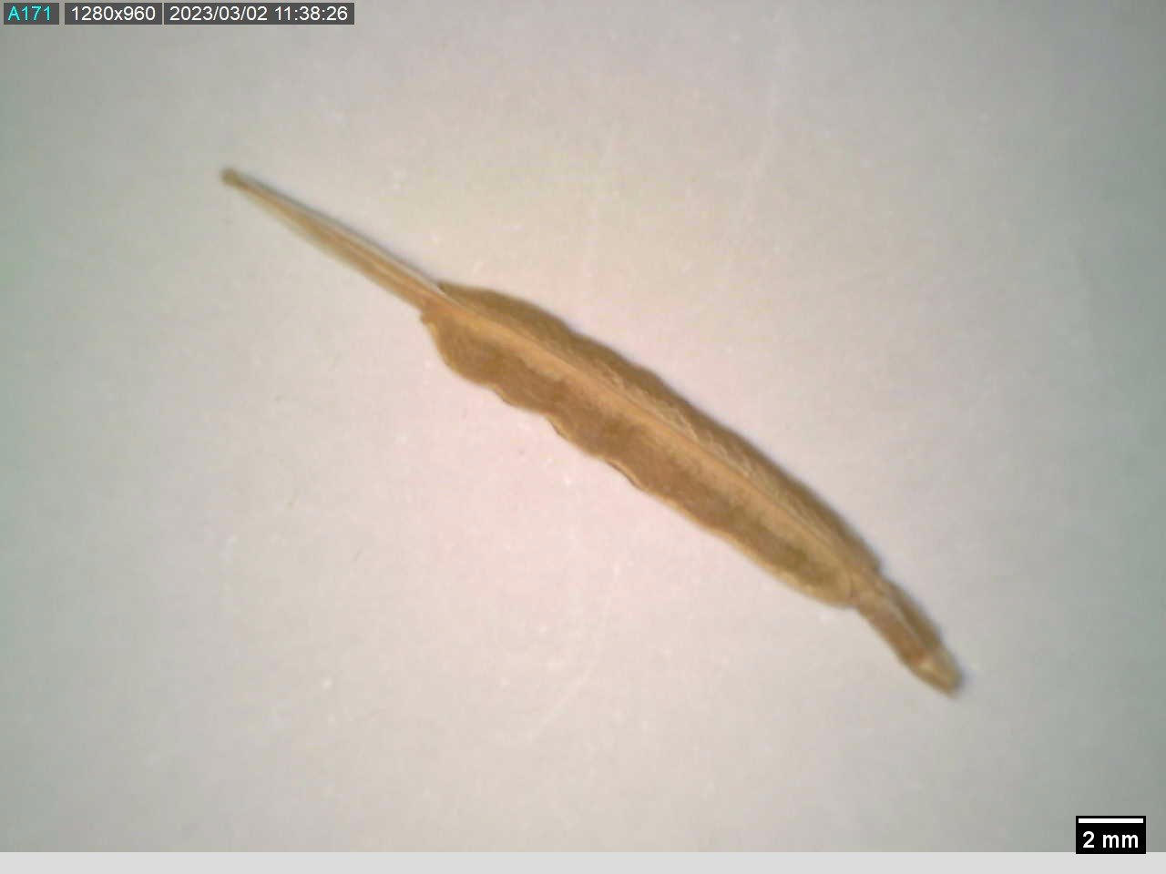 | Sinapis alba  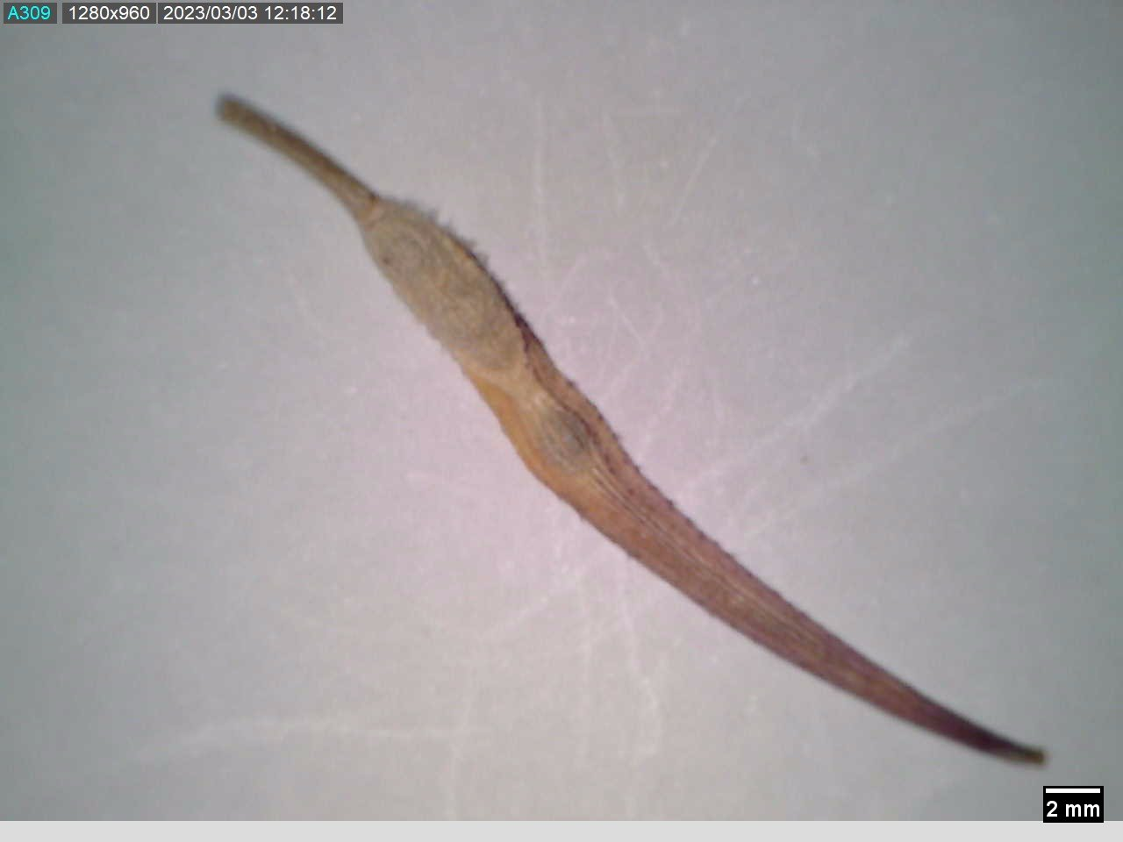

Figure S6. Top: instantaneous measurements of the wind velocity in the tunnel during the assays. The different colours represent tests with different fan rotation speeds and thus, different average wind velocities. Bottom: turbulence intensity that corresponds to each velocity average along with the turbulence intensity over the average value.

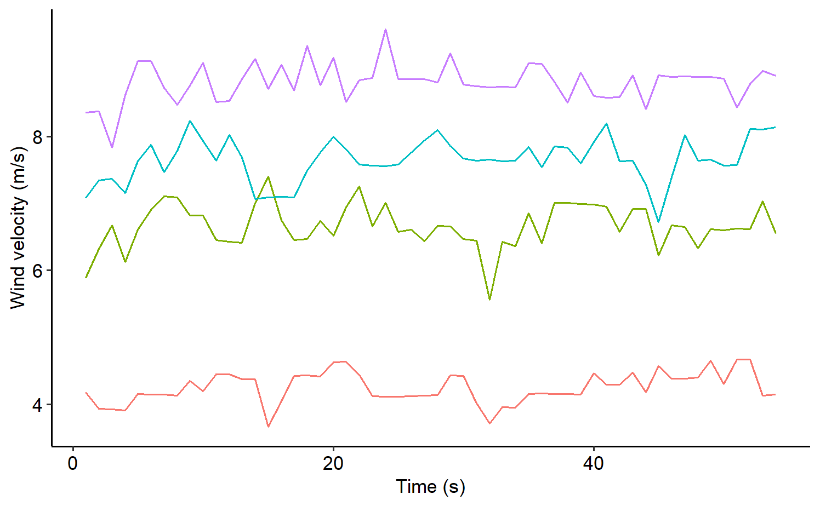

Wind speed average (m/s) | 4.24 | 6.62 | 7.66 | 8.81
Turbulence intensity | 0.23 | 0.33 | 0.32 | 0.286
Turbulent intensity over average velocity (%) | 5 | 5 | 4 | 3

Figure S7. mages of the wind tunnel used for the seed dispersal experiments. On the left, the entire device is shown, while on the right, a close-up picture of a Brachypodium seed placed on the platform, ready to be exposed to the wind flow, can be observed.

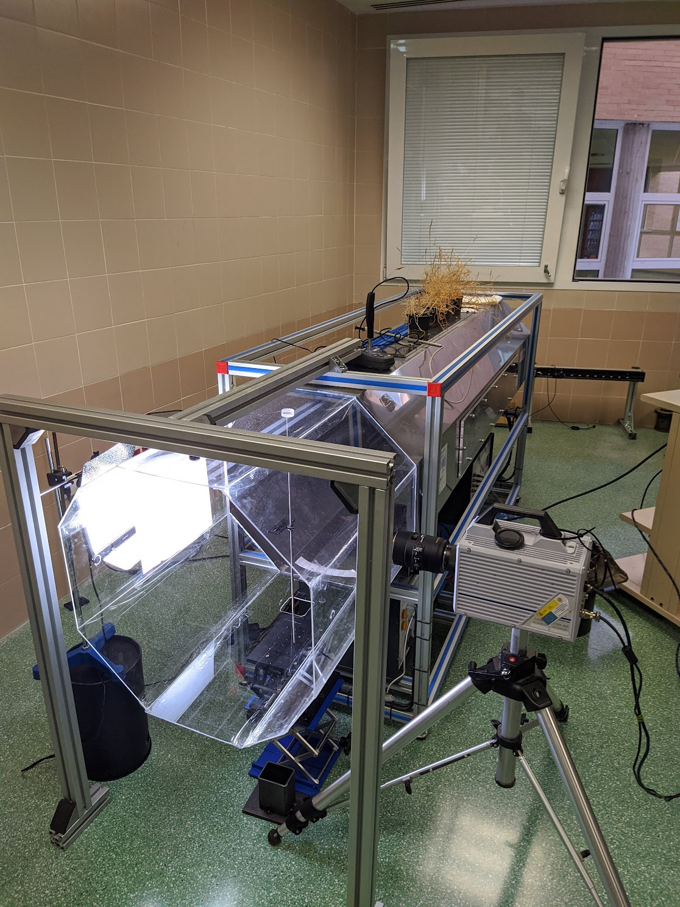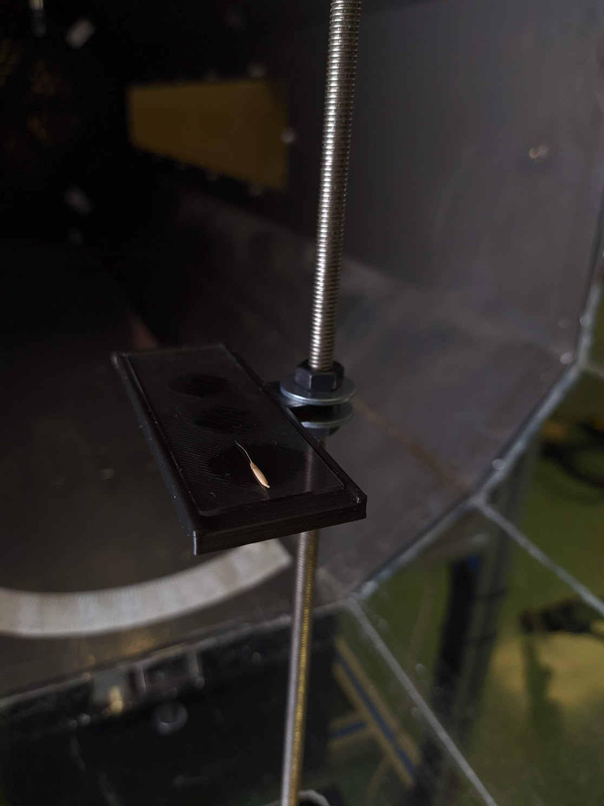

Fig. S8. Model-adjusted means ± 1SE for species-specific variation in terminal velocity of the diaspores across climate (CC = Climate change; NC = Current Ambient) and irrigation treatments (DR = drought; WW= well-watered).

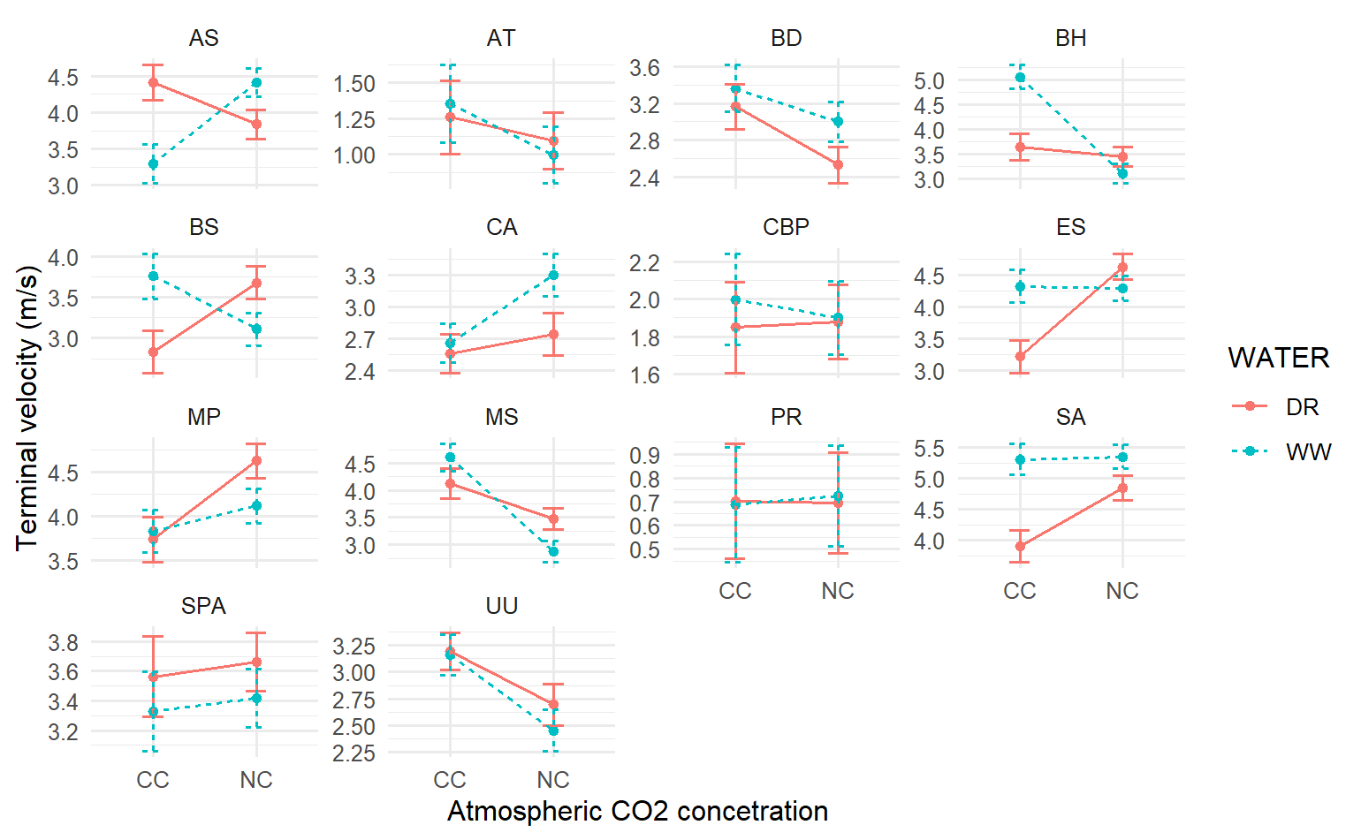

Fig. S9. Model-adjusted means ± 1SE for variation in terminal velocity across climate (CC = Climate change; NC = Current Ambient) and irrigation treatments (DR = drought; WW= well-watered) in three species with incomplete dehiscence. CBP = C. burso-pastoris, ES = E.sativa, SA = S. alba (see Table S3)

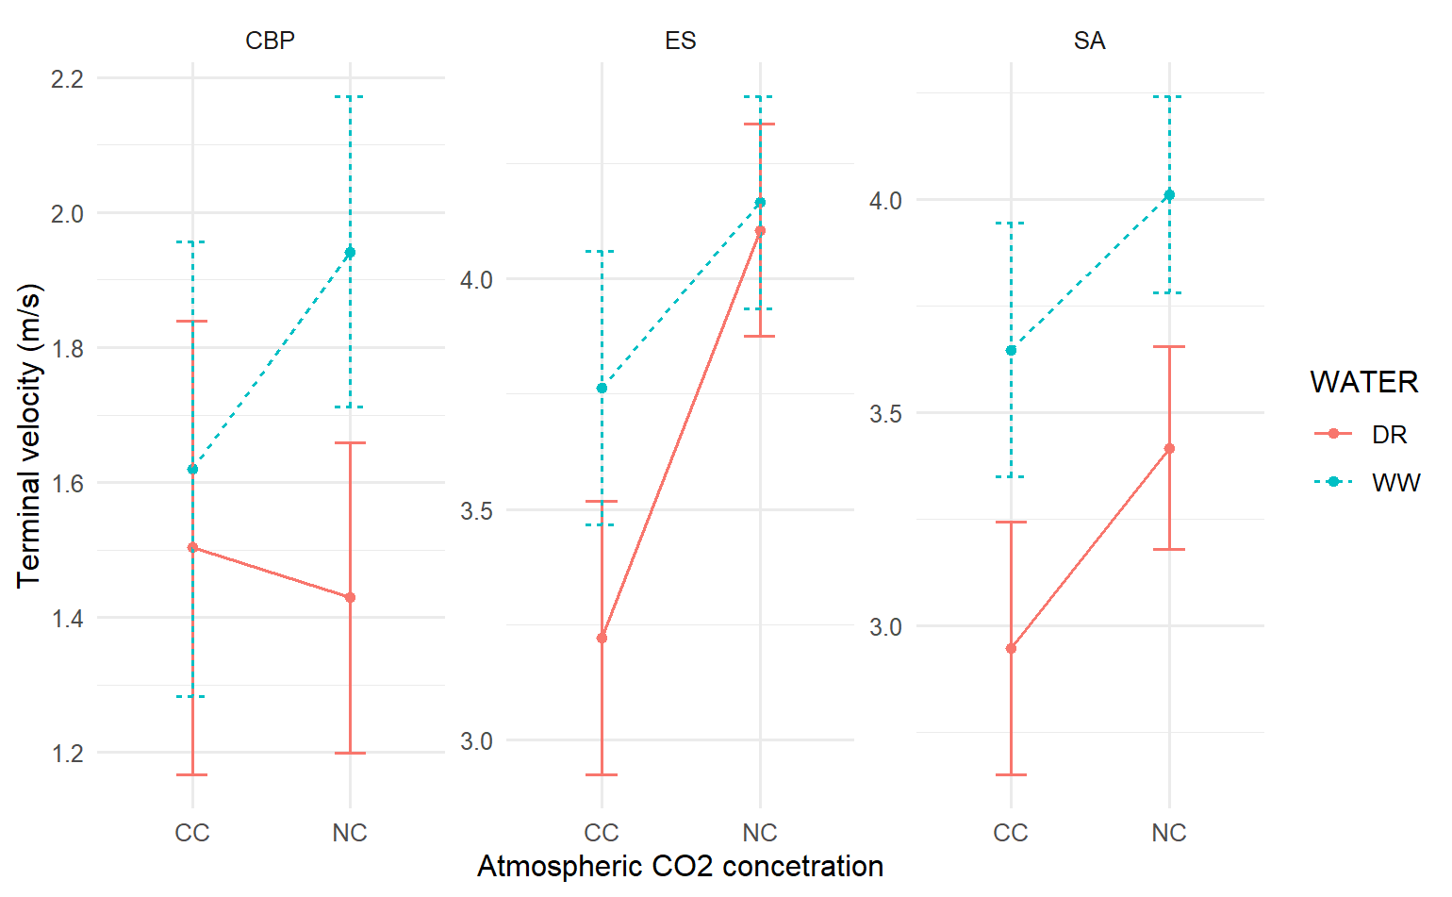

Fig. S10. Model-adjusted means ± 1SE for species-specific variation in abscission height across climate (CC = Climate change; NC = Current Ambient) and irrigation treatments (DR = drought; WW= well-watered).

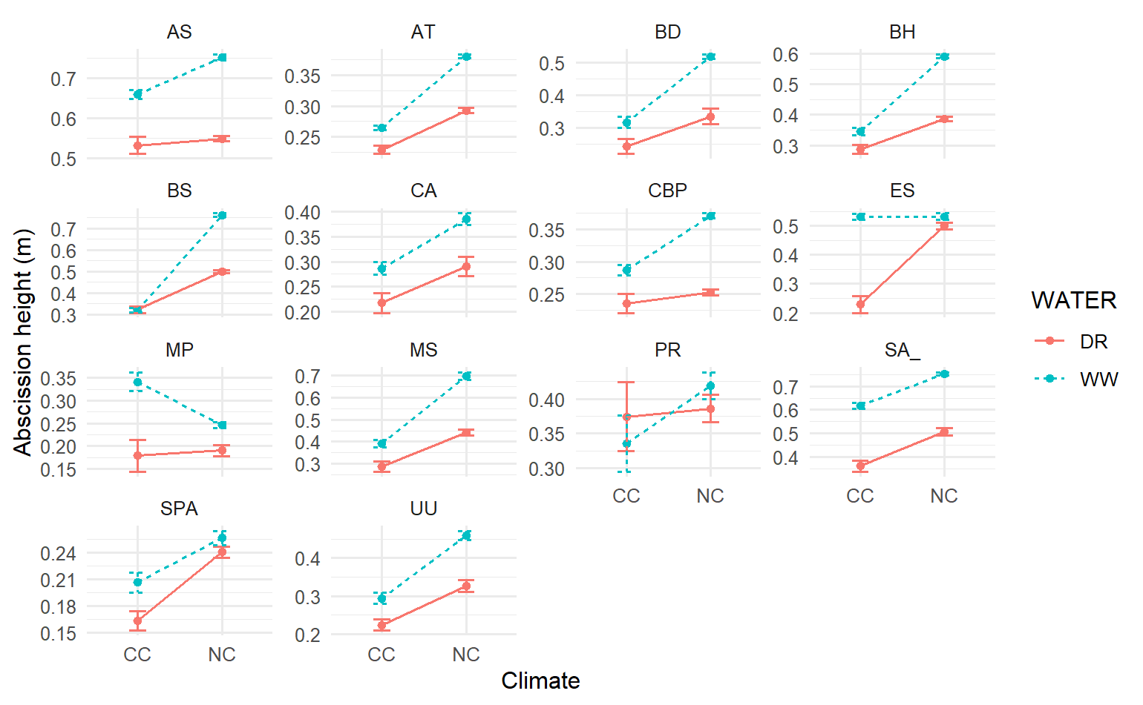

S11. Left, PCA biplot depicts diaspore and plant trait variation in the first two principal components. Right above is the score plot for the dimensions and explained variance, and bottom right is the correlation plot for each trait to the dimensions.

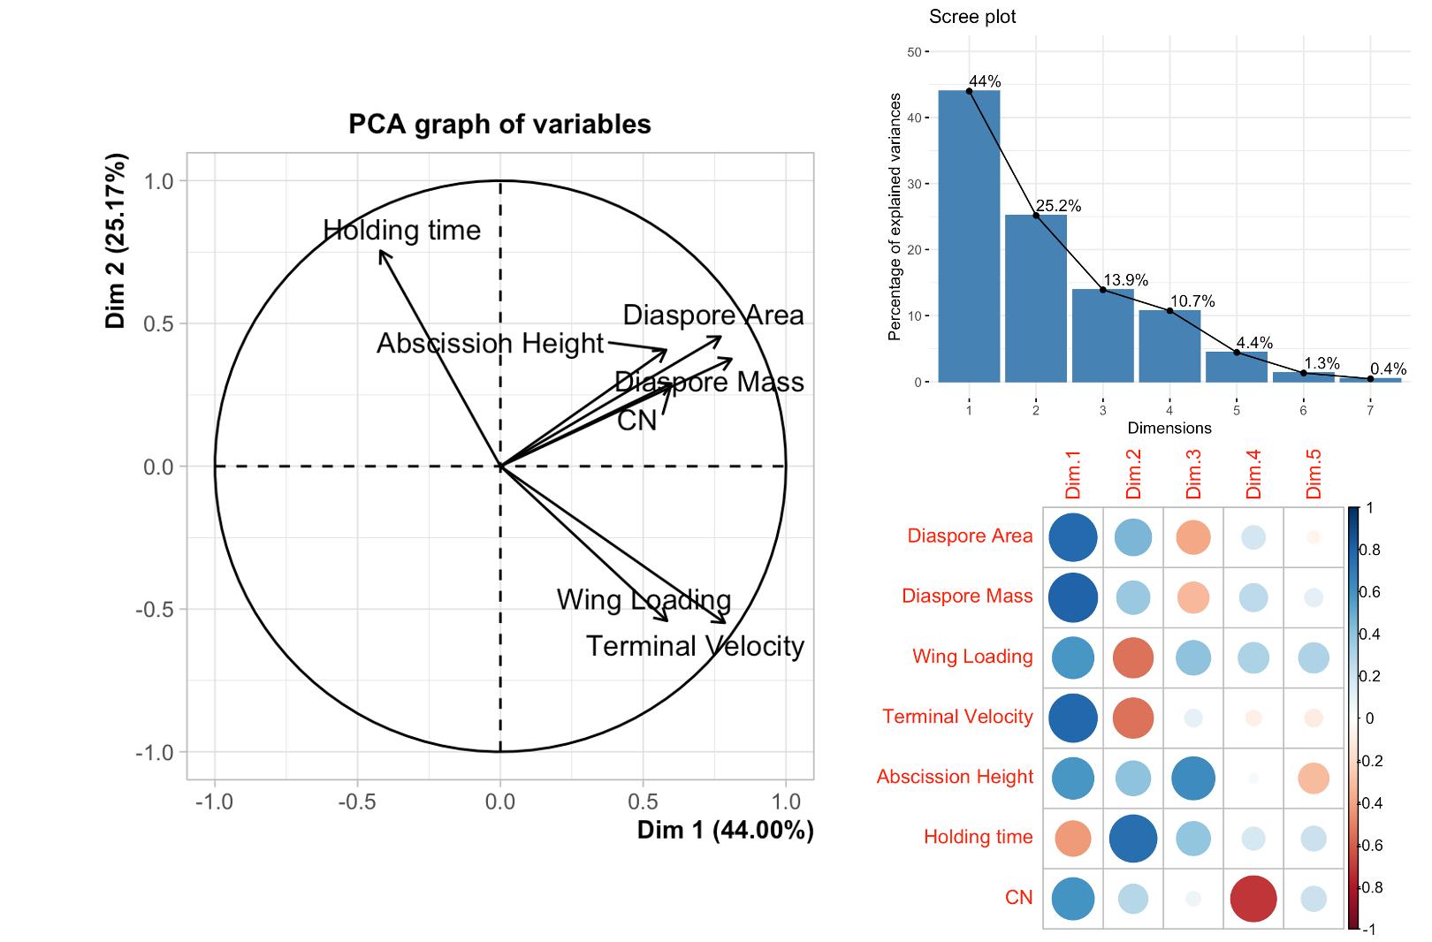

S12. Left, PCA on groups (climatic conditions: CCDR = Climate change, drought; CCWW = Climate change well-watered; NCDR = current conditions, drought; NCWW = current conditions well-watered). Right, PCA on individuals (i.e., species). Acronyms for each species are given in Table S3. Ellipses on the graphs are 95 % confidence intervals.

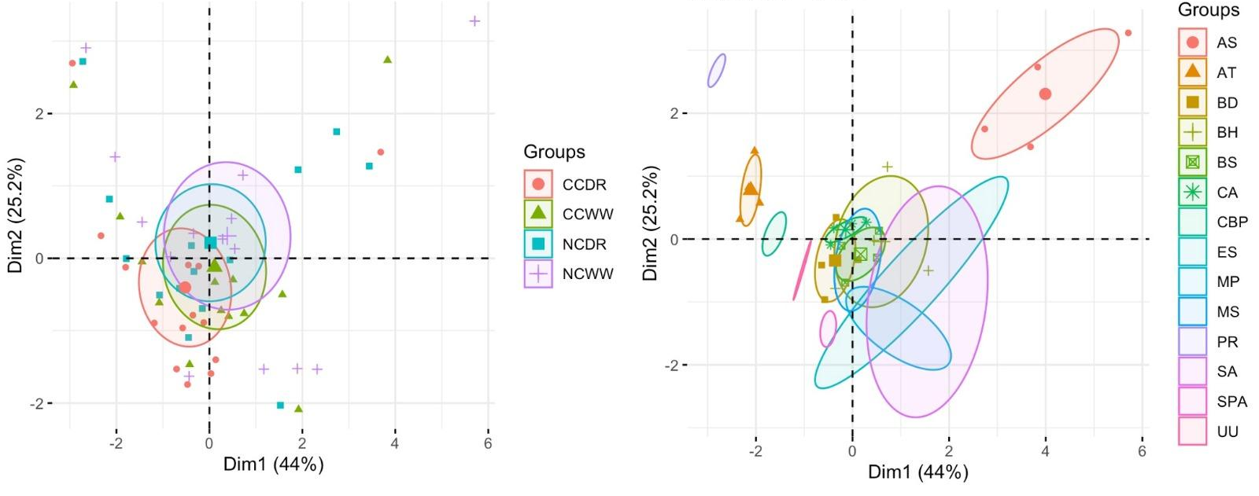

S13. Inter-specific variation in the average dispersal distance between climates and water treatments. (CC = Climate change; NC = Current Ambient) and irrigation treatments (DR = drought WW= well-watered).

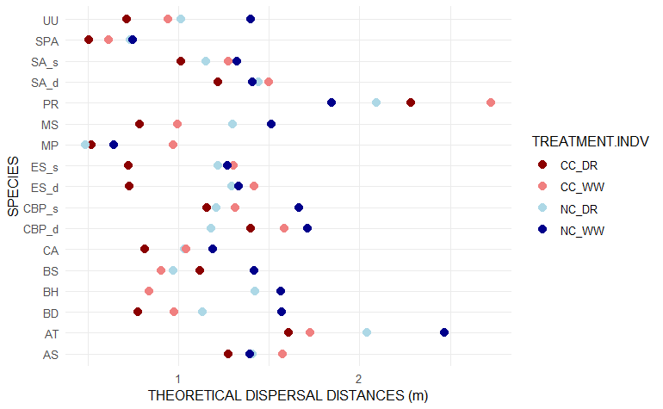

S14. Scatter plots show the relationship between observed dispersal distances from wind tunnel tests and the theoretical projection from Wald's model for each climate and water treatment. (CC = Climate change; NC = Current Ambient) and irrigation treatments (DR = drought; WW= well-watered). The lines in the graphs indicate the linear fit.
