Supplementary Mathod
RT-PCR
To quantify mRNA expression, T. vaginalis was grown in TYM medium treated with 2 or 4 μg/ml alloferon for 4 days. Total RNA was isolated using Direct-zolTM RNA MiniPrep (ZYMO Research, Irvine, CA, USA), and reverse transcription was performed using 1 μg RNA with AMV Reverse Transcriptase (Promega, Madison, WI, USA) following the manufacturer’s protocol. Gene-specific primers (Table S1) were used for PCR amplification of cDNA. The amplification involved initial DNA denaturation at 94℃ for 5 min, followed by 30 cycles of denaturation (94℃ for 1 min), annealing (65℃ for 1 min), and extension (72℃ for 2 min) for β-tubulin and ferredoxin, and 23 and 33 cycles for PFOR and malic enzymes, respectively. β-tubulin served as an internal control and was co-amplified with target gene. PCR products were separated by electrophoresis on 1.5% agarose gels and visualized using Red Safe stain (Intron Biotechnology, Seongnam, Korea). Band intensity was quantified with Image J software (NIH, Bethesda, MD, USA).

Supplementary Figure Legends
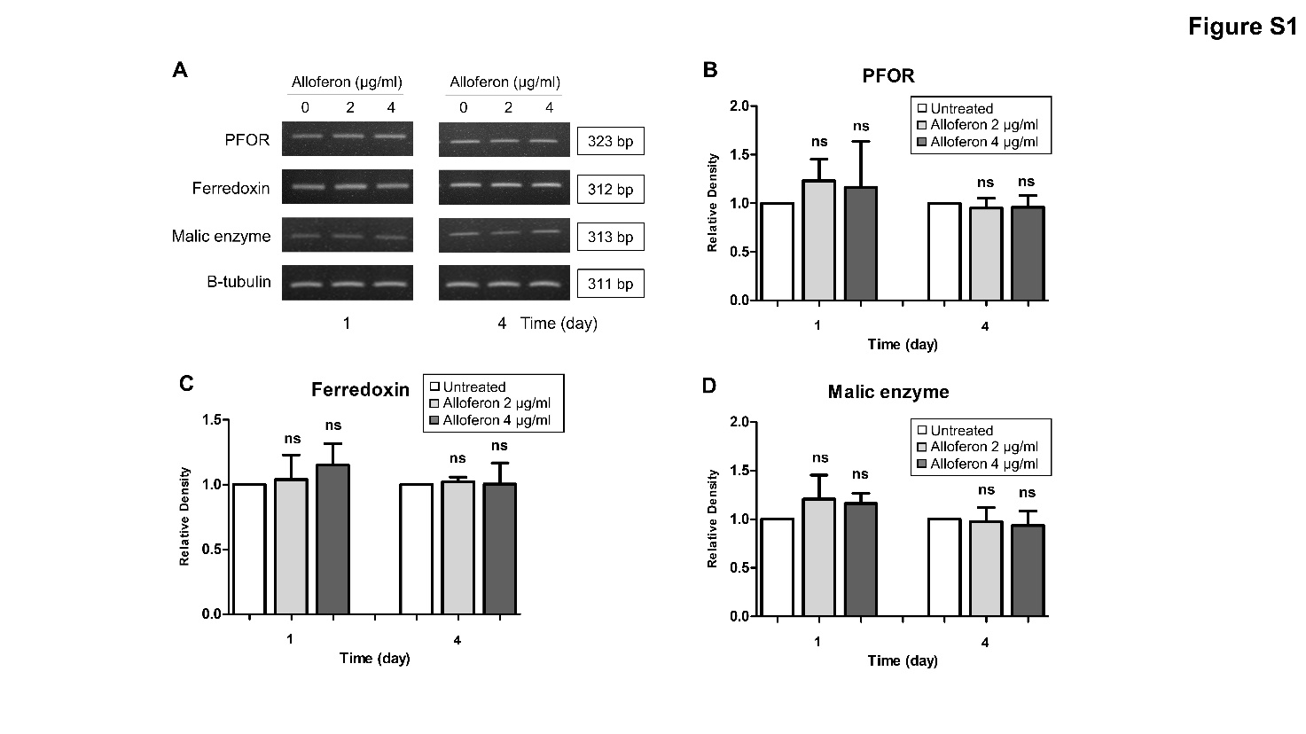
Supplementary Figure S1. Alloferon treatment dose not alters mRNA expression of hydrogenosomal enzymes in T. vaginalis. T. vaginalis was cultured and treated with alloferon for 1 or 4 days. (A) RT-PCR analysis of mRNA levels for hydrogenosomal enzymes. The bar graphs show the relative expression of (B) PFOR, (C) ferredoxin, and (D) malic enzymes compared to untreated controls. ns, not significant.

Supplementary Table 1. Primers used for RT-PCR analysis of hydrogenosomal enzymes.
Target | Primer sequence (5′-3′) |  | Accession no.
Pyruvate:ferredoxin oxidoreductase | Forward | TGCTGCTGGTTACACAAAGG | U16822.1
Pyruvate:ferredoxin oxidoreductase | Reverse | GGTCGAGGTTGTAGTCTGGC | U16822.1
Ferredoxin | Forward | ATGCTCTCTCAGTGCTCTCCTC | AY466518.1
Ferredoxin | Reverse | TTAGACCTCGAATGTAGCACCG | AY466518.1
Malic enzyme | Forward | CCTCGAGATCCAGAAGAACG | AF545470.1
Malic enzyme | Reverse | TTGGAGACGCTTCTCGATTT | AF545470.1
Beta-tubulin | Forward | CCCAGATCGTATCCTCTCCA | L05468.1
Beta-tubulin | Reverse | AGACGTGGGAATGGAACAAG | L05468.1

