Supplementary Information for

Label-free optical imaging of ion channel activity on living cells

Qing-Yue Li, Pin-Tian Lyu, Bin Kang*, Hong-Yuan Chen, Jing-Juan Xu*

State Key Laboratory of Analytical Chemistry for Life Science, Chemistry and Biomedicine Innovation Center, School of Chemistry and Chemical Engineering, Nanjing University, Nanjing 210023, China

Contents
Supplementary Note 1. Imaging principle of EM-iSCAT 2
Supplementary Note 2. Verification of EM-iSCAT signal with gold nanoparticles (AuNPs) 3
Supplementary Note 3. Relationship between $Φ$ and charge density 4
Supplementary Note 4. Effects of AC-modulation on cell electrophysiology 5
Supplementary Note 5. Extracellular solution osmolarity changing assays 7
Supplementary Note 6. NMDAR gating dynamics 8
Supplementary Note 7. Calculation of single channel lateral diffusion coefficient 8
Supplementary Note 8. Response of cells to different concentrations of cations 9
Supplementary Note 9. Finite element method (FEM) simulation of channel opening events 9
Supplementary Note 10. Effect of non-uniform background noise………………………………...11
References 12
Supplementary Figures & Table 14

Supplementary Note 1. Imaging principle of EM-iSCAT
In iSCAT, the detected signal, $I_{det}$, is described by
$I_{det}={\left|E_{r}+E_{s}\right|}^{2}={\left|E_{r}\right|}^{2}+{\left|E_{s}\right|}^{2}+2E_{r}E_{s}cos{ϕ}$ (1)
where $E_{r}$ and $E_{s}$ are the reference and scattered light fields, respectively, and $ϕ=ϕ_{r}-ϕ_{s}$ is the phase difference between the reference and scattered fields. The third term in equation (1) corresponds to the interference of $E_{r}$ and $E_{s}$. Due to its linear dependence on $E_{s}$, this term is sensitive to small changes in the scattering properties of the sample. In our work, the reference contribution, $E_{r}$, originates from reflected light at the ITO interface and contains no information about cells. Since cells are much larger than the illumination wavelength (532 nm), $E_{s}$ is dominated by scattering of light at the cell membranes interface, with minor scattering contributions from surface roughness. For heterogeneously distributed “ion nanolens” on the outer surface of cell membranes, the scattering intensity (${\left|E_{s}\right|}^{2}$) is vanishingly weak, the iSCAT signal can be obtained by subtracting the reference intensity (${\left|E_{r}\right|}^{2}$) that acts as a background from the detected intensity. Thus, the contrast obtained when comparing images with a temporal median background becomes:
$contrast=\frac{I_{det}-{\left|E_{r}\right|}^{2}}{{\left|E_{r}\right|}^{2}}=\frac{2E_{r}E_{s}cos{ϕ}}{{\left|E_{r}\right|}^{2}}=2\frac{E_{s}}{E_{r}}\cos{ϕ}$ (2)
A common way to enhance the contrast is reducing the reference light intensity to increase the ratio between $E_{s}$ and $E_{r}$. In our work, a partial reflector (PR)^{1,2} is used to attenuate the reference field over the scattered field. At the same time, the illumination intensity or the exposure time can be increased to achieve higher signal-to-noise ratio for shot-noise-limited detection.
The iSCAT signal of ion channels originates from “ion nanolens” produced by ion diffusion. Because the scale of the diffusion field is within the diffraction limit (see Section 9 for more details), the details of the ion distribution inside the “ion nanolens” have a negligible influence on the scattering intensity. We consider the empirical linear relation^{3,4} between the refractive index and salt concentration $n_{sol}=n_{w}+Kx_{salt}$, where $n_{sol}$ and $n_{w}$ is the refractive index of salt solution and water, respectively, $x_{salt}$ is the ratio between the moles of salt ions and solvent molecules and $K$ is the slope. Approximately, we regard $x_{salt}$ as the integral concentration of ions in the diffusion field, c. Thus $n_{p}∝c$, where $n_{p}$ is the refractive index of “ion nanolens”. The response of “ion nanolens” to light can be formulated as $E_{s}∝αE_{r}$, and the Rayleigh polarizability is defined as $α=3V\frac{m^{2}-1}{m^{2}+2}$, where V is the volume and m is the refractive index of the object divided by that of the surrounding medium. In neutral salt solutions (1<m<2), the relationship between $α$ and m is approximately linear. Therefore, taking the above relationship into consideration, we can conclude that the contrast of the interferometric scattering image is positively correlated with c.
In EM-iSCAT, a AC-modulated voltage with a certain frequency ($f$) is applied to the solution and the cells. “Ion nanolens” distributed near the outer surface of cell membrane will undergo periodic transformation under the action of electric field force. We perform short-time Fourier transform (STFT) to the iSCAT contrast,
$Φ=STFT(contrast, f)$ (3)
where $Φ$ is the STFT amplitude of the $contrast$ at $f$. $Φ$ is positively correlated with the integral concentration of the ion diffusion field, we will verify this relationship in next sections.

Supplementary Note 2. Verification of EM-iSCAT signal with gold nanoparticles (AuNPs)
We used AuNPs, polystyrene (PS) microspheres and silicon dioxide (SiO₂) microspheres to verify that the EM-iSCAT signal originated from periodic generation of an uneven ion distribution. Firstly, 80 nm AuNPs were dispersed on ITO electrode, 1 M NaClO₄ was used as bulk solution, and an AC-modulated voltage with an amplitude of -600 mV and a frequency of 30 Hz was applied to ITO. When electrons were injected into the particles, an electric double layer was formed on the surface of the particles. This uneven distribution of ions leads to the appearance of “ion nanolens” (Fig. S4a), that is, an electric double layer with non-uniform refractive index due to the formation of an ion concentration gradient, which is similar to the case of ion channels. The “ion nanolens” altered the local scattering field of the particle, resulting in the change of the iSCAT signal, which was synchronized with the applied voltage modulation (Fig. S4b). We performed fast Fourier transform (FFT) analysis on each pixel of the iSCAT image sequence, extracted the oscillation amplitude averaged over 1 s, and constructed a FFT image (Fig. S4e). The FFT amplitude spectrum shows a sharp peak at the frequency (30 Hz) of the applied electric field (Fig. S4f). In the amplitude image, there are significant signals on the AuNPs, and almost no signal exists on the ITO, which indicates that in the EM-iSCAT image, signals come from the uneven ion distribution field that changes with the modulated electric field. We performed control experiments on 300 nm PS microspheres and 3 μm SiO₂ microspheres respectively. As shown in Fig. S4f, the amplitude images and spectrum diagrams of FFT did not show obvious signals, because there is no “ion nanolens” around these insulated particles. Note that the FFT analysis used here is equivalent to the STFT analysis we mentioned in the method, which adds a rolling time window on the basis of the former, allowing us to analyze non-uniform changes in signals. Since the signal on the nanoparticle changes uniformly and periodically, and the data acquisition time is only a few seconds, we simplified the data processing here by using FFT instead of STFT.
Meanwhile, we verify that the FFT amplitude increases as the number of ions in the “ion nanolens” increases. The total number of excess monovalent ions N necessary for screening the nanosphere is given by $N=\frac{CV}{e}$, where C is the Stern-layer capacitance, V is the surface potential, and e is the elementary charge. When the amplitude of the modulated voltage increases, more ions will enter the screening layer. As a result, the integral ion concentration in the “ion nanolens” will increase, and the FFT amplitude will be larger. The experimental results in Fig. S4c confirm this relationship.

Supplementary Note 3. Relationship between $Φ$ and charge density
In order to explore the relationship between the STFT images intensity ($Φ$) and the ion concentration on the outer surface of cell membrane, we first measured the STFT amplitude of bare ITO surface with voltage modulation at different frequencies. Bare ITO surface can be modeled with a Randles circuit by three electrical components (Fig. S5a, inset), including solution resistance ($R_{s}$) in series with electric double layer capacitance ($C_{p}$) and polarization resistance ($R_{p}$) in parallel. The ITO impedance ($Z$) can be defined as
$Z=R_{s}+\frac{1}{\frac{1}{R_{p}}+j2πfC_{p}}=\frac{V}{I}$ (4)
where $f$ is the modulated frequency, $V$ and $I$ are the voltage and current read on the oscilloscope (SDS1000X-E, SIGLENT) at different $f$. We calculated the impedance and fitted the result with equation (4) to extract the value of each parameter, as shown in Fig. S5a. With all the parameters, the charge density on bare ITO surface ($Q_{c}$) can be calculated as
$Q_{c}=\frac{VR_{p}C_{p}}{R_{s}+R_{p}+j2πfR_{s}R_{p}C_{p}}$ (5)
Then, we compared the calculated charge density with the STFT amplitude of bare ITO surface, a linear relationship was observed, as shown in Fig. S5b.
Further, we performed cell imaging using EM-iSCAT to verify that there is a proportional relationship between $Φ$ and the membrane charge density. When an electric field is applied to a cell, the resistive component describes the ionic conduction, and the capacitive component describes the non-conductive regions, such as the plasma membrane charging, which will contribute to the impedance response⁵. A single cell can be modeled by a sequence of electrical components, including membrane capacitance $C_{m}$, membrane resistance $R_{m}$, and cytoplasm resistance $R_{i}$, as shown in Fig. S6a. When the modulated voltage ($V$) was applied, the total current ($I$) can be calculated as
$I=\frac{V}{R_{s}+R_{i}+\frac{1}{\frac{1}{R_{m}}+j2πfC_{m}}}$ (6)
where $R_{s}$ is the solution resistance. At low-frequency modulation, the charge density of cell mainly comes from the charge density on cell membrane capacitance, hence, the membrane resistance, $R_{m}$, can be neglected here for simplicity. The membrane charge density ($Q_{c}$) is calculated as,
$Q_{c}=\frac{VC_{m}}{1+j2πf\left(R_{s}+R_{i}\right)C_{m}}$ (7)
thus, the EM-iSCAT signal can be interpreted as
$Φ∝Q_{c}=\frac{kVC_{m}}{1+j2πf\left(R_{s}+R_{i}\right)C_{m}}$ (8)
where $k$ is the linear ratio.
Modulated voltage with different amplitudes and different frequencies were performed to cells to verify this single-cell model. We applied a modulation potential with the amplitude increase from 200 to 800 mV at 5 Hz frequency, and the corresponding averaged responses are linearly increased with the modulation amplitude (Fig. S6b), which is consistent with the prediction of equation (8). Furthermore, with the modulation amplitude fixed at 800 mV, we changed the frequency from 5 to 50 Hz, and a decrease in $Φ$ was observed (Fig. S6c).

Supplementary Note 4. Effects of AC-modulation on cell electrophysiology
To verify that the electrochemical modulated voltage applied in EM-iSCAT does not have an effect on cell viability or the electrophysiological properties of the cells, we performed methylthiazolyldiphenyl-tetrazolium bromide (MTT) assay and membrane potential fluorescence imaging.
Cell viability was quantified by cell proliferation reagent MTT. PC-12 cells were plated in a 96-well plate and were incubated at 37 ⁰C in a 5% CO₂ atmosphere for 24 h. Then, culture medium was replaced by 200 μl PBS. An AC-modulated voltage with the same amplitude and frequency as whole-cell experiments was applied to cells in several wells simultaneously using a two-electrode configuration, where a Pt coil and a Ag/AgCl wire served as the working and reference electrodes, respectively. The assay was performed after the 20 min AC-modulated treatment using MTT Cell Proliferation Assay Kit (Beyotime) according to the manufacturer’s instruction. The absorption of 490 nm was measured using an enzyme linked immunosorbent assay. As shown in Fig. S7, comparing to control group, cell viability with the AC-modulated voltage did not change significantly.
We recorded voltage-dependent changes in the fluorescent yield of PC-12 cells stained with the electrochromic probe di-4-ANEPPS to detect changes in membrane potential and ion channel activity with the AC-modulation. The dye was prepared as a 5 mM stock solution in DMSO and diluted to 5 μM in PBS just before use. PC-12 cells were plated on an ITO electrode slide, and were stained at room temperature for 10 min before imaging trials. The optical system is configured with a 470-495 nm band-pass excitation filter (BP470-490, Olympus), a 505 nm dichroic mirror (DM505, Olympus), and a 575 nm long-pass emission filter (BA575IF, Olympus). The light source is a mercury light source system (U-HGLGPS, Olympus), and the emitted light is detected with a sCMOS camera (Dhyana 95 V2, Tucsen).
Di-4-ANEPPS dyes cause a blue or red fluorescence shift during depolarization or hyperpolarization of membranes, respectively, after excitation in the range of ~470 nm to 490 nm⁶. The average voltage change ($∆V$) is linearly proportional to the fractional change⁷, $∆V∝{∆F\left(t\right)}/F$, where $F\left(t\right)$ is the intensity of emitted light measured at time $t$, $∆F\left(t\right)=F\left(t\right)-F$, and $F=\left(1/T\right)\sum_{t}{F\left(t\right)}$ with $T$ equals to the number of frames in the sequence. We applied a modulated voltage protocol as 5 s without modulation (no modulation), 10 s with AC-modulation, and 5 s without modulation to cells (Fig. S8a), then we extracted the fluorescence intensity of each cell in the fluorescence image sequence. During the whole process, ${∆F}/F$ fluctuated around 0, and there is no significant change in the presence of the AC-modulation, which indicates that the modulated voltage we applied will not change the cell membrane potential.
Further, we verify that the AC-modulation does not affect ion channel activity. Patch-clamp analysis revealed that cells are hyperpolarized by decreases in external osmotic pressure and that this intrinsic response results from changes in the activity of some ion channels, such as mechanosensitive cationic channels⁸. As shown in Fig. S8b and c, when the external osmotic pressure suddenly decreases, ${∆F}/F$ rapidly increases, indicating that cells activated outward expulsion of ions (mainly K⁺, Fig. 2d) and resulted in hyperpolarization. In addition, with or without the AC-modulated voltage, the response kinetics and intensity of cells were basically the same, suggesting that the AC-modulation does not affect the activity of ion channels on the cell membrane.

Supplementary Note 5. Extracellular solution osmolarity changing assays
PC-12 cells were used for osmolarity changing experiments. The extracellular solution osmolarity was regulated by adding Na⁺-free solution and high-Na⁺ solution to the isotonic saline with a pipette. The isotonic saline contained 140 mM NaCl, 5 mM KCl, 10 mM EDTA, 10 mM HEPES, and 10 mM glucose, buffered at pH 7.4 with NaOH. Na⁺-free solution contained the same formula as saline without NaCl, and high-Na⁺ solution contained 280 mM NaCl. During iSCAT image acquisition, we added 10 μl Na⁺-free or high-Na⁺ solution to 200 μl extracellular solution three times at 1 min intervals, resulting in decreased (300 to 285, 273 and 261 mOsm/L) or increased (300 to 314, 327 and 339 mOsm/L) osmolarity in the extracellular environment. In the control experiment using three different nonselective K⁺ channel blockers, cells were submitted to a 45 min incubation in culture medium with the different blockers, respectively: 1 mM quinine, 1 mM 4-AP, and 1 mM TEA. Fixed cell and ITO electrode show negligible response to solution adding process and osmolarity changing (Fig. S9a), indicating that EM-iSCAT signal are not caused by these two factors. Comparing the bright field images of cells before and after the osmolarity decreasing assays (Fig. S9b), we found that cells shrunk, which indicate that the regulatory volume increase (RVI) process was not completed. As shown in Fig. S9c, the time constants from 8 hypotonic response processes in 3 cells range from 12.9 s to 22.5 s, with a mean value as 16.5 s ± 3.1 s. The time constants from 10 hypertonic response processes in 4 cells range from 23.1 s to 76.6 s, with a mean value as 48.5 s ± 17.9 s. Both time scale for volume regulation are in the same range as observed previously⁹.

Supplementary Note 6. NMDAR gating dynamics
We performed EM-iSCAT imaging experiment 24 h after HEK-293 cells transfection. To avoid Mg²⁺ binding to the transmembrane domain of NMDARs, solutions used for cell culture, transfection and imaging were all Mg²⁺-free, and 1 mM EDTA was supplied to the extracellular solutions (in mM: 150 NaCl, 2.5 KCl, 1 EDTA, 10 HEPES, 10 glucoses, 1 glutamate, and 0.1 glycine, pH at 8.0 with NaOH) during imaging. To ensure good activity of NMDAR and get high quality data, images acquisition was limited to 10 min after the agonist was added, and we supplied more agonists every 5 min. Cells were fixed with 4% PFA immediately after imaging. According to the results of confocal fluorescence detection, cells successfully expressed NMDARs were selected for subsequent data analysis.

Supplementary Note 7. Calculation of single channel lateral diffusion coefficient
Trajectory tracking was performed by a plugin TrackMate in Fiji-ImageJ software. The center of spot in STFT images was determined with a Gaussian fit using LoG (Laplacian of Gaussian) detector. After getting the position of each spot in each frame, an algorithm for particle linking as LAP (linear assignment problem) tracker was used for getting the single channel trajectories, where the parameters for maximum linking distance, maximum gap-closing distance, and maximum gap-closing frame gap were set to 200 nm, 600 nm and 10 frames, respectively. Mean squared displacement (MSD) described the average of the squared distances between a spot’s start and end position as a function of the time lag $t_{lag}=m∆t$. Diffusion coefficient, D, for all the trajectories were obtained by fitting the first few points of MSD curves versus time using:
$MSD\left(t_{lag}=m∆t\right)=〈{r_{m∆t}}^{2}〉=4Dt_{lag}$ (9)
where square displacement (${r_{m∆t}}^{2}$) between the frames was calculated using position of X and Y coordinates from the single channel trajectories as:
${r_{m∆t}}^{2}={\left(X_{t+m∆t}-X_{t}\right)}^{2}+{\left(Y_{t+m∆t}-Y_{t}\right)}^{2}$ (10)
The error in the diffusion coefficient obtained from first few points (n) of MSD is ${\left[{2n}/{3\left(N-n\right)}\right]}^{1/2}$, where N is the number of points in the trajectory or number of frames used for tracking analysis¹⁰. In our work, MSD analysis was done using trajectory with more than 100 frames with inter-frame time $∆t$ = 0.65 ms, which correspond to an on dwell time of ≥ 65 ms, and the diffusion coefficient of ion channel was calculated by linear fitting of the first three points of the MSD curves of time. Hence the estimated error is around 10%-14%. As shown in Fig. S11, the distribution of diffusion coefficients from 47 opening events ranges from 117 × 10⁻⁴ μm²/s to 17 × 10⁻² μm²/s, with a median value as 411 × 10⁻⁴ μm²/s ± 40 × 10⁻⁴ μm²/s, which is in the same range as observed previously.

Supplementary Note 8. Response of cells to different concentrations of cations
In order to maintain consistent osmolarity for each cationic environment, we used the impermeable agent N-methyl-D-glucamine (NMDG) to control variables. The composition of the initial normal extracellular environment solution contains (in mM): 140 NaCl, 5 KCl, 2 CaCl₂, 10 HEPES, 10 glucoses, 10 NMDG, pH7.4 with NaOH. Extracellular environment solution with more Na⁺ contains (in mM): 150 NaCl, 5 KCl, 2 CaCl₂, 10 HEPES, 10 glucoses, pH7.4 with NaOH, with more K⁺ contains (in mM): 140 NaCl, 15 KCl, 2 CaCl₂, 10 HEPES, 10 glucoses, pH7.4 with NaOH, and with more Ca²⁺ contains (in mM): 140 NaCl, 5 KCl, 9.62 CaCl₂, 10 HEPES, 10 glucoses, pH7.4 with NaOH. We replaced the solution in the electrochemical cell in the order of normal extracellular solution, high concentration of K⁺, high concentration of Na⁺, and high concentration of Ca²⁺.

Supplementary Note 9. Finite element method (FEM) simulation of channel opening events
FEM simulations were performed in COMSOL 5.4 program. We constructed a 2D model of the distribution of ions near the channel using the Transport of Diluted Species (tds) and Electrostatics (es). The model has a membrane with an ion channel. Since the concentration field formed at the local region near the channel after ions pass through is concerned, the thickness and internal structure of the membrane and channels were neglected. The horizontal size of channel was set to 1 nm, and the initial concentration of solution is set to the typical extracellular sodium ion concentration of 150 mM. An ion channel can conduct 10⁸ ions per second in real time, thus the flux of the ion channel is set to 211.5 mol/(m²·s) (Figure S12a, top). Considering the presence of an external AC-modulated voltage, electromigration was added to the diffusion equation, and a resting electrostatic potential of -60 mV was added to the cell membrane. The diffusion field in the model is determined by solving the Fick's law and quasi-static form of the Maxwell equations using FEM. The boundary conditions were set to match the real experiment conditions. The concentration gradient of the diffusion field (Fig. S12a, bottom and S12b) and the relationship between the integral concentration and time at 100 nm away from the ion channel were obtained (Fig. S12c). The decay of the ion concentration field versus distance can be fitted with a multi-exponential function, $Concentration=ae^{-\frac{d}{l_{1}}}+be^{-\frac{d}{l_{2}}}+ce^{-\frac{d}{l_{3}}}$, and we defined the threefold decay constant as the scale of the concentration field, which was calculated as 183.15 nm.
Further, as a mutual verification of the experimental results, a section of single-channel data of 1.56 s selected from the signal Ch 3 in Fig. 3c was input into the model as a flux, and the result of the integral concentration over time was consistent with the experiment (Fig S12d, and Movie S1).
For influx ion channels, a negative flux was input (Fig. S13a, top). The concentration gradient of the diffusion field (Fig. S13a, bottom and S13b) and the relationship between the integral concentration and time at 100 nm away from the ion channel were obtained (Fig. S13c), which are similar to the results of efflux channels shown above.
Single-exponential fitting of the concentration curves at 50, 100, 150, 200, and 250 nm away from ion channels was performed to obtain the rise ($t_{up}$) and fall ($t_{down}$) time constants for a single opening event, and the results were shown in Table S1. The $t_{up}$ and $t_{down}$ of ion channels are related to the agonist-receptor binding and conformational transformation dynamics. In our method, single channel signals were derived from the diffusion field near the ion channels, so the opening and closing dynamics are only related to the formation and dissipation of the diffusion field. The $t_{up}$ and $t_{down}$ measured in the experiment were 0.173 ms and 0.175 ms, respectively (Fig. 3g), which were consistent with the results at 200~250 nm of simulation.
For multiple channels, such as dual channels, we considered two types of models. Due to the optical diffraction limit, ion channels distributed within 200 nm cannot be distinguished. Hence, dual-channel signals detected in the experiment may be caused by the dimer channels (Fig. S14b), or two adjacent ion channels (Fig. S14e), which lead to signal superposition when the two ion channels were opened at the same time. In the first model, twice the flux value (423 mol/(m²·s)) was input to simulate the simultaneous opening of channels (Fig. S14a, top), while in the second model, two ion channels were set 50 nm apart and two fluxes with partial overlay times were input separately to simulate the simultaneous opening of channels (Fig. S14d, top). Both models gave similar results (Fig. S14c and f): when the two channels opened at the same time, the integral concentration at 100 nm away from the channel was twice as high as the one channel, which was consistent with the experimental results.
Moreover, we verified the possibility of EM-iSCAT to distinguish different ion channels using the physical properties of ions themselves. When ion channels on the cell membrane open, typically 10⁶-10⁸ ions pass through the ion channels per second, which corresponds to 0.16-16 pA of current if we consider the ions as monovalent. We converted this value into a flux as 2.1-211.5 mol/(m²·s), and set the diffusion coefficient after ion efflux to 5 × 10⁻¹⁰-2 × 10⁻⁹ m²/s, a range that covers almost all common ions (the diffusion coefficients are taken from the thermodynamic database “phreeqc.dat”). As shown in Supplementary Figure S15a, the integral concentration of the ion diffusion field varies with the ion diffusion coefficient and the ion channel current. The most primitive description of currents in ion channels is Ohm’s law, and single-channel conductance specifies each channel¹¹. Conductance depends on the number of ions passing per unit time and can be calculated from the ratio of current to voltage. We considered ion channels with different ion permeability that having the same or similar conductance and calculated the intensity of ion diffusion field under different current (Fig. S15b). When the ion channel current is large, the EM-iSCAT signal can be used to distinguish channels with different ion selectivity, but it is challenging when the channel current is lower. Nevertheless, EM-iSCAT provides an alternative possibility to distinguish and localize different channels, and modulation of the ion diffusion coefficient by changing the medium will hopefully enable label-free differentiation of channels with very low currents.

Supplementary Note 10. Effect of non-uniform background noise
The raw images from iSCAT inevitably include non-uniform background caused by uneven illumination or spurious speckles due to back-reflections by or roughness of the ITO substrate, which deteriorates the quality of raw images and also slower the dependence of the image contrast on the ion diffusion field. As shown in Supplementary Figure S16a-c, the contrast of the iSCAT image became increasingly obvious as the substrate roughness increases. We extracted the speckle contrast^{12, 13} ($C={σ_{I}}/{〈I〉}$, where $σ_{I}$ is the standard deviation of the intensity and $〈I〉$ is the average intensity) from one of a sequence of raw iSCAT images of an bare ITO substrate without cells (Fig. S16d). The spatial speckle contrast showed a 2D map of the non-uniform distribution of background contrast (Fig. S16e) based on the intensity variation in a 15×15 pixels’ region of the image. The temporal speckle contrast based on the intensity variation over 100 raw images (Δt = 0.33 s) was close to 0 at most pixels (Fig. S16f), indicating that these background noises were time-invariant. We performed FFT analysis and constructed an amplitude image (Fig. S16g), in which the background contrast was almost disappeared, and the spatial speckle contrast was reduced ~ 45 times. Therefore, the electrochemical modulation and signal demodulation process will significantly improve the quality of image, and enhance the contrast of changes in local charge density.

References
1 Cole, D., Young, G., Weigel, A., Sebesta, A. & Kukura, P. Label-Free Single-Molecule Imaging with Numerical-Aperture Shaped Interferometric Scattering Microscopy. ACS Photonics 4, 211-216 (2017).
2 Lyu, P.-T. et al. Decrypting Material Performance by Wide-field Femtosecond Interferometric Imaging of Energy Carrier Evolution. J. Am. Chem. Soc. 144, 13928-13937 (2022).
3 An, N., Zhuang, B. L., Li, M. L., Lu, Y. Y. & Wang, Z. G. Combined Theoretical and Experimental Study of Refractive Indices of Water-Acetonitrile-Salt Systems. J. Phys. Chem. B 119, 10701-10709 (2015).
4 Namink, K., Meng, X. H., Koper, M. T. M., Kukura, P. & Faez, S. Electric-Double-Layer-modulation microscopy. Phys. Rev. Appl. 13, 044065 (2020).
5 Wang, W. et al. Single cells and intracellular processes studied by a plasmonic-based electrochemical impedance microscopy. Nat. Chem. 3, 249-255 (2011).
6 Kao, W. Y., Davis, C. E., Kim, Y. I. & Beach, J. M. Fluorescence emission spectral shift measurements of membrane potential in single cells. Biophys. J. 81, 1163-1170 (2001).
7 Delaney, K. R. et al. Waves and stimulus-modulated dynamics in an oscillating olfactory network. Proc. Natl Acad. Sci. USA 91, 669-673 (1994).
8 Bourque, C. W., Oliet, S. H. R. & Richard, D. Osmoreceptors, osmoreception, and osmoregulation. Front. Neuroendocrin. 15, 231-274 (1994).
9 Cadart, C., Venkova, L., Recho, P., Lagomarsino, M. C. & Piel, M. The physics of cell-size regulation across timescales. Nat. Phys. 15, 993-1004 (2019).
10 Qian, H., Sheetz, M. P. & Elson, E. L. Single-particle tracking - analysis of diffusion and flow in 2-dimensional systems. Biophys. J. 60, 910-921 (1991).
11 Hille, B. Ion Channels of Excitable Membranes. Edition 3. Sinauer, Sunderland, MA (2001).
12 Redding, B., Choma, M. A. & Cao, H. Speckle-free laser imaging using randon laser illumination. Nat. Photonics 6, 355-359 (2012).
13 Boas, D. A., Dunn, A. K. Laser speckle contrast imaging in biomedical optics. J Biomed Opt 15, 011109 (2010).

Supplementary Figures & Table
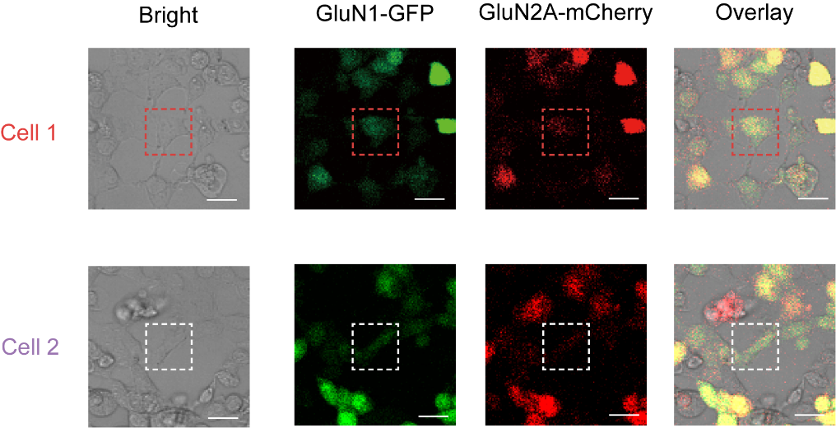
Fig. S1 Confocal fluorescence imaging of HEK-293 cells transfected with NMDARs. The cDNA constructs of GluN1 and GluN2A were transfected into the cells, with GFP and mCherry vectors, respectively. Cells in the red and white dashed boxes correspond to the signals of Cell 1 and Cell 2 in Fig. 3b. Scale bars: 25 μm

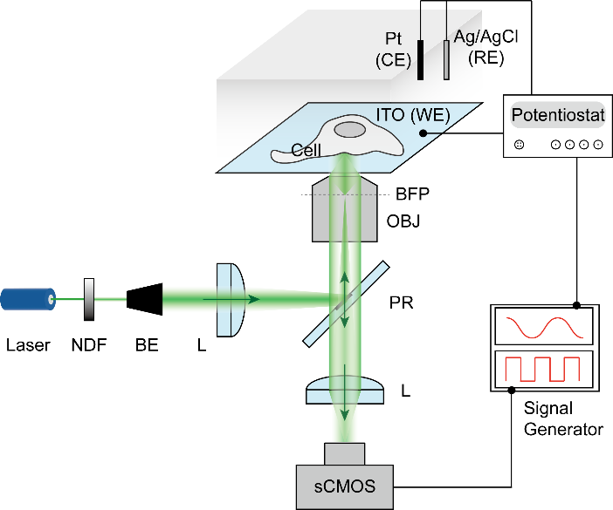
Fig. S2 Schematic of the EM-iSCAT setup. NDF, neutral density filter; BE, galilean beam expander; L, lens; OBJ, 60× objective; BFP, back focal plane; PR, partial reflector.

Fig. S3 Image processing in EM-iSCAT. Illustration of extracting whole cell signals (a) and single channel signals (b) from raw iSCAT images. Scale bars: a, 5 μm, b, 1 μm.

Fig. S4 Verification of EM-iSCAT signals. (a) When the potential modulation was applied to AuNPs (right), an electric double layer will be formed on the surface of AuNP during the charging process, leading to an “ion nanolens” (left). (b) The iSCAT signal of AuNPs (red dots) and amplitude of the potential modulation (black line). (c) FFT amplitude of AuNPs under potential modulation with different amplitudes. Data represent the mean ± SEM, n = 13-22 AuNPs. (d) iSCAT images of AuNPs (1), PS microspheres (2) and SiO₂ microspheres (3). (e) Amplitude images obtained by FFT analysis, and (f) FFT frequency distributions extracted on particles and ITO background. Scale bars: 5 μm.

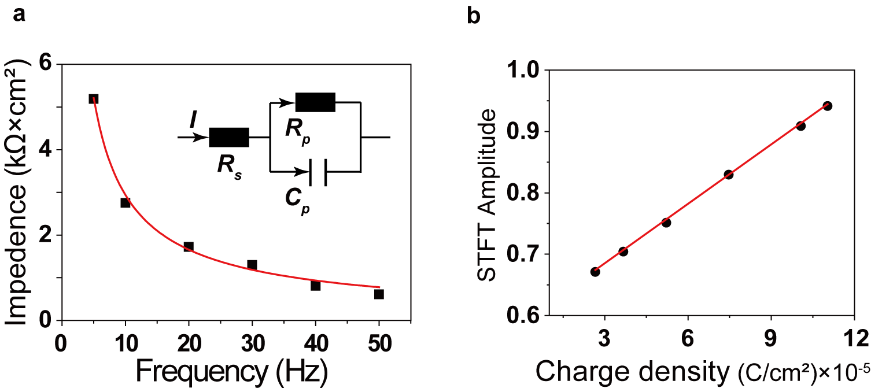
Fig. S5 The relationship between Φ and charge density on bare ITO. (a) The calculated ITO impedance at different frequencies. (b) Linear relationship between Φ and calculated ITO surface charge density.

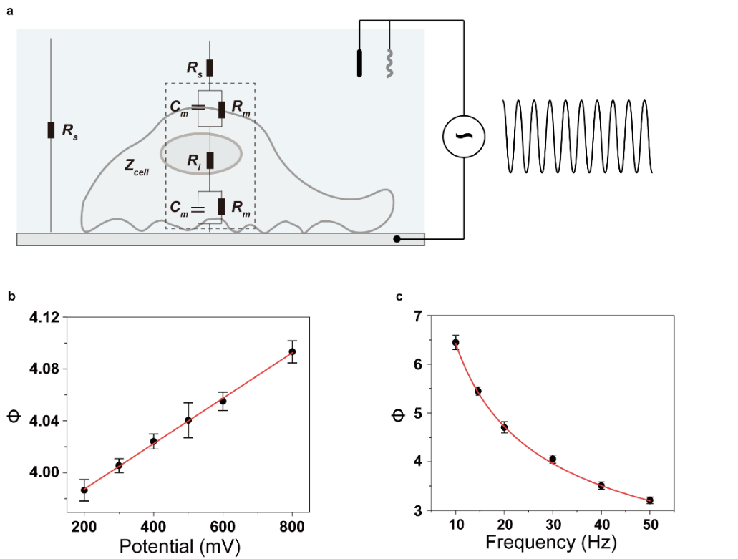
Fig. S6 Cell models in electrochemical modulation. (a) Electrochemical model of the cell in potential modulation. (c) Whole cell signals under different modulated voltage amplitudes (200, 300, 400, 500, 600, 800 mV) at 5 Hz, and (d) different frequencies (10, 15, 20, 30, 40, 50 Hz) at 800 mV.

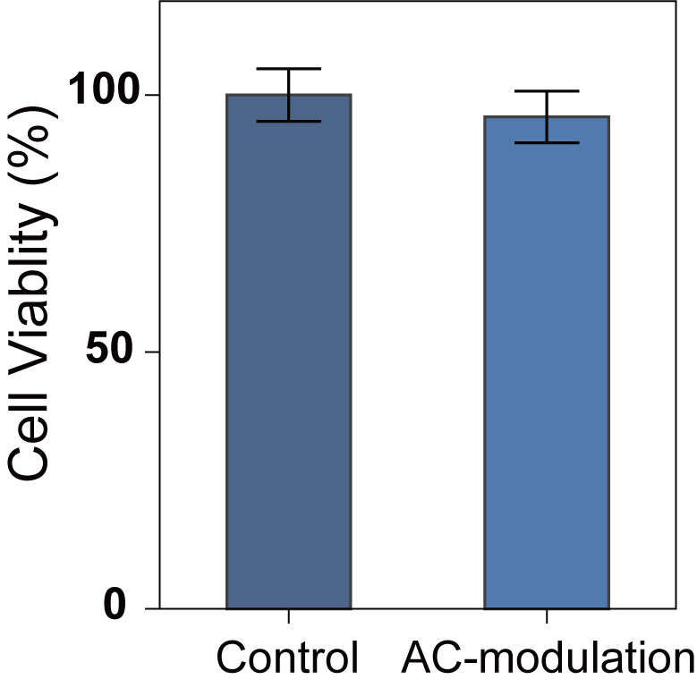
Fig. S7 MTT assay. Viability of cells after treatment with/without a 20 min AC-modulation. Data present the mean ± SEM, n = 33 wells.

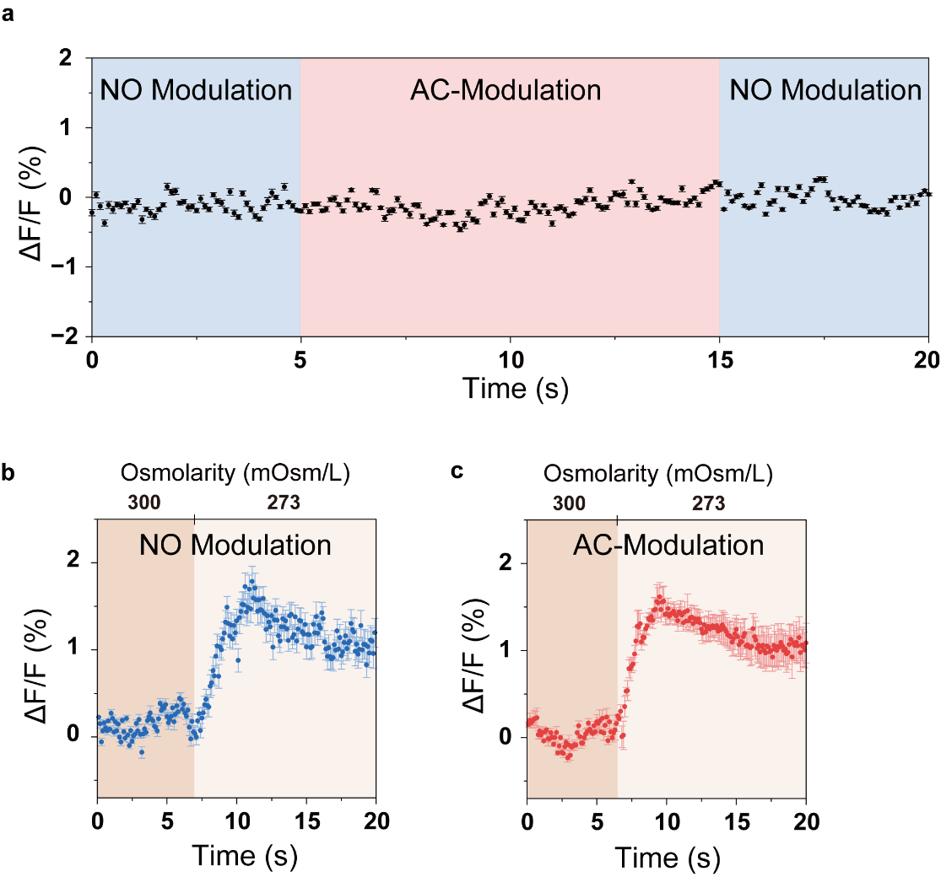
Fig. S8 Effect of AC-modulation on membrane potential. (a) Changes in cell membrane fluorescence intensity with/without the AC-modulated voltage. (b) and (c) Changes in cell membrane potential fluorescence intensity under hypotonic stimulation without/with AC-modulated voltage. Data represent the mean ± SEM, n = 10 cells.

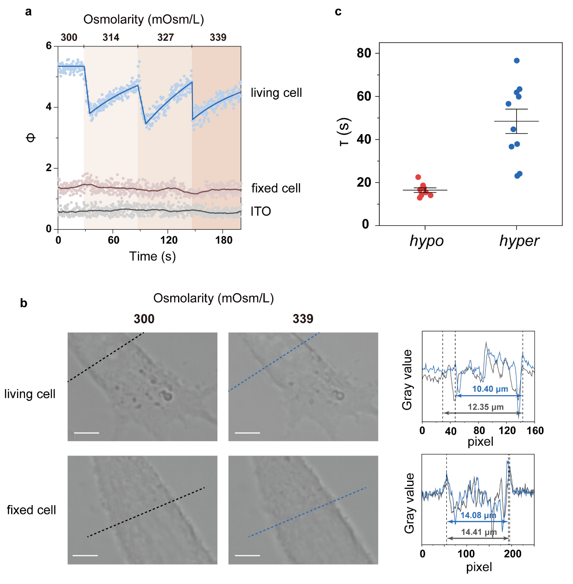
Fig. S9 Extracellular solution osmolarity changing assays. (a) Whole-cell signals on living cell and fixed cell and background (ITO) signals during the gradual increase of osmolarity. (b) Bright field images of a living cell and a fixed cell before and after osmolarity changing. The gray value of each pixel at the same position (black dashed lines at 300 mOsm/L and blue dashed lines at 339 mOsm/L) was recorded to compare the change in the cross-sectional area of the cell after osmolarity changing, indicating the change in cell volume. (c) Time constants calculated from exponential fits of cells response to osmolarity changing. Data present the mean ± SEM. Scale bars in b, 5 μm.

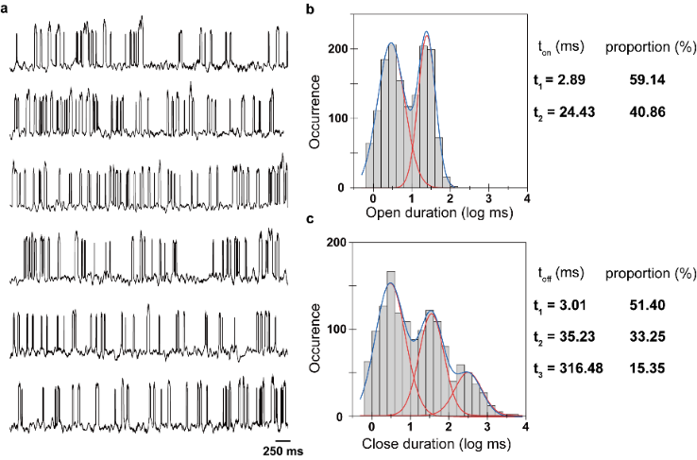
Fig. S10 NMDARs gating dynamics. (a) Single channel signals of NMDARs on HEK-293 cells. Histograms of on (b) and off (c) dwell time were obtained from signal trajectories in (a) and Fig. 3c. By fitting the histograms for the on dwell time with a multi-peak fitting process, two time components, 2.89 ms (59.14%) and 24.43 ms (40.86%), were observed. Similarly, for the off dwell time three time components were observed as 3.01 ms (51.4%), 35.23 ms (33.25%), and 316.48 ms (15.35%).

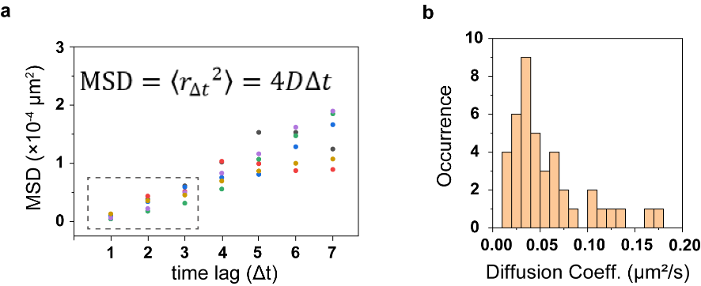
Fig. S11 MSD analysis of NMDARs’ diffusion. (a) Illustration of the MSD calculated for each individual trajectory at their respective Δt (each color represents a trajectory track, and six tracks are given here as examples), and the first three points (gray dashed box) were used to calculate the diffusion coefficient. (b) Histogram of the diffusion coefficients from 47 opening events.

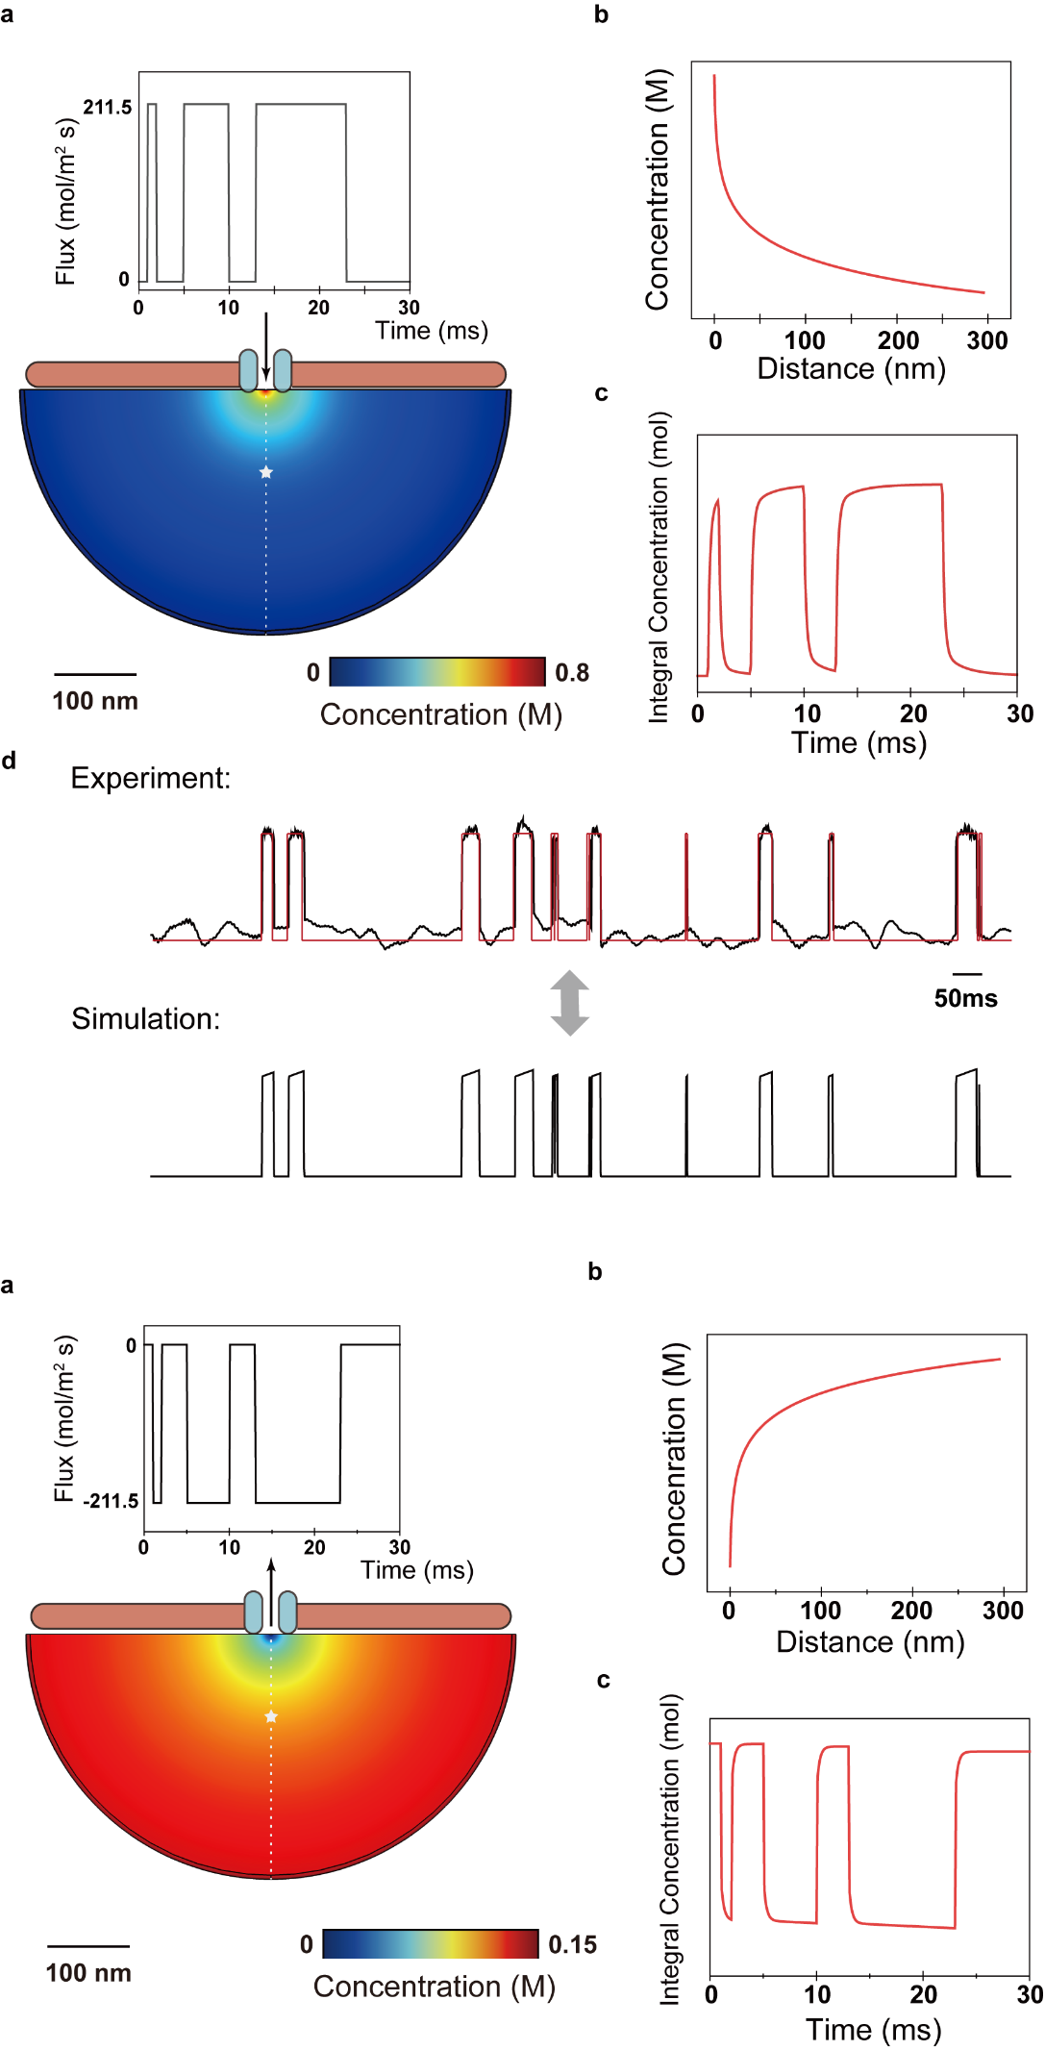
Fig. S12 FEM simulations of the ion diffusion field. (a) Top: the flux input to the ion channel. Bottom: the simulation model and distribution of ions. (b) The distribution of concentration with distance along the axis (white dashed line). (c) The integral concentration vs. time at 100 nm from the ion channel (white pentagram). (d) The EM-iSCAT signal of the actual experiment (black line), the extracted track profile (red line), and the simulation results obtained after it was input as a flux.

Fig. S13 FEM simulations of the influx ion channels. (a) Top: the flux (current) input to the ion channel. Bottom: the simulation model and distribution of ions. (b) The distribution of concentration with distance along the axis (white dashed line). (c) The integral concentration vs. time at 100 nm from the ion channel (white pentagram).

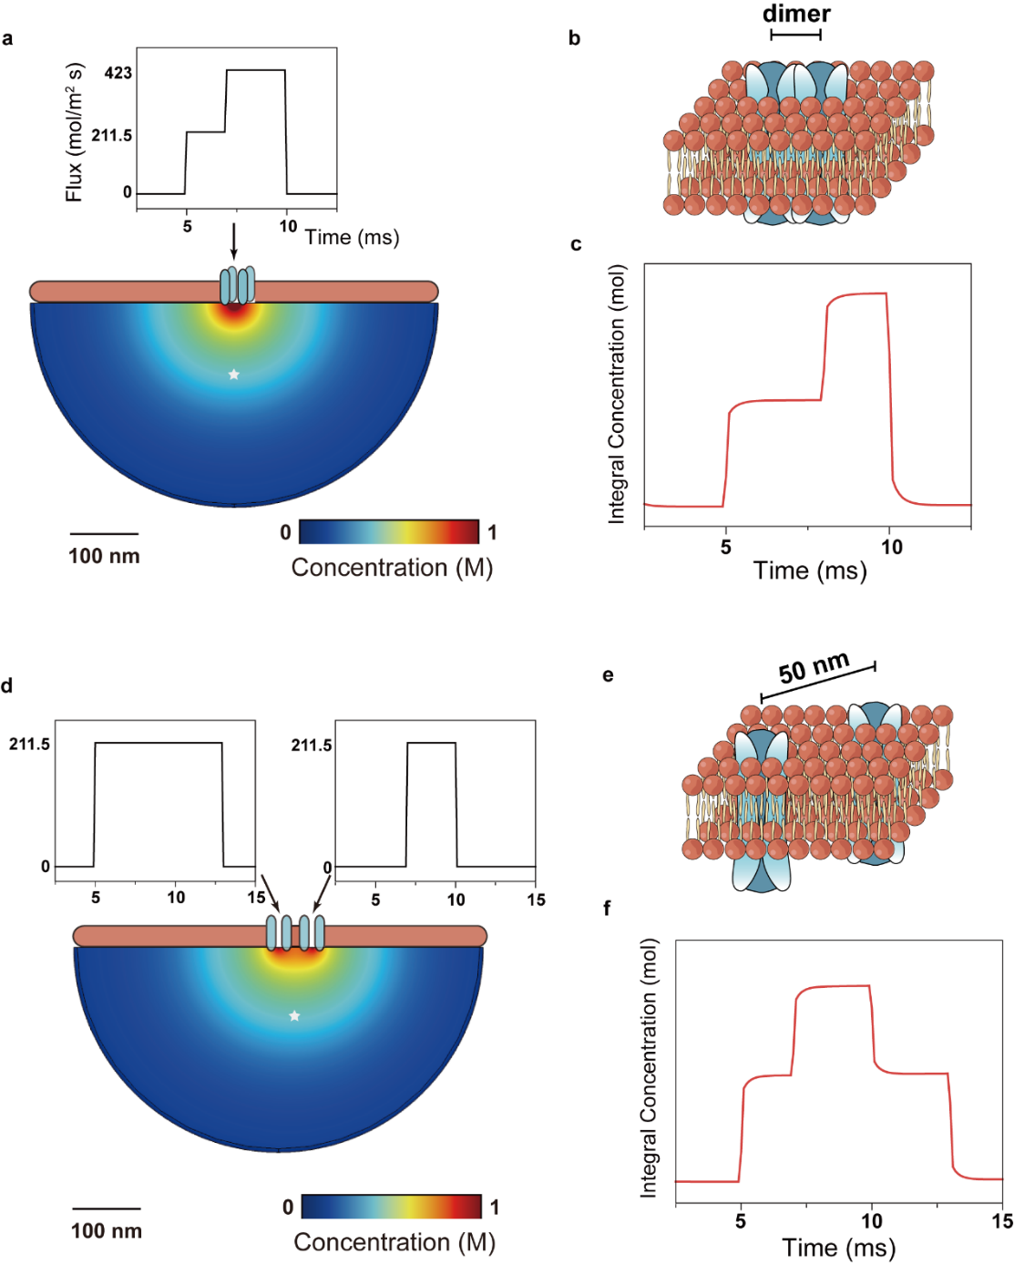
Fig. S14 FEM simulations of dual channels. (a, d) Top: the flux (current) input to the ion channels. Bottom: the simulation model and distribution of ions. (b, e) Model schematics of dimer channels and two adjacent ion channels. (c, f) The integral concentration vs. time at 100 nm from the ion channel (white pentagram).

Fig. S15 FEM simulations of different ion diffusion field. (a) The integral concentration of ion diffusion field within a diffusion scale of 200 nm for different channel currents and ion diffusion coefficients. (b) The integral concentration of K⁺, Na⁺, Ca²⁺ diffusion field at the same channel current, respectively.

Fig. S16 Effect of non-uniform background noise on EM-iSACT image. (a) Raw iSCAT image of bare silicon substrate. (b) Raw iSCAT image of bare glass substrate. (c) Raw iSCAT image of bare ITO substrate. (d) A raw iSCAT image of bare ITO surface without cells. (e) Spatial speckle contrast map of (d) estimated from a 15×15 window of pixels. (f) Temporal speckle contrast map of (d) estimated over 100 frames (Δt = 0.33 s). (g) Amplitude image obtained by FFT analysis. Scale bar in a-c, 2.5 μm, d-g, 5 μm.

Supplementary Table 1 | $t_{up}$ and $t_{down}$ at different distance.
The $t_{up}$ and $t_{down}$ of a single opening event, fitted to the integral concentration curve at 50, 100, 150, 200 and 250 nm away from the ion channel.
Distance (nm) | $t_{up}$ (ms) | $t_{down}$ (ms)
50 | 0.049 | 0.049
100 | 0.064 | 0.064
150 | 0.085 | 0.086
200 | 0.121 | 0.122
250 | 0.317 | 0.318

Supplementary Video Guide:
Supplementary Video 1
EM-iSCAT images and signals vs. time of cellular response to fixation in 4% PFA shown in Fig 2a.

Supplementary Video 2
EM-iSCAT images and signals vs. time of cellular response to hypotonic stimulation during first cycle shown in Fig 2f.

Supplementary Video 3
EM-iSCAT images and signals vs. time of cellular response to hypertonic stimulation during first cycle shown in Fig 2h.

Supplementary Video 4
A section of EM-iSCAT images and signals vs. time of NMDAR open-close events from signal Ch 1 shown in Fig 3c.

Supplementary Video 5
A section of EM-iSCAT images and signals vs. time of NMDAR open-close events from signal Ch 3 shown in Fig 3c, and the corresponding FEM simulation results, which obtained after the actual experimental trajectory was input as a flux.

Supplementary Video 6
FEM simulation results of two types of dual-channel models, dimer channels and two adjacent ion channels which lead to signal superposition when the two ion channels were opened at the same time.

