Data and Methods Supplement to: Bioaccumulation of Microplastics in Decedent Human Brains Assessed by Pyrolysis Gas Chromatography-Mass Spectrometry

Alexander J. Nihart^{1†}, Marcus A. Garcia^{1†}, Eliane El Hayek¹, Rui Liu¹, Marian Olewine¹, Eliseo F. Castillo², Tamara Howard³, Barry Bleske⁴, Justin Scott⁵, Jorge Gonzalez-Estrella⁵, Natalie L. Adolphi⁶, Daniel F Gallego⁶, Matthew J. Campen^{1*}

¹ Department of Pharmaceutical Sciences, College of Pharmacy, University of New Mexico Health Sciences, Albuquerque, NM, USA
² Division of Gastroenterology and Hepatology, Department of Internal Medicine, University of New Mexico School of Medicine, Albuquerque, NM, USA
³ Department of Cell Biology and Physiology, University of New Mexico School of Medicine, Albuquerque, NM, USA
⁴ Department of Pharmacy Practice and Administrative Sciences, College of Pharmacy, University of New Mexico Health Sciences, Albuquerque, NM, USA
⁵ School of Civil & Environmental Engineering, Oklahoma State University, Stillwater, OK, USA
⁶ Office of the Medical Investigator, University of New Mexico, Albuquerque, NM, USA
† Contributed equally to this manuscript
* Corresponding Author
*To whom correspondence should be addressed. Matthew J Campen, PhD, Department of Pharmaceutical Sciences, MSC09 5360, 1 University of New Mexico, Albuquerque, NM 87131-0001, (505) 272-5569
Email: MCampen@salud.unm.edu
ORCID ID: 0000-0002-2292-5050
Running Title: Bioaccumulation of microplastics in human brain
Statement of Interests: The authors declare no conflicts of interest with the content of this manuscript.
- SUPPLEMENTAL MATERIALS AND METHODS
  - Sample Preparation for Spectroscopy
Samples consisted of five homogenized, previously digested brain tissue (2016) pellets labeled B1-B2-B3-B4-B5. Pellets were distributed using a stainless-steel micro spatula and weighed using a precision balance (Mettler Toledo XP2U, USA). Pellets were then separated into aliquots for particle imaging and Nile Red particle quantification followed by analysis using Reflectance and Attenuated Total Reflectance-Fourier-transform infrared spectroscopy with attenuated total reflectance (ATR-FTIR) and pyrolysis gas chromatography mass spectrum (Py-GC/MS). Glass vessels were used for the remaining experiments to avoid plastic contamination. Sample aliquots for imaging and Nile Red particle quantification, and ATR-FTIR were suspended into 10 mL of ultra-pure water and vortexed to bring to solution and sonicated for 10 min. To remove salt particle interferences, the solution was adjusted to a pH of 2.5 by adding 50 µL of nitric acid, followed by vortexing and sonicating for another 10 min. The extracted particles were carefully transferred to a 25 mm-diameter, 0.2 μm aluminum oxide (Al₂O₃) filter under the fume hood using a glass pipette. For Py-GC/MS aliquots were weighed out into stainless steel furnace cups for analysis.
  - Imaging and Nile Red Particle Quantification
Each of the five sample’s Al₂O₃ filters and a control blank (consisting of ultra-pure water prepared identical to the samples) were stained with 60 μL of a 30 μg of Nile Red/L methanol solution for particle quantification. The filters were left to react with the dye for 10 min, then were rinsed with 600 μL of n-hexane on a glass filtration stack to remove excess dye. Each filter was imaged with a stereomicroscope (AmScope 7X-180X Trinocular Zoom Stereo Microscope) for initial visual identification. The six filters were placed on a Greiner 6-well plate and imaged using a fluorescence microscope (Cytation 5 Cell Imaging Multi-Mode Reader, Agilent Technologies). A series of images were taken at 4x magnification with an RFP filter cube (excitation 531 nm/emission 593 nm) to produce a stitched image of each filter using Gen5® software. The detection limit of Cytation 5 cell Imaging at this magnification is ~ 0.5 µm. Each image was preprocessed to reduce background fluorescence. Further reduction of background fluorescence was made by increasing image contrast and decreasing brightness. Each preprocessed image was run through the MPVAT 2.0 macros three times using ImageJ and the average with standard deviations was reported. Only the filter flow-through area was considered for quantification.
  - Microplastic Analysis by Attenuated Total Reflectance-Fourier-transform Infrared Spectroscopy with (ATR-FTIR)
Each filter was mounted on a gold mirror slide for particle identification with a FTIR spectrometer (Thermo Nicolet iN10 MX). First, using the reflectance detector, a mosaic image of the filter flow-through area was taken using OMNIC Picta® software and a heat map was established with spectra being quantified for particle identification. Each measurement was taken using a 90 sec detection time with 256 scans, a spectral range of 4000-675 cm⁻¹, number of points consisted of 10 X and 13 Y, with a step size of 100 μm by 100 μm, aperture width of 150 μm and height of 150 μm, and a spectral resolution of 4 cm⁻¹. Another mosaic map was acquired to guide the selection of potential plastic particles for further examination using a cooled ATR detector and germanium tip. The aperture size of the ATR detector was adapted to fit each particle. The number of particles examined with ATR-FTIR was about 10% of the particles identified during fluorescence microscopy quantification, or at least ten points, whichever was greater. The number of particles for the control blank consisted of only one point due to a lack of particles present. Each measurement was taken using a 90 sec detection time with 256 scans, a spectral range of 4000-675 cm⁻¹, with an aperture width of 150 μm and height of 150 μm and a spectral resolution of 4 cm⁻¹. The resulting spectra were searched against the HR Polymer Additives and Plasticizers, Hummel Polymer Sample Library, Polymer Laminate Films, and Synthetic Fibers by Microscope libraries. A good match (%) with the polymer type is considered a value greater than 60%. Backgrounds were collected before each sample point and mosaic heat mapping.
  - Pyrolysis Gas Chromatography Mass Spectrometry (PY-GC/MS)
Both UNM and OSU operated an Agilent 8890 GC/5975 MS system with a EGA/PY-3030D Pyrolysis Unit (Frontier Labs) attached to the back inlet. A UAMP column (length 30 m, i.d. 0.25 mm, film thickness: 0.25 μm) and vent free splitter was attached. The Pyrolysis settings consisted of: temperature (600°C) and analysis mode (Single-Shot). The GC/MS settings consisted of: inlet temperature (300°C), MS source temperature (250°C), starting oven temperature (40°C), and inlet pressure (10.437 mL/min. The column was initially held at 40°C for 2 mins and ramped up to 280°C at 20°C/min and held there for 10 mins. Then, the temperature increased to 320°C at 40°C/min and maintained there for 15 mins. The experiment was conducted in split injection and the split ratio is 1:50. The twelve polymers of interest are polyethylene (PE), polypropylene (PP), polystyrene (PS), acrylonitrile-butadiene-styrene resin (ABS), sytrene-butadiene rubber (SBR), polymethyl methacrylate (PMMA), polycarbonate (PC), polyvinyl chloride (PVC), polyurethane (PU), polyethylene terephthalate (PET), nylon-6 (N6), and nylon-6,6 (N66). The calibration curve was created by using MPs-CaCO3 calibration standard at 5 different weights (0.1mg, 0.2mg, 0.5mg, 2mg, and 4mg).
  - Transmission Electron Microscopy (TEM)
To assess the size distribution of the extracted particulates from the brain, liver, and kidney, we prepared at least triplicate samples from each organ by suspending the pellet of particulates in 100% ethanol. Particles were deposited on copper TEM mesh grids covered with a holey carbon support film. The grids were not stained and were observed in a Hitachi HT7700 TEM operated at 80 kV. The images were acquired with an AMT XR16M digital camera.
  - Statistical Analysis
Data were analyzed for normality (Table S1) and lognormality (Table S2) using the Shapiro-Wilk test. Kidney and liver samples were both lognormally distributed. Brains samples were more consistently normal distributions.
Table S1. Normality test for untransformed total plastics concentrations
Shapiro-Wilk test | Liver ‘16 | Liver ‘24 | Kidney ‘16 | Kidney ‘24 | Brain ‘16 | Brain ‘24
W | 0.8969 | 0.9114 | 0.8775 | 0.8698 | 0.9434 | 0.9669
P value | 0.0114 | 0.0436 | 0.0108 | 0.0116 | 0.0854 | 0.6393
Passed normality test (alpha=0.05)? | No | No | No | No | Yes | Yes
P value summary | * | * | * | * | ns | ns

Table S2. Lognormality test for untransformed total plastics concentrations
Shapiro-Wilk test | Liver ‘16 | Liver ‘24 | Kidney ‘16 | Kidney ‘24 | Brain ‘16 | Brain ‘24
W | 0.9693 | 0.9143 | 0.9556 | 0.9395 | 0.9305 | 0.9180
P value | 0.5826 | 0.0504 | 0.4064 | 0.2348 | 0.0363 | 0.0691
Passed lognormality test (alpha=0.05)? | Yes | Yes | Yes | Yes | No | Yes
P value summary | ns | ns | ns | ns | * | ns

Data were log-transformed and the normality test was rerun. Log-transformed data were all normally distributed (Table S3).
Table S3. Normality test for log-transformed total plastics concentrations
Shapiro-Wilk test of Log-Transformed Data | Liver ‘16 | Liver ‘24 | Kidney ‘16 | Kidney ‘24 | Brain ‘16 | Brain ‘24
W | 0.9693 | 0.9143 | 0.9556 | 0.9395 | 0.9407 | 0.9180
P value | 0.5826 | 0.0504 | 0.4064 | 0.2348 | 0.0647 | 0.0691
Passed normality test (alpha=0.05)? | Yes | Yes | Yes | Yes | Yes | Yes
P value summary | ns | ns | ns | ns | ns | ns

For the main manuscript, it was important to convey the real units of concentration in µg/g (see Figure 1A, B). However, a 2-way ANOVA of the log-transformed data (Table S4) provides highly confident conclusions that A) the brain has higher levels of plastics than liver or kidney and B) that there is an increasing trend over time (Figure S1).

Table S4. Analysis of log-transformed total plastics data | Log transformed brain liver kidney
Two-way ANOVA | Ordinary
Alpha | 0.05
Source of Variation | % of total variation | P value | P value summary | Significant?
Interaction | 2.000 | 0.0073 | ** | Yes
Organ | 66.01 | <0.0001 | **** | Yes
Time | 3.740 | <0.0001 | **** | Yes
ANOVA table | SS (Type III) | DF | MS | F (DFn, DFd) | P value
Interaction | 1.264 | 2 | 0.6322 | F (2, 142) = 5.096 | P=0.0073
Organ | 41.74 | 2 | 20.87 | F (2, 142) = 168.2 | P<0.0001
Time | 2.365 | 1 | 2.365 | F (1, 142) = 19.06 | P<0.0001
Residual | 17.62 | 142 | 0.1241
 | Figure S1. Comparison of log-transformed data identifying the complete comparisons of a 2-way ANOVA with Tukey’s posthoc test (GraphPad Prism)
Difference between column means
Predicted (LS) mean of 2016 | 2.683
Predicted (LS) mean of 2024 | 2.939
Difference between predicted means | -0.2567
SE of difference | 0.05880
95% CI of difference | -0.3730 to -0.1405
Data summary
Number of columns (Time) | 2
Number of rows (Organ) | 3
Number of values | 148

- SUPLEMENTAL RESULTS
  - Demographics and Relationship with Microplastics
Decedent samples were procured at random from 2016 stockpiles slated for discard and from recently processed decedents from 2024. In terms of demographic data, only age and sex were included in the present investigation. The average age of 2016 decedents was 49.9 years and the average age of 2024 decedents was 52.3 (Figure S2). A t-test revealed no significant difference (P=0.36). No significant effect of sex was noted either.
Figure S2. A. Ages of decedent samples from 2016 and 2024. B. Microplastics distribution. B. Distribution across sex for each collection period. C. and D. Lack of a relationship between tissue concentrations and age of subject.
  - Nile Red Staining
The mass and aliquots for sample preparation of the pellets for instrumentation can be found in Table S5. Total particle numbers including individual particles, fibers, and fragments can be found in Table S6. Imaging of stereoscope and Nile Red can be found in Figure S3.
  - Heat Mapping and Reflectance Analysis
Heat mapping reflectance results can be found in Table S7. Mosaic and heat map imaging can be found in Figure S4. Overall, polymers matched for heat mapping and reflectance in all five samples. The specific type of polymer is indicated as the highest match of the library selection per point. Copolymer matches (e.g., polyethylene:propylene:diene) were identified in all five samples. The highest match was chosen for reporting, however, in some cases individual polymers were found at a lower match and varying polymer libraries based on the collected spectra (individual data not provided). Therefore, the specific type of polymer being reported from the copolymer may need further consideration. Regardless, the presence of plastics was both visually, and analytically confirmed for the samples and reinforces the presence of multiple polymer and copolymer types in the samples (Figure S5).
  - ATR-FTIR Analysis
Individual particles analyzed for ATR-FTIR can be found in Table S8. Images of the selected particles can be found in Figures S6-S11. Polymers that matched above 60% were only found in three samples (B1, B3, and B5) with rayon being measured in all 3. Results where polymers were measured at less than 60% may be an issue with the size of the particles. Samples that were around 20 µm will result in reduced sensitivity of the spectra analysis as this is the minimum threshold for sensitivity of the instrument. Therefore, the polymers spectra may have increased matching accuracy with increased particle size. However, both mosaic heat mapping and ATR-FTIR confirmed the presence of some polymers in the samples.
  - Py-GC/MS Analysis
Mass of the Py-GC/MS measured at OSU can be found in Table S9, with numbers expressed relative to the pellet weight, but not to the tissue sample weight (as in Figure 1 of the main manuscript). Results indicated polymers in each sample aliquot. Polyethylene (PE) was the highest concentration found in all 5 samples followed by Nylon 66 (N66), acrylonitrile butadiene styrene (ABS) and polyethylene terephthalate (PET). Polyvinyl chloride (PVC) was detected only in Sample B1 and styrene-butadiene rubber (SBR) was found only in Sample B5. Sample 4 had the lowest concentration of the majority of polymers, however the sample size should be considered for reporting. The concentrations found in the samples reinforce results of heatmapping reflectance where the abundance of plastic spectra identified were similar plastic types found by Py-GC/MS. Moreover, the number of points identified as polymers with reflectance specific to the individual samples, highlights the concentrations found in Py-GC/MS (i.e. sample B4 having lower detection points and concentrations and with Samples B1-3 having higher points and concentrations).

Table S5. Sample mass of tissue pellets and aliquots for Py-GC-MS.

Table S6. Particles numbers detected and identified with Nile Red using fluorescence.

Table S7. Particles detected and identified with ATR heat maps and spectra analysis of individual points.
Table S8. The number of particles detected and identified with ATR-FTIR, including the particle type and percentage matches.

Table S9. Polymer concentrations measured by Py-GC/MS relative to pellet weight. Results are presented as average ± standard deviation. Samples were repeated in triplicate unless otherwise notated.

* Indicates sample size of n = 1.
** Indicates sample size of n = 2.

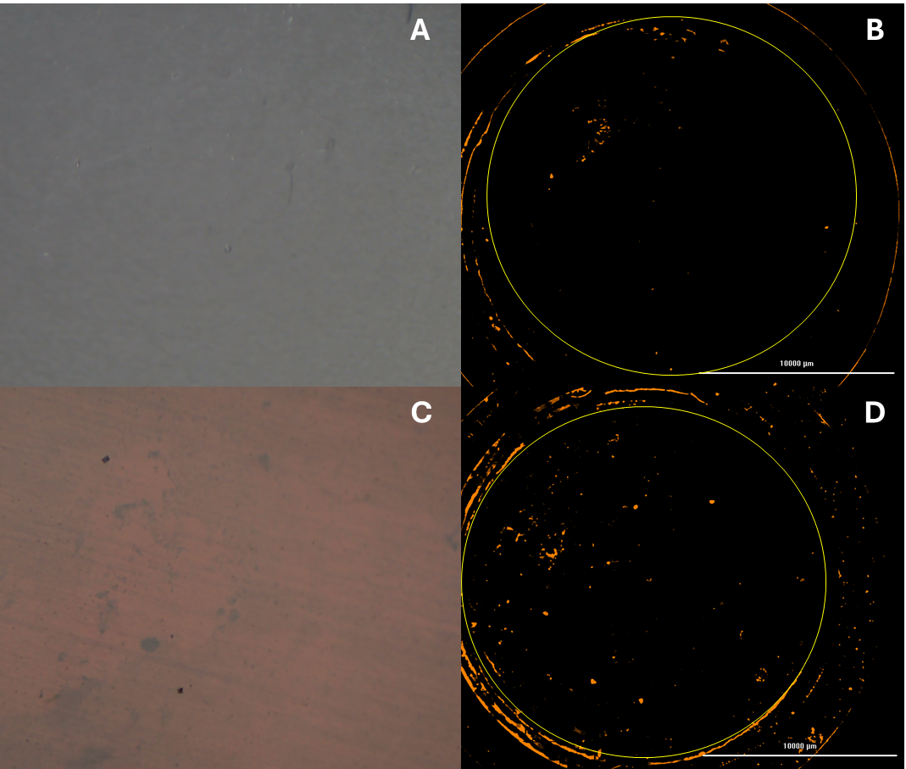

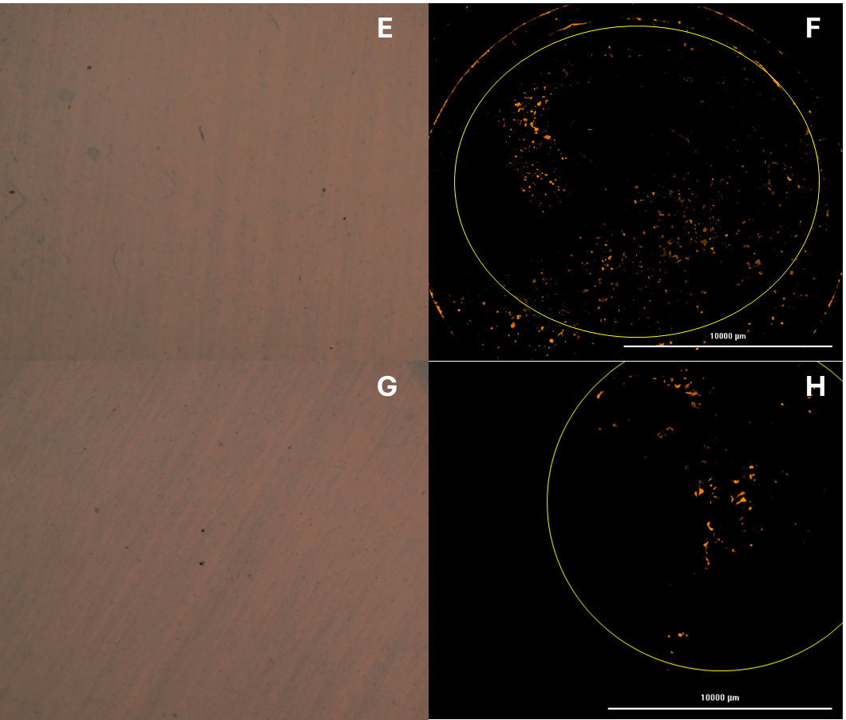

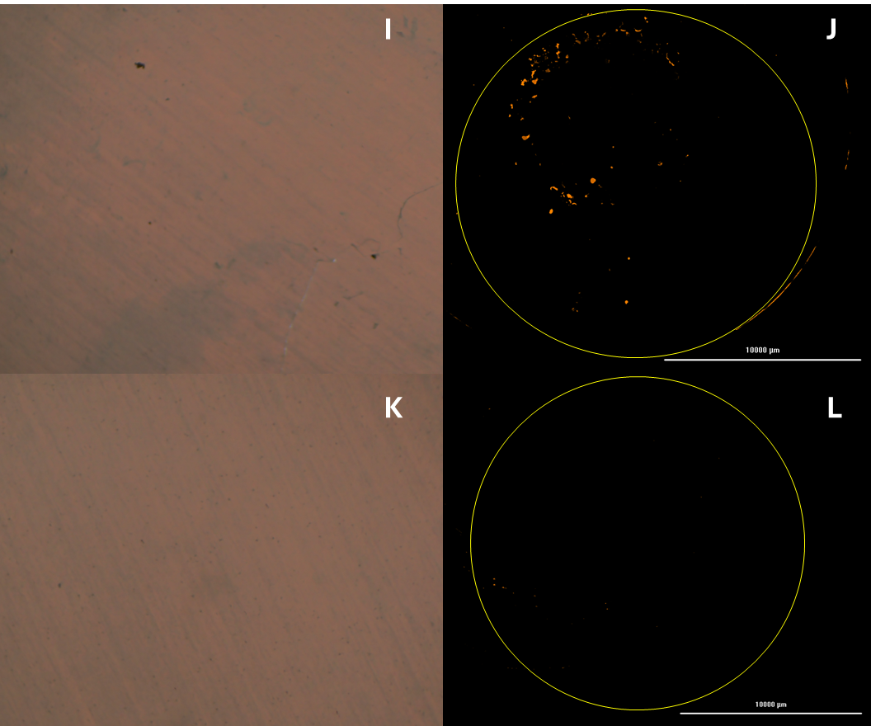
Figure S3. Sample B1 stereomicroscope (A) and Nile Red fluorescently stained (B) particle images. Sample B2 stereomicroscope (C) and Nile Red fluorescently stained (D) particle images. Sample B3 stereomicroscope (E) and Nile Red fluorescently stained (F) particle images. Sample B4 stereomicroscope (G) and Nile Red fluorescently stained (H) particle images. Sample B5 stereomicroscope (I) and Nile Red fluorescently stained (J) particle images. Control sample stereomicroscope (K) and Nile Red fluorescently stained (L) particle images The yellow circle demonstrates the filter area that was selected for particle quantification.

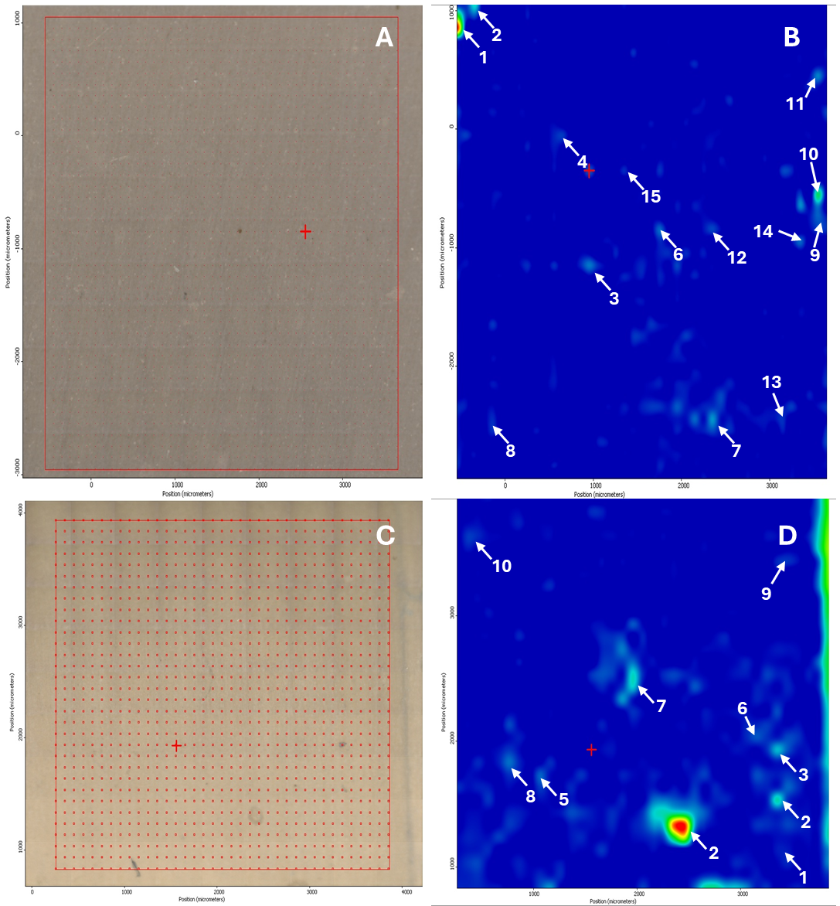

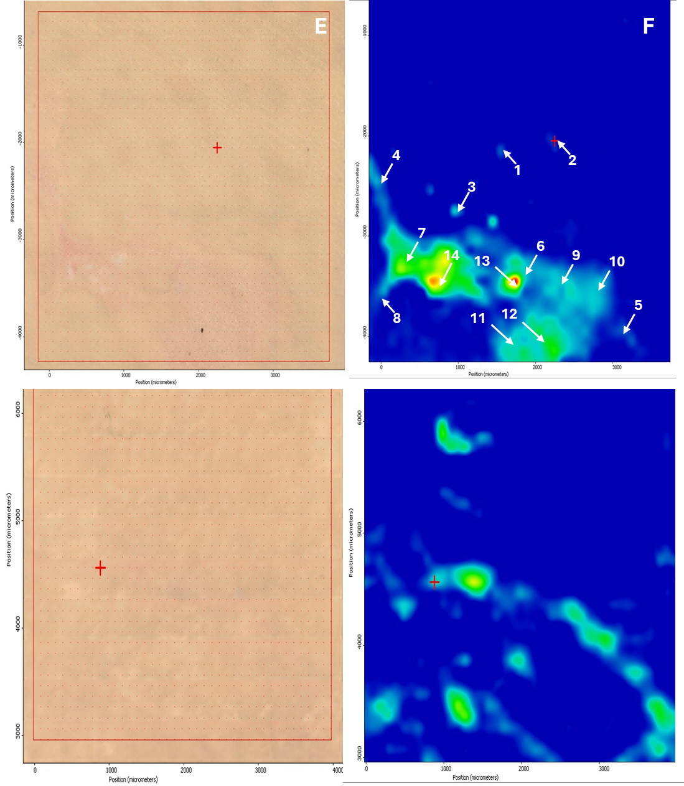
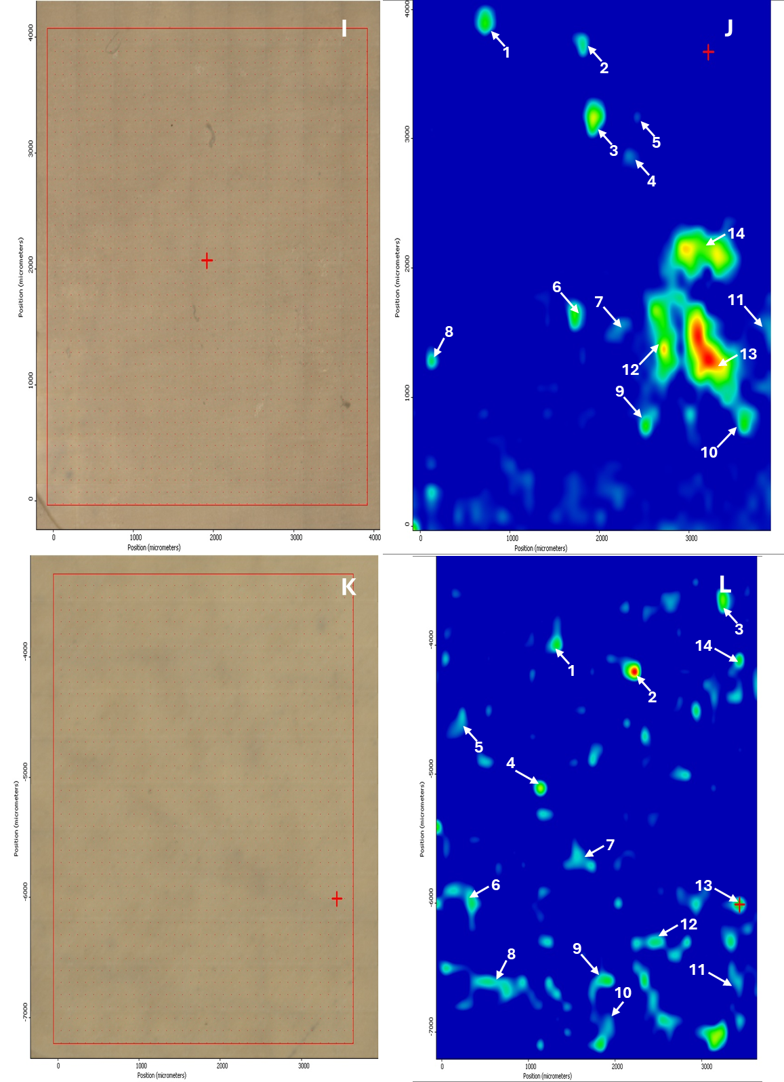
Figure S4. Sample B1 mosaic image (A) and heat mapping (B) particle images. Sample B2 B1 mosaic image (C) and heat mapping (D) particle images. Sample B3 mosaic image (E) and heat mapping (F) particle images. Sample B4 mosaic image (G) and heat mapping (H) particle images. Sample B5 mosaic image (I) and heat mapping (J) particle images. Control sample mosaic image (K) and heat mapping (L) particle images. Numbers and arrows indicate analyzed particle spectra found in Table S7.
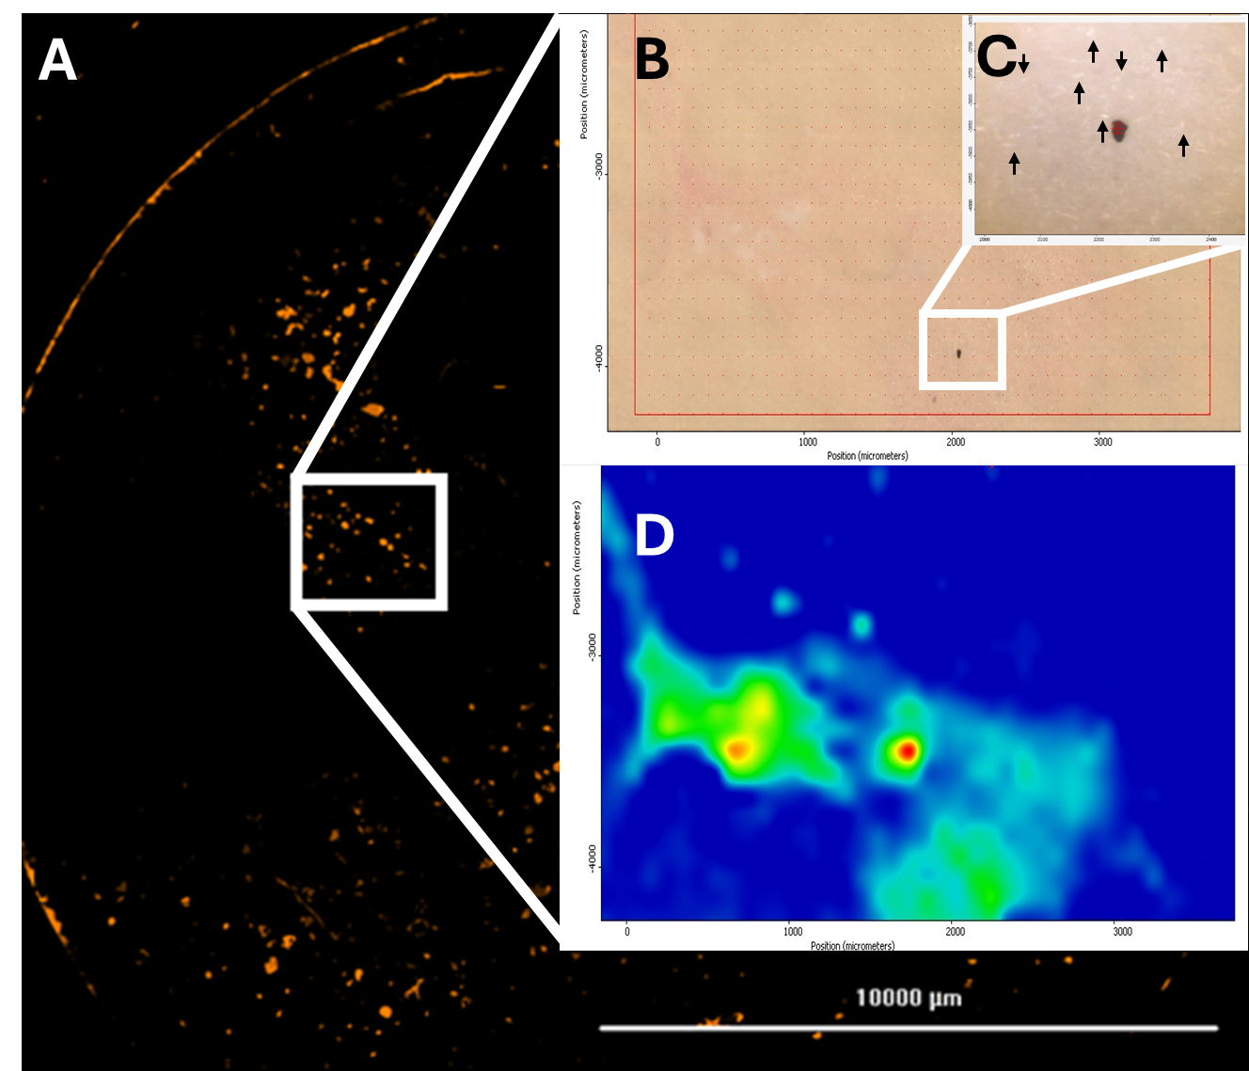
Figure S5: Particle imaging of human brain tissue using Nile Red staining with fluorescence (A). ATR-FTIR mosaic mapping (B) was used to visually inspect particles indicated with arrows (C). Particle types were confirmed using ATR heat mapping (D).

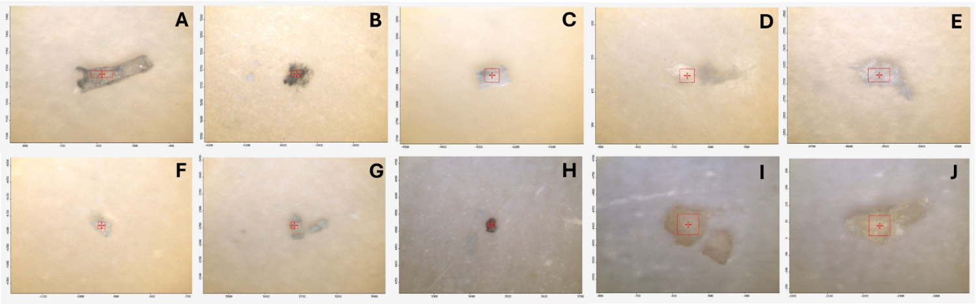Figure S6. ATR-FTIR particle selection for Sample B1.

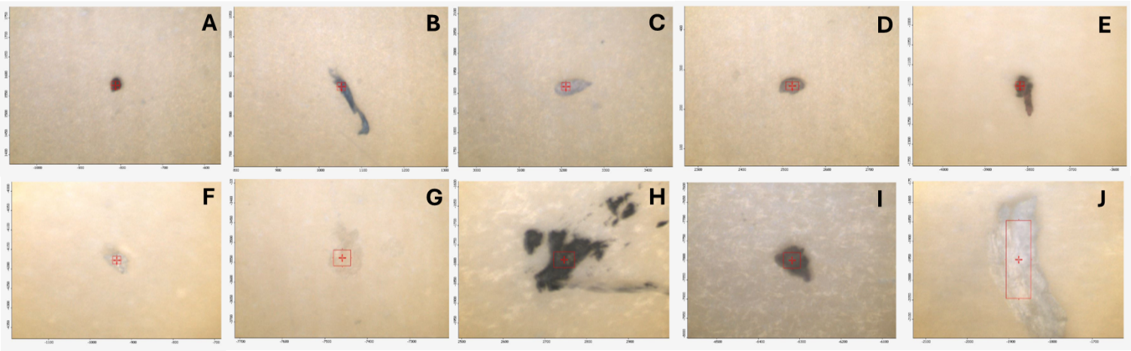
Figure S7. ATR-FTIR particle selection for Sample B2.

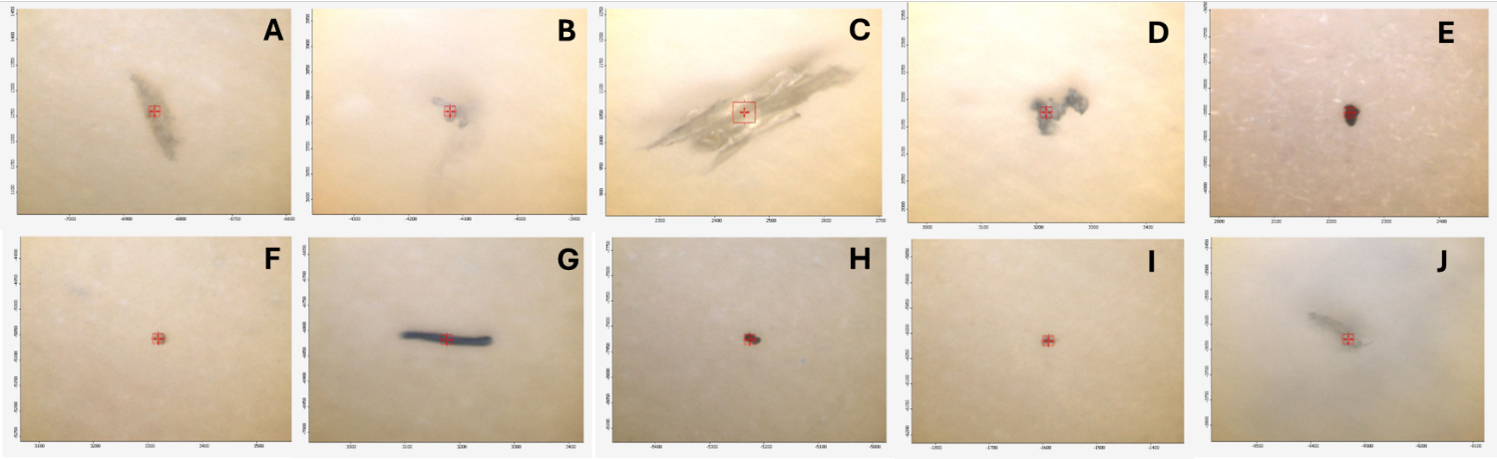Figure S8. ATR-FTIR particle selection for Sample B3.

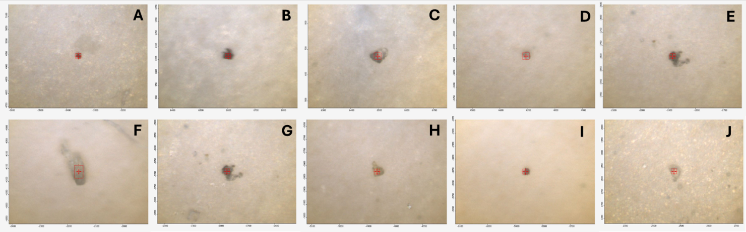
Figure S9. ATR-FTIR particle selection for Sample B4.
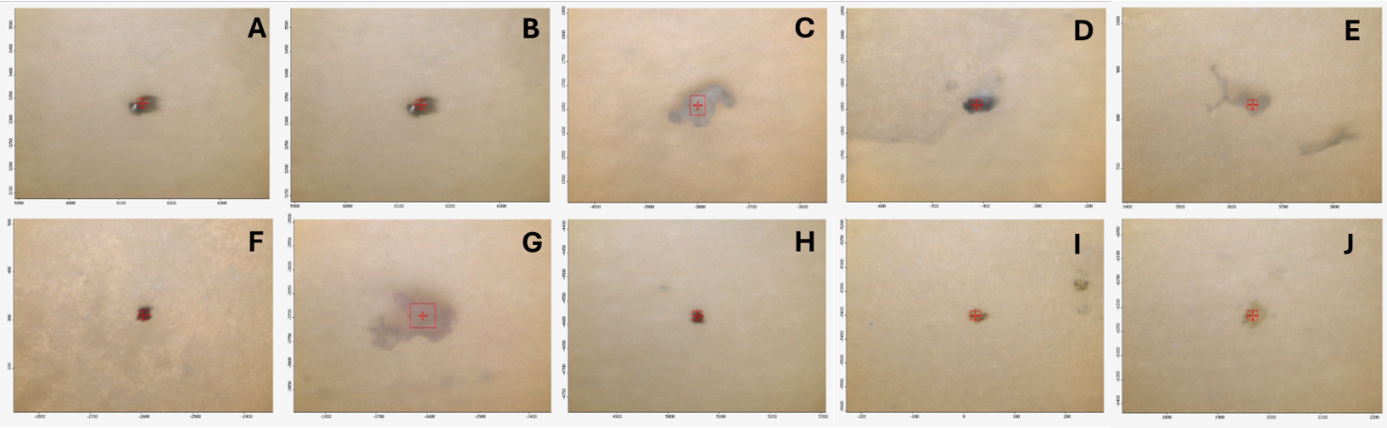

Figure S10. ATR-FTIR particle selection for Sample B5.

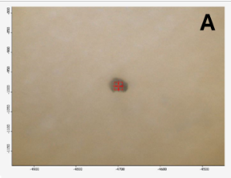
Figure S11. ATR-FTIR particle selection for Control Sample.

