Supplementary Electronic Material

Title: Quality issues in kinematic traces from three head impact sensors in boxing: prevalence, effects, and implications for exposure assessment

Abbreviated title: Quality issues in kinematic traces from three head impact sensors

Authors:
Enora Le Flao^{1,2}*, Seth Lenetsky^{2,3}, Gunter P. Siegmund^{4,5}, Robert Borotkanics²

- The Ohio State University, Columbus, OH, USA
- Auckland University of Technology, Auckland, New Zealand
- Canadian Sport Institute Pacific, Victoria, BC, Canada
- MEA Forensic Engineers & Scientists, Laguna Hills, CA, USA
- University of British Columbia, Vancouver, Canada

*Corresponding author:
Enora Le Flao – enora.leflao@osumc.edu - +1 (650) 643 8596
Health & Rehabilitation Sciences, The Ohio State University, Columbus, OH, USA
ORCID: 0000-0002-0006-0244

Submitted to Annals of Biomedical Engineering

Table S1 Descriptive statistics for the resultant peak linear and angular accelerations measured by the mouthguard, skin patch, and headgear patch, at various steps of the inclusion process
 | Mouthguard |  |  |  | Skin patch |  |  |  | Headgear patch
 | N | PLA (g) | PAA (rad.s⁻²) |  | N | PLA (g) | PAA (rad.s⁻²) |  | N | PLA (g) | PAA (rad.s⁻²)
Video-verified | 693 |  |  |  | 1569 |  |  |  | 1678
Median |  | 22.14 | 2573.62 |  |  | 61.38 | 6921.86 |  |  | 54.98 | 3590.46
IQR |  | 14.58 - 38.41 | 1508.55 - 5016.81 |  |  | 38.81 - 112.21 | 4001.15 - 12807.65 |  |  | 37.06 - 96.33 | 2199.32 - 6647.95
Mean ± SD |  | 30.43 ± 23.4 | 3901.23 ± 3432.72 |  |  | 96.74 ± 95.25 | 10676.43 ± 10697.27 |  |  | 86.85 ± 98.31 | 5889.16 ± 7142.13
Range |  | 4.47 - 176.54 | 414.44 - 20000.55 |  |  | 11.54 - 736.06 | 538.77 - 79717.18 |  |  | 11.87 - 980.93 | 644.99 - 67392.12
Included recordings | 442 |  |  |  | 442 |  |  |  | 442
Median |  | 21.85 | 2556.49 |  |  | 79.68 | 8231.02 |  |  | 71.88 | 4674.57
IQR |  | 14.6 - 36.99 | 1532.62 - 4854.87 |  |  | 48.73 - 139.33 | 4911.96 - 15806.52 |  |  | 46.77 - 119.12 | 2890.31 - 8514.47
Mean ± SD |  | 29.73 ± 23.16 | 3769.21 ± 3320.39 |  |  | 120.25 ± 114.22 | 13301.8 ± 12912.65 |  |  | 106.64 ± 106.64 | 7337.27 ± 7859.45
Range |  | 4.47 - 176.54 | 414.44 - 20000.55 |  |  | 14.87 - 736.06 | 1331.64 - 79717.18 |  |  | 14.93 - 980.93 | 752.46 - 67392.12
High-quality recordings | 235 |  |  |  | 89 |  |  |  | 113
Median |  | 16.32 | 1685.35 |  |  | 41.54 | 4167.76 |  |  | 45.74 | 2702.53
IQR |  | 11.77 - 21.37 | 1129.75 - 2358.9 |  |  | 33.34 - 58.12 | 3040.91 - 5416.03 |  |  | 33.41 - 60.98 | 1860.7 - 3691.08
Mean ± SD |  | 17.63 ± 7.96 | 1851.74 ± 952.1 |  |  | 47.41 ± 19.67 | 4423.76 ± 1811.04 |  |  | 50.95 ± 25.43 | 3033.15 ± 1630
Range |  | 4.47 - 43.01 | 414.44 - 5292.28 |  |  | 18.66 - 97.42 | 1331.64 - 8379.74 |  |  | 14.93 - 144.83 | 798.72 - 8098.76
Questionable recordings | 50 |  |  |  | 56 |  |  |  | 150
Median |  | 26.66 | 3283.86 |  |  | 51.61 | 5587.83 |  |  | 58.24 | 3820.64
IQR |  | 18.07 - 38.06 | 2120.21 - 4854.87 |  |  | 35.75 - 70.62 | 3969.16 - 7653.22 |  |  | 44.21 - 81.11 | 2670.11 - 5247.74
Mean ± SD |  | 28.23 ± 13.38 | 3655.93 ± 1888.83 |  |  | 59.93 ± 38.2 | 6381.28 ± 3940.58 |  |  | 66.69 ± 31.98 | 4339.48 ± 2336.32
Range |  | 6.26 - 65.99 | 726.85 - 9222.96 |  |  | 14.87 - 242.84 | 2010.23 - 25661.83 |  |  | 20.01 - 193.98 | 752.46 - 15167.53
Low-quality recordings | 157 |  |  |  | 297 |  |  |  | 179
Median |  | 40.25 | 5342.07 |  |  | 104.09 | 11838.93 |  |  | 130.89 | 9527.49
IQR |  | 28.11 - 59.86 | 3899.06 - 8700.93 |  |  | 69.41 - 194.66 | 7612.3 - 21813.99 |  |  | 88.09 - 225.98 | 6079.13 - 16316.92
Mean ± SD |  | 48.31 ± 28.22 | 6675.37 ± 3826.72 |  |  | 153.45 ± 125.14 | 17267.1 ± 14000.63 |  |  | 175.28 ± 137.34 | 12566.5 ± 9998.31
Range |  | 12.79 - 176.54 | 713.32 - 20000.55 |  |  | 26.89 - 736.06 | 2789.85 - 79717.18 |  |  | 27.91 - 980.93 | 1506.7 - 67392.12
PLA: peak linear acceleration, PAA: peak angular acceleration, IQR: interquartile range, SD: standard deviation.
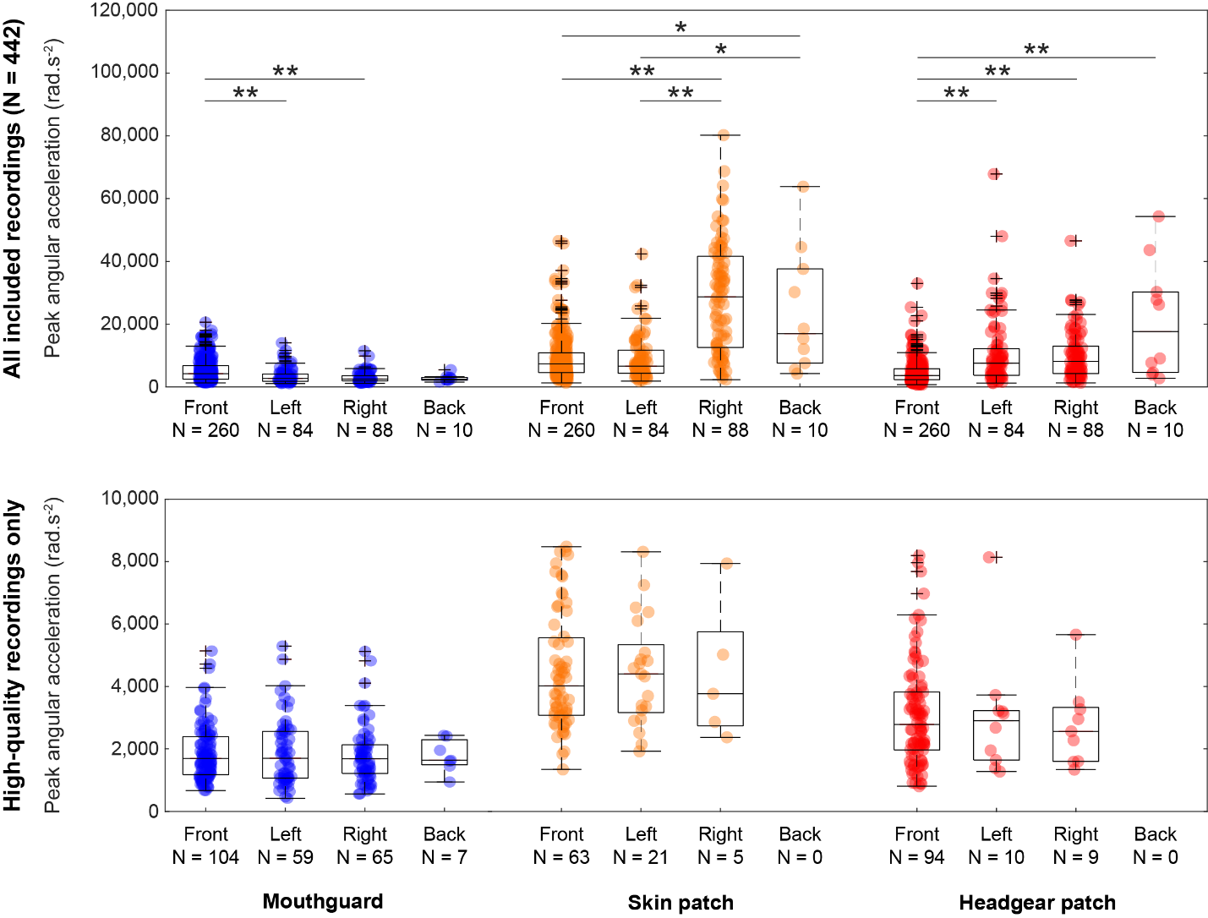

Fig. S1 Distribution of the peak angular acceleration measured by the mouthguard (left), skin patch (middle), and headgear patch (right) across the four impact location bins, as determined by the video analysis.The top panel comprises all included recordings, the bottom panel only the recordings assessed as high-quality for each sensor (note the different scale). On each box, the central line indicates the median, and the bottom and top edges of the box indicate the 25th and 75th percentiles, respectively. The whiskers extend to the most extreme data points not considered outliers, and the outliers (any value that is more than 1.5 times the interquartile range away from the bottom or top of the box) are plotted individually using the '+' symbol. The horizontal lines and asterisks above the plots indicate a significant difference between the mean ranks of the groups, determined from a Kruskal-Wallis analysis of variance, completed with post-hoc tests with a Dunn-Sidák correction (*p < 0.05, **p < 0.001).

