Supplementary Table S1: Demographic data of keloid samples used in this study.

Sample No. Gender Ethnic Background Age Site of Specimen

KD1 M Asian 32 Chest
KD2 M Asian 43 Chest
KD3 M Asian 29 Chest
KD4 M Asian 25 Chest
KD5 F Asian 33 Chest
KD6 M Asian 32 Chest
KD7 M Asian 27 Chest
KD8 F Asian 33 Chest
KD9 M Asian 35 Chest
KD10 F Asian 29 Chest
KD11 F Asian 25 Chest
KD12 F Asian 27 Chest
KD13 M Asian 38 Chest
KD14 M Asian 22 Chest
KD15 F Asian 26 Chest
KD16 F Asian 29 Chest
KD17 F Asian 25 Chest
KD18 M Asian 27 Chest
KD19 F Asian 42 Chest
KD20 F Asian 33 Chest
KD21 F Asian 52 Chest
KD22 F Asian 32 Chest
KD23 M Asian 29 Chest
KD24 F Asian 22 Chest
KD25 F Asian 28 Chest
KD26 F Asian 23 Chest
KD27 F Asian 33 Chest
KD28 M Asian 22 Chest
KD29 F Asian 24 Chest
KD30 M Asian 40 Chest
KD31 F Asian 23 Chest
KD32 F Asian 31 Chest
KD33 M Asian 26 Chest
KD34 F Asian 23 Chest
KD35 M Asian 50 Chest

Note: Samples KD31-KD35 were used for ex-vivo keloid explant culture.

Supplementary Table S2: Primers used in quantitative PCR analysis.

Gene Name Primer Sequence (5’-3’)

Collagen I Sense: GGCGGCCAGGGCTCCGACCC
Antisense:AATTCCTGGTCTGGGGCACC
Collagen III Sense: TGGTGTTGGAGCCGCTGCCA
Antisense:CTCAGCACTAGAATCTGTCC
TGF-β1 Sense: AAGGACCTCGGCTGGAAGTG
Antisense: CCGGGTTATGCTGGTTGTA
SPOCD1 Sense: CTCCCCAAGTTGCTGACCTG
Antisense: CCCCTGTAGCGGGCAAATATC
IFNγ Sense: TGGGTTGTGTGTTTATTTCACT
Antisense: CATTAAAGCACTGGCTCAGAT
DNMT3A Sense: GCAGGATAGCCAAGTTCAG
Antisense: AATACCCTTTCCATTTCAGTG
DNMT3B Sense: CGAATTTTACCACCTGCTGAATT
Antisense: AGAACGGCCGGTCATCAC
DNMT1 Sense: CCTCCAAAAACCCAGCCAAC
Antisense: TCCAGGACCCTGGGGATTTC
SLC7a11 Sense: TGCTGGGCTGATTTTATCTTCG
Antisense: GAAAGGGCAACCATGAAGAGG
SLC3a2 Sense: CTGGTGCCGTGGTCATAATC
Antisense: GCTCAGGTAATCGAGACGCC
GPX4 Sense: CGATACGCCGAGTGTGGTTTAC
Antisense: ACAGCCGTTCTTGTCAATGAGG
GSH Sense: GACCAGCGTGCCATAGAGA
Antisense: CCAGAGACCCCTTTTCAGAGAT
GAPDH Sense: TCACCATCTTCCAGGAGCG
Antisense: CTGCTTCACCACCTTCTTGA

Supplementary materials S3：The results of RNA-seq.

Supplementary Table S4: The sequences of si-RNA. Yellow indicates the actual sequence in use.

gene name | numbers | sequences
gene name | numbers | sense（5'-3'） | antisense（5'-3'）
human DNMT1 | DNMT1-S1 | GGGACUGUGUCUCUGUUAUTT | AUAACAGAGACACAGUCCCTT
human DNMT1 | DNMT1-S2 | GAGGACAACAAGUUCAAAUTT | AUUUGAACUUGUUGUCCUCTT
human DNMT1 | DNMT1-S3 | GAGGCCUAUAAUGCAAAGATT | UCUUUGCAUUAUAGGCCUCTT
human DNMT3A | DNMT3A-S1 | GCGUCACACAGAAGCAUAUTT | AUAUGCUUCUGUGUGACGCTT
human DNMT3A | DNMT3A-S2 | GGCUCUUCUUUGAGUUCUATT | UAGAACUCAAAGAAGAGCCTT
human DNMT3A | DNMT3A-S3 | GUCCACUAUACUGACGUCUTT | AGACGUCAGUAUAGUGGACTT
human DNMT3B | DNMT3B-S1 | CACGCAACCAGUGGUUAAUTT | AUUAACCACUGGUUGCGUGTT
human DNMT3B | DNMT3B-S2 | CGCCUCAAGACAAAUUGCUTT | AGCAAUUUGUCUUGAGGCGTT
human DNMT3B | DNMT3B-S3 | GCCCAUUUGACUUGGUGAUTT | AUCACCAAGUCAAAUGGGCTT
human SPOCD1 | SPOCD1-S1 | CAGAGACGGUGGAAUGAGUUCUCCA | UGGAGAACUCAUUCCACCGUCUCUG
human SPOCD1 | SPOCD1-S2 | CCAAGUAUCGCAGCCUGCUGUUCAA | UUGAACAGCAGGCUGCGAUACUUGG
human SPOCD1 | SPOCD1-S3 | CAGUAAGGUGGAGAAGAGAUACUAU | AUAGUAUCUCUUCUCCACCUUACUG
human IFN-r
human IFN-r | IFN-r-S4 | UGGAGACCAUCAAGGAAGACAUGAA | UUCAUGUCUUCCUUGAUGGUCUCCA

Supplementary materials S5: The results of Infinium MethylationEPIC (850K) array.

Supplementary materials S6: The results of co-ip.

Supplementary materials S7: IFN-γ has no effect on the proliferation of KFs. A, B) The impact of varying concentrations of IFN-γ and its antibodies on the proliferation of KFs. C) The study investigates the impact of IFN-γ(10ng/ml), an ferr-inducer(erastin, 2.5μM), and an ferr-inhibitor(ferrostatin, 1μM) on the proliferation of KFs using CCK8.

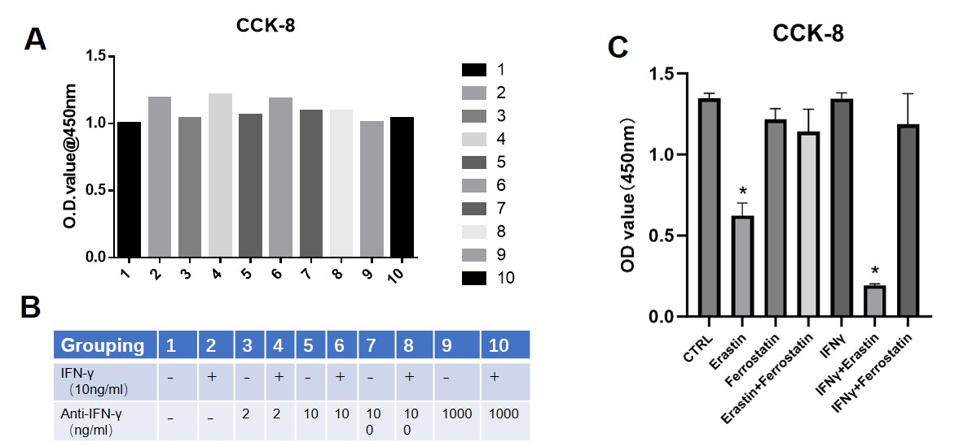

Supplementary materials S8: ki-67 staining of ex-vivo keloid explant.

