Supplementary Table S1.

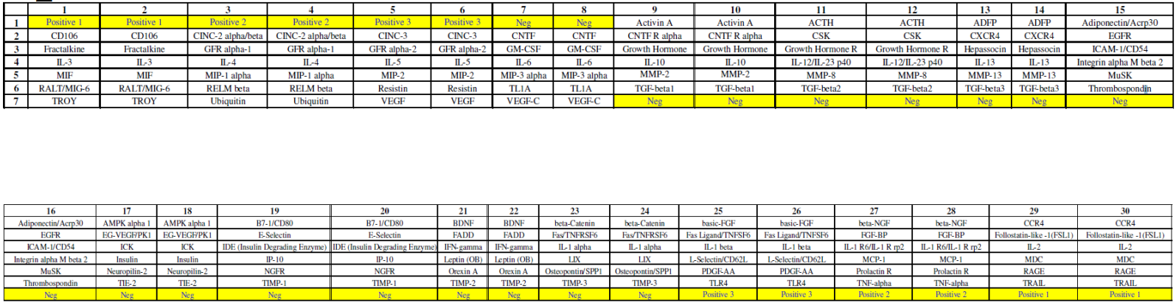
Supplementary Table S2. Differential gene expression analysis of Standard diet group versus MCD diet group. Top 10 DEGs in ascending order of FDRs.

Symbol | logFC | logSIGNAL | P value | FDR
LOC100360095 | -7.44 | 9.87 | 0 | 0
Cyp7a1 | 5.08 | 8.76 | 0 | 0
Igfbp1 | 4.15 | 9.09 | 0 | 0
Mt1m | -1.74 | 10.0 | 0 | 0
Hamp | 1.19 | 10.8 | 6.51E-319 | 2.94E-315
Cyp2c11 | -1.67 | 9.70 | 1.20E-276 | 4.53E-273
Mt1a.1 | -1.53 | 9.88 | 1.54E-264 | 4.96E-261
Hsd17b2 | -2.67 | 8.69 | 2.19E-254 | 6.18E-251
Dhrs7 | -4.00 | 7.95 | 3.13E-240 | 7.87E-237
G6pc | 2.03 | 9.21 | 2.29E-239 | 5.17E-236

Supplementary Table S3. Differential gene expression analysis of MCD diet group versus control group. Top 10 DEGs in ascending order of FDRs.

Symbol | logFC | logSIGNAL | P value | FDR
Mt2A | 5.88 | 10.2 | 1.14E-64 | 2.58E-60
Mir770 | 5.98 | 9.50 | 2.49E-62 | 2.82E-58
Cyp7a1 | -6.24 | 8.73 | 8.13E-52 | 6.13E-48
Fads1 | -5.20 | 9.20 | 1.23E-47 | 6.94E-44
Rnase4 | -5.16 | 9.00 | 6.29E-46 | 2.65E-42
Hmgcs1 | -5.11 | 9.09 | 7.03E-46 | 2.65E-42
Cth | -4.87 | 9.33 | 6.16E-45 | 1.99E-41
Cyp3a23.3a1.1 | -6.14 | 7.98 | 1.05E-43 | 2.97E-40
Vom2r70 | 5.90 | 7.08 | 7.68E-42 | 1.93E-38
Pkib.1 | 4.52 | 8.78 | 8.57E-42 | 1.94E-38

Supplementary Table S4. GO Biological Processes that are enriched in DEGs in Standard diet group versus MCD diet group. Top 10 GO biological processes in ascending order of P values.

GO.ID | Term | Annotated | Significant | Expected | P value
GO:0044281 | small molecule metabolic process | 1620 | 99 | 39.4 | 1.30E-18
GO:0043436 | oxoacid metabolic process | 900 | 66 | 21.9 | 4.50E-16
GO:0006082 | organic acid metabolic process | 910 | 66 | 22.1 | 7.80E-16
GO:0006629 | lipid metabolic process | 1303 | 81 | 31.7 | 1.70E-15
GO:0019752 | carboxylic acid metabolic process | 887 | 63 | 21.6 | 1.10E-14
GO:0008202 | steroid metabolic process | 310 | 35 | 7.56 | 3.50E-14
GO:0009410 | response to xenobiotic stimulus | 679 | 53 | 16.5 | 4.40E-14
GO:0014070 | response to organic cyclic compound | 1386 | 79 | 33.7 | 4.30E-13
GO:0032787 | monocarboxylic acid metabolic process | 626 | 48 | 15.2 | 1.50E-12
GO:0044283 | small molecule biosynthetic process | 536 | 43 | 13.0 | 5.70E-12

Supplementary Table S5. GO Biological Processes that are enriched in DEGs in MCD diet group versus control group. Top 10 GO biological processes in ascending order of P values.

GO.ID | Term | Annotated | Significant | Expected | Fisher’s Test
GO:0050877 | nervous system process | 1351 | 1133 | 921 | < 1e-30
GO:0007186 | G protein-coupled receptor signaling pathway | 981 | 839 | 668 | < 1e-30
GO:0007600 | sensory perception | 755 | 663 | 514 | < 1e-30
GO:0003008 | system process | 2031 | 1612 | 1384 | < 1e-30
GO:0032501 | multicellular organismal process | 7090 | 5148 | 4833 | 1.40E-28
GO:0007606 | sensory perception of chemical stimulus | 262 | 249 | 178 | 2.20E-27
GO:0051606 | detection of stimulus | 311 | 276 | 212 | 8.00E-18
GO:0050906 | detection of stimulus involved in sensory perception | 219 | 201 | 149 | 3.40E-17
GO:0007268 | chemical synaptic transmission | 864 | 695 | 589 | 7.00E-17
GO:0098916 | anterograde trans-synaptic signaling | 864 | 695 | 589 | 7.00E-17

