Table 1. Detectability of phenophases of C. bulbocodium. *As C. bulbocodium is a strictly protected species, bulbs are not suitable for monitoring.
 | 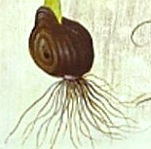 | 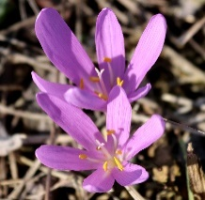 | 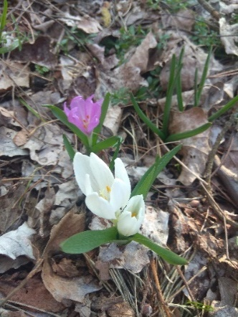 | 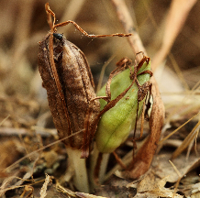
Phenophase | Bulb* | Flowers | Leaves | Capsules
Season of detectability | - | March | April | May/June
Difficulty of detection | - | Low | Very high | High
What the phenophase indicates | Total number of individuals (non-dormant+dormant) | Number of individuals with reproductive potential | Number of assimilating individuals | Number of successfully reproduced individuals

