Investigation of the Anti-Cancer of Photodynamic Therapy Effects by Using the Novel Schiff-Base Ligand Complex on Human Breast Cancer Cell Line

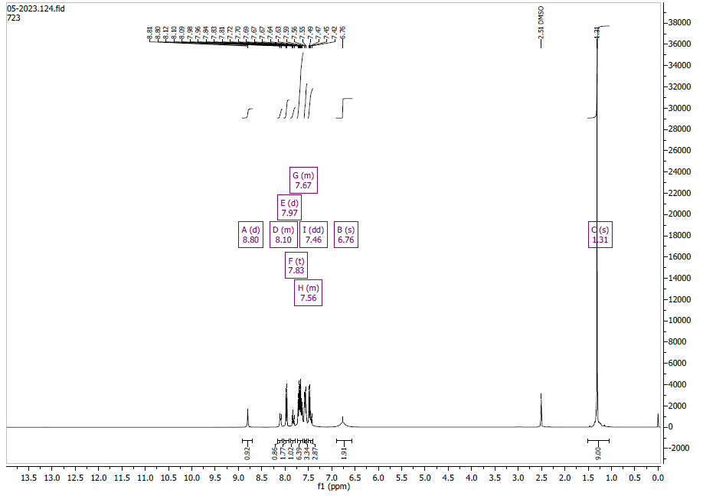

Figure S1: Complex 1 H-NMR spectra

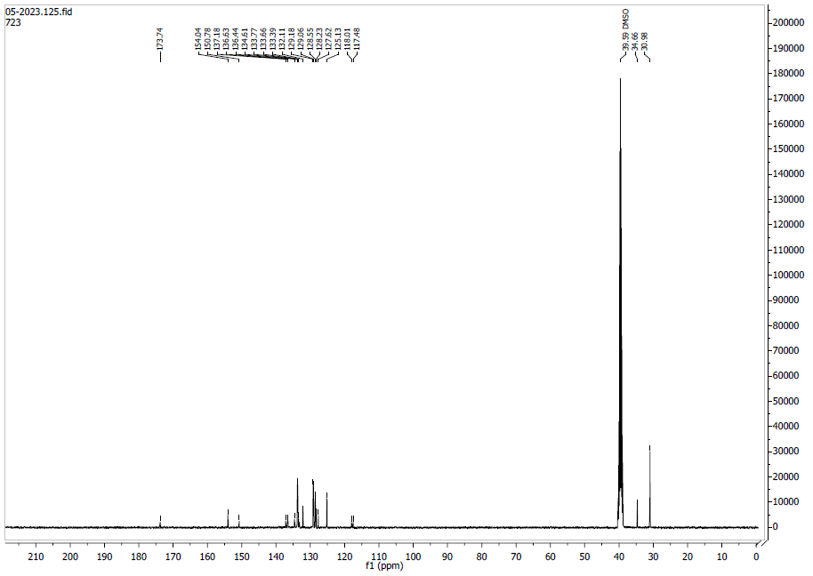

Figure S2: Complex 1 C-NMR spectra
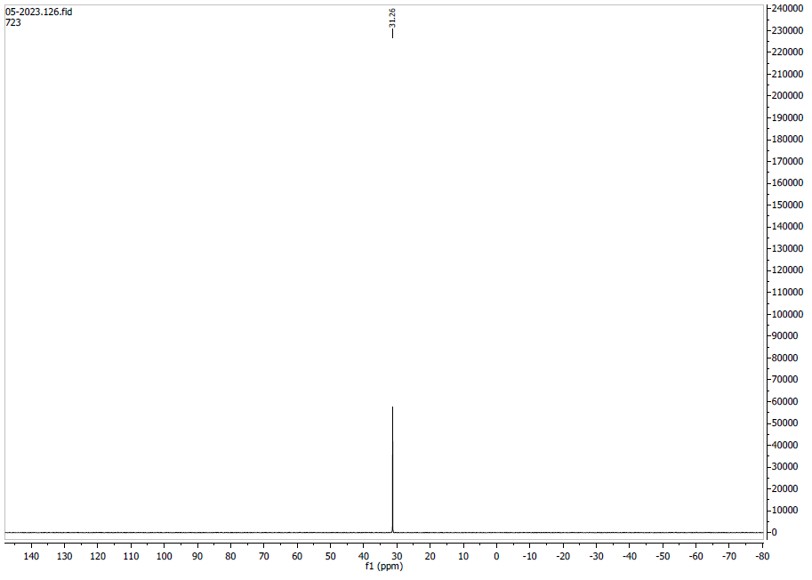

Figure S3: Complex 1 P-NMR spectra

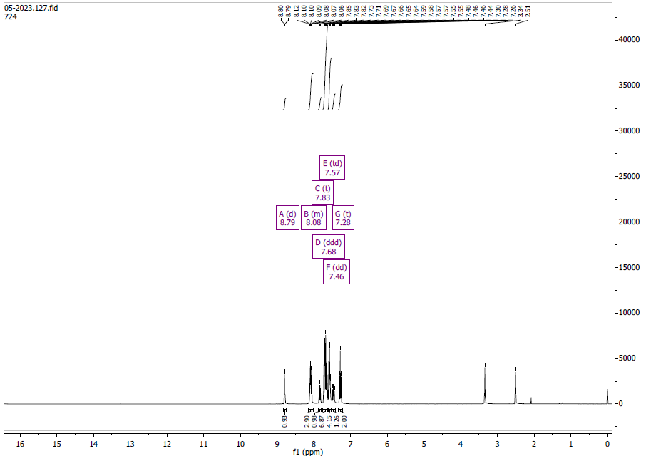

Figure S4: Complex 2 H-NMR spectra

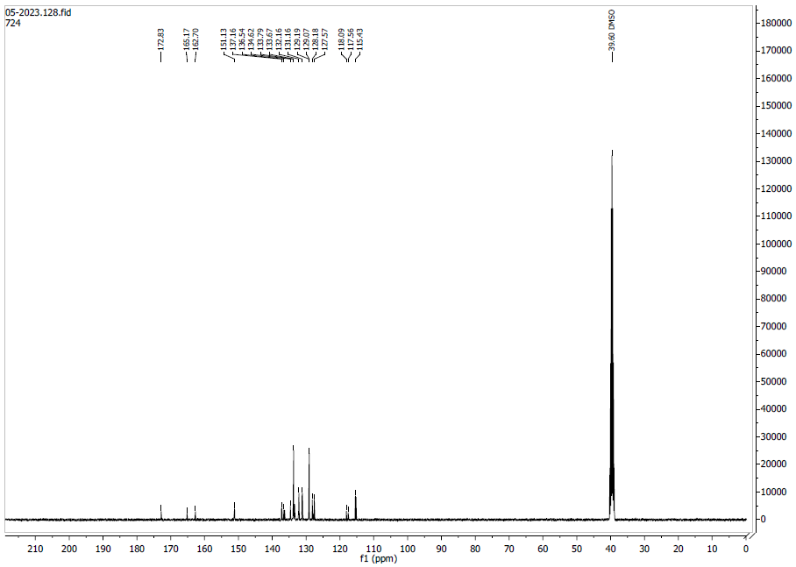

Figure S5: Complex 2 C-NMR spectra

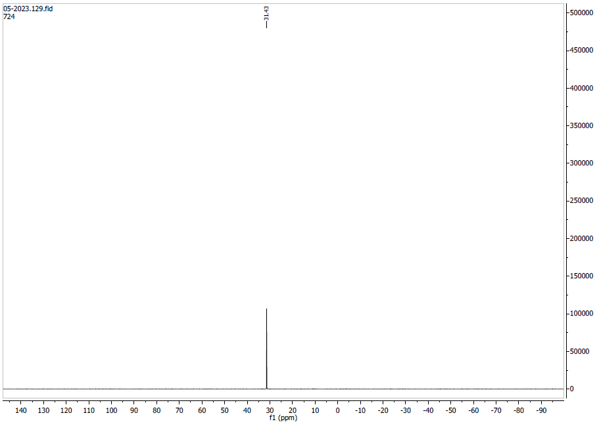

Figure S6: Complex 2 P-NMR spectra

