Supplementary Information

Resistance exercise-induced skeletal muscle damage is mitigated by adaptation-dependent changes in protein localization and phosphorylation

Maithreyan Kuppusamy^{1,#,+}, Daniel Jacko^{2,3,#}, Martin Matijass^{1,2,4}, Ricarda Jahnke⁵, Kirill Schaaf², Käthe Bersiner⁶, Jonas Zacher⁷, Peter F.M. van der Ven⁵, Wilhelm Bloch², Dieter O. Fürst⁵, Jörg Höhfeld⁵, Pitter F. Huesgen^{1,4,8,9,10,$,}*, Sebastian Gehlert^{2,6,$,}*

¹ Central Institute for Engineering, Electronics and Analytics, ZEA-3, Forschungszentrum Jülich, Germany
² Institute of Cardiovascular Research and Sports Medicine, German Sport University, Cologne, Germany
³ Olympic Base Center, North Rhine-Westphalia/Rhineland, Cologne, Germany
⁴ Institute of Biochemistry, Department for Chemistry, University of Cologne, Cologne, Germany
⁵ Institute for Cell Biology, Rheinische Friedrich-Wilhelms University Bonn, Bonn Germany,
⁶ Department for the Biosciences of Sports, Institute of Sports Science, University of Hildesheim, Hildesheim, Germany
⁷ Department of Preventative and Rehabilitative Sports and Performance Medicine, Institute of Cardiology and Sports Medicine, German Sports University Cologne, Cologne, Germany;
⁸ Cologne Excellence Cluster on Cellular Stress Responses in Aging-Associated Diseases (CECAD), Medical Faculty and University Hospital, University of Cologne, Cologne, Germany
⁹ Faculty of Biology, University of Freiburg, Freiburg, Germany
¹⁰ CIBSS- Centre for Integrative Biological Signaling Studies, University of Freiburg, Freiburg, Germany
# equal contribution, § shared senior authorship
+ Present address: Research Group Proteomics and Cancer Cell Signalling, German Cancer Research Centre, Heidelberg, Germany
*Correspondence: P. F. Huesgen, pitter.huesgen@bio.uni-freiburg.de; S. Gehlert, gehlert@uni-hildesheim.de
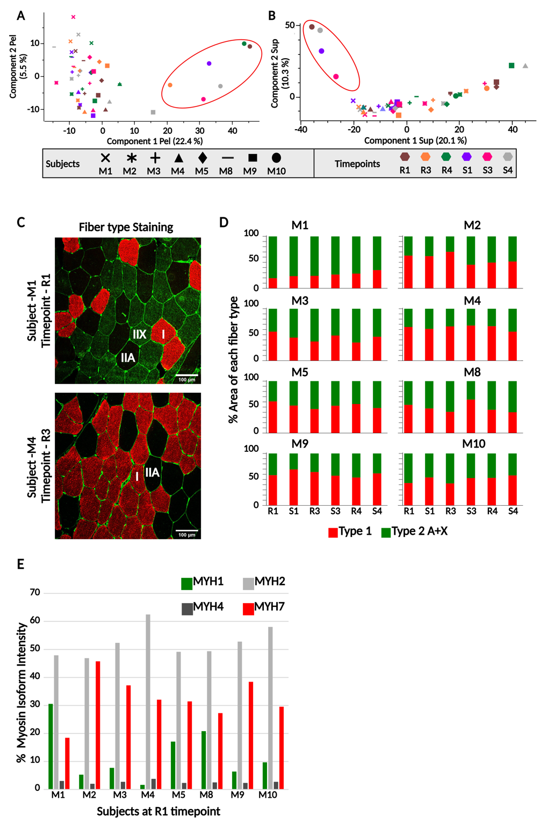
Fig S1: Stratification of the data set. Principal Component Analysis of proteins quantified in A) the pellet and B) the supernatant fractions of all the eight subjects and six timepoints. M10 is the only female participant. C) Immunostaining for myosin heavy chain isoforms. MyHC-I (MYH7), representing Type 1 fibers, is stained red; MyHC-II-X (MYH1), representing Type 2B fibers stained green; and MyHC-II-A (MYH2), representing Type 2A fibers, is unstained. D) Proportion covered by each fiber type in the immunostainings. The red bars represent type 1 fibers, and the green bars type 2 A and B combined. Analysed section area is normalized to 100 percent. E) Mass spectrometry-based quantification of myosin heavy chain isoforms at timepoint R1. MaxQuant LFQ intensities are summed and normalized to 100 percent.
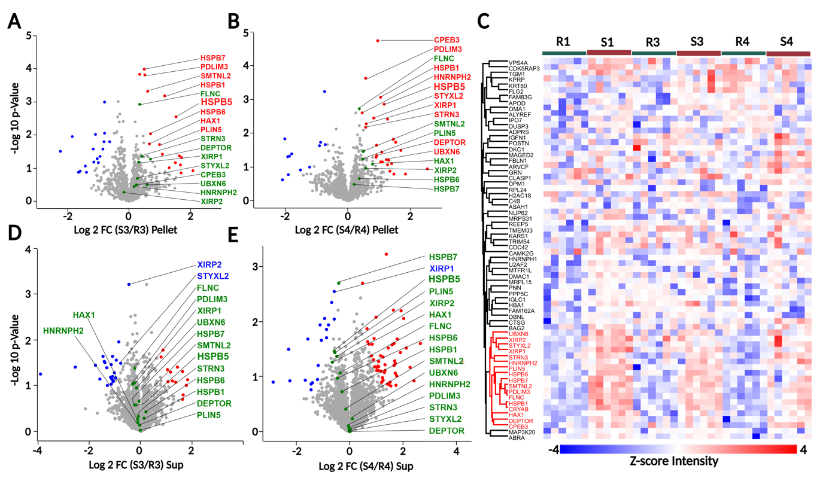Fig. S2: Quantitative proteome analysis of SMO applied after training and detraining. Volcano plots showing the response to SMO compared to rest after training (S3/R3) and detraining (S4/R4) in A), B) the pellet and C), D) the supernatant. E) Heatmap showing cluster analysis of the 66 proteins that were more significantly more abundant in the pellet in at least one time point. 17 proteins consistently changing between SMO and the REST conditions are highlighted in both the volcano plot and in the heatmap.

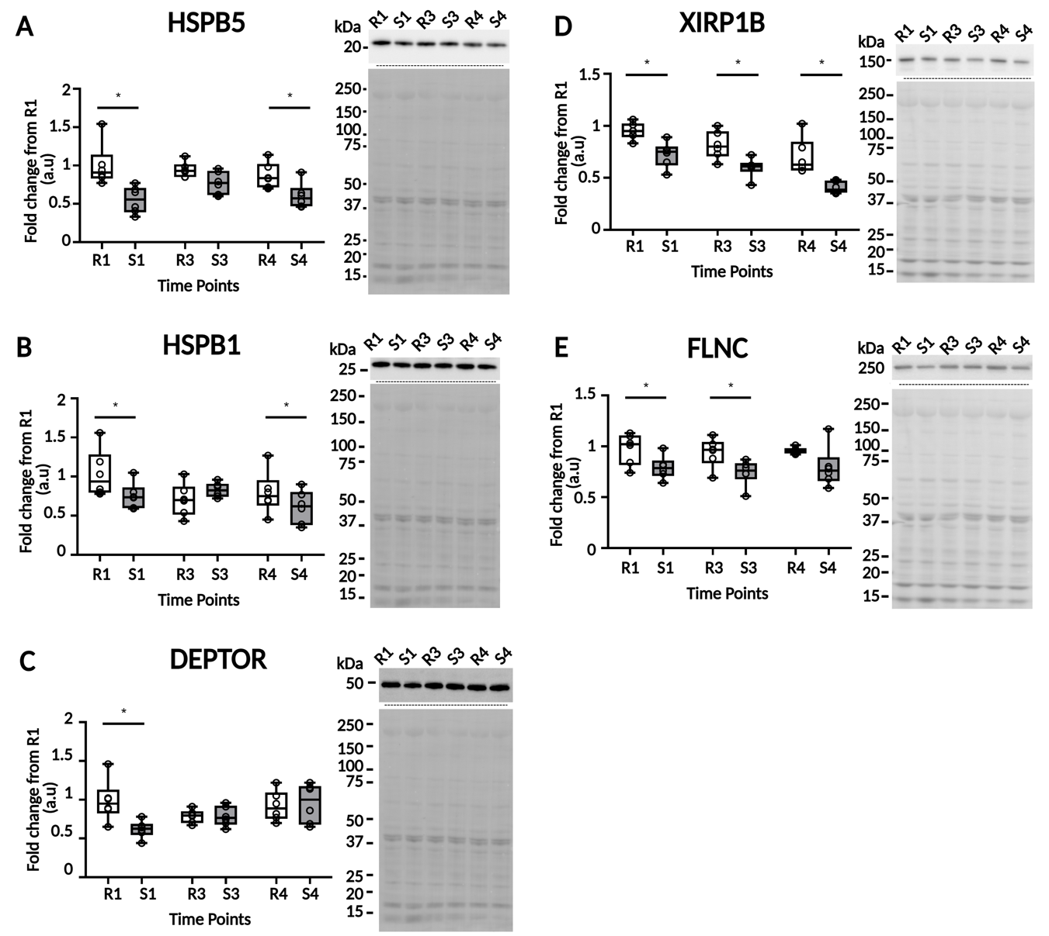
Fig. S3: Immunoblot analysis of selected proteins of interest in the supernatant fraction. A) HSPB5, B) HSPB1, C) DEPTOR, D) XIRP1B, E) FLNC, left panels show quantification of the stratified cohort (n=6), right panels exemplary quantified immunoblot bands (top) with control gel (bottom). * paired t-test p-value < 0.05.

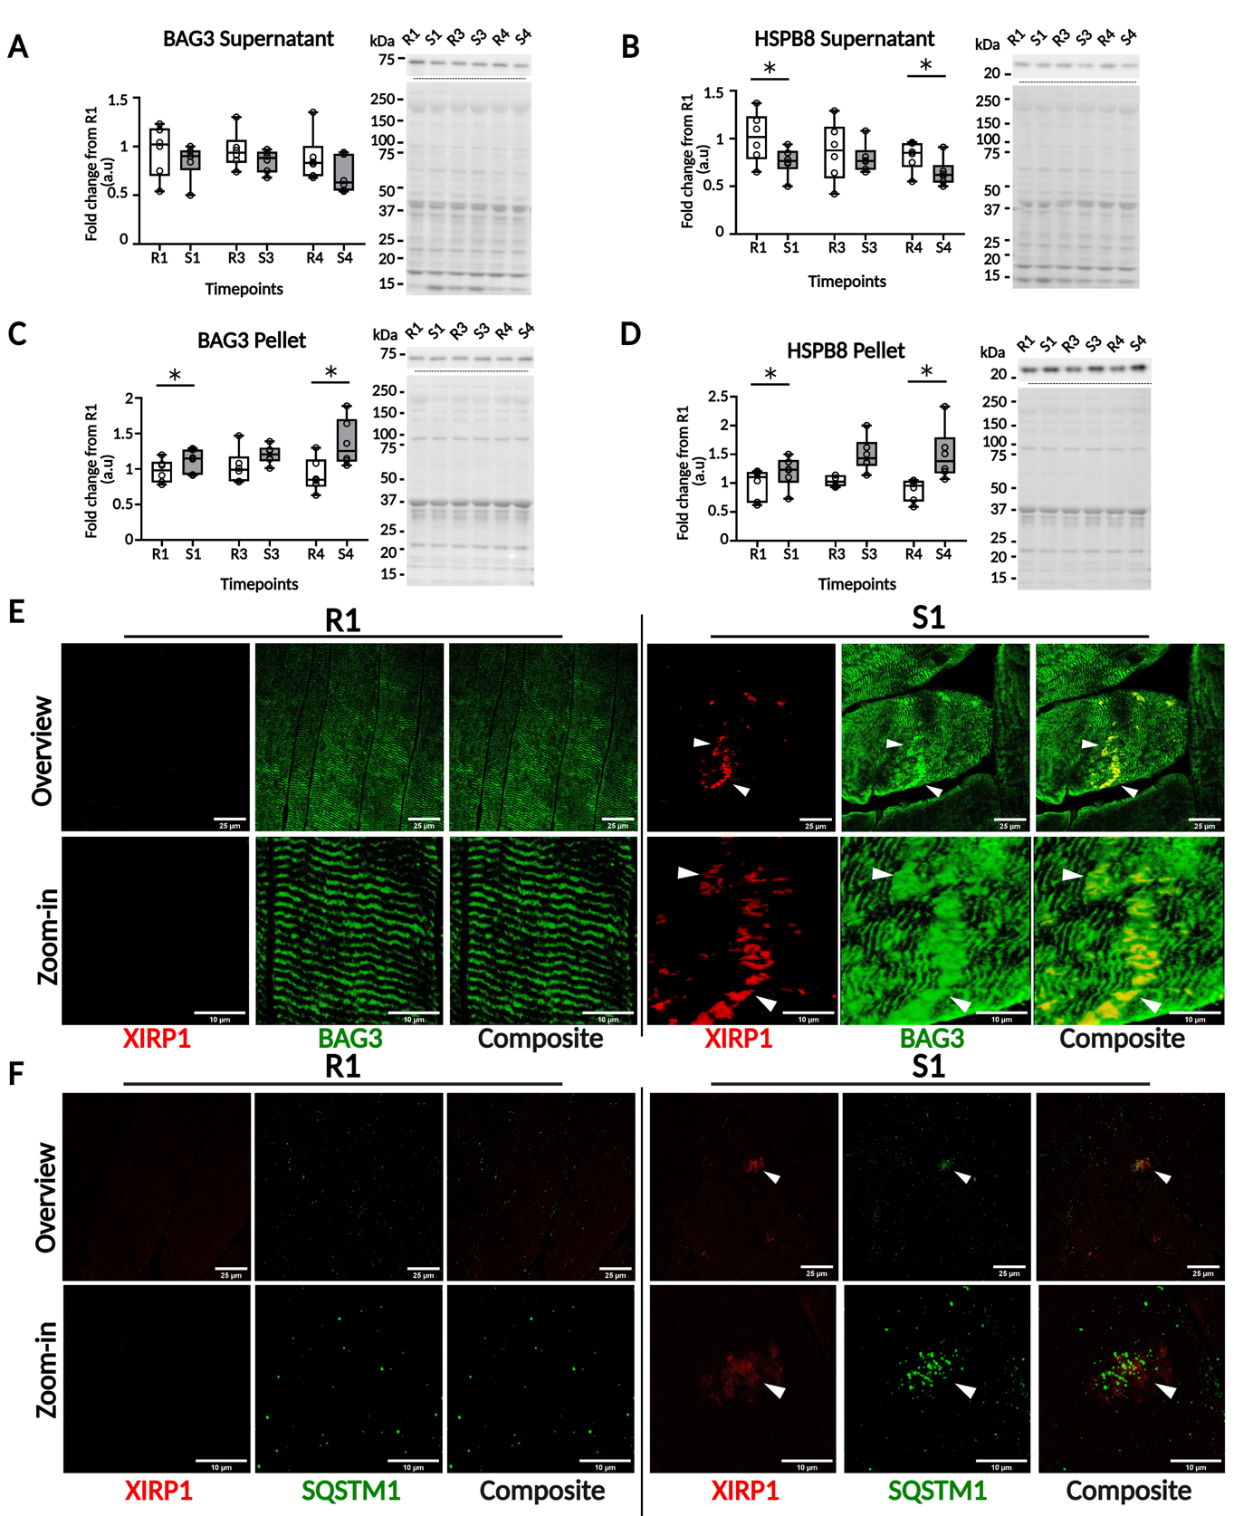
Fig. S4: Immunoblot and immunohistochemical analysis of CASA complex components. Quantification of abundance of BAG3 and HSPB8 abundance in a A), B) the supernatant and C), D) the pellet, respectively. Left panels show quantification, right panels exemplary immunoblots with control gel. n= 6 (stratified cohort), * paired t-test p-value < 0.05. E) Co-immunostainings for XIRP1A and BAG3 and F) XIRP1B and SQSTM1 before (R1) and after SMO (S1) in untrained muscle. The scale bar for the overview is 25 μm and 10 μm for the zoom-in.
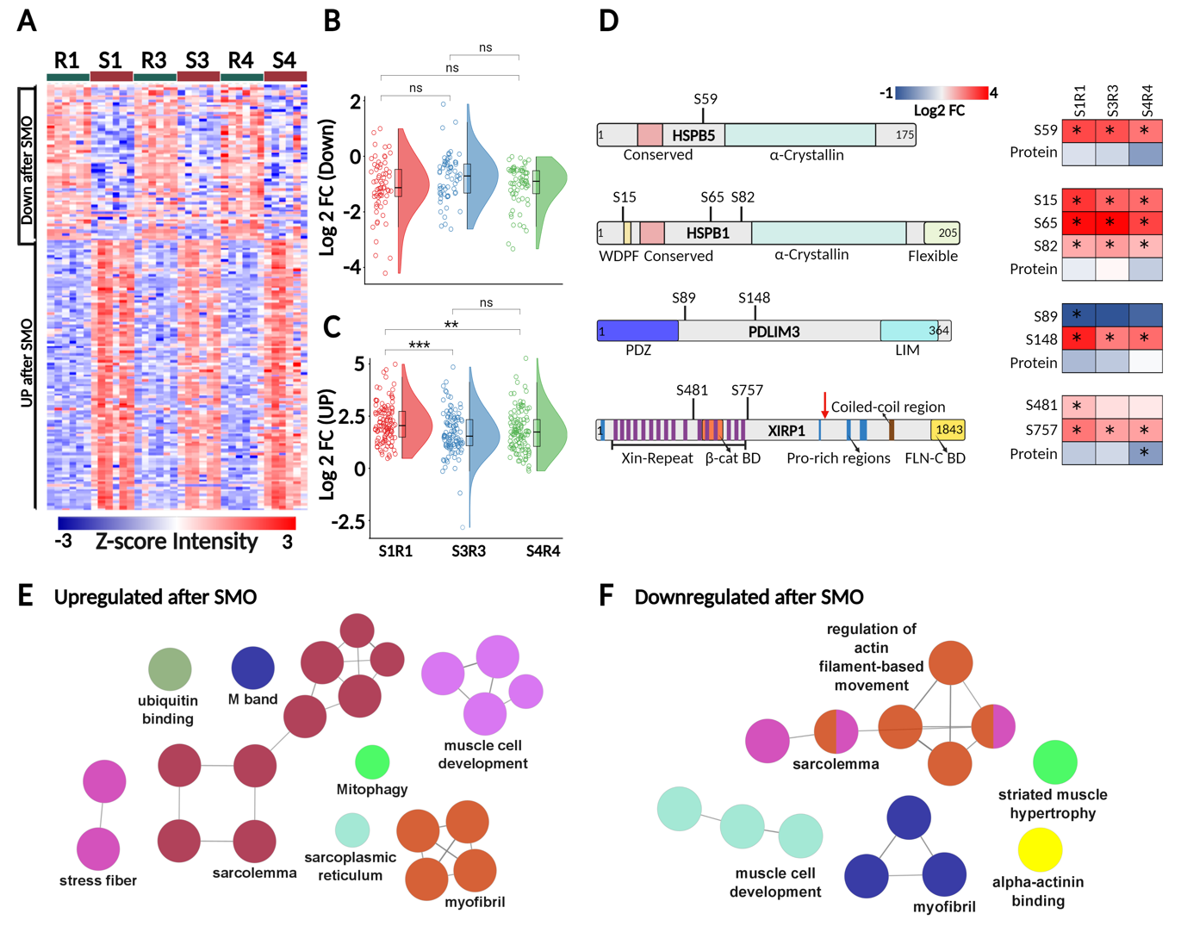
Fig. S5: Analysis of SMO-regulated changes in the phosphoproteome in the supernatant. A) Hierarchical clustering of Z-score normalized intensities of phosphosites significantly changing in the supernatant (ANOVA test p-value < 0.05, followed by Tukey´s post-hoc test with FDR < 0.05). Raincloud plots show the distribution of regulated phosphosites that are significantly B) dephosphorylated and C) phosphorylated in response to SMO in untrained (S1/R1), adapted (S3/R3), and deadapted (S4/R4) conditions. D) Regulated phosphosites in selected soluble proteins that were showed increased association with the cytoskeleton after SMO. Change in abundance is indicated by color scale, * marks time points with significant changes in phosphorylation or protein abundance (ANOVA test p-value < 0.05, followed by Tukey´s post-hoc test with FDR < 0.05. Enrichment of gene ontology cellular component (GO-CC) terms associated with proteins with the phosphosites that are E) phosphorylated and F) dephosphorylated in response to SMO (see panel A).

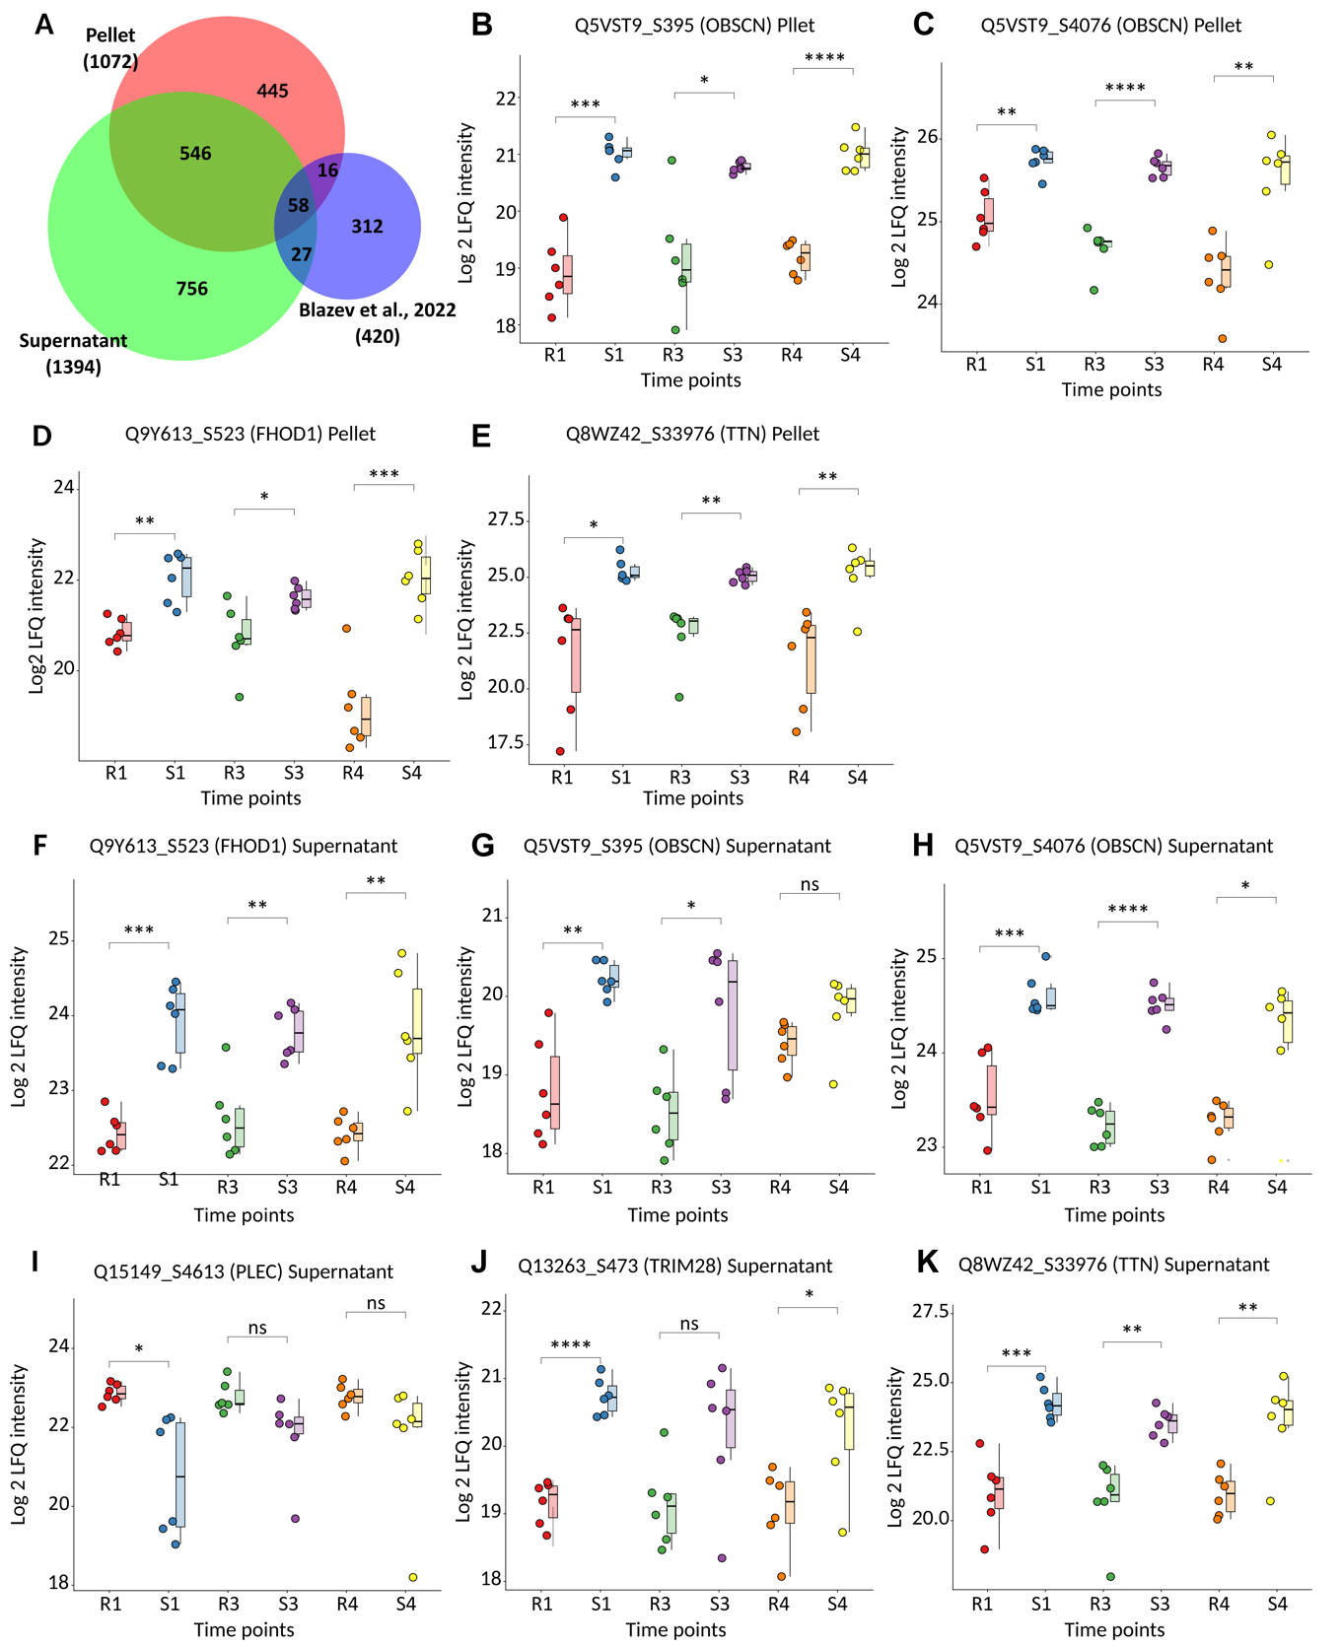
Fig. S6: Comparison of the phosphoproteome data with (Blazev et al., 2022). A) Overlap of phosphosites found in the pellet and supernatant fractions with phosphosites identified as significantly exercise-regulated by Blazev et al. 2022. Boxplots illustrate the behaviour of selected regulated sites of interest in B - E) the pellet and F – K) the supernatant. n= 6 (stratified cohort), significance in paired t-test is indicated (* p-value < 0.05, ** p-value < 0.01, *** p-value < 0.001, **** = p-value < 0.0001).

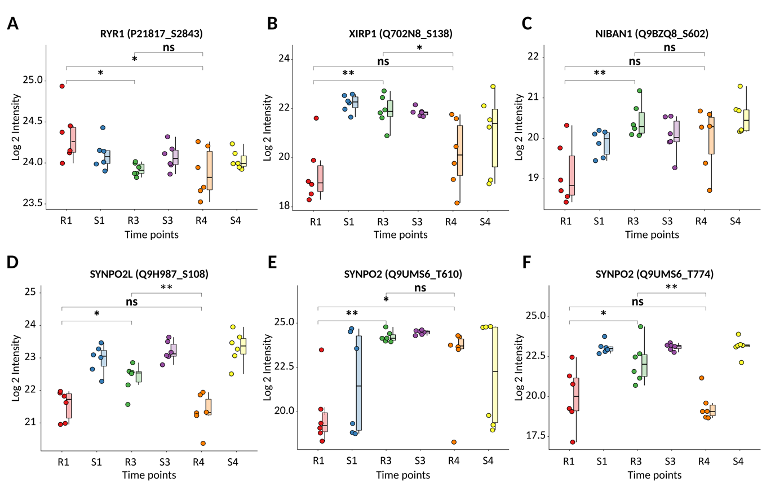
Fig. S7: Phosphosites with significant differences in phosphorylation between trained (R3) and untrained (R1) states at rest. A-F) Boxplot comparison of phosphosites abundance of these six sites in the investigated time points. n= 6 (stratified cohort), significance in paired t-tests comparing R1 and R3, R4 and R1, and R4 and R3 (* p-value < 0.05, ** p-value < 0.01, *** p-value < 0.001, **** = p-value < 0.0001).

