Supplementary Material
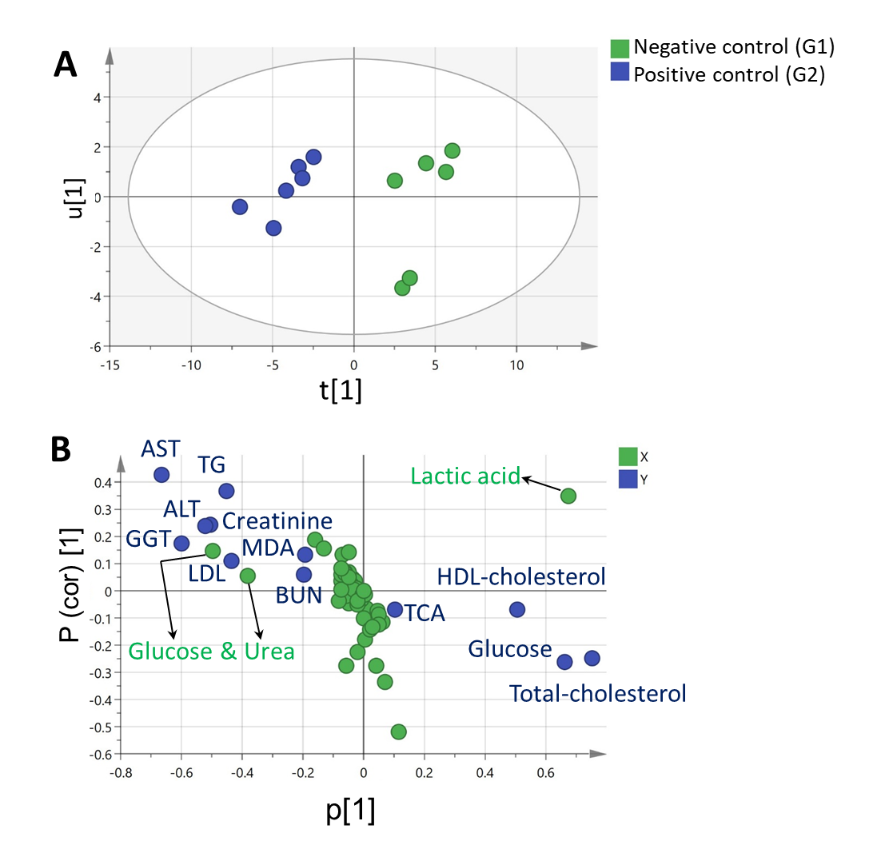
Fig. S1 Partial least-squares-regression analysis (PLS)model correlating GC/MS-metabolite profiles of the serum of healthy control group (G 1) and pneumonic control group (G 2) to the tested biochemical parameters i.e. malondialdehyde (MDA) and total antioxidant activity (TAC), lipid profile (i.e. triglycerides (TG), cholesterol, HDL-cholesterol, LDL-cholesterol) and blood glucose concentrations, liver activities (i.e. blood serum aspartate aminotransferase (AST), alanine aminotransferase (ALT), gamma-glutamyl transferase (GGT) and kidney function tests (i.e. creatinine and urea). (A) PLS score plot. (B) Loading plot showing the covariance p[1] against the correlation p(cor) [1] of the variables of the discriminating component of the PLS model.

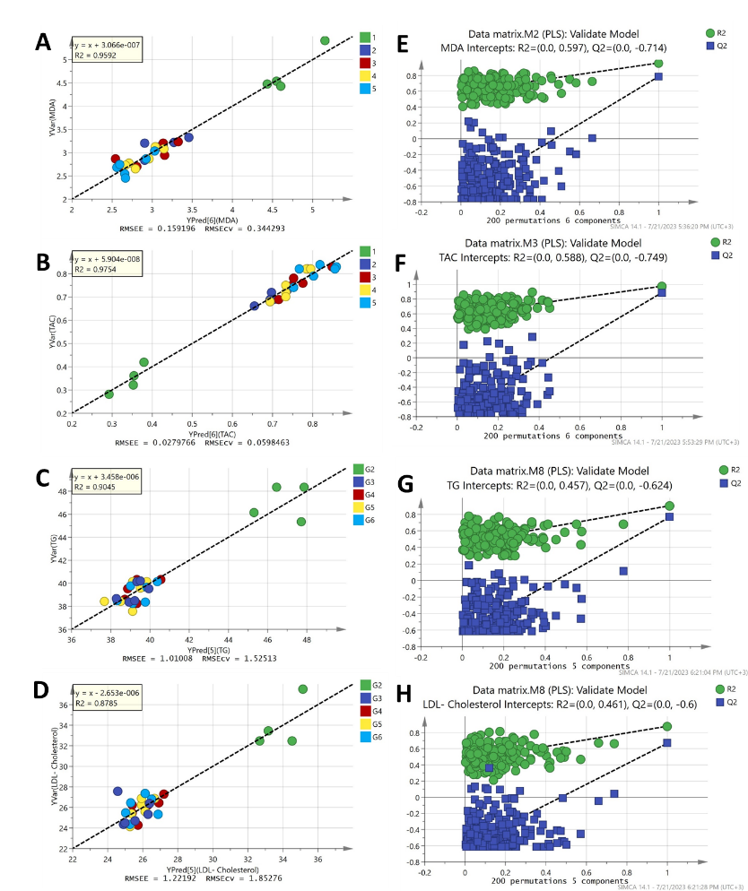 | 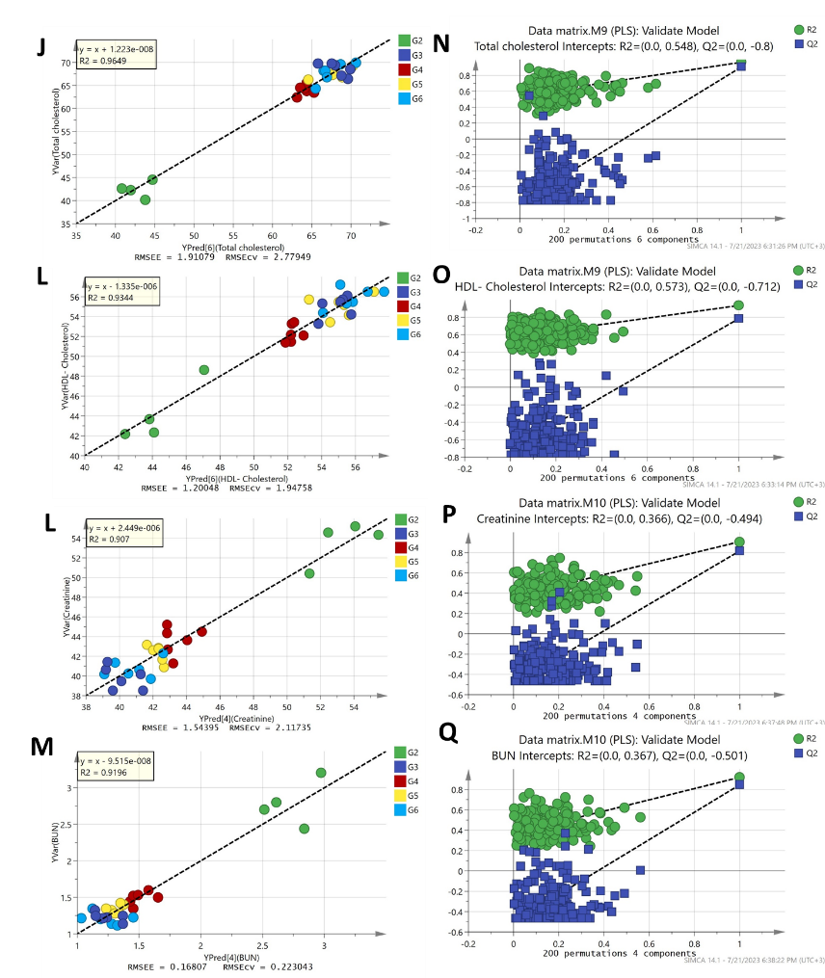
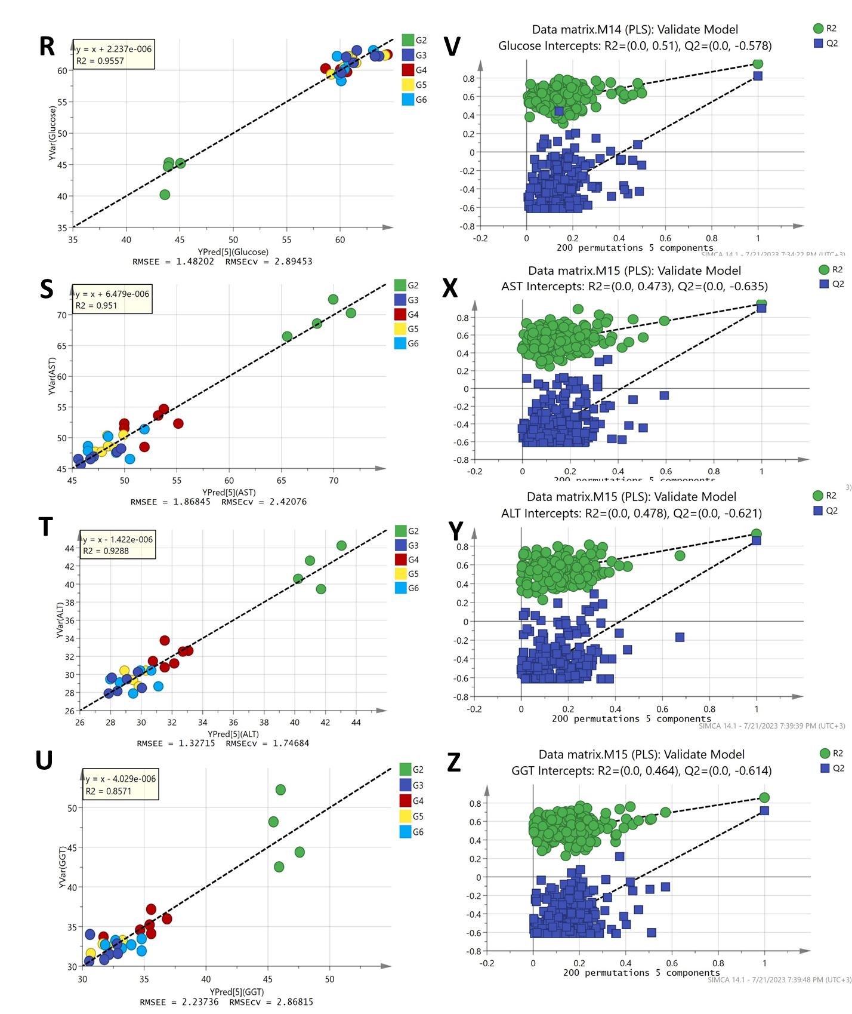

Fig. S2 Regression analysis of the PLS predictive model for each y variable modeled in PLS models shown in Figure 1 and their respective permutation plots. (A & E) Malondialdehyde (MDA), (B &F) Total antioxidant activity (TAC), (C & G) Triglycerides (TG), (D & H) LDL- cholesterol, (J & N) Total cholesterol, (L & O) HDL- cholesterol, (L & P) Creatinine, (M & Q) urea, (R & V) Blood glucose concentrations, (S & X) Blood serum aspartate aminotransferase (AST), (T & Y) alanine aminotransferase (ALT) and (U & Z) gamma-glutamyl transferase (GGT).
RMSEE: Root mean square errors of estimation; RMSEcv: Root mean square errors of cross validation

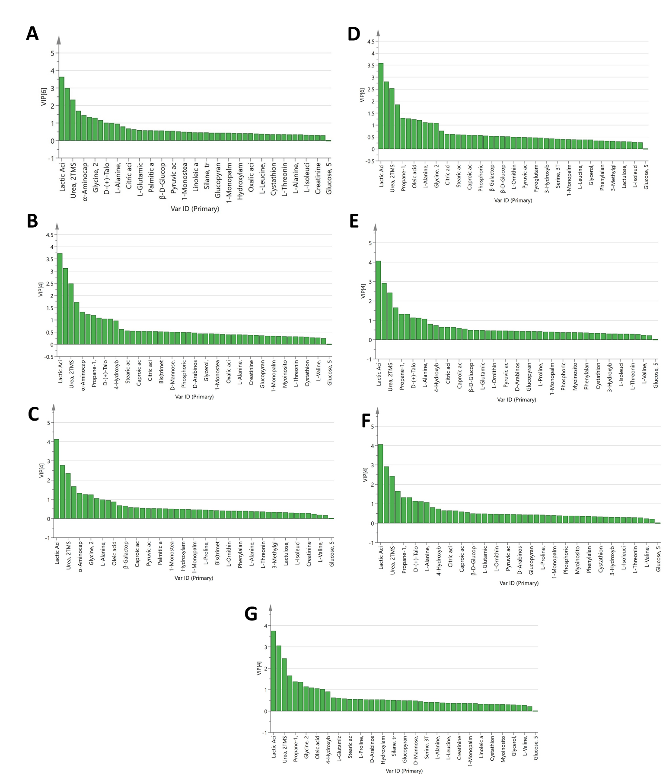
Fig. S3 Variable Importance for Projection (VIP) plots (A-G) obtained from the PLS models in Fig. 1A-G.

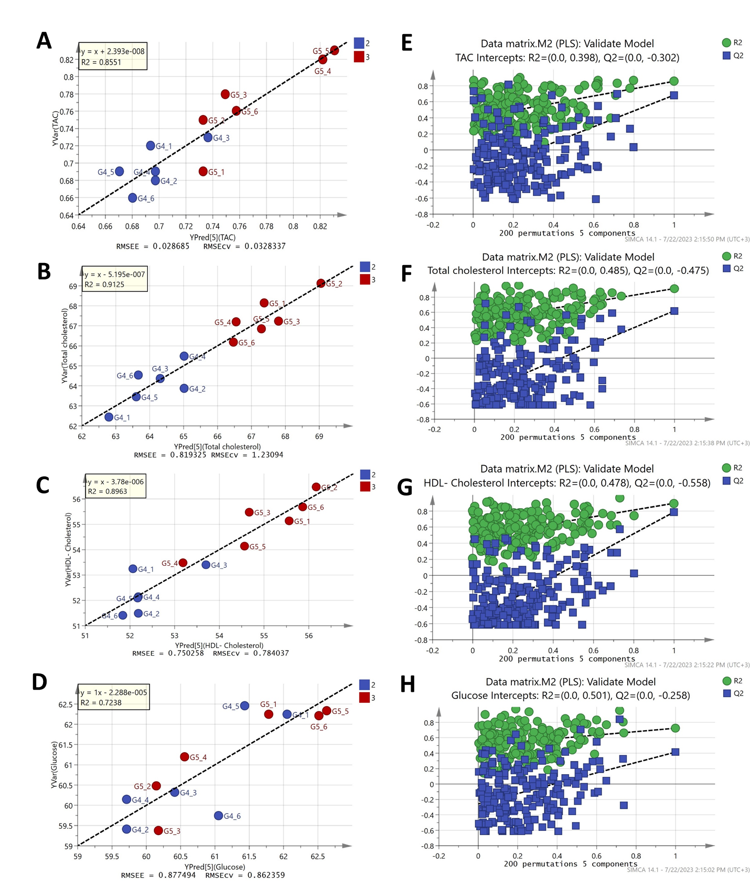
Fig. S4 Regression analysis of the PLS predictive model for each y variable modeled in PLS model shown in Figure 2A and their respective permutation plots. (A & E) Total antioxidant activity (TAC), (B &F) Total cholesterol, (C & G) HDL- cholesterol, and (D & H) Blood glucose concentrations, respectively. RMSEE: Root mean square errors of estimation; RMSEcv: Root mean square errors of cross validation

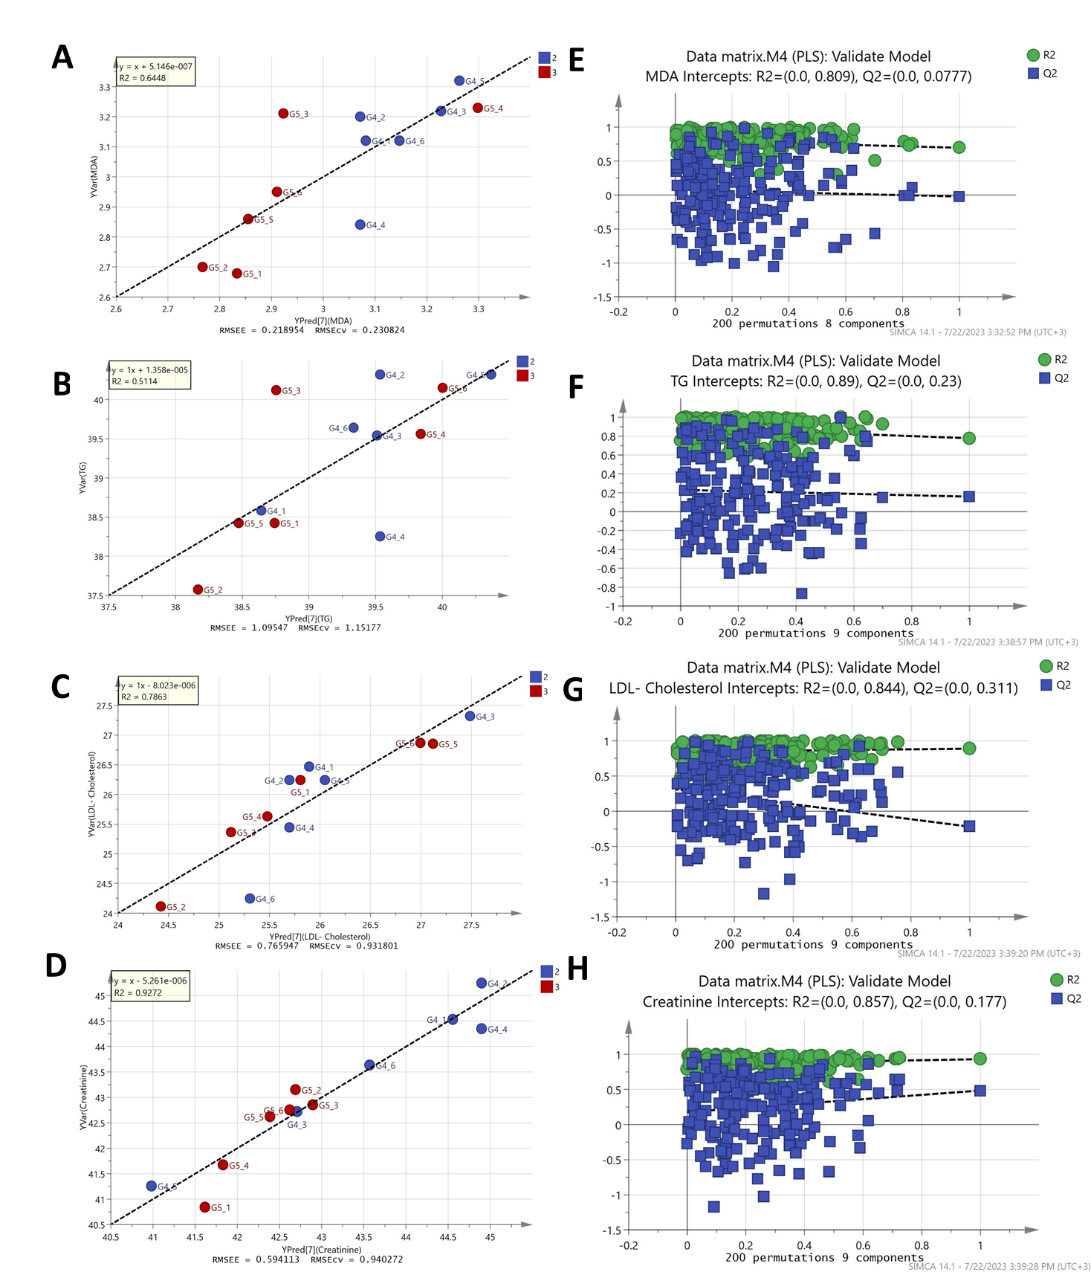 | 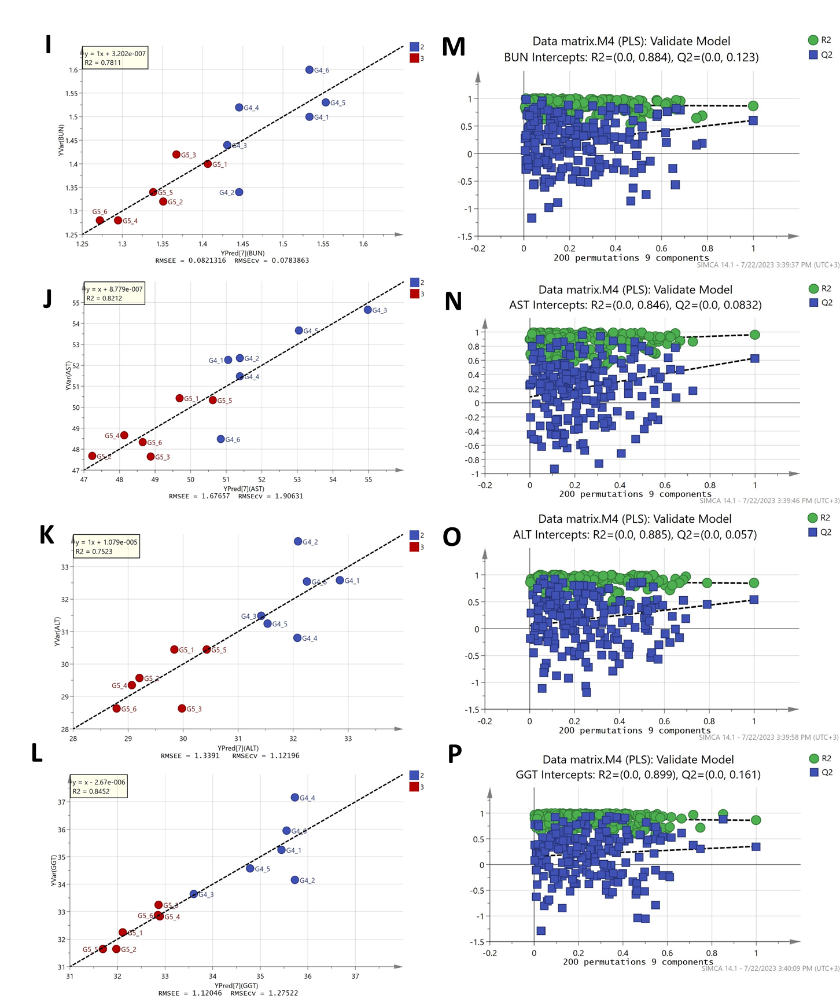

Fig. S5 Regression analysis of the PLS predictive model for each y variable modeled in PLS model shown in Figure 2B and their respective permutation plots. (A & E) Malondialdehyde (MDA), (B &F) Triglycerides (TG), (C & G) LDL- cholesterol, (D & H) Creatinine, (I & M) urea, (J & N) Blood serum aspartate aminotransferase (AST), (K & O) Alanine aminotransferase (ALT) and (L & P) Gamma-glutamyl transferase (GGT), respectively. RMSEE: Root mean square errors of estimation; RMSEcv: Root mean square errors of cross validation

