List of supplementary table
Table S1: Compositional makeup of ɷ-3 fatty acid loaded nanoemulsions
S.No. | Ultrasonication time (min) | WPC | MD | GA | Sample code
Composition 1 (C-1)
1 | 0 | 1 | 1 | 0.15 | E1
2 | 2 |  |  |  | E4
3 | 4 |  |  |  | E7
4 | 6 |  |  |  | E10
Composition 2 (C-2)
5 | 0 | 1.5 | 0.5 | 0.10 | E2
6 | 2 |  |  |  | E5
7 | 4 |  |  |  | E8
8 | 6 |  |  |  | E11
Composition 3 (C-3)
9 | 0 | 0.5 | 1.5 | 0.20 | E3
10 | 2 |  |  |  | E6
11 | 4 |  |  |  | E9
12 | 6 |  |  |  | E12

List of supplementary figure
Fig. S1 Microcapsules loded with ɷ-3 fatty acids obtained after spray drying of ɷ-3 fatty acid loaded nanoemulsions. Code, P1, P2......P12: represent the microcapules (powder) obtained by the spray drying of ɷ-3 fatty acid nanoemulsions code E1, E2,.....E12.
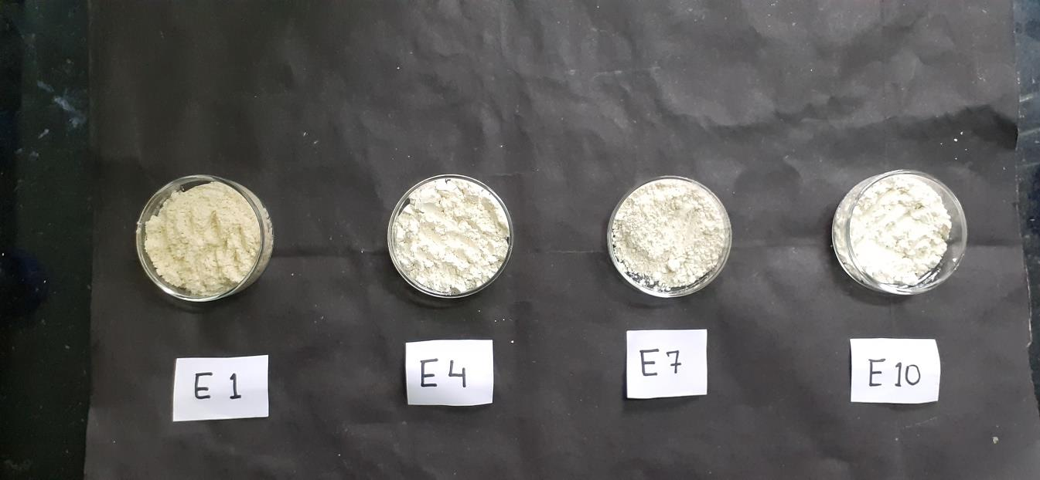
P10
P7
P4
P1

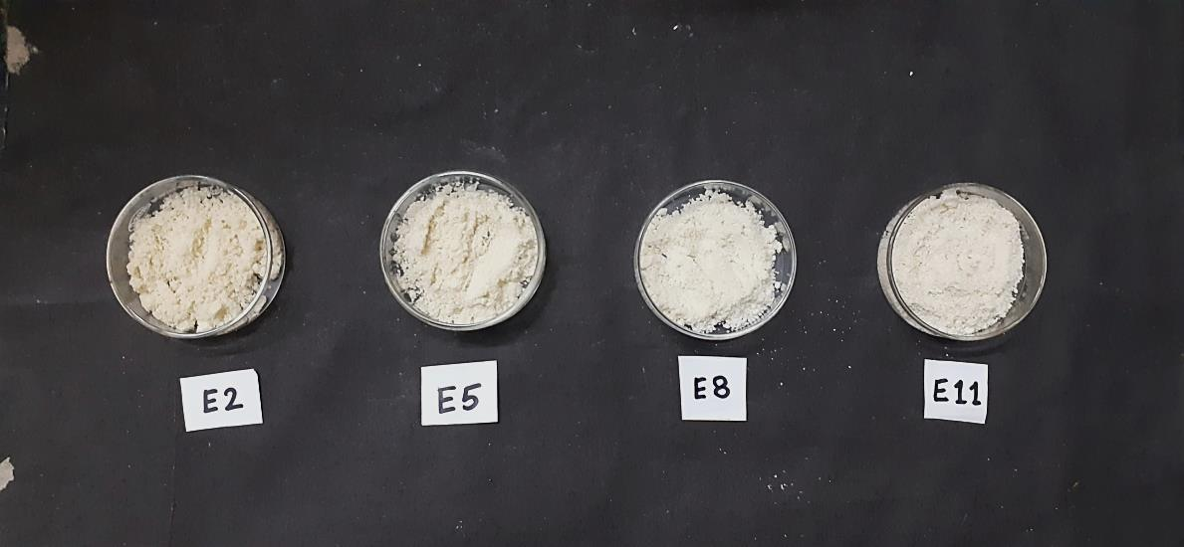
P2
P11
P8
P5
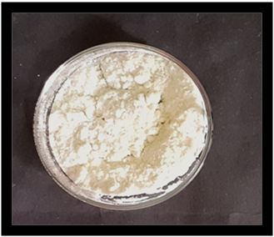
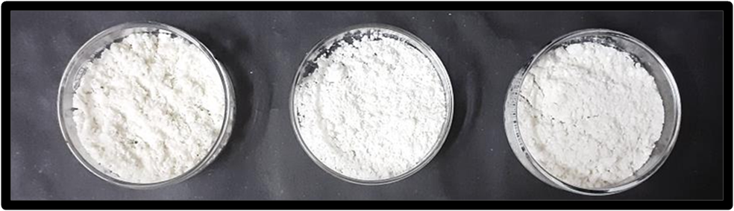
P12
P9
P6
P3

