Supplementary figures
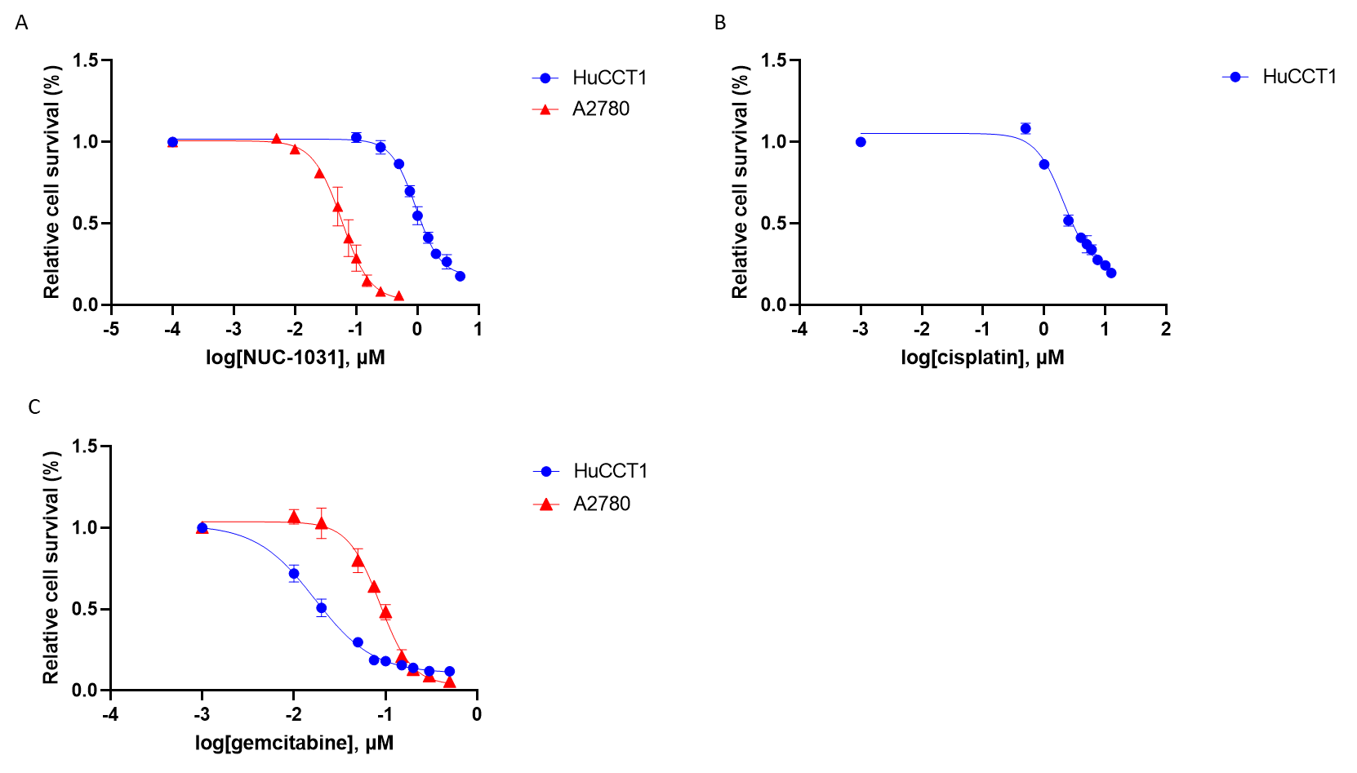
Supplementary Figure 1: NUC-1031, gemcitabine and cisplatin show cytotoxicity in BTC and ovarian carcinoma cell lines. Cells were treated for either 24 or 2 hours and relative cell survival was determined by protein stain via SRB assay at 96 hours post-treatment. (A) HuCCT1 treated with NUC-1031 for 24hrs and A2780 for 2 hours. (B) HuCCT1 cells treated with cisplatin for 24 hours. (C)HuCCT1 treated with gemcitabine for 24 hours and A2780 cells for 2 hrs. IC₅₀ was determined by SRB assay at 96hrs post-treatment, with range determined by 95% confidence interval, (n=3).
Supplementary Table 1: Mass Spectrometric Parameters. Analytes were detected using either positive or negative polarity from the electrospray ionisation (ESI) source. Samples measured for DNA were analysed in multiple reaction monitoring (MRM) only and triphosphate samples analysed in full scan TOF mode (50-800 m/z).
Analyte¤ | Polarity¤ | Mode¤ | Ion¤ | Ion(s) monitored (m/z)¤
dFdC¤ | Positive¤ | MRM¤ | [M+H]⁺¤ | 112.0519 (± 0.05 Da)¤
dG¤ | Positive¤ | MRM¤ | [M+H]⁺¤ | 152.0563 (± 0.05 Da)¤
13C15N2-dFdC¤ | Positive¤ | MRM¤ | [M+H]⁺¤ | 115.0494 (± 0.05 Da)¤
13C15N2-2dG¤ | Positive¤ | MRM¤ | [M+H]⁺¤ | 155.0555 (± 0.05 Da)¤
dFdCTP¤ | Negative¤ | TOF¤ | [M-H]⁻¤ | 501.9635(± 0.05 Da)¤
¹³C₁₀¹⁵N₅-dATP¤ | Negative¤ | TOF¤ | [M-H]⁻¤ | 505.0123 (± 0.05 Da)¤
NUC-1031¤ | Positive ¤ | MRM¤ | [M-H]⁺¤ | 246.0702 (± 0.05 Da)¤

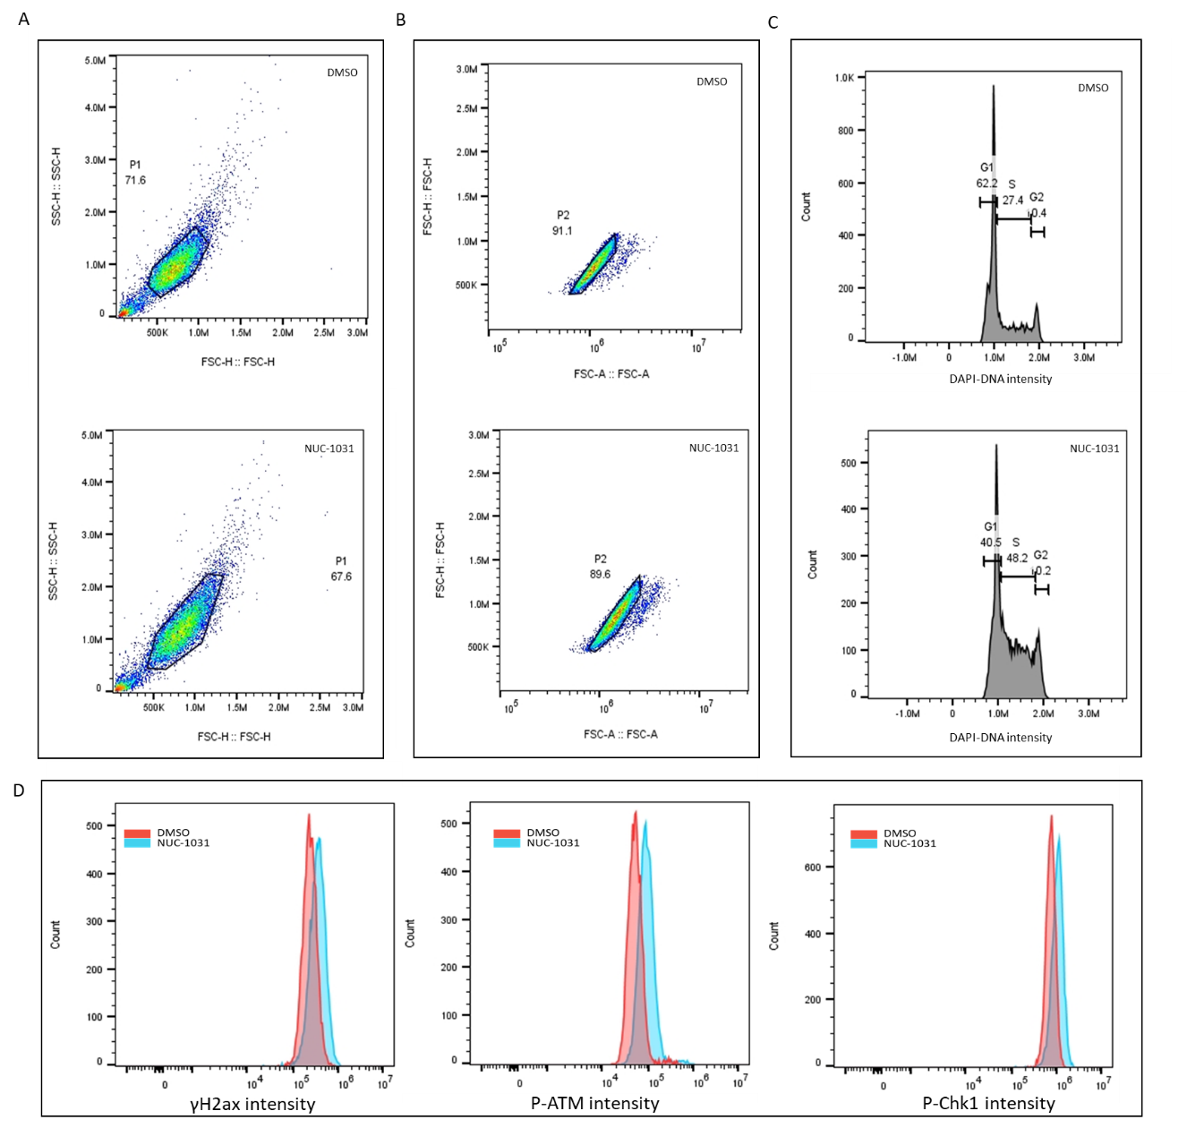
Supplementary Figure 2: Flow cytometry gating strategy for determining relative DNA damaging signals and cell cycle proportions. Single cells were gated by forward and side scatter defining P1 parameters (A). Doublets were excluded via forward scatter height and area (B). Cell cycle populations were determined by DAPI DNA staining (C), and DNA damage response signals were determined by relative fold change to DMSO-treated cells (D).
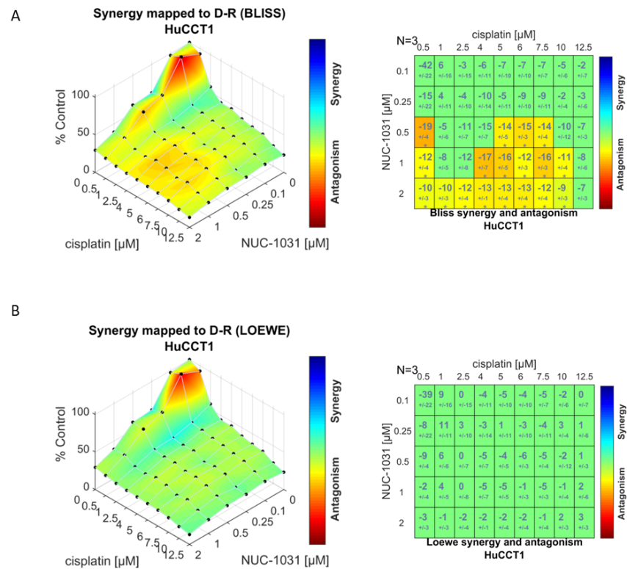
Supplementary Figure 3: Synergy and antagonism of NUC-1031 and cisplatin in HuCCT1 cells treated for 24 hours as determined by (A) Bliss and (B) Loewe null models at 96 hours post-treatment. Models of the cell viability in response to single-agent or drug combinations, as a percentage of DMSO-treated controls (bottom left). Synergy and antagonism in matrix format (bottom right) are displayed as a matrix derived from drug combinations and reference dose-response (n=3).

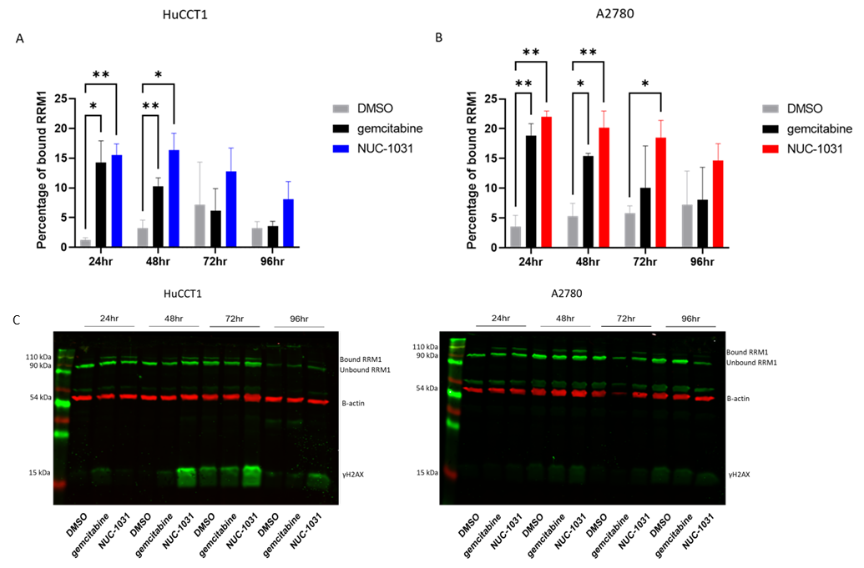
Supplementary Figure 4: Percentage of RRM1 bound by either NUC-1031 or gemcitabine in HuCCT1 (A) and A2780 cells (B), Two-way ANOVA test, n-3, ^{ns}p>0.123, *p<0.033, **p<0.002. (C) Representative whole gel Western blot scans of RRM1 and β-actin HuCCT1 and A2780 cells.

