Supplementary Information
N-doped nano-casted carbon monolith for Pb (II) removal and photocatalytic degradation of thiamethoxam from aqueous solution
Jasminder Singh^{1*}, Akansha Mehta² and Soumen Basu³
¹Department of Chemistry, School of Chemical Engineering and Physical Sciences, Lovely Professional University, Phagwara-144411, Punjab, India

² FunGlass—Centre for Functional and Surface Functionalized Glass, Alexander Dubcek University of Trencin, 91150 Trencin, Slovakia

³Department of Chemistry, Thapar Institute of Engineering and Technology, Patiala 147004, Punjab, India

Corresponding E-mail: jasminder.singh91@gmail.com

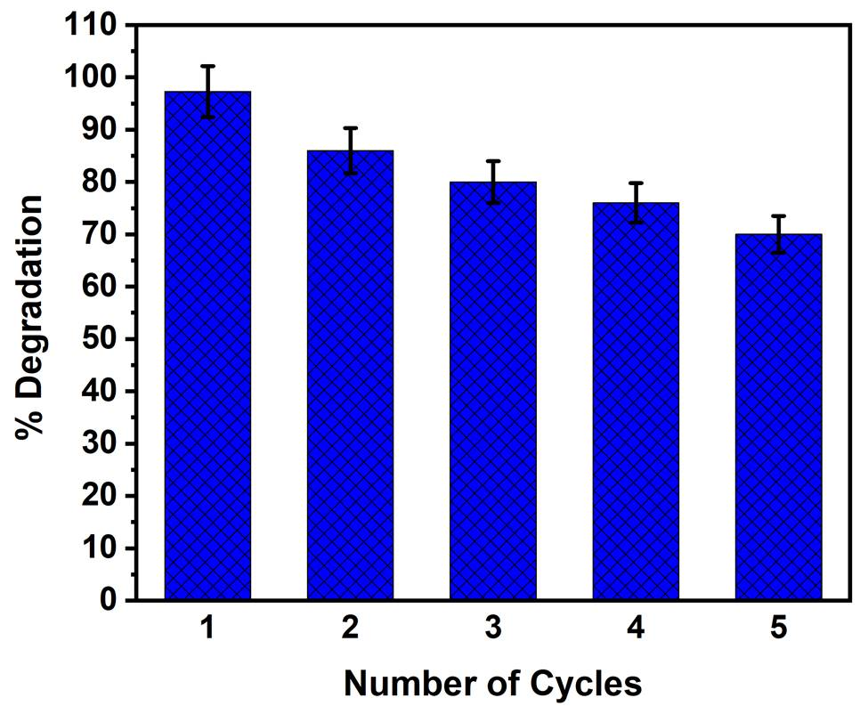
Fig. S1 Reusability studies for ND-PFCM

