Identification and validation of drugs for repurposing in Glioblastoma: a computational and experimental workflow
Gonzalez, N^{*1}; Pérez Küper, M^{*1, 2}; Garcia Fallit, M^{1, 3}; Peña Agudelo, JA¹; Nicola Candia, AJ¹; Suarez Velandia, M¹; Videla-Richardson, GA^{4, 5}; Candolfi, M¹
* Contributed equally to this work
¹Instituto de Investigaciones Biomédicas (INBIOMED, UBA-CONICET), Facultad de Medicina, Universidad de Buenos Aires, Consejo Nacional de Investigaciones Científicas y Técnicas, Ciudad Autónoma de Buenos Aires, C1121ABG, Argentina
²Departamento de Ciencia y Tecnología, Universidad Nacional de Quilmes, Quilmes, B1876, Buenos Aires, Argentina.
³Departamento de Fisiología, Biología Molecular y Celular, Facultad de Ciencias Exactas y Naturales, Universidad de Buenos Aires, Ciudad Autónoma de Buenos Aires, C1428EGA, Argentina.
⁴Fundación Para la Lucha Contra las Enfermedades Neurológicas de la Infancia (FLENI), Ciudad Autónoma de Buenos Aires, C1428AQK, Argentina.
⁵Instituto de Biología y Medicina Experimental (IByME-CONICET), Ciudad Autónoma de Buenos Aires, C1428 ADN, Argentina.

CORRESPONDING AUTHOR
Dr. Marianela Candolfi – ORCID ID: 0000-0002-0843-6568
Instituto de Investigaciones Biomédicas (UBA-CONICET)
Facultad de Medicina, Universidad de Buenos Aires
Paraguay 2155, piso 10 (C1121ABG), Buenos Aires; Argentina
Email: mcandolfi@fmed.uba.ar, marucandolfi@gmail.com
Phone/FAX +54-11-59509612
Twitter: @CandolfiLab

METHODS
Drug sensitivity prediction model
We established a workflow for identifying potentially effective drugs for GBM (Fig. 1A). We processed and analyzed data from CancerRxTissue [1] to evaluate the IC50 values of each drug in the TCGA LGG-GBM cohort, aligning patients with the most recent WHO classification of tumors of the CNS [2], which categorizes glioma patients based on the mutational status of IDH. This workflow involves three key stages (Fig. 1A): 1) identifying potential drugs; 2) in-silico analyses; and 3) in vitro validation of predicted effects.
In the first stage, we stratified TCGA glioma patients based on the 2021 WHO CNS classification to predict IC50 values. We then selected potentially effective drugs using the median of the medians of predicted IC50 values as a cut-off. The second stage consisted of in-silico evaluations that included: 1) predicting blood-brain barrier (BBB) permeability to assess drug delivery potential; 2) assessing target expression in glioma biopsies and normal brain to ensure drug specificity; and 3) evaluating target expression levels in relevant GBM cell models. In the third stage selected drugs were tested in experimental settings using glioma cells with varying molecular characteristics, as well as normal cells, to provide empirical evidence of their therapeutic potential in GBM and to validate predictions from the computational model.
Drugs
Daporinad was dissolved in dimethyl sulfoxide (DMSO) to achieve a final concentration of 10 mM. Aliquots of the stock solution were prepared to prevent repeated freeze–thaw cycles and stored at -80 °C until later use in experiments.
Dulbecco’s Modified Eagle Medium (DMEM; Cat# 12100046), Dulbecco’s Modified Eagle Medium: F-12 Nutrient Mix (DMEM/F-12; Cat# 12500062), Neurobasal Medium (Cat# 21103049), B-27 and N-2 supplements (Cat# A35828-01 and Cat# 17502-048, respectively), Geltrex LDEV-Free Reduced Growth Factor Basement Membrane Matrix (Cat# A14132-02), penicillin–streptomycin (Cat# 15140122), trypsin–EDTA (0.025%, Cat# 25200114) were obtained from Gibco (Invitrogen, Carlsbad, CA, USA). Fetal bovine serum (FBS) was acquired from Natocor (Cordoba, Argentina).

Cell Culture
Human GBM commercial cell lines (U-251 MG, (RRID:CVCL_0021); LN-229 (RRID:CVCL_0393) and U-87MG ATCC; (RRID:CVCL_0022)), and GBM neurospheres derived from murine (wtIDH and mIDH) gliomas were kindly donated by Dr Maria G Castro (University of Michigan School of Medicine, Ann Arbor, MI, USA).
Human GBM commercial cell lines, were maintained routinely in Dulbecco’s Modified Eagle Medium (DMEM) (Sigma, New York, NY, USA), supplemented with 5% fetal bovine serum (FBS) and 1% penicillin-streptomycin (PS) (Sigma, New York, NY, USA), pH 7.4, under 5% CO2 atmosphere and 37°C. Once the cells reached 80% of confluence, they were dissociated with 0.05% trypsin-ethylenediamine tetraacetic acid (EDTA) and subcultured in 100mm plastic petri dishes every three days.
Murine GBM neurospheres were cultured in DMEM-F12 supplemented with 1% penicillin-streptomycin, 1X B-27, 1X N-2, 100 g/mL Normocin, 20 ng/mL bFGF, and 20 ng/mL EGF. Neurospheres were collected and disaggregated using accutase.
Patient-derived gliomas stem cells used in this study were previously isolated from human biopsies following relevant guidelines and national regulations. Cell lines, named G02, G03, G08 and G09, have been described previously [3]. The use of these cultures for biomedical research was approved by the Research Ethics Committee “Comité de Ética en Investigaciones Biomédicas de la Fundación para la Lucha contra Enfermedades Neurológicas de la Infancia (FLENI)”. These cells were cultured on Geltrex-coated Petri dishes with serum-free neurobasal medium supplemented with glucose, sodium pyruvate, PBS-BSA (7.5 mg/mL), 1X B27, 1X N2, 20 ng/mL bFGF and EGF, 2 mM L-glutamine, 2 mM non-essential amino acids, and 50 U/mL penicillin/streptomycin. Cells were harvested using accutase
In vitro validation of therapeutic potential
The anti-tumoral effects of chemotherapeutic and alternative drugs (Temozolomide, Cisplatin and Etoposide) and Daporinad were assessed using a 3-(4,5-dimethylthiazol-2-yl)-2,5-diphenyltetrazolium bromide (MTT) colorimetric assay. For this analysis, 5,000 cells were seeded per well in 96-well plates. After 24 hours, cells were washed and incubated with 100 μL of the respective treatments (diluted in the previously described culture medium). Following 72 hours of incubation, the treatment was removed, and the wells were washed. Subsequently, 110 μL of MTT 450 μg/mL (Molecular Probes, Invitrogen, Thermo Fisher Scientific,Waltham,MA, USA) in Krebs–Henseleit solution was added to each well. Plates were then incubated for 4 hours at 37°C, and after this incubation period, were analyzed on a spectrophotometer by measuring the absorbance at 595 nm. Dose-response curves were plotted, and IC50 values were calculated through non-linear regression fit using GraphPad Prism software.
Wound closure assay
To assess human GBM migration, U-251 and LN-229 cells were seeded (100,000 cells per well) in 24-well plates and cultured under culture conditions described before. After 24 hours, cells were treated with Etoposide (1 µM) or Daporinad (10 nM) for 24 hours. A scratch wound was then made, cells were washed with phosphate-buffered saline (PBS), and reincubated in serum-free DMEM with or without treatment. Wound area was quantified using ImageJ Software after photographing at various time points.
Propidium Iodide Exclusion Assay
Cell death (apoptosis) quantification was conducted through propidium iodide staining followed by FACS analysis. For each treatment, 60,000 cells were seeded per well in 24-well plates and incubated for 24 hours. Subsequently, cells were treated with either DMSO, Etoposide (1 µM), Daporinad (10 nM), or a combination of both for 72 hours. Following treatment, cells were washed with PBS and dissociated using 0.025% trypsin–EDTA. Supernatants and detached cells were collected, centrifuged, and the supernatant was discarded. Propidium iodide stock solution (1 mg/mL in distilled water) was prepared, and a working solution was made using 1 μL of stock solution in 100 μL of PBS. Cells were resuspended in 200 μL of the working solution and immediately analyzed using a BD FACSCalibur Flow Cytometer. Flow cytometry was performed on the fluorochrome PI channel with a 488 nm excitation laser and detection of PI fluorescence using a long pass filter (556 nm) and a band pass filter (616/23 nm) for emission. Data analysis was conducted using FlowJo™ v10 Software (BD Biosciences), with 20,000 events analyzed per sample.

ONLINE SOURCES CAPTIONS
Fig. 6 TOP2A correlations with EMT gene expression. Spearman correlation between TOP2A expression levels and proteins involved in epithelial-mesenchymal transition (EMT). r, Spearman coefficient. *, p<0.05
Fig. 7 Criteria for the selection of potentially effective drugs for GBM a) Blood-brain barrier (BBB) permeability prediction of drugs evaluated in this study. BBB+, permeable; BBB-; not-permeable. b) Forest plot of progression-free interval (PFI) and overall survival (OS) in wtIDH patients between low and high expression levels of the different targets for the selected drugs
Fig. 8 NAMPT correlations with EMT gene expression. Spearman correlation between NAMPT expression levels and proteins involved in epithelial-mesenchymal transition (EMT). r, Spearman coefficient. *, p<0.05
Fig. 9 Potential of Daporinad combination with chemotherapy in GBM cells a) Spearman correlation analysis between NAMPT expression in GBM patients and TMZ predictive effect (left panel; green: NAMPT low expression; red: NAMPT high expression). r, Spearman coefficient. Temozolomide predicted IC50 for wtIDH patients stratified according to NAMPT levels (right panel; green: NAMPT low expression; red: NAMPT high expression). wtIDH patients were classified according to NAMPT expression levels into “Low” and “High” expression, using the median of expression as a cut-off. * p <0.05; Mann-Whitney test. b) Relative expression levels of NAMPT analyzed by RNA-seq in G02 and G09 cells derived from GBM biopsies. c) G02 and G09 cells were incubated with Daporinad (60 nM) and Temozolomide (150uM) alone or in combination, and 72h later cell viability was assessed by MTT assay. d) Spearman correlation analysis between NAMPT expression in GBM patients and Etoposide predictive effect (left panel; green: NAMPT low expression; red: NAMPT high expression). r, Spearman coefficient. Etoposide predicted IC50 for wtIDH patients stratified according to NAMPT levels (right panel; green: NAMPT low expression; red: NAMPT high expression). wtIDH patients were classified according to NAMPT expression levels into “Low” and “High” expression, using the median of expression as a cut-off. * p <0.05; Mann-Whitney test. e) GBM cell lines (U-251 and U-87) were incubated with Daporinad (10 nM) and Etoposide (1 µM) alone or in combination and cell death was evaluated using the iodide propidium exclusion assay by FACS analysis. *p<0.05 vs control (One-way ANOVA)
Fig. 10 Predictive effect of Temozolomide according to the expression of targets for alternative drugs. Temozolomide predicted IC50 for wtIDH patients classified according to canonical pathways expression levels into “Low” (green) and “High” (red) expression, using the median of expression of each pathway as a cut-off. * p <0.05; Mann-Whitney test
Fig. 11 Correlations of Temozolomide predictive effect with the expression of targets for alternative drugs.
Spearman correlation between Temozolomide predicted IC50 and expression levels of specific canonical pathways. Each point represents a sample, color-coded by the expression level of the pathway (green: Low, red: High). Black lines indicate linear regression. r, Spearman coefficient
Table 1 Ranking of drug efficacy prediction for novel drugs with potential effects in GBM
Table 2 Ranking of drug efficacy prediction model for BBB⁺ and BBB⁻ drugs with potential effects in GBM
Table 3 Summary of Temozolomide correlations with canonical pathways and potential drug combinations for GBM

Fig. 6 TOP2A correlations with EMT gene expression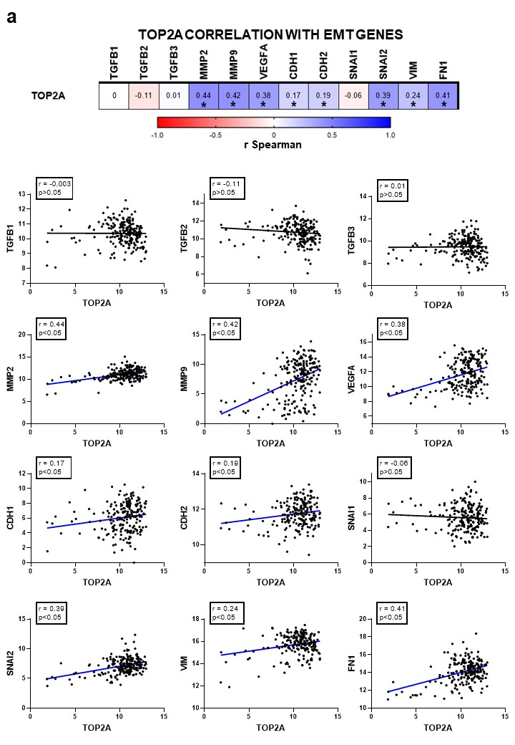

Fig. 7 Criteria for the selection of potentially effective drugs for GBM 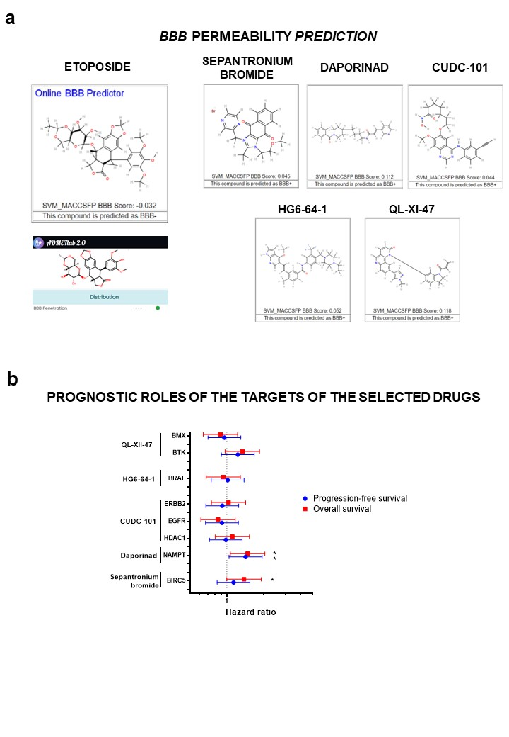

Fig. 8 NAMPT correlations with EMT gene expression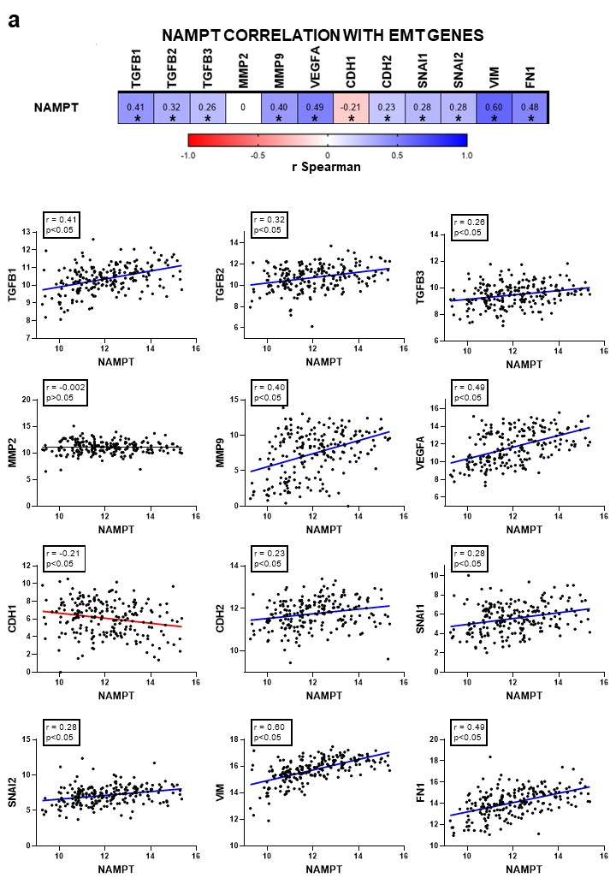

Fig. 9 Potential of Daporinad combination with chemotherapy in GBM cells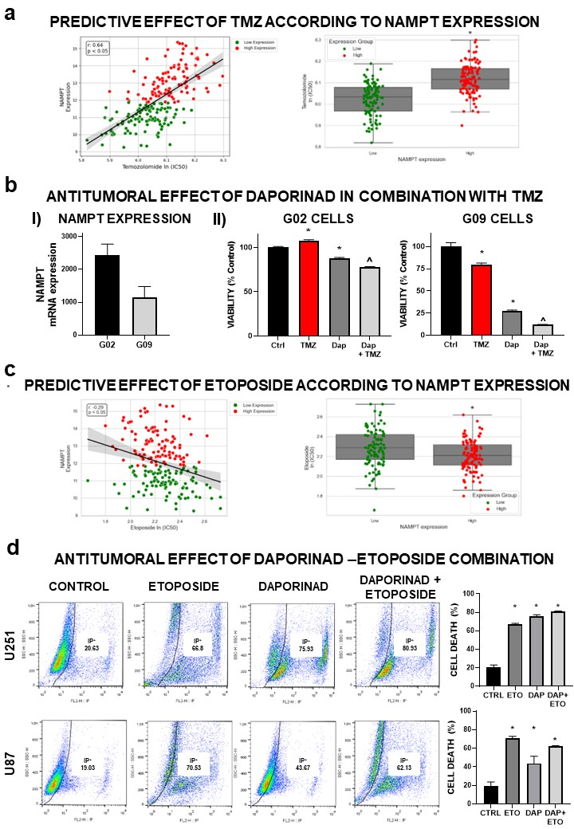

Fig. 10 Predictive effect of Temozolomide according to the expression of targets for alternative drugs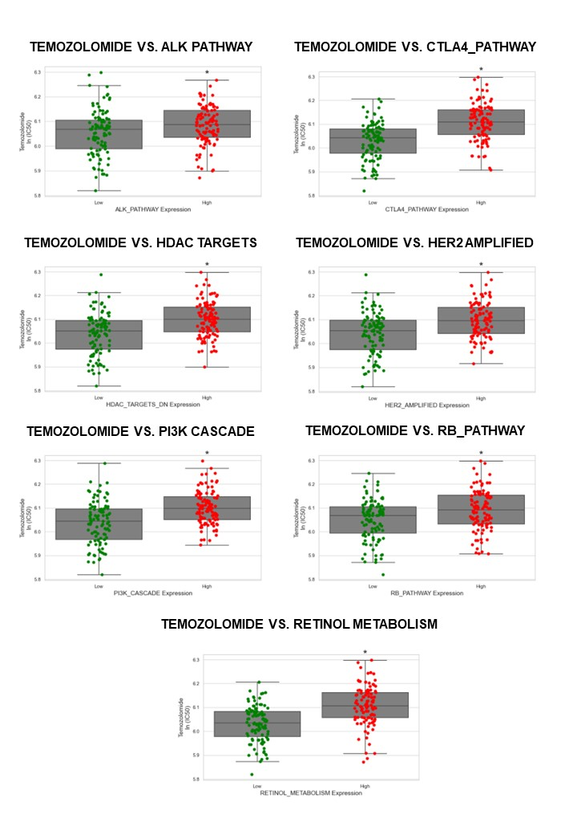

Fig. 11 Correlations of Temozolomide predictive effect with the expression of targets for alternative drugs
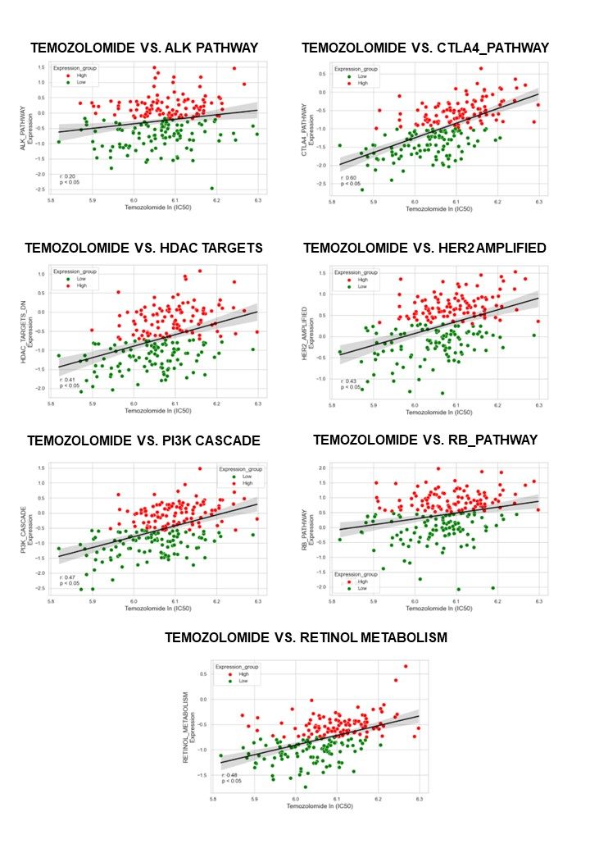
1. Li Y, Umbach DM, Krahn JM, Shats I, Li X, Li L (2021) Predicting tumor response to drugs based on gene-expression biomarkers of sensitivity learned from cancer cell lines. BMC Genomics 22: 272 doi:https://doi.org/10.1186/s12864-021-07581-7
2. Louis DN, Perry A, Wesseling P, Brat DJ, Cree IA, Figarella-Branger D, Hawkins C, Ng HK, Pfister SM, Reifenberger G, Soffietti R, von Deimling A, Ellison DW (2021) The 2021 WHO Classification of Tumors of the Central Nervous System: a summary. Neuro Oncol 23: 1231-1251 doi: https://doi.org/10.1093/neuonc/noab106
3. Videla Richardson GA, Garcia CP, Roisman A, Slavutsky I, Fernandez Espinosa DD, Romorini L, Miriuka SG, Arakaki N, Martinetto H, Scassa ME, Sevlever GE (2016) Specific Preferences in Lineage Choice and Phenotypic Plasticity of Glioma Stem Cells Under BMP4 and Noggin Influence. Brain pathology (Zurich, Switzerland) 26: 43-61 doi: https://doi.org/10.1111/bpa.12263

