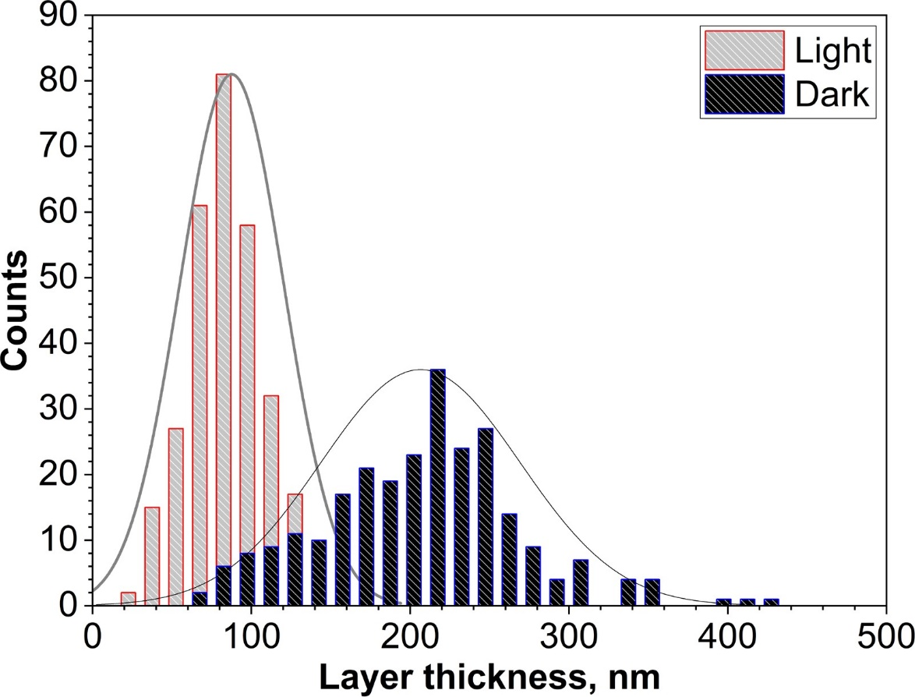

Figure S1: The measured nanolamellae thickness distribution for BCC (Light) and FCC (Dark) in the as-printed EHEA Ni₄₀Co₂₀Fe₁₀Cr₁₀Al₁₈W₂.

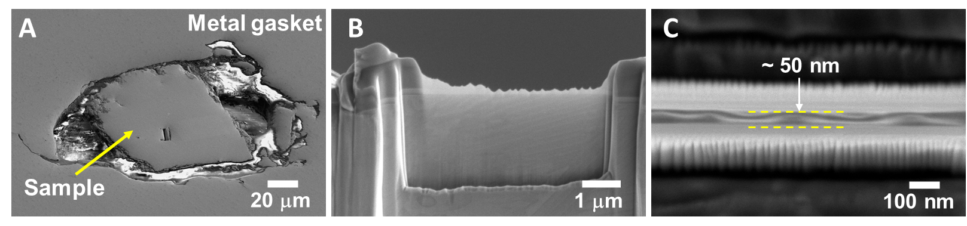

Figure S2: Ni₄₀Co₂₀Fe₁₀Cr₁₀Al₁₈W₂ EHEA sample at the center of the metal gasket after diamond anvil cell compression (A), side (B), and top (C) views of TEM specimen lifted out from the sample using gallium-ion milling method.

Table S1: Measured lattice spacings from SADP in Figure 3B and simulated spacings for FCC and BCC phases.
Measured lattice spacings, nm | Simulated lattice spacings, nm
Measured lattice spacings, nm | FCC (a=0.3591 nm) | BCC (a=0.2872 nm)
0.208 | 0.206 (111) | 0.203 (110)
0.127 | 0.126 (220) | 0.128 (210)
0.114 | 0.113 (310) | 0.117 (211)
0.108 | 0.108 (311)
0.104 | 0.104 (222) | 0.102 (220)
0.086 | 0.086 (322) | 0.087 (311)
0.080 | 0.080 (420) | 0.080 (320)
0.073 | 0.073 (422) | 0.072 (400)

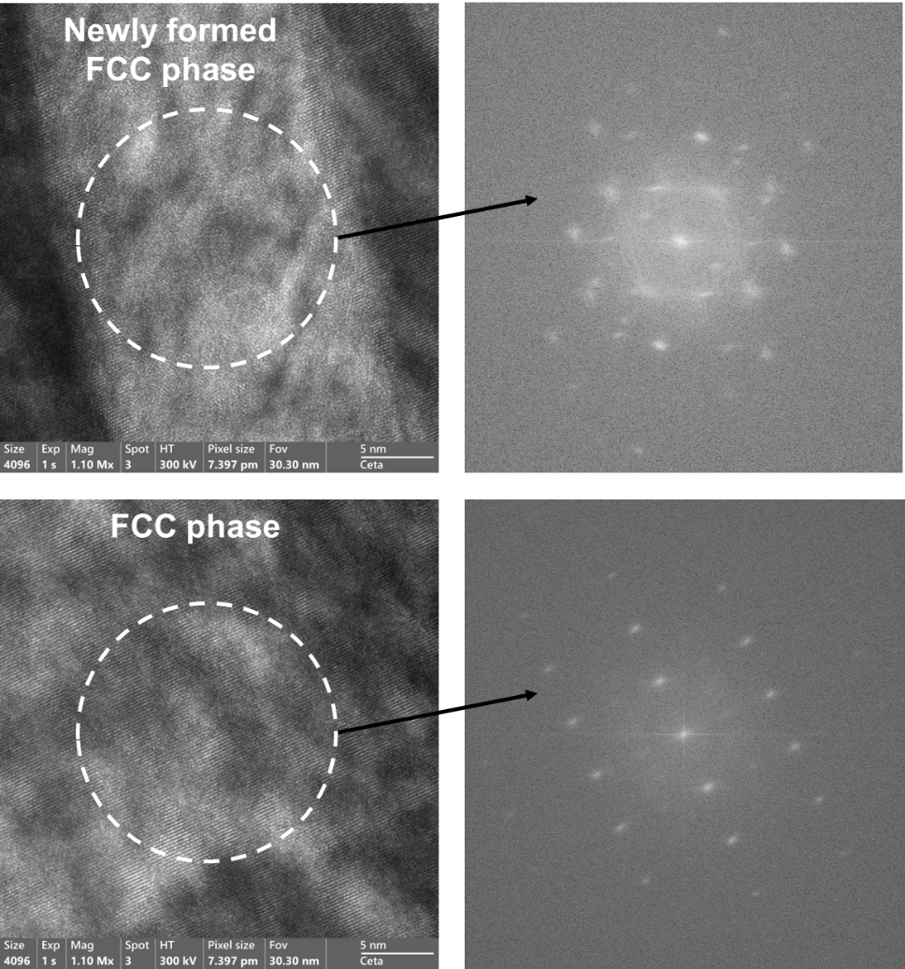

Figure S3: High-resolution TEM and Fast Fourier Transform (FFT) images of two FCC phases in the recovered sample.
Table S2: Elemental analysis of as-printed EHEA Ni₄₀Co₂₀Fe₁₀Cr₁₀Al₁₈W₂ for both BCC and FCC phases
Element | BCC-Phase (atomic %) | FCC-Phase (atomic %)
Al | 27.41 ± 1.93 | 10.83 ± 0.76
Cr | 4.16 ± 0.61 | 12.39 ± 1.67
Fe | 6.94 ± 0.99 | 11.50 ± 1.56
Co | 15.44 ± 2.02 | 22.96 ± 2.76
Ni | 45.20 ± 3.79 | 39.75 ± 3.83
W | 0.85 ± 0.10 | 2.57 ± 0.31

Table S3: Elemental analysis of pressure recovered EHEA Ni₄₀Co₂₀Fe₁₀Cr₁₀Al₁₈W₂ sample for the two FCC phases.
Element | FCC-Phase (atomic %)  (pressure formed) | FCC-Phase (atomic %)  (as printed)
Al | 23.07 ± 1.74 | 9.58 ± 0.71
Cr | 3.89 ± 0.58 | 10.84 ± 1.51
Fe | 7.22 ± 1.04 | 11.42 ± 1.58
Co | 16.55 ± 2.19 | 22.32 ± 2.75
Ni | 48.40 ± 3.86 | 43.69 ± 3.95
W | 0.88 ± 0.11 | 2.15 ± 0.27

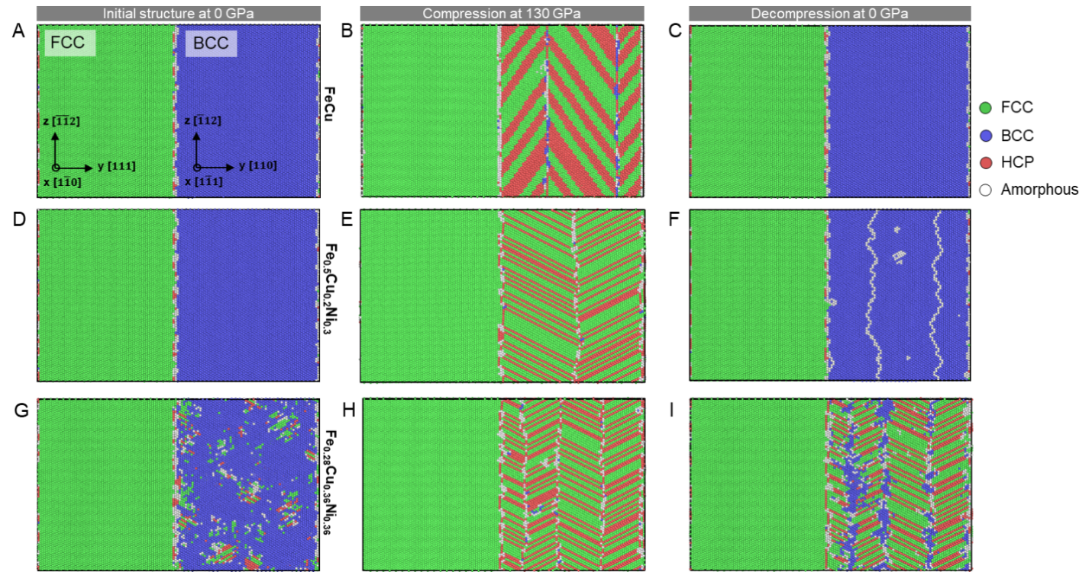
Figure S4: Atomistic simulation of BCC → FCC transition in different dual phase models. (A-C) BCC phase is FeCu B2 structure. Atomic slides show structural distribution at (A) initial state, (B) compressed at 130 GPa, (C) decompressed at 0 GPa. (D-F) BCC phase is RSS Fe_{0.5}Cu_{0.2}Ni_{0.3}. (G-I) BCC phase is RSS Fe_{0.5}Cu_{0.2}Ni_{0.3}.

