Supplementary material

Characterization of polystyrene-degrading bacteria isolated from plastic processing plants

Table S1
List and number of bacterial strains, isolated from plastic raw material or plastic final products from three processing plants.

Microorganism | No. (%) of strains
Gram positive bacteria | 93 (96.87)
Staphylococcus spp. | 38 (39.58)
S. epidermidis | 15 (15.62)
S. warneri | 3 (3.12)
S. aureus | 6 (6.25)
S. condimenti | 1 (1.04)
S.saprophyticus | 1 (1.04)
S. haemolyticus | 2 (2.08)
S. cohnii | 1 (1.04)
S. capitis | 2 (2.08)
S. hominis | 7 (7.29)
Micrococcus spp. | 11 (11.45)
M. luteus | 11 (11.45)
Bacillus spp. | 44 (45.83)
B. megaterium | 1 (1.04)
B. cereus | 12 (12.5)
B. licheniformis | 14 (14.58)
B. clausii | 1 (1.04)
B. subtilis | 4 (4.07)
B. pumilus | 6 (6.25)
B. safensis | 1 (1.04)
Brevibacillus parabrevis | 4 (4.17)
Lysinibacillus boronitolerans | 1 (1.04)
Gram-negative bacteria | 3 (3.1)
Moraxella nonliquefaciens | 1 (1.04)
Burkholderia fungorum | 2 (2.08)
Total | 96 (100 %)

Fig. S1 The concentration of bacterial strains after 60 days incubation at 37 °C in MSM and NB in the presence of PS.
Strain No. 1: Burkholderia fungorum; 2: Bacillus subtilis; 3: Bacillus licheniformis; 4: Micrococcus luteus; 5: Micrococcus luteus; 6: Bacillus cereus; 7: Moraxella nonliquefaciens; 8: Bacillus licheniformis; 9: Bacillus cereus; 10: Micrococcus luteus

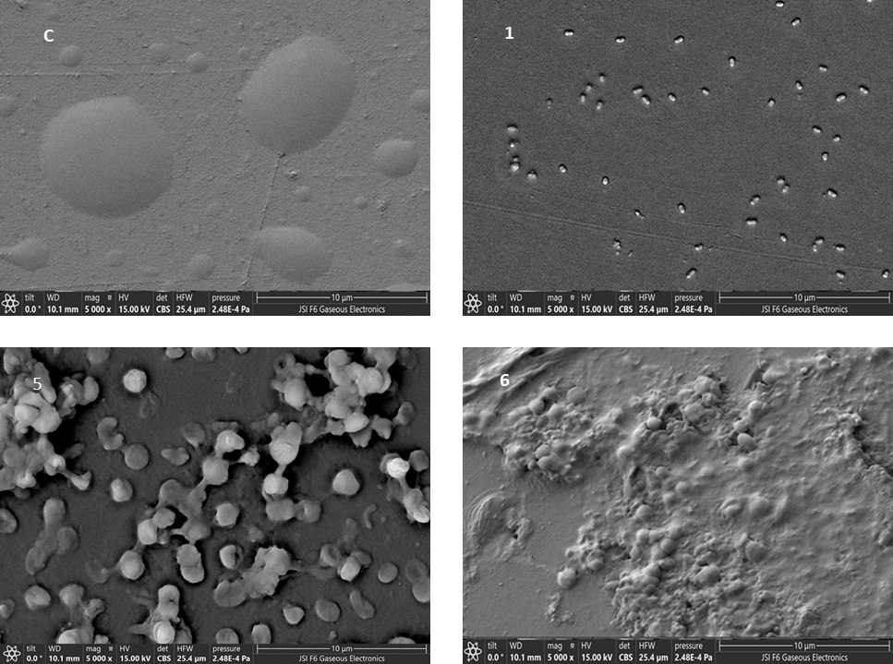

Fig. S2 SEM images of the biofilms formed on PS coupons after 60 days incubation in MSM at 37 °C, taken at the magnification of 5,000 ×.
C. negative control without bacteria; 1: Burkholderia fungorum; 4: Micrococcus luteus; 6: Bacillus cereus.

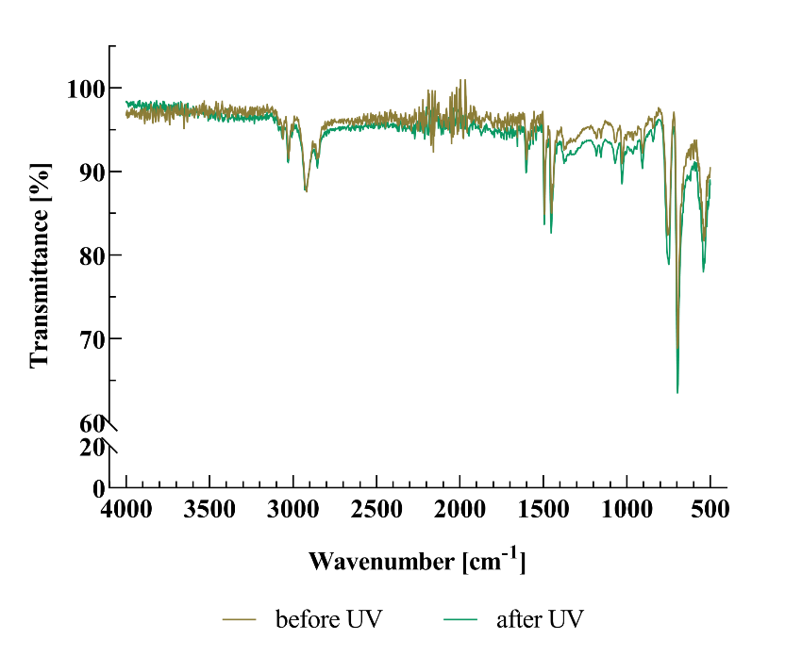

Fig. S3 ATR-FTIR spectra of pristine PS pellets (before UV) and PS pellets after 30 minutes exposure to UV light (after UV).

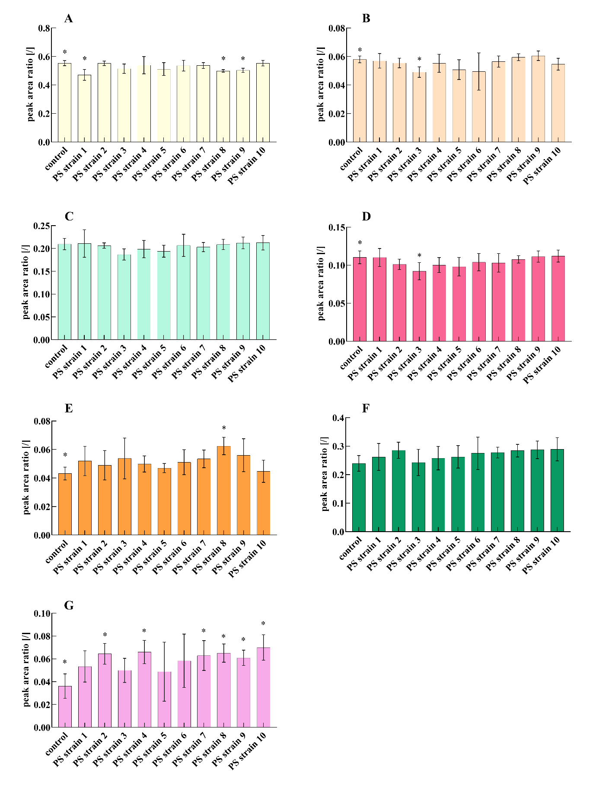
Fig. S4 ATR-FTIR vibrational band ratios: A - 750 cm⁻¹/696 cm⁻¹, B - 1027 cm⁻¹/696 cm⁻¹, C - 1455 cm⁻¹/696 cm⁻¹, D - 1494 cm⁻¹/696 cm⁻¹, E - 2850 cm⁻¹/696 cm⁻¹, F - 2924 cm⁻¹/696 cm⁻¹, and G - 3026 cm⁻¹/696 cm⁻¹. * Signifies the statistically significant differences between the sample and the control (p < 0,05).PS strain No. 1: Burkholderia fungorum; 2: Bacillus subtilis; 3: Bacillus licheniformis; 4: Micrococcus luteus; 5: Micrococcus luteus; 6: Bacillus cereus; 7: Moraxella nonliquefaciens; 8: Bacillus licheniformis; 9: Bacillus cereus; 10: Micrococcus luteus.

