Supplementary Information

Supplementary Table S1. Search strategy
Supplementary Table S2. Quality assessment
Supplementary Figure S1. Leave-one-out sensitivity analysis
Supplementary Figure S2. Subgroup analysis (High-income countries versus middle-income countries)
Supplementary Table S1. Search strategy

Database: PubMed last ran on: Mar 1, 2024
#1 | "nutritional status"[Mesh] OR "nutrition assessment"[Mesh] OR "malnutrition"[Mesh] OR nutrition OR nourishment OR diet* OR nourish* "adequate nutrition" OR "inadequate nutrition" OR proper nutrition OR "appropriate nutrition" OR "sufficient nutrition" OR "insufficient nutrition" OR malnutrition OR "nutrition deficiency" | 23,859
#2 | outcome* OR result* OR consequence* OR immediate outcome* pre-operative OR pre-op* OR post-operative OR post-surgery OR after surgery OR hospital outcome* OR length of stay OR hospital acquired infection* OR inotrope* OR length of mechanical ventilation | 1,484,863
#3 | child* OR children OR toddler OR kid OR infant OR newborn | 1,543,596
#4 | "heart defects, congenital"[Mesh] OR "cardiac surgical procedures"[Mesh] OR congenital heart disease OR CHD OR congenital heart disease surgery OR congenital cardiac defect OR heart surgery | 86,044
#5 | #1 AND #2 AND #3 AND #4 | 234
Filters applied: English, Child: birth-18 years, from 2000 - 2024

Supplementary Table S2. Quality assessment
Author | Title | Selection |  |  |  | Comparability | Outcome |  |  | Score | Threshold
Author | Title | Representativeness of Exposed Cohort | Selection of Non-Exposed Cohort | Ascertainment of Exposure | Demonstration That Outcome of Interest Not Present at Start of Study | Comparability of Cohorts on the Basis of the Design or Analysis Controlled for Confounders | Assessment of Outcome | Follow-up Long Enough for Outcomes to Occur | Follow-up Adequacy | Score | Threshold
Souza 2020 | Association of nutritional status and clinical outcomes in pediatric cardiac surgery | Truly representative | Drawn from the same community as the exposed cohort | Secure record | Yes | Study controls for other factors (age, sex, weight, height) | Record linkage | Yes (follow up was immediate post-op only, it accounted for the study outcomes) | Complete follow up- all subjects accounted for | 8 | Good quality
Luo 2020 | The nutritional status of pediatric patients with single ventricle undergoing a bidirectional Glenn procedure | Truly representative | Drawn from the same community as the exposed cohort | Secure record | Yes | Study controls for other factors (age, sex, weight, height) | Record linkage | Yes (follow up was immediate post-op only, it accounted for the study outcomes) | Complete follow up- all subjects accounted for | 8 | Good quality
Lim 2019 | The impact of pre-operative nutritional status on outcomes following congenital heart surgery | Truly representative | Drawn from the same community as the exposed cohort | Secure record | Yes | Study controls for other factors (age, sex, weight, height) | Record linkage | Yes (follow up was immediate post-op only, it accounted for the study outcomes) | Complete follow up- all subjects accounted for | 8 | Good quality
Vivanco-Munoz 2010 | Impact of nutritional support on length of hospitalization and mortality in children after open heart surgery | Truly representative | Drawn from the same community as the exposed cohort | Secure record | Yes | Study controls for other factors (age, sex, weight, height) | Record linkage | Yes (follow up was immediate post-op only, it accounted for the study outcomes) | Complete follow up- all subjects accounted for | 8 | Good quality
Reddy 2015 | Preoperative determinants of outcomes of infant heart surgery in a limited-resource setting | Truly representative | Drawn from the same community as the exposed cohort | Secure record | Yes | Study controls for other factors (age, sex, weight, height) | Record linkage | Yes (follow up was immediate post-op only, it accounted for the study outcomes) | Complete follow up- all subjects accounted for | 8 | Good quality
AlSoufi 2014 | Low-weight infants are at increased mortality risk after palliative or corrective cardiac surgery | Truly representative | Drawn from the same community as the exposed cohort | Secure record | Yes | Study controls for other factors (age, sex, weight, height) | Record linkage | Yes (mean follow-up: 5.8 ± 3.7 years) | Follow-up was 89% complete. | 8 | Good quality
Silva-Gburek 2023 | Perioperative nutritional status and organ dysfunction following surgery for congenital heart disease | Truly representative | Drawn from the same community as the exposed cohort | Secure record | Yes | Study controls for other factors (age, sex, weight, height) | Record linkage | Yes (follow up was till post-op day 3, it accounted for the study outcomes) | Complete follow up- all subjects accounted for | 8 | Good quality
Sethasathien 2022 | Prevalence and predictive factors of malnutrition in Thai children with congenital heart disease and short-term postoperative growth outcomes | Truly representative | Drawn from the same community as the exposed cohort | Secure record | Yes | Study controls for other factors (age, sex, weight, height, ethnicity) | Record linkage | Yes (follow up was immediate post-op & at 2 weeks after discharge, it accounted for the study outcomes) | Complete follow up- all subjects accounted for | 8 | Good quality
Marwali 2015 | Does malnutrition influence outcome in children undergoing congenital heart surgery in a developing country? | Truly representative | Drawn from the same community as the exposed cohort | Secure record | Yes | Study controls for other factors (age, sex, weight) | Record linkage | Yes (follow up was immediate post-op & at 2 weeks after discharge, it accounted for the study outcomes) | Follow-up not required for the variables being studied | 6 | Fair quality
Mitting 2015 | Nutritional status and clinical outcome in postterm neonates undergoing surgery for congenital heart disease | Truly representative | Drawn from the same community as the exposed cohort | Secure record | Yes | Study controls for other factors (age, sex, weight, height) | Record linkage | Yes (study outcomes don't warrant follow-up after discharge) | Complete follow up- all subjects accounted for | 8 | Good quality
Assy 2023 | Effect of preoperative nutritional status on postoperative outcomes in children with congenital heart diseases undergoing surgical repair | Truly representative | Drawn from the same community as the exposed cohort | Secure record | Yes | Study controls for other factors (age, sex, weight, height) | Record linkage | Yes (follow up was immediate post-op & at 30 days after discharge, it accounted for the study outcomes) | Complete follow up- all subjects accounted for | 8 | Good quality
Huang 2023 | Preoperative nutritional status of infants with non-restricted ventricular septal defect and its influence on postoperative recovery | Truly representative | Drawn from the same community as the exposed cohort | Secure record | Yes | Study controls for other factors (age, sex, weight) | Record linkage | Yes (study outcomes don't warrant follow-up after discharge) | Complete follow up- all subjects accounted for | 8 | good quality
Newell 2018 | Obesity: risk factor for increased resource utilization at bidirectional Glenn | Truly representative | Drawn from the same community as the exposed cohort | Secure record | Yes | Study controls for other factors (age, sex, weight) | Record linkage | Yes (study outcomes don't warrant follow-up after discharge) | Complete follow up- all subjects accounted for | 8 | good quality
Sekhon 2023 | Incidence and impact of malnutrition in patients with Fontan physiology | Truly representative | Drawn from the same community as the exposed cohort | Secure record | Yes | Study controls for other factors (age, sex, weight, height) | Record linkage | Yes (follow up was at immediate discharge, 6 months, 1, 5, and 10 years) | Follow-up 43% complete [at the time of publication, 9 patients had not reached the 5‐year time point and 21 had not reached the 10‐year time point. total patients: 69] | 7 | good quality
Shivashankaran 2023 | Association between preoperative risk factors and outcome of cardiac surgery in children presenting with congenital heart disease in a tertiary care hospital in South India | Truly representative | Drawn from the same community as the exposed cohort | Secure record | Yes | Study controls for other factors (age, sex, weight) | Record linkage | Yes (patients were also followed up at 1 and 3-month intervals) | Complete follow up- all subjects accounted for | 8 | good quality
Toole 2014 | Perioperative nutritional support and malnutrition in infants and children with congenital heart disease | Truly representative | Drawn from the same community as the exposed cohort | Secure record | Yes | Study controls for other factors (age, sex, weight, length) | Record linkage | Yes (study outcomes don't warrant follow-up after discharge) | Complete follow up- all subjects accounted for | 8 | good quality

Supplementary Figure S1. Leave-one-out sensitivity analysis

- Length of stay in the hospital (days)
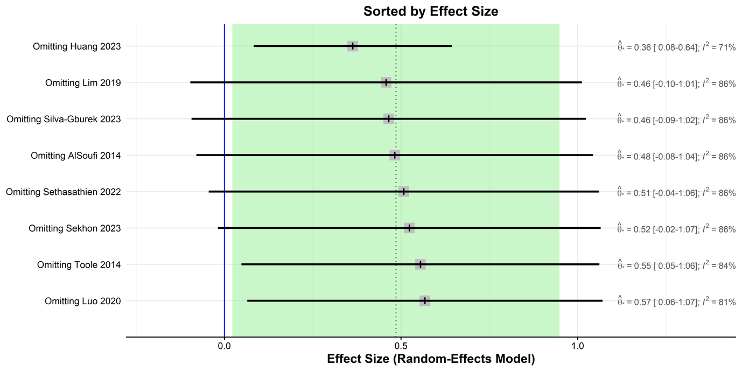

- Length of stay in the intensive care unit (days)
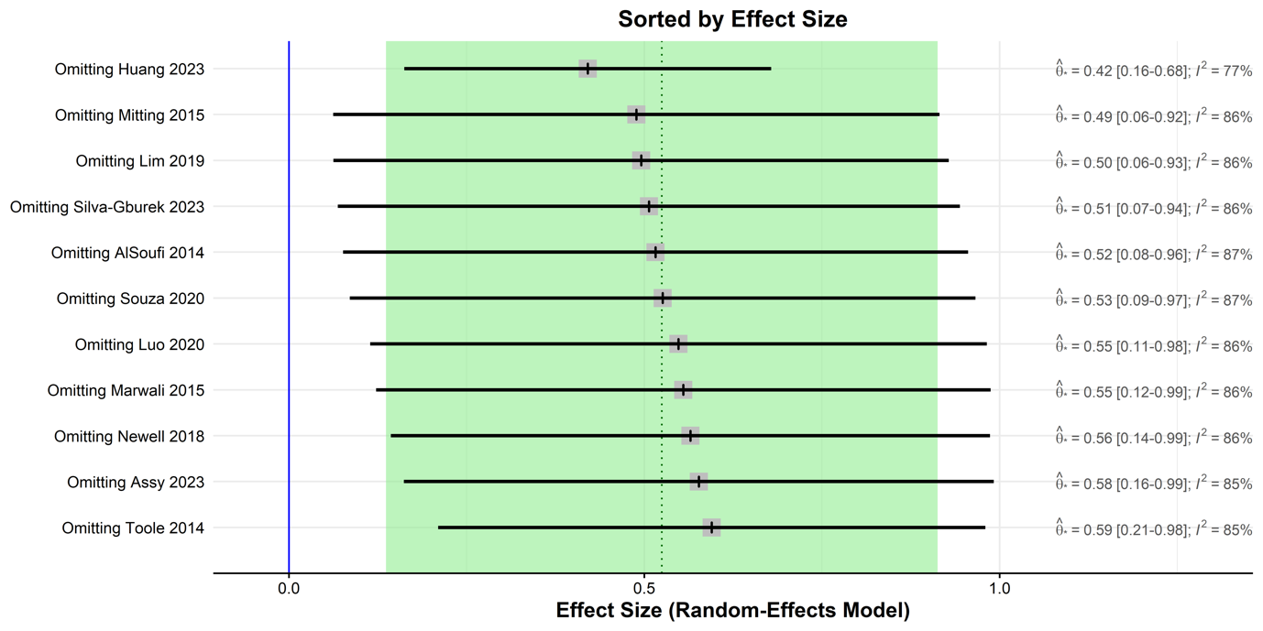

- Risk Adjustment for Congenital Heart Surgery-1 (RACHS-1) or the Society of Thoracic Surgeons-European Association for Cardio-Thoracic Surgery (STAT) score >4
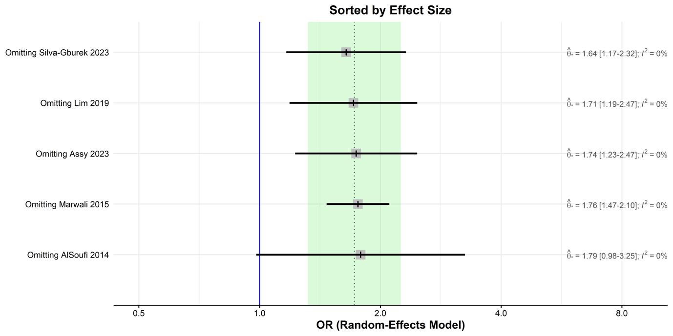

- Mechanical ventilation time (hours)
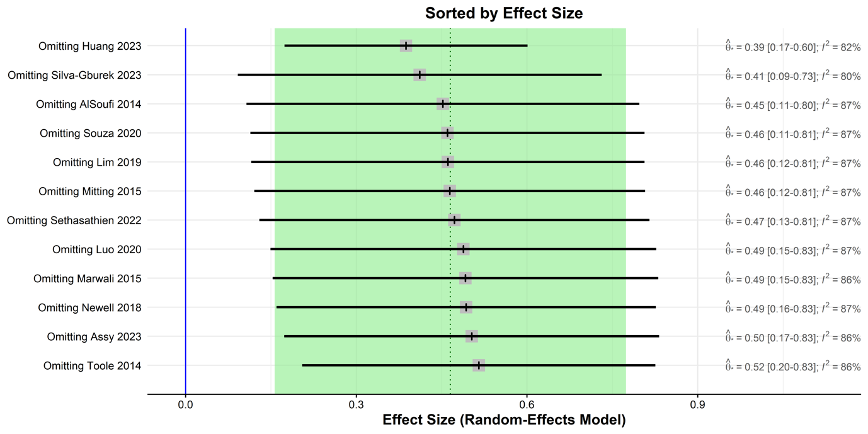

- Mortality (odds ratio between malnourished and well-nourished patients)
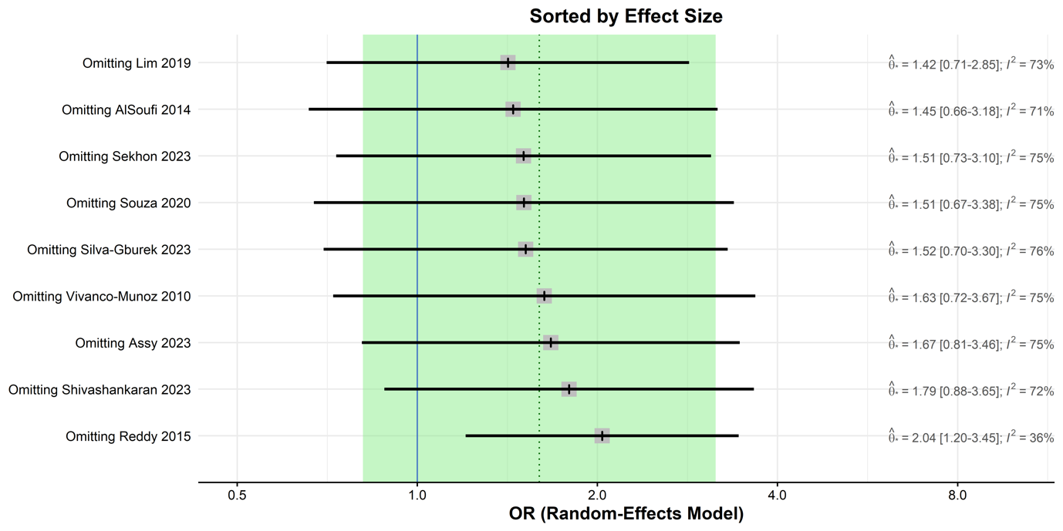

- Post-operative infections (odds ratio between malnourished and well-nourished patients)

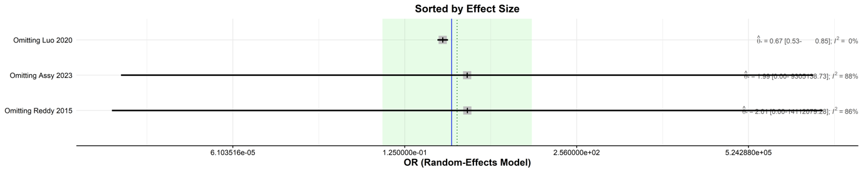

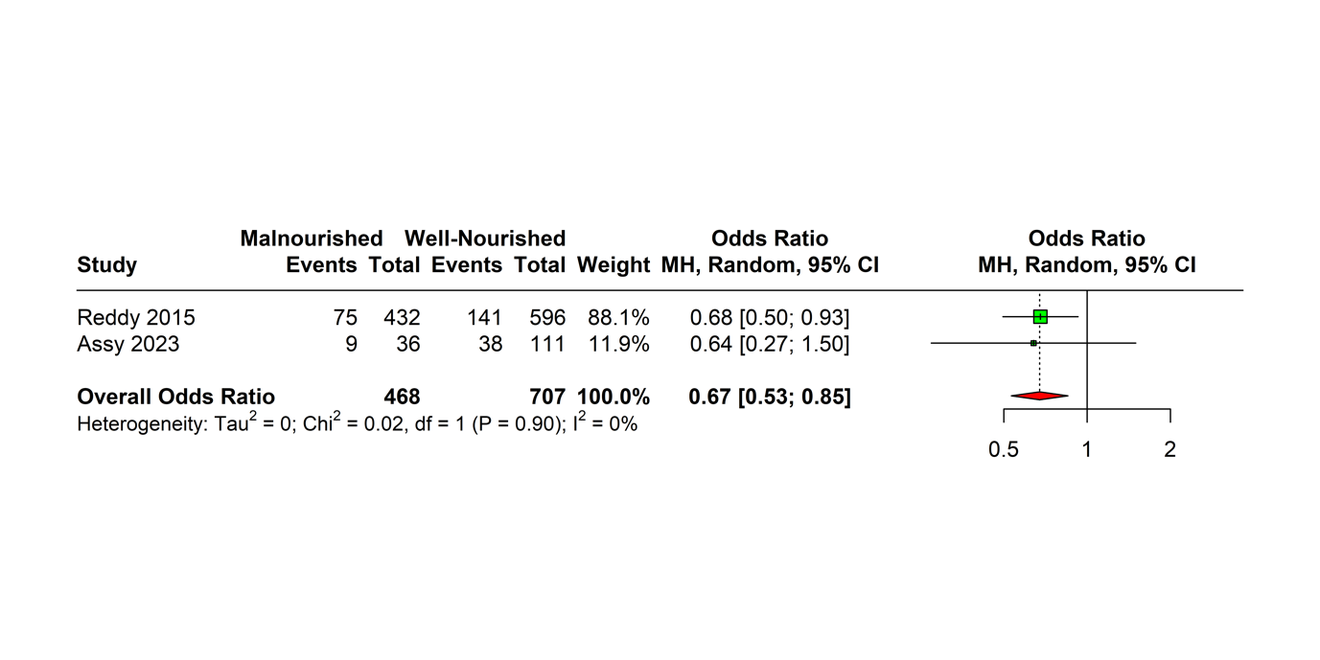

Supplementary Figure S2. Subgroup analysis (High-income countries versus middle-income countries)

- Length of stay in the hospital (days)
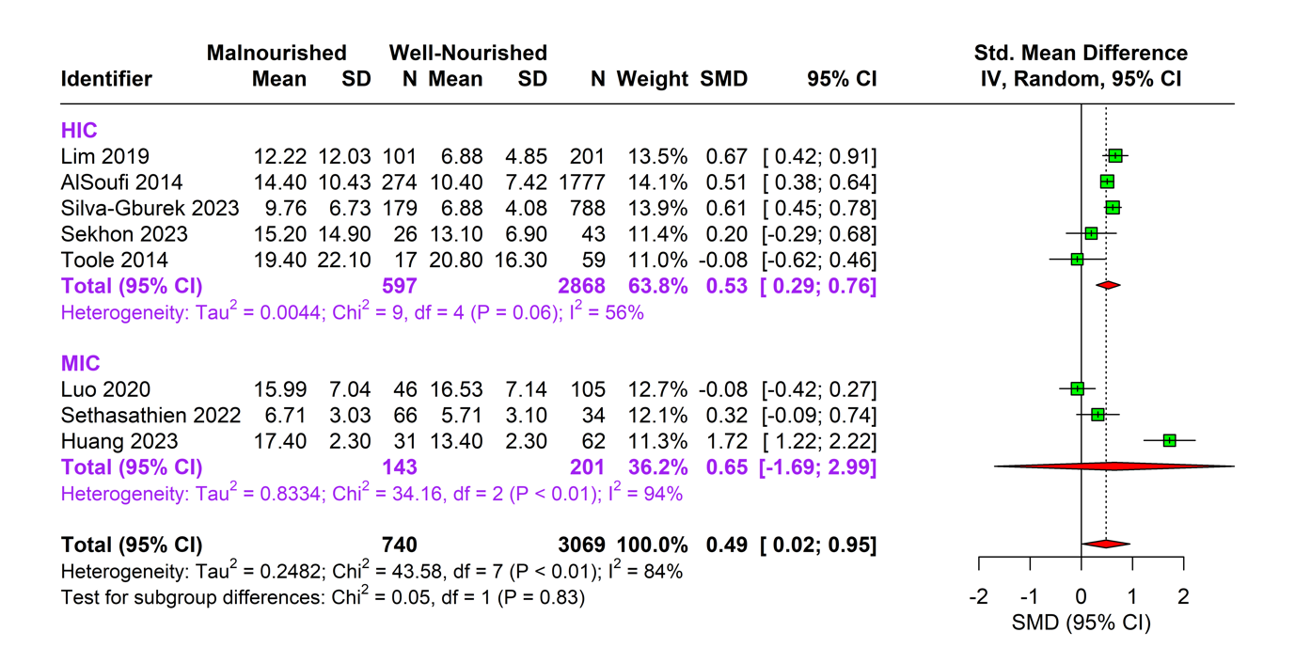

- Length of stay in the intensive care unit (days)
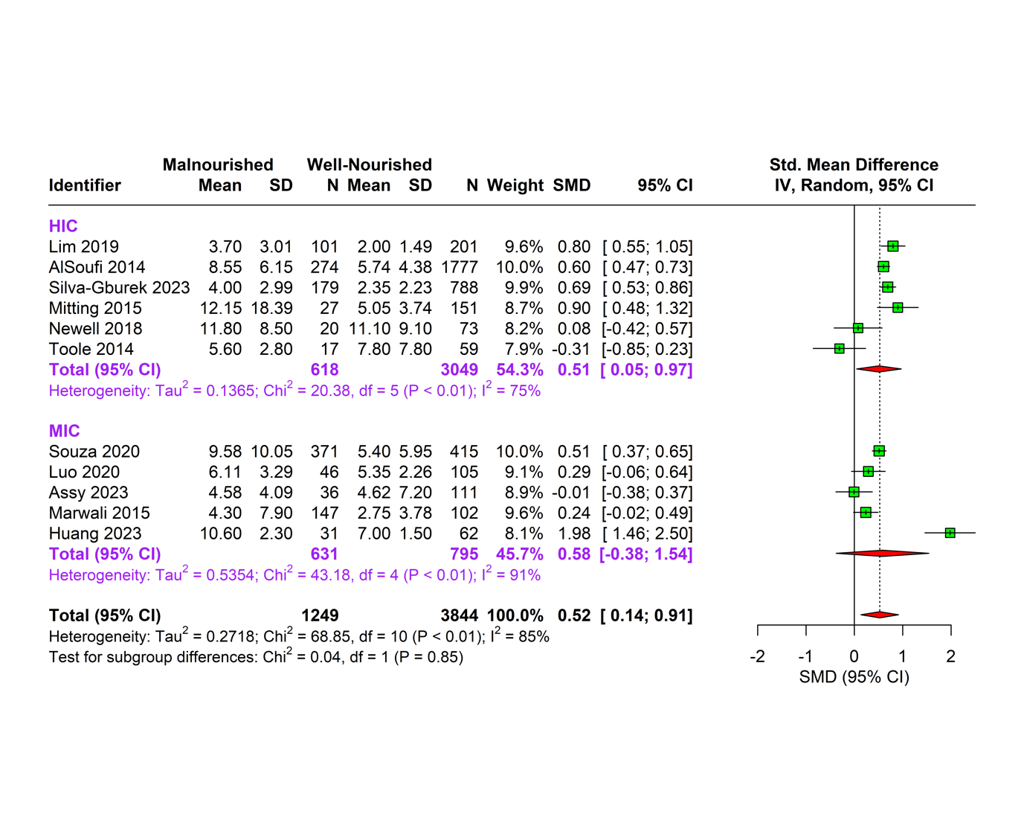

- Risk Adjustment for Congenital Heart Surgery-1 (RACHS-1) or the Society of Thoracic Surgeons-European Association for Cardio-Thoracic Surgery (STAT) score >4
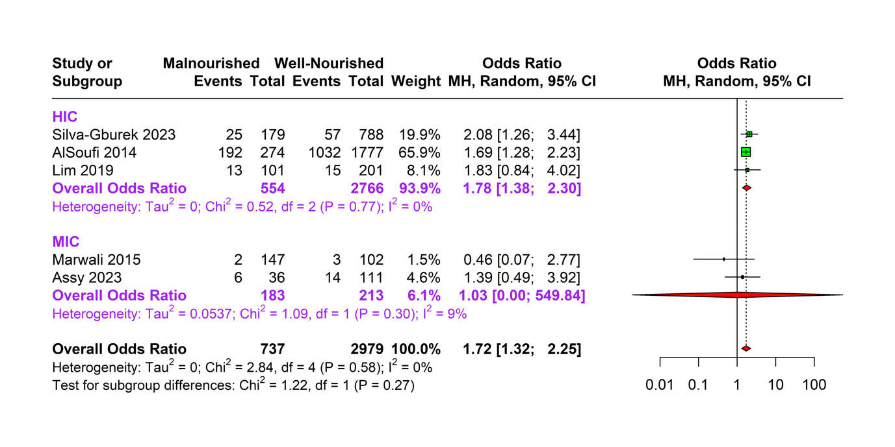

- Mechanical ventilation time (hours)
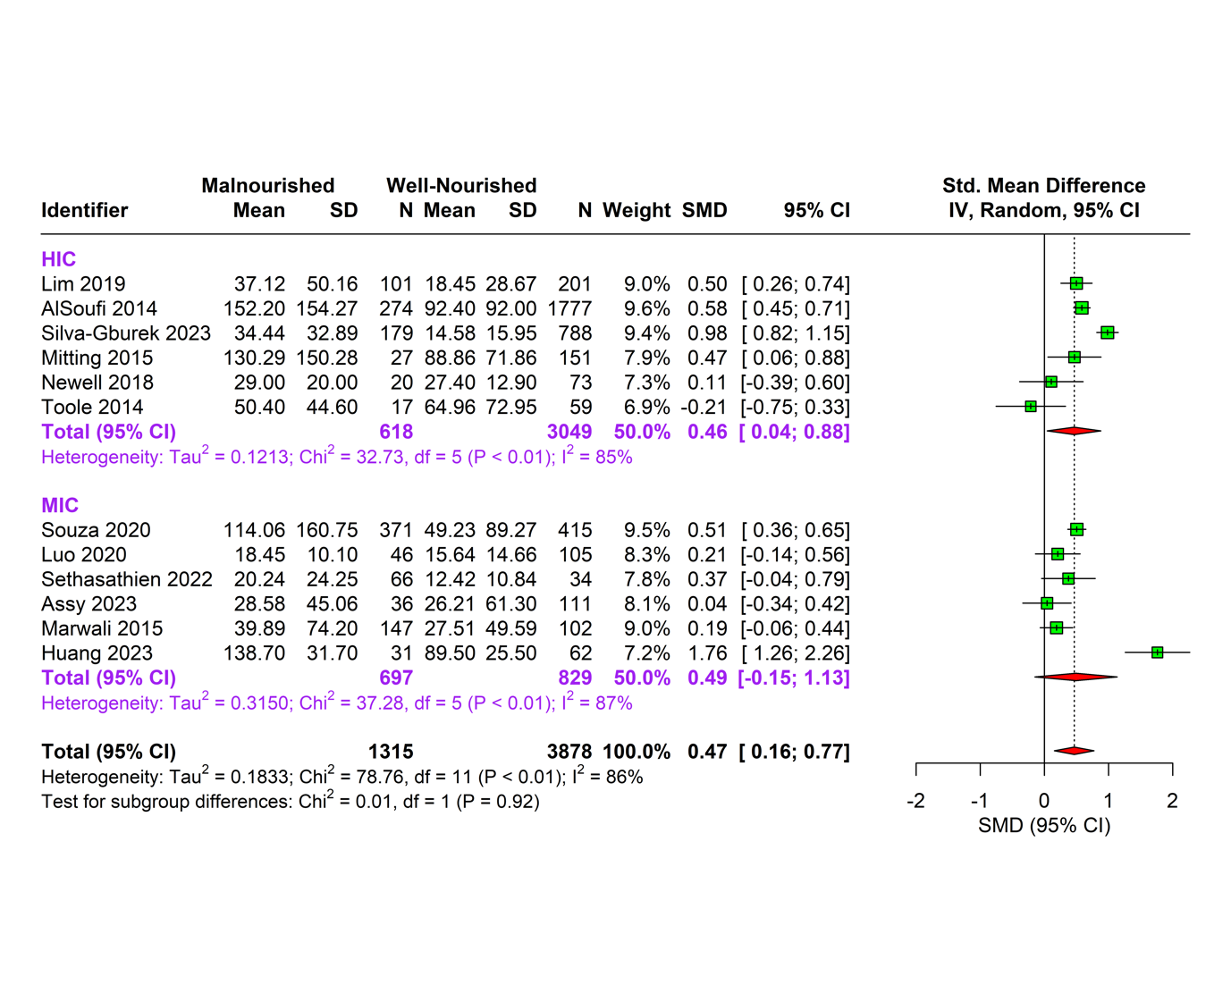

- Mortality (odds ratio between malnourished and well-nourished patients)
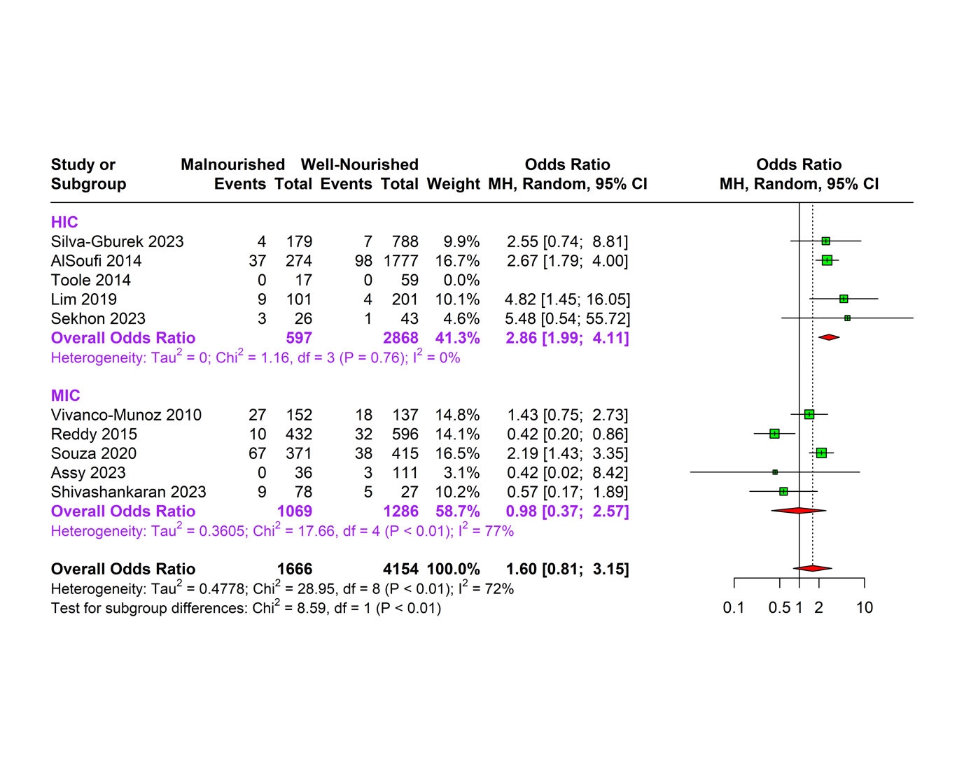

- Mortality (pooled prevalence in malnourished patients)
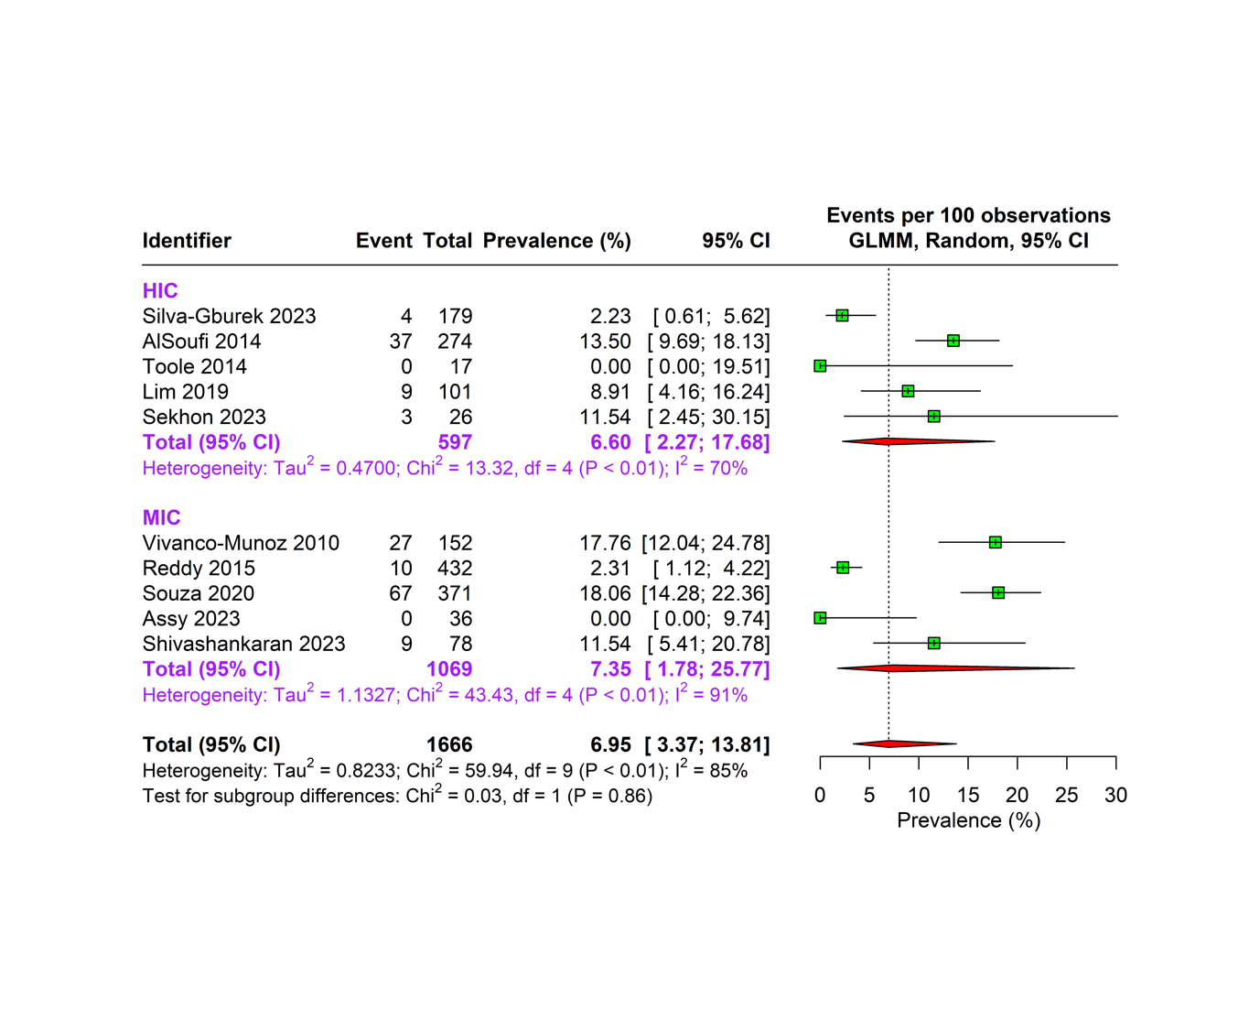

- Mortality (pooled prevalence in well-nourished patients)
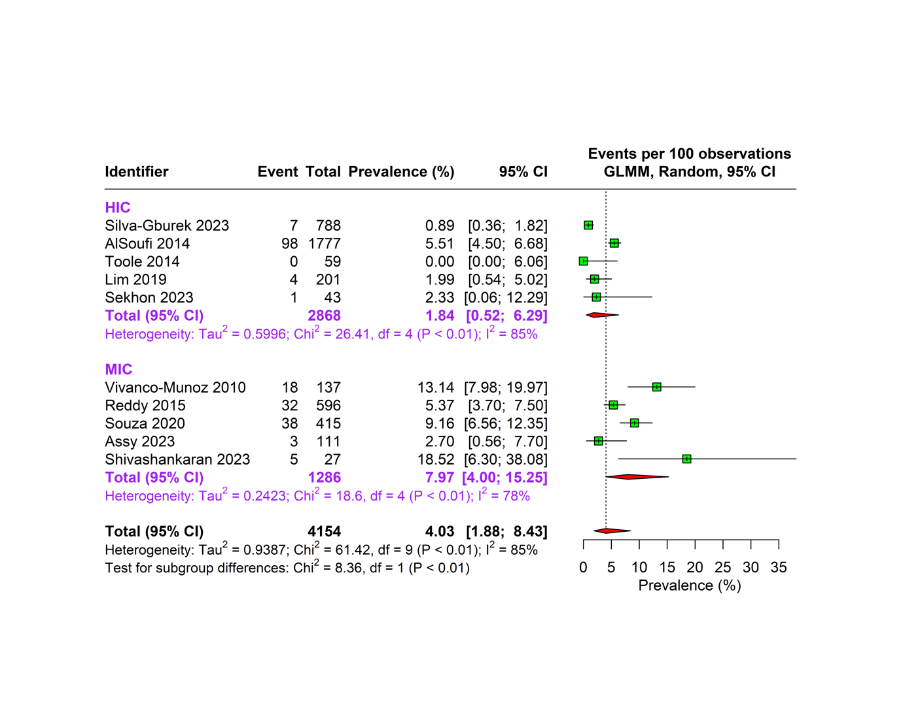

- Post-operative infections (odds ratio between malnourished and well-nourished patients)
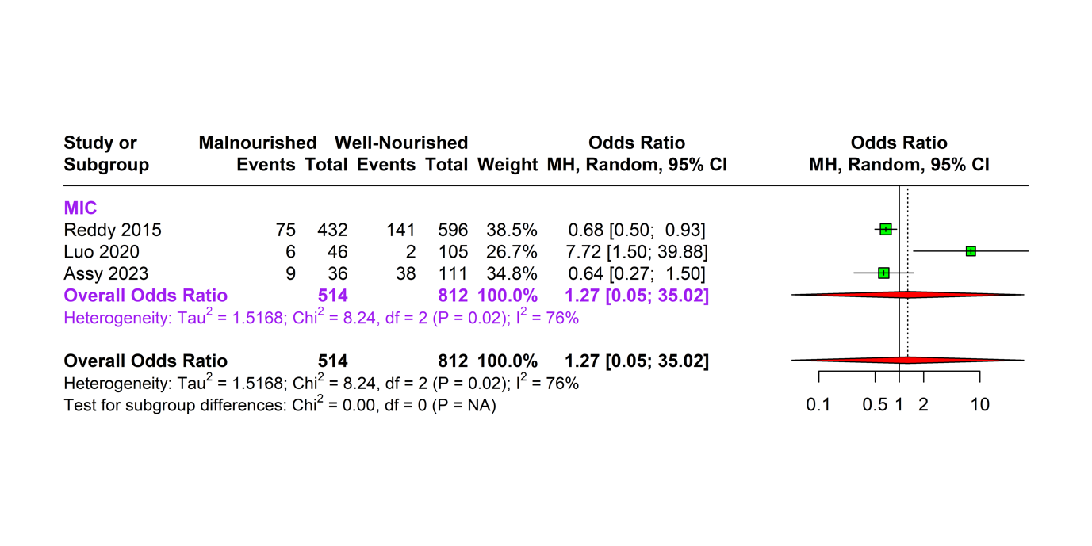

- Post-operative infections (pooled prevalence in malnourished patients)
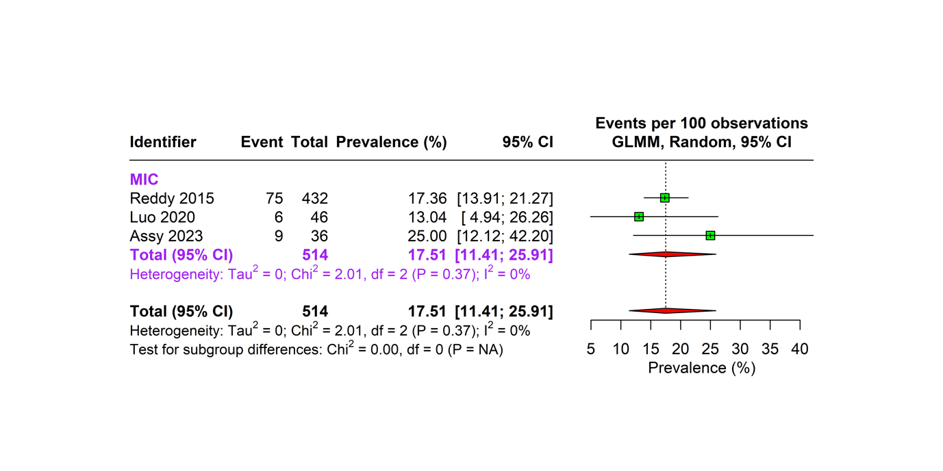

- Post-operative infections (pooled prevalence in well-nourished patients)
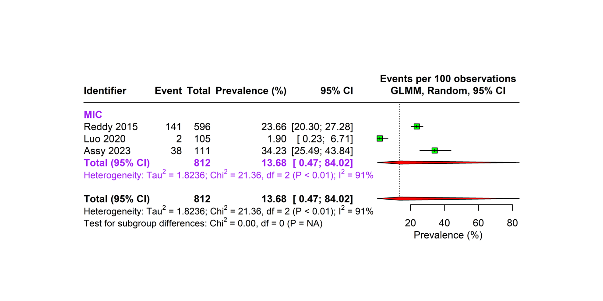

- Age (months)
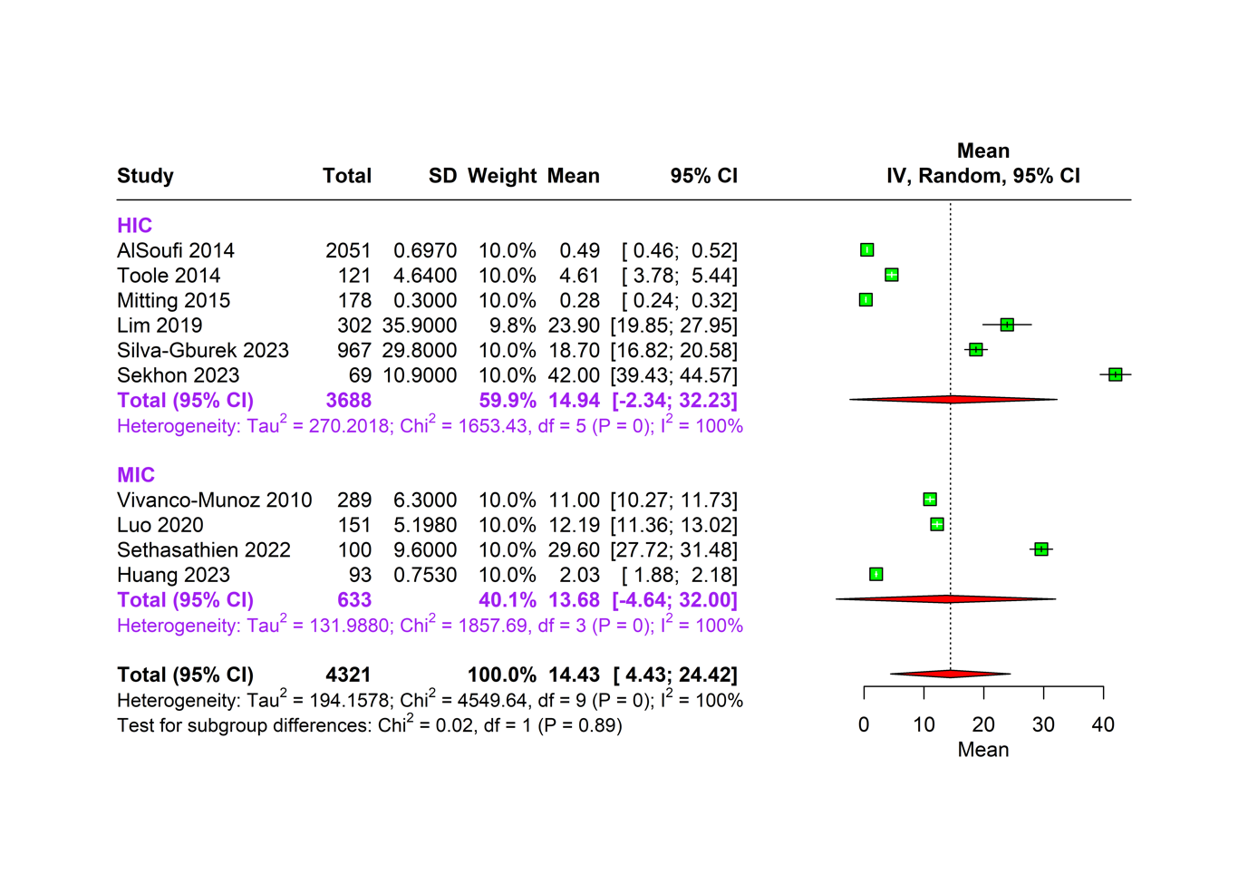

Position of the squares on the x-axis indicates standard mean difference/odds ratio/prevalence/mean (as applicable), with horizontal lines indicating 95% confidence intervals; diamonds indicate pooled estimates, with outer points of the diamonds indicating 95% confidence intervals.

