Supplementary Information for

Consecutive Northward Super Typhoons Induced Extreme Ozone Pollution Events in Eastern China
Jiahe Wangª, Peng Wang^{a, b,c,*}, Chunfeng Tianª, Meng Gao^{d}, Tiantao Chengª, and Wei Meiª
ª Department of Atmospheric and Oceanic Sciences, Institute of Atmospheric Sciences, Fudan University, Shanghai, China.
^{b} Shanghai Key Laboratory of Ocean-land-atmosphere Boundary Dynamics and Climate Change, Shanghai, China.
^{c} Institute of Eco-Chongming (IEC), Shanghai, China
^{d} Department of Geography, State Key Laboratory of Environmental and Biological Analysis, Hong Kong Baptist University, Hong Kong SAR, China.
*Corresponding author.
E-mail addresses: w_peng@fudan.edu.cn (Peng Wang)

Contents of this file：
Supplementary Texts 1 to 4.
Supplementary Equations
Supplementary Tables 1 to 4.
Supplementary Figures 1 to 10.

Supplementary Texts
- The filter of MDA8 O₃
The maximum daily 8-hour average (MDA8) O₃ in each site was selected and calculated based on the following criteria. Data with missing values are removed. The data exceeding 6 hours within the 8-hour sliding interval is considered to derive the effective 8-hour average O₃ concentration. The determination of MDA8 involves assessing the presence of at least 14h effective 8-hour average O₃ concentrations within the 8:00 to 24:00 timeframe on a given day. The highest among these values is identified as the MDA8 O₃ for that day; otherwise, the value is denoted as null. In instances where effective 8-hour average O₃ concentrations are less than 14h, the data is retained if the maximum 8-hour average concentration exceeds the concentration limit standard of 160μg·m⁻³. The formula for calculating MDA8 O₃ is as follows:
$$\begin{aligned}C_{O_{3}}=\max_{t=8,9,. ..,24}\left\{\frac{1}{n_{c}}\sum_{i=t-7}^{t}{c_{t}}\right\} \#\left(1\right)\end{aligned}$$
Where c_{t} is the hourly O₃ concentration from t−1 to t on a given day. n_{c} is the number of effective c_{t}, n_{c} needs to be greater than or equal to 6, and the number of the effective $\frac{1}{n_{c}}\sum_{i=t-7}^{t}{c_{t}}$, we define as n_{t}, needs to be greater than or equal 14. When n_{t} is less than 14, if $C_{O_{3}}$ is greater than or equal to 160, it is also considered valid data.
- The formula used to estimate the relative humidity (RH) at 2m
We refer to the water vapor pressure calculation formula provided by National Oceanic and Atmospheric Administration (NOAA) to calculate the relative humidity (https://www.weather.gov/epz/wxcalc_vaporpressure, https://www.weather.gov/media/epz/wxcalc/vaporPressure.pdf)
The saturated vapor pressure ($e_{s}\left(T\right)$) and the actual vapor pressure ($e_{s}\left(T_{d}\right)$) can be calculated using the formula listed below:
$$\begin{aligned}e_{s}\left(T\right)=6.11×{10}^{\left(\frac{7.5×T}{T+237.3}\right)}\#\left(2\right)\end{aligned}$$
$$\begin{aligned}e_{s}\left(T_{d}\right)=6.11×{10}^{\left(\frac{7.5×T_{d}}{T_{d}+237.3}\right)}\#\left(3\right)\end{aligned}$$
Where T and T_{d} are 2m temperature and 2m dewpoint temperature at the surface from ERA5. The RH can be calculated using the equation below:
$$\begin{aligned}RH=100×\frac{e_{s}​\left(T_{d}\right)}{e_{s}​\left(T\right)}​\#\left(4\right)\end{aligned}$$
- The unit conversion of O₃ precursor
The unit of Total Column (TC) of HCHO, NO₂ in the ECMWF Atmospheric Composition Reanalysis 4 (EAC4) is kg·m⁻². By using Avogadro's constant ($N_{Av}$) and the molecular weights (MW) for the respective species, we converted the unit from Total Column (TC, kg·m⁻²) to Column Number Density (CND, molec·cm⁻²) (https://wiki.ucar.edu/display/camchem/Using+CAM-chem+Output).
$$\begin{aligned}CND_{HCHO}(molec·{cm}^{-2})=TC_{HCHO}\left(kg·m^{-2}\right)×N_{Av}\left(molecules·{mol}^{-1}\right) \\ ×1000(g·{kg}^{-1})/10000({cm}^{2}·m^{-2})/{MW}_{HCHO}\left(g·mol^{-1}\right) \#\left(5\right)\end{aligned}$$
$$\begin{aligned}CND_{NO_{2}}\left(molec·{cm}^{-2}\right)=TC_{NO_{2}}\left(kg·m^{-2}\right)×N_{Av}\left(molecules·{mol}^{-1}\right) \\ ×1000(g·{kg}^{-1})/10000({cm}^{2}·m^{-2})/{MW}_{{NO}_{2}}\left(g·mol^{-1}\right) \#\left(6\right)\end{aligned}$$
Where the $N_{Av}$ equals 6.022×10²³ (molecules·mol⁻¹), ${MW}_{HCHO}$ equals 30.0252(g·mol⁻¹), ${MW}_{{NO}_{2}}$ equals 46.0055(g·mol⁻¹).

- Model application and validation
The meteorological inputs and the initial and boundary conditions were generated by the Weather Research and Forecasting (WRF) model version 4.2.1 (https://www2.mmm.ucar.edu/wrf/users), based on the FNL reanalysis data with a resolution of 1°×1°from the National Centers for Environmental Prediction (NCEP) (https://rda.ucar.edu/datasets/ds083.2). Based on the meteorological field of WRF output, the Community Multiscale Air Quality (CMAQ) mode v5.0.2 was used to assist in the analysis of the physical and chemical processes in this process. The anthropogenic emissions in China were from the Multiresolution Emission Inventory for China (MEIC) version 1.4 (http://www.meicmodel.org/), and regions outside of China within the simulation domain used the Emissions Database for Global Atmospheric Research (EDGAR v5.0, https://edgar.jrc.ec.europa.eu/dataset_ap50) (Crippa et al., 2020). Biogenic emissions were generated using the Model of Emissions of Gases and Aerosols from Nature version 2.1 (MEGAN2.1) (Guenther et al., 2012).

The WRF model underwent performance evaluation by comparing predicted 2m temperature (T) and 2m relative humidity (RH), wind speed (WS), and wind direction (WD) at 10 m above the surface with observational data from the National Climatic Data Center (~1400 sites) (Table S3) (ftp://ftp.ncdc.noaa.gov/pub/data/noaa/). In August, the model slightly overestimated T, with mean bias (MB) values of 2.2, consistent with previous findings (Wang et al., 2021). However, T predictions for September were generally successful. The model slightly overestimated WS, with MB values ranging from 0.8 to 0.6, and gross error (GE) values (1.5-1.4) of WS within the benchmark (Emery et al., 2001). WD predictions were generally in line with previous studies (Wang et al., 2021), and RH simulations were comparable to other research (Hu et al., 2016; Shen et al., 2020; Zhang et al., 2012). Overall, the WRF model performed well, providing reliable meteorological inputs for the CMAQ model.

CMAQ model simulations underwent validation using observations (~1500 sites) from the national air quality monitoring network (http://www.cnemc.cn/) (Table S4). The model overestimated the hourly O3 concentrations, with mean normalized bias (MNB) values of 0.22 and 0.18 in August and September similar to a previous study (Hu et al., 2017). The mean normalized error (MNE) values were 0.28 and 0.24, within the criteria (EPA, 2005, 2007). The model accurately captured changes in O₃, NO_{2,} and SO₂ during the simulation periods, performing well in simulating O3 levels throughout the analyzed periods.

Supplementary Equations
The assessment of the WRF model involved metrics including mean bias (MB), gross error (GE), and root mean square error (RMSE), and the validation of the CMAQ model relied on mean normalized bias (MNB), mean normalized error (MNE), mean fractional bias (MFB), and mean fractional error (MFE).
$$\begin{aligned}MB=\frac{1}{N}\sum_{i=1}^{N}{\left(C_{m, i}-C_{o,i}\right) }\#\left(7\right)\end{aligned}$$
$$\begin{aligned}GE=\frac{1}{N}\sum_{i=1}^{N}{\left|C_{m, i}-C_{o,i}\right|}\#\left(8\right)\end{aligned}$$
$$\begin{aligned}RMSE={\left(\frac{1}{N}\sum_{i=1}^{N}{\left.{\left(C_{m,i}-C_{o,i}\right)}^{2}\right.}\right)}^{\frac{1}{2}}\#\left(9\right)\end{aligned}$$
$$\begin{aligned}MNB= \frac{1}{N}\sum_{i=1}^{N}{\frac{C_{m, i}-C_{o,i}}{C_{o,i}}}\#\left(10\right)\end{aligned}$$
$$\begin{aligned}MNE= \frac{1}{N}\sum_{i=1}^{N}{\frac{\left|C_{m, i}-C_{o,i}\right| }{C_{o,i}}}\#\left(11\right)\end{aligned}$$
$$\begin{aligned}MFB=\frac{2}{N}\sum_{i=1}^{N}{\frac{C_{m,i}-C_{o,i}}{C_{m,i}+C_{o,i}}}\#\left(12\right)\end{aligned}$$
$$\begin{aligned}MFE=\frac{2}{N}\sum_{i=1}^{N}{\frac{\left|C_{m,i}-C_{o,i}\right|}{C_{m,i}+C_{o,i}}}\#\left(13\right)\end{aligned}$$
where C_{m,i} and C_{o,i} refer to the i^{th} predicted and observed value, respectively. N is the number of prediction-observation pairs drawn from all measurement sites.

Supplementary Tables

Table S1. Physical and chemical processes in the IPR analysis.
Process | Abbreviation
Net sum of all gas-phase chemical processes | CHEM
Cloud process | CLDS
Dry deposition | DDEP
Horizontal advection | HADV
Horizontal diffusion | HIDF
Vertical diffusion | VDIF
Vertical advection | ZADV

Table S2. Meteorological WRF mode performance in the simulation period (August 1 to September 30, 2020). T2: temperature, WS: wind speed, WD: wind direction, RH: relative humidity. (OBS is mean observation; PRE is mean prediction; MB is mean bias; GE is gross error; and RMSE is root mean square error).
 |  | Aug | Sep | Benchmark*
T2 (K) | OBS | 297.4 | 293.1
 | PRE | 297.4 | 292.7
 | MB | 0.0 | -0.4 | ≤ ±0.5
 | GE | 2.2 | 2.0 | ≤ 2.0
 | RMSE | 3.0 | 2.9
WS (m·s⁻¹) | OBS | 3.0 | 2.9
 | PRE | 3.9 | 3.6
 | MB | 0.8 | 0.6 | ≤ ±0.5
 | GE | 1.5 | 1.4 | ≤ 2.0
 | RMSE | 1.9 | 1.8 | ≤ 2.0
WD (°) | OBS | 170.1 | 165.4
 | PRE | 174.3 | 160.4
 | MB | 6.9 | 1.2
 | GE | 44.0 | 44.2 | ≤ ±30
 | RMSE | 60.6 | 61.0
RH (%) | OBS | 72.3 | 73.3
 | PRE | 70.6 | 71.8
 | MB | -1.7 | -1.5
 | GE | 10.5 | 10.1
 | RMSE | 13.8 | 13.6
Note: * are benchmarks limits suggested by Emery et al. (2001). Predictions which do not fall under the benchmark are shown as bold.

Table S3. CMAQ model performances of key pollutants in the simulation period from August to September 2020. (MFB: mean fractional bias; MFE: mean fractional error; MNB: mean normalized bias; MNE: mean normalized error).
 |  | Aug | Sep | Criteria*
O₃-1h (ppb) | OBS | 57.71 | 58.28
 | PRE | 68.37 | 67.10
 | MFB | 0.16 | 0.14
 | MFE | 0.24 | 0.22
 | MNB | 0.22 | 0.18 | ≤ ±0.15
 | MNE | 0.28 | 0.24 | ≤ 0.3
PM_{2.5} (μg·m⁻³) | OBS | 27.02 | 31.05
 | PRE | 22.47 | 23.95
 | MFB | -0.18 | -0.29 | ≤ ±0.6
 | MFE | 0.44 | 0.50 | ≤ 0.75
 | MNB | -0.03 | -0.09
 | MNE | 0.44 | 0.49
PM₁₀ (μg·m⁻³) | OBS | 43.99 | 51.60
 | PRE | 24.06 | 26.54
 | MFB | -0.55 | -0.62
 | MFE | 0.65 | 0.73
 | MNB | -0.33 | -0.34
 | MNE | 0.51 | 0.57
CO (ppm) | OBS | 0.50 | 0.54
 | PRE | 0.24 | 0.33
 | MFB | -0.79 | -0.68
 | MFE | 0.86 | 0.79
 | MNB | -0.46 | -0.34
 | MNE | 0.63 | 0.65
NO₂ (ppb) | OBS | 18.27 | 21.76
 | PRE | 21.19 | 22.64
 | MFB | 0.09 | -0.00
 | MFE | 0.42 | 0.45
 | MNB | 0.30 | 0.20
 | MNE | 0.56 | 0.54
SO₂ (ppb) | OBS | 17.20 | 16.81
 | PRE | 24.69 | 27.44
 | MFB | 0.14 | 0.19
 | MFE | 0.49 | 0.48
 | MNB | 0.73 | 0.92
 | MNE | 0.98 | 1.14
Note: * are benchmarks limits suggested by (EPA, 2005, 2007). Predictions which do not fall under the criteria are shown as bold.

Table S4. MDA8 O₃ concentrations (μg·m⁻³) in PRE- CTYT, CTYT, and AFT- CTYT in 9 key cities of eastern China. The 9 key cities are shown in Fig. S1.
City | PRE-CTYT | CTYT | AFT-CTYT | Max-CTYT* | Exc-CTYT* | Exc-Prop in Aug. & Sep.* | Location
Beijing | 130.4 | 114.4 | 91.8 | 221.3 | 1 | 12.5% | 116.4°E, 39.9°N
Tianjin | 133.8 | 141.6 | 101.8 | 224.6 | 4 | 29% | 117.2°E, 39.1°N
Shijiazhuang | 136.3 | 153.0 | 122.4 | 241.7 | 6 | 27% | 114.5°E, 38.0°N
Jinan | 120.4 | 178.1 | 141.3 | 250.2 | 8 | 40% | 117.1°E, 36.6°N
Zhengzhou | 113.9 | 169.9 | 135.7 | 221.5 | 6 | 43% | 113.6°E, 34.7°N
Xuzhou | 104.6 | 157.6 | 129.5 | 212.9 | 6 | 75% | 117.3°E, 34.2°N
Nanjing | 131.9 | 147.9 | 126.8 | 204.9 | 5 | 31% | 118.8°E, 32.1°N
Shanghai | 109.5 | 128.7 | 98.1 | 243.2 | 4 | 57% | 121.5°E, 31.2°N
Hangzhou | 122.3 | 149.3 | 102.3 | 198.7 | 7 | 58% | 120.2°E, 30.2°N
*: Max- CTYT is the maximum MDA8 O₃ during CTYT and Exc- CTYT refers to days exceeding the air quality standard during CTYT. Exc-Prop in Aug. & Sep. refers to the proportion of exceeding days during CTYT of all exceeding days in August and September 2020.

Supplementary Figures
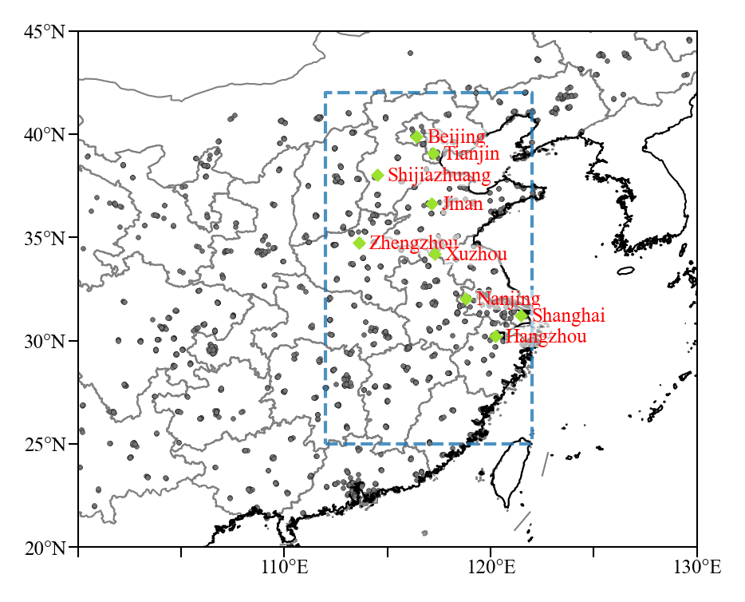

Fig. S1 Spatial distribution of air quality observation sites and selected key cities. Spatial distribution of air quality observation sites (grey solid dot), the range of eastern China (24.5°N-42°N and 112°E-122°E, the blue dotted box), and the location of nine key cities (green points), including Beijing, Tianjin, Shijiazhuang, Jinan, Zhengzhou, Xuzhou, Nanjing, Shanghai, and Hangzhou.

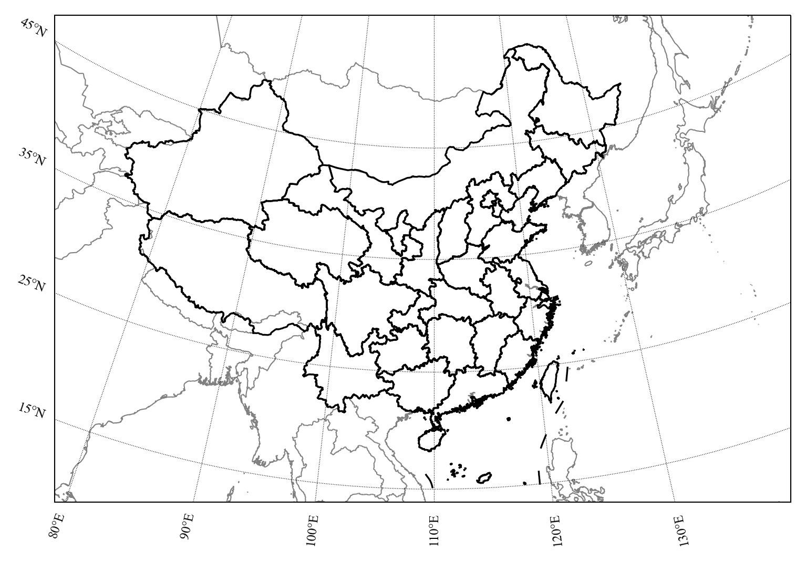
Fig. S2 The model simulation domain.

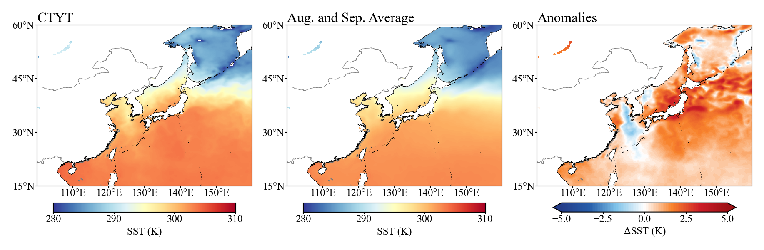

Fig. S3 Changes in sea surface temperature (SST). The SST during the CTYT, climatological SST in August-September, and their difference.

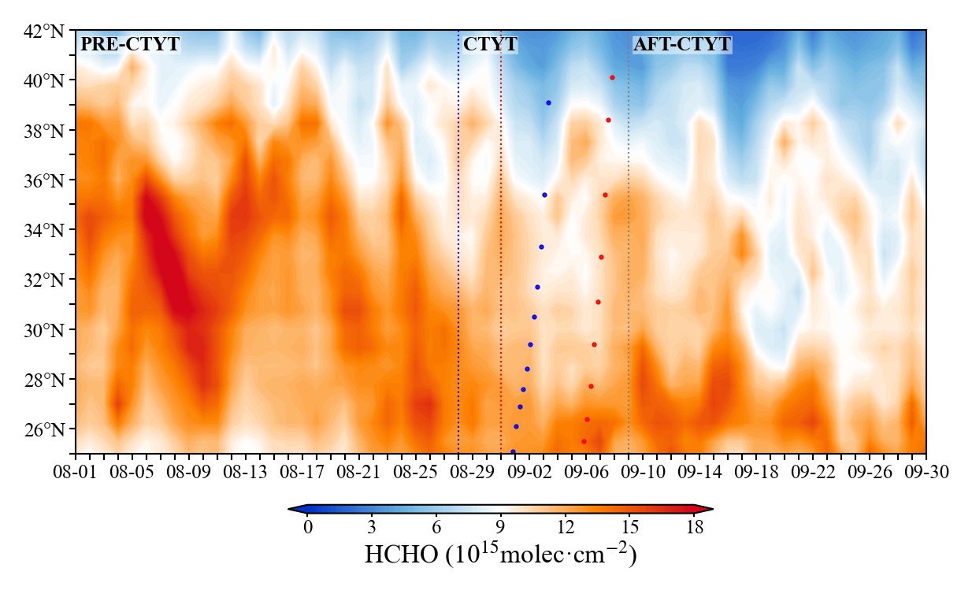

Fig. S4 Observed HCHO column number density. Same as Fig. 1c but for HCHO column number density.

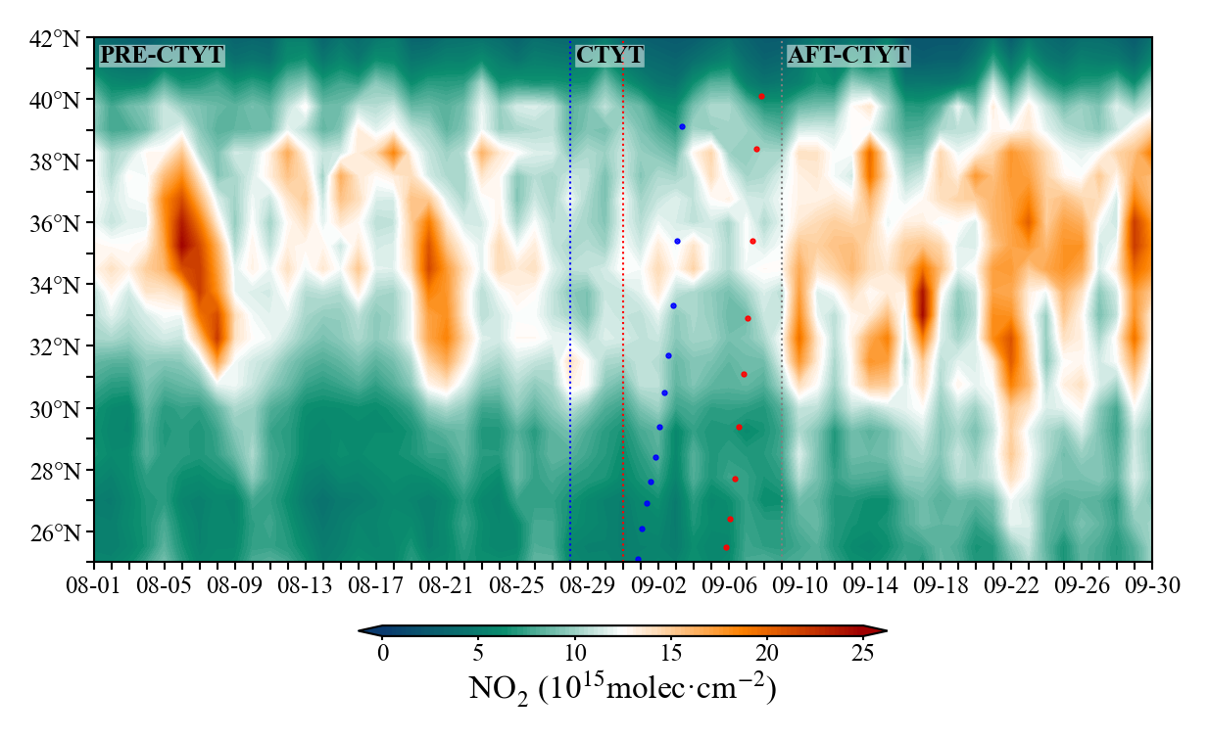

Fig. S5 Observed NO₂ column number density. Same as Fig. 1c but for NO₂ column number density.

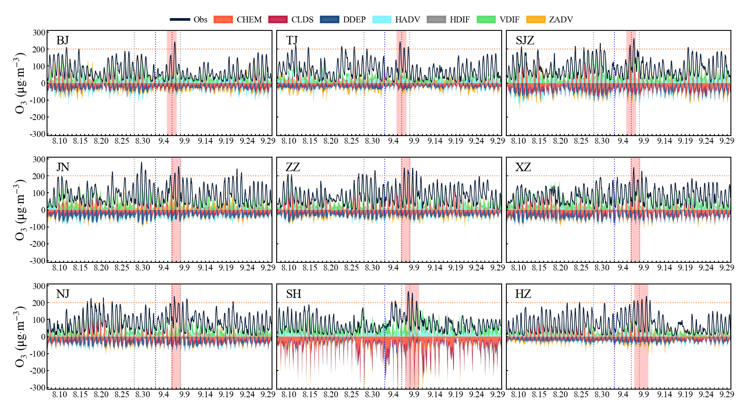

Fig. S6 O₃ IPR results in the selected key cities. O₃ process analysis in the 9 key cities during the CTYT. The solid lines show hourly O₃ observations for nine key cities. The red shadow marks the time of the second round of O₃ pollution in different cities.

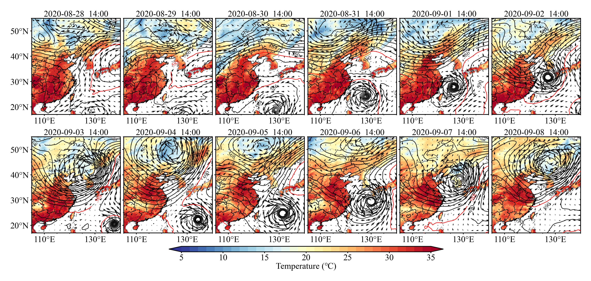

Fig. S7 Key meteorological parameters. The 500hPa height (black line), wind field, and 2m temperature at 14:00 local time. The solid red lines highlight the position of WPSH (588 dagpm at 500hPa).

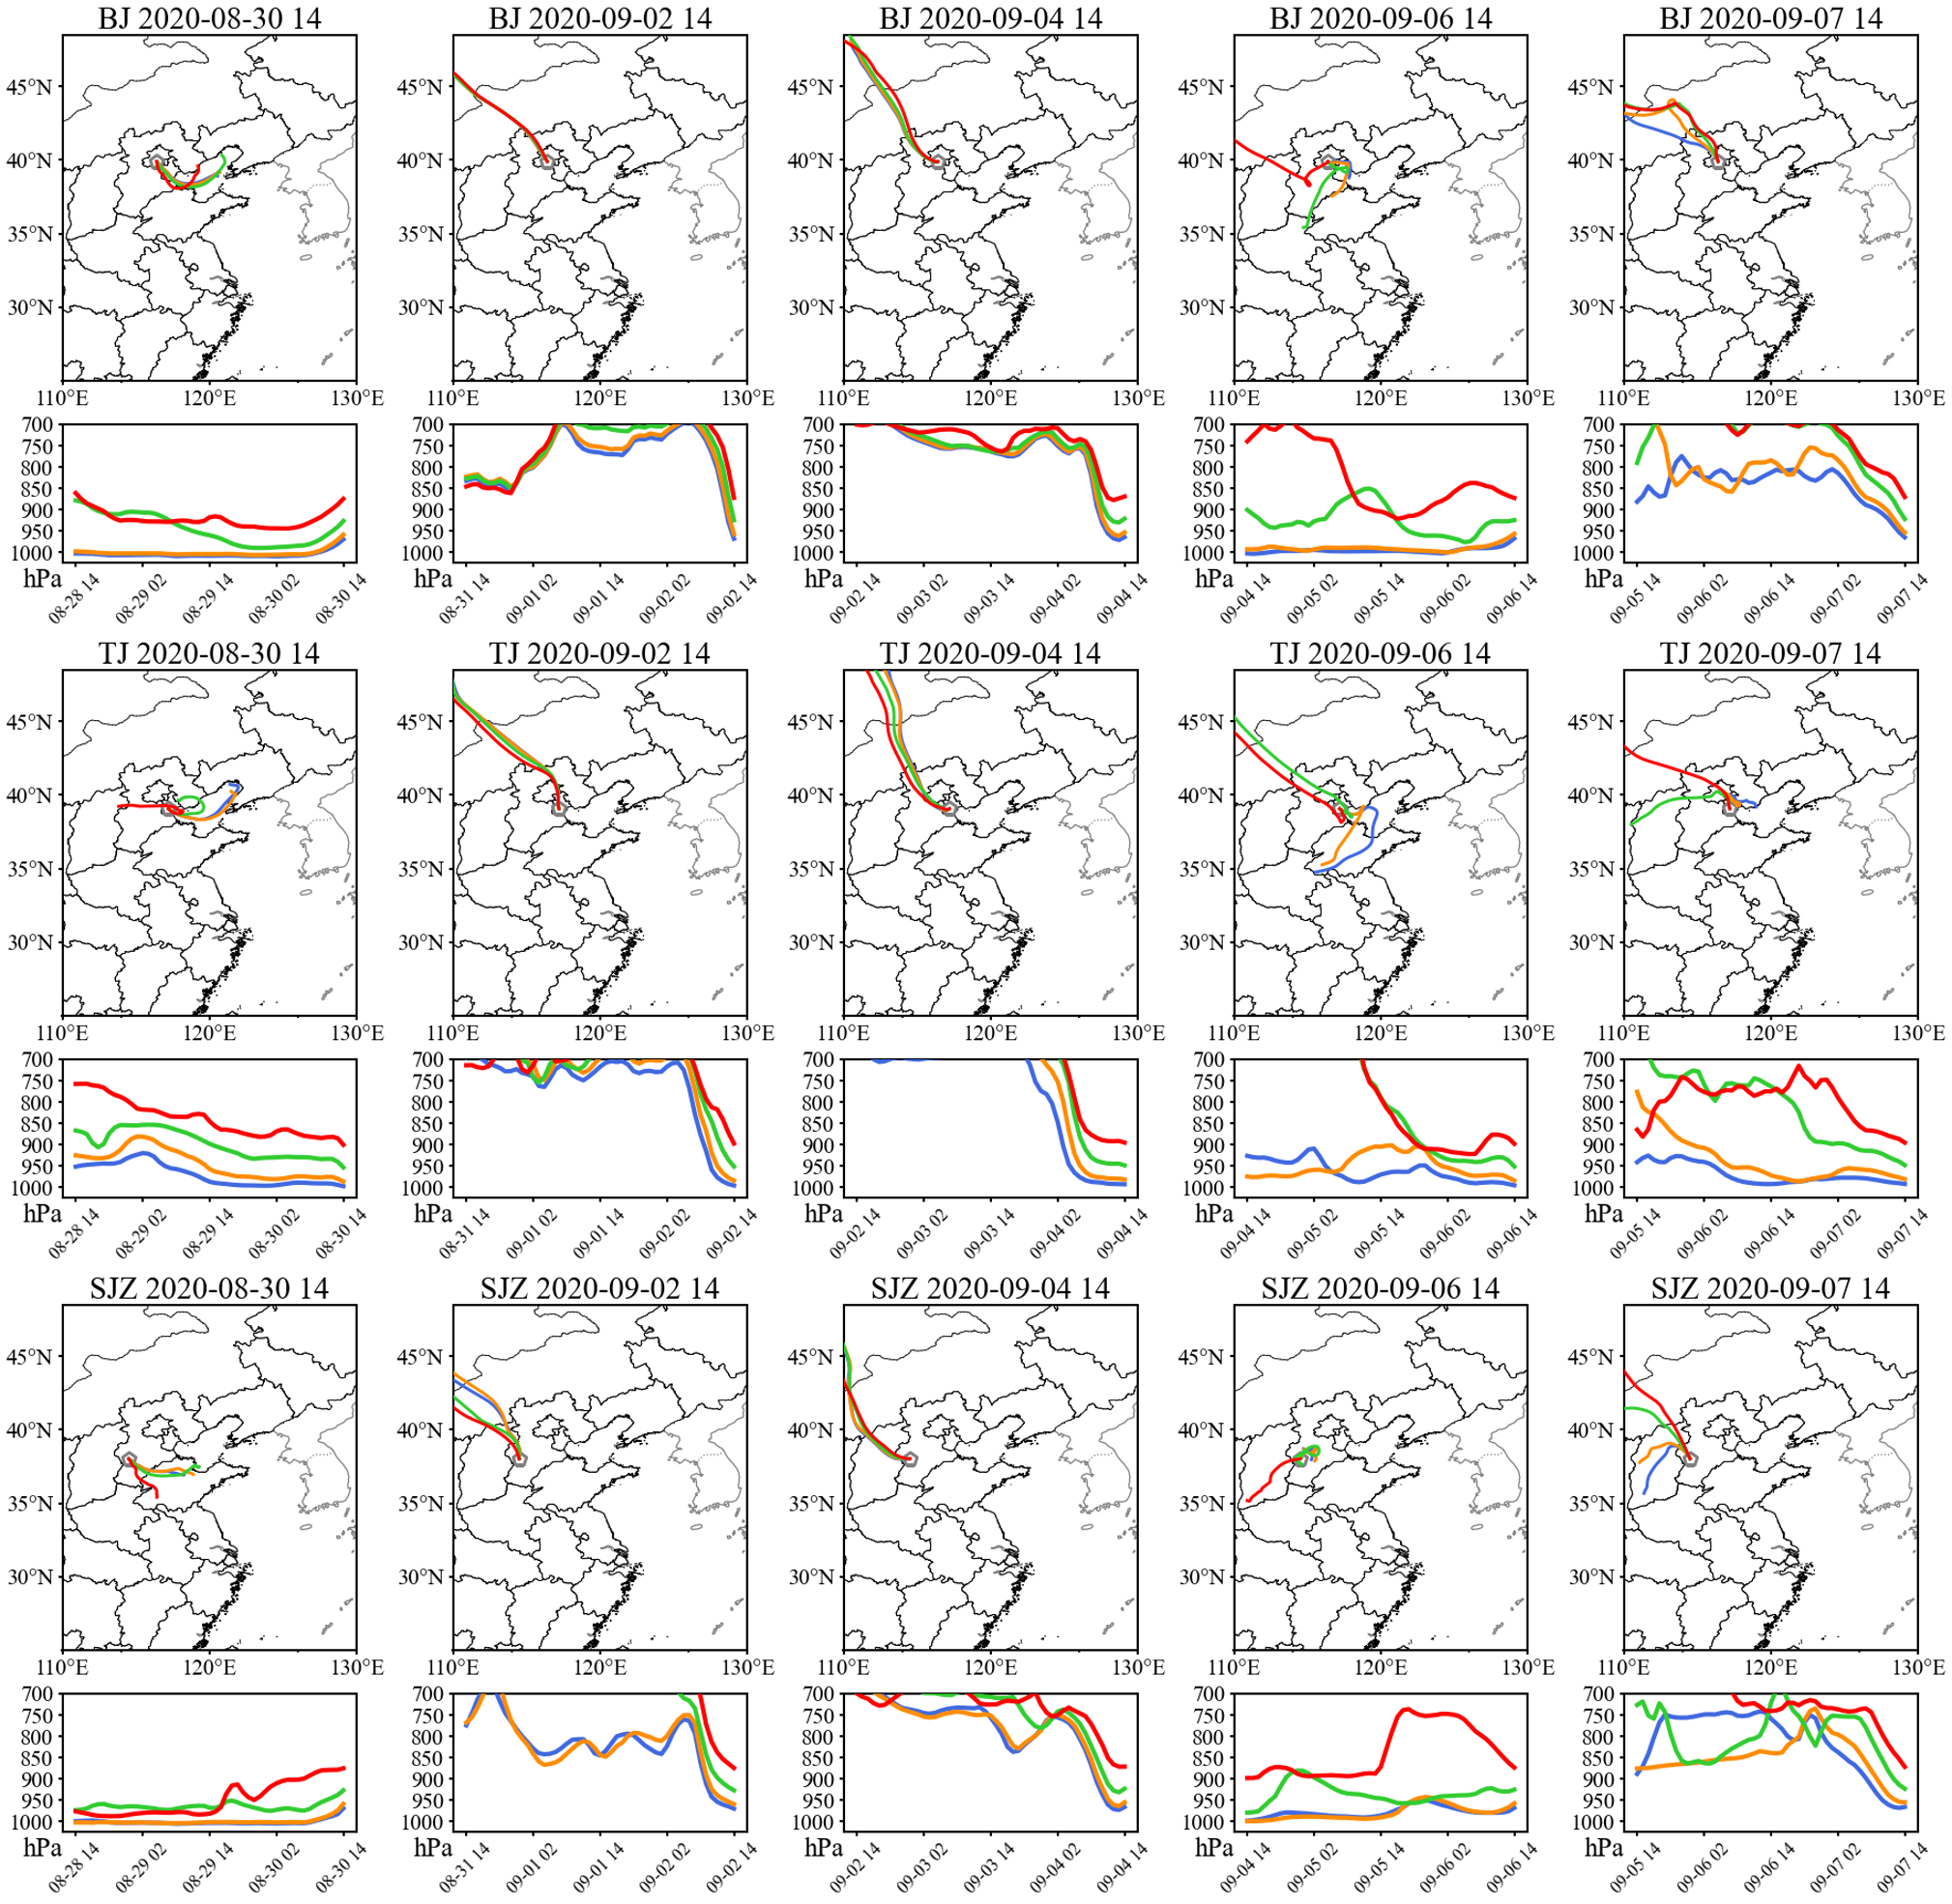

Fig. S8 48 hours backward air mass trajectories in north China. 48 hours backward air mass trajectories with arrival height of 100m, 200m, 500m, and 1000m above ground level at Beijing, Tianjin, and Shijiazhuang at 14:00 local time during the CTYT.

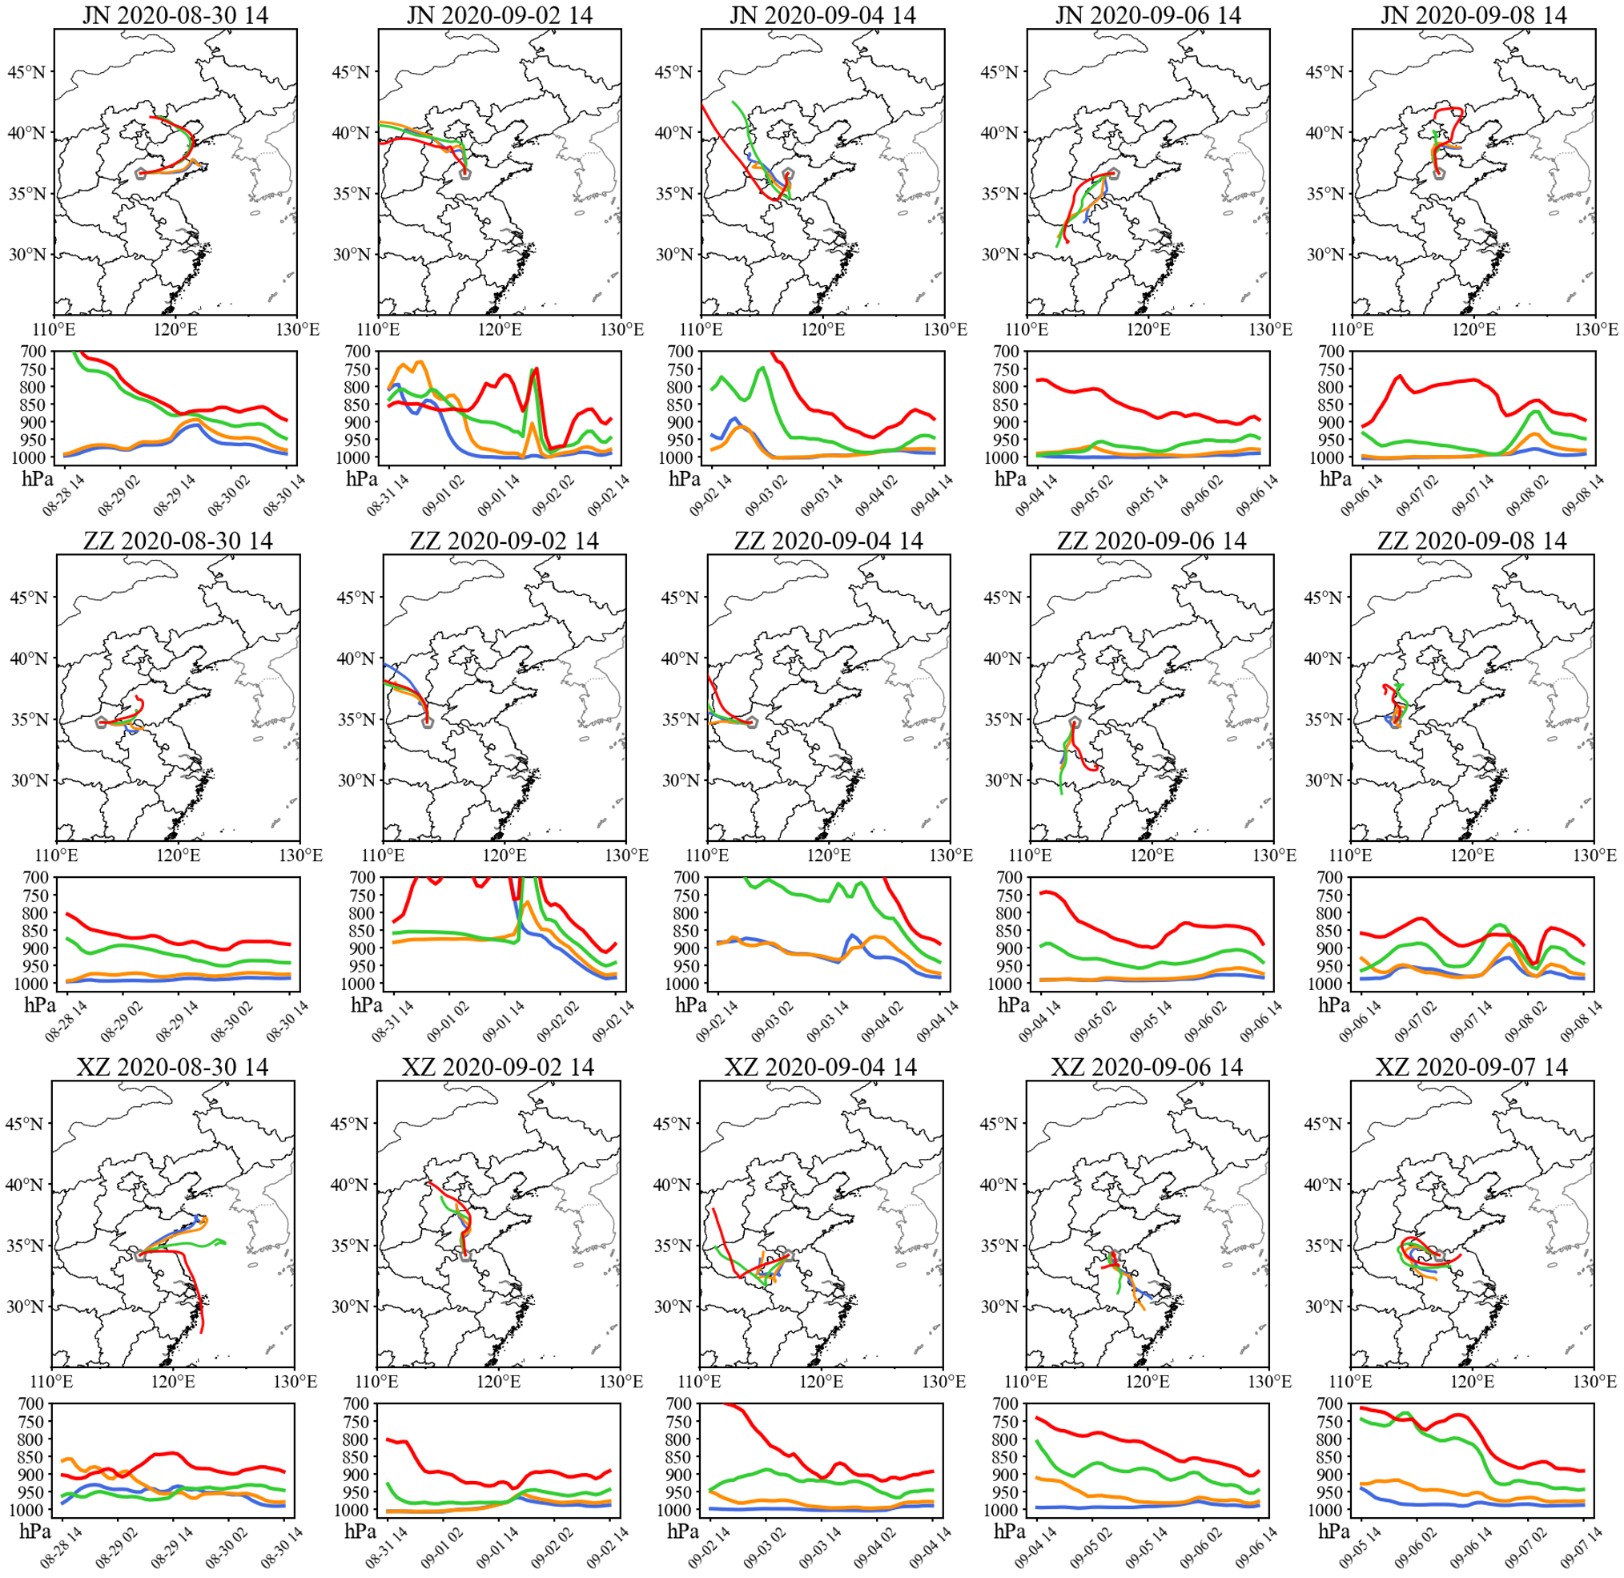

Fig. S9 48 hours backward air mass trajectories in east China. 48 hours backward air mass trajectories with arrival height of 100m, 200m, 500m, and 1000m above ground level at Jinan, Zhengzhou, and Xuzhou at 14:00 local time during the CTYT.

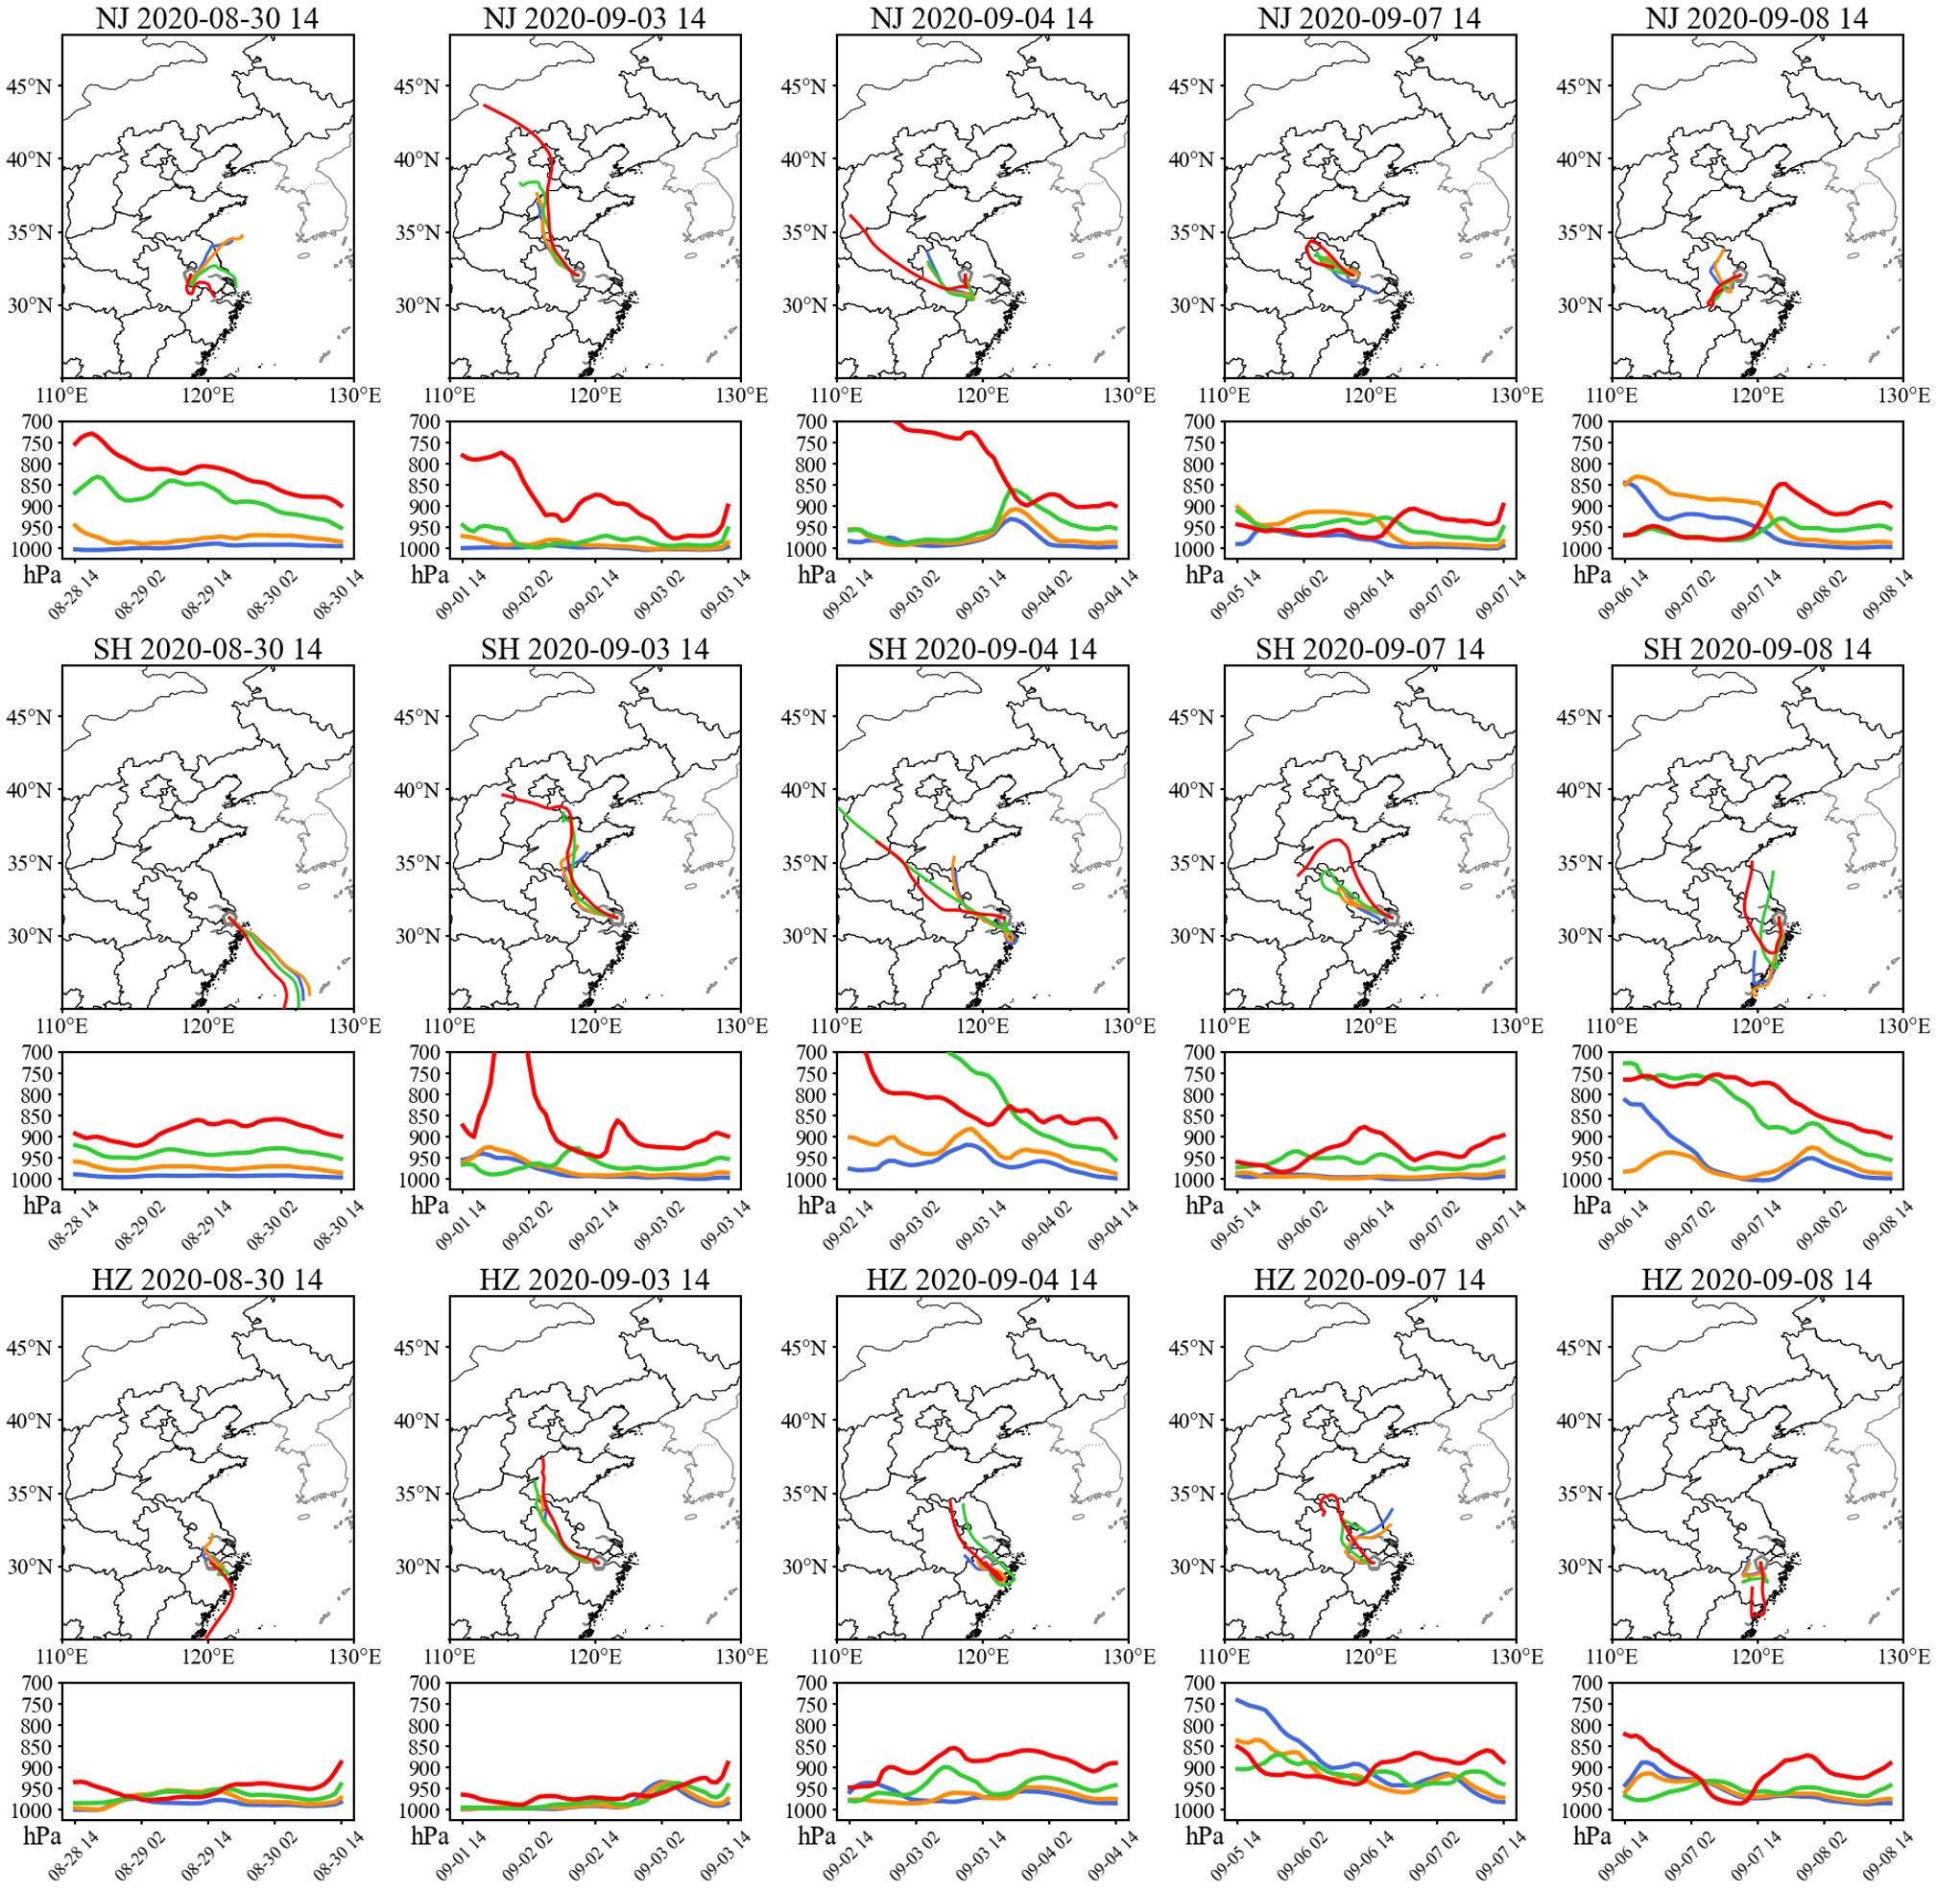

Fig. S10 48 hours backward air mass trajectories in the YRD. 48 hours backward air mass trajectories with arrival height of 100m, 200m, 500m, and 1000m above ground level at Nanjing, Shanghai, and Hangzhou at 14:00 local time during the CTYT.

Reference
Emery, C., Tai, E., & Yarwood, G. (2001). Enhanced meteorological modeling and performance evaluation for two texas episodes. In: Report to the Texas Natural Resources Conservation Commission. p.b.E., International Corp (Ed.), Novato, CA.,

